Table 5. Data convergence matrix on the effectiveness of the program by the learning objectives

Learning objectives | Quantitative data |  | Qualitative data | Data convergence label
Identify the acupuncture point location on the meridian | Average score of ‘process of acupuncture point location’ and ‘accuracy of acupuncture point location’ was higher in the implementation group. |  | Theme ‘Improved competency in finding acupuncture points and acupuncture through practical exercises’  “I think I had a little bit of confidence in finding points because I practiced a lot. I realized that if I practice, I can do this, and at first I thought I couldn’t do it at all, but then I did it.” (Student 7) | Confirm
Identify the acupuncture point location on the meridian | 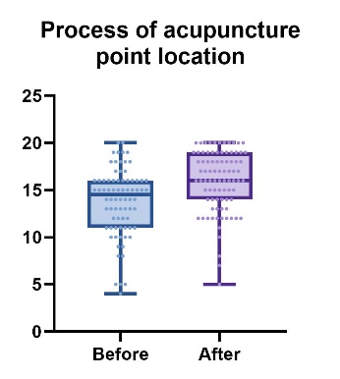 | 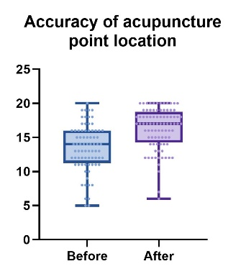 |  | Confirm
Perform acupuncture procedures hygienically and safely | Average score of ‘hygiene management’ and ‘safety of the subject’ was higher in the implementation group. |  | Theme ‘Establishing practice for hygiene and safety’  “In the case of hygiene, we really achieved 100% (…)” (Student 1)  “We’ve done so much in terms of safety and hygiene that I would say that’s really the whole thing (…)” (Student 4) | Enhance
Perform acupuncture procedures hygienically and safely | 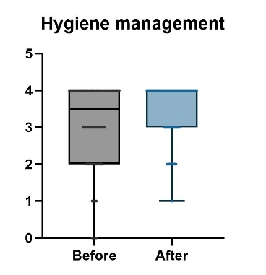 | 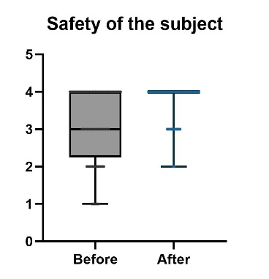 |  | Enhance
Appropriately utilize medical tools and devices required for the procedure | Average score of ‘process of acupuncture and ability of using tools’ was lower in the implementation group |  | “The manual indicates where the items are, and I know that the blood sugar checks are in this locker, but it’s a little confusing as to where this locker is in the lab. (…) I wonder if we could just add a quick note that says here are these things (…)” (Student 2) | Mixed
 | 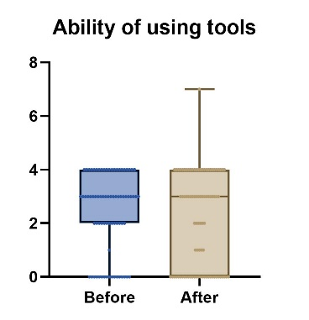 |  |  | Mixed

