Supplementary Table 1
Environment | Pathotype
2018_COB | 134 E16+Yr17+Yr27+, 199 E76A-, 110 E143A+
2018_HRD | WA+17 and 239 E237 A-17+33+
2019_COB | Culture 674
2019_HRD | 198E16A+J+T+17+ / 239 E237 A- 17+ 33+ /238 E191 A+ 17+ 33+
2020_COB | 34E16A+Yr17+Yr27+
2020_HRD | 198E16A+J+T+17+ / 239 E237 A- 17+ 33+ /238 E191 A+ 17+ 33+
2021_COB | 198 E16 A+ J+ T+ 17+ (687) and traces of 239E237A- 17+33+ (674)
2021_HRD | 198 E16 A+ J+ T+ 17+ and 239 E237 A- 17+ 33+
2022_COB | 134 E16 A+ Yr17+ Yr27+ [=617],198 E16 A+ J+ T+ [=687],110 E143 A+ [=444],239 E237 A- 17+ 33+ [=674]
2022_HOR | 239 E237 A- 17+ 33+
Summary of YR pathotypes used in each environment of the study.

Supplementary Table 2
Data summary of wheat lines used in the study.
Total stripe rust observations | 61,262
Environments | 10
Experiments | 148
Years | 5 (2018-2022)
Locations | 2: Cobbity (COB) and Horsham (HRD/HOR)
Unique lines | 35,986
Total inbred lines genotyped | 20,829

Supplementary Table 3
Percentage of genetic variance captured by each factor for each environment and the total percentage of genetic variance captured for each environment using the factor analytic model 4 (FA4) model.
Environment | Factor 1 | Factor 2 | Factor 3 | Factor 4 | % Genetic variance
2018_COB | 54.03473 | 4.492467 | 0.953304 | 0.144336 | 59.62483
2018_HRD | 42.68133 | 25.44565 | 14.39367 | 17.47935 | 100
2019_COB | 74.03907 | 6.95202 | 8.238781 | 4.069538 | 93.29941
2019_HRD | 35.01067 | 61.18684 | 0.082079 | 3.720411 | 100
2020_COB | 67.03674 | 8.503652 | 9.478739 | 14.98087 | 100
2020_HRD | 14.18862 | 80.21865 | 3.531983 | 2.060744 | 100
2021_COB | 86.56146 | 0.907584 | 6.514089 | 1.191817 | 95.17495
2021_HRD | 85.96334 | 0.992575 | 12.06212 | 0.981969 | 100
2022_COB | 82.84522 | 11.58663 | 5.274269 | 0.293882 | 100
2022_HOR | 94.91884 | 2.0286 | 2.59241 | 0.460151 | 100

Supplementary Fig. 1
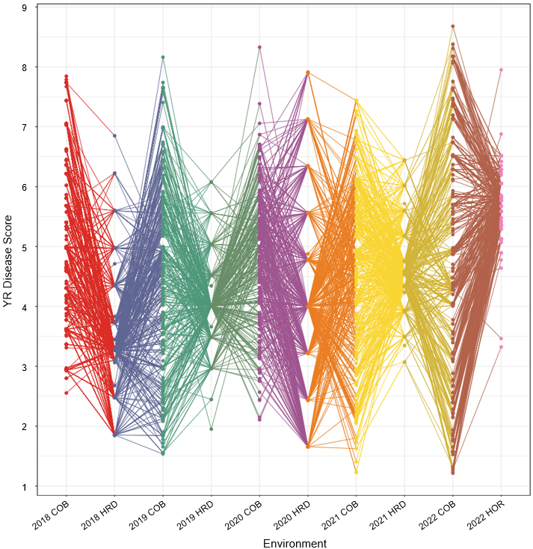
Best linear unbiased predications (BLUPs) for stripe rust (YR) disease response for all 10 environments derived from multi-environment trial (MET) analysis using the base diagonal model.

Supplementary Fig. 2
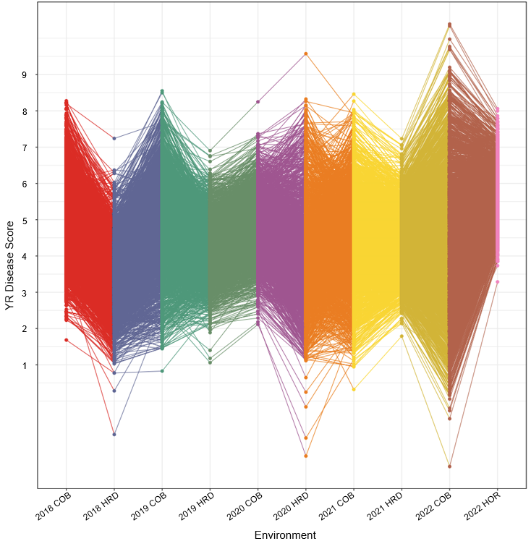
Best linear unbiased predications (BLUPs) for stripe rust (YR) disease response for all 10 environments derived from multi-environment trial (MET) analysis using the factor analytic (FA) model at order four where the performance is predicted for all genotypes at each environment, whether physically present or not.

