S1 Three months after operation, the medication and IOP of the experimental group and the control group.
Time (weeks) | Procedure | Experiment  (mmHg) | Control  (mmHg) | T-value | P-value
0 | —— | 8.50±1.19 | 9.11±0.99 | 2.32 | 0.041
1 | Tobradex + Diclofenac sodium, qid | 9.53±1.65 | 10.14±1.32 | 2.101 | 0.059
2 | Tobradex + Diclofenac sodium, qid | 10.45±2.05 | 10.83±1.69 | 1.756 | 0.107
3 | Tobradex + Diclofenac sodium, bid | 10.38±1.77 | 10.82±1.02 | 1.388 | 0.193
4 | Tobradex + Diclofenac sodium, qd | 10.07±1.45 | 10.39±1.23 | 1.228 | 0.245
5 | Diclofenac sodium, qd | 10.51±1.43 | 10.82±0.85 | 1.391 | 0.192

S2 IOP changes in the experimental group and the control group after re-administration
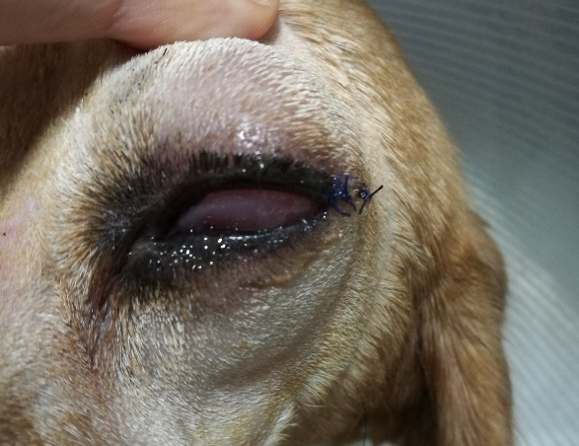

S3 Conjunctival edema in the control group after operation

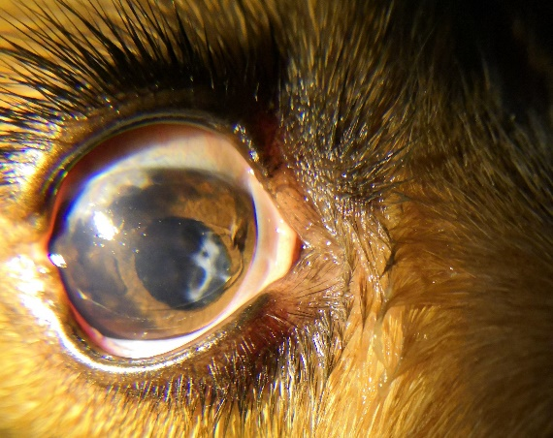
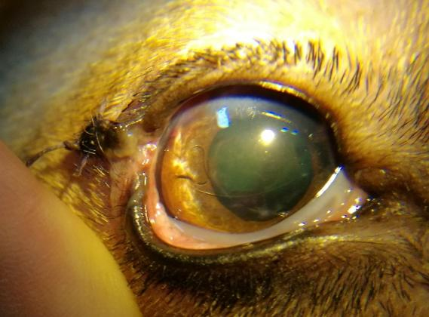
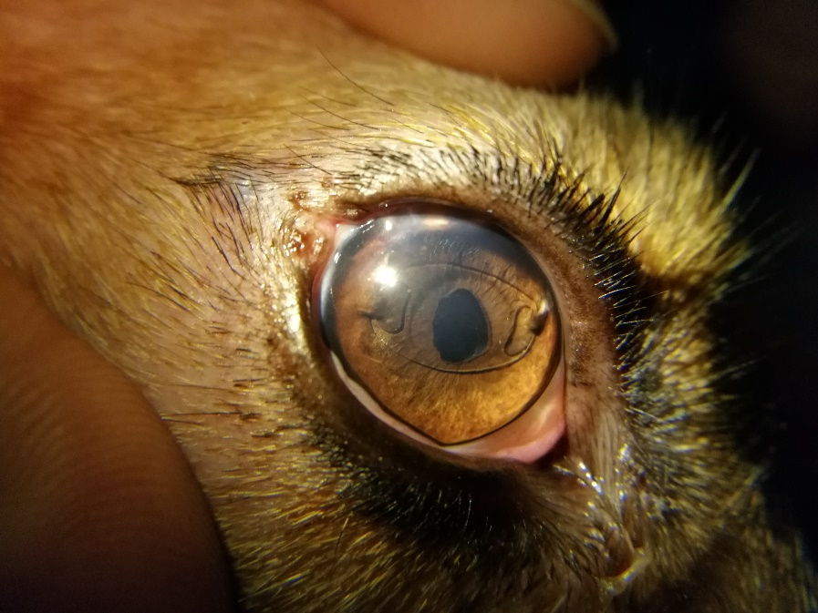
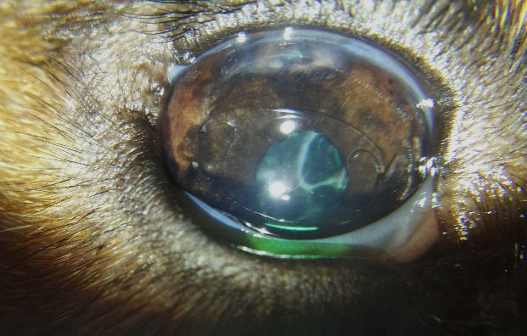
A
B
C
D

D
S4 After anterior chamber lens implantation: Compared with 5 days (A), 30 days (B), 60 days (C) and 90 days (D) after operation, the position of anterior chamber lens was fixed and had no effect on iris function. The iris root incision exists, and the posterior capsule of the lens has fiber attachment.

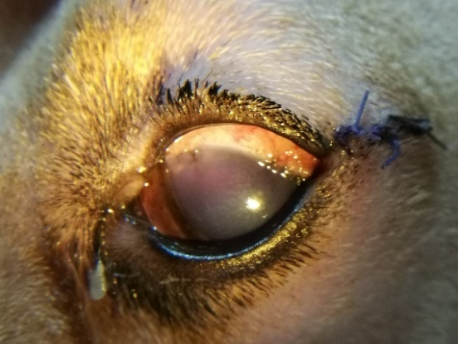
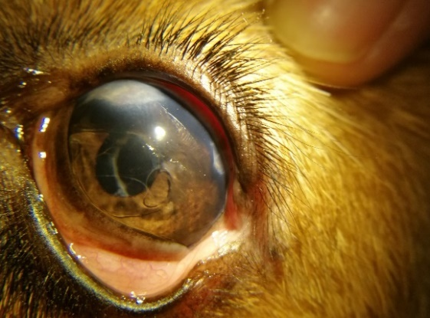
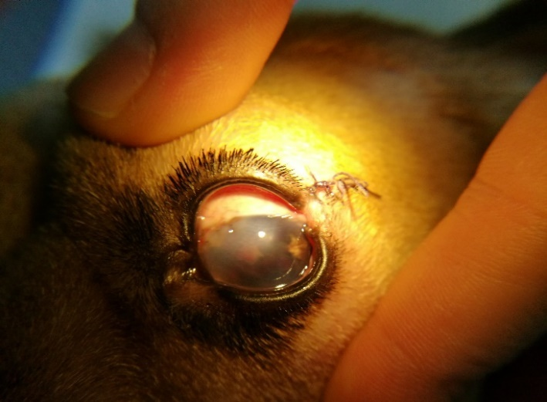
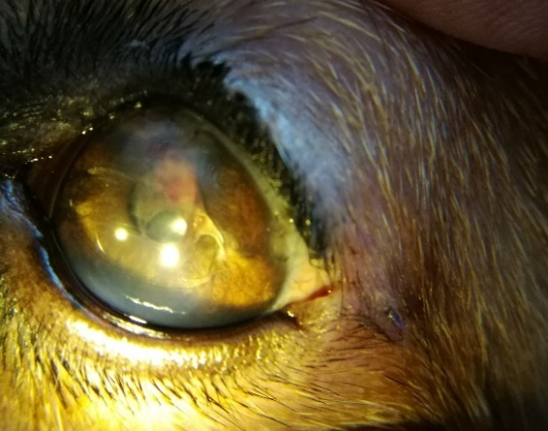
A
D
B
C

S5 Postoperative iris root incision bleeding: Bleeding occurred in iris root incision 2 days after operation (A). Corneal edema was aggravated. After 4 days (B), corneal edema was significantly reduced. It can be seen that part of the red blood cells wrapped in the anterior chamber were attached to the anterior chamber lens. After 17 days (C), corneal edema was basically restored. After 40 days (D), the fiber was almost completely absorbed.
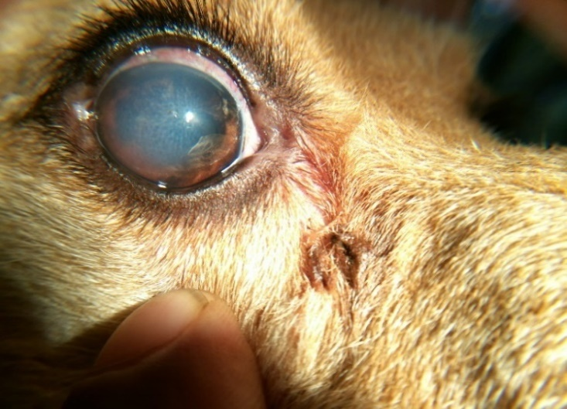
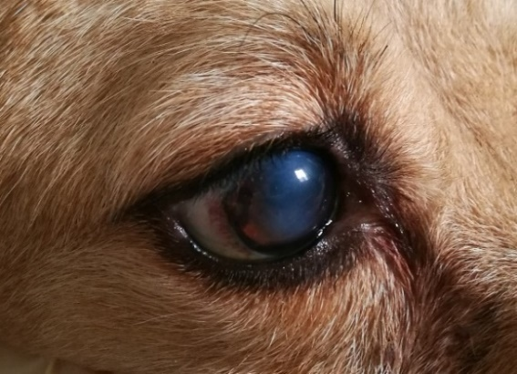
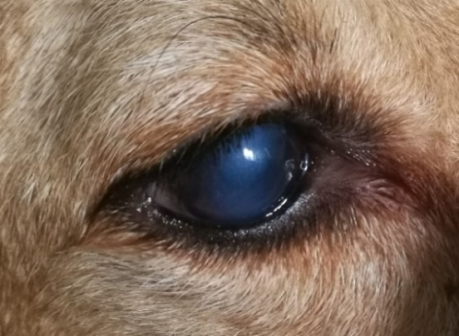
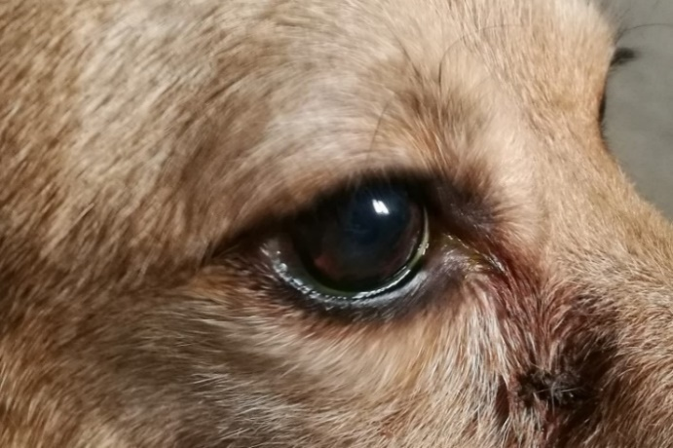
A
C
B
D

S6 Corneal edema after anterior chamber lens implantation: Corneal edema was observed at 20 days (A), 30 days (B) and 40 days (C) after surgery in the same canine experimental group, and corneal transparency was restored at 60 days after surgery (D).

