SUPPLEMENTARY INFORMATION

Structural molecular and developmental evidence for cell-type diversity in cnidarian mechanosensory neurons

Supplementary Movie 1: A long, erect cilium of a type II hair cell
A 3D projection image of confocal sections through the surface ectoderm of a live tentacle of pou-iv::kaede transgenic adult polyp, rotated around the y-axis. pou-iv::kaede expression is shown in grey. The purple arrowhead points to a <50 µm long, erect cilium characteristic of type II hair cells. Scale bar: 50 µm

Supplementary Movie 2: A serial z-stack SBF-SEM images of a two-way chemical synapse between type II hair cells shown in Figure 1M and Supplementary Fig. 2A
Scale bar: 500 nm

Supplementary Movie 3: A 3-D model of a two-way chemical synapse between type II hair cells shown in Supplementary Fig. 2B, rotated around the y axis

Supplementary Movie 4: A lateral view of a 3-D reconstruction of a type II hair cell shown in Figure 1L, rotated around the y-axis.
The apical side is up. The cilium – the apical projection – is shown in blue, stereovilli/microvilli in purple, the cell body and basal neurites in cyan, the nucleus within the cell body in blue, and vesicle clouds associated with synapses in yellow. Note that vesicle clouds, and therefore synapses, are located primarily in basal regions including neurites.

Supplementary Movie 5: Gentle touch assay
A movie of gentle touch assay where a tungsten needle was brought close to F3 polycystin-1 primary polyps with the expected frequencies of 25% polycystin-1 +/+, 50% polycystin-1 +/-, and 25% polycystin-1 -/- genotypes. Polyps that bent their tentacles towards the needle were deemed gentle-touch-sensitive (green arrowhead), while those that did not were deemed gentle-touch-insensitive (purple arrowhead).

Supplementary Movie 6: Gentle touch assay on an F3 pkd1 +/+ N. vectensis polyp

Supplementary Movie 7: Gentle touch assay on an F3 pkd1 -/- N. vectensis polyp

Supplementary Movie 8: Harsh touch assay on an F3 pkd1 -/- N. vectensis polyp

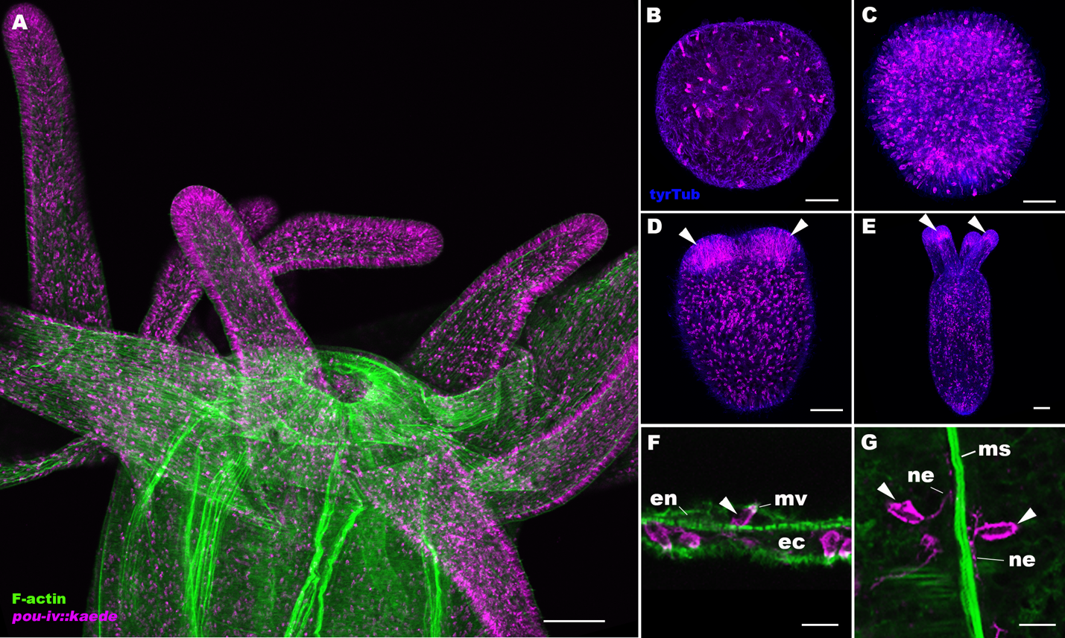
Supplementary Figure 1: Developmental expression pattern of Kaede fluorescent protein in pou-iv::kaede transgenic Nematostella vectensis.
Confocal sections of pou-iv::kaede transgenic N. vectensis at juvenile polyp (A), gastrula (B), planula (C), tentacle-bud (D), and primary polyp (E-G) stages, labeled with an antibody against tyrosinated ∂-tubulin (“tyrTub”). Filamentous actin is labeled with phalloidin (A) or SirActin (F, G) (“F-actin”), and Kaede is labeled with an anti-Kaede antibody in A-E. Panels A-E show side views of animals with the blastopore/mouth facing up. Panels A and E show sections through the entire animal, and panels B-D show sections through surface ectoderm. Panel F shows sections through a cnidocyte (arrowhead) in the endoderm of the body column, with the apical microvilli (mv) facing up. Panel G shows sections through endodermal cnidocytes (arrowheads) extending basal neurite-like processes (ne) along the longitudinal muscle fibers (ms); the oral side is up. pou-iv::kaede is expressed predominantly in the ectoderm in scattered epithelial cells throughout development; in the endoderm, pou-iv::kaede is expressed in cnidocytes, which are rare. Arrowheads in D and E indicate concentration of pou-iv::kaede expression in the tip of growing tentacles. Scale bar: 100 µm (A); 50 µm (B-E); 10 µm (F, G)

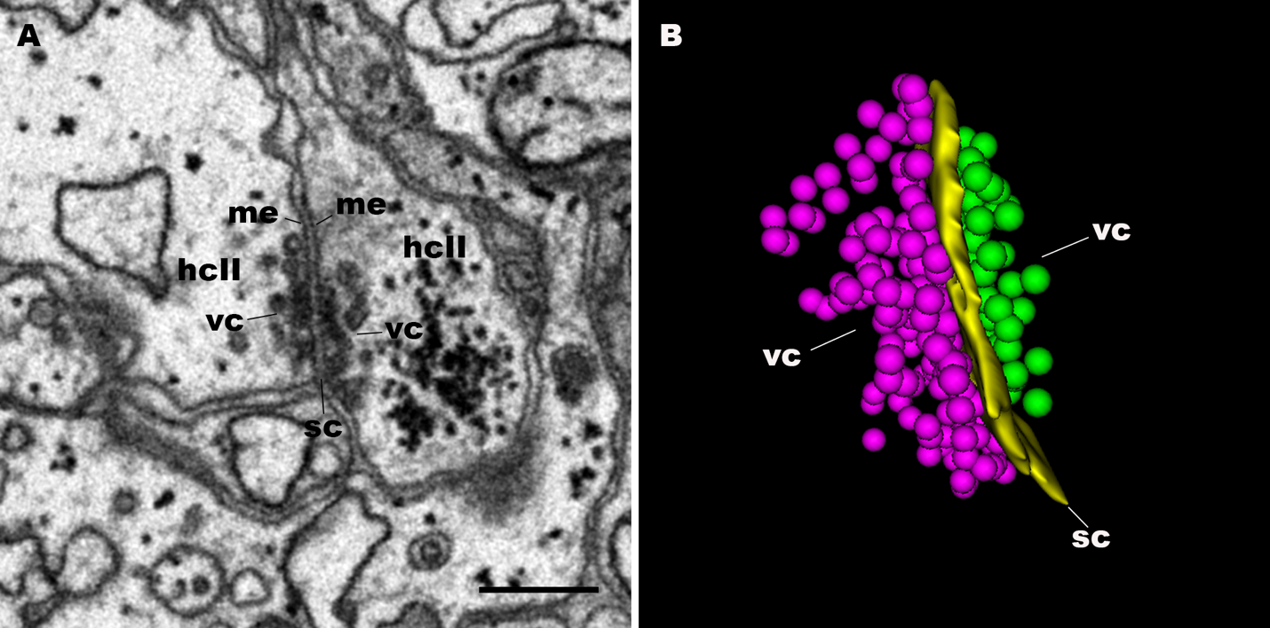
Supplementary Figure 2: Structure of a two-way chemical synapse between type II hair cells
A serial block-face scanning electron microscopy (SBF-SEM) image (A) and a 3-D reconstruction (B) of a two-way chemical synapse between type II hair cells (hcII) shown in Figure 1M. Note in panel A that the synapse consists of two rigid, parallel membranes (me) sandwiching an approximately 30 nm wide, electron-dense synaptic cleft (sc). Panel B is a 3-D model of the synapse showing dense accumulation of synaptic vesicles, forming vesicle clouds (vc), on both sides of the synapse. Purple balls represent the vesicles of the type II hair cell on the left in panel A, and green balls represent those of the type II hair cell on the right. Scale bar: 500 nm

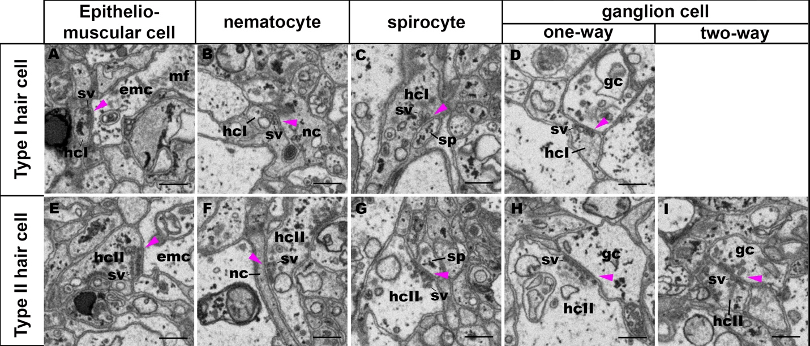
Supplementary Figure 3: Synaptic connectivity of type I and type II hair cells
Serial block-face scanning electron microscopy (SBF-SEM) images of chemical synapses (purple arrowheads) of type I and type II hair cells (hcI and hcII, respectively). Both type I and type II hair cells are presynaptic to epitheliomuscular cell (emc; A, E), nematocyte (nc; B, F), spirocyte (sp; C, G), and ganglion cell (gc; D, H). In addition, type II hair cells, but not type I hair cells, form two-way synapses with ganglion cells (I). Note also that synaptic vesicles (sv) of type I hair cells are relatively large (ca. 95 nm) and primarily dense-cored (A-D), while those of type II hair cells are relatively small (ca. 70 nm), primarily opaque (E, G-I) and sometimes dense-cored (F). Scale bar: 500 nm

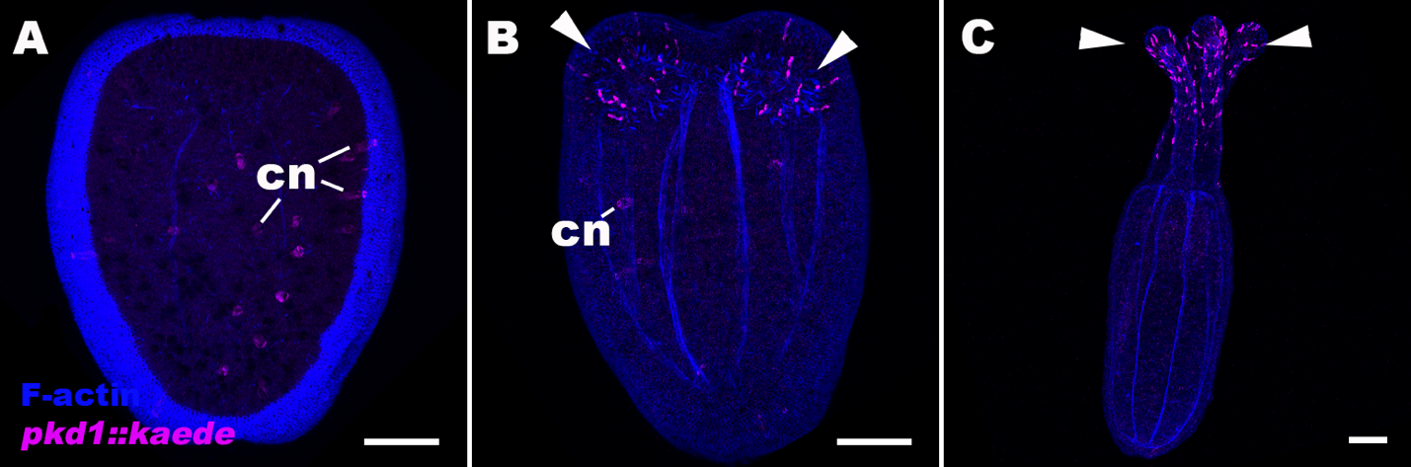
Supplementary Figure 4: Developmental expression pattern of Kaede fluorescent protein in polycystin-1::kaede transgenic Nematostella vectensis.
Confocal sections of polycystin-1(pkd1)::kaede N. vectensis at planula (A), tentacle-bud (B), and primary polyp (C) stages. Filamentous actin (“F-actin”) is labeled with a fluorescent dye SiR-Actin. All panels show side views of animals with the blastopore/mouth facing up. Panel A shows sections through the center of the animal, and panel B and C show sections through the entire animal. Low to moderate levels of pkd1::kaede expression are often observed in a subset of cnidocytes (cn) in the ectoderm during planula development through the tentacle-bud stage. pkd1::kaede expression in cnidocytes largely disappears by the primary polyp stage, while it becomes strongly expressed in a subset of ectodermal epithelial cells in tentacular ectoderm at life cycle transition - at the tentacle-bud and primary polyp stages (arrowheads in B and C). We note that cnidocyte expression of the transgene does not reflect the expression of endogenous polycystin-1; in situ hybridization with an antisense riboprobe against polycystin-1 mRNA does not show cnidocyte expression (e.g.¹), and there is no evidence from published cnidocyte transcriptome data (e.g.²) that polycystin-1 is expressed in cnidocytes in planula larvae or adults. Scale bar: 50 µm

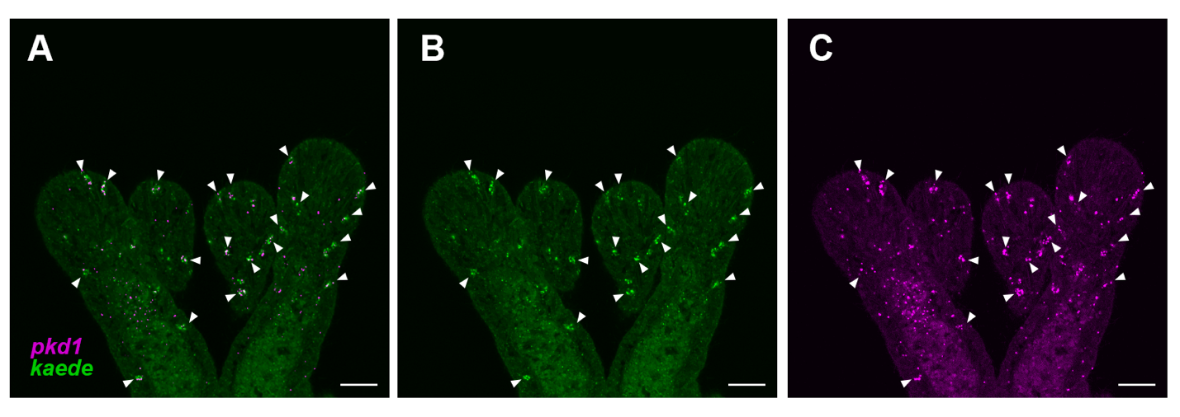Supplementary Figure 5: The expression pattern of polycystin-1::kaede recapitulates that of endogenous polycystin-1 at the primary polyp stage.
A-C: Confocal sections of a polycystin-1::kaede transgenic N. vectensis at the primary polyp stage, labeled with antisense riboprobes against polycystin 1 transcript (‘pkd1’, shown in magenta) and polycystin-1::kaede transcript (‘kaede’ shown in green). Regions of overlapping signal are indicated with white arrows. Scale bar: 20 µm

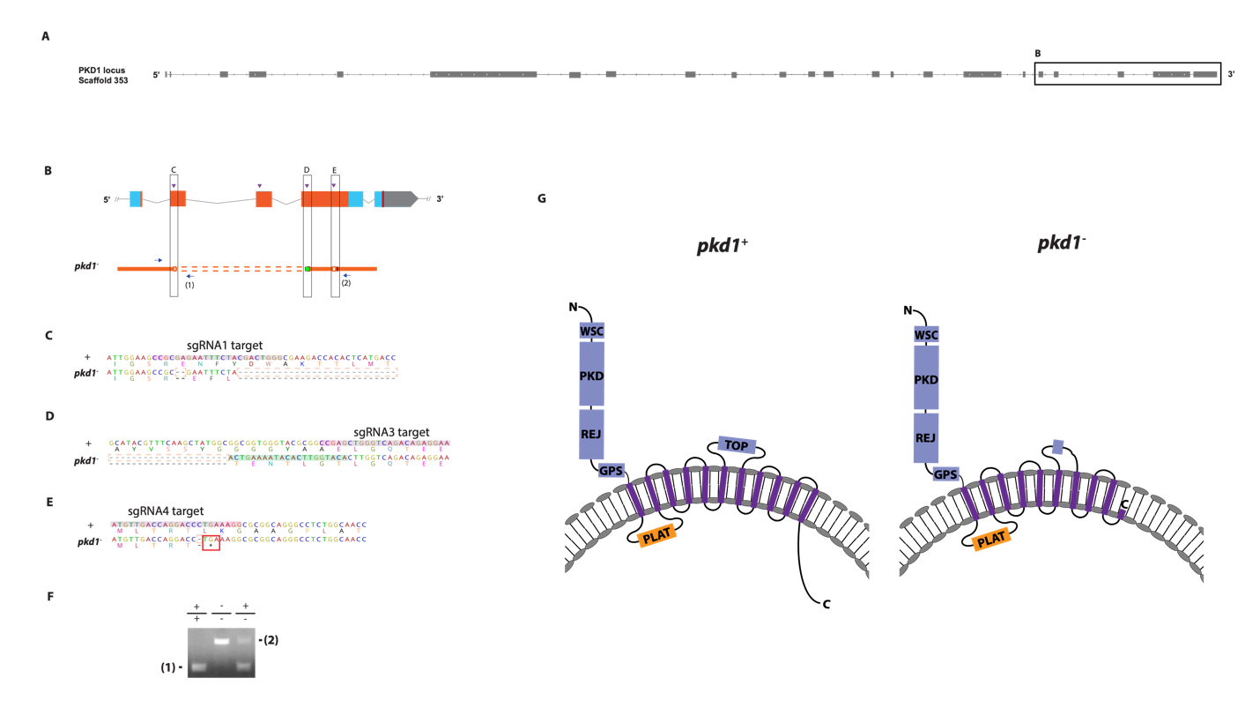
Supplementary Figure 6: Generation of polycystin-1 mutant sea anemone.
A, B: Schematic views of the polycystin-1/PKD1 locus and the mutant allele (pkd1⁻; B). Filled boxes represent 23 exons. Boxed region in A contains exons 19-23, expanded in B. In B, grey boxes are untranslated regions; aqua-colored boxes are translated regions. The region predicted to encode the Transient Receptor Potential (TRP) cation channel is highlighted in orange. Red bars show predicted translation termination sites, and purple arrowheads indicate sgRNA target sites. The pkd1⁻mutant allele contains a deletion mutation (dotted orange lines) and an insertion mutation (green). Blue arrows mark regions targeted in PCR analysis (F); reverse primers are numbered (1)-(2). C-E: nucleotide and translated amino acid sequences of wild-type and mutant alleles (from B). sgRNA target sites are shown in purple, PAM sites in pink, predicted translation termination site in red, insertions labeled in green, and deletions in dotted orange boxes. The mutant allele carries a 2 bp deletion mutation at the sgRNA1 target site, creating a translation frameshift (C), followed by a large deletion encompassing exons 20 and 22 (C, D), a 21 bp insertion mutation at the sgRNA3 target site (D), and a 1 bp deletion at the sgRNA4 target site generating a premature stop codon immediately after the mutation (E). F: Genotyping PCR. Primer (1) generates a 249 bp PCR product from the wildtype allele ('+') but cannot bind to the pkd1⁻ allele due to deletion mutation. Primer (2) generates a 829 bp PCR product from the pkd1⁻ allele, and a 3554 bp PCR product from the wildtype allele. G: Schematics of wildtype (pkd1+) and mutant (pkd1-) Polycystin-1 protein. Extracellular domains are in blue, the intracellular domains in orange, and the transmembrane domains in purple. Domain prediction was performed as previously described¹. The pkd1- mutant protein has a truncated TOP (tetragonal opening for polycystins) domain, and is missing the two C-terminal transmembrane domains thought to contribute to forming the channel pore³, and the C-terminal cytoplasmic tail. Abbreviations: WSC, cell wall integrity and stress response component; REJ, receptor for egg jelly; GPCR, G-protein coupled receptor; TM, transmembrane domain; PLAT, polycystin-1, lipoxygenase and alpha toxin

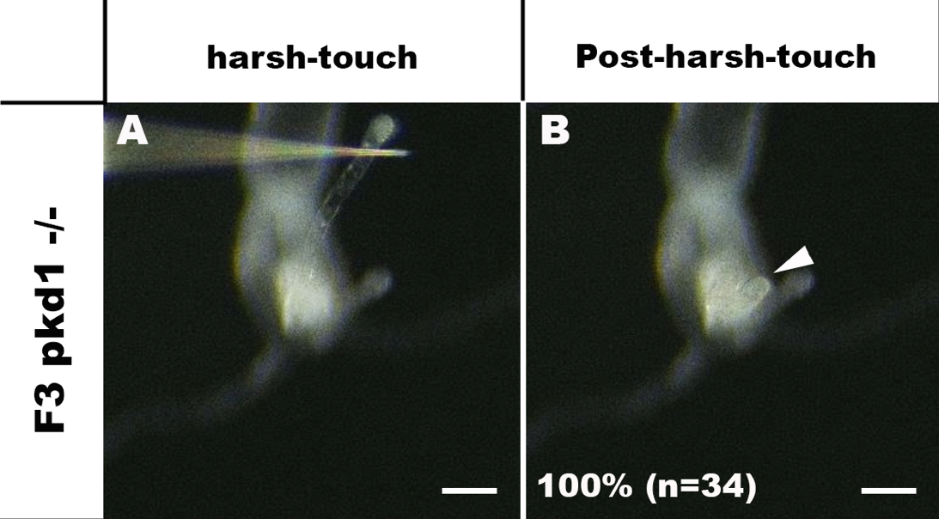
Supplementary Figure 7: polycystin-1 -/- homozygous mutants respond to harsh touch.
Behavior of an F3 pkd1 -/- N. vectensis polyp in response to harsh touch to its oral tentacle. Either a microinjection needle (shown) or a tungsten needle was used to press onto the surface epithelium of the tentacle to elicit harsh touch response – contraction of the stimulated tentacle. An animal before (A) and after (B) harsh touch are shown. All of the pkd1 homozygous mutants tested were harsh touch-sensitive (100%, n=34), indicating that polycystin-1 is not essential for harsh touch response. The arrowhead in B points to a stimulated tentacle exhibiting normal harsh touch response. Scale bar: 100 µm
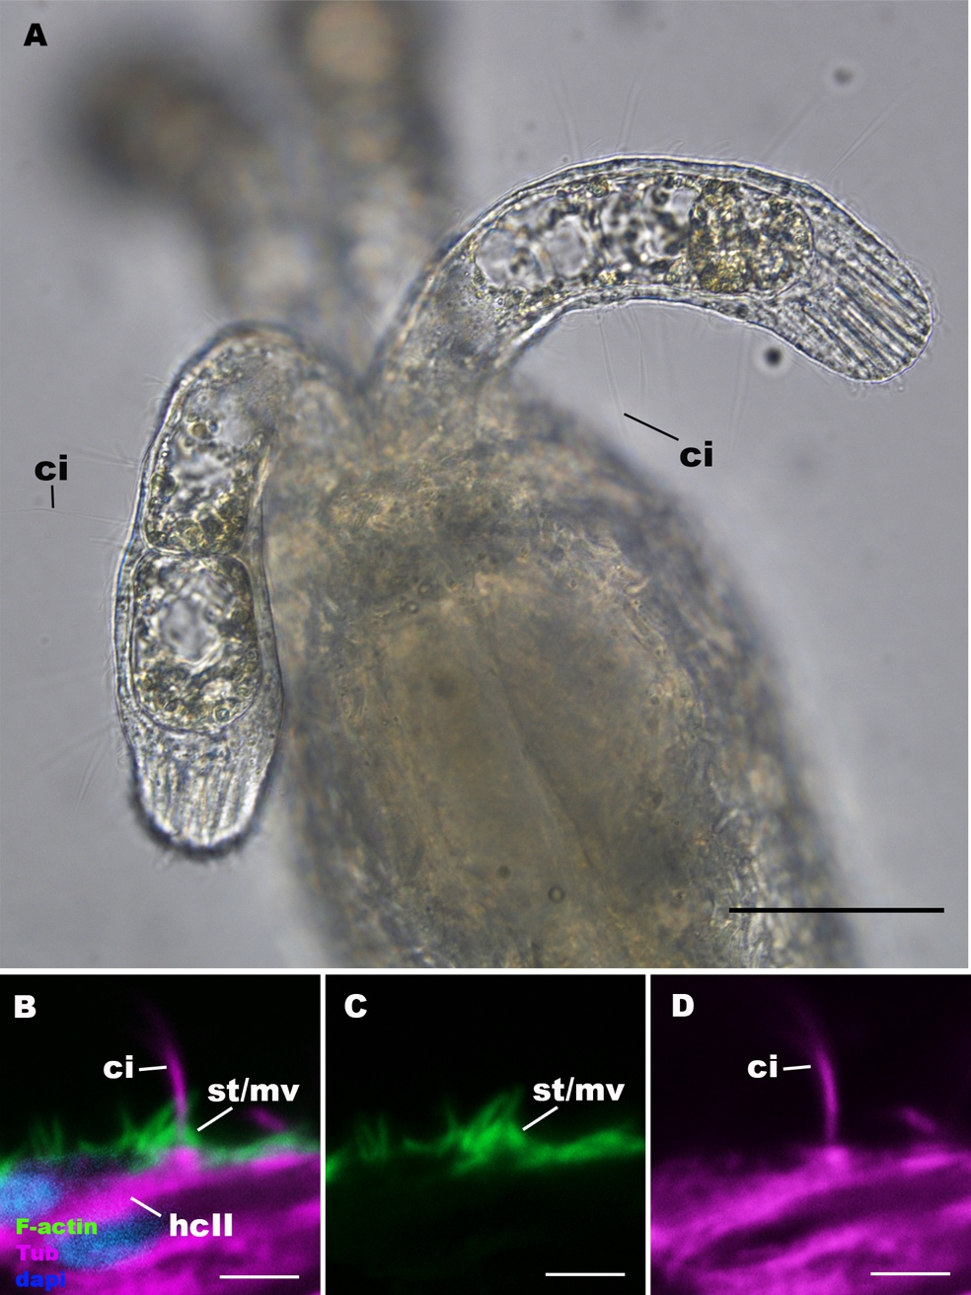
Supplementary Figure 8: The apical sensory apparatus of type II hair cell develops in polycystin-1 -/- homozygous mutant polyps.
A: An optical section of oral tentacles of a polycystin-1 -/- homozygous mutant polyp. The oral side is up. 20-40 µm long, erect cilia (ci) characteristic of type II hair cells emanate from tentacular ectoderm. B-D: Confocal sections of a type II hair cell (hcII) in a polycystin-1 -/- homozygous mutant polyp, stained with antibodies against acetylated ∂-tubulin and tyrosinated ∂-tubulin (“Tub”). Filamentous actin is labelled with phalloidin (“F-actin”), and nuclei are labeled with DAPI (“dapi”). The apical epithelial surface faces up. Note the presence of an apical sensory apparatus consisting of a single cilium (ci) surrounded by rings of stereovilli/microvilli (st/mv). Scale bar: 50 µm (A); 5 µm (B-D
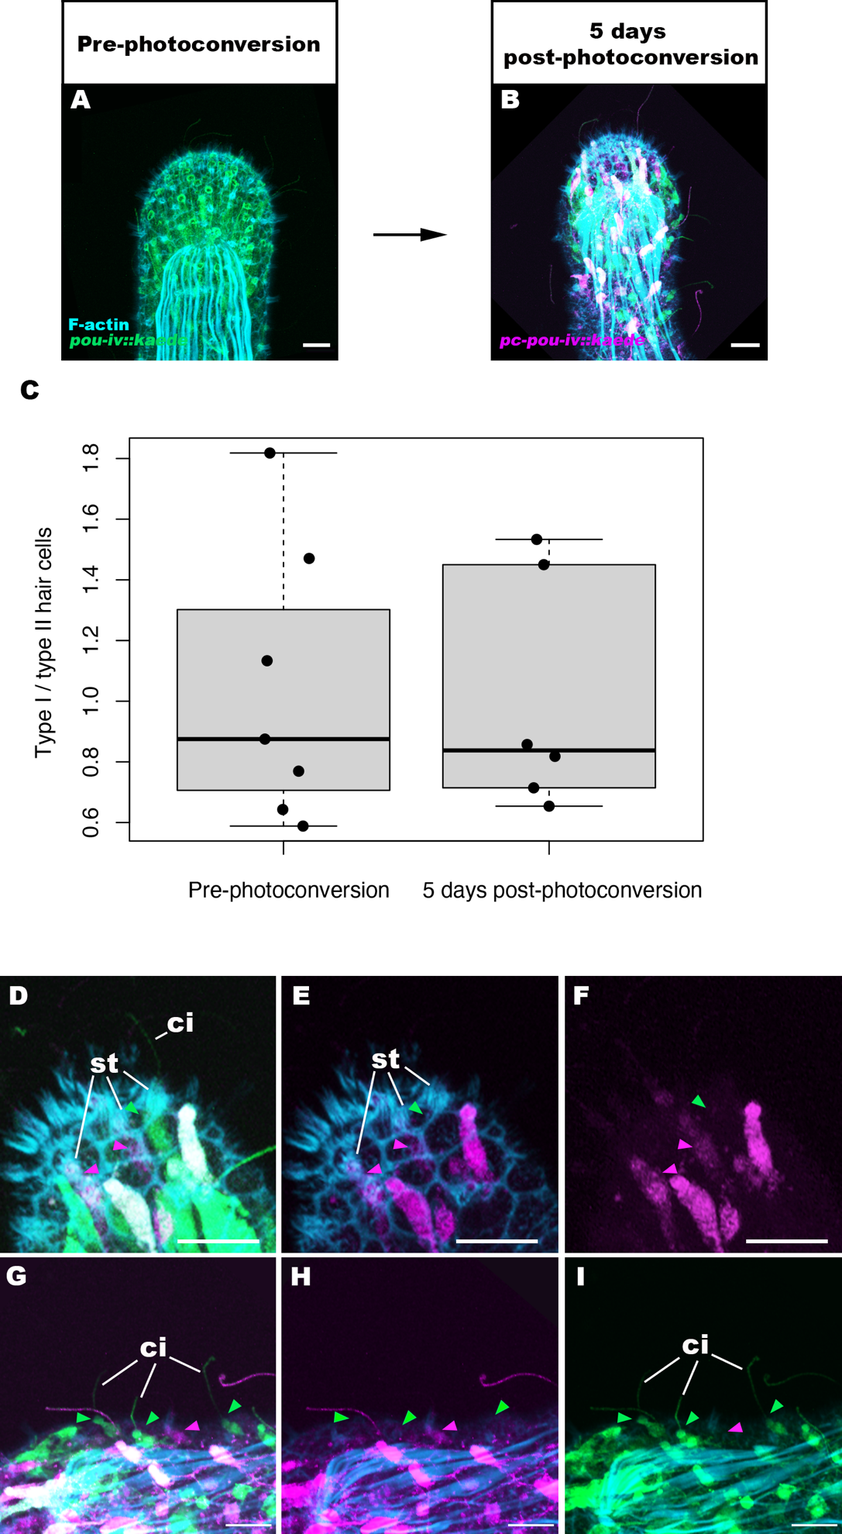

Supplementary Figure 9: Cell tracking of type I and type II hair cells at the primary polyp stage provides no evidence of transformation between type I and type II hair cells.
A, B: confocal sections of tentacles of pou-iv::kaede transgenic N. vectensis polyp. At the 16 dpf primary polyp stage (“Pre-photoconversion”; A), Kaede fluorescent protein (“pou-iv::kaede”) was photoconverted (“pc-pou-iv::kaede”) by ultraviolet illumination, and photoconverted kaede was used as a cell marker to examine the fate of pou-iv::kaede-positive type I and type II hair cells after 5 days (“5 days post-photoconversion”; B). Filamentous actin (“F-actin”) is labelled with a fluorescent dye SiR-Actin. Panels A and B show sections through the surface ectoderm; the distal end of the tentacle faces up. C: a box plot showing the proportions of type I hair cells relative to type II hair cells immediately before photoconversion (“Pre-photoconversion”; n=7 animals; mean 1.04) and 5 days after photoconversion (“5 days post-photoconversion”; n=6 animals; mean 1.00). Median (middle line), 25th, 75th percentile (box) and 5th and 95th percentile (whiskers) are shown. Note that the proportion of type I hair cells relative to type II hair cells pre-photoconversion was determined based on the number of (non-photoconverted) pou-iv::kaede-positive cells, which is assumed to correspond directly to the proportion immediately after photoconversion (i.e. day 0), while the relative proportion of type I and type II hair cells 5 days post-photoconversion was calculated based on the number of photoconverted pou-iv::kaede-positive cells. The relative proportion did not significantly change (two tailed t-test, p=0.876), providing no support for the hypothesis that type I and type II hair cells represent different developmental states of the same cell type. D-I: magnified views of the tentacle shown in B. Note the presence of non-photoconverted type I (green arrowhead in D-F) and type II (green arrowheads in G-I) hair cells, characterized by pronounced stereovilli (st) and long cilia (ci), respectively; this indicates that the 5 day incubation period was sufficient to generate new type I and type II hair cells. Purple arrowheads show photoconverted type I hair cells. Scale bar: 10 µm
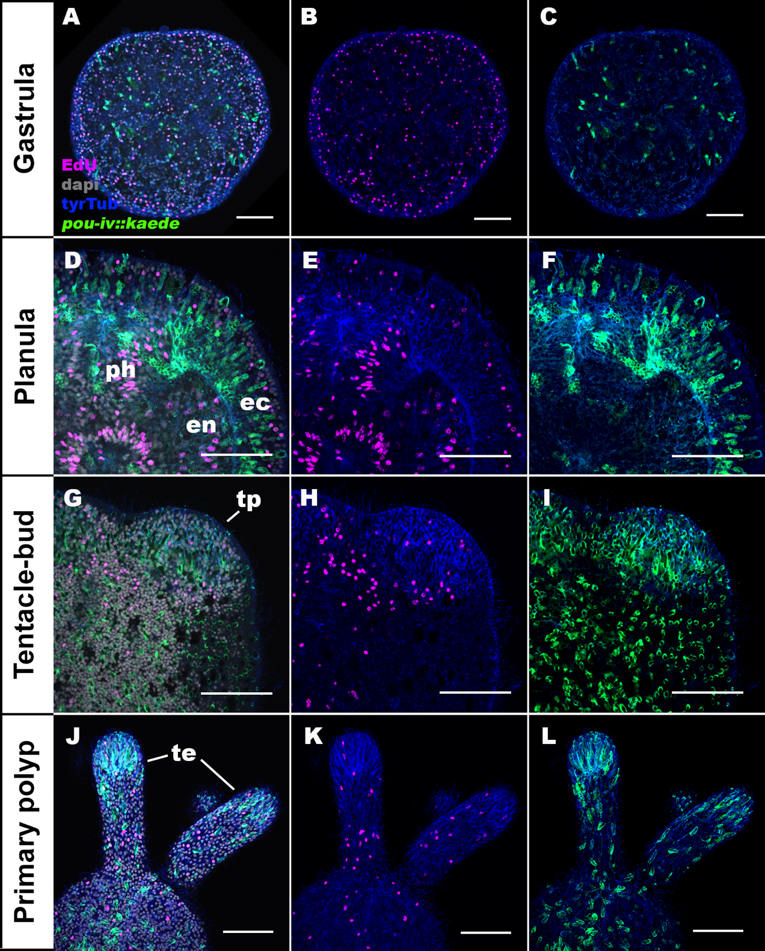
Supplementary Figure 10: pou-iv::kaede-positive cells in the ectoderm are postmitotic.
Confocal sections of pou-iv::kaede transgenic N. vectensis at gastrula (A-C), planula (D-F), tentacle-bud (G-I), and primary polyp (J-L) stages, labeled with antibodies against Kaede (pou-iv::kaede) and tyrosinated ∂-tubulin (“tyrTub”). S-phase nuclei are labeled by the thymidine analog EdU. In all panels, the blastopore/mouth faces up. A-C show sections through surface ectoderm of the entire embryo. D-F show medial sections of a circumoral region of the animal. G-I show sections of a tentacle primordium (tp) at the level of surface ectoderm. J-L show sections of oral tentacles (te) at the level of surface ectoderm. Consistent with postmitotic expression of endogenous pou-iv mRNA and protein reported previously^{1,4}, pou-iv::kaede-positive cells in the ectoderm were EdU-negative across all developmental stages examined (gastrula n=2; early planula n=3; mid-planula I, n=3; mid-planula II, n=3; late planula, n=2; tentacle-bud, n=3; primary polyp, n=3; at least 30 pou-iv::kaede-positive cells were examined per animal for a total of 915 cells across stages), evidencing their postmitotic cell-cycle status. Abbreviations: ec ectoderm; en endoderm; ph pharynx. Scale bar: 50 µm

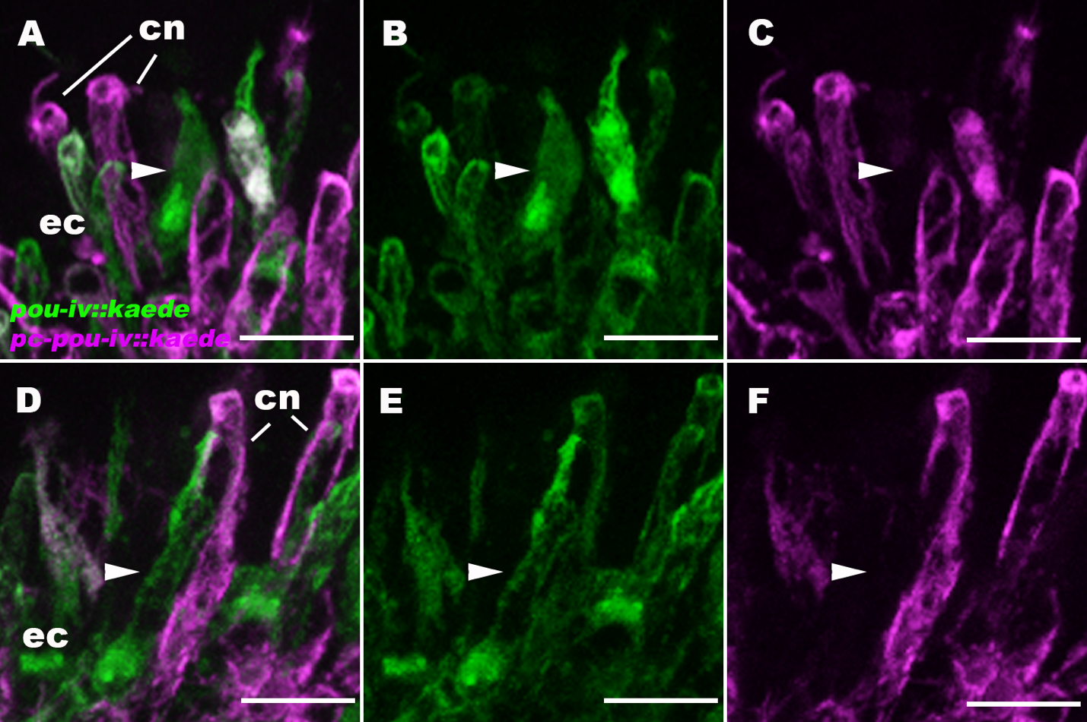
Supplementary Figure 11: pou-iv::kaede-positive cells include morphologically immature cells.
Confocal sections of tentacular ectoderm (ec) of pou-iv::kaede transgenic N. vectensis at the primary polyp stage. pou-iv::kaede-positive cells of the primary polyp were photoconverted at 12 dpf, and non-photoconverted Kaede (“pou-iv::kaede”) and photoconverted Kaede (“pc-pou-iv::kaede”) were imaged at 17 dpf. The apical epithelial surface faces up. While photoconverted cells are largely at morphologically mature states (e.g. cnidocytes (cn)), a subset of non-photoconverted Kaede-positive cells - which began expressing Kaede post-photoconversion – show immature morphology (arrowheads), evidencing that pou-iv::kaede-positive cells consist of postmitotic cells at different stages of maturation. Immature cells (arrowheads) are subepidermal in position, which suggests that tentacular sensory cells and cnidocytes establish apical contact with the external environment during maturation via basal-to-apical cell migration, cell shape changes or a combination of the two. Scale bar: 10 µm
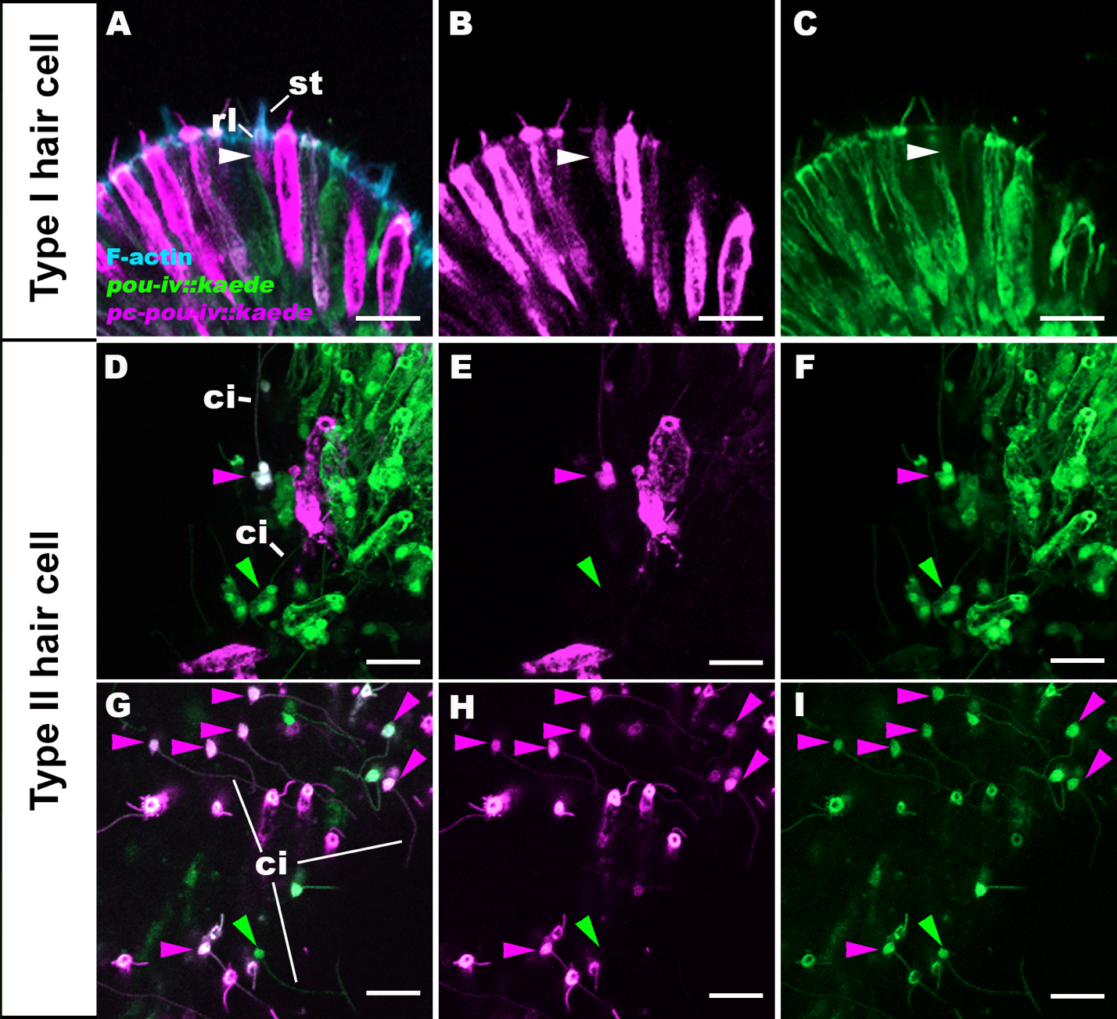
Supplementary Figure 12: pou-iv promoter activity is differentially regulated in type I and type II hair cells.
Confocal sections of tentacular ectoderm (ec) of pou-iv::kaede transgenic N. vectensis at the primary polyp stage. pou-iv::kaede-positive cells were photoconverted at the late planula (A-F) and primary polyp (G-I) stages, and non-photoconverted Kaede (“pou-iv::kaede”) and photoconverted Kaede (“pc-pou-iv::kaede”) were imaged at 5 days post-photoconversion. Filamentous actin (“F-actin”) is labeled with a fluorescent dye SiR-Actin. In A-C, the apical epithelial surface faces up. Panels D-I show superficial planes of section at the level of surface epithelium. The white arrowhead in A-C shows a photoconverted type I hair cell characterized by pronounced stereovilli (st) and their rootlets (rl). Note the lack of detectable levels of non-photoconverted Kaede in C, evidencing transient pou-iv promoter activities in type I hair cells. Purple arrowheads in D-I show photoconverted type II hair cells characterized by long cilia (ci); green arrowheads show non-photoconverted type II hair cells, which represent cells newly born after photoconversion. Note that photoconverted type II hair cells express non-photoconverted Kaede at levels comparable to newly born type II hair cells, evidencing persistent pou-iv promoter activities in type II hair cells. Scale bar: 10 µm

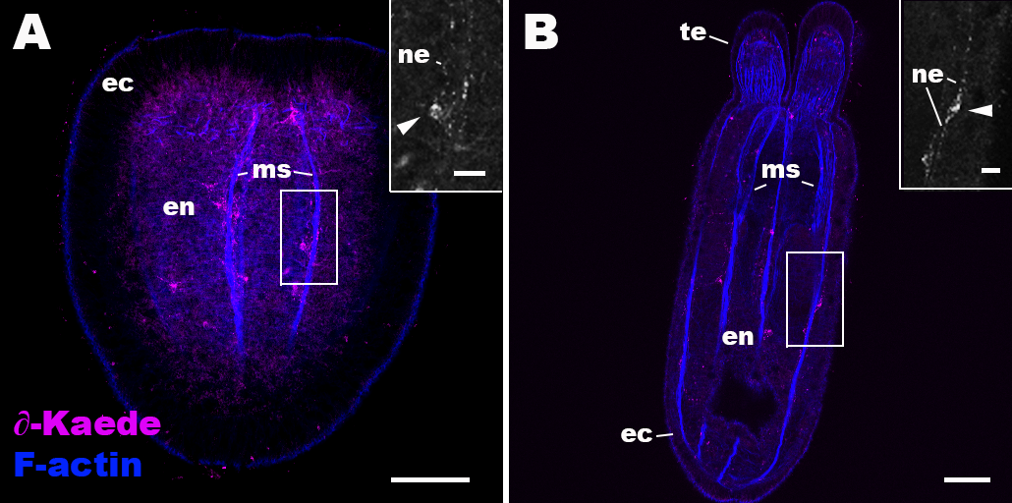
Supplementary Figure 13: Anti-Kaede immunoreactivity occurs in a subset of endodermal neurons in wildtype Nematostella vectensis.
Confocal sections of wildtype N. vectensis at the planula (A) and primary polyp (B) stages, labeled with an antibody against Kaede fluorescent protein (“∂-Kaede”). Filamentous actin is labeled with phalloidin (“F-actin”). Oral side is up. Sections are through the body column at the level of longitudinal retractor and parietal muscle fibers (ms). Insets show magnified views of anti-Kaede-immunoreactive endodermal neurons (arrowheads) with neurites (ne). Anti-Kaede immunoreactivity was not detectable in circumoral ectoderm of planula or tentacular ectoderm of primary polyp. Abbreviations: ec ectoderm; en endoderm; te tentacle. Scale bar: 50 µm; 10 µm (inset)

Supplementary References

- Ozment, E. et al. Cnidarian hair cell development illuminates an ancient role for the class IV POU transcription factor in defining mechanoreceptor identity. Elife 10 (2021). https://doi.org/ARTN e7433610.7554/eLife.74336

- Sebe-Pedros, A. et al. Cnidarian Cell Type Diversity and Regulation Revealed by Whole-Organism Single-Cell RNA-Seq. Cell 173, 1520-+ (2018). https://doi.org/10.1016/j.cell.2018.05.019

- Su, Q. et al. Structure of the human PKD1-PKD2 complex. Science 361, 992-+ (2018). https://doi.org/ARTN eaat9819

- Tourniere, O. et al. NvPOU4/Brain3 Functions as a Terminal Selector Gene in the Nervous System of the Cnidarian Nematostella vectensis. Cell Rep 30, 4473-+ (2020). https://doi.org/10.1016/j.celrep.2020.03.031

