Supplementary figures and tables
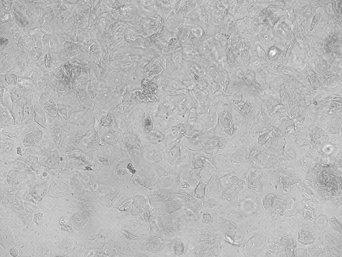
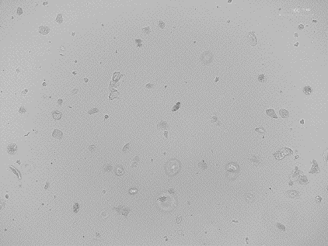

Fig. S1
Brightfield microscopy of resuspended and seeded pellet after centrifugation and wash step during isolation of USCs. Left female sample that contains an extensive number of cells. Right male sample with only limited epithelial cells.

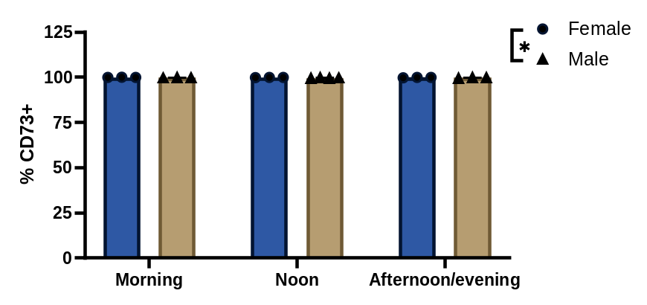
Fig. S2 Expression of CD73 significantly lower on USC from male donors. The clones arising from three different collection times were analyzed by flow cytometry, to determine the expression of selected surface markers. Mixed model analysis, grouping samples by gender, showed that in the investigated cohort expression of CD73+ was significantly lower in USC from male donors, compared to female donors (p=0.0147). Data is displayed as mean ± SEM.

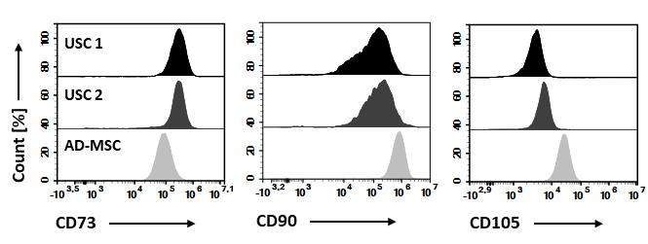
Fig. S3 Expression levels of classical MSC markers different between USC and AD-MSC. After culturing, USC from two different donors were analyzed for the expression of classical MSC markers CD73, CD90, and CD105, using flow cytometry. The results were compared to the expression of the same markers on cultured human adipose-derived MSC (AD-MSC). Histogram show the fluorescence intensities detected for each of the three surface markers. Although the percentwise expression was similar for USC and AD-MSC, the expression levels, extrapolated from the magnitude of signal intensity, varied between stem cells of different tissue origin.

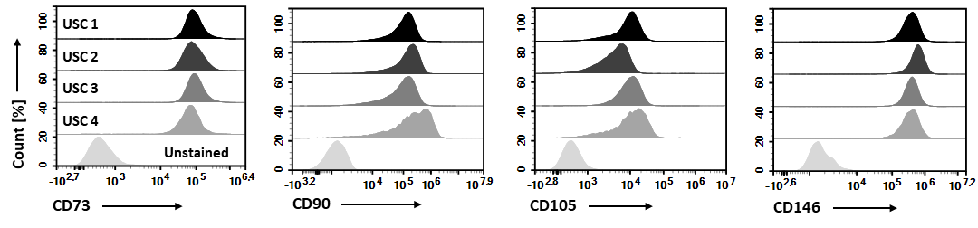
Fig. S4 CD146 is also expressed on USC, in addition to the canonical MSC markers CD73, CD90, and CD105. After culturing, USC clones from four different donors were analyzed for the expression of CD73, DC90, CD105, and CD146, using flow cytometry. Histograms show the obtained signal intensities for each marker, including the signal obtained for unstained cells, demonstrating expression of all four markers in all analyzed clones.

Sample | RFU 565-650
F1-5 (Void volume) | 89
EV fraction USC_{mCherry} | 105
EV fraction HEK293T_{mCherry} | 6198
Table S1.
EVs derived from mCherry-PTGFRN -engineered USCs are not fluorescent in contrast to HEK293T engineered ones.
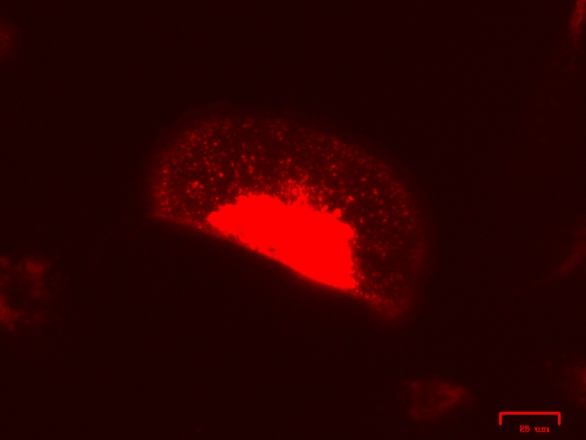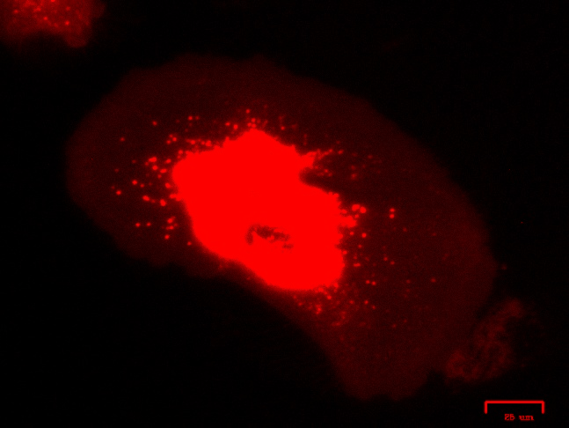
Fig. S5
45-second timelapse of mCherry-PTGFRN-engineered USCs, seemingly endosomal migration.

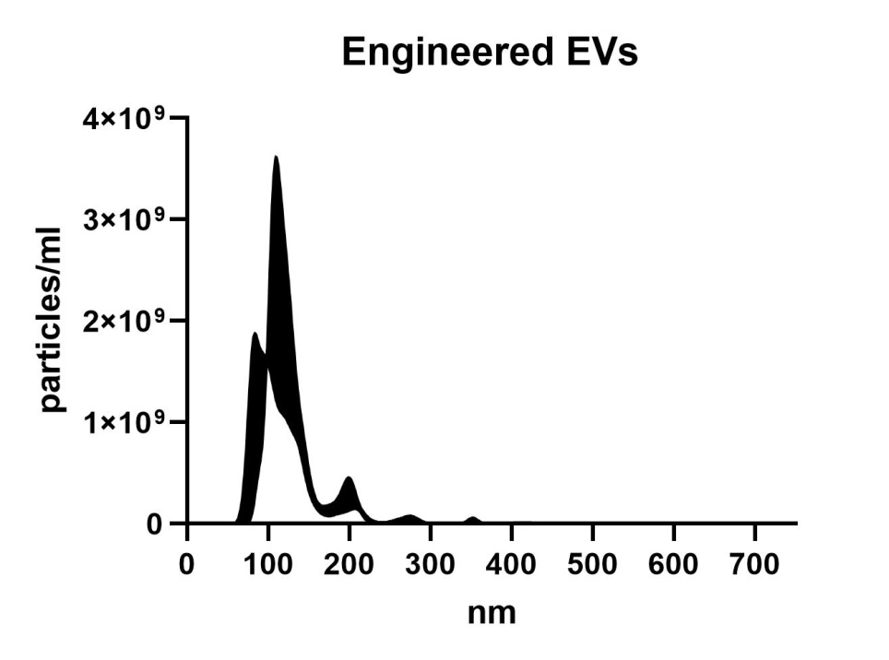
Fig. S6
NTA profile of EVs derived from mCherry-PTGFRN -engineered USCs. Similar size and concentration profile as non-engineered.

