Supplementary Materials
Event attribution for quantifying the role of climate change in internal displacement: The case of Somalia

This Supplementary Material contains 4 sections:
A. Displacement context and data 1
B. Descriptive statistics 2
C. Multi-model attribution 5
Supplementary Material References 13

Displacement context and data
A.a) Flood as displacement trigger in Somalia

In East Africa and Somalia, extreme weather events are well-known, reoccurring climate-related phenomena. However, their impacts and intensity vary across the region, impacting vulnerable populations, food security and the economy.¹ The impact of climate on human wellbeing and livelihoods is further exacerbated by the absence of a central government coupled with poverty and civil conflict that can escalate to crisis-level food insecurity and large-scale involuntary human mobility. After the 2016/17 drought across Somalia, heavy rains during Gu season of 2018 led to episodes of flash floods. The United Nations High Commissioner for Refugees (UNHCR) measured more than 200,000 flood-related internal displacement (IDPs) in the regions of Juba and Shabelle in the aftermath of the disasters. The history of drought and flash flood displacement has continued. The numbers of displaced indicate that flash floods cause more harm than in part due to Somali population increase and continuing lack of preparation mechanisms.

In April 2020, floods in South Somalia affected multiple states and territories: South West, Jubaland, Banadir, Puntland, and Somaliland, Belet Weyne, Jowhar (Hirshabelle State). Extreme rainfall between 20-28 April 2020 in southern Ethiopia resulted in flooding of the Juba River and Shabelle river basins (main text Fig. 2). Consecutive heavy rains lead to flooding along the Juba river² and affected approximately 1 million people, displaced 283,000 and killed 26 people due to the resulting flood. From a climatological perspective, the region of the heavy precipitation is considered in this step as a the 7-day extreme rainfall event.

A.b) Displacement data underlying flood-related displacement

Estimates and official statistics from international organizations, such as UNHCR and the Internal Displacement Monitoring Center (IDMC), and population migration data, e.g., WorldPop³ can be used to assess a potential climate change-induced mobility event. Given the findings from the previous literature that climate-related migration often occurs within a short distance⁴, it is relevant to rigorously consider climate mobility within a country or region. Whilst data on international migration flows have become increasingly available both through improved data collection efforts and new estimates using innovative methods^{5,6}, data on bilateral internal migration are notoriously scarce.^{7,8} Studying internal migration flows is thus a particularly challenging task. It is however possible to derive internal migration flows using census or administrative data ⁹ and even from migration stock data.¹⁰ Examples include internal migration datasets at a granular subnational level based on statistical reconstruction efforts for Colombia¹¹ and bilateral internal migration flows are estimated from census microdata for 64 countries.¹²

Available datasets on internal displacement or refugee incidences tend to focus on country-level movements and data at the subnational state or district level are rare. Similarily, data from population registries, surveys or censuses are usually not available in the temporal and geographical scales that allow capturing of short-term and short-distance movements or displacement.¹³ In recent years, there have been efforts to use alternative data sources such as high-resolution optical satellite imagery¹⁴ and internet-based data^{15,16} to estimate migration flows and displacement. Although these new data sources are promising, internet or social media users are not nationally representative, in particular, for the pastoralist population. Furthermore, the analysis of satellite data implies a high degree of computational complexity given.

The displacement statistics are based on data from the UNHCR Protection and Return Monitoring Network (PRMN). The dataset consists of monthly records of IDP flows at the regional level. According to the PRMN methodology, population displacements and movement are recorded by targeting strategic points including transit sites, established IDP settlements, border crossings and other ad hoc locations. Interviews are carried out with IDP generating ‘household-level’ reports at points of arrival or with key informants generating ‘group reports’. The point of departure and reason for departure (drought, conflict, flood) are recorded. A clear advantage of this dataset lies in its large spatial coverage and datapoints. In South and Central Somalia, the project is implemented in Banadir, Bay, Bakool, Gedo, Lower Jubba, Hiraan, Lower Shabelle, Middle Shabelle, middle Juba and Galgaduud region. In Puntland, project operations focus on the regions of Galmadug, Mudug and Bari. In Somaliland, geographic coverage includes Woqooyi Galbeed, Marodijeh, Sool and Awdal regions. Therefore, this dataset makes it possible to study local flood-related displacement.

Descriptive statistics
Observed probability, return time and trend

This step entails a trend detection in observational data (see step 3 in Fig. 1 in the main text). We used the Climate Research Unit time series data version 4.0 (CRU Ts4.0)¹⁷ to expand the time series of the CHIRPS dataset. Rainfall variation from 1901 to 2019 using the CRU TS4.0 dataset show the suggested downward shift in the Intertropical Convergence Zone which is likely caused by atmospheric aerosols during the 1950 to 1960 period.¹⁸

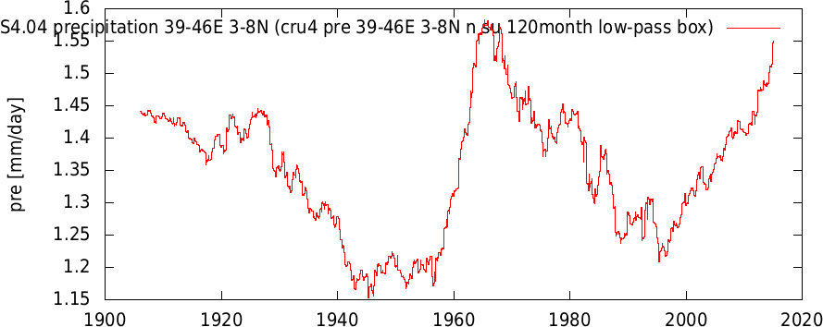
Figure S 1: Rainfall time series 1901-2019 (Source: CRU TS4.0). The dashed line indicates the start of the CHIRPS timeseries in 1981.

Here, we perform a ranking of the extreme precipitation for the period 2018 to 2020 (Fig. S 2). Compared to recent years, the heavy precipitation in April 2020 ranks as the third largest extreme rainfall event. The return period of the 7-day rainfall maxima during April 2020 is estimated using the block maxima method, in which a generalized extreme value (GEV) distribution is fitted to the distribution of 7-day maxima observed within each time step.

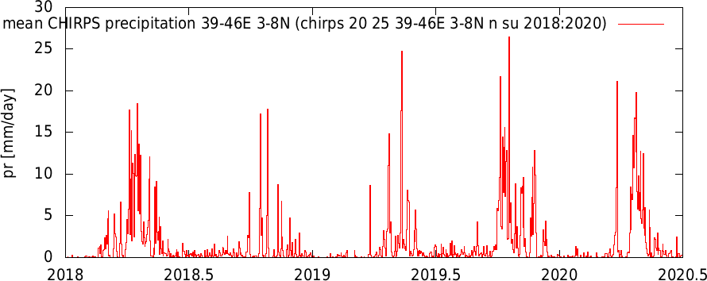
Figure S 2: Mean precipitation over the study region between January 2018 and June 2020. Blue circle indicates the timing of the flood event.

Observed return periods

Apr 7-day ave CHIRPS 38-44E 2-7N precipitation 38-44E 2-7N pr [mm/day] dependent on Global mean surface temperature (4-yr smoothed GMST)
parameter | year | value | 5-95% empirical confidence interval
covariate: | 1900 | -0.16375
 | 2020 | 0.95361
N: |  | 39
Fitted to GEV distribution P(x) = exp(-(1+ξ(x-μ')/σ')^(-1/ξ))
with μ' = μ exp(αT/μ) and σ' = σ exp(αT/μ) and a Gaussian penalty on ξ of width 2σ = 0.4
μ': | 1900 | 7.450 | 6.635... 8.335
σ': | 1900 | 2.097 | 1.520... 2.504
μ': | 2020 | 9.074 | 8.256... 9.961
σ': | 2020 | 2.554 | 1.891... 2.993
σ/μ: |  | 0.281 | 0.212... 0.324
ξ: |  | -0.070 | -0.289... 0.122
α: |  | 1.480 | -2.290... 5.171
return period event 2020 (value 18.475 ) | 1900 | 708.80 | 24.440 ... ∞
probability | 1900 | 0.14108E-02 | 0 ... 0.40916E-01
return period event 2020 (value 18.475 ) | 2020 | 71.261 | 15.188 ... 0.22974E+06
probability | 2020 | 0.14033E-01 | 0.43527E-05 ... 0.65843E-01
probability ratio |  | 9.9465 | 0.49281E-02 ... ∞
p-value probability ratio (one-sided) | ≠ 1 | 0.2057
change in intensity 1900 -2020 | diff % | 21.794 | -26.414 ... 101.355
Table S 1: Results of the GEV distribution fitting. The table lists statistical methods and properties.

a
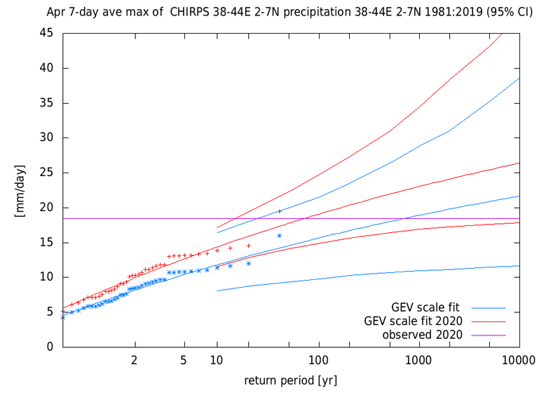

b
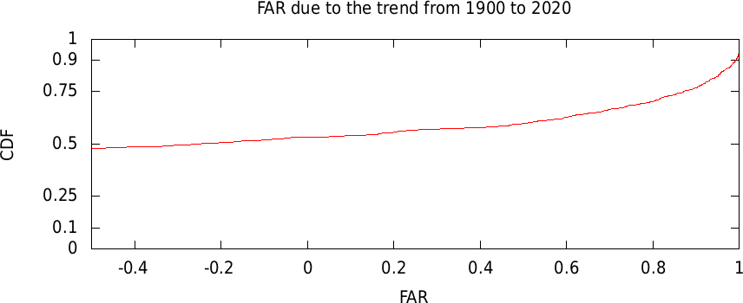
Figure S 3: a, The GEV fit of the 7-day averaged data in 2020 (red) and 1900 (blue). The observations are drawn twice, scaled up with the trend (smoothed global mean temperature) to 2020 and scaled down to 1900. The purple line shows the observed value at present date (2020). The observations are drawn twice, scaled up with the trend (smoothed global mean temperature) to 2020 and scaled down to 1900. The purple line shows the observed value at present date (2020). b, Fraction of attributable risk of the extreme event

Multi-model attribution
We make use of a 15 member ensemble from the HadGEM3-A ¹⁹ model, the atmospheric component of the Met Office’s Global Environment Model version 6. When comparing with the year 2050, an event like the April 2020 flood is 1.6-fold instead compared to the likelihood of occurrence under pre-industrial conditions in the year 1900 (see Table 1 in the main text).

EC-Earth23 model (1981-2020)
The return value for this event is 73.021.

Apr 7-day ave ECEARTH23 rcp85 38-44E 2-7N pr 38-44E 2-7N ensemble pr [mm/day] dependent on t Tglobal EC-Earth23 mean
parameter | year | value | 5-95% empirical confidence interval
covariate: | 1900 | 12.500
 | 2020 | 13.961
N: |  | 640
Fitted to GEV distribution P(x) = exp(-(1+ξ(x-μ')/σ')^(-1/ξ))
with μ' = μ exp(αT/μ) and σ' = σ exp(αT/μ) and a Gaussian penalty on ξ of width 2σ = 0.4
μ': | 1900 | 4.070 | 3.994... 4.228
σ': | 1900 | 1.298 | 1.245... 1.403
μ': | 2020 | 3.930 | 3.855... 4.088
σ': | 2020 | 1.254 | 1.201... 1.357
σ/μ: |  | 0.319 | 0.305... 0.341
ξ: |  | -0.056 | -0.103... -0.011
α: |  | -0.095 | -0.450... 0.340
return period event 2020 (value 9.0148 at 000) | 1900 | 73.021 | 32.157 ... 210.91
probability | 1900 | 0.13695E-01 | 0.47414E-02 ... 0.31097E-01
return period 2020 (value 9.0148 at 000) | 2020 | 100.00 | 46.139 ... 185.05
probability | 2020 | 0.10000E-01 | 0.54039E-02 ... 0.21674E-01
probability ratio |  | 0.73021 | 0.24008 ... 3.2299
inverse probability ratio |  | 1.3695 | 0.30961 ... 4.1653
p-value probability ratio (one-sided) | ≠ 1 | 0.3983
return value 100 yr | 1900 | 9.335 | 8.424 ... 10.429
 | 2020 | 9.015 | 8.508 ... 9.951
change in intensity 1900 -2020 | diff % | -3.431 | -15.209 ... 13.128
Table S 2: 7-day average EC-Earth23 RCP8.5 precipitation ensemble at the origin location.

HadGEM2-ES model (1981-2020)
Return value is 58.045.

HadGEM2-ES rcp85 tas 0-360E -90-90N ensemble mean anomalies
parameter | year | value | 5-95% empirical confidence interval
covariate: | 1900 | -1.1872
 | 2020 | 0.40771E-01
N: |  | 705
Fitted to GEV distribution P(x) = exp(-(1+ξ(x-μ')/σ')^(-1/ξ))
with μ' = μ exp(αT/μ) and σ' = σ exp(αT/μ) and a Gaussian penalty on ξ of width 2σ = 0.4
μ': | 1900 | 10.447 | 10.171... 10.664
σ': | 1900 | 2.340 | 2.290... 2.566
μ': | 2020 | 10.244 | 9.969... 10.462
σ': | 2020 | 2.295 | 2.244... 2.517
σ/μ: |  | 0.224 | 0.216... 0.250
ξ: |  | -0.329 | -0.401... -0.318
α: |  | -0.165 | -0.814... 0.122
return period event 2020 (value 15.688 at 000) | 1900 | 58.045 | 27.100 ... 170.79
probability | 1900 | 0.17228E-01 | 0.58553E-02 ... 0.36900E-01
return period 2020 (value 15.688 at 000) | 2020 | 100.00 | 61.885 ... 4377.7
probability | 2020 | 0.10000E-01 | 0.22843E-03 ... 0.16159E-01
probability ratio |  | 0.58045 | 0.93259E-02 ... 1.6551
inverse probability ratio |  | 1.7228 | 0.60418 ... 107.23
p-value probability ratio (one-sided) | ≠ 1 | 0.0579
return value 100 yr | 1900 | 15.998 | 15.491 ... 16.515
 | 2020 | 15.688 | 14.872 ... 15.940
change in intensity 1900 -2020 | diff % | -1.936 | -9.187 ... 1.462
Table S 3: 7-day average HadGEM2-ES RCP8.5 precipitation ensemble at the origin location.

Data up to 2020

EC-Earth 2.3 model (1930 – 2020 values)

Apr 7-day ave ECEARTH23 rcp85 38-44E 2-7N pr 38-44E 2-7N ensemble pr [mm/day] dependent on t Tglobal EC-Earth23 mean
parameter | year | value | 5-95% empirical confidence interval
covariate: | 1900 | 12.500
 | 2020 | 13.961
N: |  | 1456
Fitted to GEV distribution P(x) = exp(-(1+ξ(x-μ')/σ')^(-1/ξ))
with μ' = μ exp(αT/μ) and σ' = σ exp(αT/μ) and a Gaussian penalty on ξ of width 2σ = 0.4
μ': | 1900 | 4.327 | 4.252... 4.402
σ': | 1900 | 1.360 | 1.308... 1.412
μ': | 2020 | 3.881 | 3.805... 3.956
σ': | 2020 | 1.220 | 1.171... 1.269
σ/μ: |  | 0.314 | 0.302... 0.327
ξ: |  | -0.079 | -0.118... -0.049
α: |  | -0.307 | -0.508... -0.130
return period event 2020 (value 8.5832 at 000) | 1900 | 36.958 | 27.171 ... 55.925
probability | 1900 | 0.27058E-01 | 0.17881E-01 ... 0.36804E-01
return period 2020 (value 8.5832 at 000) | 2020 | 100.00 | 62.983 ... 193.43
probability | 2020 | 0.10000E-01 | 0.51697E-02 ... 0.15877E-01
probability ratio |  | 0.36958 | 0.18134 ... 0.65630
inverse probability ratio |  | 2.7058 | 1.5237 ... 5.5146
p-value probability ratio (one-sided) | ≠ 1 | 0.0018
return value 100 yr | 1900 | 9.570 | 9.063 ... 10.033
 | 2020 | 8.583 | 8.113 ... 9.034
change in intensity 1900 -2020 | diff % | -10.313 | -16.327 ... -4.489
Table S 4: Using threshold return period of 100 yr the return value in the year 2020 is estimated at the origin region.

HadGEM2-ES model (1930 – 2020 values)

Apr 7-day ave HadGEM3-A-N216 historical 38-44E 2-7N pr 38-44E 2-7N ensemble pr [mm/day] dependent on HadGEM2-ES rcp85 tas 0-360E -90-90N ensemble mean anomalies
parameter | year | value | 5-95% empirical confidence interval
covariate: | 1900 | -1.1872
 | 2020 | 0.40771E-01
N: |  | 1020
Fitted to GEV distribution P(x) = exp(-(1+ξ(x-μ')/σ')^(-1/ξ))
with μ' = μ exp(αT/μ) and σ' = σ exp(αT/μ) and a Gaussian penalty on ξ of width 2σ = 0.4
μ': | 1900 | 10.613 | 10.454... 10.774
σ': | 1900 | 2.344 | 2.255... 2.461
μ': | 2020 | 10.176 | 10.018... 10.337
σ': | 2020 | 2.248 | 2.161... 2.362
σ/μ: |  | 0.221 | 0.211... 0.233
ξ: |  | -0.323 | -0.358... -0.298
α: |  | -0.358 | -0.643... -0.084
return period event 2020 (value 15.560 at 000) | 1900 | 35.125 | 25.301 ... 51.287
probability | 1900 | 0.28470E-01 | 0.19498E-01 ... 0.39523E-01
return period 2020 (value 15.560 at 000) | 2020 | 100.00 | 51.964 ... 364.48
probability | 2020 | 0.10000E-01 | 0.27437E-02 ... 0.19244E-01
probability ratio |  | 0.35125 | 0.91650E-01 ... 0.78911
inverse probability ratio |  | 2.8470 | 1.2673 ... 10.911
p-value probability ratio (one-sided) | ≠ 1 | 0.0101
return value 100 yr | 1900 | 16.227 | 15.936 ... 16.519
 | 2020 | 15.560 | 15.088 ... 15.961
change in intensity 1900 -2020 | diff % | -4.111 | -7.314 ... -0.984

Table S 5: Using threshold return period of 100 yr the return value in 2020 is estimated for the origin region with the HadGEM2-ES model.

Future projections origin region
EC-Earth 2.3 model (1930 – 2050 values)

Apr 7-day ave ECEARTH23 rcp85 38-44E 2-7N pr 38-44E 2-7N ensemble pr [mm/day] dependent on t Tglobal EC-Earth23 mean
parameter | year | value | 5-95% empirical confidence interval
covariate: | 1900 | 12.500
 | 2020 | 13.961
N: |  | 1936
Fitted to GEV distribution P(x) = exp(-(1+ξ(x-μ')/σ')^(-1/ξ))
with μ' = μ exp(αT/μ) and σ' = σ exp(αT/μ) and a Gaussian penalty on ξ of width 2σ = 0.4
μ': | 1900 | 4.176 | 4.115... 4.243
σ': | 1900 | 1.344 | 1.296... 1.389
μ': | 2020 | 4.037 | 3.976... 4.105
σ': | 2020 | 1.300 | 1.253... 1.344
σ/μ: |  | 0.322 | 0.309... 0.333
ξ: |  | -0.056 | -0.087... -0.028
α: |  | -0.094 | -0.198... -0.000
return period event 2020 (value 8.5830 at 000) | 1900 | 37.997 | 29.319 ... 51.227
probability | 1900 | 0.26318E-01 | 0.19521E-01 ... 0.34108E-01
return period 2020 (value 8.5830 at 000) | 2020 | 49.650 | 39.847 ... 66.881
probability | 2020 | 0.20141E-01 | 0.14952E-01 ... 0.25096E-01
probability ratio |  | 0.76529 | 0.57150 ... 0.99856
inverse probability ratio |  | 1.3067 | 1.0014 ... 1.7498
p-value probability ratio (one-sided) | ≠ 1 | 0.0248
change in intensity 1900 -2020 | diff % | -3.317 | -6.837 ... -0.017
Table S 6: Using threshold return period of 100 yr the return value in 2050 is estimated with EC-Earth 2.3 at the origin location.

HadGEM2-EM model (1930 – 2050 values)

Apr 7-day ave HadGEM3-A-N216 historical 38-44E 2-7N pr 38-44E 2-7N ensemble pr [mm/day] dependent on HadGEM2-ES rcp85 tas 0-360E -90-90N ensemble mean anomalies
parameter | year | value | 5-95% empirical confidence interval
covariate: | 1900 | -1.1872
 | 2020 | 0.40771E-01
N: |  | 1020
Fitted to GEV distribution P(x) = exp(-(1+ξ(x-μ')/σ')^(-1/ξ))
with μ' = μ exp(αT/μ) and σ' = σ exp(αT/μ) and a Gaussian penalty on ξ of width 2σ = 0.4
μ': | 1900 | 10.613 | 10.450... 10.779
σ': | 1900 | 2.344 | 2.255... 2.459
μ': | 2020 | 10.176 | 10.014... 10.342
σ': | 2020 | 2.248 | 2.161... 2.359
σ/μ: |  | 0.221 | 0.212... 0.233
ξ: |  | -0.323 | -0.353... -0.298
α: |  | -0.358 | -0.647... -0.052
return period event 2020 (value 15.560 at 000) | 1900 | 35.123 | 25.227 ... 52.152
probability | 1900 | 0.28471E-01 | 0.19175E-01 ... 0.39640E-01
return period 2020 (value 15.560 at 000) | 2020 | 99.992 | 49.862 ... 292.61
probability | 2020 | 0.10001E-01 | 0.34175E-02 ... 0.20056E-01
probability ratio |  | 0.35126 | 0.10559 ... 0.86550
inverse probability ratio |  | 2.8469 | 1.1554 ... 9.4706
p-value probability ratio (one-sided) | ≠ 1 | 0.0066
change in intensity 1900 -2020 | diff % | -4.111 | -7.301 ... -0.601
Table S 7: Using threshold return period of 100 yr the return value in 2050 is estimated with HadGEM3-A at the origin location.

Supplementary Material References
1. Funk, C. Ethiopia, Somalia and Kenya face devastating drought. Nature (2020) doi:10.1038/d41586-020-02698-3.
2. FAO SWALIM. Somalia Flood Update. https://www.faoswalim.org/resources/site_files/Somalia_Flood_Update-27042020.pdf (2020).
3. Tatem, A. J. WorldPop, open data for spatial demography. Sci Data 4, 170004 (2017).
4. Hoffmann, R., Dimitrova, A., Muttarak, R., Crespo Cuaresma, J. & Peisker, J. A meta-analysis of country-level studies on environmental change and migration. Nature Climate Change 1–9 (2020) doi:10.1038/s41558-020-0898-6.
5. Abel, G. J. & Cohen, J. E. Bilateral international migration flow estimates for 200 countries. Sci Data 6, 82 (2019).
6. Abel, G. J. & Cohen, J. E. Bilateral international migration flow estimates updated and refined by sex. Sci Data 9, 173 (2022).
7. Bell, M. et al. Internal Migration Data Around the World: Assessing Contemporary Practice. Popul. Space Place 21, 1–17 (2015).
8. Bell, M. & Charles-Edwards, E. Cross-National Comparisons of Internal Migration: An Update of Global Patterns and Trends. https://www.un.org/en/development/desa/population/publications/pdf/technical/TP2013-1.pdf (2013).
9. Kirchberger, M. Measuring internal migration. Regional Science and Urban Economics 91, 103714 (2021).
10. Abel, G. J. & Sander, N. Quantifying Global International Migration Flows. Science 343, 1520–1522 (2014).
11. Siraj, A. S., Sorichetta, A., España, G., Tatem, A. J. & Perkins, T. A. Modeling human migration across spatial scales in Colombia. PLOS ONE 15, e0232702 (2020).
12. Abel, G., Muttarak, R. & Stephany, F. Climatic Shocks and Internal Migration - Evidence from 442 Million Personal Records in 64 Countries. https://papers.ssrn.com/abstract=3943281 (2021) doi:10.2139/ssrn.3943281.
13. Thalheimer, L. & Oh, W. S. An inventory tool to assess displacement data in the context of weather and climate-related events. Climate Risk Management 40, 100509 (2023).
14. Heslin, A. & Thalheimer, L. The Picture from Above: Using Satellite Imagery to Overcome Methodological Challenges in Studying Environmental Displacement. 8, (2020).
15. Fiorio, L. et al. Using Twitter Data to Estimate the Relationship between Short-term Mobility and Long-term Migration. in Proceedings of the 2017 ACM on Web Science Conference 103–110 (Association for Computing Machinery, New York, NY, USA, 2017). doi:10.1145/3091478.3091496.
16. Zagheni, E., Weber, I. & Gummadi, K. Leveraging Facebook’s Advertising Platform to Monitor Stocks of Migrants. Population and Development Review 43, 721–734 (2017).
17. Harris, I., Jones, P. D., Osborn, T. J. & Lister, D. H. Updated high-resolution grids of monthly climatic observations – the CRU TS3.10 Dataset. International Journal of Climatology 34, 623–642 (2014).
18. Peterson, T. C., Hoerling, M. P., Stott, P. A. & Herring, S. C. Explaining Extreme Events of 2012 from a Climate Perspective. Bulletin of the American Meteorological Society 94, S1–S74 (2013).
19. Christidis, N. et al. A New HadGEM3-A-Based System for Attribution of Weather- and Climate-Related Extreme Events. Journal of Climate 26, 2756–2783 (2013).

