Supplementary Information
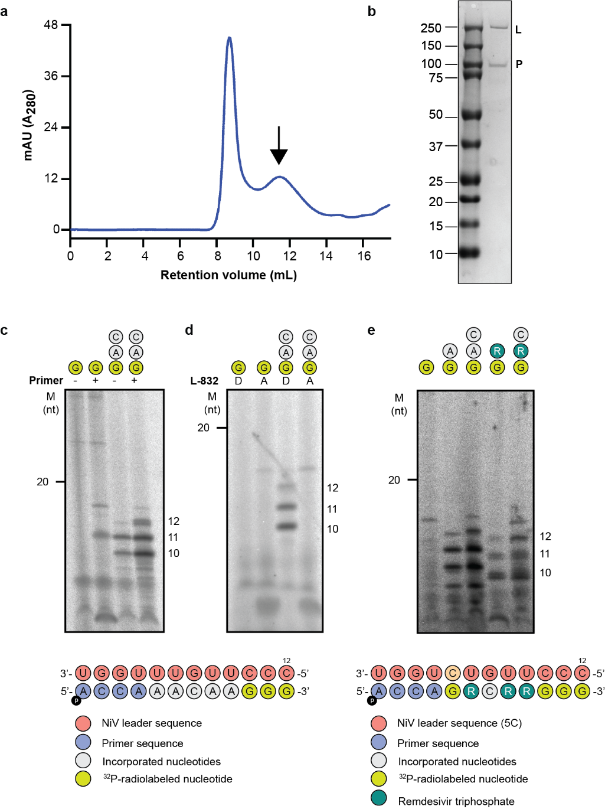
Supplementary Figure 1. Purified NiV L-P complex is transcriptionally active. a. Size exclusion chromatography profile of the L-P complex. Fractions eluting during the second peak (indicated by an arrow) were collected for subsequent functional and structural studies. b. SDS-PAGE analysis of the purified protein complex. c - e. In-vitro [α³²P]-GTP incorporation assays for the 3’ extension activity of the L-P complex assessing elongation with (+) or without (-) a 4-mer primer (c), wild type (D) or L-D832A mutant of NiV L (d) and ATP substitution with remdesivir triphosphate (e). The 12-mer nucleotide(nt)-long NiV leader sequence used as a template for panels c-d was exchanged for a sequence with a U-to-C mutation at position 5 (highlighted in orange) for panel e. Product lengths are indicated on the right.

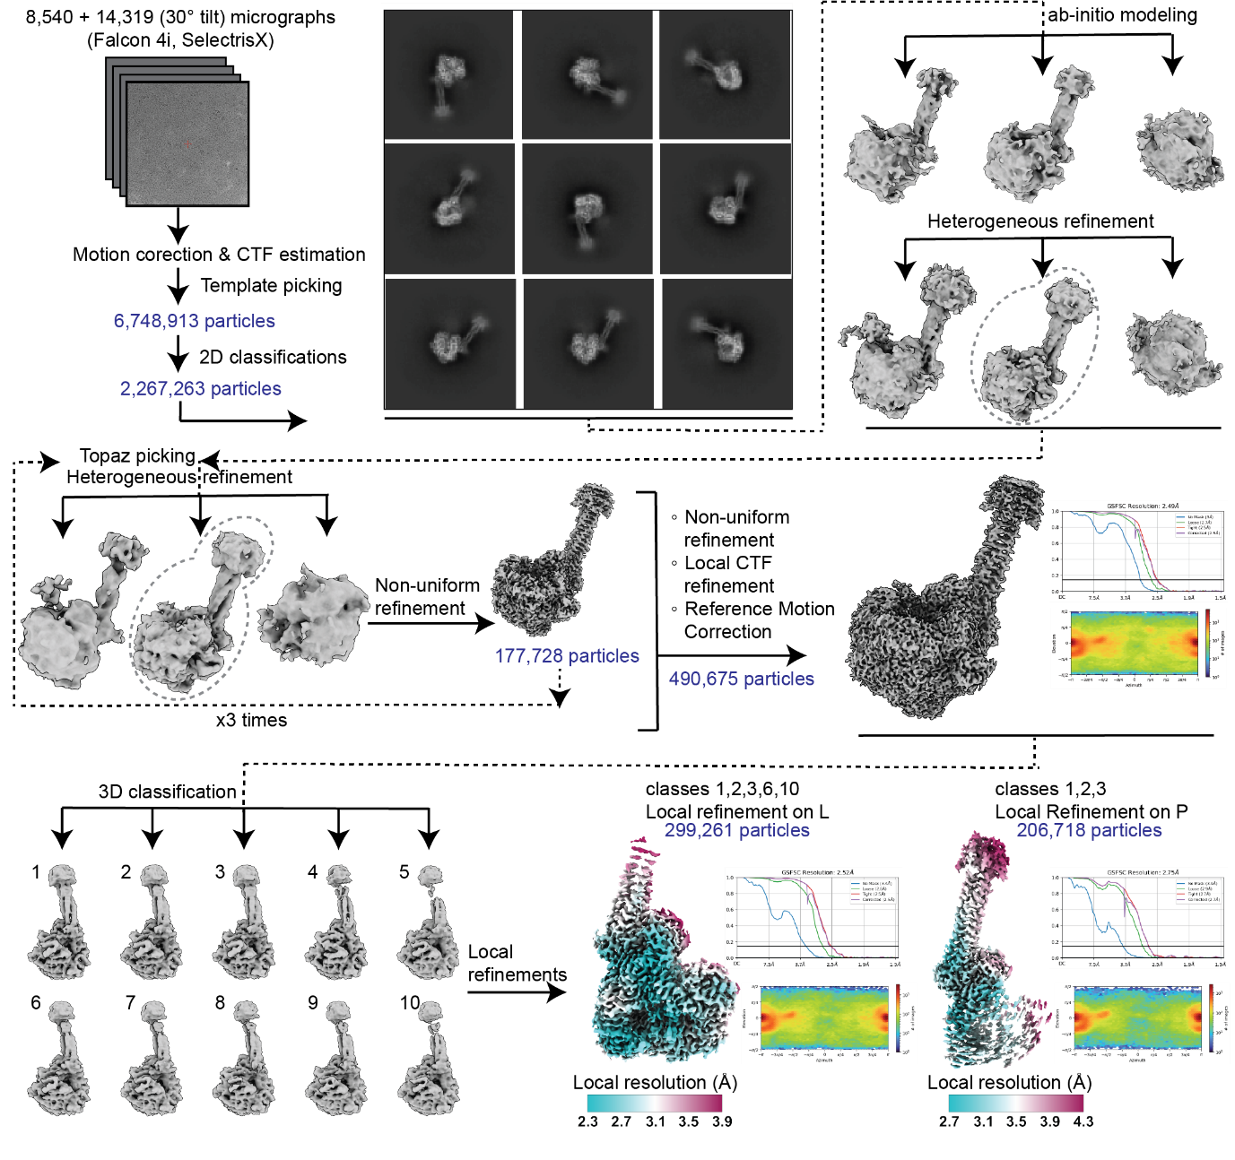Supplementary Figure 2. Cryo-EM data processing workflow. Flowchart indicates the path for data processing, classification and map reconstitution of the NiV L-P complex using CryoSPARC.

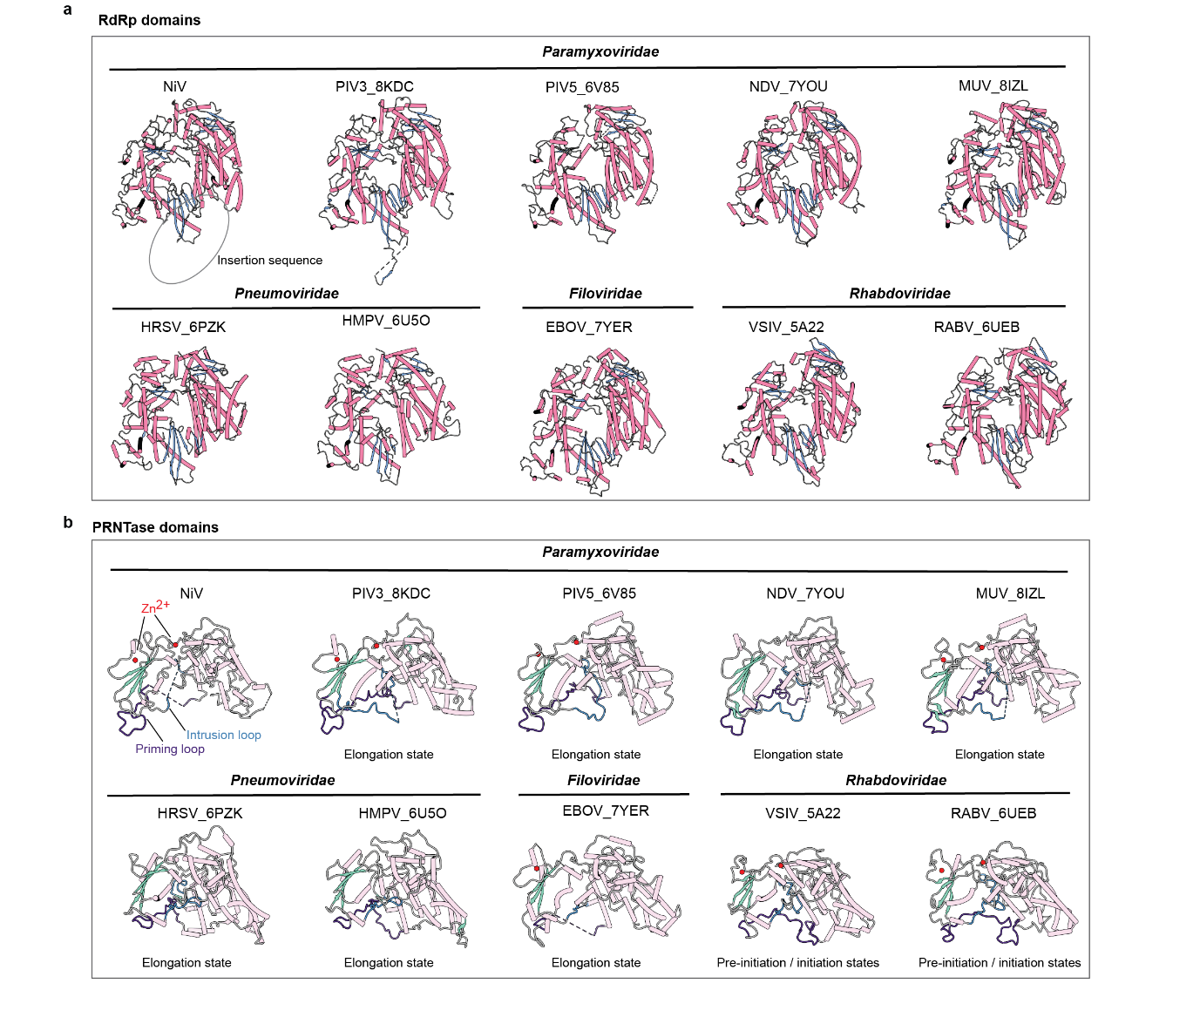Supplementary Figure 3. a. Structural comparisons of RdRp and PRNTase domains of NiV L with those of nsNSVs. a. The RdRp domains are shown with helices coloured in pale purple-red and β-sheets in blue. The location of the unmodelled palm-insertion sequence is shown by a dashed circle. b. The PRNTase domains are represented using secondary structure colourings: helices are shown in pale pink, β-strands are in green. Zinc (Zn²⁺) ions bound to the PRNTase domains are coloured in red, while the priming loop is represented in dark purple and the intrusion loop in marine blue.

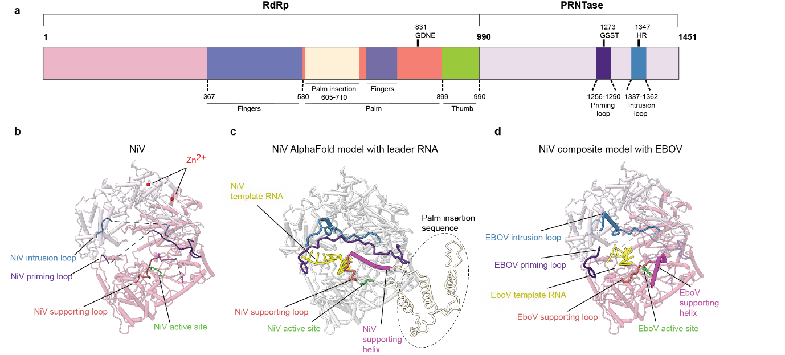Supplementary Figure 4. a. Schematic diagram of the domain architecture of NiV L RdRp (pale purple-red) and PRNTase domains (pale rose). The conserved motifs on the RdRp, are represented in different colours as well as the priming and intrusion loops on the PRNTase domain. b. The structural elements on the NiV RdRp are represented by arrows. Two zinc (Zn²⁺) ions bound on the NiV PRNTase are represented as red spheres. c. The NiV L-P complex bound to RNA (5’-CCCUUGUUUGGU-3’) was predicted using AlphaFold 3, which demonstrated the stabilization of these structural elements. The predicted region for the palm insertion sequence (residues 605-710) is indicated by a dashed circle. d. A composite model was generated using the EBOV priming loop, intrusion loop, supporting loop and supporting helix along with its bound template RNA (PDB ID 8JSL).

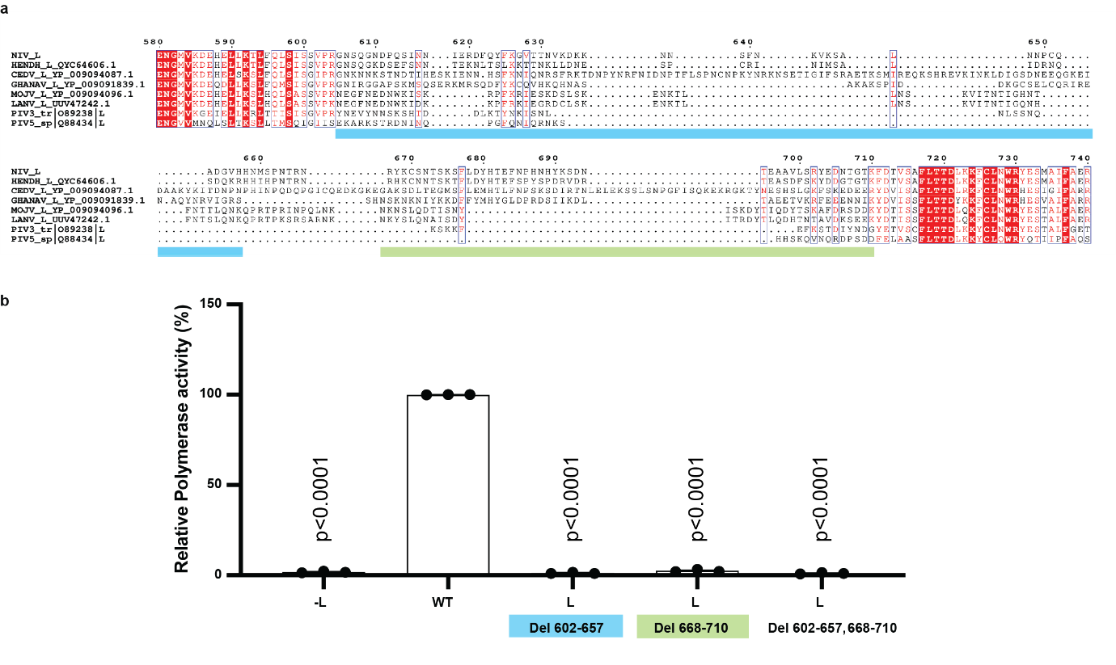Supplementary Figure 5. a. Sequence alignment of the palm-insertion sequence region of L proteins from Henipaviruses and its comparison with the L proteins of PIV3 and PIV5. The GenBank accession codes for each L protein of the Henipavirus family are shown alongside the sequence name: QYC64606.1 for Hendra virus, YP_009094087.1 for Cedar virus, YP_009091839.1 for Ghana virus, YP_009094096.1 for Mojiang virus, LUUV47242 for Langya virus. The UniProt IDs are O89238 for PIV3 and Q88434 for PIV5. Sequences were aligned in Clustal Omega and rendered in ESPript 3.0. b. Polymerase activity dependent on the presence of the NiV L palm insertion assessed using the minireplicon assay. BSR-T7/5 cells were co-transfected with plasmids expressing P, N as well as wild type (WT) and truncated versions of L, together with a bicistronic minigenome encoding for the Renilla luciferase. Relative Renilla luciferase activities are presented as the mean percentage activity of WT (±SEM), n=3 independent biological replicates of technical duplicates. P values from Dunnett’s multiple comparison (WT) one-way ANOVA test are indicated.

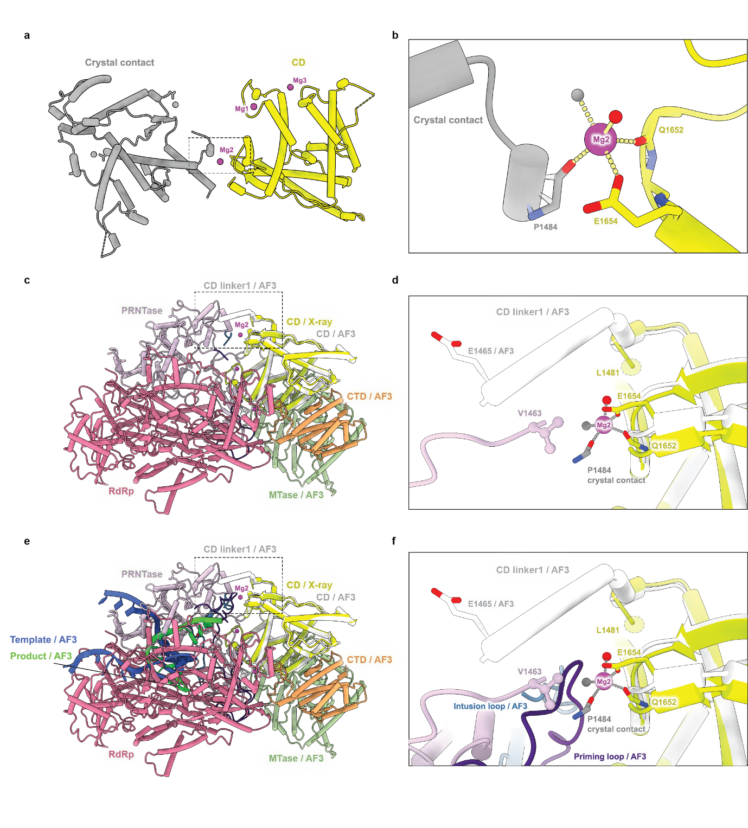Supplementary Figure 6. The CD crystal structure bound to three Mg ions (Mg1, Mg2, Mg3) is shown with the Mg ions represented as magenta spheres. a. Mg2 is coordinated within the CD crystal structure (yellow), along with asymmetrical crystal contacts (grey). Water molecules are depicted as red spheres for the CD and grey spheres for the crystal contacts. b. The coordination of the Mg2 involves the main chain of Gln1652, the side chain of Glu1654, and a water molecule (red), as well as the main chain of Pro1484 and a water molecule derived from the crystal contact. c. The position of Mg2 is shown in the composite model comprising RdRp, PRNTase, CD, CD/AF3, MTase/AF3, and CTD/AF3. d. A close-up view of the bound Mg2 within the composite model is presented, with the coordinating residues depicted as sticks. In the cryo-EM structure of NiV L, the last residue (Val1463) is represented as ball-and-stick, whereas the first residue (Leu1481) built in the CD X-ray structure is shown with dashes. The unbuilt CD linker1, predicted by AF3, is illustrated in white, with residue Glu1465 shown as a stick. e. The composite model was expanded to include priming loop f. A close-up view of the RNA-modelled composite reveals the positioning of the Mg2 near the priming loop.
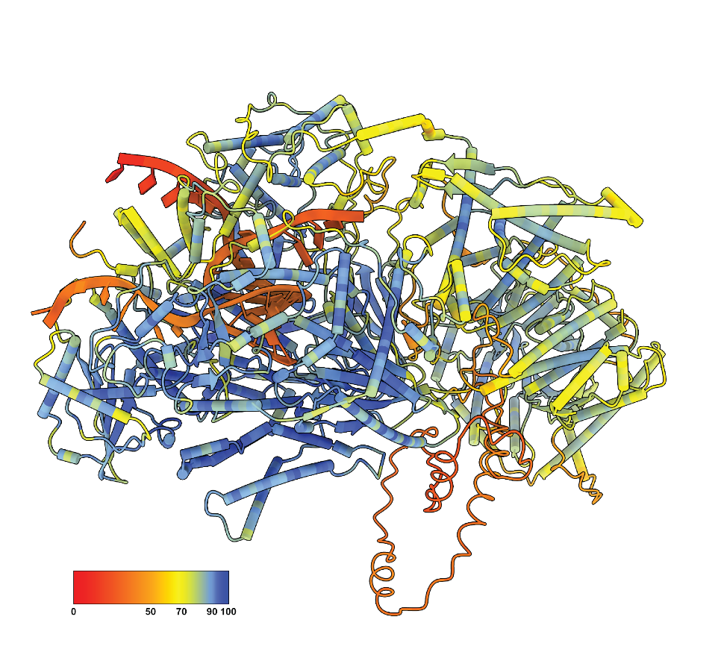
Supplementary Figure 7. The AF3 model of the NiV L protein is colored by the confidence scores of the AF3 prediction, with red indicating the lowest confidence and blue indicating the highest confidence.

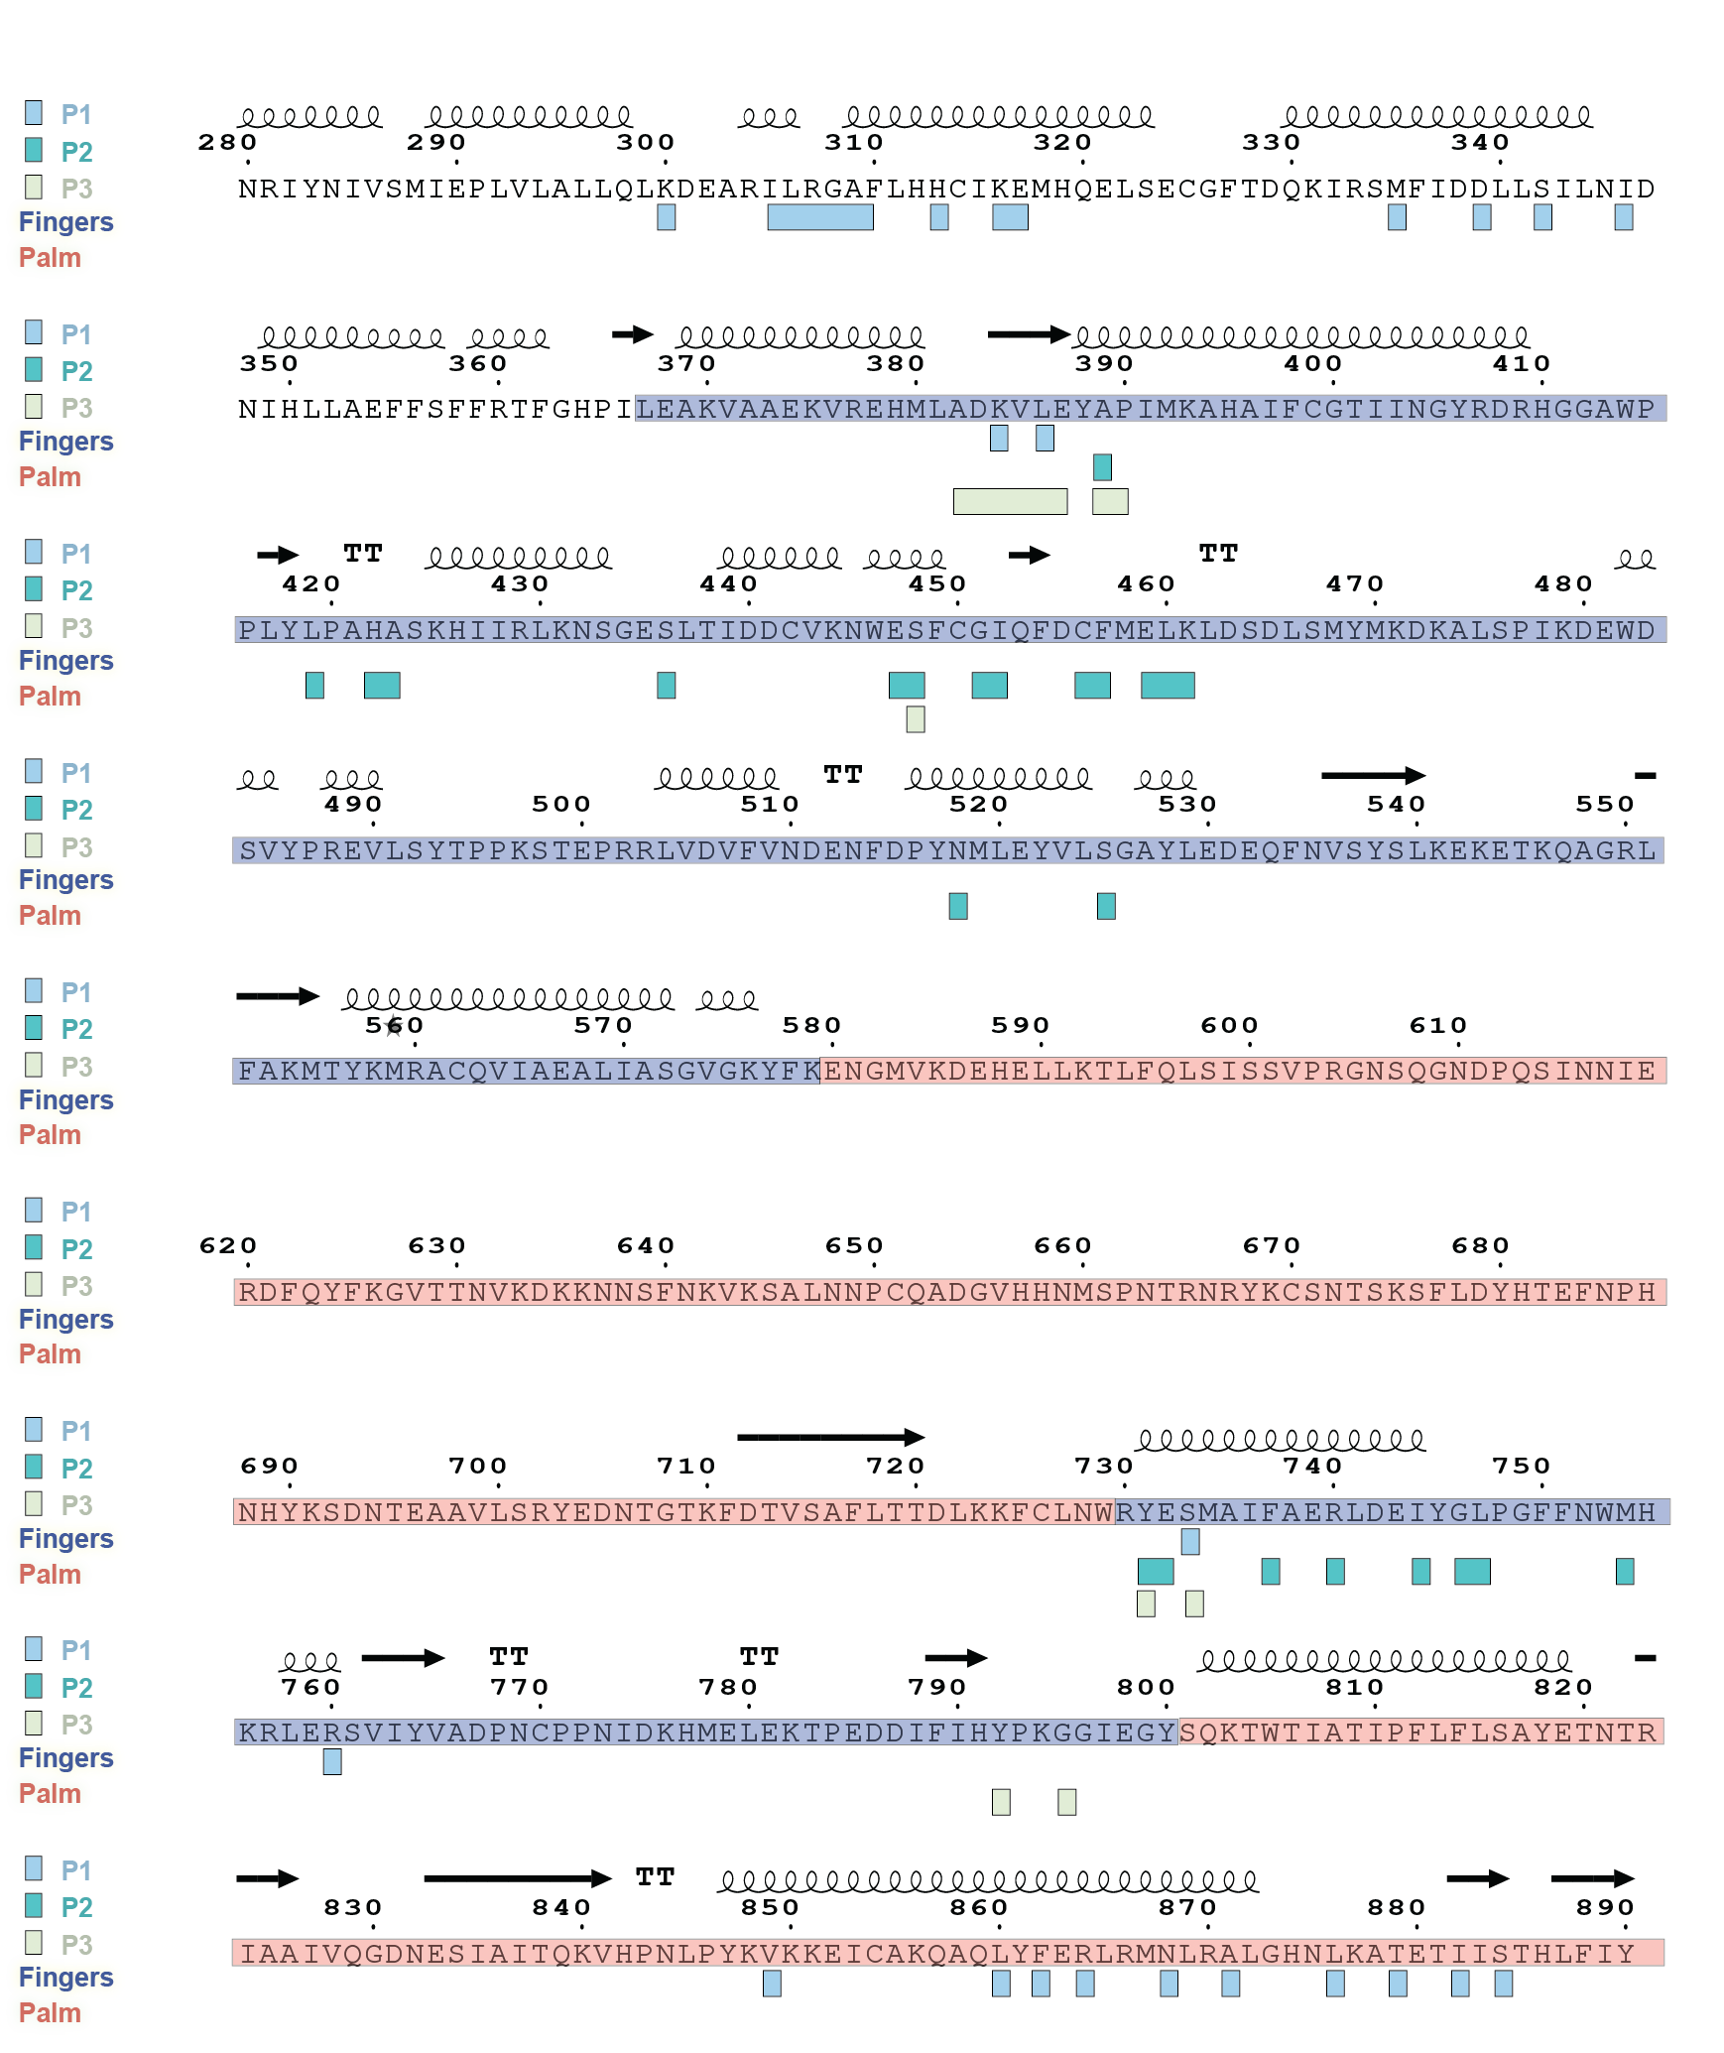
Supplementary Figure 8. Binding regions of P protomers on the sequence of L. Each monomer of the P tetramer interacts with various residues on the L protein, and some of these interactions also involve common regions ((384-389) and (731-733)) on the L sequence that can simultaneously recruit each of the 3 protomers of P.

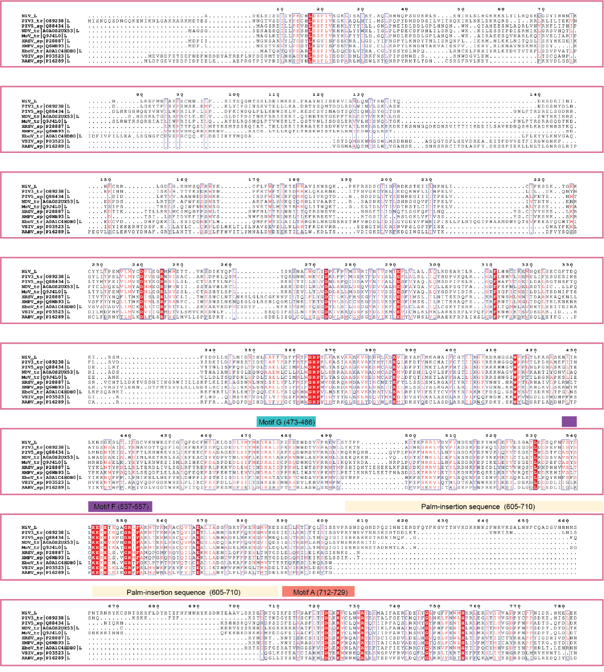
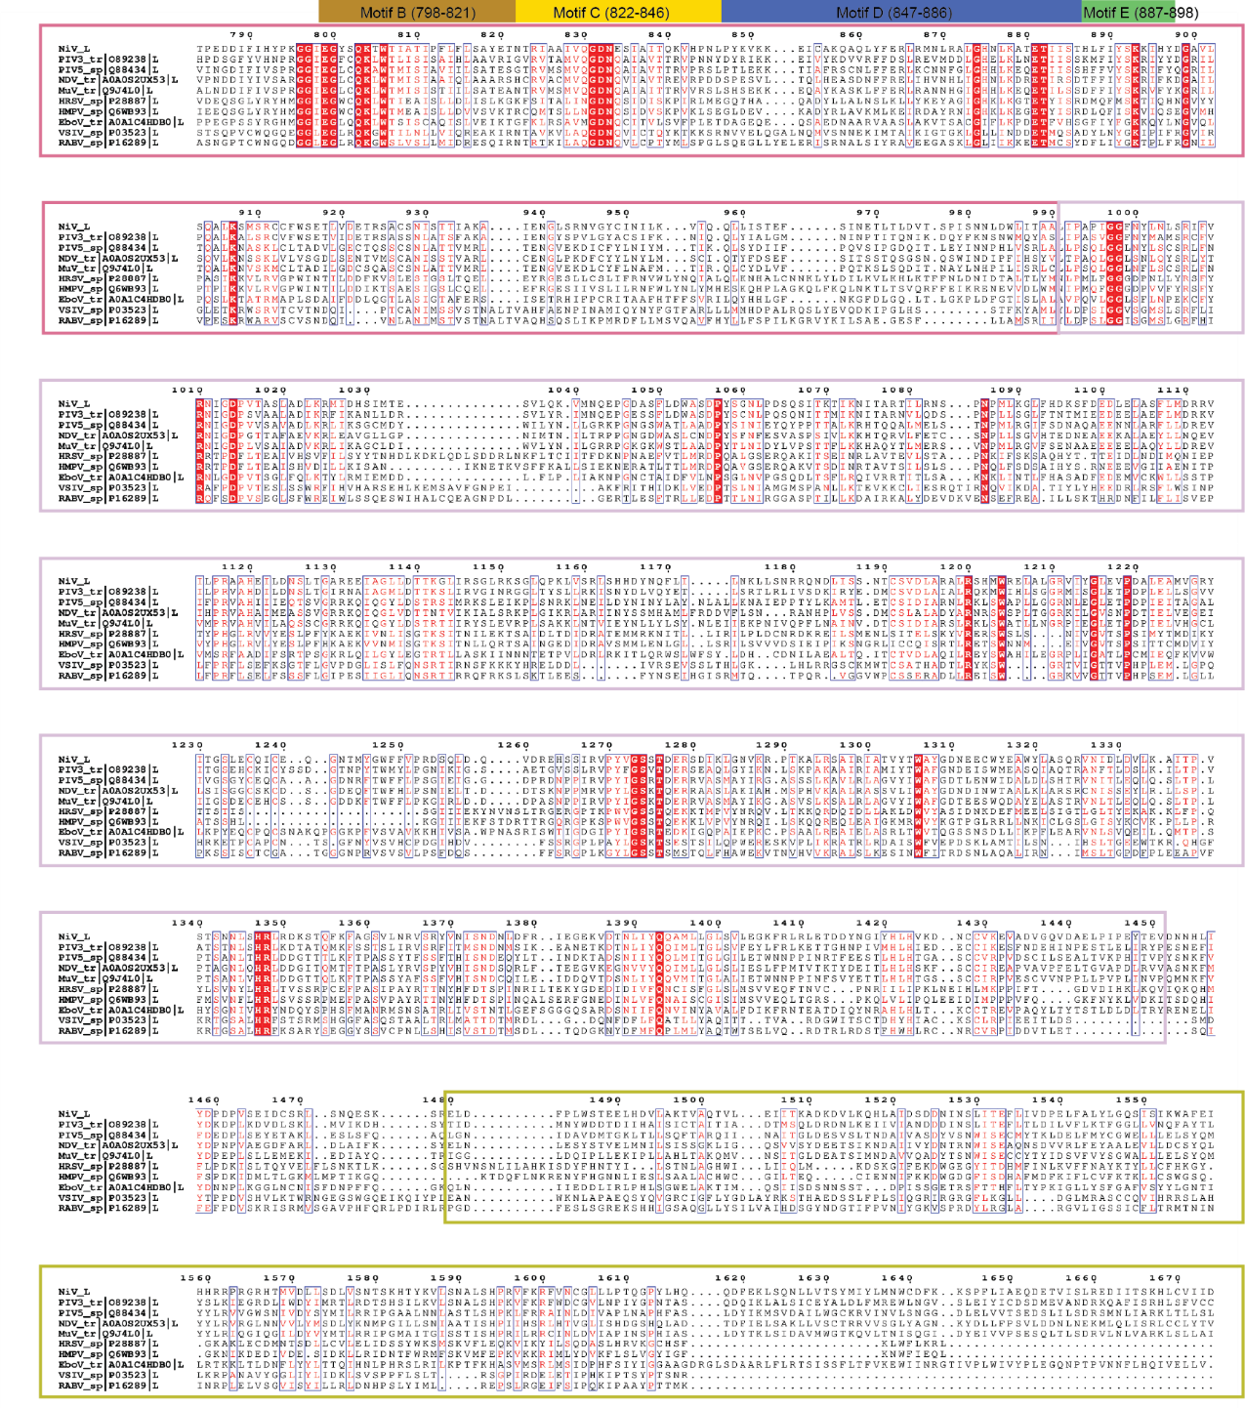
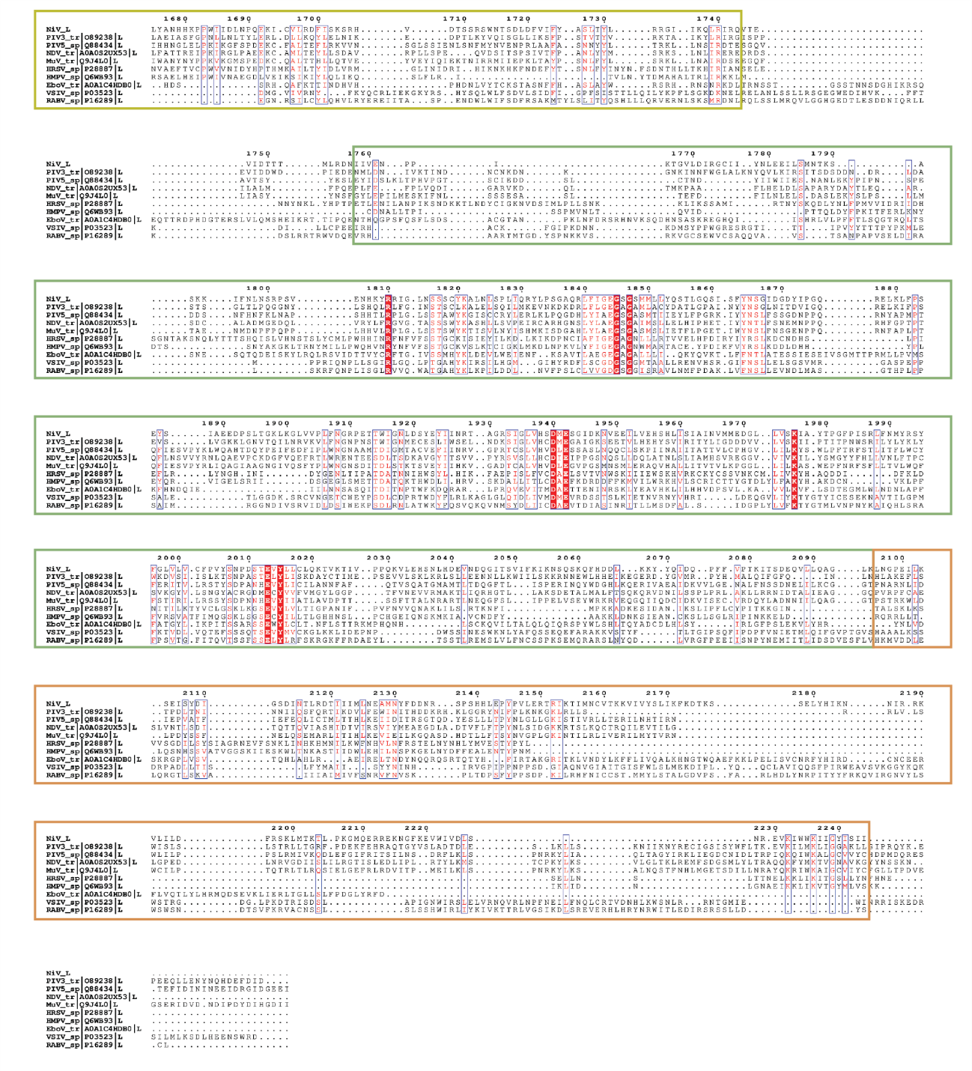Supplementary Figure 9. Multiple sequence alignment for the L proteins of members of Paramyxoviridae, Pneumoviridae, Filoviridae, and Rhabdoviridae. The RdRp domain sequence is framed in pale purple red, the PRNTase domain in pale pink, the CD in yellow, the MTase in green, and the CTD in orange. The palm insertion sequence and the RdRp motifs are represented by bars colored with their respective colours. The amino acid sequences of L from PIV3 (UniProt ID: O89238), PIV5 (UniProt ID: Q88434), NDV (UniProt ID: AOA0S2UX53), MuV (UniProt ID: Q9J4L0), HRSV (UniProt ID: P28887), HMPV (UniProt ID: Q6WB93), EboV (UniProt ID: A0A1C4HDB0), VSIV (UniProt ID: P03523), and RABV (UniProt ID: P16289) were aligned using Clustal Omega and rendered in ESPript 3.0.
Table S1. Cryo-EM data collection, refinement and validation statistics

NiV L-P complex
(EMDB-50781), (PDB 9FUX)
Data collection and processing
Magnification | 165,000
Voltage (kV) | 300
Electron exposure (e–/Å²) | 50
Defocus range (μm) | 1.4 to 2.4
Pixel size (Å) | 0.7303
Symmetry imposed | C1
Initial particle images (no.) | 6,748,913
Final particle images (no.) | 490,675
Map resolution (Å)  FSC threshold | 2.49  0.143
Map resolution range (Å) | 2.5 - 30.00
Refinement
Initial model used (PDB code) | ModelAngelo
Model resolution (Å)  FSC threshold | 2.5  0.5
Map sharpening B factor (Å²) | 85.1
Model composition  Non-hydrogen atoms  Protein residues  Ligands | 14537  1811  2
B factors (Å²)  Protein (min/max/mean)  Ligand (min/max/mean) | 16.19/191.32/61.92  94.27/122.61/108.44
R.m.s. deviations  Bond lengths (Å)  Bond angles (°) | 0.004  0.596
Validation  MolProbity score  Clashscore  Poor rotamers (%) | 1.63  7.32  0.67
Ramachandran plot  Favored (%)  Allowed (%)  Disallowed (%) | 96.53  3.41  0.06

Table S2. X-ray data collection and refinement statistics.

 | CD
Data collection
Space group | P 1 21 1
Cell dimensions
a, b, c (Å) | 40.76, 50.54, 61.00
α, β, γ (°) | 90.00, 95.71, 90.00
Resolution (Å) | 60.80 - 1.85 (1.92 - 1.85)
R_{sym} or R_{merge} | 0.102 (2.065)
I / σI | 10.3 (0.6)
Completeness (%) | 91.30% (55.69%)
Redundancy | 6.0 (3.3)
Refinement
Resolution (Å) | 60.80 - 1.85 (1.92 - 1.85)
No. reflections | 19413 (1175)
R_{work} / R_{free} (%) | 19.3 (33.1) / 21.9 (37.3)
No. atoms | 2358
Protein | 2146
Ligand/ion | 3
Water | 209
Average B-factor, all atoms (Å² ) | 28.8
R.m.s. deviations
Bond lengths (Å) | 0.0023
Bond angles (°) | 0.55
Ramachandran Plot  Favored (%) | 98.44
Outliers (%) | 0.00
Values in the parentheses are for the highest resolution shell.

