Supplementary Material 2. The pathways’ diagrams of KEGG analysis
(a) The calcium signaling pathway in the KEGG pathway analysis
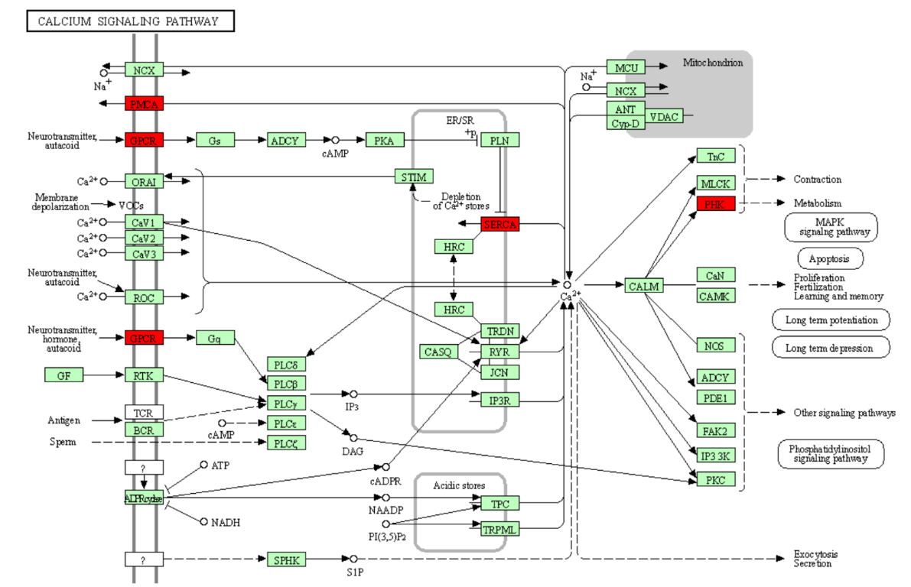
(b) The aldosterone synthesis and secretion in the KEGG pathway analysis
