Interpeduncular GABAergic neuron function controls threat processing and innate defensive adaptive learning
Elora W. Williams, B.S.^{1,2} ; Leshia Snively, B.A.¹ ; Benjamin O’Meara, B.A.^{1,2} ; Hannah Jacobs, B.A.^{1,2} ; Miranda Kolb^{1,2} ; Rubing Zhao-Shea, Ph.D.⁴ ; Michael V Baratta, Ph.D.² ; Andrew R Tapper, Ph.D.⁴ and Susanna Molas, Ph.D. ^{1,2,3,4}

¹Institute for Behavioral Genetics, University of Colorado Boulder, 1480 30th St, Boulder, 80303, CO, USA.
²Department of Psychology and Neuroscience, University of Colorado Boulder, 1905 Colorado Ave, Boulder, 80309, CO, USA.
³Crnic Institute Boulder Branch, BioFrontiers Institute, University of Colorado Boulder, 3415 Colorado Avenue, Boulder, 80303, CO, USA.
⁴Department of Neurobiology, Brudnick Neuropsychiatric Research Institute, University of Massachusetts Chan Medical School, 364 Plantation St, LRB, Worcester, 01605, MA

Corresponding author:
Susanna Molas, PhD
Institute for Behavioral Genetics/Department of Psychology and Neuroscience, University of Colorado Boulder, Boulder, CO
Email: susanna.molas@colorado.edu

SUPPLEMENTARY FIGURES

Suppl. Figure 1. Visual threat perception and adaptive learning.
| (a) Schematic of the overhead (top) and side (bottom) VLS paradigms. (b) Time spent inside the nest (s) across both groups. Unpaired t-test (t₍₃₇₎ = 3.224, P = 0.0026). ** p < 0.01. (c) Latency to nest (s) across both groups (t₍₃₇₎ = 1.755, P = 0.0875). (d) Quantification of max speed (cm/s) 10s upon VLS across 3 days in (figure 1e). One-way RM ANOVA (day effect: F_{(2,92)} = 1.680, P = 0.2038). (e) Latency to nest (s) relative to VLS, across 3 days. One-way RM ANOVA (day effect: F_{(2,92)} = 0.023, P = 0.9647). (f) Representative image of VLS apparatus with defined zones. (g) Trace of time spent in the trigger zone (%) relative to VLS, across 3 days. (h) Quantification of time spent in the trigger area (%) 30 sec upon VLS in (g). One-way RM ANOVA (day effect: F_{(2,92)} = 0.061, P = 0.8902). (i) Trace of time spent in the safe zone (%) relative to VLS, across 3 days. (j) Quantification of time spent in the safe zone 30 sec upon VLS in (i). One-way RM ANOVA (day effect: F_{(2,92)} = 0.488, P = 0.5924). (n = 31 mice). Data represent mean ± SEM.

Suppl. Figure 2. Defensive adaptive learning does not occur within a trial session.
| (a) Freezing time (%) 2s upon VLS across events for day 1 (REML, time effect: F_{(5.088, 132.3)} = 0.8472, P = 0.5203), day 2 (REML, time effect: F_{(4.547, 119.0)} = 1.156, P = 0.3347) and day 3 (REML, time effect: F_{(5.015, 123.7)} = 2.070, P = 0.0734). (b) Max speed (cm/s) 2s upon VLS across events for day 1 (REML, time effect: F_{(4.871, 126.7)} = 0.335, P = 0.8868), day 2 (REML, time effect: F_{(3.855, 100.9)} = 0.8318, P = 0.5044) and day 3 (REML, time effect: F_{(3.009, 74.22)} = 0.4555, P = 0.7148). (c) Max speed (cm/s) 10s upon VLS across events for day 1 (REML, time effect: F_{(2.915, 75.80)} = 1.490, P = 0.2248), day 2 (REML, time effect: F_{(4.359, 114.1)} = 0.3308, P = 0.8715) and day 3 (REML, time effect: F_{(3.291, 81.18)} = 0.4586, P = 0.7295). (d) Latency to nest (s) across events for day 1 (REML, time effect: F_{(3.436, 87.63)} = 1.147, P = 0.3376), day 2 (REML, time effect: F_{(3.689, 97.76)} = 0.4151, P = 0.7823) and day 3 (REML, time effect: F_{(4.189, 104.7)} = 1.258, P = 0.2906). (e) Time in nest (s) across events for day 1 (REML, time effect: F_{(3.297, 86.27)} = 2.513, P = 0.0584), day 2 (REML, time effect: F_{(4.199, 113.4)} = 0.8134, P = 0.5242) and day 3 (REML, time effect: F_{(3.426, 90.21)} = 0.9577, P = 0.425). (f) Time near the wall (%) across events for day 1 (REML, time effect: F_{(4.002, 104.1)} = 1.321, P = 0.2669), day 2 (REML, time effect: F_{(4.135, 108.2)} = 0.6265, P = 0.6499) and day 3 (REML, time effect: F_{(4.111, 101.4)} = 1.172, P = 0.328). (n = 31 mice). Data represent mean ± SEM.

Suppl. Figure 3. Predictive variables of defensive responses and threat adaptation.
| Correlation heatmaps reporting Pearson’s correlation coefficients (a) and p values (b) for each comparison for days 1-3. *p < 0.05. (n = 189 – 192 VLS events/day, from n = 31 mice)

Suppl. Figure 4. Aversive stimuli increase activity in IPN GAD2 neurons.
| (a) Left, schematics of the overhead and side VLS paradigms. Right, z-score values of time-locked IPN GAD2 neuronal activity relative to VLS (t = 0) presented from an overhead or side view. (b) Z-score values of IPN GAD2 neuronal activity relative to VLS (t = 0) in mice expressing GCaMP or eGFP. IPN GAD2 neuronal activity responses upon a tail lift (c), a foot shock (d) or rearing behavior across 3 days (e). (f) Z-score traces of IPN GAD2 neuronal activity across VLS events within a session, for 3 consecutive days. (g) Maximum z-score values of IPN GAD2 neuronal activity levels across VLS events on day 1 (REML, time effect: F_{(2.236, 15.28)} = 1.262, P = 0.3148), day 2 (REML, time effect: F_{(3.294, 22.51)} = 1.631, P = 0.2076) and day 3 (REML, time effect: F_{(3.067, 18.40)} = 0.951, P = 0.4380). (n = 4 – 7 VLS events/day, from n = 8 mice). Data represent mean ± SEM.

Suppl. Figure 5. IPN GAD2 GCaMP activity responses predict defensive behaviors.
| (a) Example of speed trace (cm/s) overlapped with IPN GAD2 fiber photometry signals (dF/F0) across full loom sessions, on days 1-3. Initiation of each VLS is indicated by black circle. Correlation between z-score IPN GAD2 activity responses on day 1 and (b) average speed (cm/s) 10s upon VLS initiation (Pearson’s correlation, r = -0.385, p = 3.672 E-004), (c) latency to the nest (Pearson’s correlation, r = 0.523, p = 5.048 E-005) and (d) time spent near the walls (%) 30 sec upon VLS initiation (Pearson’s correlation, r = 0.365, p = 0.00658). (n = 26 - 33 VLS events per condition each day, from 8 mice). Data represent mean ± SEM.

Suppl. Figure 6. Silencing IPN GAD2 neurons increases time nearby safety areas.
| (a) Traces of time spent in the safe zone (%) relative to VLS, across 3 days in IPN GAD2 eGFP and NpHR animals. (b) Quantification of time spent in the safe zone 30 sec upon VLS in (a). Two-way RM ANOVA (day effect: F_{(2,32)} = 1.077, P = 0.3515; treatment effect: F_{(1,16)} = 2.365, P = 0.1436; interaction: F_{(2,32)} = 3.857, P = 0.0316), Tukey’s multiple comparisons *p<0.05. (c) Latency to nest (s) relative to VLS, across 3 days in IPN GAD2 eGFP and NpHR animals. Two-way RM ANOVA (day effect: F_{(2,32)} = 1.517, P = 0.2351; treatment effect: F_{(1,16)} = 0.8876, P = 0.3601; interaction: F_{(2,32)} = 0.2180, P = 0.8053). (d) Traces of time spent near the wall (%) relative to VLS, across 3 days in IPN GAD2 eGFP and NpHR animals. (e) Quantification of time spent near the wall (%) 30 sec upon VLS in (d). Two-way RM ANOVA (day effect: F_{(2,32)} = 7.239, P = 0.0055; treatment effect: F_{(1,16)} = 0.1373, P = 0.7158; interaction: F_{(2,32)} = 0.1158, P = 0.8911), day effect $$ p < 0.01. (f) Traces of time spent in the trigger zone (%) relative to VLS, across 3 days in IPN GAD2 eGFP and NpHR animals. (g) Quantification of time spent in the trigger area (%) 30 sec upon VLS in (f). Two-way RM ANOVA (day effect: F_{(2,32)} = 2.830, P = 0.0785; treatment effect: F_{(1,16)} = 0.2695, P = 0.6108; interaction: F_{(2,32)} = 0.5648, P = 0.5740). (n = 6 eGFP and 12 NpHR mice). Data represent mean ± SEM.

Suppl. Figure 7. Photostimulation of IPN GAD2 neurons is not sufficient to trigger defensive behaviors.
| (a) Schematic and representative image of ChR2 injection and fiber placement in the IPN in GAD2 Cre mice. (b) Schematic representation of IPN GAD2 neuronal photostimulation (blue, 473 nm, 20 Hz, 12 ms pulse, 3s) on day 1 and day 3 of VLS test. (c) Latency to nest (s) relative to photostimulation, across 3 days in IPN GAD2 mCherry and ChR2 animals. Two-way RM ANOVA (day effect: F_{(2,40)} = 0.8774, P = 0.4229; treatment effect: F_{(1,20)} = 0.2504, P = 0.6222; interaction: F_{(2,40)} = 0.7381, P = 0.4844). (d) Traces of freezing time (%) relative to photostimulation, across 3 days in IPN GAD2 mCherry and ChR2 animals. (e) Quantification of freezing time (%) 2s upon photostimulation in (d). Two-way RM ANOVA (day effect: F_{(2,40)} = 2.409, P = 0.1084; treatment effect: F_{(1,20)} = 0.4240, P = 0.5223; interaction: F_{(2,40)} = 0.4077, P = 0.6679). (f) Trace of time spent inside the nest (%) relative to photostimulation (t = 0), across 3 days in IPN GAD2 mCherry and ChR2 animals. (g) Quantification of time in nest (s) after photostimulation across days. Two-way RM ANOVA (day effect: F_{(2,40)} = 10.00, P = 0.0003; treatment effect: F_{(1,20)} = 0.07145, P = 0.7920; interaction: F_{(2,40)} = 0.1960, P = 0.8228). (h) Traces of time spent in the safe zone (%) relative to photostimulation, across 3 days in IPN GAD2 mCherry and ChR2 animals. (i) Quantification of time spent in the safe zone 30 sec upon photostimulation in (h). Two-way RM ANOVA (day effect: F_{(2,40)} = 2.484, P = 0.0988; treatment effect: F_{(1,20)} = 3.304, P = 0.0841; interaction: F_{(2,40)} = 0.237, P = 0.7901). (j) Traces of time spent near the wall (%) relative to photostimulation, across 3 days in IPN GAD2 mCherry and ChR2 animals. (k) Quantification of time spent near the wall (%) 30 sec upon photostimulation in (j). Two-way RM ANOVA (day effect: F_{(2,40)} = 0.1490, P = 0.8464; treatment effect: F_{(1,20)} = 4.142, P = 0.0553; interaction: F_{(2,40)} = 0.04355, P = 0.9574). (n = 10 mCherry and 12 ChR2 mice). Data represent mean ± SEM.

Suppl. Figure 8. IPNLDTg GAD2 GCaMP activity responses predict defensive behaviors.
| (a) Z-score traces of IPNLDTg GAD2 neuronal activity across VLS events within a session, for 3 consecutive days. (b) Maximum z-score values of IPNLDTg GAD2 neuronal activity levels across VLS events on day 1 (REML, time effect: F_{(2.266,12.08}) = 0.8133, P = 0.4802), day 2 (REML, time effect: F_{(2.753, 14.22)} = 0.5369, P = 0.6502) and day 3 (REML, time effect: F _{(2.115, 10.93)} = 1.056, P = 0.3847). (n = 4 – 7 VLS events/day, from n = 7 mice). Correlation between z-score IPNLDTg GAD2 activity responses on day 1 and (c) average speed (cm/s) 10s upon VLS initiation (Pearson’s correlation, r = -0.342, p = 0.02129), (d) latency to the nest (Pearson’s correlation, r = 0.0812, p = 0.6046) and (e) time spent near the walls (%) 30 sec upon VLS initiation (Pearson’s correlation, r = 0.330, p = 0.02681). (n = 13 - 33 VLS events per condition, from 7 mice). Data represent mean ± SEM.

Suppl. Figure 9. Silencing the IPNLDTg GAD2 circuit does not affect additional defensive strategies.
| (a) Traces of time spent in the safe zone (%) relative to VLS, across 3 days in IPNLDTg GAD2 eGFP and NpHR animals. (b) Quantification of time spent in the safe zone 30 sec upon VLS in (a). Two-way RM ANOVA (day effect: F_{(2,60)} = 6.537, P = 0.0040; treatment effect: F_{(1,30)} = 0.05379, P = 0.8182; interaction: F_{(2,60)} = 2.287, P = 0.1104), day effect $$ p < 0.01. (c) Latency to nest (s) relative to VLS, across 3 days in IPNLDTg GAD2 eGFP and NpHR animals. Two-way RM ANOVA (day effect: F_{(2,60)} = 0.9975, P = 0.3678; treatment effect: F_{(1,30)} = 2.143, P = 0.1536; interaction: F_{(2,60)} = 1.788, P = 0.1761). (d) Traces of time spent near the wall (%) relative to VLS, across 3 days in IPNLDTg GAD2 eGFP and NpHR animals. (e) Quantification of time spent near the wall (%) 30 sec upon VLS in (d). Two-way RM ANOVA (day effect: F_{(2,60)} = 2.106, P = 0.1352; treatment effect: F_{(1,30)} = 0.3112, P = 0.5811; interaction: F_{(2,60)} = 1.581, P = 0.2141). (f) Traces of time spent in the trigger zone (%) relative to VLS, across 3 days in IPNLDTg GAD2 eGFP and NpHR animals. (g) Quantification of time spent in the trigger area (%) 30 sec upon VLS in (f). Two-way RM ANOVA (day effect: F_{(2,60)} = 0.09885, P = 0.9024; treatment effect: F_{(1,30)} = 0.4902, P = 0.4893; interaction: F_{(2,60)} = 0.8449, P = 0.4346). (n = 15 eGFP and 17 NpHR mice). Data represent mean ± SEM.

Suppl. Figure 10. IPN Sst+ GCaMP activity responses predict threat and safety cues.
| (a) Representative images of rostro-caudal distribution of immunolabelled Sst⁺ neurons in the IPN. Scale bar 100μm. (b) Representative image of GCaMP expression in the IPN (green) of Sst immunolabelled with Sst staining (red). Nuclei are counterstained with DAPI (blue). Scale bar 50μm. IPN Sst⁺ neuronal activity responses upon a tail lift (c) or a foot shock (d). Correlation between z-score IPN Sst⁺ activity responses upon nest entry on day 1 and (e) average speed (cm/s) 10s upon VLS initiation (Pearson’s correlation, r = 0.3909, p = 0.0482), (f) time in nest (Pearson’s correlation, r = 0.4501, p = 0.0210), (g) latency to the nest (Pearson’s correlation, r = -0.3815, p = 0.0544) and (h) time spent near the walls (%) 30 sec upon VLS initiation (Pearson’s correlation, r = -0.4148, p = 0.0391). (n = 10 - 15 VLS events per condition each day, from 5 mice). Data represent mean ± SEM.

Suppl. Figure 11. Genetic ablation of IPN Sst+ neurons reduces avoidance behaviors.
| (a) Traces of freezing time (%) relative to VLS (t = 0), across 3 days in IPN Sst mCherry and taCasp3-TEVp animals. (b) Quantification of freezing time (%) 2 sec upon VLS in (a). Two-way RM ANOVA (day effect: F_{(2,38)} = 11.96, P = 0.0004; treatment effect: F_{(1,19)} = 0.4742, P = 0.4994; interaction: F_{(2,38)} = 1.120, P = 0.3369), day effect $$$ p< 0.001. (c) Traces of speed (cm/s) relative to VLS (t = 0), across 3 days in IPN Sst mCherry and taCasp3-TEVp animals. (d) Quantification of max speed (cm/s) 2 sec upon VLS in (c). Two-way RM ANOVA (day effect: F_{(2,38)} = 4.130, P = 0.0405; treatment effect: F_{(1,19)} = 0.3698, P = 0.5503; interaction: F_{(2,38)} = 5.483, P = 0.0081), day effect $ p< 0.05. (e) Traces of time spent in the safe zone (%) relative to VLS, across 3 days in IPN Sst mCherry and taCasp3-TEVp animals. (f) Quantification of time spent in the safe zone 30 sec upon VLS in (e). Two-way RM ANOVA (day effect: F_{(2,38)} = 1.797, P = 0.1863; treatment effect: F_{(1,19)} = 6.255, P = 0.0217; interaction: F_{(2,38)} = 0.2111, P = 0.8106), treatment effect # p < 0.05. (g) Traces of time spent near the wall (%) relative to VLS, across 3 days in IPN Sst mCherry and taCasp3-TEVp animals. (h) Quantification of time spent near the wall (%) 30 sec upon VLS in (g). Two-way RM ANOVA (day effect: F_{(2,38)} = 3.315, P = 0.0627; treatment effect: F_{(1,19)} = 3.889, P = 0.0633; interaction: F_{(2,38)} = 0.4455, P = 0.6438). (i) Latency to nest (s) relative to VLS, across 3 days in IPN Sst mCherry and taCasp3-TEVp animals. Two-way RM ANOVA (day effect: F_{(2,38)} = 6.506, P = 0.0046; treatment effect: F_{(1,19)} = 1.130, P = 0.3011; interaction: F_{(2,38)} = 0.5404, P = 0.5869), day effect $$ p<0.01. (n = 9 mCherry and 12 taCasp3-TEVp mice). (j) Time spent in the open arms of the EPM in IPN Sst mCherry and taCasp3-TEVp animals. Unpaired t test (t₍₂₂₎ = 2.156, P = 0.0423). (k) Number of entries in the closed arms of the EPM. Unpaired t test (t₍₂₂₎ = 0.310, P = 0.7592). (l) Time spent in the center of the OF in IPN Sst mCherry and taCasp3-TEVp animals. Unpaired t test (t₍₂₂₎ = 2.22, P = 0.037). (m) Total distance travelled in the OF. Unpaired t test (t₍₂₂₎ = 0.4099, P = 0.6859). (n = 11 mCherry and 13 taCasp3-TEVp mice). Data represent mean ± SEM.

Suppl. Table 1.
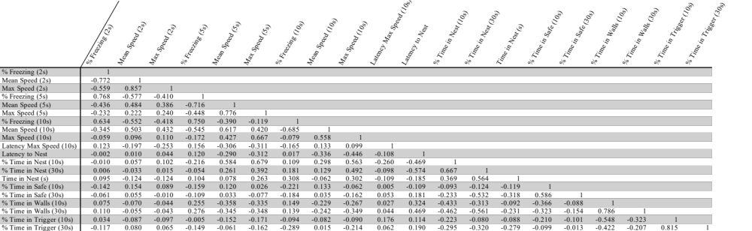
Correlation analysis reporting Pearson’s correlation coefficients on day 1. (n = 189 – 192 VLS events/day, from n = 31 mice).

Suppl. Table 2.
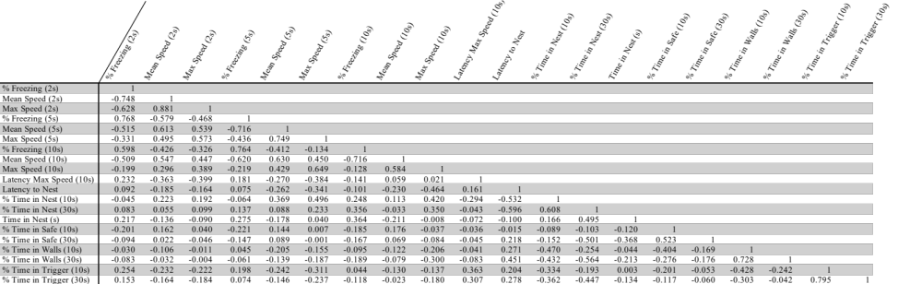
Correlation analysis reporting Pearson’s correlation coefficients on day 2. (n = 189 – 192 VLS events/day, from n = 31 mice).

Suppl. Table 3.
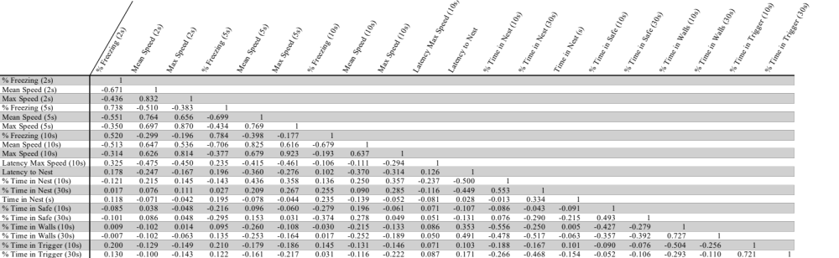
Correlation analysis reporting Pearson’s correlation coefficients on day 3. (n = 189 – 192 VLS events/day, from n = 31 mice).

Suppl. Table 4.
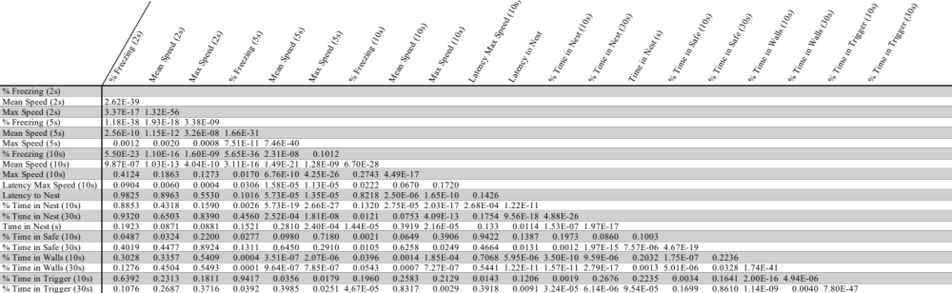
Correlation analysis reporting Pearson’s correlation p values on day 1. (n = 189 – 192 VLS events/day, from n = 31 mice).

Suppl. Table 5.
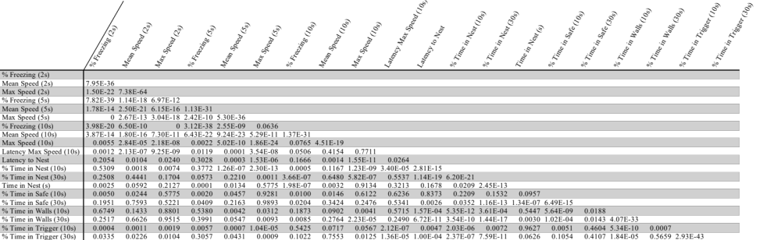
Correlation analysis reporting Pearson’s correlation p values on day 2. (n = 189 – 192 VLS events/day, from n = 31 mice).

Suppl. Table 6.
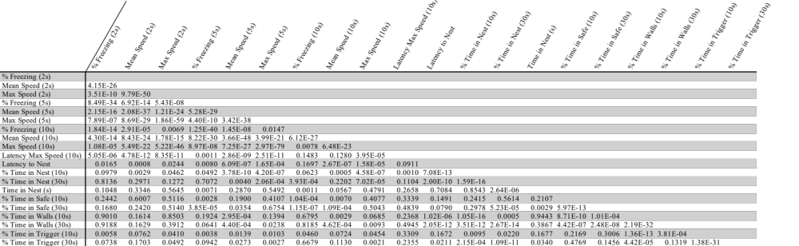
Correlation analysis reporting Pearson’s correlation p values on day 3. (n = 189 – 192 VLS events/day, from n = 31 mice).

