Supplementary file
Table S1: The physicochemical properties of CAPB
Parameter | UoM | Typical specification | Results
Appearance @ 25 °C | Visual | Viscous Liquid | Viscous Liquid
Color (Gardner) | Visual | Clear, colorless to slightly yellow liquid | colorless
Solids Content | % | 33.0 - 37.0 | 36.1
Active Substance | % | 28.0 - 32.0 | 31.5
Sodium Chloride Content | % | 4.0 - 6.0 | 5.6
pH value (10% Aqueous Solution @25 °C | - | 4.5 – 5.5 | 4.9
Free Amine | % | ≤ 0.5 | 0.15
Viscosity | cps | 300-600 | 450
Water content | % | 62-66 | 63

- Materials and Methods
  - Methods
    - Physicochemical properties of CAPB

      - Determination of pH value
According to the standard method (ASTM D1293-12), Place the CAPB sample in a clean glass beaker provided with a stirring bar and pH electrode with integral temperature sensor. Stir during the period of pH measurement at a rate that will prevent splashing out the sample. Insert the electrodes and determine a pH value.
      - Determination of solid content (NVM)
Reference to the standard method (AWWA 2540C), 1.5g~2.0g of the CAPB sample was poured into a weighing bottle that has been dried to constant weight. Rotate the weighing bottle to make the sample evenly spread on the bottom of the bottle. Put weight bottle in an oven at (105 ± 2) ℃, remove the bottle cap and heat it for 3h. Cover, move into the dryer, cool for 30min, and weigh it. The solid content (NVM) is calculated according to the following equation (Eq.3)
$$NVM=\frac{\left(m2-m0\right)}{(m1)} ×100 Eq.3$$
Where, m0: mass of empty weighing bottle, g, m1: mass of sample, g, and m2: mass of the empty weighing bottle sample after drying, g.
      - Determination of sodium chloride content (SC)
Regarding the standard method ISO 1269, Into 100mL conical flask, 1mL of potassium chromate solution was added to ~1g of the CAPB dissolved in 50mL of distilled water. The addressed solution was titrated with 0.1mol/L silver nitrate standard titration solution until the solution is stable orange red as the end point. Record the volume of silver nitrate standard titration solution consumed. The content of sodium chloride (SC)is calculated as follows (Eq. 2)
$$SC=\frac{\left(V2×C2×58.44\right)}{(M2)} ×100 Eq.2$$
Where, V2 is the volume of silver nitrate standard titration solution consumed for titration, mL, C2 is the molar concentration of silver nitrate standard titration solution, mol/L, 58.44: molar mass of sodium chloride, g/mol, and M2: Sample mass, g.
      - Determination of free amidoamine (AV)
According to the standard method EN 13435:2002, In a 250 ml conical flask, add an appropriate amount of 1-5 g CAPB sample. Afterwords, 50 ml absolute ethanol was added, boil it for 1 minute for removing free ammonia, cool it to room temperature. Add 5 drops of bromophenol blue indicator. The solution was titrated with 0.5mol/L isopropanol hydrochloride solution to the end point (yellow color). The total amine value (KOHmg equivalent/g) is calculated as according to the following equation formula (Eq. 3):
$$X=\frac{\left(V×C ×56.11\right)}{(m)} Eq.3$$
Where, X is the total amine value of the test sample, KOHmg equivalent /g, C is the Concentration of hydrochloric acid standard solution, mol/l, V is the amount of hydrochloric acid standard solution, ml, and m is the sample mass, g.
      - Effect of H₂O₂ (Bacterial analysis)
According to SASO-ISO-21149;2008, SASO-ISO-21150;2008, SASO-ISO-22717;2008, US FDA BAM 8th Ed Chapter 18, the bacterial growth of aerobic plate count, E. coli, Pseudomonas aeruginosa, Yeast & Molds, respectively was conducted at Bureau Veritas Laboratory, Saudi Arabia (third-party Laboratory).
      - Fourier Transform Infrared Spectroscopy (FTIR) analysis
The chemical structures of the synthesized C3-copolymer were justified using a Nicolet IS50 FTIR, Thermo Fisher Scientific, Waltham, USA. 0.5 mg of dried CAPB was directly poured on the detected hole. The analysis was conducted without grinding the CAPB with KPR to form the KBr disks or pellets.

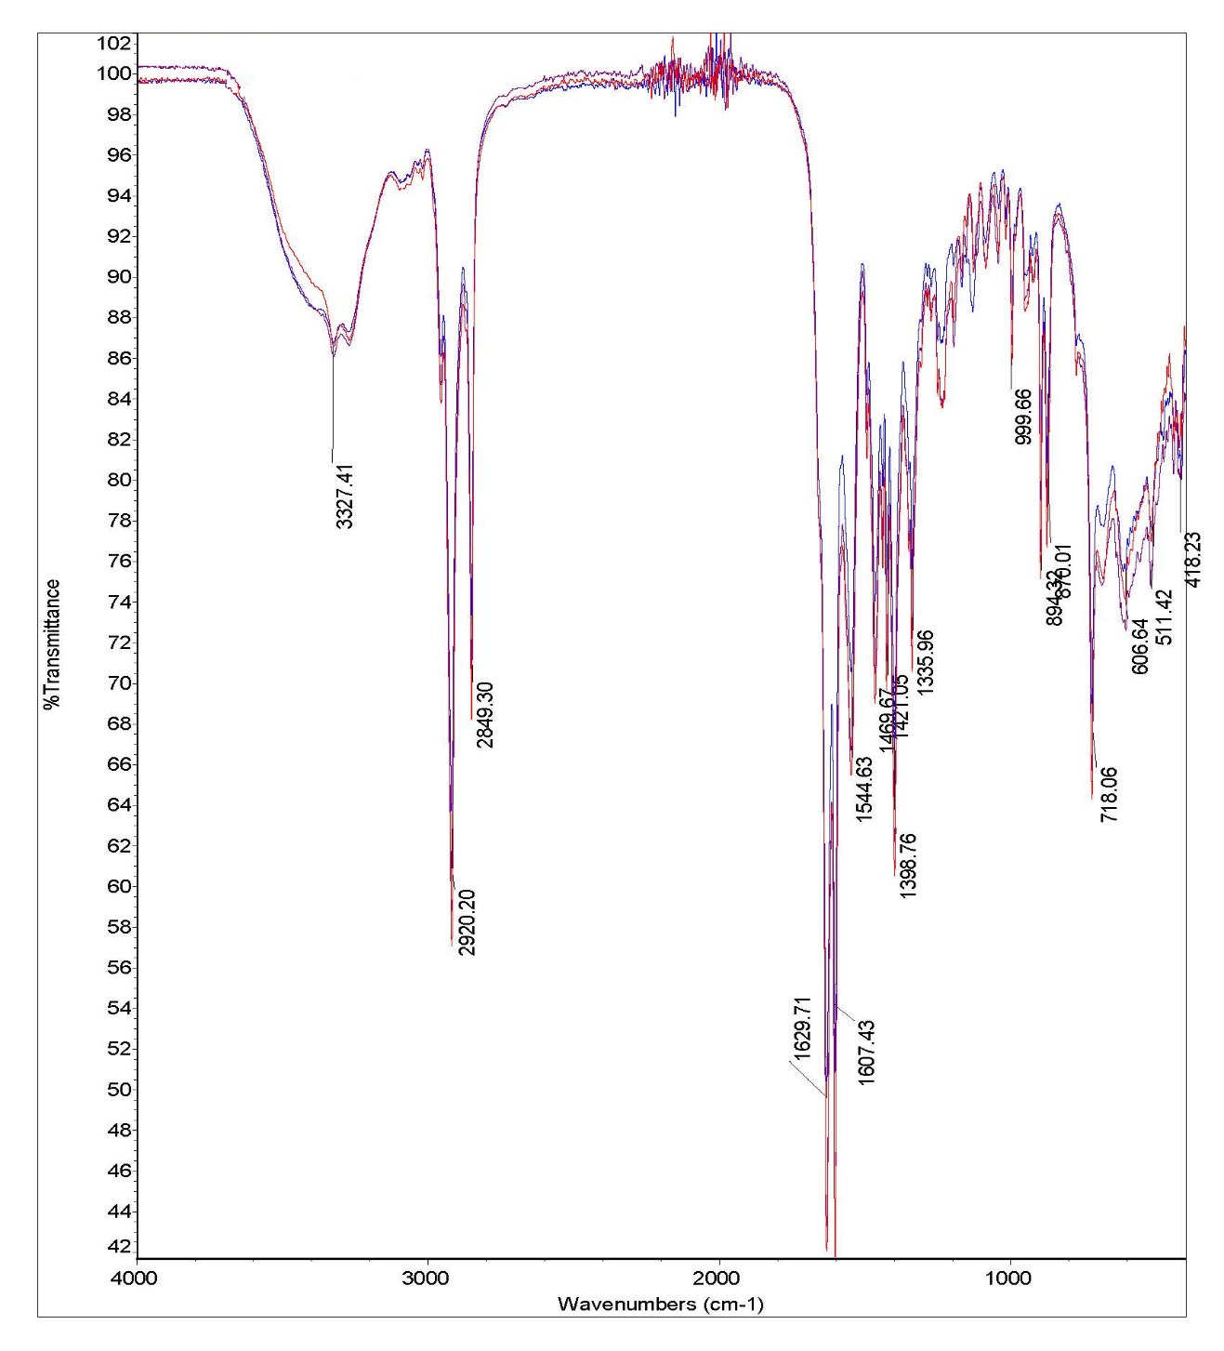
0 month
6 months
12 months
Figure S2: FTIR spectrum of CAPB-betaine (Batch #1) at time interval of 0, 6 months, and 12 months.

