Supplementary materials
Supplementary figure legends.
Figure S1. Pearson correlation analysis between the dietary macronutrients and taxa detected in the gut bacterial community that have a significant association with them. Genera that that did not have at least one * (denoting level of significance) were filtered out.
Figure S2. Relative abundance of D10 larval samples demonstrating the gut bacterial composition of LD and WT for diets used for performance analysis. Samples are labelled according to genetic line (i.e., LD or WT), the diet it was fed on (e.g., CF, PKM, etc.), followed by replicate number (R1, R2, or R3). Taxa with relative abundances below 1% were consolidated as "< 1%".

Supplementary tables.
Table S1. Primer and barcode sequences used for 16S rRNA Illumina sequencing.
Primer ID | Barcode | Linker | 5’ Primer | Full forward sequence
338Fbc0 | AGCCTTCGTCGC | CT | ACTCCTACGGGAGGCAGCAG | AGCCTTCGTCGCCTACTCCTACGGGAGGCAGCAG
338Fbc1 | TCCATACCGGAA | CT | ACTCCTACGGGAGGCAGCAG | TCCATACCGGAACTACTCCTACGGGAGGCAGCAG
338Fbc2 | AGCCCTGCTACA | CT | ACTCCTACGGGAGGCAGCAG | AGCCCTGCTACACTACTCCTACGGGAGGCAGCAG
338Fbc3 | CCTAACGGTCCA | CT | ACTCCTACGGGAGGCAGCAG | CCTAACGGTCCACTACTCCTACGGGAGGCAGCAG
338Fbc4 | CGCGCCTTAAAC | CT | ACTCCTACGGGAGGCAGCAG | CGCGCCTTAAACCTACTCCTACGGGAGGCAGCAG
338Fbc5 | TATGGTACCCAG | CT | ACTCCTACGGGAGGCAGCAG | TATGGTACCCAGCTACTCCTACGGGAGGCAGCAG
338Fbc6 | TACAATATCTGT | CT | ACTCCTACGGGAGGCAGCAG | TACAATATCTGTCTACTCCTACGGGAGGCAGCAG
338Fbc7 | AATTTAGGTAGG | CT | ACTCCTACGGGAGGCAGCAG | AATTTAGGTAGGCTACTCCTACGGGAGGCAGCAG
338Fbc8 | GACTCAACCAGT | CT | ACTCCTACGGGAGGCAGCAG | GACTCAACCAGTCTACTCCTACGGGAGGCAGCAG
338Fbc9 | GCCTCTACGTCG | CT | ACTCCTACGGGAGGCAGCAG | GCCTCTACGTCGCTACTCCTACGGGAGGCAGCAG
338Fbc10 | ACTACTGAGGAT | CT | ACTCCTACGGGAGGCAGCAG | ACTACTGAGGATCTACTCCTACGGGAGGCAGCAG
338Fbc11 | AATTCACCTCCT | CT | ACTCCTACGGGAGGCAGCAG | AATTCACCTCCTCTACTCCTACGGGAGGCAGCAG
338Fbc12 | CGTATAAATGCG | CT | ACTCCTACGGGAGGCAGCAG | CGTATAAATGCGCTACTCCTACGGGAGGCAGCAG
338Fbc13 | ATGCTGCAACAC | CT | ACTCCTACGGGAGGCAGCAG | ATGCTGCAACACCTACTCCTACGGGAGGCAGCAG
338Fbc14 | ACTCGCTCGCTG | CT | ACTCCTACGGGAGGCAGCAG | ACTCGCTCGCTGCTACTCCTACGGGAGGCAGCAG
338Fbc15 | TTCCTTAGTAGT | CT | ACTCCTACGGGAGGCAGCAG | TTCCTTAGTAGTCTACTCCTACGGGAGGCAGCAG
338Fbc16 | CGTCCGTATGAA | CT | ACTCCTACGGGAGGCAGCAG | CGTCCGTATGAACTACTCCTACGGGAGGCAGCAG
338Fbc17 | ACGTGAGGAACG | CT | ACTCCTACGGGAGGCAGCAG | ACGTGAGGAACGCTACTCCTACGGGAGGCAGCAG
338Fbc18 | GGTTGCCCTGTA | CT | ACTCCTACGGGAGGCAGCAG | GGTTGCCCTGTACTACTCCTACGGGAGGCAGCAG
338Fbc19 | CATATAGCCCGA | CT | ACTCCTACGGGAGGCAGCAG | CATATAGCCCGACTACTCCTACGGGAGGCAGCAG
338Fbc20 | GCCTATGAGATC | CT | ACTCCTACGGGAGGCAGCAG | GCCTATGAGATCCTACTCCTACGGGAGGCAGCAG
338Fbc21 | CAAGTGAAGGGA | CT | ACTCCTACGGGAGGCAGCAG | CAAGTGAAGGGACTACTCCTACGGGAGGCAGCAG
338Fbc22 | CACGTTTATTCC | CT | ACTCCTACGGGAGGCAGCAG | CACGTTTATTCCCTACTCCTACGGGAGGCAGCAG
338Fbc23 | TAATCGGTGCCA | CT | ACTCCTACGGGAGGCAGCAG | TAATCGGTGCCACTACTCCTACGGGAGGCAGCAG
338Fbc24 | TGACTAATGGCC | CT | ACTCCTACGGGAGGCAGCAG | TGACTAATGGCCCTACTCCTACGGGAGGCAGCAG
338Fbc25 | CGGGACACCCGA | CT | ACTCCTACGGGAGGCAGCAG | CGGGACACCCGACTACTCCTACGGGAGGCAGCAG
338Fbc26 | CTGTCTATACTA | CT | ACTCCTACGGGAGGCAGCAG | CTGTCTATACTACTACTCCTACGGGAGGCAGCAG
338Fbc27 | TATGCCAGAGAT | CT | ACTCCTACGGGAGGCAGCAG | TATGCCAGAGATCTACTCCTACGGGAGGCAGCAG
338Fbc28 | CGTTTGGAATGA | CT | ACTCCTACGGGAGGCAGCAG | CGTTTGGAATGACTACTCCTACGGGAGGCAGCAG
338Fbc29 | AAGAACTCATGA | CT | ACTCCTACGGGAGGCAGCAG | AAGAACTCATGACTACTCCTACGGGAGGCAGCAG
338Fbc30 | TGATATCGTCTT | CT | ACTCCTACGGGAGGCAGCAG | TGATATCGTCTTCTACTCCTACGGGAGGCAGCAG
338Fbc31 | CGGTGACCTACT | CT | ACTCCTACGGGAGGCAGCAG | CGGTGACCTACTCTACTCCTACGGGAGGCAGCAG
338Fbc32 | AATGCGCGTATA | CT | ACTCCTACGGGAGGCAGCAG | AATGCGCGTATACTACTCCTACGGGAGGCAGCAG
338Fbc33 | CTTGATTCTTGA | CT | ACTCCTACGGGAGGCAGCAG | CTTGATTCTTGACTACTCCTACGGGAGGCAGCAG
338Fbc34 | GAAATCTTGAAG | CT | ACTCCTACGGGAGGCAGCAG | GAAATCTTGAAGCTACTCCTACGGGAGGCAGCAG
338Fbc35 | GAGATACAGTTC | CT | ACTCCTACGGGAGGCAGCAG | GAGATACAGTTCCTACTCCTACGGGAGGCAGCAG
338Fbc36 | GTGGAGTCTCAT | CT | ACTCCTACGGGAGGCAGCAG | GTGGAGTCTCATCTACTCCTACGGGAGGCAGCAG
338Fbc37 | ACCTTACACCTT | CT | ACTCCTACGGGAGGCAGCAG | ACCTTACACCTTCTACTCCTACGGGAGGCAGCAG
338Fbc38 | TAATCTCGCCGG | CT | ACTCCTACGGGAGGCAGCAG | TAATCTCGCCGGCTACTCCTACGGGAGGCAGCAG
338Fbc39 | ATCTAGTGGCAA | CT | ACTCCTACGGGAGGCAGCAG | ATCTAGTGGCAACTACTCCTACGGGAGGCAGCAG

Table S2. Multivariate analysis to assess the influence of diet, genetic lineage, and larval age on the composition of gut microbiota.
Multivariate test:
 | Res.Df | Df.diff | Dev | Pr(>Dev)
(Intercept) | 124
Diet | 114 | 10 | 16259 | 0.001 | ***
Genetic line | 113 | 1 | 1340 | 0.001 | ***
Larval age | 111 | 2 | 3559 | 0.001 | ***
Diet: Genetic line | 101 | 10 | 1434 | 0.001 | ***
Diet: Larval age | 82 | 19 | 2264 | 0.011 | *
Genetic line: Larval age | 80 | 2 | 286 | 0.001 | ***
Diet: Genetic line: Larval age | 83 | 18 | 525 | 0.002 | **
---
Signif. codes: 0 ‘***’ 0.001 ‘**’ 0.01 ‘*’ 0.05 ‘.’ 0.1 ‘ ’ 1

Table S3. SIMPER (Similarity Percentage) analysis used to identify genus-level taxa that showed significantly different relative abundances between the two genetic lineages across the tested diets over experimental days (D5 an D10). The table displays the average relative abundances ± SD (%) of significant bacterial genera for each genetic line. The number of asterisks denotes the significance level of the corresponding p-value of bacterial genera that were differentially enriched between the genetic lines.

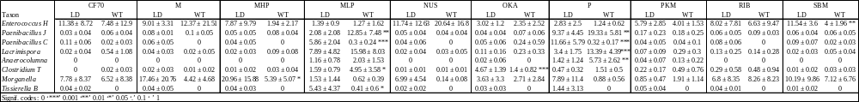

Table S4. ANOVA test to calculate the significant contribution of each diet macronutrients to the larval gut microbiota.
ANOVA test:
 | Df | SumOfSqs | F | Pr(>F)
Fat | 1 | 2.615 | 9.442 | 0.001 | ***
Protein | 1 | 0.912 | 3.295 | 0.001 | ***
Ash | 1 | 1.272 | 4.592 | 0.001 | ***
Carbohydrate | 1 | 1.480 | 5.345 | 0.001 | ***
Residuals | 120 | 33.230
---
Signif. codes: 0 ‘***’ 0.001 ‘**’ 0.01 ‘*’ 0.05 ‘.’ 0.1 ‘ ’ 1

Table S5. A heatmap was used to visualize the significant correlations between bacterial genera and their respective relative abundances. These correlations were determined through Spearman’s Rank correlation test analysed in relation to larval performance parameters (i.e., biomass conversion ratio (BCR), prepupal weight (PW), protein and fat conversion rate, prepupal protein content and prepupal fat content) across different diets. Bacterial community composition at D10 was used as this closely corresponded to the larvae’s harvesting age used for performance analyses (Zhang et al. 2023).
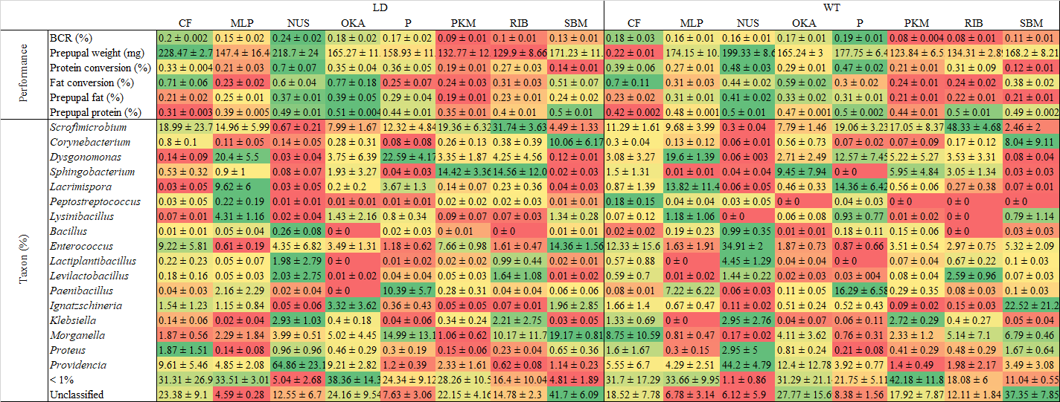
Figure S1.
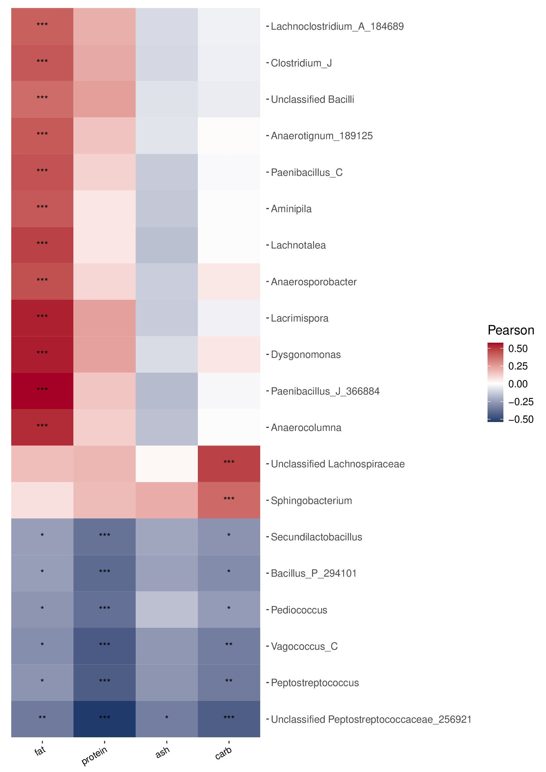

Figure S2.
