Supplementary Information:

iDOM: Statistical analysis of dissolved organic matter based on high-resolution mass spectrometry

Fanfan Meng^{a, b,1}, Ang Hu^{a,1}, Kyoung-Soon Jang^{c}, Jianjun Wang ^{a,}*

ª Key Laboratory of Lake and Watershed Science for Water Security, Nanjing Institute of Geography and Limnology, Chinese Academy of Sciences, Nanjing 210008, China
^{b} University of Chinese Academy of Sciences, Beijing 100049, China
^{c} Bio-Chemical Analysis Team, Korea Basic Science Institute, Cheongju 28119, South Korea

¹ These authors contributed equally to this work.
* Corresponding author.
E-mail address: jjwang@niglas.ac.cn (J. J. Wang).

Table S1. Descriptions of molecular traits
Group | Variable | Description
Molecular weight | Mass | The mass to charge ratio (m/z)
Molecular weight | C | The number of carbon
Molecular weight | kdefect_{CH2} | Kendrick Defect
Stoichiometry | O/C | O/C ratio
Stoichiometry | H/C | H/C ratio
Stoichiometry | N/C | N/C ratio
Stoichiometry | P/C | P/C ratio
Stoichiometry | N/P | N/P ratio
Stoichiometry | S/C | S/C ratio
Chemical structure | AI_{mod} | The modified aromaticity index
Chemical structure | DBE | Double bond equivalence
Chemical structure | DBE_{O} | Double bond equivalence minus oxygen
Chemical structure | DBE_{AI} | Double bond equivalence minus aromaticity index
Oxidation state | GFE | Gibbs free energy
Oxidation state | NOSC | Nominal oxidation state of carbon
Carbon use efficiency | Y_{met} | Carbon use efficiency

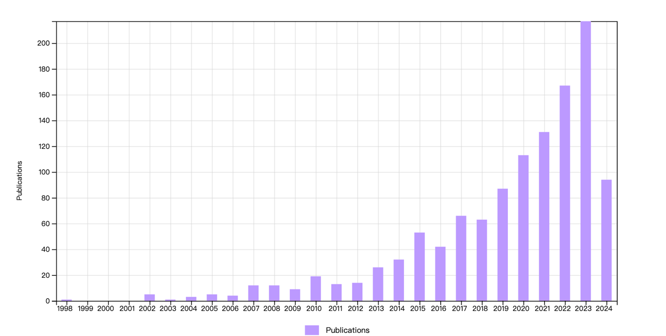
Figure S1. The compilation of publications searched on the Web of Science. We used the keywords: ("Fourier Transform Ion Cyclotron Resonance Mass Spectrometry" OR "FT-ICR MS") OR "FTICR-MS" AND ("Dissolved Organic Matter" OR "DOM" OR "Dissolved Organic Carbon" OR "DOC").

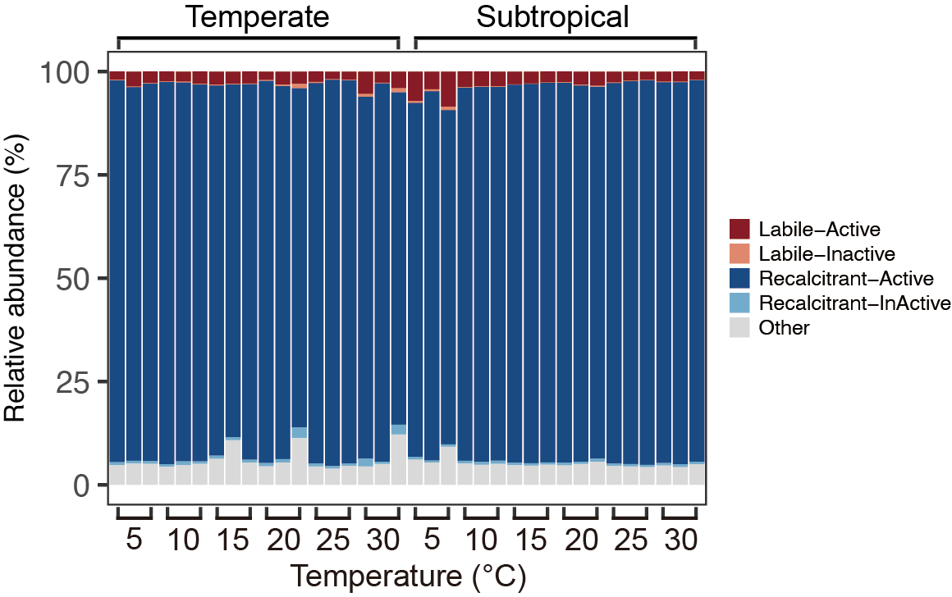
Figure S2. The relative abundance of different molecular groups. These groups were identified based on molecular H/C ratio and putative biochemical transformations: labile-active, recalcitrant-active, recalcitrant-inactive, and labile-inactive.

