Supplementary Information
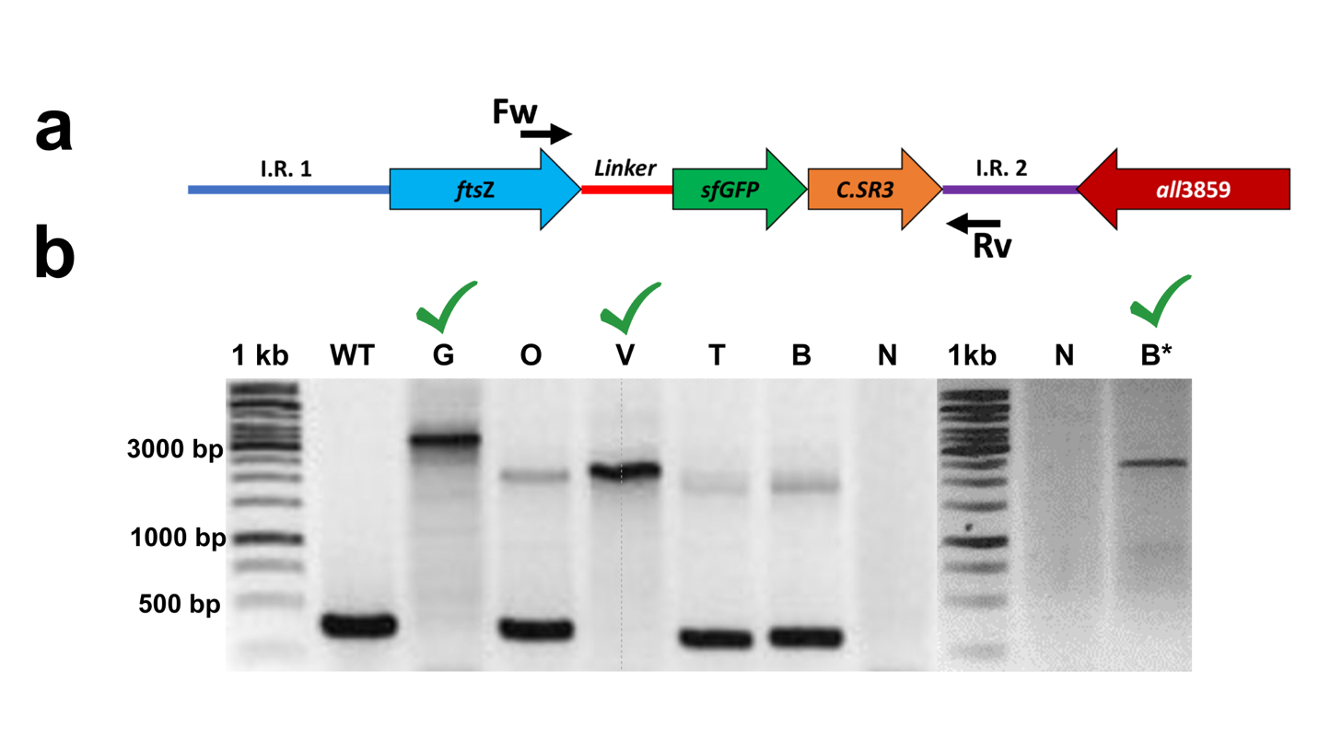
Supplementary Figure 1. Segregation level of the mutant strains. (a) Example of one sequence designed to replace the genomic ftsZ gene, in this case, the FtsZ-sfGFP coding region, with the segregation primers. C.SR3 = Sp/Sm resistance cassette; I.R.= Intergenic region; Fw = Forward primer; Rv = Reverse primer. (b) Determination of the segregation level by PCR of the strains with FtsZ fused to different fluorescent proteins. The wild-type band corresponds below 500 bp, and the mutant band is approximately 3200 bp for FstZ-sfGFP and approximately 2500 bp for the rest of the fusions. WT = wild-type; N = Negative; G = FtsZ-sfGFP; O = FtsZ-mOrange; V = FtsZ-mVenus; T = FtsZ-mTurquoise; B = FtsZ-mTagBFP2. *After the segregation of the mutant.
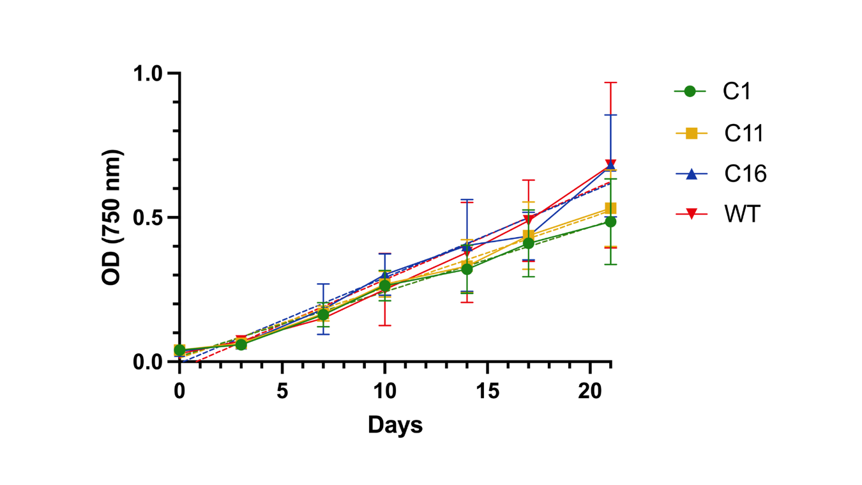
Supplementary Figure 2. Growth curve of the WT strain and the FtsZ mutants in Anabaena sp. The cultures of the wild-type (WT, red), FstZ-sfGFP (C1, green), FstZ-mVenus (C11, yellow), and FtsZ-mTagBFP2 (C16, blue) were grown in BG11 medium with the corresponding antibiotics under a 12:12 LD cycle at 25°C for 21 days. The OD of the three replicates of each condition was determined at 750 nm and the logarithm growth phase was plotted (solid lines). A simple linear regression was performed with no significant differences between the curves (dashed lines).
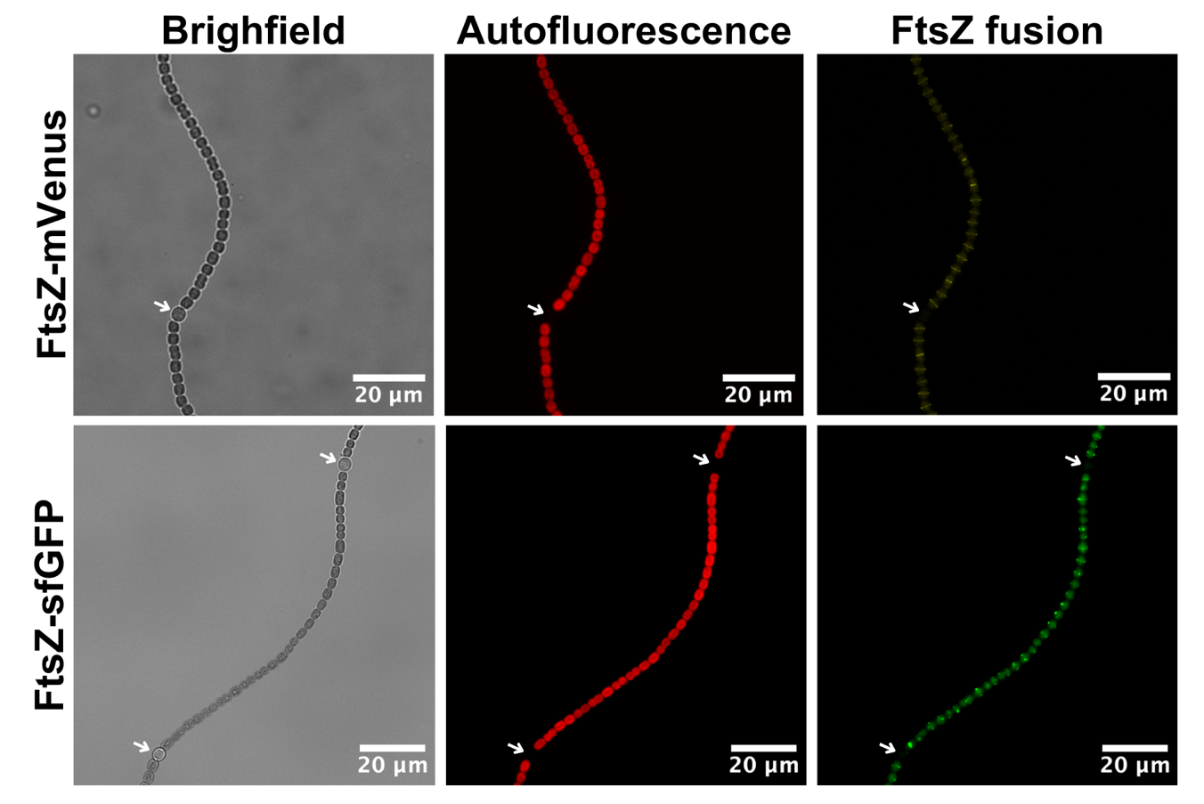
Supplementary Figure 3. Subcellular localization of FtsZ in nitrogen deficiency conditions. The FtsZ-mVenus and the FtsZ-sfGFP mutant were grown in BG11₀ medium with antibiotics under a 12:12 LD cycle at 25°C for 14 days. Then, a visualization of the cultures was performed employing confocal microscopy. The brightfield, autofluorescence, and the FtsZ fusion (mVenus in yellow and sfGFP in green) are shown. The presence of the heterocyst is highlighted with a white arrow.

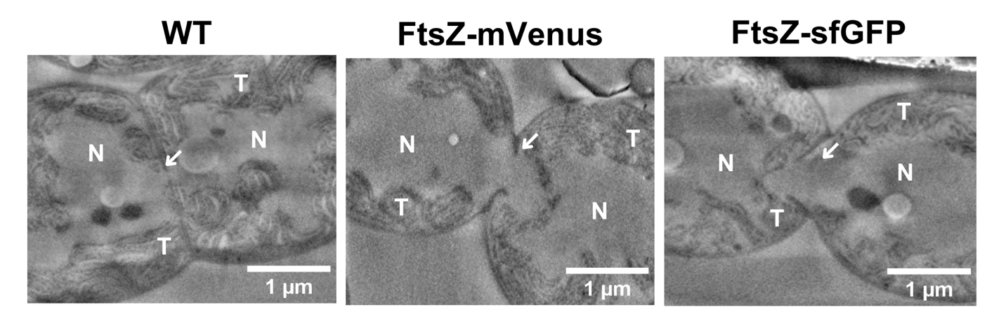
Supplementary Figure 4. Cryo-FIB-SEM imaging. Cell division events in the wild-type (WT), FtsZ-sfGFP, and FtsZ-mVenus strains. The white arrows indicate the positioning of the genetic material in the septum region. N = Nucleoid; T = Thylakoids.

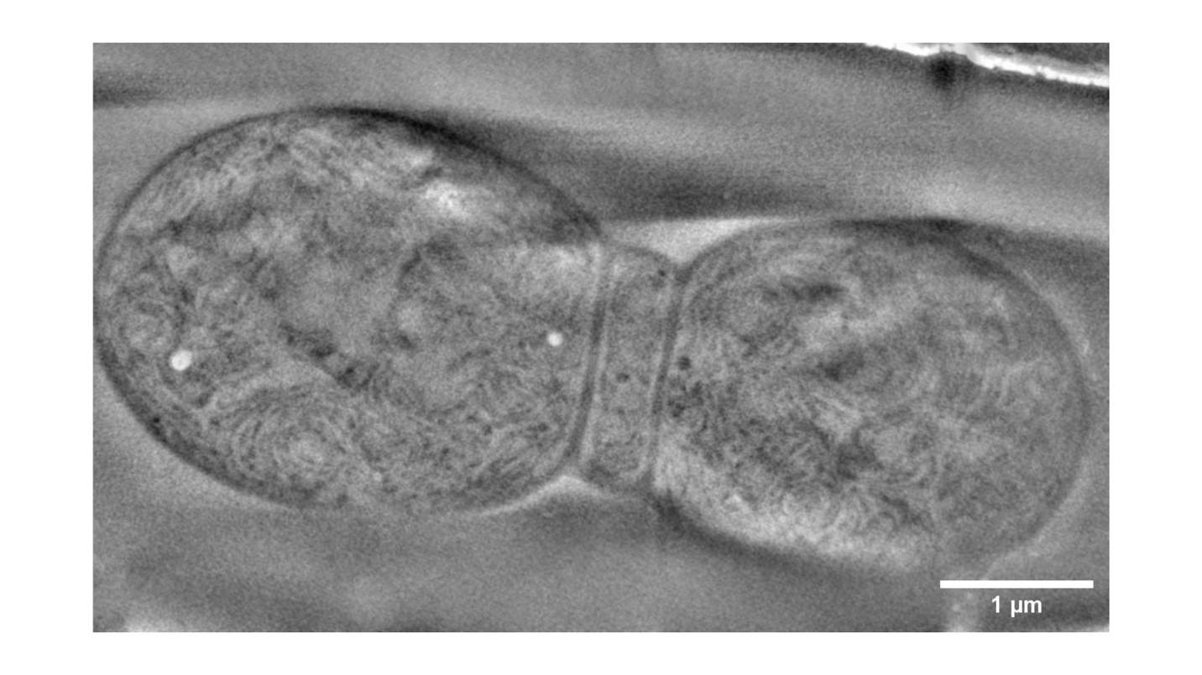
Supplementary Figure 5. Double septum present in the FtsZ-sfGFP mutant of Anabaena sp. Cryo-FIB-SEM imaging of a cell division event with a double septum in the FtsZ-sfGFP mutant of Anabaena sp.

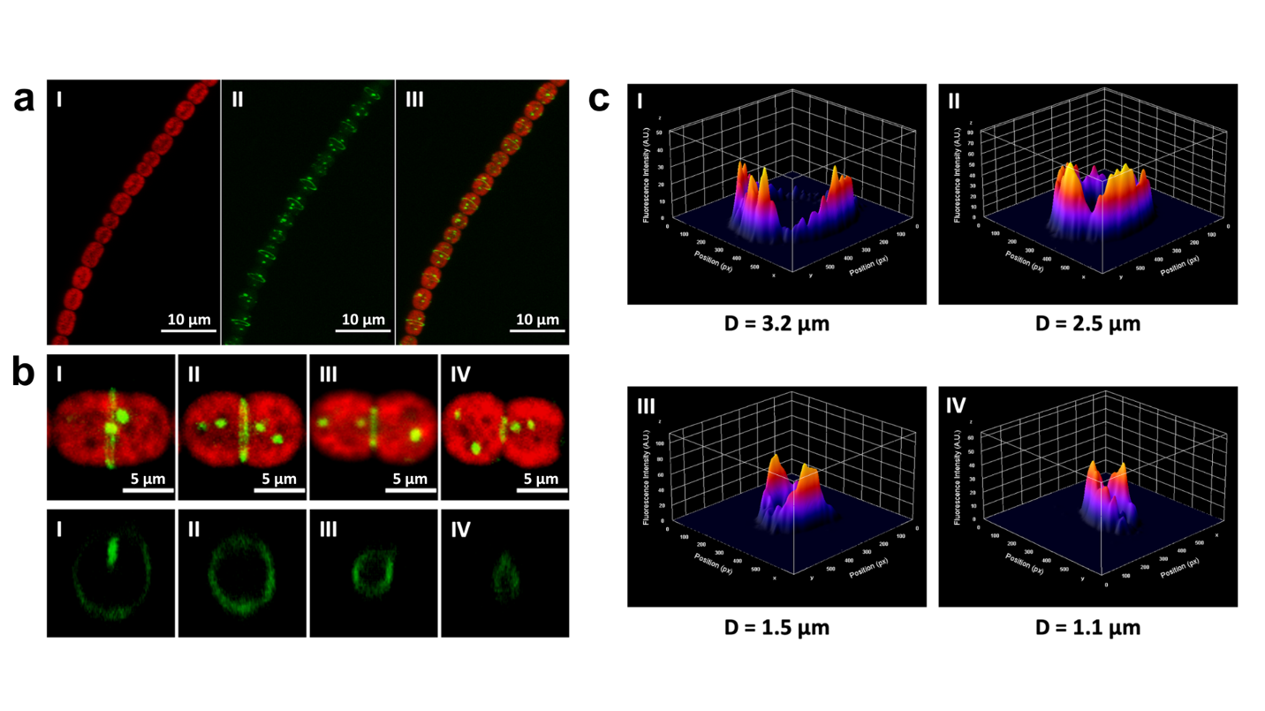
Supplementary Figure 6. 3D reconstruction of the Z-ring in the FtsZ-sfGFP mutant of Anabaena sp. The FtsZ-sfGFP mutant filaments were observed using conventional confocal microscopy. (a) Representative 3D reconstruction of a mutant filament with its autofluorescence signal (I), FtsZ-sfGFP signal (II) and the merge (III). (b) Merge of autofluorescence and FtsZ-sfGFP signal in cells of mutant filaments at four different division stages represented by diameters of 3.17 μm (I), 2.48 μm (II), 1.54 μm (III) and 1.12 μm (IV). (c) 3D reconstruction of the rings shown in B. (d) Distribution of fluorescence intensity of FtsZ-sfGFP signal within the Z-rings shown in B and C and its respective diameters.
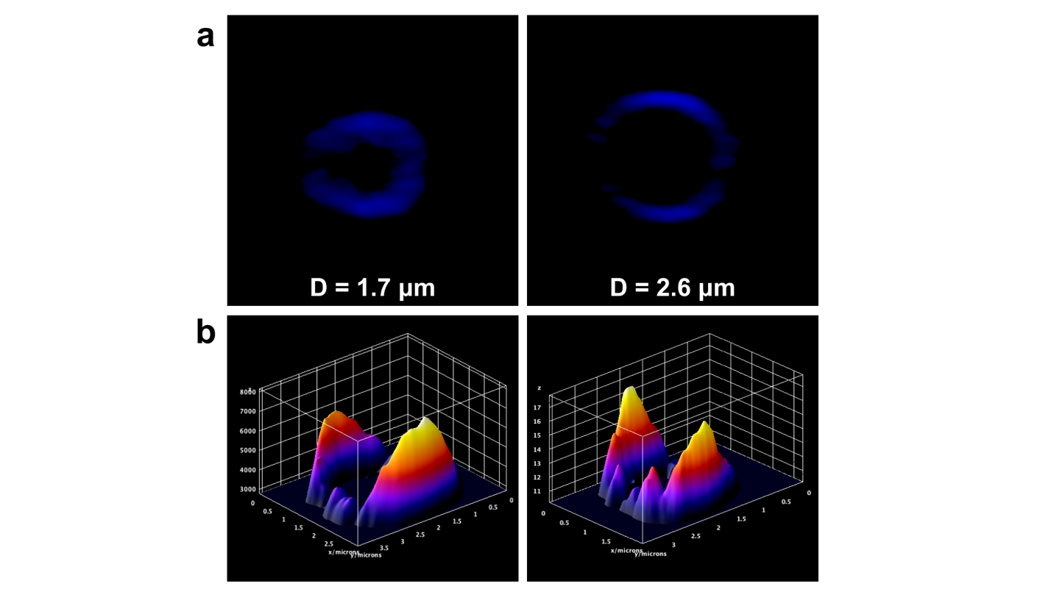
Supplementary Figure 7. 3D reconstruction of the Z-ring in the FtsZ-mTagBFP2 mutant of Anabaena sp. The FtsZ-mTagBFP2 mutant was observed using conventional confocal microscopy. (a) 3D reconstruction of representative rings with a diameter of 1.7 μm and 2.6 μm. (b) Fluorescence intensity plots of the Z-rings that are shown in A.

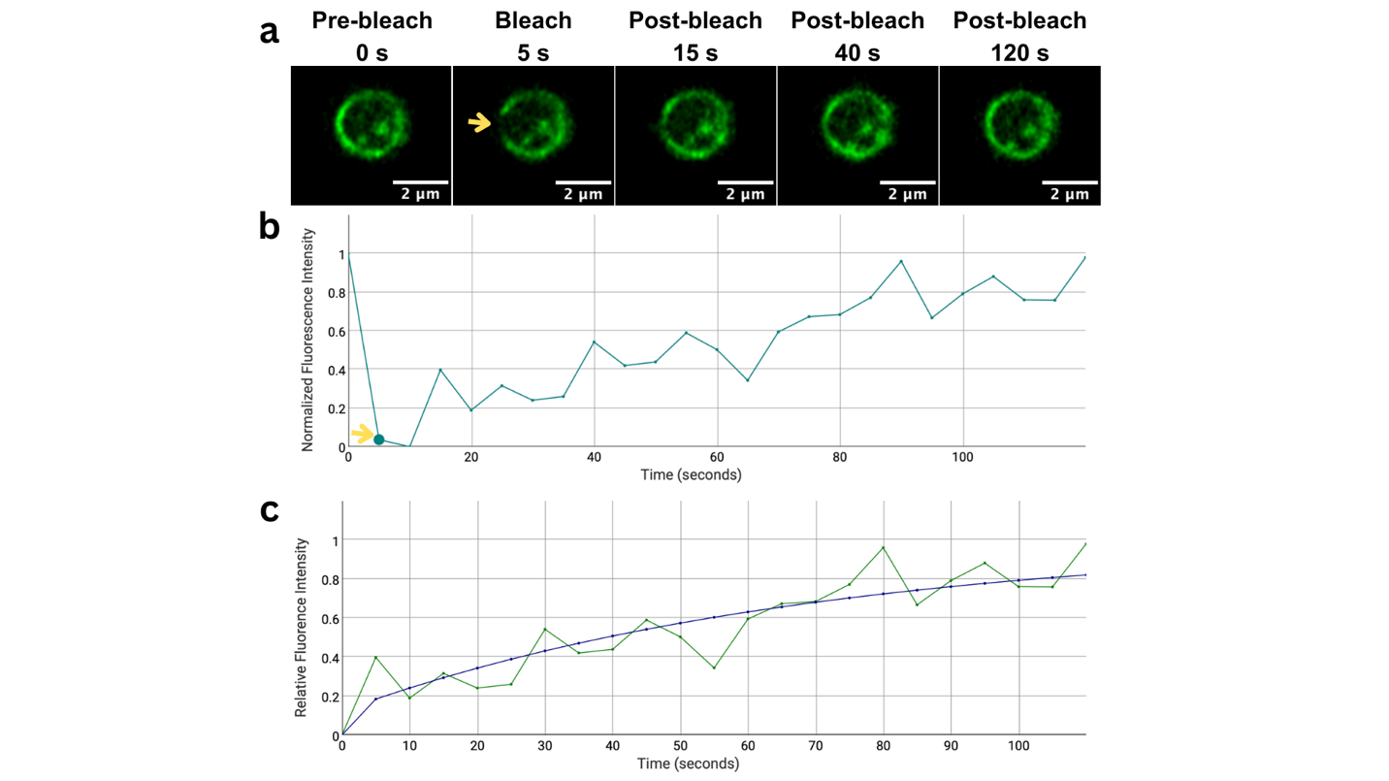
Supplementary Figure 8. Fluorescence recovery after photobleaching in the FtsZ-sfGFP mutant of Anabaena sp. The bleaching of a region of the Z-ring was performed in the FtsZ-sfGFP mutant, and the recovery of the fluorescence was recorded every 5 seconds. (a) Images of a FRAP experiment before, during, and after applying the bleaching. (b) Normalized fluorescence intensity versus time. The bleaching is indicated with a yellow arrow. (c) Relative fluorescence intensity versus time (blue line) and the curve fitting using a double-term exponential equation.

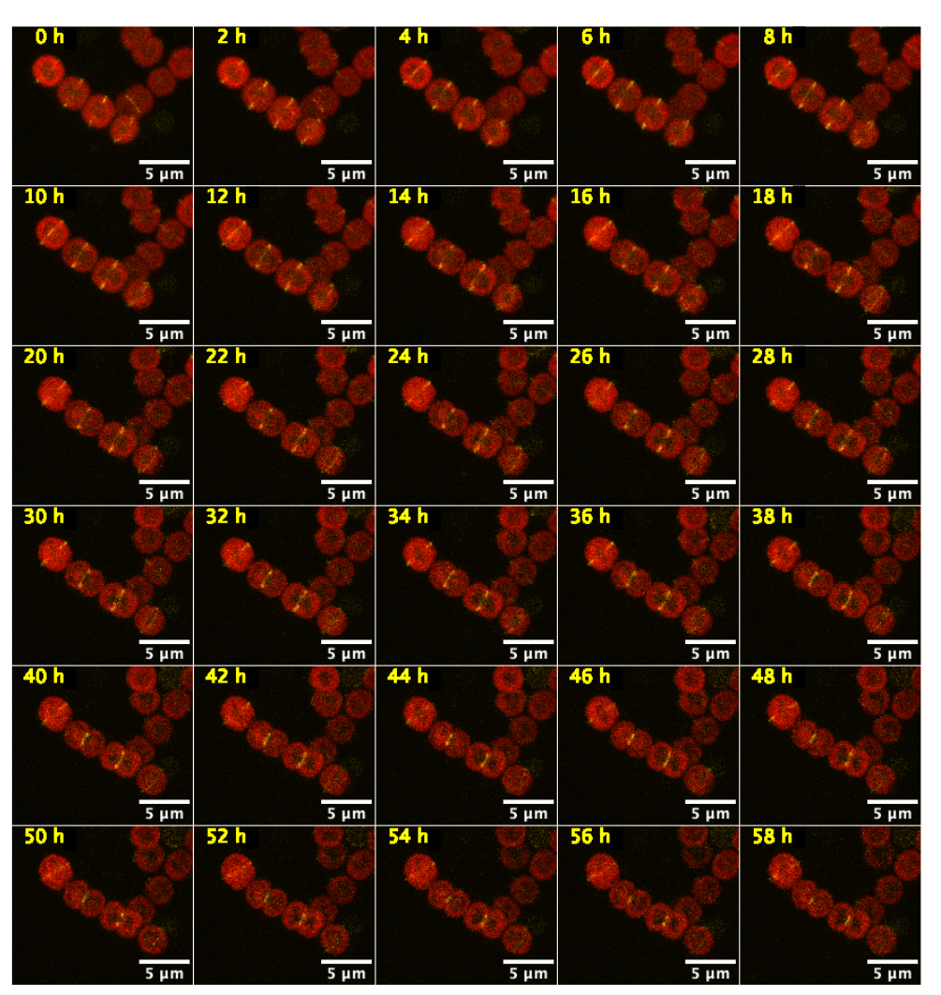
Supplementary Figure 9. Time-lapse recording of cell division in Anabaena sp. The subcellular localization of the FtsZ-mVenus mutant was observed in Anabaena sp. PCC7120 at 25°C within a period of 58 hours. Time (hours) is indicated in the upper left corner of each image.

