Supplementary Material
NADH-mediated in-situ formation of gold nanoparticles for the enzymatic determination of atropine
M. Domínguez, S. de Marcos, J. Galbán
Analytical Chemistry Department, University of Zaragoza, Zaragoza 50009, Spain.
Instituto de Nanociencia y Materiales de Aragón (INMA), CSIC-Universidad de Zaragoza, Zaragoza 50009, Spain

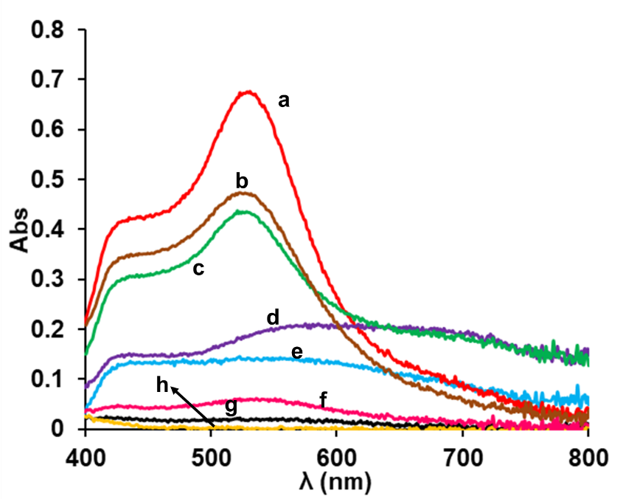
Figure S1A: Optimization of the pH. a) pH 5 with acetate. b) pH 7 with phosphate. c) pH 5 acetate and phosphate. d) pH 11 phosphate. e) pH 3 phosphate. f) pH 9 carbonate and phosphate. g) pH 9 carbonate. h) pH 9 TRIS. In all cases [Au(III)]=1.0*10⁻⁴M, [NAD(P)H]=2.0*10⁻⁴M

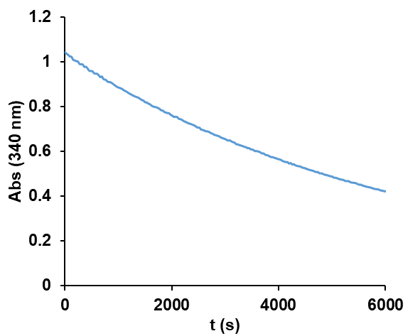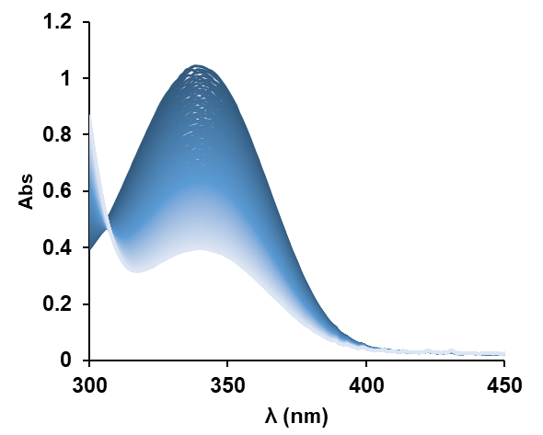
B
A
Figure S1B: Instability of NAD(P)H in acetate buffer. A) Kinetic profile at 340 nm, B) Kinetic Spectra.

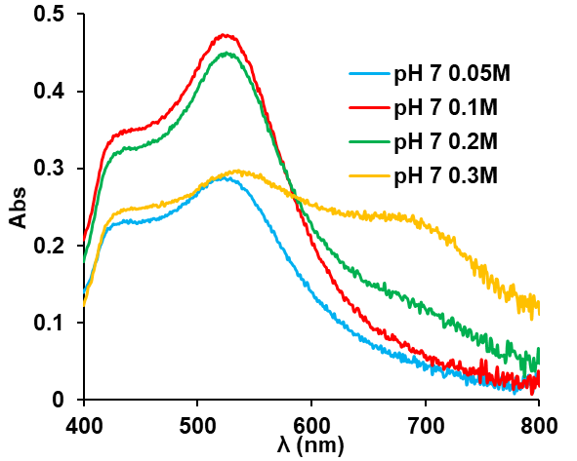
Figure S1C: Optimization of the ionic strength. pH 7 phosphate buffer. [Au(III)] = 1.0*10⁻⁴M, [NAD(P)H] = 2.0*10⁻⁴M.
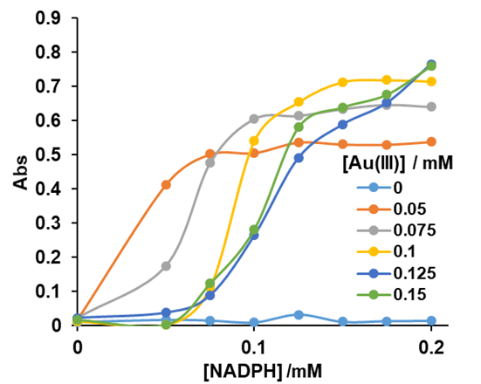
Figure S2: Calibration lines obtained with different Au(III) concentrations. In all cases NADPH concentrations were: 0, 0.05, 0.075, 0.1, 0.125, 0.15, 0.175 and 0.2 mM. pH=0.7 0.1M phosphate buffer.

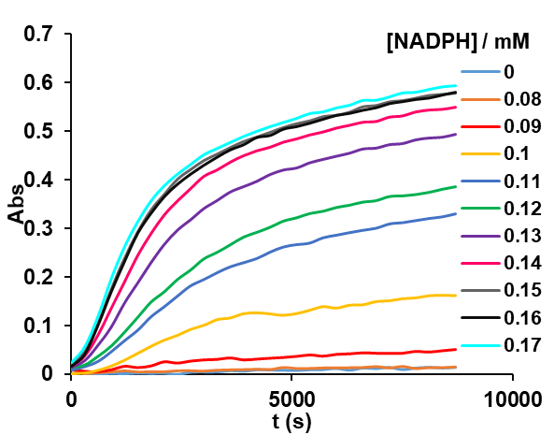
Figure S3A: Absorbance versus time profiles obtained for different NAD(P)H concentrations in the optimum conditions found for AuNP in-situ generation. [Au(III)] = 1*10⁻⁴ M.
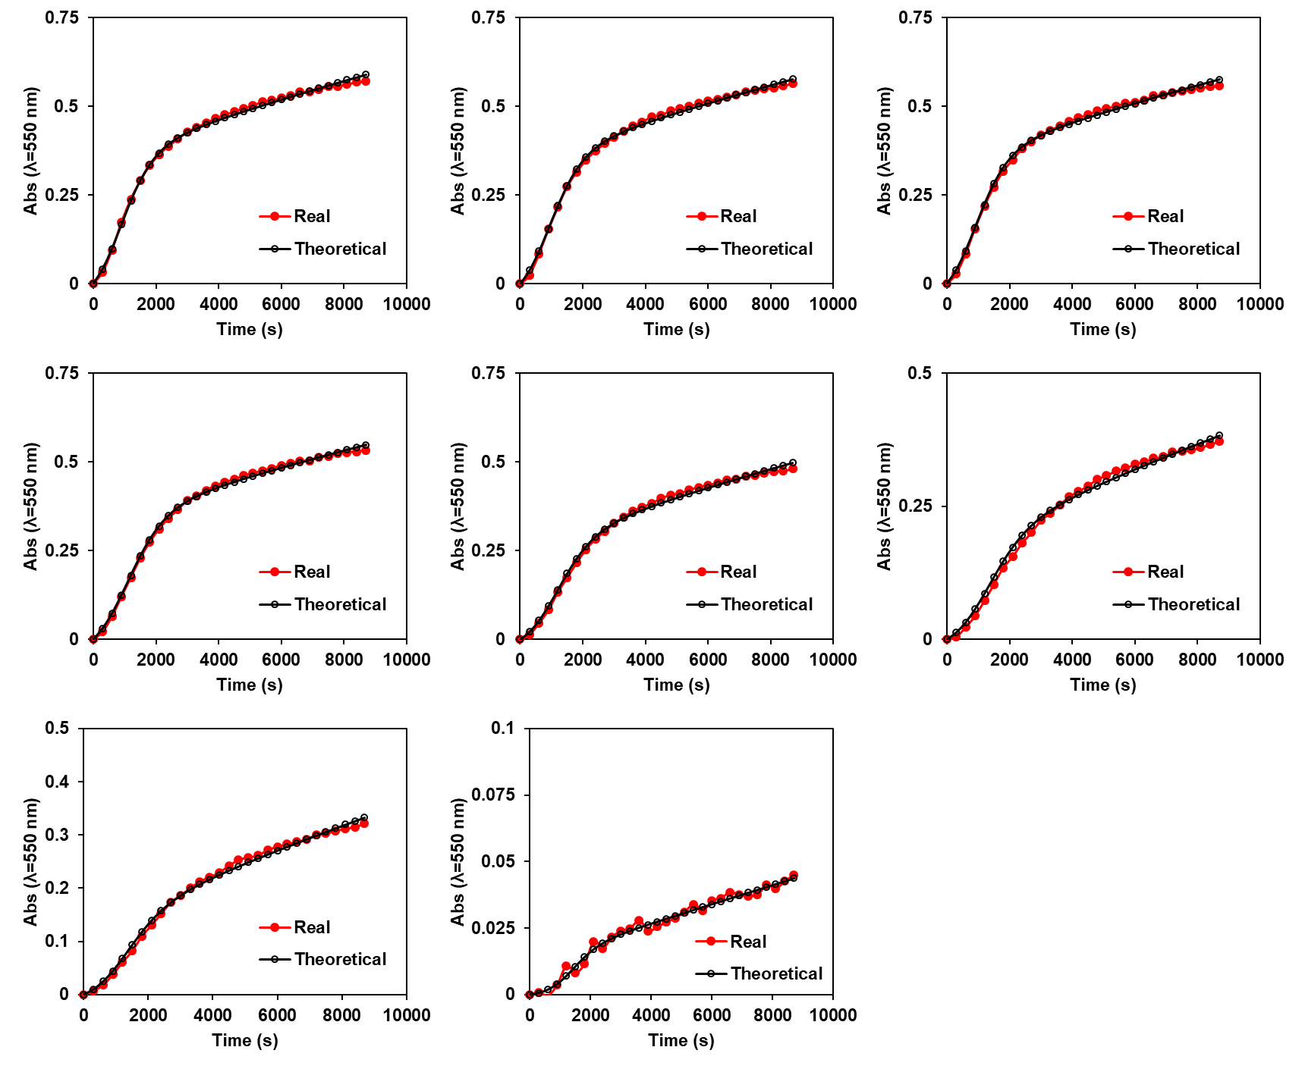
Figure S3B: Comparison between the experimental and theoretical profiles (according to equation (14)) for the calibration points and representation of the obtained constants.

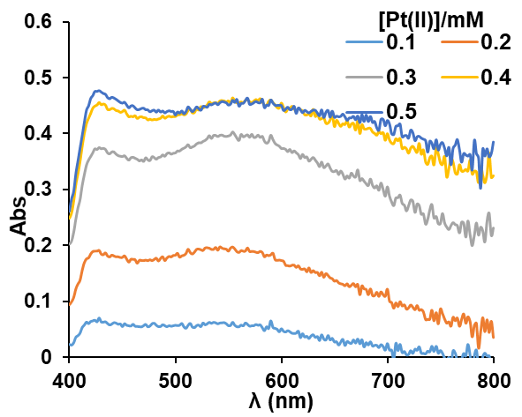
Figure S4: Final spectra obtained for the reaction using 1·10⁻⁵ M of NADPH, 1·10⁻⁴ M of Au(III) and different concentrations of Pt(II).
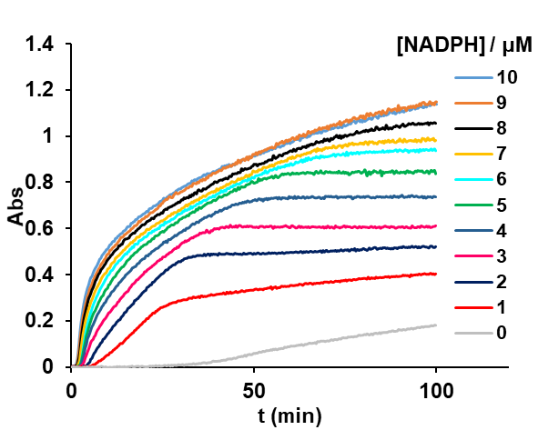
Figure S5A: Absorbance versus time profiles obtained for different NAD(P)H concentrations in the optimum conditions found for AuPtNP in-situ generation. [Au(III)] = 1*10⁻⁴ M. [Pt(II)] =4*10⁻⁴ M.
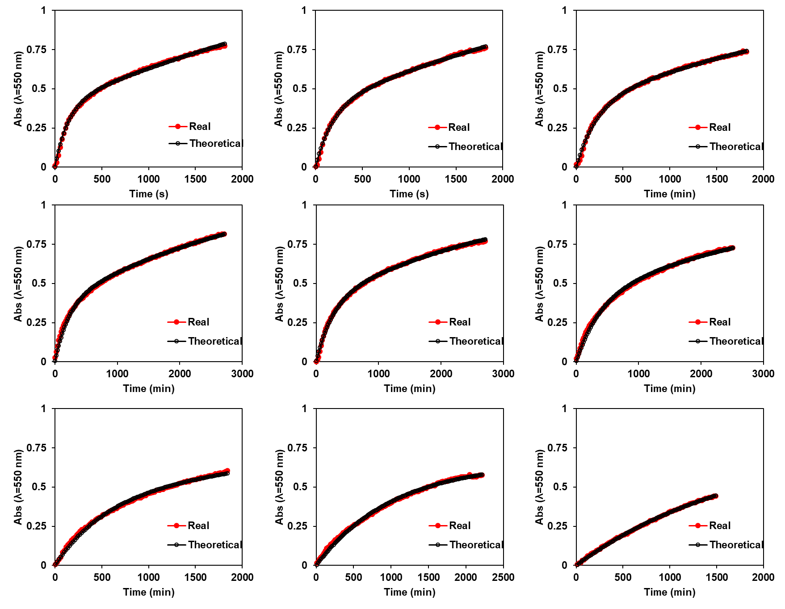
Figure S5B: Comparison between the experimental and theoretical profiles (according to equation (14)) for the calibration points and representation of the obtained constants.
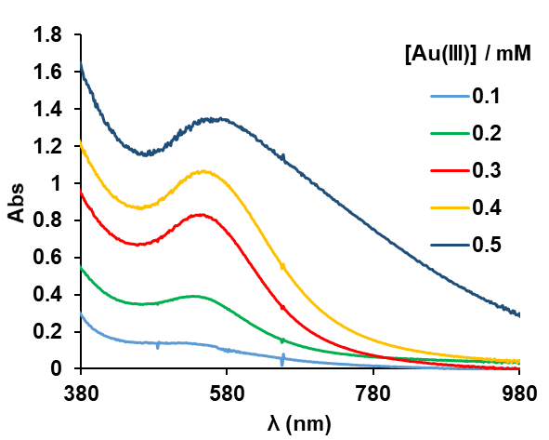

Figure S6A: Spectra obtained for each Au(III) concentration ([Pt(II)] = 4*[Au(III)] in each case).

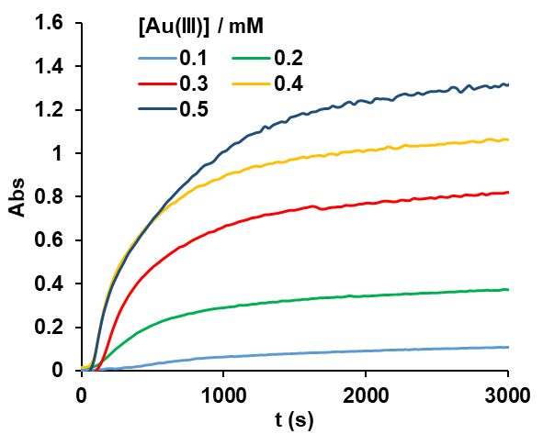
Figure S6B: Kinetics obtained at 550 nm for each Au(III) concentration ([Pt(II)] = 4*[Au(III)] in each case).
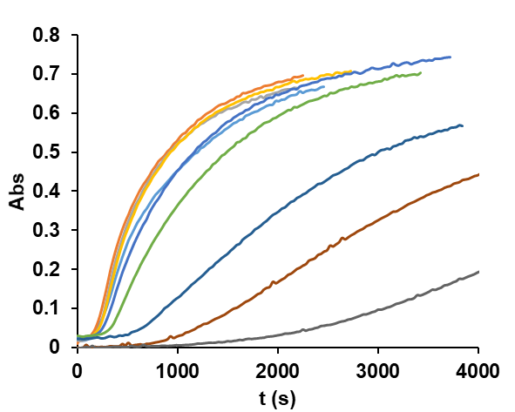
Figure S7: Kinetics obtained at 550 nm for each tropine concentration used from 2·10⁻⁵ M to 1·10⁻⁴ M.

