Role of size, surface charge, and PEGylated lipids of lipid nanoparticles (LNPs) on intramuscular delivery of mRNA

Weiwen Kongª, Yuning Weiª, Zirong Dongª, Wenjuan Liuª, Jiaxin Zhaoª, Yan Huang^{b,c}, Jinlong Yangª, Wei Wuª, Haisheng Heª*, Jianping Qiª*

ª Key Laboratory of Smart Drug Delivery of MOE, School of Pharmacy, Fudan University, Shanghai 201203, China
^{b} Department of Oncology, Shanghai Medical College of Fudan University, 270 Dong-an Road, Shanghai, 200032, China
^{c} Department of Gynecologic Oncology, Fudan University Shanghai Cancer Center, 270 Dong-an Road, Shanghai, 200032, China

*Corresponding author: Haisheng He, he_haisheng@fudan.edu.cn; Jianping Qi, qijianping@fudan.edu.cn

Supplementary Table

Tab. S1. Flow ratio and total flow rate of LNP-S, LNP-M and LNP-L
 | Flow ratio (lipid:mRNA) | Total flow rate (mL/min)
LNP-S | 1:3 | 12
LNP-M | 2:3 | 8
LNP-L | 2:3 | 4

Tab. S2. Ratio of SM102 and DOTAP or DSPG, particle size, PDI, zeta potential and encapsulation efficiency (EE) of LNPs with different charge.
 | Ratio (SM102: DOTAP or DSPG) | Particle size (nm) | PDI | Zeta potential (mV) | EE (%)
LNP | 50:0 | 91.66±1.08 | 0.13±0.02 | -3.47±3.03 | 90.5±0.1
15% DSPG | 42.5:7.5 | 81.59±0.43 | 0.24±0.02 | -25.3±3.02 | 94.8±0.2
25% DSPG | 25:25 | 86.98±1.76 | 0.27±0.02 | -25.9±1.39 | 95.1±0.1
15% DOTAP | 42.5:7.5 | 109.83±0.64 | 0.25±0.04 | 12.83±0.67 | 91.4±0.1
25% DOTAP | 37.5:12.5 | 126.57±1.63 | 0.02±0.01 | 19.03±0.23 | 97.4±0.1
50% DOTAP | 25:25 | 125.33±3.33 | 0.14±0.01 | 23.37±0.61 | 97.9±0.1

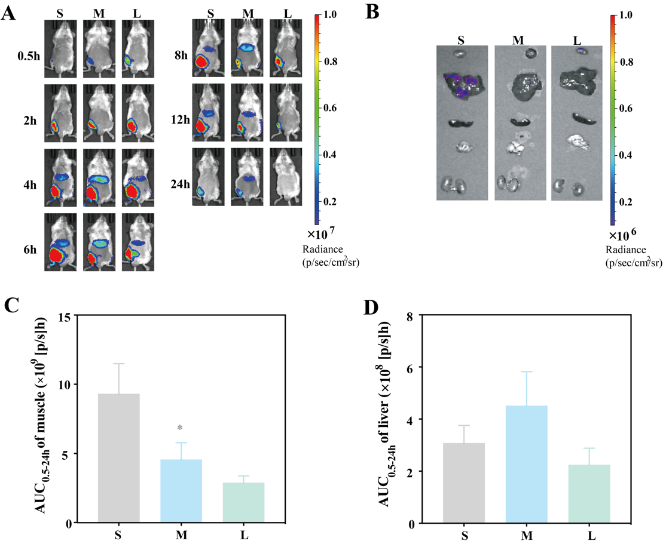

Fig. S1. Luminescence images of LNP-S, LNP-M and LNP-L. (A) In vivo luminescence images at 0.5 h-24 h. (B) Ex vivo luciferase distribution of LNPs with various sizes at 4 h after intramuscular injection. Luminescence images were harvested by IVIS. AUC_{0.5-24 h} of muscle (C) and AUC_{0.5-24 h} of liver (D) indicate total luciferase expression during 0.5 h-24 h (n=3), *: p<0.05, compared with LNP-S.

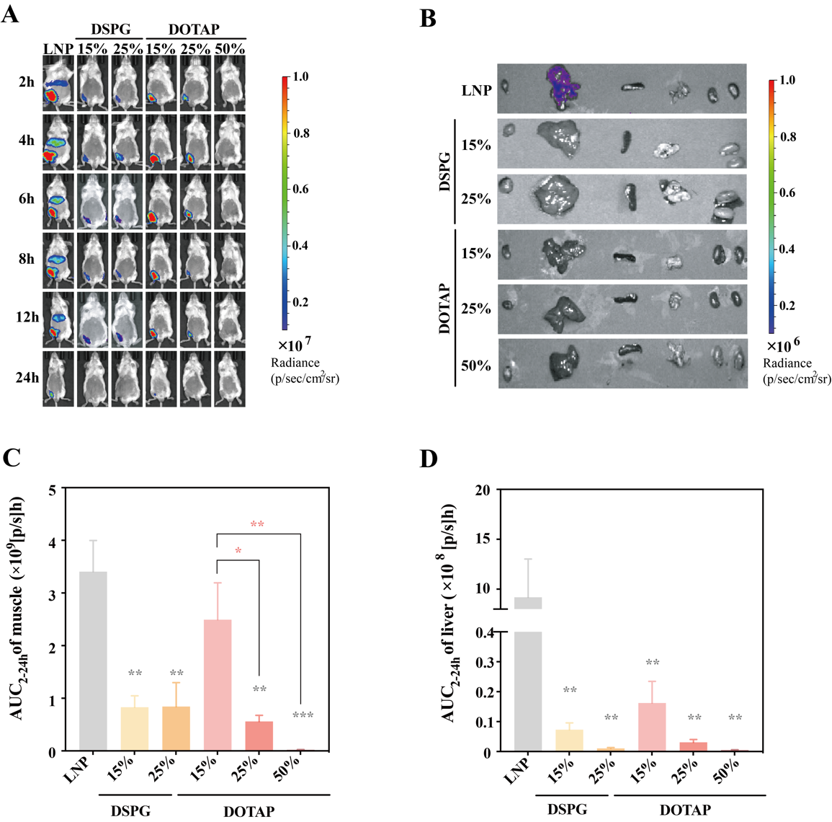

Fig. S2. Luminescence images of LNPs with various charges. (A) In vivo luminescence images of LNPs with different charges at 2 h-24 h. (B) Ex vivo luciferase distribution of LNPs with various charge at 4 h after intramuscular injection. Luminescence images were harvested by IVIS. AUC_{2-24 h} of muscle (C) and AUC_{2-24 h} of liver (D) indicate total luciferase expression during 2 h-24 h (n=3), *: p<0.05, **: p<0.01, ***: p<0.001, compared with LNP.

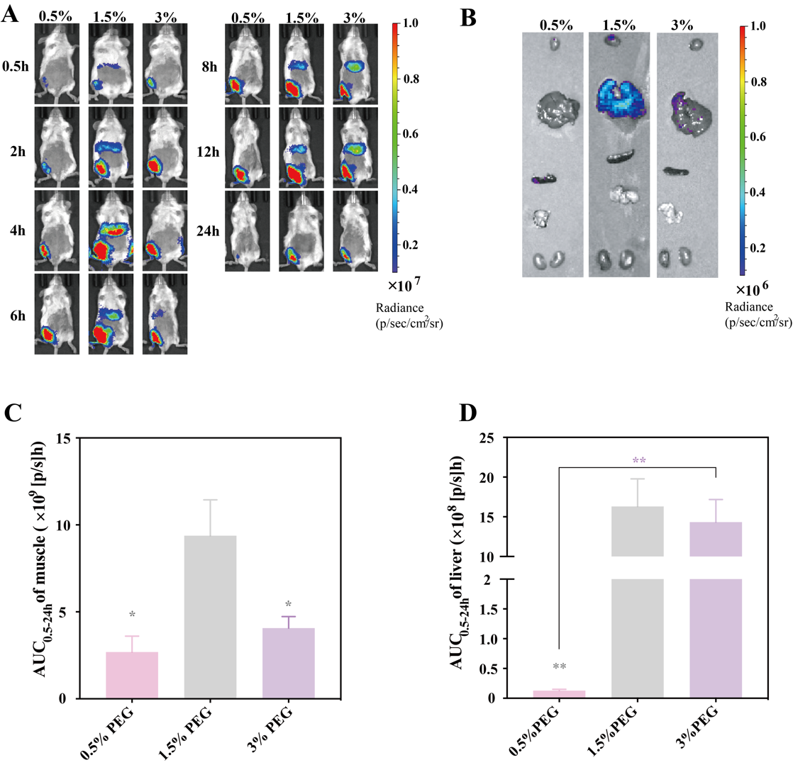

Fig. S3. Luminescence images of LNPs with varying contents of PEGylated lipids. (A) In vivo luminescence images of LNPs with different DMG-PEG2k contents at 0.5h-24h. (B) Luciferase distribution of LNPs with 0.5 mol%, 1.5 mol% and 3 mol% DMG-PEG2k at 4h after intramuscular injection. Luminescence images were harvested by ivis. AUC_{0.5-24 h} of muscle (C) and AUC_{0.5-24 h} of liver (D) indicate total luciferase expression during 0.5 h-24 h (n=3), *: p<0.05, **: p<0.01, compared with 0.5% DMG-PEG2k.

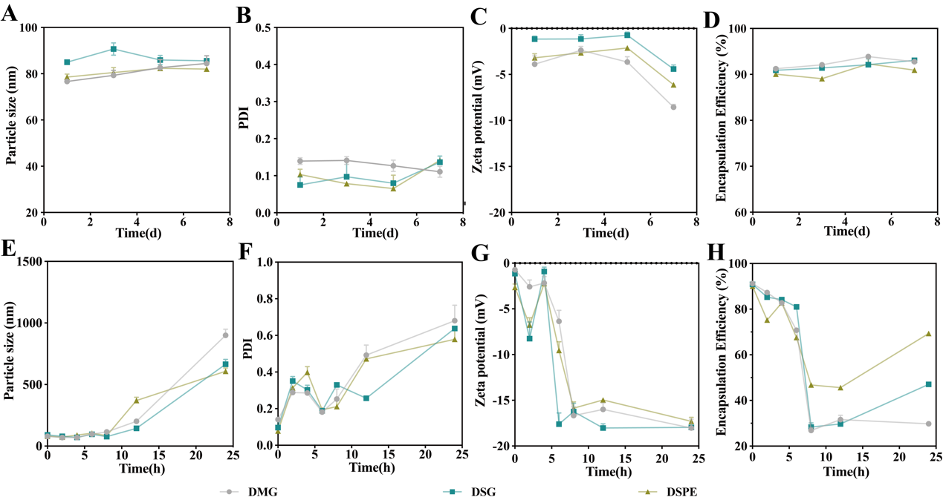
Fig. S4. Stability of LNPs with different types of PEGylated lipids. Stability on particle size (A), PDI (B), zeta potential (C) and encapsulation efficiency (D) in PBS at 4 °C. Stability on particle size (E), PDI (F), zeta potential (G) and encapsulation efficiency (H) in PBS with 10% FBS at 37 °C.

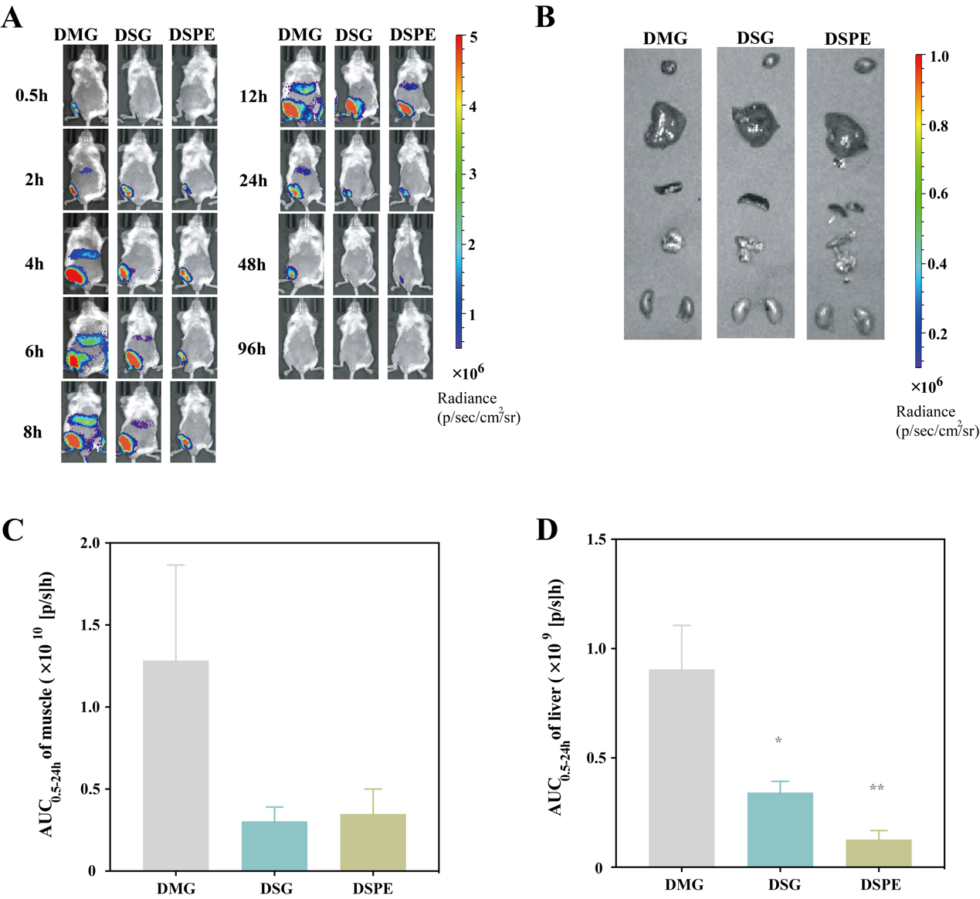
Fig. S5. Luminescence images of LNPs with different types of PEGylated lipids. (A) In vivo luminescence images of LNPs with different types of PEGylated lipid at 0.5 h-24 h. (B) Luciferase distribution of LNPs with DMG-PEG2k, DSG-PEG2k of DSPE-PEG2k at 24 h after intramuscular injection. Luminescence images were harvested by IVIS. AUC_{0.5-24 h} of muscle (C) and AUC_{0.5-24 h} of liver (D) indicate total luciferase expression during 0.5 h-24 h (n=3), *: p<0.05, **: p<0.01, compared with LNPs with DMG-PEG2k.

