SUPPLEMENTARY MATERIALS
Fig. S1. The abundance of sesquiterpene lactone in Inula helianthus aquatica alleviates LPS-induced ARDS in mice.
Fig. S2. Gene expression omnibus analysis of NLRP3.
Fig. S3. Bigelovin inhibits NLRP3 inflammasome activation in BMDMs, THP-1, and PBMCs.
Fig. S4. Bigelovin inhibits NLRP3 inflammasome activation in vivo.
Fig. S5. Bigelovin alleviates LPS-induced ARDS in mice.
Fig. S6. Biosafety evaluation of bigelovin.
Fig. S7. Function of bigelovin in LPS-induced priming.
Fig. S8. Structure activity relationship of bigelovin derivatives.
Fig. S9. Bigelovin binds to RACK1 protein.
Fig. S10. Bigelovin inhibits NLRP3 inflammasome mainly by binding to RACK1.
Fig.S11. Spectroscopic data of chemical.
Fig.S12. Schematic diagram showing the potential mechanism of action of Bigelovin.
Table S1. Patient Characteristics with Direct ARDS.

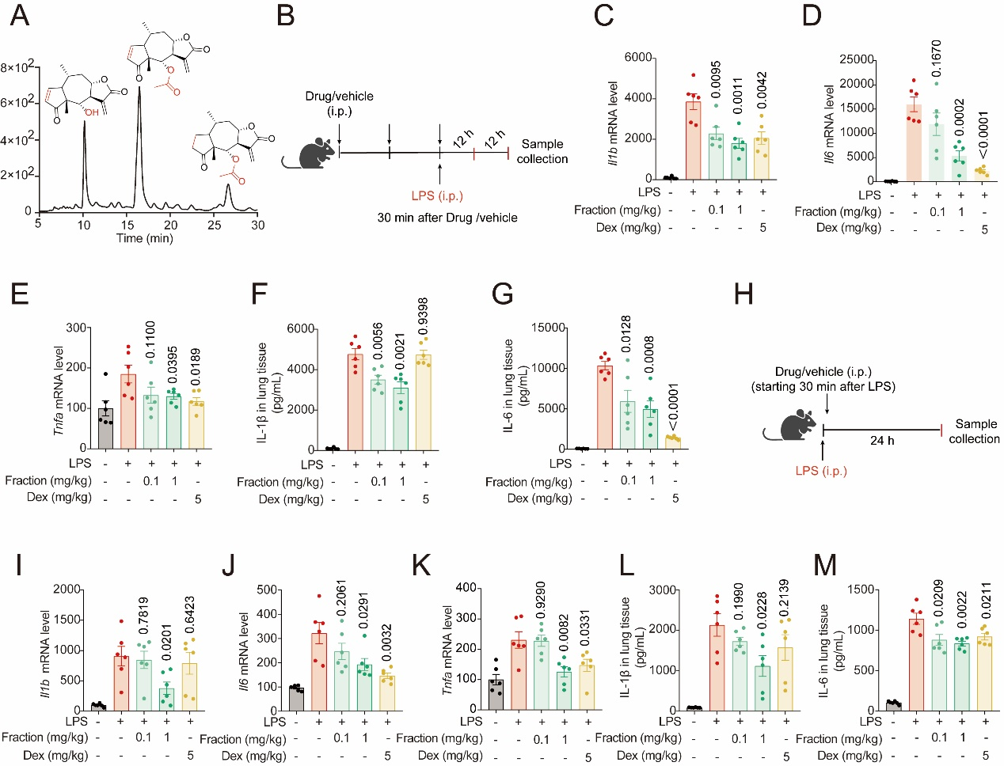
Fig.S1. The abundance of sesquiterpene lactone in Inula helianthus aquatica alleviates LPS-induced ARDS in mice. (A) The abundance of sesquiterpene lactone in Inula helianthus aquatica. (B) The scheme of prophylactic administration bigelovin or dexamethasone in ARDS induced by LPS. (C-E) qRT-PCR analysis of Il1b (C), Il6 (D) and Tnfa (E) mRNA expression in lung tissues from above mice. (F-G) ELISA analysis of IL-1β (F) and IL-6 (G) levels of lung tissues from above mice. (H) The scheme of therapeutic administration of bigelovin or dexamethasone in ARDS induced by LPS. (I-K) qRT-PCR analysis of Il1b (I), Il6 (J) and Tnfa (K) mRNA expression in lung tissues from above mice. (L-M) ELISA analysis of IL-1β (L) and IL-6 (M) levels of lung tissues from above mice. Data were presented as mean ± SEM and were representative of six independent experiments. Statistical significance was assessed by two-tailed unpaired t test.
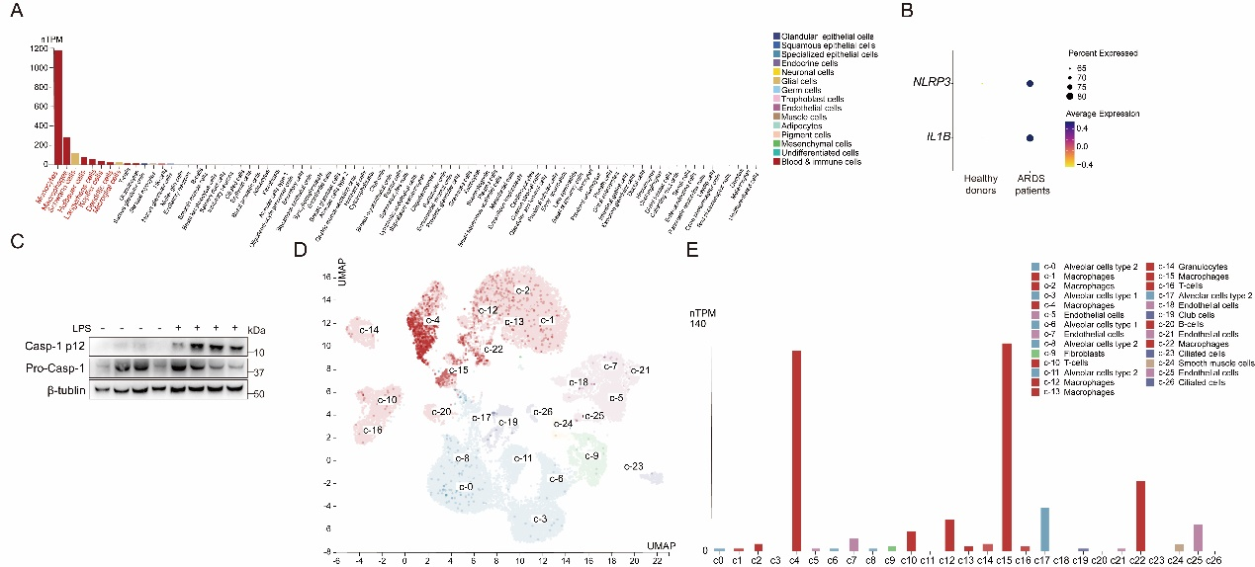
Fig.S2. Gene expression omnibus analysis of NLRP3. (A) Single cell type expression cluster of Nlrp3. (B) Bubble plots showing the expression of NLRP3 and IL-1B in single-cell data (GSE175450). The darker the color and the larger the circle are, the higher the expression. (C) Western blotting analysis of caspase-1 (p12) of mice induced by ARDS. (D-E) The UMAP plot (D) and color scale (E) of cell type of Nlrp3 in lung tissues.
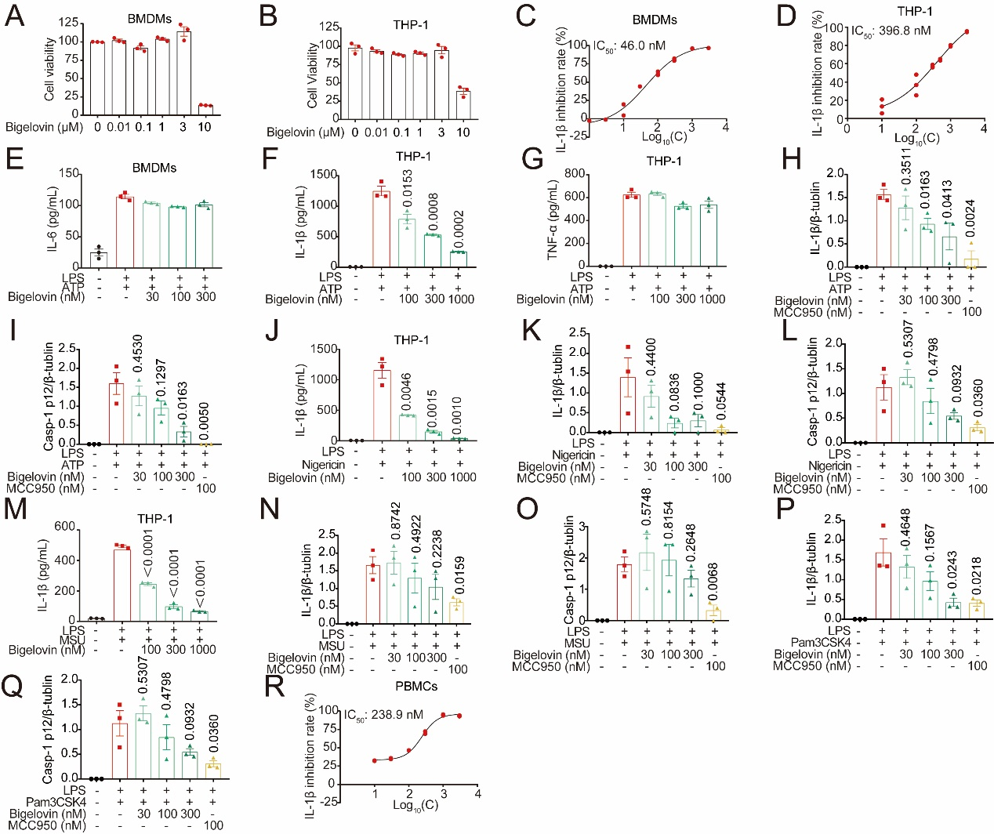
Fig.S3. Bigelovin inhibits NLRP3 inflammasome activation in BMDMs, THP-1, and PBMCs. (A-B) The cell viability of BMDMs (A) or THP-1 (B) cells treatment with bigelovin at different concentrations for 24 h. (C-D) ELISA analysis of IL-1β in culture supernatants of LPS-primed BMDMs (C) or THP-1 (D) treated with bigelovin before stimulation with ATP. (E) ELISA analysis of IL-6 in culture supernatants of LPS-primed BMDMs treated with bigelovin before stimulation with ATP. (F-G) ELISA analysis of IL-1β (F) or TNF-α (G) in culture supernatants of LPS-primed THP-1 treated with bigelovin before stimulation with ATP. (H-I) Quantitative analysis of cleaved IL-1β (H) or caspase-1 (p12) (I) described in Fig. 2D. (J) ELISA analysis of IL-1β in culture supernatants of LPS-primed THP-1 treatment with bigelovin before stimulation with nigericin. (K-L) Quantitative analysis of cleaved IL-1β (K) and caspase-1 (p12) (L) described in Fig. 2G. (M) ELISA analysis of IL-1β in culture supernatants of LPS-primed THP-1 treated with bigelovin before stimulation with MSU. (N-O) Quantitative analysis of cleaved IL-1β (N) or caspase-1 (p12) (O) described in Fig. 2I. (P-Q) Quantitative analysis of IL-1β (P) or caspase-1 (p12) (Q) described in Fig. 2K. (R) ELISA analysis of IL-1β in culture supernatants of PBMCs treated with bigelovin and then stimulated with LPS for 16 h. Data were presented as mean ± SEM and were representative of three independent experiments. Statistical significance was assessed by two-tailed unpaired t test.
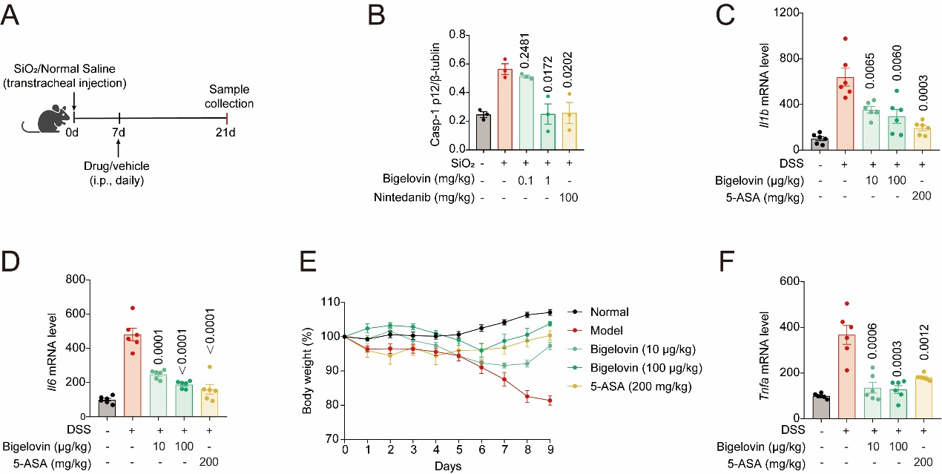
Fig.S4 Bigelovin inhibits NLRP3 inflammasome activation in vivo. (A) Quantitative analysis of the immublot of Casp-1 p12 described in Fig. 3H. (B) Body weight loss. (C-E) Gene expression of inflammatory factors (Il1b, Il6, Tnfa) in colon levels were assessed by Q-PCR. Data were presented as mean ± SEM and were representative of three independent experiments. Statistical significance was assessed by two-tailed unpaired t test.

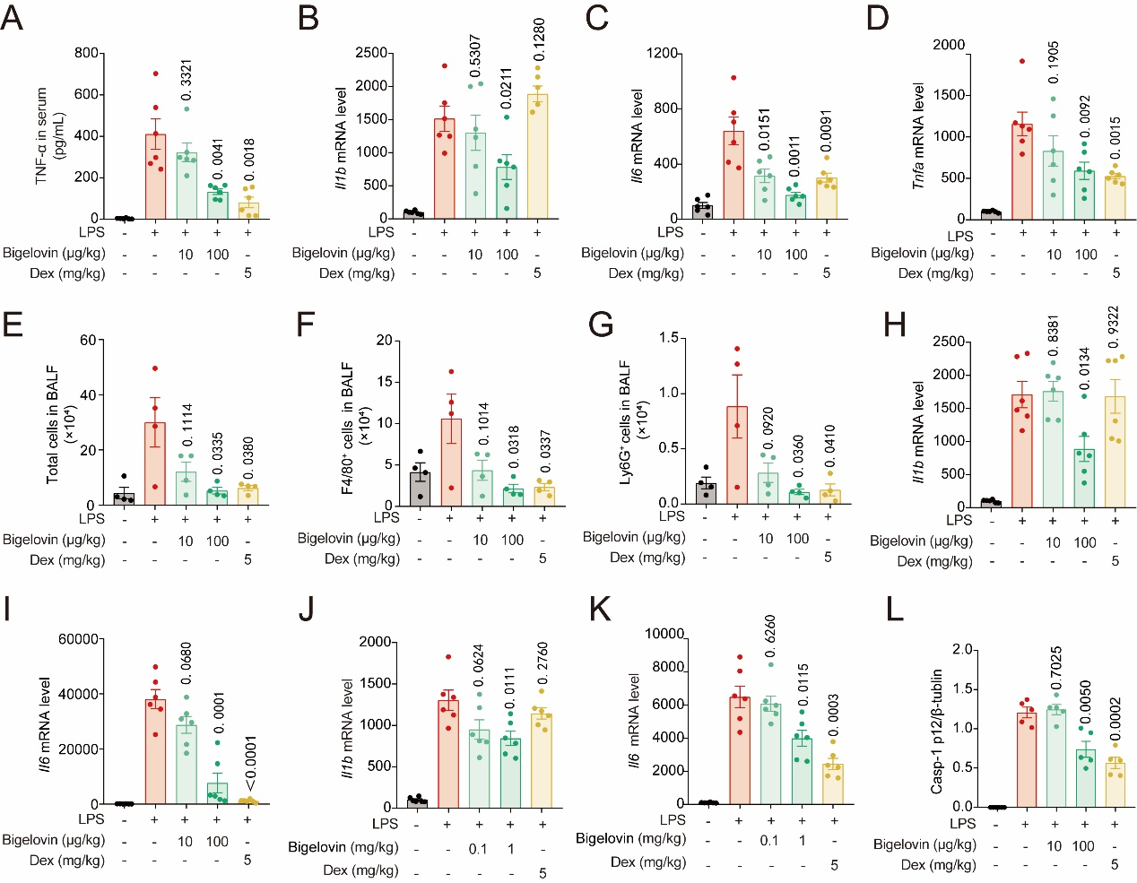
Fig.S5. Bigelovin alleviates LPS-induced ARDS in mice. (A-D) Mice were prophylactic intraperitoneal injection of bigelovin and then challenged with 7.5 mg/kg LPS for 12 h (n = 6). (A) ELISA analysis of TNF-α levels of serum from above mice w. (B-D) qRT-PCR analysis of Il1b (B), Il6 (C) and Tnfa (D) mRNA expression in lung tissues from above mice. (E-G) Mice were prophylactic intraperitoneal injection of bigelovin and then challenged with 7.5 mg/kg LPS for 12 h (n = 4). (E) Total cells, (F) macrophages, (G) neutrophils, were quantified in BALF fluid. (H-I) Mice were treated with 7.5 mg/kg LPS and then injected intraperitoneally bigelovin for 24 h (n = 6). qRT-PCR analysis of Il1b (H) and Il6 (I) mRNA expression in lung tissues from above mice. (J-K) Mice were prophylactic intragastric administration of bigelovin and then challenged with 7.5 mg/kg LPS for 12 h (n = 6). qRT-PCR analysis of Il1b (J) and Il6 (K) mRNA expression in lung tissues from above mice. (L) Quantitative analysis of the immunoblot of caspase-1 (p12) described in Fig. 4D (n = 5). Data were presented as mean ± SEM and statistical significance was assessed by two-tailed unpaired t test.
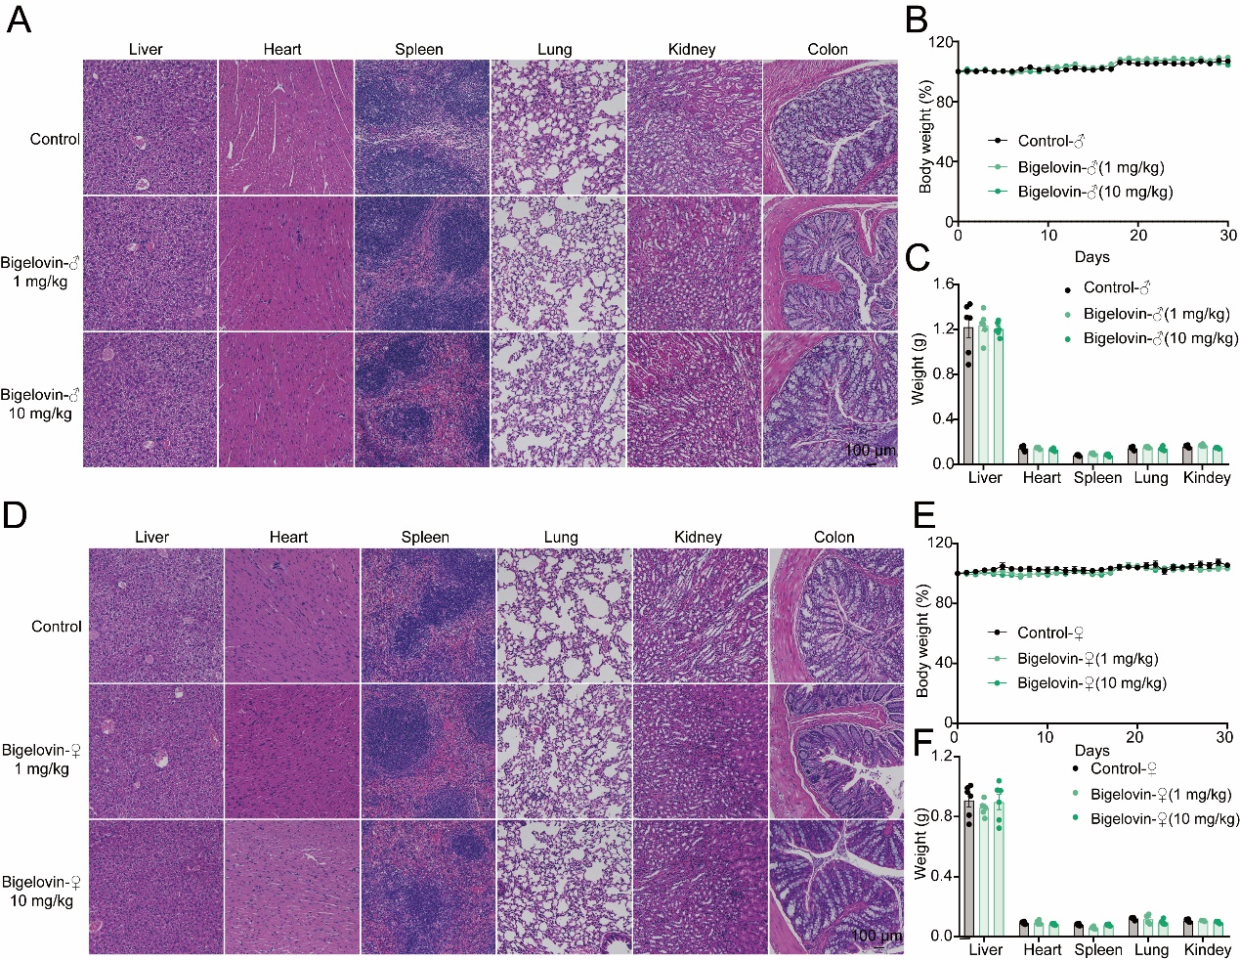
Fig.S6. Biosafety evaluation of bigelovin. (A-C) Male C57BL/6J mice were intragastric administration of bigelovin (1 mg/kg, 10 mg/kg) continuously for 30 days. (A) H&E staining of liver, heart, spleen, lung, kidney, and colon tissues from above mice (scale bar = 100 μm). (B) Body weight analysis of mice treated with bigelovin (1 mg/kg, 10 mg/kg). (C) The weight of liver, heart, spleen, lung, and kidney tissues from above mice. (D-F) Female C57BL/6J mice were intragastric administration of bigelovin continuously (1 mg/kg, 10 mg/kg) for 30 days. (D) H&E staining of liver, heart, spleen, lung, kidney, and colon tissues from above mice (scale bar = 100 μm). (E) Body weight analysis of mice treated with bigelovin (1 mg/kg, 10 mg/kg). (F) The weight of liver, heart, spleen, lung, and kidney tissues from above mice. Data were presented as mean ± SEM and were representative of six independent experiments.
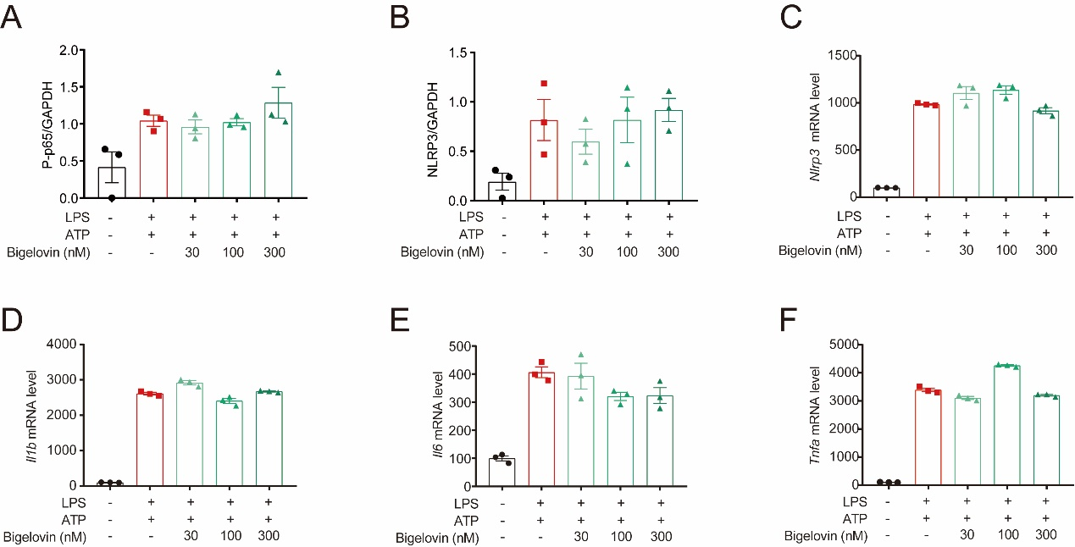
Fig.S7. Function of bigelovin in LPS-induced priming. (A-B) Quantitative analysis of the immunoblot of p-p65/GAPDH (A) or NLRP3/GAPDH (B) described in Fig. 5C. (C-F) Nlrp3 (C), Il1b (D), Il6 (E), and Tnfa (F) mRNA expression in LPS-primed BMDMs treated with bigelovin before stimulation with ATP. Data were presented as mean ± SEM and were representative of three independent experiments. Statistical significance was assessed by two-tailed unpaired t test.
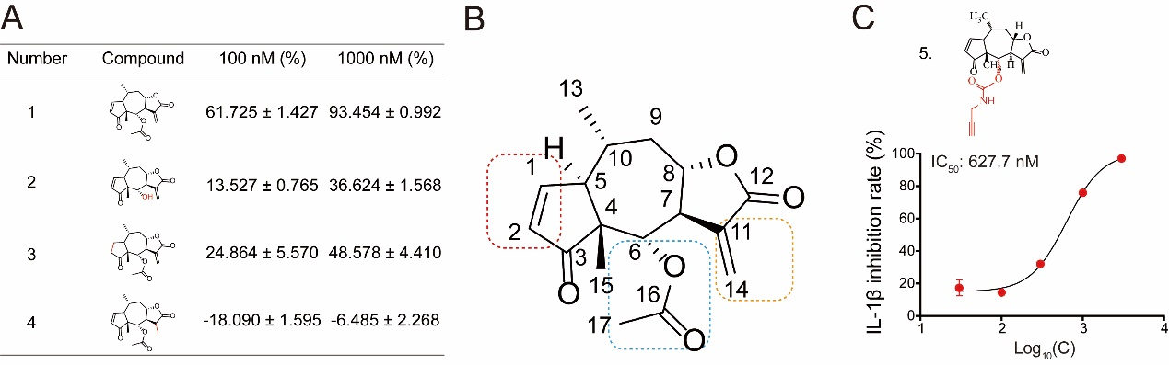
Fig.S8. Structure activity relationship of bigelovin derivatives. (A) The inhibitory rate of IL-1β in culture supernatants of LPS-primed BMDMs treated with compound before stimulation with ATP were measured by ELISA (n = 3). (B) Structure activity relationship of bigelovin. (C) ELISA analysis of IL-1β in culture supernatants of LPS-primed BMDMs treated with the biotin labeled bigelovin before stimulation with ATP (n = 3). Data were presented as mean ± SEM.
Fig.S9. Bigelovin binds to RACK1 protein. (A-C) Quantitative analysis of the immublot of Gbp4 (A), Agfg2 (B) and Sash1 (C) described in Fig. 7C and D. (D-F) Quantitative analysis of RACK1 described in Fig. 7E, F, and I. Data were presented as mean ± SEM and were representative of three independents.
Fig.S10. Bigelovin inhibits NLRP3 inflammasome mainly by binding to RACK1. (A) The scheme of LPS-induced ARDS mice knocked down RACK1. (B-C) qRT-PCR analysis of Rack1 (B) and Il1b (C) in lung tissues from above mice transfected with control siRNA or siRNA against Rack1. (D) ELISA analysis of IL-1β levels of lung tissues from above mice. Data were presented as mean ± SEM and were representative of six independent experiments. Statistical significance was assessed by two-tailed unpaired t test.
Fig.S11. Spectroscopic data of chemical
8-epi-helenalin: C₁₅H₁₈O₄, white powder; ¹H NMR (500 MHz, CD₃OD) δ 7.79 (dd, J = 5.9 and 2.0 Hz 1H), 6.26 (d, J = 3.6 Hz, 1H), 6.16 (dd, J = 6.0 , 2.8 Hz, 1H), 6.10 - 5.99 (m. 1H), 4.55 (ddd, J = 11.8 , 10.2 ,d 3.0 Hz, 1H), 4.17 (dd, J = 8.3 , 2.2 Hz, 1H), 3.01 (dt, J = 10.8 , 2.4 Hz, 1H), 2.93 (ddt, J = 10.2 , 8.2 , 3.4 Hz, 1H) 2.54 (ddd, J = 13.1 , 4.6 , 2.9 Hz, 1H), 2.26 - 2.00 (m, 2H), 1.57 - 1.47 (m, 1H), 1.29 (d, J = 6.6 Hz, 3H), 1.20 (s, 3H)。ESI-MS (m/z): [M+H]⁺ = 263.1;
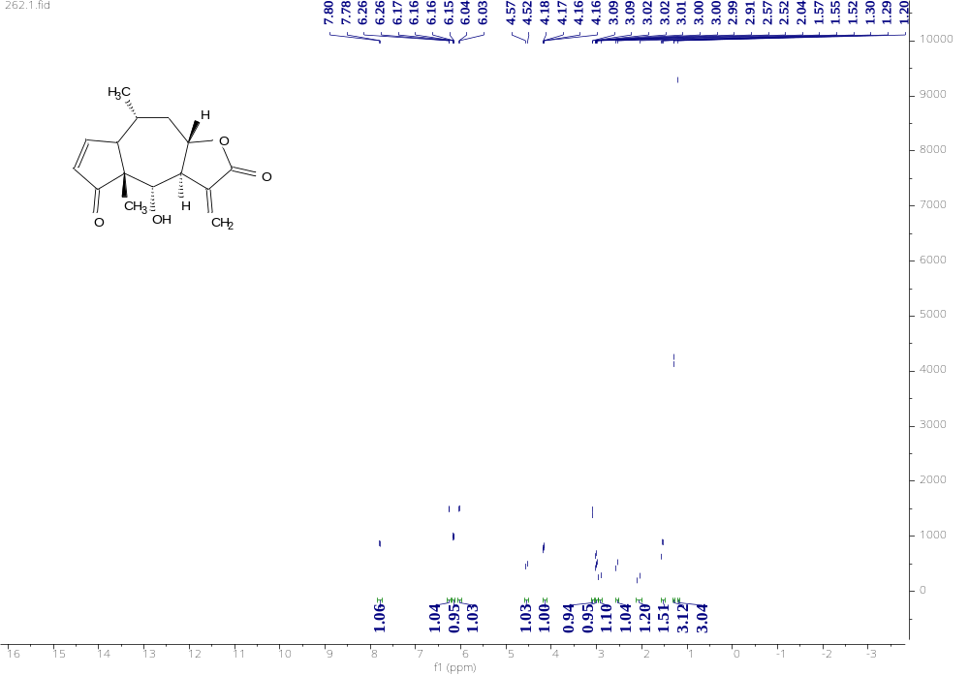
¹H NMR spectrum (500 MHz) of 8-epi-helenalin in CDCl₃
Bigelovin: C₁₇H₂₀O₅, white powder; ¹H NMR (500 MHz, CDCl₃) δ 7.70 (d, J = 7.9 Hz, 1H), 6.22 (s, 1H), 6.11 (d, J = 8.9 Hz, 1H), 5.91 (d, J = 3.2 Hz, 1H), 5.61 (d, J = 7.5 Hz, 1H), 4.61 (d, J = 25.1 Hz, 1H), 3.11 – 2.99 (m, 2H), 2.57 (d, J = 20.5 Hz, 1H), 2.06 (d, J = 34.2 Hz, 1H), 1.96 (s, 3H), 1.54 (dt, J = 13.2, 11.9 Hz, 1H), 1.28 (d, J = 6.6 Hz, 3H), 1.21 (s, 3H), ESI-MS (m/z): [M+H]⁺ = 305.1;
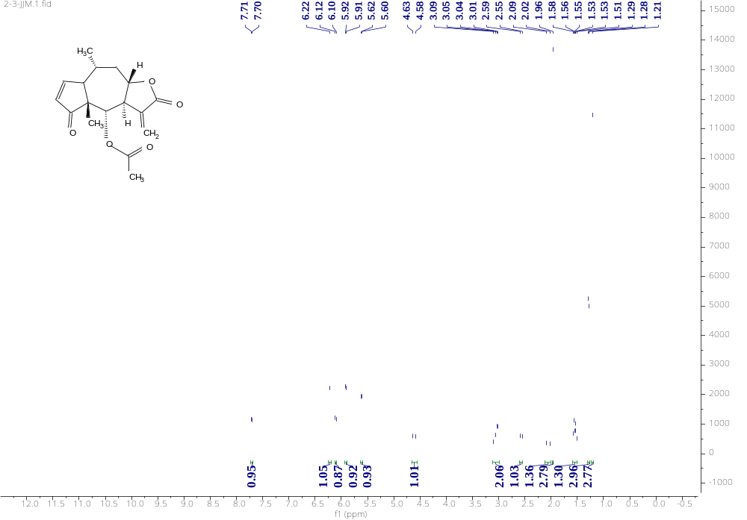
¹H NMR spectrum (500 MHz) of Bigelovin in CDCl₃
Ergolide: C₁₇H₂₂O₅, white powder; ¹H NMR (500 MHz, CDCl₃) δ 6.23 (d, J = 3.5 Hz, 1H), 5.87 (d, J = 3.2 Hz, 1H), 5.52 (d, J = 7.8 Hz, 1H), 4.51 (d, J = 24.8 Hz, 1H), 3.06 (d, J = 24.6 Hz, 1H), 2.53 (d, J = 20.4 Hz, 1H), 2.45 (s, 1H), 2.31 (d, J = 28.5 Hz, 1H), 2.17 (d, J = 54.4 Hz, 2H), 2.00 (s, 3H), 1.85 (s, 1H), 1.50 (d, J = 60.5 Hz, 2H), 1.14 (d, J = 6.6 Hz, 3H), 1.09 (s, 3H), ESI-MS (m/z): [M+H]⁺ = 307.1。
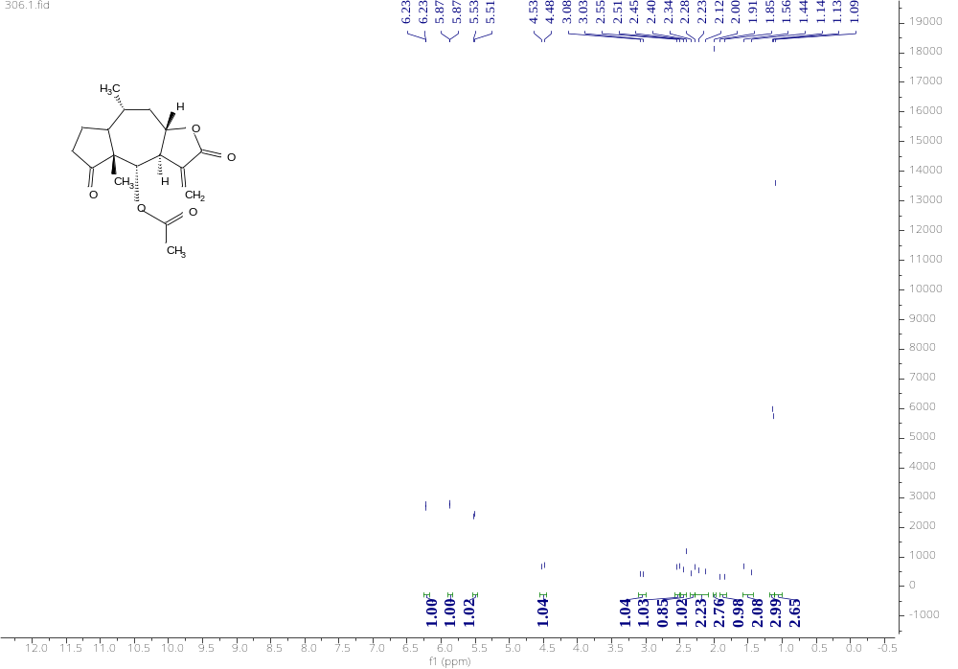
¹H NMR spectrum (500 MHz) of Ergolide in CDCl3

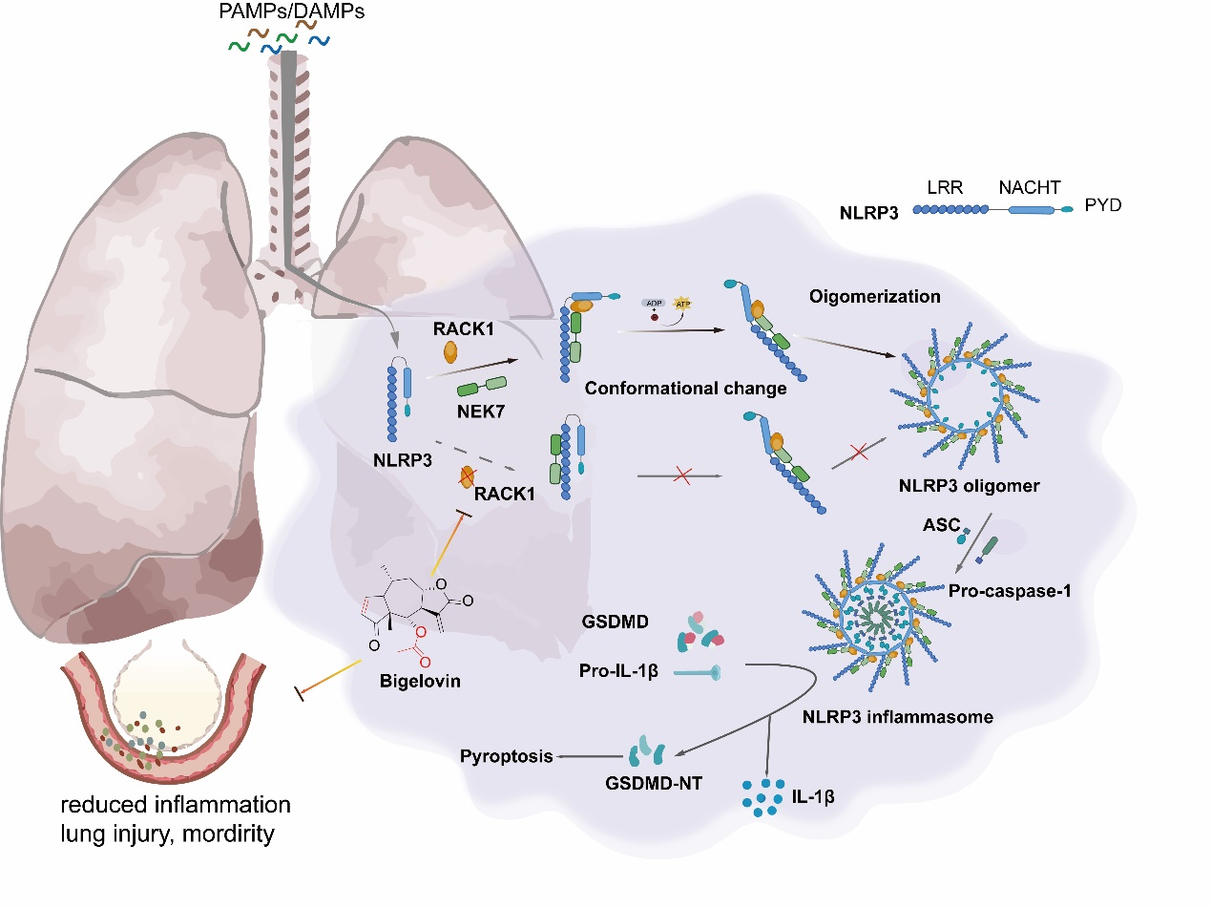
Fig.S12 Schematic diagram showing the potential mechanism of bigelovin on the activation of NLRP3 inflammasome
Bigelovin may inhibit activated protein C kinase 1 (RACK1) by directly binding with cys168 of RACK1. Bigelovin thus prevents oligomerization of NLRP3 (NLRP3 active conformation) and subsequent assembly of NLRP3 inflammasome, blocking the activation of canonical, non-canonical, and alternative NLRP3 inflammasome.

Table 1. Patient Characteristics with Direct ARDS
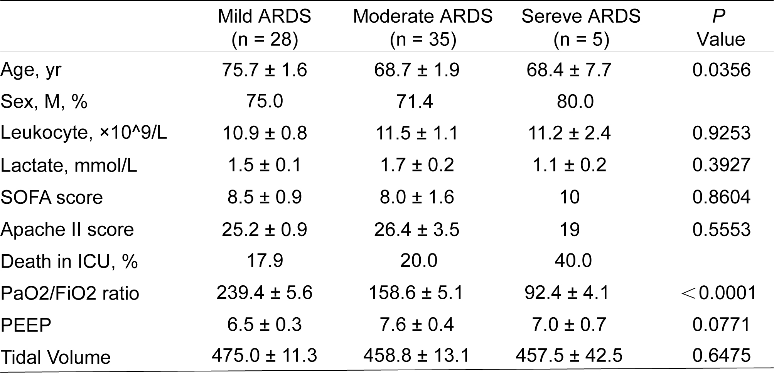
Definition of abbreviations: APACHE II = Acute Physiology and Chronic Health Evaluation II. ARDS = acute respiratory distress syndrome; PEEP = positive endexpiratory pressure; SOFA = sepsis-related organ failure assessment. Data are presented as mean ± SEM. Statistical significance was assessed by one-way ANOVA.

