Multicomponent Reaction for Synthesis, Molecular Docking and Anti-inflammatory Evaluation of Novel Indole-Thiazole Hybrid Derivatives
Faeza Alkorbi¹, Shareefa Ahmed Alshareef², Mahmoud A. Abdelaziz², Noha Omer², Rasha Jame^{2,} Ibrahim Saleem Alatawi², Ali M. Ali³, Omran A. Omran³, Rania B. Bakr **⁴,
¹Department of Chemistry, Faculty of Science and Arts at Sharurah, Najran University, Sharurah, 68342, Saudi Arabi
²Department of Chemistry, Faculty of Science, University of Tabuk, Tabuk 71491, Kingdom of Saudi Arabia
³ Department of Chemistry, Faculty of Science, Sohag University, Sohag 82524, Egypt
⁴ Department of Pharmaceutical Organic Chemistry, Faculty of Pharmacy, Beni-Suef University, 62511 Beni-Suef, Egypt.
Corresponding authors; Ali M. Ali ³*E-mail: elssan@yahoo.com; Rania B. Bakr **⁴*E-mail: raniabakr@ymail.com

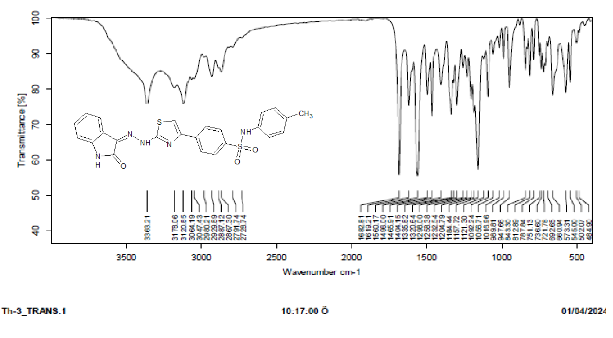 Figure S1. IR spectrum of the compound 4a.

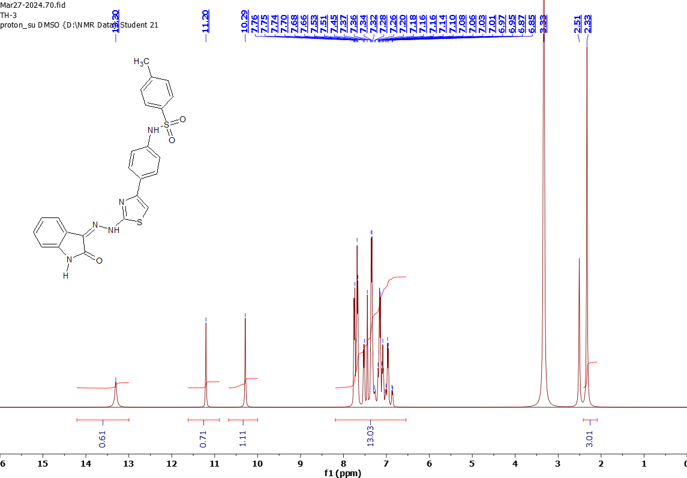
Figure S2. ¹H-NMR spectrum of the compound 4a.

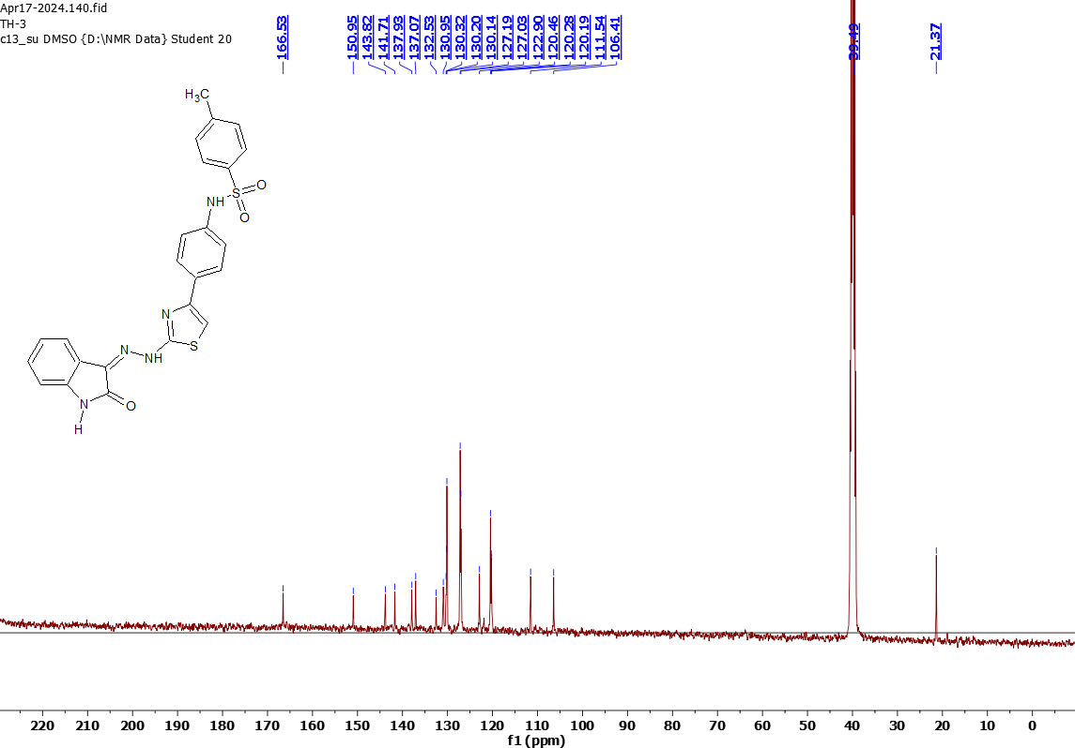
Figure S3. ¹³C-NMR spectrum of the compound 4a

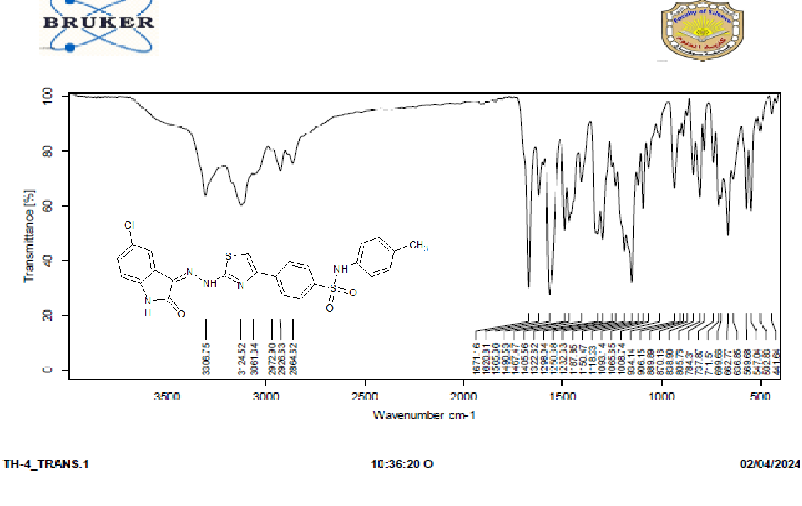
Figure S4. IR spectrum of the compound 4b.

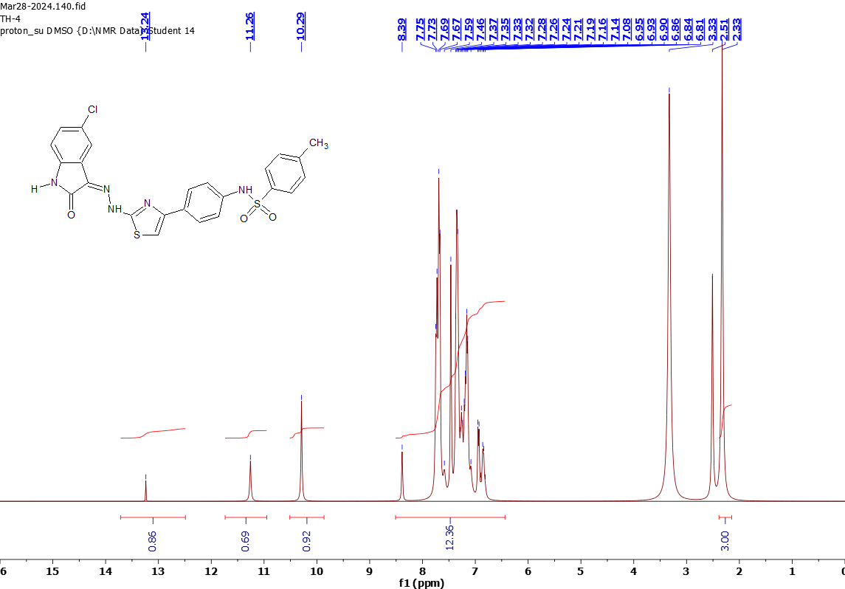

Figure S5. ¹H-NMR spectrum of the compound 4b.

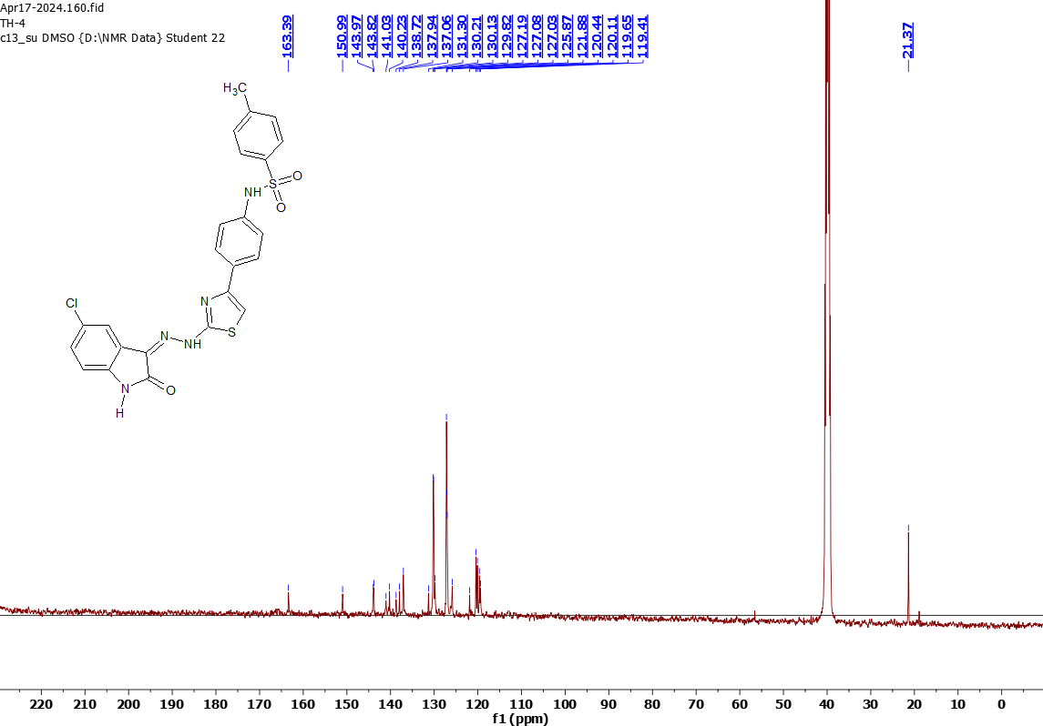

Figure S6. ¹³C-NMR spectrum of the compound 4b

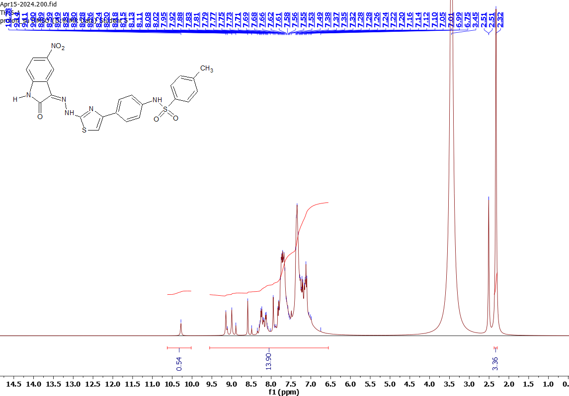

Figure S7. ¹H-NMR spectrum of the compound 4c.

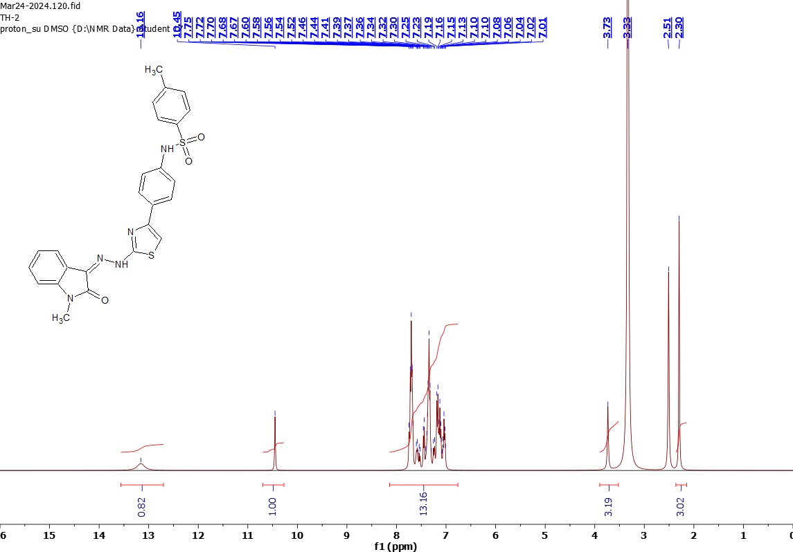
Figure S8. ¹H-NMR spectrum of the compound 4d.

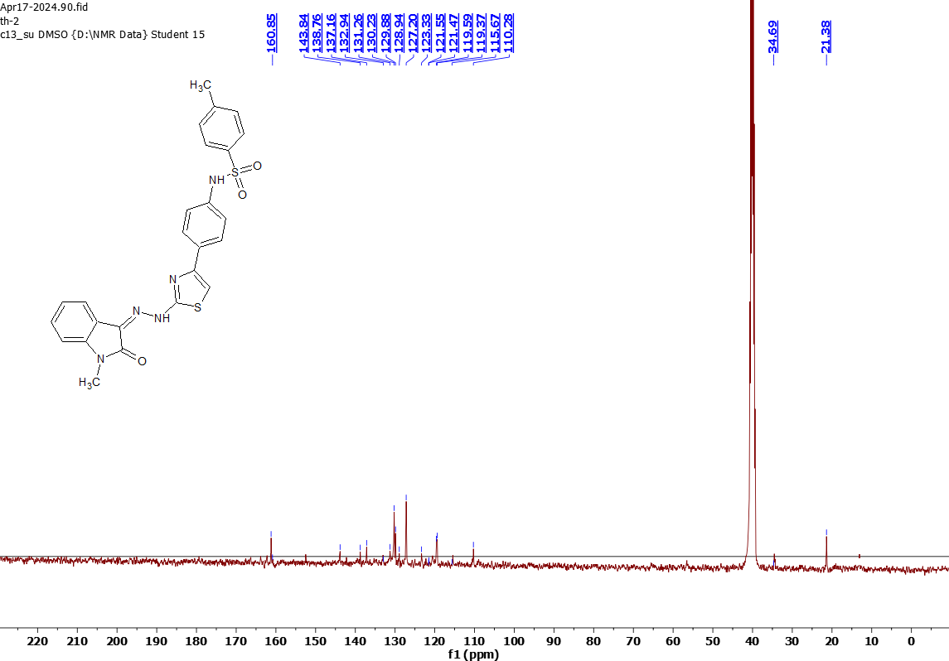

Figure S9. ¹³C-NMR spectrum of the compound 4d

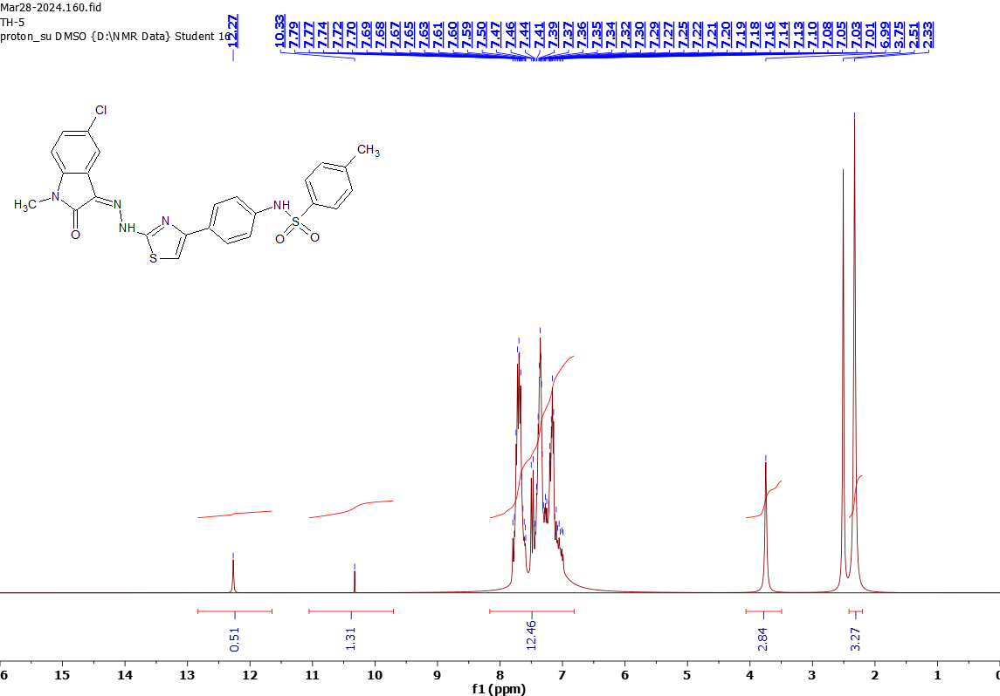

Figure S10. ¹H-NMR spectrum of the compound 4e.

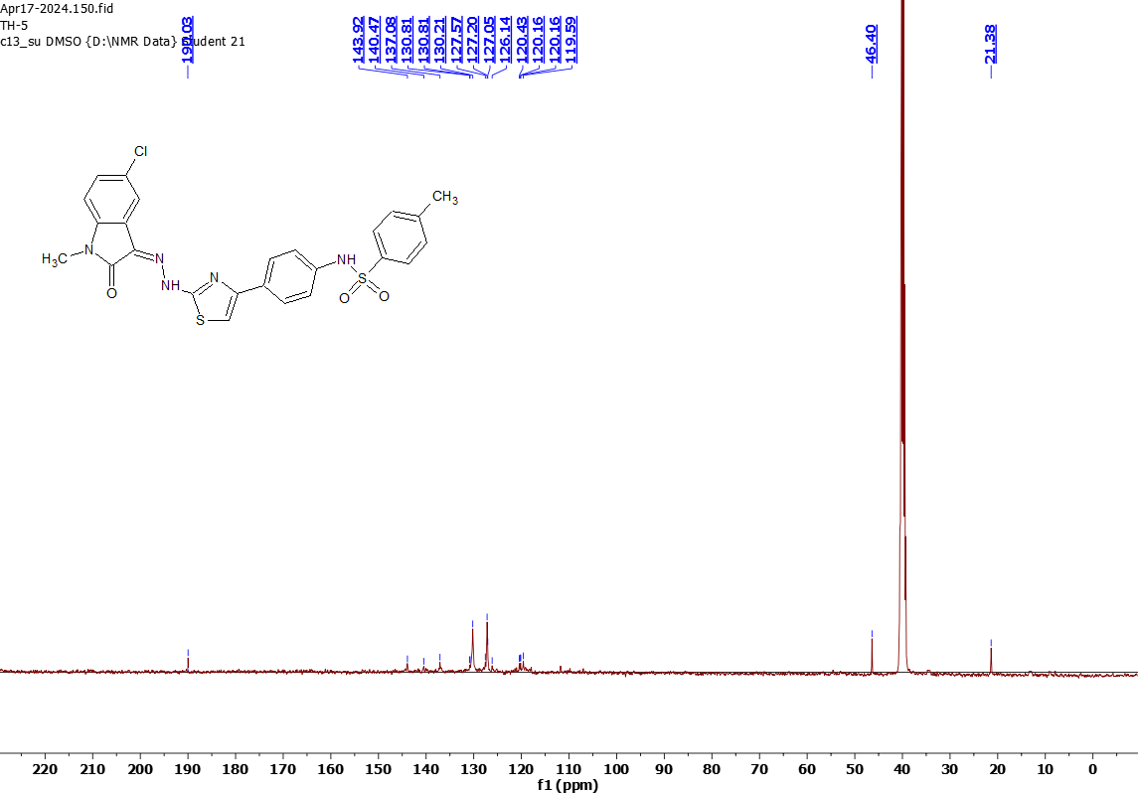

Figure S11. ¹³C-NMR spectrum of the compound 4e

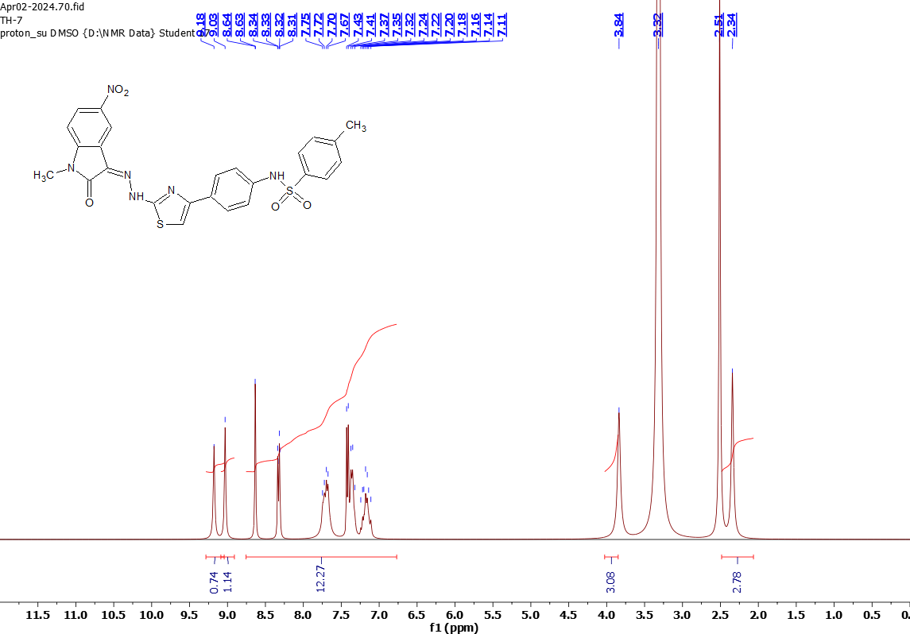
Figure S12. ¹H-NMR spectrum of the compound 4f.

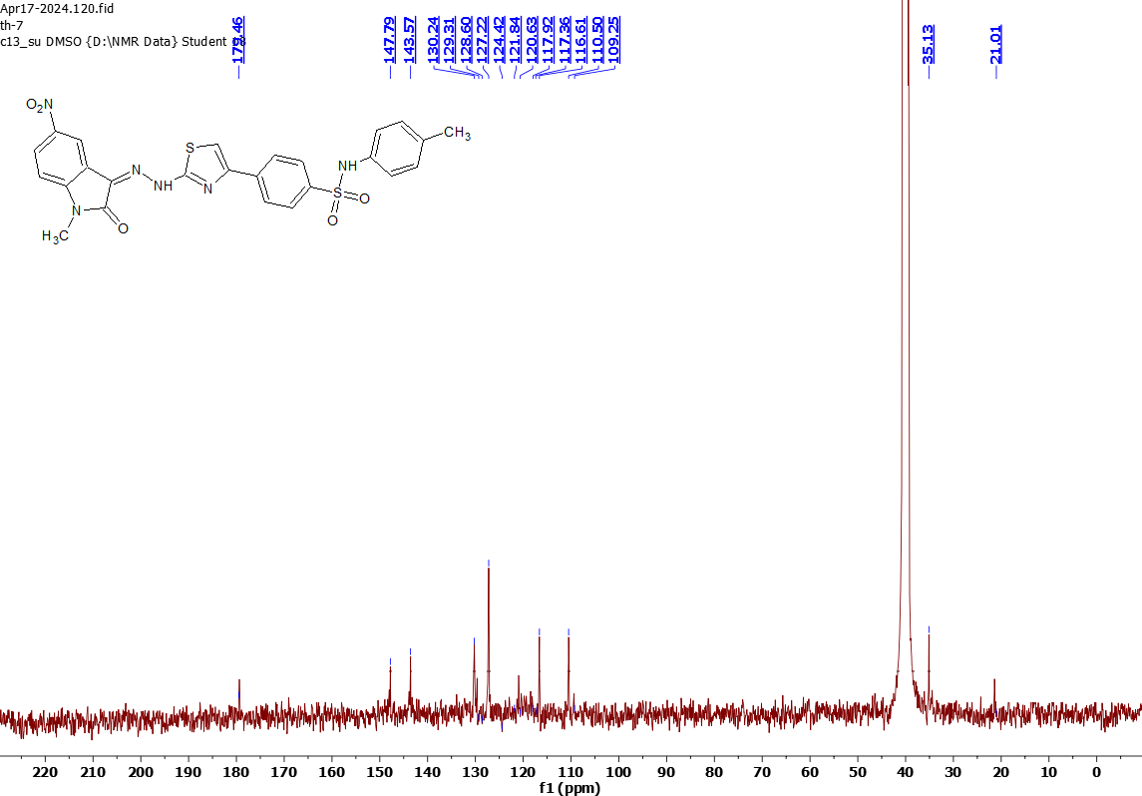
Figure S13. ¹³C-NMR spectrum of the compound 4f

