ADDITIONAL FILE 1

Results

Analysis of the 35-item PRECIS Instrument
Item response distributions were compared between patient and control groups. The patient group had consistently wider response distributions. The control group had diminished variability and noticeable “floor effects” across most items. Patients with schizophrenia had a consistently wider range of scores across all domains compared with controls (Additional Figures A2–A3). The Attention and Bother domains showed wider distributions of scores, and less floor effect (ie, negative skew) than memory domain items.

Factor Analysis
The initial exploratory factor analysis, carried out on the 35-item PRECIS instrument, identified a 6-factor solution with 1 strong central factor (eigenvalue: 14.8) and 5 secondary factors (eigenvalues: 1–2). This 6-factor solution accounted for 62% of the total item variance. Similar factor solutions and Eigenvalues were calculated using Promax and Varimax rotations for both the patient group and the patients plus controls combined (data not shown).

Reliability
The Cronbach’s alpha measure of internal consistency for the 35-item PRECIS instrument was 0.959, indicating a high level of internal consistency. This high internal consistency was confirmed by relatively high inter-item correlations of 0.50–0.74. When assessing test-retest reliability, intra-class correlation coefficients (ICCs) were 0.3–0.7, with only one item (CIAS #135; “If your recent experiences with the items in this survey stayed the same for the rest of your life, how much would that bother you?”) meeting the ICC pre-determined cut-off of ≥0.7 for determining reliability.

Validity
Discriminant validity between patient and control groups was confirmed with significant differences found on both an item (p<0.001) and domain (p<0.0001) level (Additional Tables A1 and A2).

Additional Figure A1. Thirty-five item, five-domain, draft PRO instrument for CIAS
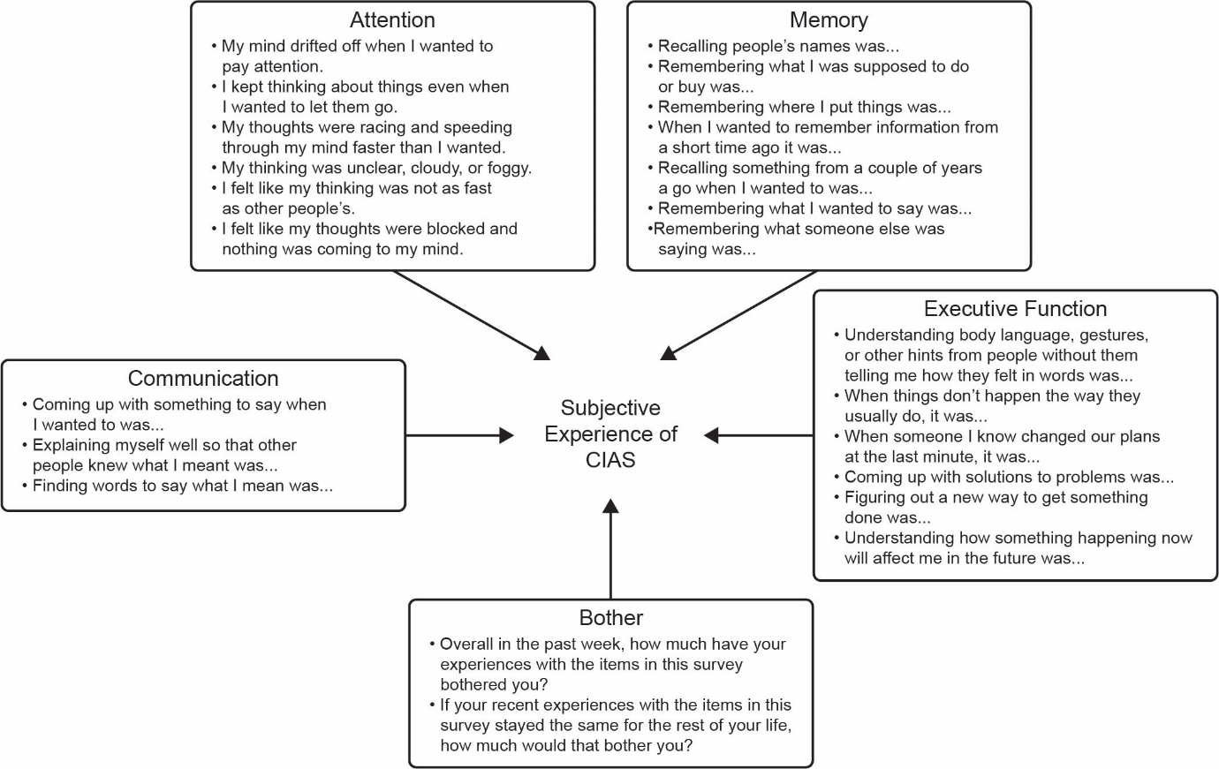
CIAS, cognitive impairment associated with schizophrenia; PRO, patient-reported outcome.

Additional Figure A2. Distribution of responses for each of the draft items in the 35-item version of the PRECIS instrument. Response frequency plot for (A) Memory items, (B) Communication items, (C) Control items, and (D) Planning items
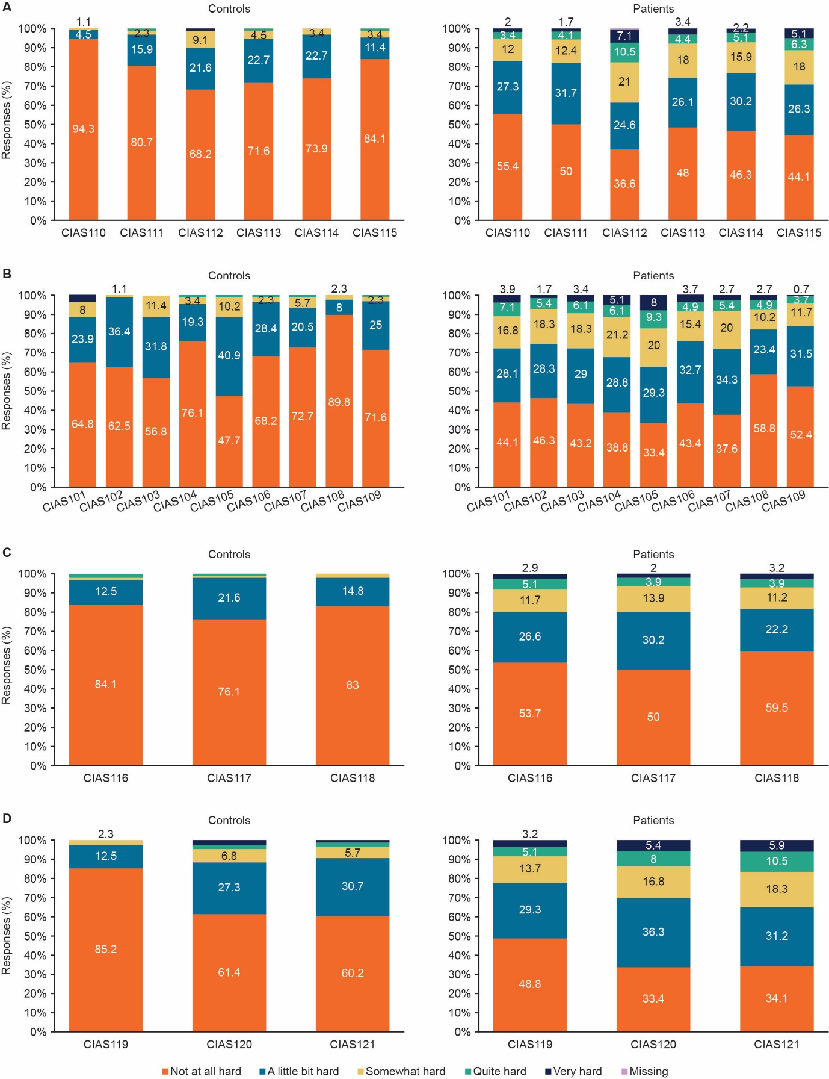
Responses for patients on the right side and controls on the left for each domain. Patients had consistently wider response distributions and controls had marked “floor effects” across most items.
CIAS, cognitive impairment associated with schizophrenia; PRECIS, Patient-Reported Experience of Cognitive Impairment of Schizophrenia.

Additional Figure A3. Distribution of responses for each of the draft items in the 35-item version of the PRECIS instrument. Response frequency plot (A) Handling problem items, (B) Attention items, (C) Sharp Thinking items, and (D) Overall Experience and Bother
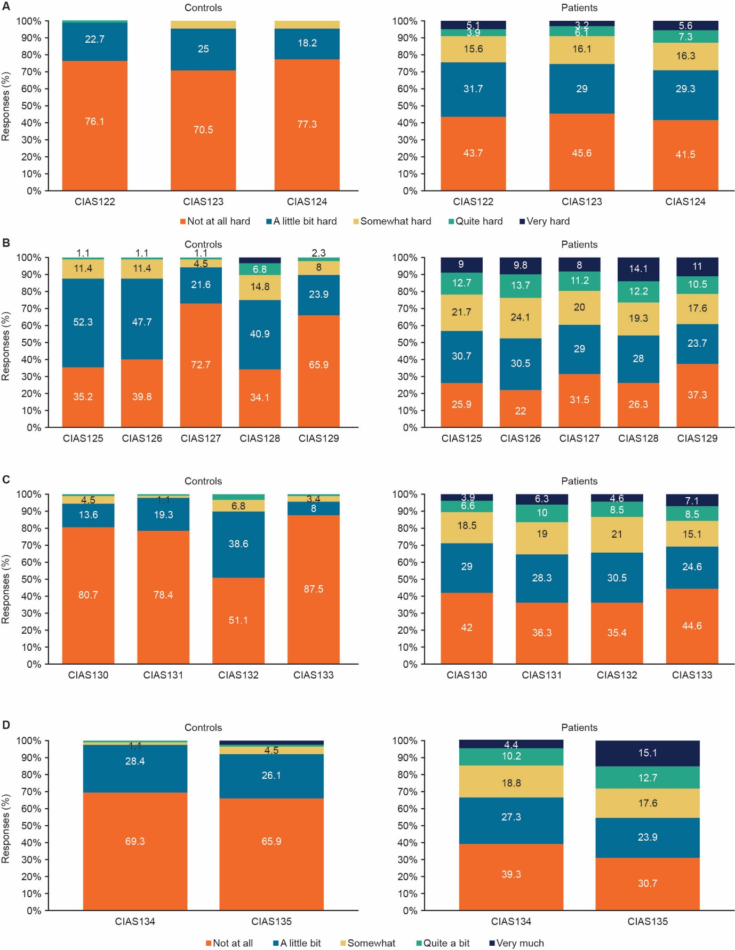
Responses for patients on the right side and controls on the left for each domain. Patients had consistently wider response distributions and controls had marked “floor effects” across most items.
CIAS, cognitive impairment associated with schizophrenia; Patient-Reported Experience of Cognitive Impairment of Schizophrenia.

Additional Figure A4. (A) Scree plot and (B) proportion of variance explained for the 22-item CFA
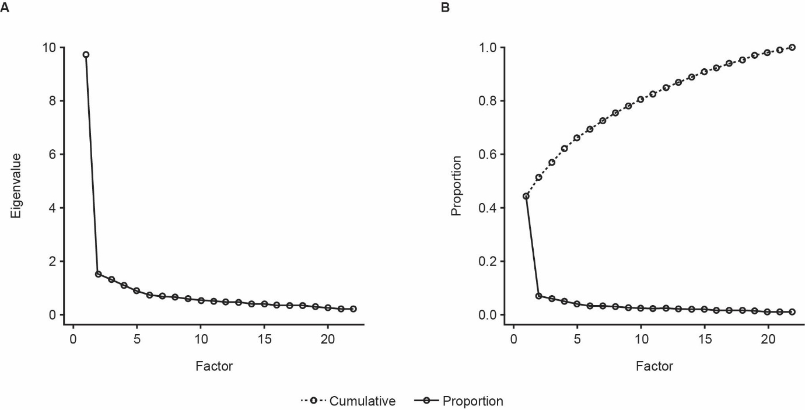
CFA, confirmatory factor analysis.

Additional Table A1. Discriminant validity of the 35-item PRECIS domain scores.
 | Patients with schizophrenia  (N=410) | Controls  (N=88)
PRECIS domain | Mean (SD) | Mean (SD) | Mean difference (SD) | Unadjusted p-value
Memory: Remembering what I want to do | 1.95 (1.08) | 1.40 (0.65) | -0.55 (1.02) | <0.0001
Communication: Talking and interacting with others | 1.91 (1.08) | 1.27 (0.58) | -0.65 (1.01) | <0.0001
Control: Saying and doing what I mean | 1.75 (1.01) | 1.23 (0.52) | -0.52 (0.94) | <0.0001
Planning: Making and changing plans | 2.08 (1.14) | 1.42 (0.76) | -0.65 (1.08) | <0.0001
Handling Problems: Coming up with solutions & taking the future into account | 1.98 (1.12) | 1.29 (0.54) | -0.69 (1.04) | <0.0001
Attention: Paying attention to what I want to | 2.47 (1.30) | 1.68 (0.81) | -0.80 (1.23) | <0.0001
Sharp Thinking: Thinking that is clear, fast and easy | 2.12 (1.18) | 1.33 (0.64) | -0.79 (1.11) | <0.0001
Overall Experience | 2.35 (1.32) | 1.41 (0.71) | -0.94 (1.24) | <0.0001
Total | 2.06 (1.16) | 1.39 (0.67) | -0.67 (1.09) | <0 .0001
PRECIS, Patients’ Subjective Experience of Cognitive Impairment of Schizophrenia; SD, standard deviation.

Additional Table A2. Discriminant validity of the individual item scores from the 35-item version of the PRECIS instrument.
 | Patients with schizophrenia  (N=410) | Controls  (N=88)
PRECIS item | Mean (SD) | Mean (SD) | Mean difference (SD) | Unadjusted  p-value
CIAS101 - Recalling people’s names was… | 1.99 (1.12) | 1.53 (0.91) | -0.45 (1.08) | 0.0001
CIAS102 - Remembering what I was supposed to do or buy was… | 1.88 (1.00) | 1.39 (0.51) | -0.49 (0.93) | <0.0001
CIAS103 - Remembering where I put things (for example, my keys, phone, glasses, or other items) was… | 1.98 (1.08) | 1.55 (0.69) | -0.43 (1.02) | 0.0013
CIAS104 – When I wanted to remember information from a short time ago (for example, what I read or watched in a  movie or TV show), it was... | 2.10 (1.14) | 1.30 (0.59) | -0.80 (1.06) | <0.0001
CIAS105 - Recalling something from a couple of years ago when I wanted to (for example, information I used to know or an important event) was... | 2.29 (1.24) | 1.65 (0.71) | -0.64 (1.17) | <0.0001
CIAS106 - Remembering what I wanted to say was… | 1.93 (1.05) | 1.36 (0.59) | -0.56 (0.99) | <0.0001
CIAS107 - Remembering what someone else was saying was… | 2.01 (1.02) | 1.35 (0.64) | -0.66 (0.96) | <0.0001
CIAS108 - Remembering how to get someplace that I wanted to go was… | 1.69 (1.02) | 1.13 (0.40) | -0.57 (0.94) | <0.0001
CIAS109 - Remembering what I was just about to do was… | 1.69 (0.87) | 1.33 (0.58) | -0.36 (0.83) | 0.0003
CIAS110 - Understanding what someone was talking about was… | 1.69 (0.95) | 1.07 (0.30) | -0.62 (0.87) | <0.0001
CIAS111 - Coming up with something to say when I wanted to was… | 1.76 (0.94) | 1.24 (0.55) | -0.52 (0.89) | <0.0001
CIAS112 - Interacting with people I don’t know well was… | 2.27 (1.25) | 1.44 (0.76) | -0.82 (1.18) | <0.0001
CIAS113 - Explaining myself well so that other people knew what I meant was… | 1.89 (1.07) | 1.35 (0.63) | -0.54 (1.00) | <0.0001
CIAS114 - Finding words to say what I mean was… | 1.86 (1.01) | 1.30 (0.53) | -0.57 (0.94) | <0.0001
CIAS115 - Understanding body language, gestures, or other hints from people without them telling me how they felt in words was… | 2.02 (1.16) | 1.22 (0.56) | -0.80 (1.08) | <0.0001
CIAS116 - Keeping things from slipping out when I didn’t want to say it was… | 1.77 (1.04) | 1.22 (0.58) | -0.55 (0.97) | <0.0001
CIAS117 - Stopping to think through things before saying or doing them was… | 1.78 (0.96) | 1.27 (0.54) | -0.50 (0.90) | <0.0001
CIAS118 - Stopping myself from saying or doing something wrong or inappropriate was… | 1.69 (1.03) | 1.19 (0.45) | -0.50 (0.95) | <0.0001
CIAS119 - Without someone’s help, planning ahead for an event or how to get to a goal was… | 1.85 (1.05) | 1.17 (0.43) | -0.68 (0.97) | <0.0001
CIAS120 - When things don’t happen the way they usually do, it was… | 2.16 (1.13) | 1.57 (0.89) | -0.59 (1.10) | <0.0001
CIAS121 - When someone I know changed our plans at the last minute, it was… | 2.23 (1.19) | 1.53 (0.80) | -0.69 (1.13) | <0.0001
CIAS122 - Coming up with solutions to problems was… | 1.95 (1.10) | 1.26 (0.51) | -0.69 (1.02) | <0.0001
CIAS123 - Figuring out a new way to get something done was… | 1.92 (1.07) | 1.34 (0.57) | -0.58 (1.00) | <0.0001
CIAS124 - Understanding how something happening now will affect me in the future was… | 2.06 (1.17) | 1.27 (0.54) | -0.79 (1.09) | <0.0001
CIAS125 - My mind drifted off when I wanted to pay attention. | 2.48 (1.25) | 1.78 (0.69) | -0.70 (1.17) | <0.0001
CIAS126 - I got distracted by things going on around me (for example, other people talking or making noise, or the radio or TV playing). | 2.59 (1.24) | 1.74 (0.70) | -0.85 (1.17) | <0.0001
CIAS127 - It was hard to focus on something so I could finish it. | 2.35 (1.25) | 1.34 (0.62) | -1.01 (1.17) | <0.0001
CIAS128 - I kept thinking about things even when I wanted to let them go. | 2.60 (1.37) | 2.05 (1.04) | -0.55 (1.31) | 0.0009
CIAS129 - My thoughts were racing and speeding  through my mind faster than I wanted. | 2.34 (1.36) | 1.47 (0.74) | -0.88 (1.27) | <0.0001
CIAS130 - My thinking was unclear, cloudy, or foggy. | 2.01 (1.11) | 1.26 (0.60) | -0.75 (1.03) | <0.0001
CIAS131 - I felt like my thinking was not as fast as other people’s. | 2.22 (1.22) | 1.25 (0.53) | -0.97 (1.13) | <0.0001
CIAS132 - When I was tired, my thinking slowed down more than I wanted it to. | 2.17 (1.14) | 1.63 (0.76) | -0.54 (1.08) | <0.0001
CIAS133 - I felt like my thoughts were blocked and nothing was coming to my mind. | 2.09 (1.25) | 1.18 (0.54) | -0.91 (1.16) | <0.0001
CIAS134 - Overall in the past week, how much have your experiences with the items in this survey bothered you? | 2.13 (1.17) | 1.34 (0.57) | -0.79 (1.09) | <0.0001
CIAS135 - If your recent experiences with the items in this survey stayed the same for the rest of your life, how much would that bother you? | 2.58 (1.42) | 1.48 (0.83) | -1.10 (1.34) | <0.0001
CIAS, cognitive impairment associated with schizophrenia; PRECIS, Patients’ Subjective Experience of Cognitive Impairment of Schizophrenia; SD, standard deviation.

Additional Table A3. Item elimination summary
PRECIS items | Reason for elimination
CIAS108 - Remembering how to get someplace that I wanted to go  was… | Response distribution (floor > 50%)
CIAS109 - Remembering what I was just about to do was… | Response distribution (floor > 50%)
CIAS110 - Understanding what someone was talking about was… | Response distribution (floor > 50%)
CIAS112 - Interacting with people I don’t know well was… | Test-retest reliability (paired t-test  P value < 0.05)
CIAS116 - Keeping things from slipping out when I didn’t want to say it was… | Response distribution (floor > 50%)
CIAS117 - Stopping to think through things before saying or doing them  was… | Factor structure (poor loading, varimax correlation < 0.50)
CIAS118 - Stopping myself from saying or doing something wrong or  inappropriate was… | Item characteristics (floor > 50%)
CIAS119 - Without someone’s help, planning ahead for an event or how  to get to a goal was… | Factor structure (poor loading, varimax correlation < 0.50)
CIAS126 - I got distracted by things going on around me (for example, other people talking or making noise, or the radio or TV playing). | Test-retest reliability  (percent agreement < 50%)
CIAS127 - It was hard to focus on something so I could finish it. | Test-retest reliability  (percent agreement < 50%)
CIAS132 - When I was tired, my thinking slowed down more than I  wanted it to. | Test-retest reliability  (percent agreement < 50%)
CIAS, cognitive impairment associated with schizophrenia; PRECIS, Patients’ Subjective Experience of Cognitive Impairment of Schizophrenia.

Additional Table A4. Revised 24-item PRECIS scale
Attention
Overall, in the past week… | Not at all | A little bit | Somewhat | Quite a bit | Very much
My mind drifted off when I wanted to pay attention. | 1 | 2 | 3 | 4 | 5
I kept thinking about things even when I wanted to let them go | 1 | 2 | 3 | 4 | 5
My thoughts were racing and speeding through my mind faster than I wanted | 1 | 2 | 3 | 4 | 5
My thinking was unclear, cloudy, or foggy. | 1 | 2 | 3 | 4 | 5
I felt like my thinking was not as fast as other people’s. | 1 | 2 | 3 | 4 | 5
I felt like my thoughts were blocked and nothing was coming to my mind. | 1 | 2 | 3 | 4 | 5
Memory
Overall, in the past week… | Not at all hard | A little bit hard | Somewhat hard | Quite hard | Very hard
Recalling people’s names was… | 1 | 2 | 3 | 4 | 5
Remembering what I was supposed to do or buy was …. | 1 | 2 | 3 | 4 | 5
Remembering where I put things (for example, my keys, phone, glasses, or other items) was… | 1 | 2 | 3 | 4 | 5
When I wanted to remember information from a short time ago (for example, what I read or watched in a movie or TV show), it was... | 1 | 2 | 3 | 4 | 5
Recalling something from a couple of years ago when I wanted to (for example, information I used to know or an important event) was... | 1 | 2 | 3 | 4 | 5
Remembering what I wanted to say was… | 1 | 2 | 3 | 4 | 5
Remembering what someone else was saying was… | 1 | 2 | 3 | 4 | 5
Executive Function
Overall, in the past week… | Not at all hard | A little bit hard | Somewhat hard | Quite hard | Very hard
Understanding body language, gestures, or other hints from people without them telling me how they felt in words was… | 1 | 2 | 3 | 4 | 5
When things don’t happen the way they usually do, it was…. | 1 | 2 | 3 | 4 | 5
When someone I know changed our plans at the last minute, it was… | 1 | 2 | 3 | 4 | 5
Coming up with solutions to problems was… | 1 | 2 | 3 | 4 | 5
Figuring out a new way to get something done was… | 1 | 2 | 3 | 4 | 5
Understanding how something happening now will affect me in the future was… | 1 | 2 | 3 | 4 | 5
Communication
Overall, in the past week… | Not at all hard | A little bit hard | Somewhat hard | Quite hard | Very hard
Coming up with something to say when I wanted to was… | 1 | 2 | 3 | 4 | 5
Explaining myself well so that other people knew what I meant was… | 1 | 2 | 3 | 4 | 5
Finding words to say what I mean was… | 1 | 2 | 3 | 4 | 5
Bother
 | Not at all | A little bit | Somewhat | Quite a bit | Very much
Overall in the past week, how much have your experiences with the items in this survey bothered you? | 1 | 2 | 3 | 4 | 5
If your recent experiences with the items in this survey stayed the same for the rest of your life, how much would that bother you? | 1 | 2 | 3 | 4 | 5
PRECIS, Patients’ Subjective Experience of Cognitive Impairment of Schizophrenia.

Additional Table A5. Eigenvalues and proportion of variance explained for the 22-item CFA
Number | Eigenvalue | Difference | Proportion | Cumulative
1 | 9.73519200 | 8.21532078 | 0.4425 | 0.4425
2 | 1.51987123 | 0.19516323 | 0.0691 | 0.5116
3 | 1.32470800 | 0.22567820 | 0.0602 | 0.5718
4 | 1.09902980 | 0.21401339 | 0.0500 | 0.6218
5 | 0.88501641 | 0.16233577 | 0.0402 | 0.6620
6 | 0.72268064 | 0.04115415 | 0.0328 | 0.6948
7 | 0.68152649 | 0.03912452 | 0.0310 | 0.7258
8 | 0.64240198 | 0.05157562 | 0.0292 | 0.7550
9 | 0.59082636 | 0.07016412 | 0.0269 | 0.7819
10 | 0.52066224 | 0.02184750 | 0.0237 | 0.8055
Bold indicates eigenvalues that corresponded to identified factors.
CFA, confirmatory factor analysis.

