Table S1. List of strain and plasmid
Strain/plsmid | Illustration | Source
A. baumannii strain ATCC19606 | I-Fa CRISPR-Cas | ATCC
pAT03 | Flippase(FLP)，Amp^{R} | This study
pAT04 | RecAb system，Tet^{R} | This study
pKD4 | Kan^{R} | This study
pMMB67EH | Amp^{R} | This study

Table S2. Primers used in this study
Primer name | Nucleotide sequence (5’ to 3’) | Purpose of amplification | Size/bp
cas3-upstream-F | AGCAAGAAATGACACCTCAGT | cas3 upstream | 165
cas3-upsteam-R | GAAGCAGCTCCAGCCTACACGC  AGGTGGTTGCAGTCATTT | cas3 upstream | 165
cas3-downstream-F | TAAGGAGGATATTCATATGGTAG  CCTTCCATCGCAGCTA | cas3 downstream | 142
cas3-downstream-R | ACCCTAGATCTGTCATGAGTTCA | cas3 downstream | 142
cas3-kan-F | GTGTAGGCTGGAGCTGCTTCATG  ATTGAACAAGATGG | kanamycin cassette（including FRT locus） | 1477
cas3-kan-R | CATATGAATATCCTCCTTATCAGA  AGAACTCGTCAAG | kanamycin cassette（including FRT locus） | 1477
pcas3-F | GGAATTCCATGCATGTCATTCTCATCTCG | cas3 complementary | 3329
pcas3-R | CGGGATCCCGCTATTTTTGCATCACGCC
cas3-F | TTCACCCGCTGCAATCAGAT | screening and identification cas3 | 600
cas3-R | GCTTCACGCATTGCAGTTCA | screening and identification cas3 | 600

Figure S1. Detection of construction of cas3 deletion strain(19606Δcas3). A. Lane M: 5000bp DNA marker. Lane1: amplification of cas3 fragment contains upstream and downstream (3770bp). Lane2: amplification of Recombinant Kana gene (1783 bp). Lane3: amplification of Recombinant FRT fragment (391 bp) and cas3 deleted. B. Sequence alignment of knockout genes.

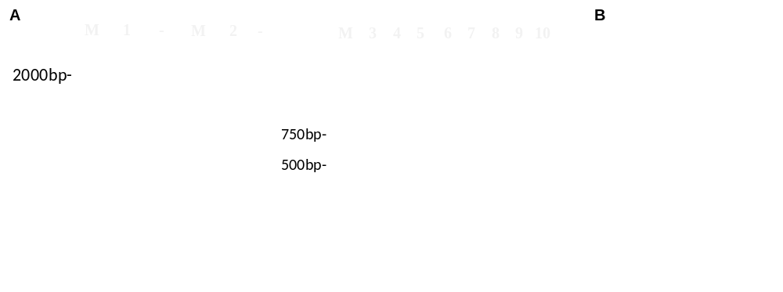
Figure S2. Detection of construction of cas3 complementaion strain(19606Δcas3/pcas3). A. Lane M: 2000bp DNA marker. Lane1: amplification of complementary fragment cas3(3329bp) from strain ATCC19606. Lane 2: Verification that the complementary fragment cas3 is connected to the plasmid pMMB67EH vector. Lane3-8: verification of 600bp cas3 fragment in monoclone of the complementaion strain. Lane9: positive control. Lane 10: empty vector(pMMB67EH) control. B. qPCR verified the expression of cas3 in three strains.

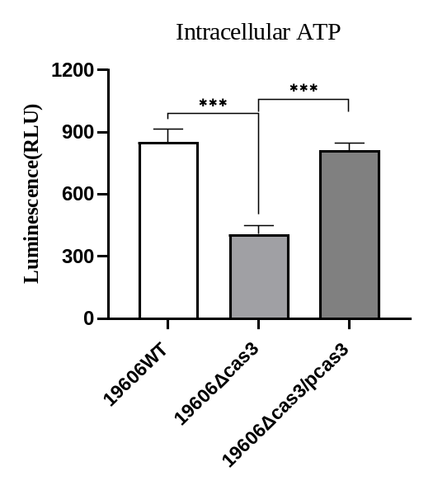
Figure S3. Intracellular ATP content in 19606WT, 19606Δcas3 and 19606Δcas3/pcas3 strains.

