Entry for the Table of Contents

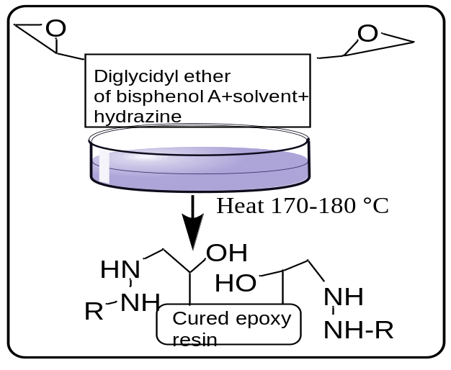

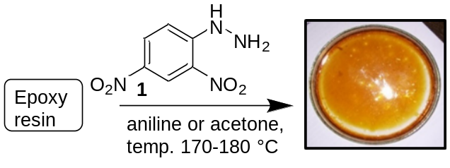

Scheme 1. Solidification and coating of Epoxy resin on glass Petri dish

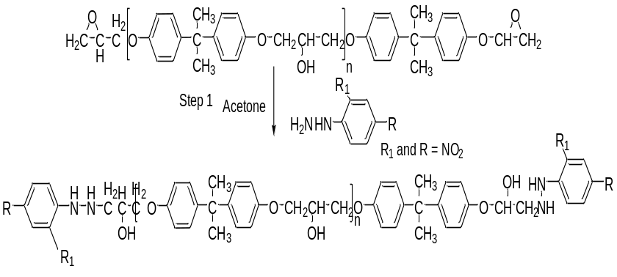
Scheme 2: Reaction of Diglycidyl ether of bisphenol A (DGEBA) with the use of hardeners 2,4-dinitro phenyl hydrazine according to the literature

