Community Composition and Seasonal Dynamics of Microplastic Biota in the Eastern Mediterranean Sea
Keren Davidov¹, Katherine S. Marsay¹, Sheli Itzahri¹, Maxim Rubin-Blum², Paula Sobral³, Chana F. Kranzler⁴ & Matan Oren*¹
1. Department of Molecular Biology, Ariel University, Ariel, Israel.
2. Israel Oceanographic and Limnological Research, National Institute of Oceanography, Tel Shikmona, Haifa, Israel.
3. MARE - Marine and Environmental Sciences Centre & ARNET - Aquatic Research Network Associated Laboratory, NOVA School of Science and Technology, NOVA University of Lisbon, Lisbon, Portugal,
4. The Mina and Everard Goodman Faculty of Life Sciences, Bar-Ilan University, Ramat-Gan, Israel.

Supplementary material

Supplementary figure S1. Sea surface temperature and salinity at the time of sampling.
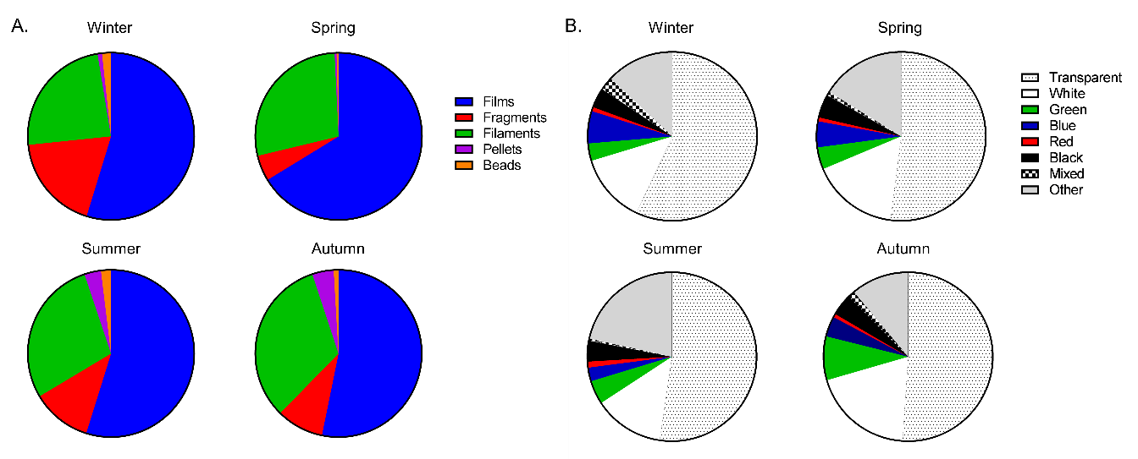
Supplementary figure S2. Physical characteristics of the microplastic that was sampled during 2021. (A) Abundance of plastic shapes by season, expressed in % relative to total microplastics analyzed (repeats combined) (B) Plastic abundances by color at every season.

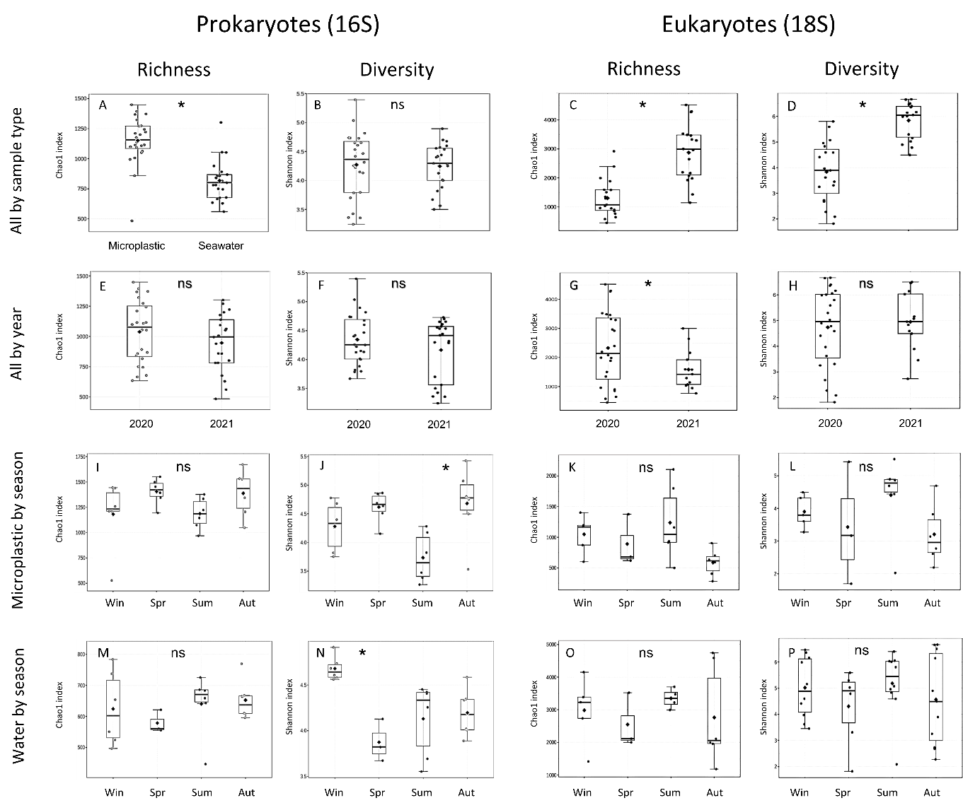
Supplementary figure S3. Prokaryotic and eukaryotic biodiversity within samples (alpha diversity). On the left – Prokaryotes (16S barcode). On the right – Eukaryotes (18S barcode). A-D. Biodiversity by sample type (microplastic/seawater), E-H. Biodiversity by sampling year, I-P. Biodiversity by the season of the microplastic samples (I-L) and the seawater samples (M-P). Species richness was assessed by Chao1 index and diversity was assessed by Shannon index.

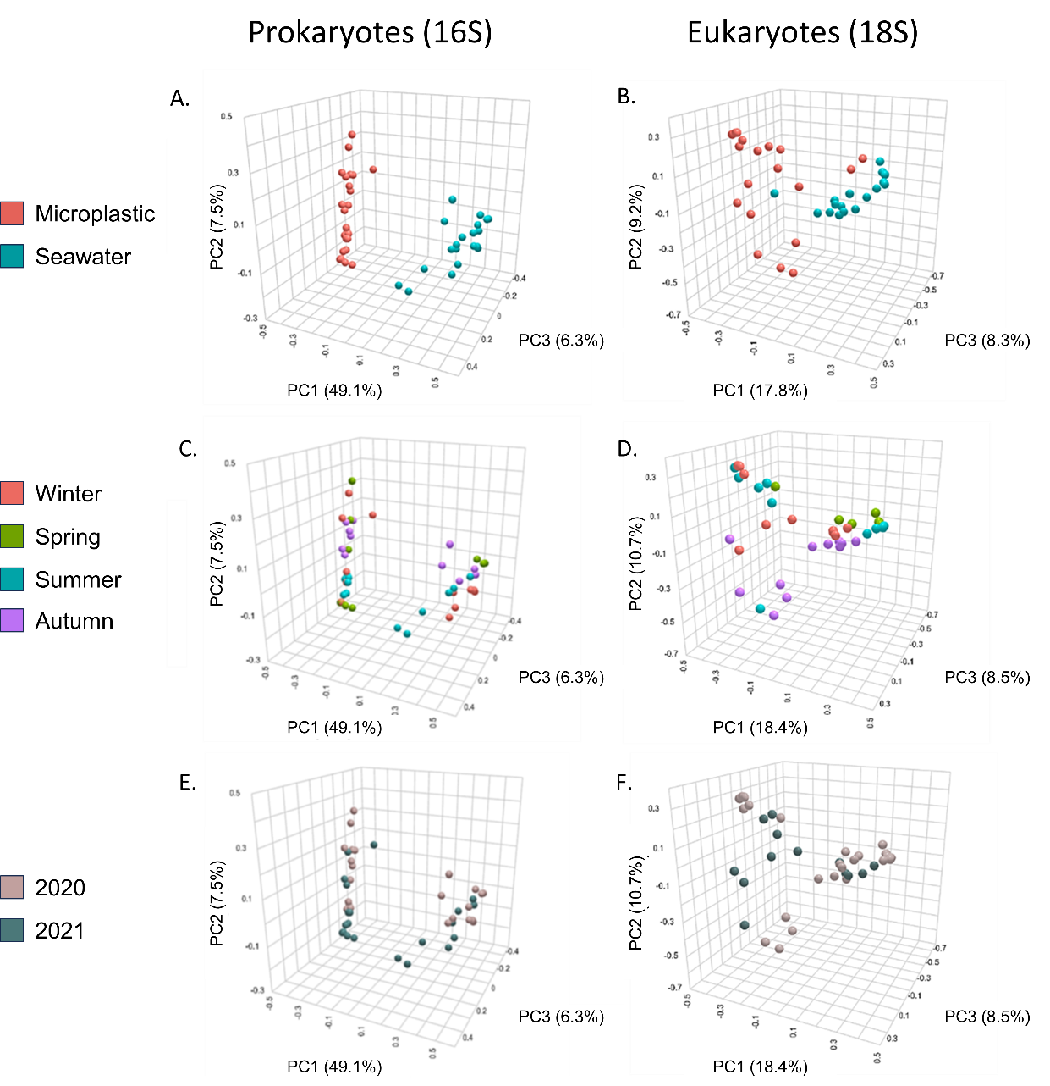
Supplementary figure S4. Prokaryotic and eukaryotic biodiversity across samples (beta diversity). On the Left – Prokaryotes (16S barcode). On the Right side – Eukaryotes (18S barcode). A-B. colored by sample type, C-D. colored by season, E-F. colored by year. Three dimensions represent the three PCA vectors that explain the highest portion of the variance.

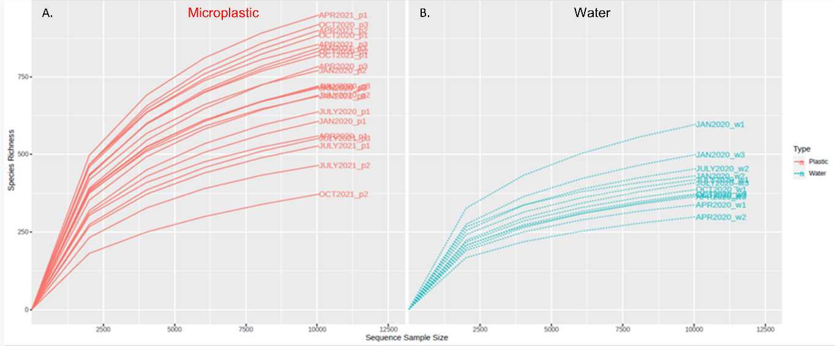
Supplementary figure S4. Rarefication curves of species richness in the 16S metabarcoding datasets. The 10,000-read cutoff was chosen based on the sequencing coverage. A. Microplastic samples. B. Water samples.
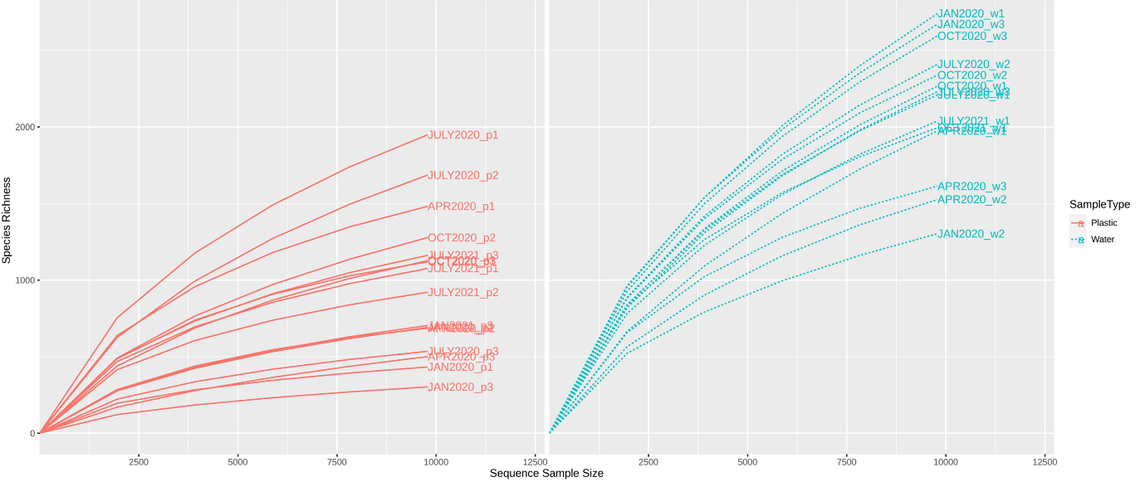
Supplementary figure S5. Rarefication curves of species richness in the 18S metabarcoding datasets. The 10,000-read cutoff was chosen based on the sequencing coverage. A. Microplastic samples. B. Water samples.
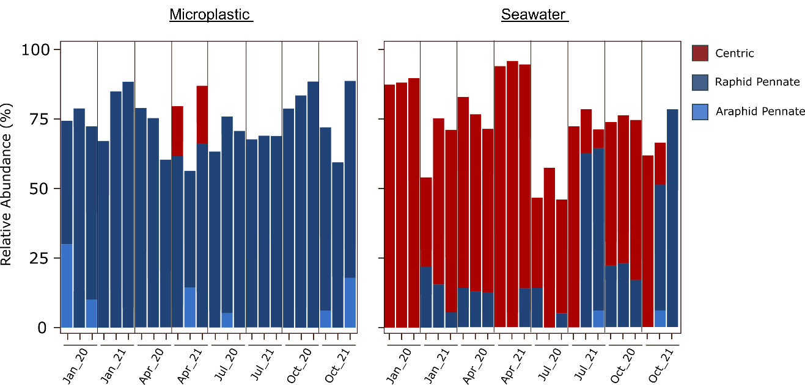
Supplementary figure S6. Classification of diatom morphotypes. Relative 18S rRNA abundance of centric (red), raphid pennate (dark blue) and araphid pennate (light blue) diatoms in (a) plastic and (b) whole seawater samples. Graphs show diatom genera with >5% relative abundance and present within at least three samples

