Table 2. Medical chemistry of Emodin and Emodin-derivative
Property | Emodin | Emodin-  derivative | Comments
MCE-18 | 38 | 42 | MCE-18 stands for medicinal chemistry evolution.  MCE-18 ≥ 45 is considered a suitable value.
SAscore (Synthetic accessibility score is designed to estimate ease of synthesis of drug-like molecules) | 2.409 | 2.550 | SAscore ≥ 6: difficult to synthesize  SAscore < 6: easy to synthesize
Lipinski  Rule | Accepted | Accepted | MW ≤ 500  logP ≤ 5  Hacc ≤ 10  Hdon ≤ 5  If two properties are out of range, a poor absorption or permeability is possible, one is acceptable.
Golden Triangle | Accepted | Accepted | 200 ≤ MW ≤ 500  -2 ≤ logD ≤ 5  Compounds satisfying the Golden Triangle rule may have a more favorable ADMET profile
PAINS | 1 alerts  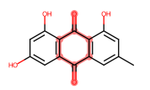 | 1 alerts  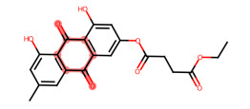 | Pan Assay Inteerference Compounds, frequent hitters, Alpha-screen artifacts and reactive compound.
ALARM NMR | 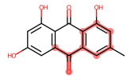  1alerts | 1 alerts  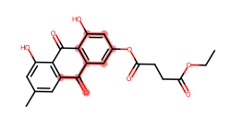 | Thiol reactive compounds.
BMS | 0 alerts | 0 alerts | Undesirable, reactive compounds.
Chelator Rule | 0 alerts | 0 alerts | Chelating compounds.
Caco-2 permeability | -5.149 | -4.911  Caco-2 Permeability ↑ | Optimal: higher than -5.15
MDCK permeability | 1.1e-0.5 | 4.2e-05 | Low permeability: < 2×10⁻⁶ cm/s  Medium permeability: 2-20 × 10⁻⁶ cm/s  High passive permeability: > 20 × 10⁻⁶ cm/s
Pgp-inhibitor | 0.014  (---) | 0.465  (-) | Category 1: Inhibitor  Category 0: Non-inhibitor  The output value is the probability of being Pgp-inhibitor
Pgp-substrate | 0.006  (---) | 0.004  (---) | Category 1: Inhibitor  Category 0: Non-inhibitor  The output value is the probability of being zgp-inhibitor
Human Intestinal Absorption | 0.016  (---) | 0.013  (---) | Value 1: HIA+ ≥ 30%  Value 0: HIA- < 30%  The output value is the probability of being HIA+
F_{20%} | 0.82 | 0.017  Bioavailability ↑ | 20% Bioavailability  Value 1: bioavailability < 20%  Value 0: bioavailability ≥ 20%  The output value is the probability of being F_{20%}+
Plasma Protein Binding | 99.295% | 97.92%  Drug release ↑ | Optimal: < 90%.  Drugs with high protein-bound  may have a low therapeutic index.
Volume distribution | 0.482 | 0.449 | Optimal: 0.04-20L/kg
Blood-Brain Barrier Penetration (BBB) | 0.056  (---) | 0.045  (---) | Category 1: BBB+  Category 0: BBB-  The output value is the probability of being BBB+
Fraction unbound in plasma | 1.64% | 1.035% | Low: < 5%  Middle: 5~20%  High: > 20%
CYP1A2 inhibitor | 0.95  (+++) | 0.956  (+++) | Category 1: Inhibitor  Category 0: Non-inhibitor  The output value is the probability of being inhibitor.
CYP1A2 substrate | 0.338  (-) | 0.121  (--)  Metabolized by CYP1A2 ↓ | Category 1: Substrate  Category 0: Non-substrate  The output value is the probability of being substrate.
CYP2C19 inhibitor | 0.103  (--) | 0.587  (+) | Category 1: Inhibitor; Category 0: Non-inhibitor; The output value is the probability of being inhibitor.
CYP2C19 substrate | 0.054  (---) | 0.052  (---) | Category 1: Substrate  Category 0: Non-substrate  The output value is the probability of being substrate.
CYP2C9 inhibitor | 0.575  (+) | 0.803  (++) | Category 1: Inhibitor  Category 0: Non-inhibitor  The output value is the probability of being inhibitor.
CYP2C9 substrate | 0.479  (-) | 0.408  (-) | Category 1: Substrate  Category 0: Non-substrate  The output value is the probability of being substrate.
CYP2D6 inhibitor | 0.378  (-) | 0.537  (+) | Category 1: Inhibitor  Category 0: Non-inhibitor  The output value is the probability of being inhibitor.
CYP2D6 substrate | 0.184  (--) | 0.174  (--) | Category 1: Substrate  Category 0: Non-substrate  The output value is the probability of being substrate.
CYP3A4 inhibitor | 0.651  (+) | 0.708  (++) | Category 1: Inhibitor  Category 0: Non-inhibitor  The output value is the probability of being inhibitor.
CYP3A4 substrate | 0.114  (--) | 0.141  (--) | Category 1: Substrate  Category 0: Non-substrate  The output value is the probability of being substrate.
Clearance | 9.245 | 7.703  Excretion ↓ | High: > 15mL/min/kg Moderate: 5-15 mL/min/kg  Low: < 5 mL/min/kg
T_{1/2} | 0.385 | 0.609  Half life ↑ | Category 1: long half-life  Category 0: short half-life  The output value is the probability of having long half-life

Table 3. Toxicity of Emodin and Emodin-derivative
Property | Emodin | Emodin-derivative | Comments
hERG Blocker | 0.039  (---) | 0.036  (---) | Category 1: active  Category 0: inactive  The output value is the probability of being active.
Human Hepatotoxicity (H-HT) | 0.046  (---) | 0.066  (---) | Value 1: H-HT positive  Value 0: H-HT negative  The output value is the probability of being toxic
Drug Induced Liver Injury (DILI) | 0.935  (+++) | 0.935  (+++) | Value 1: drugs with a high risk of DILI  Value 0: drugs with no risk of DILI
AMES  Toxicity | 0.823  (++) | 0.8  (++) | Category 1: Ames positive  Category 0: Ames negative  The output value is the probability of being toxic
FDAMDD | 0.916  (+++) | 0.882  (++)  Maximum recommended daily dose ↓ | Maximum recommended daily dose  Category 1: FDAMDD+; Category 0: FDAMDD-  The output value is the probability of being positive.
Skin Sensitization | 0.678  (+) | 0.337  (-)  Skin sensitization ↓ | Category 1: Sensitizer; Category 0: Non-sensitizer;  The output value is the probability of being sensitizer.
Carcinogencity | 0.301  (-) | 0.206  (--)  Carcinogencity ↓ | Value 1: carcinogens;  Value 0: non-carcinogens
Eye corrosion | 0.005  (---) | 0.003  (---) | Category 1: corrosives; Category 0: Non-corrosives;  The output value is the probability of being corrosives.
Eye irritation | 0.961  (+++) | 0.793  (++)  Eye irritation ↓ | Category 1: corrosives; Category 0: Non-corrosives;  The output value is the probability of being corrosives.
Respiratory  Toxicity | 0.076  (---) | 0.039  (---) | Value 1: high-toxicity;  Value 0: low-toxicity;
Bioconcentration factors | 1.566 | 1.143  Emodin residue ↓ | Bioconcentration factors are used for considering secondary poisoning potential and assessing risks to human health via the food chain.
IGC₅₀ | 5.391 | 5.445 | Tetrahymena pyriformis 50 percent growth inhibition  concentration
LC₅₀FM | 4.452 | 4.275 | 96-hour fathead minnow 50 percent lethal concentration
LC₅₀DM | 6.716 | 6.82 | 48-hour daphnia magna 50 percent lethal concentration
Acute Toxicity Rule | 0 alert | 0 alert | Acute toxicity during oral administration
Genotoxic Carcinogenicity  Rule | 1 alert  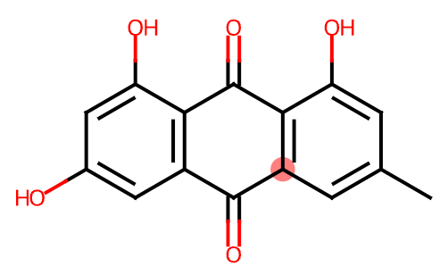 | 1 alert  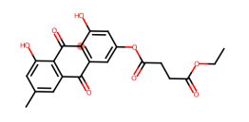 | Carcinogenicity or mutagenicity
Nongenotoxic Carcinogenicity  Rule | 1 alert | 1 alert  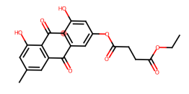 | carcinogenicity through nongenotoxic mechanisms
Skin  Sensitization Rule | 6 alert  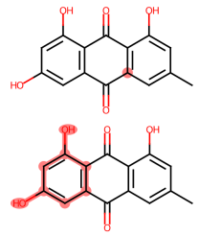  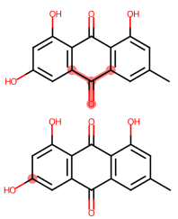  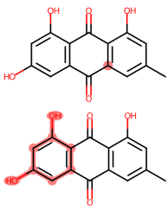 | 4 alert  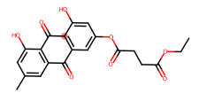  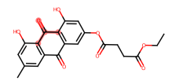  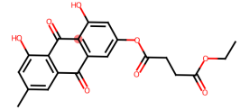  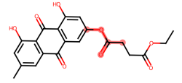  Skin sensitation ↓ | Substructure for skin irration
Aquatic toxicity Rule | 2 alert  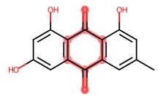  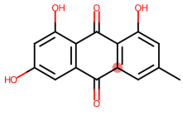 | 2 alert  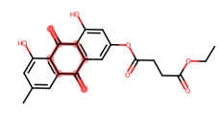  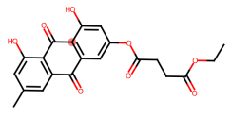 | Toxicity to liquid (water)
Nonbiodegradable Rule | 1 alert  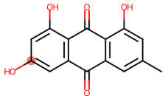 | 0 alert  Biodegradable ↑ | Non-biodegradable
SureChEMBL Rule | 0 alert | 0 alert | MedChem unfriendly status
FAF-drugs 4 Rule | 2 alert  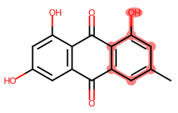  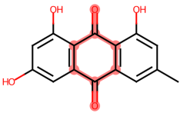 | 2 alert  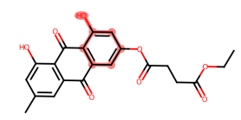  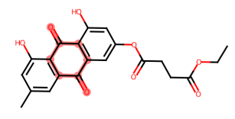 | Toxic substructure from FAF-drugs

