MRI and CT Compatible Asymmetric Bilayer Hydrogel Electrodes for EEG-Based Brain Activity Monitoring

Guoqiang Ren¹, Mingxuan Zhang², Liping Zhuang¹, Lianhui Li³, Shunying Zhao¹, Jinxiu Guo¹, Yinchao Zhao², Zhaoxiang Peng¹, Jiangfan Lian¹, Botao Liu¹, Jingyun Ma¹, Xiaodong Hu¹, Zhewei Zhang¹, Ting Zhang^{3*}, Qifeng Lu^{2*}, and Mingming Hao^{1*}

¹ The Affiliated Lihuili Hospital of Ningbo University, Ningbo, Zhejiang 315046, P. R. China.
² School of CHIPS, XJTLU Entrepreneur College (Taicang), Xi’an Jiaotong-Liverpool University, Taicang, Suzhou, Jiangsu 215400, China.
³ i-lab, Key Laboratory of Multifunctional Nanomaterials and Smart Systems, Suzhou Institute of Nano-Tech and Nano-Bionics (SINANO), Chinese Academy of Sciences (CAS), 398 Ruoshui Road, Suzhou, Jiangsu 215123, P. R. China.

Fig. S1. shows the water loss of the HBE within 48 hours.
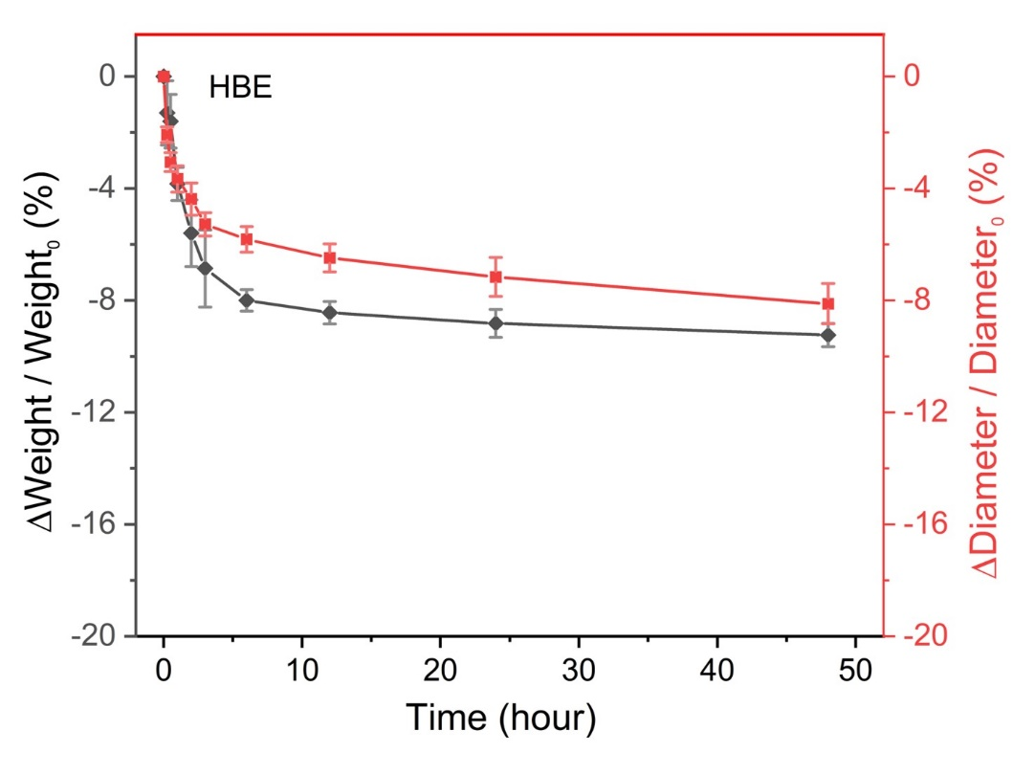
Fig. S1 Weight and diameter change of HBE over a 48-hour period

Fig. S2 shows the representative EEG signals in 295 to 299 seconds with HBE electrodes
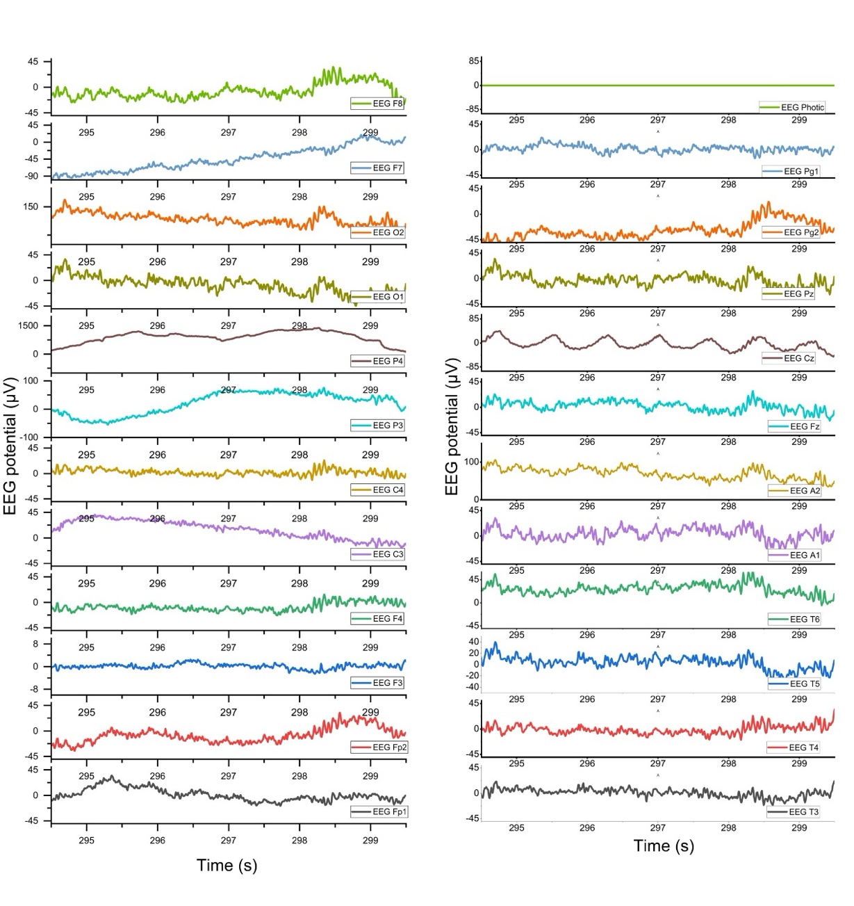
Fig. S2 Representative EEG signals in 295 to 299 seconds with HBE electrodes

Fig. S3 shows the contact impedance between brain electrode and scalp observed during EEG signal detection

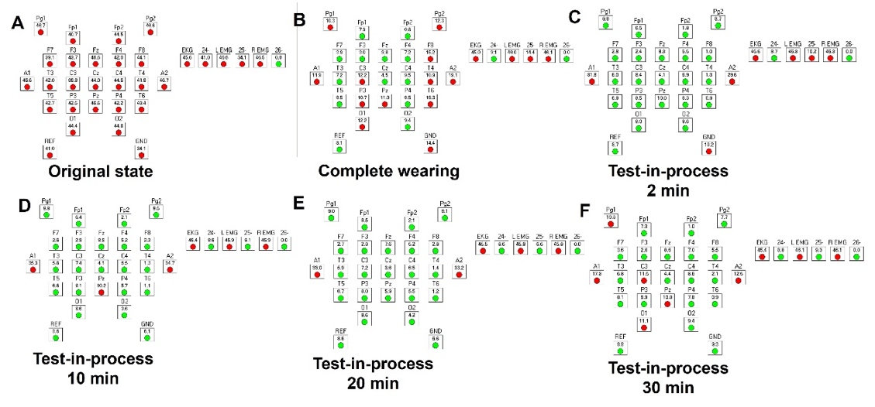
Fig. S3 Changes of impedance with signal acquisition time during EEG collection by HBE

