Extended Data Figure 1. Clinical efficacy. (A) Swimmer plot showing treatment regimen in the neoadjuvant setting, surgery, and follow-up status, per patient. (B) Waterfall plot of maximum percent change in tumor size, from baseline, as measured according to RECIST v1.1. CR, complete response, PR, partial response, SD stable disease, PD, progressive disease. (C) Representative, radiologic response, endoscopic response, and pathologic response, before and after neoadjuvant treatment. (D) Path changes between initial clinical stages of patients and treatment responses. The first column represents the initial clinical staging of patients, ranging from IIA to IIIC. The second column reflects pathological responses to treatment, with tumor regression grade TRG0 to TRG3 denoting a scale from no residual tumor cells to a high proportion of tumor cells remaining. The third column shows post-treatment clinical outcomes by RECIST 1.1 criteria. The last column shows endoscopic response or non-response.

Extended Data Figure 2. Mutational landscape of LARC. (A) Overview of cohort (n = 30) showing proportion of mutational signatures, TMB per megabase, number of somatic SNVs and somatic indels, percent of genomic CNVs, tumor purity, clinical data, and consensus molecular subtypes (CMSs). (B) Box plots of TMBs, CNVs, somatic indels, and somatic SNVs, in responders and non-responders. (C) Number of predicted tumors neoantigen burdens (TNBs). WB, weak binding level, SB, strong binding level. (D) Box plots of the predicted TNBs in responders and non-responders. For all boxplots, P values were calculated based on two-sided Wilcoxon tests.

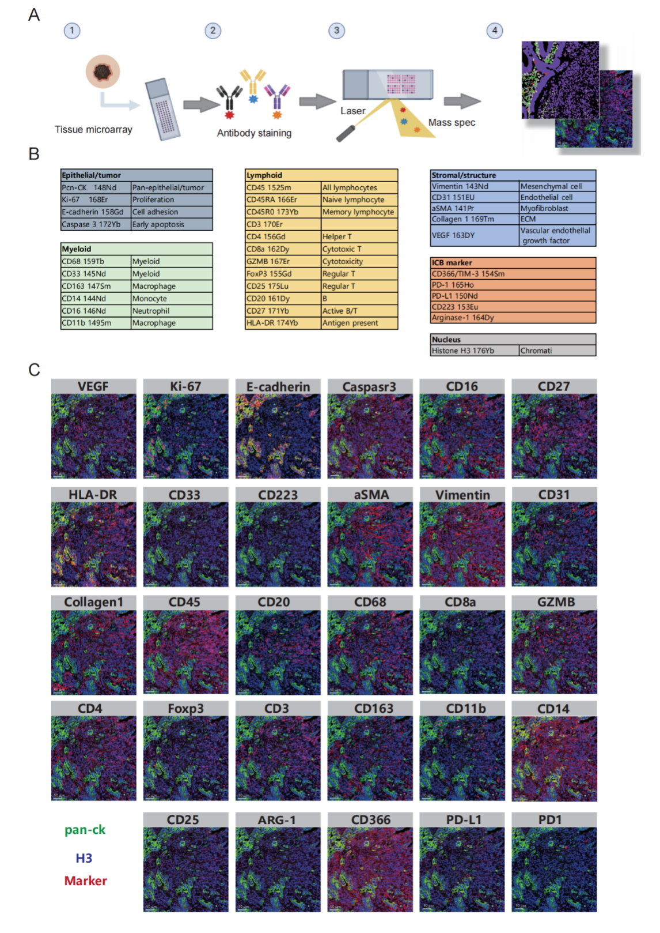
Extended Data Figure 3. IMC workflow. (A) Illustration of the data acquisition workflow used for IMC. (B) Antibody panel targeting 33 protein markers. (C) Representative images of protein expression.

Extended Data Figure 4. Clusters and composition of the LARC immune microenvironment. (A) UMAP projection of immune cells, using identity marker expression. Cells were categorized and labeled, according to cell types identified through clustering. (B) Heatmap of the mean intensity of each identity marker for each immune cell type. (C) UMAP projection of non-immune cells using identity marker expression. Cells were categorized and labeled according to the cell types identified through clustering. (D) Heatmap of the mean intensity of each identity marker, for each non-immune cell type. (E) Total proportion of cells identified for each cell type in responders. (F) Total proportion of cells identified for each cell type in non-responders.

Extended Data Figure 5. Schematic representation of the TME showing the spatial distribution and interactions in responders and non-responders. (A) In responders, more M1 macrophages were present. (B) In non-responders, the TME contained more Ki67^{hi} tumor epithelial cells, in the tumor periphery. (C) Fewer PD-L1⁺ MyoCAFs were distributed close to tumor cells in responders, facilitating interaction between CD8⁺ T cells and tumor cells, activating the TME more easily after treatment. (D) In non-responders, an increased distribution of PD-L1⁺MyoCAFs, close to tumor cells, prevented CD8⁺ T cell interactions with tumor cells, making CD8⁺ T more likely to become exhausted.

