Supplementary Figure 1
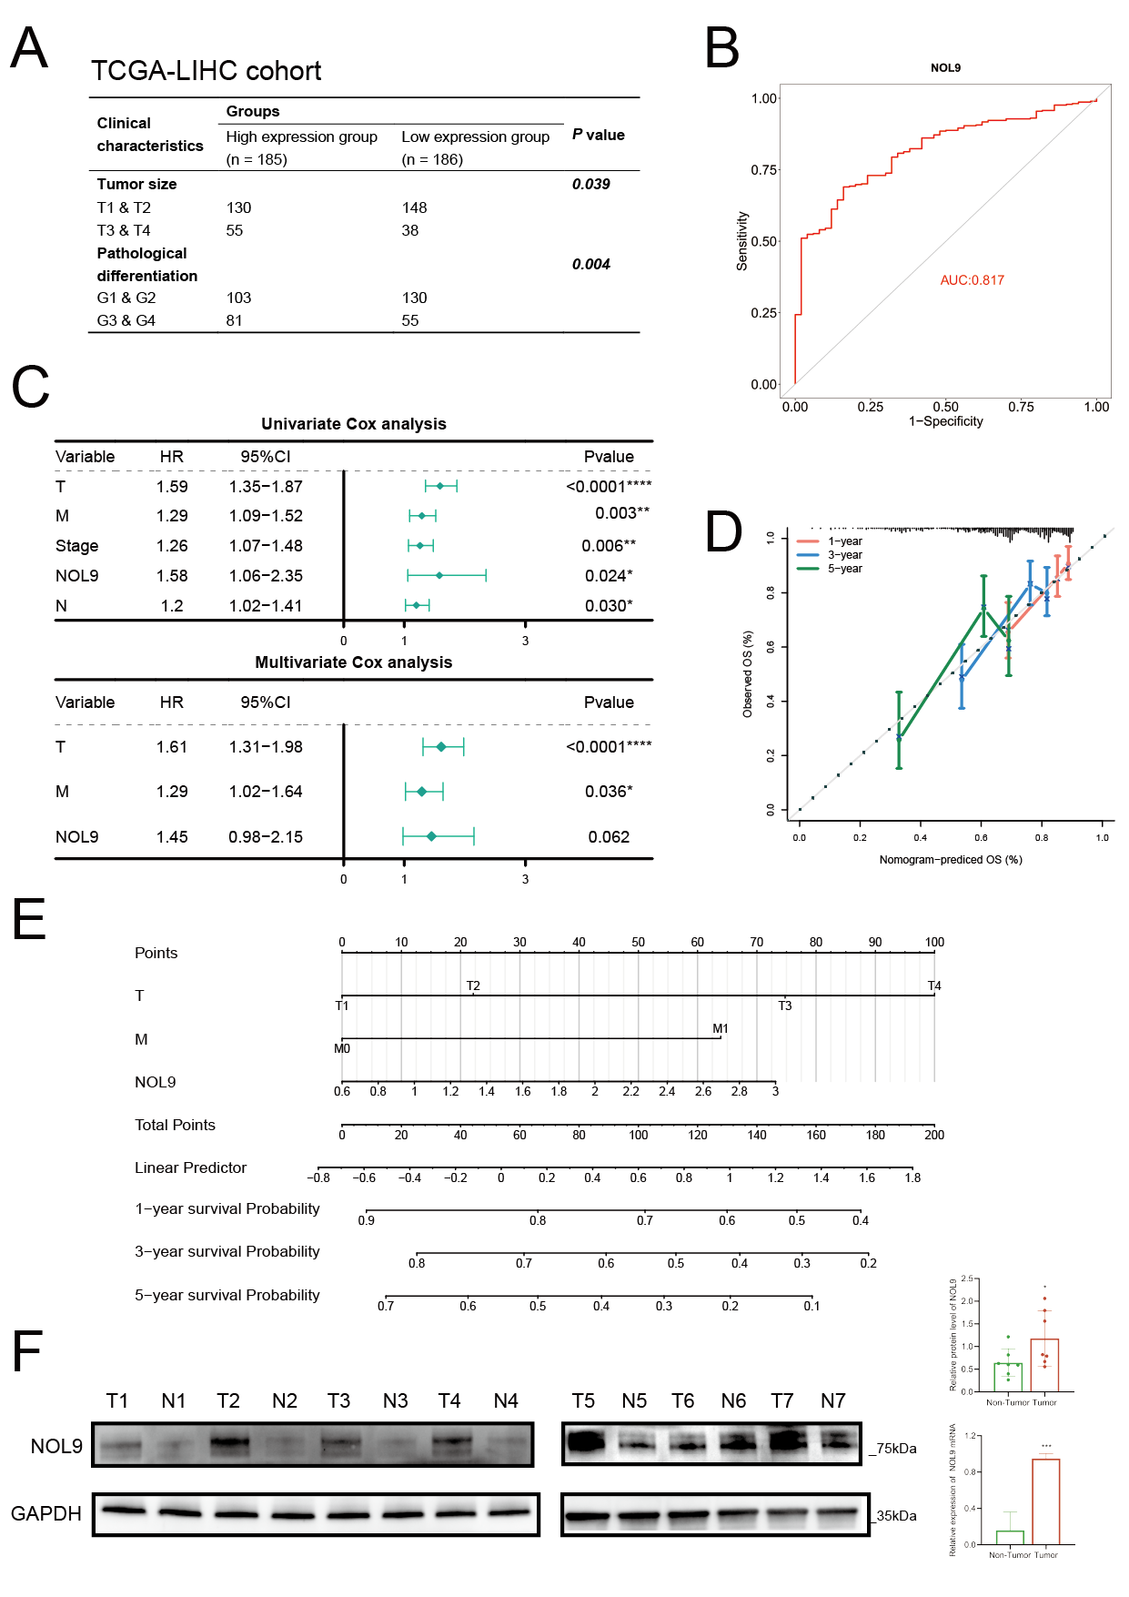

Supplementary Figure 2
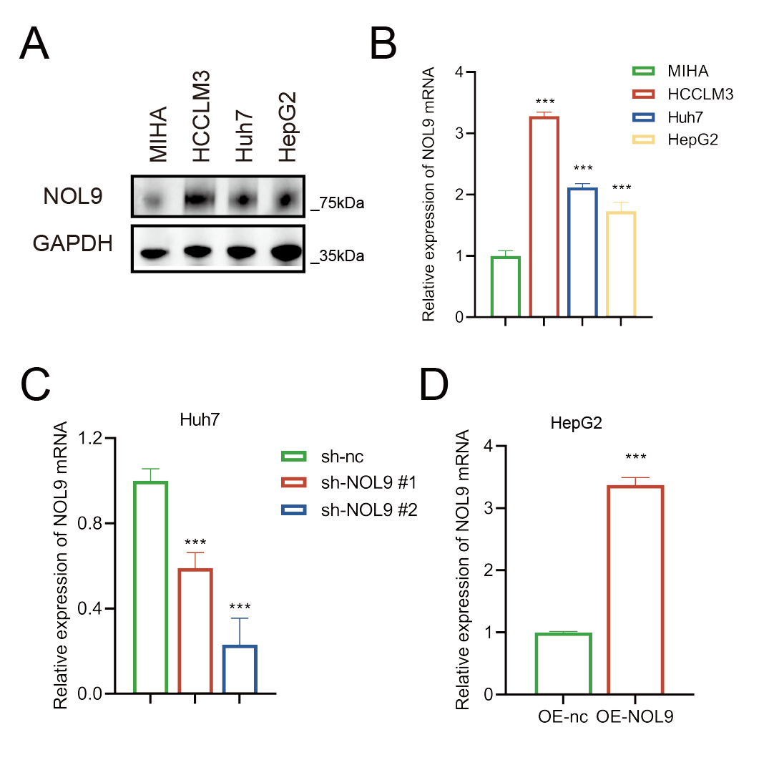

Supplementary Figure 3
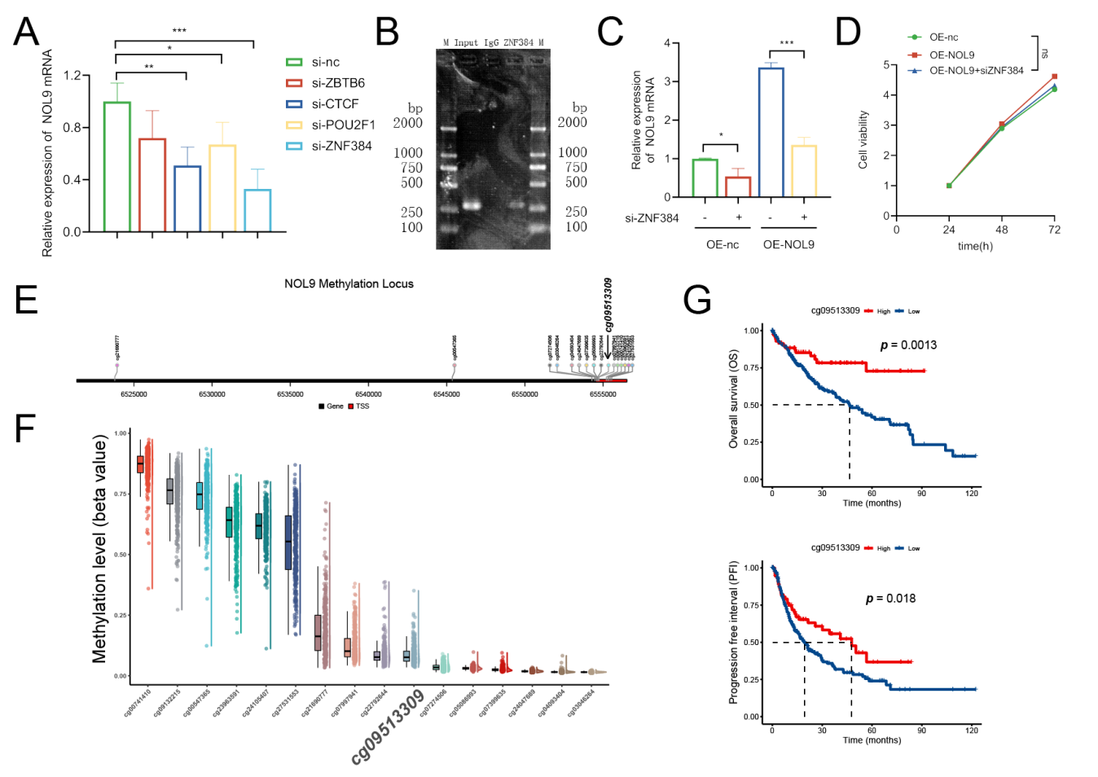

Supplementary Table 1: The Reagents used in this project.

REAGENT | SOURCE | Catalog
Sorafenib | MedChemExpress | HY-10201
5-Aza-2’-deoxycytidine | MedChemExpress | HY-A0004
Cell Counting Kit-8 assays | DOJINDO | CK04
Thymidine Analog 5-ethynyl-2’-deoxyuridine Assays | KeyGEN | KGA337
Crystal violet | Beyotime | C0121
NOL9 antibody for IH | absin | abs139241
NOL9 antibody for WB | abcam | ab140597
GAPDH antibody for WB | abcam | ab8245
β-Tubulin antibody for WB | ABclonal | A12289-50
Rb antibody for WB | CST | 9309S
P-Rb antibody for WB | CST | 8516T
CDK6 antibody for WB | ThermoFisher | PA5-27978
Cyclin D1 antibody for WB | CST | 2978T
β-catenin antibody for WB | CST | 9562S
Goat anti-rabbit IgG-HRP | saiguotech | E030120-01
Goat anti-mouse IgG-HRP | saiguotech | E030110-01
ZNF384 antibody for ChIP | abcam | ab176689
RIPA lysis buffer | EpiZyme | PC101
Polyvinylidene fluoride membranes | Millipore | IPVH00010
Excellent Chemiluminescent Substrate detection kit | EpiZyme | SQ201
RNA Quick Purification kit | ES Science | RN001
Fast Reverse Transcription kit  (5 × Mix with gDNA Remover) | ES Science | RT001
TB Green Premix Ex Taq II | Takara | RR820A
Lipofectamine 3,000 | Invitrogen | SQ201
Puromycin | InvivoGen | Ant-pr-5b
EpiTect Bisulfite Kits | Qiagen | 59104
Annexin V-APC/PI Apoptosis Detection Kit | KeyGEN | KGA1030-100
Cell Cycle Detection Kit | KeyGEN | KGA512
Dual-Luciferase Reporter Assay System | Promega | E1910

Supplementary Table 2: Primer sequences for quantitative real-time PCR.

Gene name | Primer
RT-qPCR
NOL9-F | 5’- ATCTGTCGTGTGACTTGCCTC -3’
NOL9-R | 5’- AAAAATTCTGCATCGACCAACG -3’
GAPDH-F | 5’- ACAACTTTGGTATCGTGGAAGG -3’
GAPDH-R | 5’- GCCATCACGCCACAGTTTC -3’
ChIP
ChIP-NOL9-F | 5’- CATGAGAATCACTTGAGCCCAG -3’
ChIP-NOL9-R | 5’- GTTCAAAGTTCCCTAGAGTCCCAG -3’
MSP
MSP-NOL9-methylated-F | 5’- GTTTTATTTAGGAATTGGGTAGGAC -3’
MSP-NOL9-methylated-R | 5’- CAAATAAAAAATTCTAAAACCTCGC -3’
MSP-NOL9-unmethylated-F | 5’- TTTATTTAGGAATTGGGTAGGATGA -3’
MSP-NOL9-unmethylated-R | 5’- AAATAAAAAATTCTAAAACCTCACA -3’

Nucleolar NOL9 regulated by DNA methylation promotes hepatocellular carcinoma growth by activating wnt/beta-catenin pathway

1. Materials and Methods
1.1 Data Download: The TCGA-LIHC dataset, comprising 524 samples including 374 Cancer and 50 Normal samples, was downloaded from the UCSC Xena database (https://xenabrowser.net/datapages/). The dataset includes gene expression data (log2(FPKM+1)), clinical information, and survival data.

1.2 ROC Curve: The R package “PROR” was utilized to plot the ROC curve for the NOL9 gene.

1.3 Univariate and Multivariate Cox Regression: Clinical variables including age, metastasis (M), node status (N), tumor size (T), gender, and stage were incorporated to group the samples. Wilcoxon rank-sum tests were conducted to assess the significance of these differences between groups. Univariate and multivariate Cox regression analyses were performed using the TCGA database to determine whether NOL9 is an independent prognostic factor. A nomogram was constructed based on the gene expression levels and clinical pathological parameters from the TCGA database to estimate the potential 1-year, 3-year, and 5-year survival rates of LIHC patients. Calibration curves for the nomogram were also created to examine the deviation between predicted and actual survival rates. Utilizing the results from the multivariate analysis, a nomogram incorporating NOL9 gene expression, T, and M data was developed to estimate the 1-year, 3-year, and 5-year survival probabilities for hepatocellular carcinoma (HCC) patients, and calibration curves were generated to assess the agreement between predicted and observed survival.
2. Supplementary Figure Legends
Supplementary Fig.1: A. The correlation of clinical characteristics and NOL9 expression in TCGA-LIHC cohort. B. The diagnostic values of NOL9 in HCC. C. Univariate Cox analysis and multivariate Cox analysis. D-E. A nomogram and a calibration curve of the nomogram. F. Western blotting and RT-qPCR analysis of NOL9 expression in seven paired HCC and tumor-adjacent normal tissues samples, with GAPDH used as loading control.

Supplementary Fig.2: A-B. Western blotting and RT-qPCR analysis of NOL9 expression in the indicated cells, with GAPDH used as loading control. C-D. RT-qPCR analysis of NOL9 expression, with GAPDH used as loading control.

Supplementary Fig.3: A. RT-qPCR analysis of NOL9 expression, with GAPDH used as loading control. B. ChIP assay of the enrichment of ZNF384 on the NOL9 promoter region. C. RT-qPCR analysis of NOL9 expression, with GAPDH used as loading control. D. CCK8 assay. E. Methylation locus in the NOL9 gene. F. The extent of methylation at different loci in the NOL9 gene. G. Overall survival is higher in HCC patients with high cg09513309 methylation; Progression free interval is higher in HCC patients with high cg09513309 methylation.

