Supplementary Materials:

Developing a Risk Model of lipid metabolism-associated genes: Implications for Clinical Prognosis and Tumor Immune Microenvironment in Gastric Cancer

Yanan Xiao, Qin Yu, Zewen Zhu, Shan Zhou, Zhe Wu, Xin Luo, Hui Peng, Zhiqiang Zhan

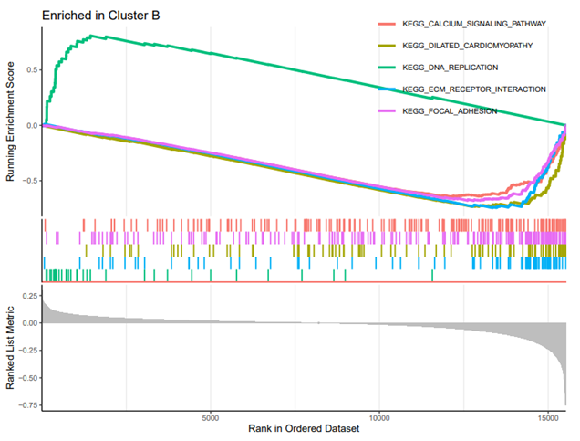

Figure S1 Gene set enrichment analysis of the top 5 pathways significantly enriched in the risk groups

Table S1：Summary of patients' clinic characteristics
Characteristics |  | Entire set |  | Training set |  | Texting set
 |  | Number | Percentage | Number | Percentage | Number | Percentage
Age
＜60 year |  | 129 | 28.41% | 79 | 61.24% | 50 | 38.76%
≥60 year |  | 304 | 70.21% | 182 | 59.87% | 122 | 40.13%
Gender
Female |  | 152 | 35.10% | 93 | 61.18% | 59 | 38.82%
Male |  | 281 | 64.90% | 196 | 69.75% | 85 | 30.25%
Stage
Stage I-II |  | 187 | 43.19% | 111 | 59.36% | 76 | 40.64%
Stage III-VI |  | 225 | 51.96% | 164 | 72.89% | 61 | 27.11%
Not available |  | 21 | 4.85% | 13 | 61.90% | 8 | 38.10%
T
T1-2 |  | 112 | 25.87% | 67 | 59.82% | 45 | 40.18%
T3-4 |  | 316 | 72.98% | 224 | 70.89% | 92 | 29.11%
Not availabe |  | 5 | 1.15% | 3 | 60.00% | 2 | 40.00%
M
M0 |  | 382 | 88.22% | 283 | 74.08% | 99 | 25.92%
M1 |  | 30 | 6.93% | 19 | 63.33% | 11 | 36.67%
Not available |  | 21 | 4.85% | 13 | 61.90% | 8 | 38.10%
N
N0 |  | 131 | 30.25% | 71 | 54.20% | 60 | 45.80%
N1-3 |  | 289 | 66.74% | 214 | 74.05% | 75 | 25.95%
Not available |  | 13 | 3.00% | 8 | 61.54% | 5 | 38.46%

