High-throughput separation of microalgae on a runway-shaped channel with ordered semicircular micro-obstacles
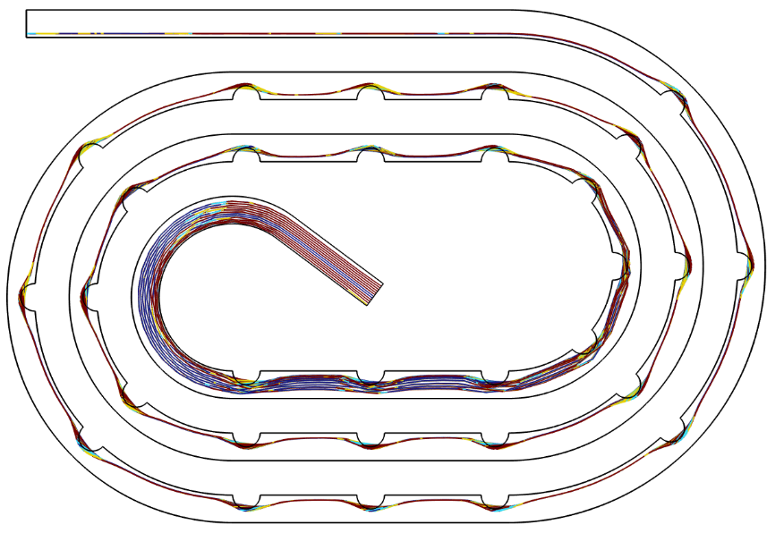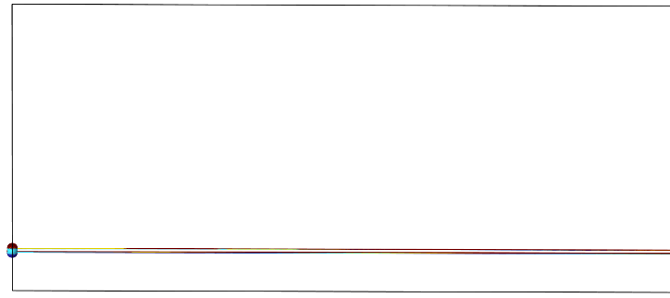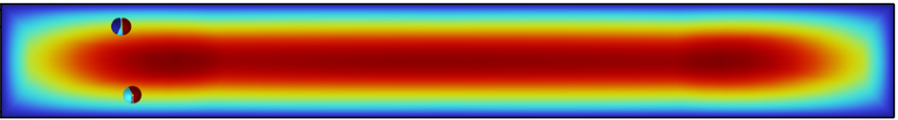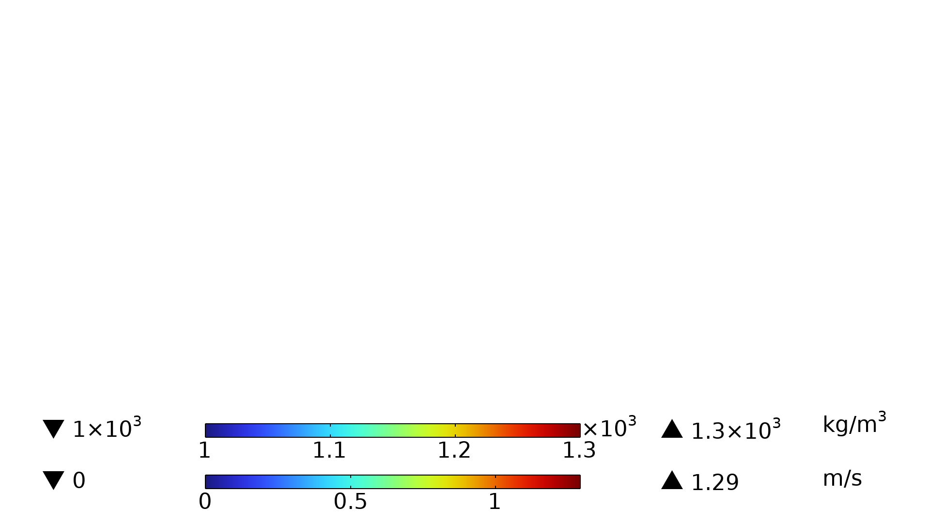
y
z
x
y
x
y
inner wall
outer wall
Velocity(m/s)
Density (kg/m³)
Density (kg/m³)
Inner wall
Outer wall

(a)
(b)
(c)
Fig. s1 Particle trajectories of different densities of particles with a size of 15 μm: (a) Particle trajectories at the microchannel with micro-obstacles; (b) Particle trajectories at the outlet; (c) Particle distribution in the outlet cross-section.
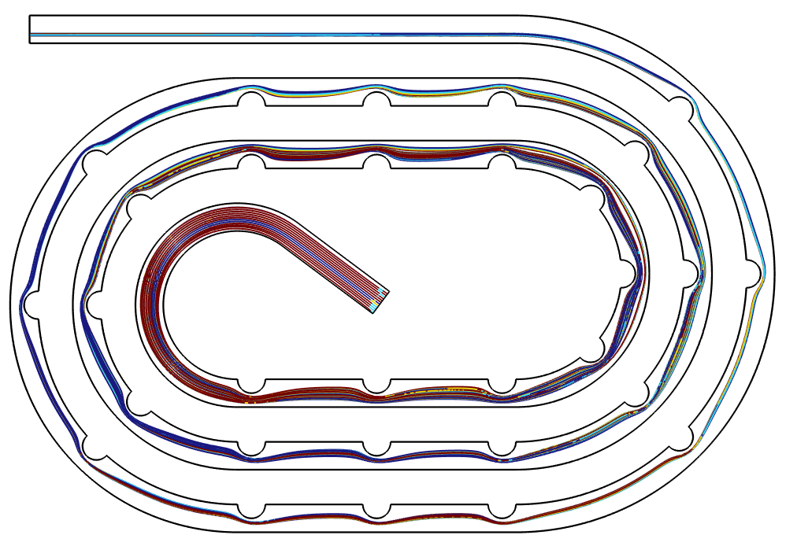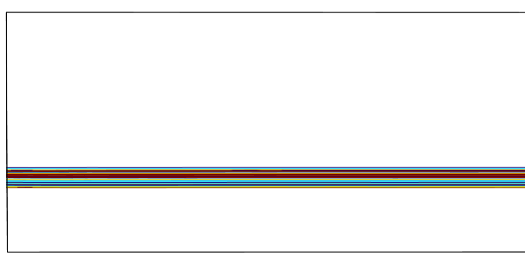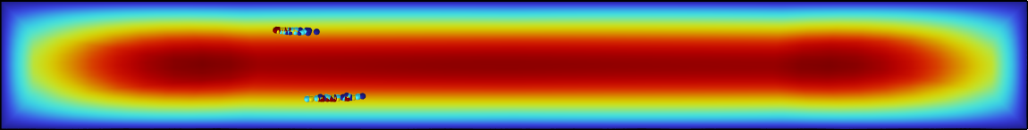
(c)
x
y
Density (kg/m³)
x
y
inner wall
outer wall
Density (kg/m³)
(a)
(b)
Inner wall
Outer wall

y
z
Velocity(m/s)
Fig. s2 Particle trajectories of different densities of particles with a size of 5 μm: (a) Particle trajectories at the microchannel with micro-obstacles; (b) Particle trajectories at the outlet; (c) Particle distribution in the outlet cross-section.
The effect of density on the focusing position of 15 μm and 5 μm particles was verified at a flow rate of 0.8 m/s. The density of fluorescent microbeads is about 1050 kg/m³, and the density of algae is about 1200 kg/m³, so four densities of 1000/1100/1200/1300 were selected for simulation verification. As can be seen from the results in Fig.s 1, the 15 μm particle positions of the four densities are very close to each other and almost overlap. As shown in Fig. s2, the 5 μm particles form a focusing band near the centerline of the channel, and the focusing bands of the particles of different densities are only a few μm away, and the positions of most of the particles overlap. So the smaller density difference has little effect on the focusing behavior of particles of the same size and does not affect the separation effect.

