Transdermal Microneedle Patch for Antioxidants Release
Samuel Mugo*ª, Scott Robertsonª and Weihao Luª
ª Physical Sciences Department, MacEwan University, 10700-104 Avenue, Edmonton,
AB, T5J 4S2 Canada. E-mail: mugos@macewan.ca; Tel: (+1) 780-633-3493; Fax: (+1) 780-497-5655

Supporting Documentation:
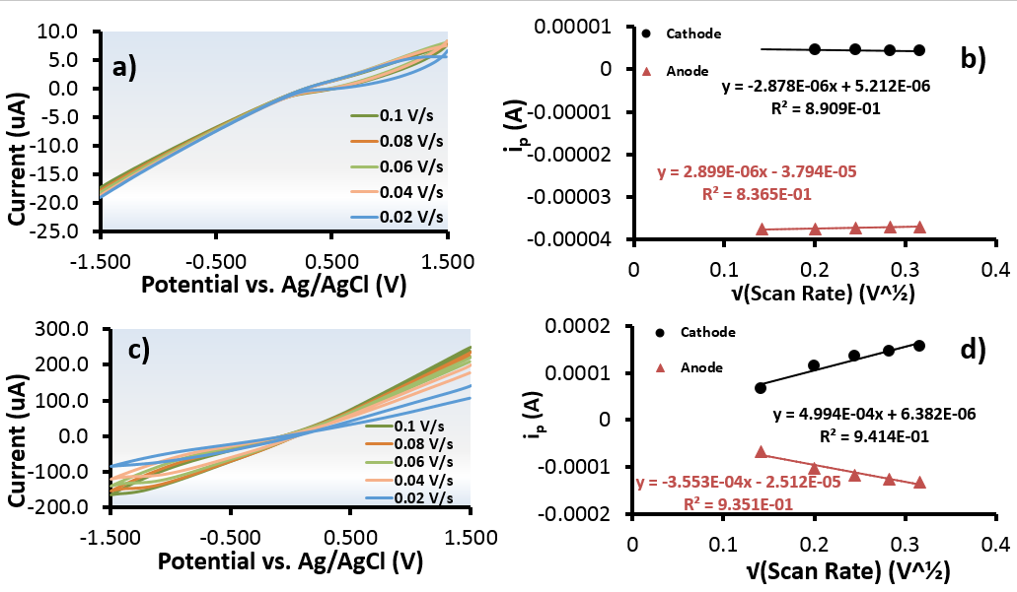
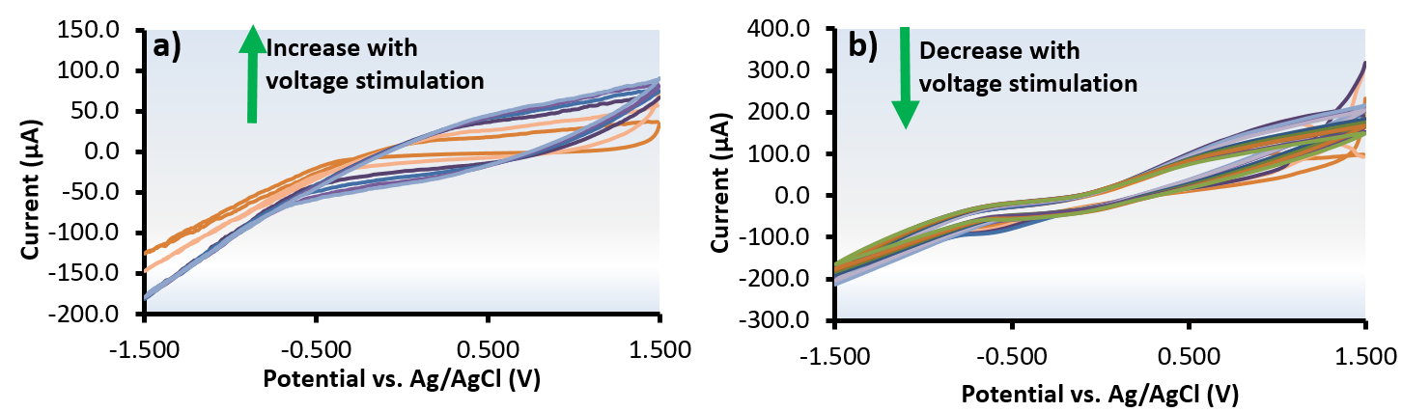
Figure S1. Overlaid cyclic voltammograms and resulting plot of peak current vs. square root of scan rate of differing scan rates for a) and b) PDMS@CNC/CNT microneedle base; c) and d) 0.2 M PDMS@CNC/CNT@PANI; in 25 mM K₃[Fe(CN)₆] solution in 0.1 M PBS.

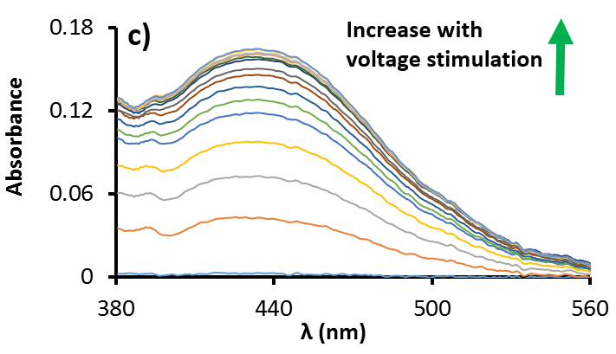

Figure S2. Representative cyclic voltammograms for thymol blue (dissolved in 100% ethanol) release from a) PDMS@CNC/CNT microneedle base; and b) PDMS@CNC/CNT@PANI patch into PBS (0.1 M, pH 7.1). c) Representative overlapped spectra for voltage-mediated thymol blue PDMS@CNC/CNT@PANI microneedle array release.
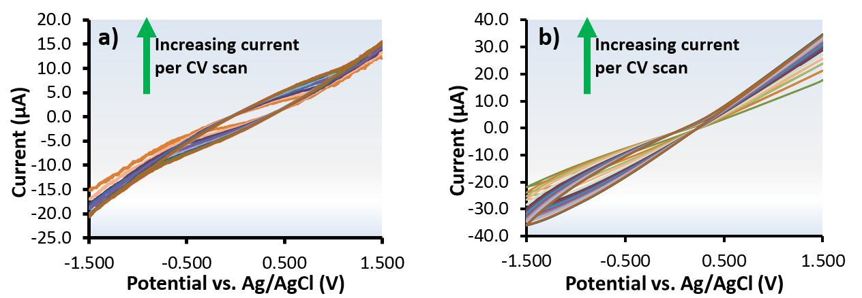
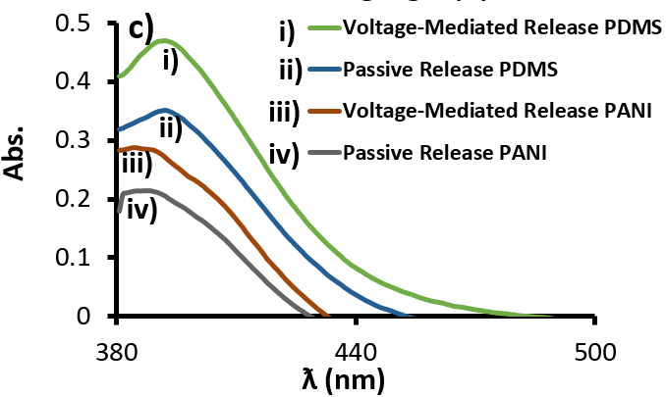

Figure S3. Representative cyclic voltommograms for a) rutin (dissolved in 20 % diethylamine) release from PDMS microneedle base into PDMS skin mimic; and b) rutin (dissolved in 20 % diethylamine) release from PANI@PDMS patch into PDMS skin mimic. c) Overlapped spectra for rutin release from PDMS@CNC/CNT (PDMS) PDMS@CNC/CNT@PANI (PANI) microneedle array.
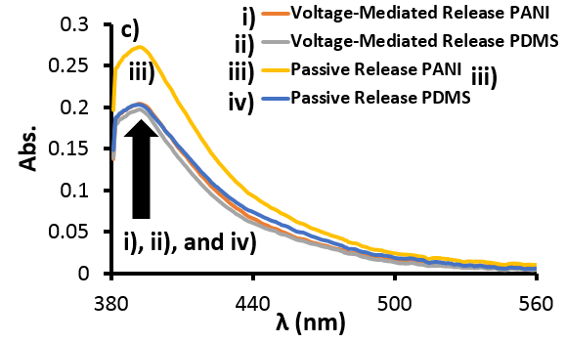
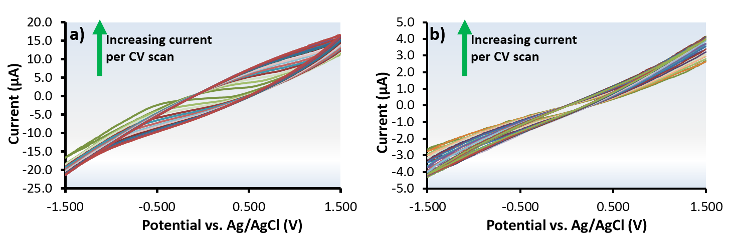

Figure S4. Representative cyclic voltommograms for a) rutin (dissolved in 20 % diethylamine) release from PDMS microneedle base; b) rutin (dissolved in 20 % diethylamine) release from PANI@PDMS patch into chicken skin; c) Overlapped spectra for rutin release from PDMS@CNC/CNT (PDMS) and PDMS@CNC/CNT@PANI (PANI) microneedle array.

