Supplementary Files
c.
b.
a.
TET2 CHIP

DNMT3A CHIP

Any CHIP

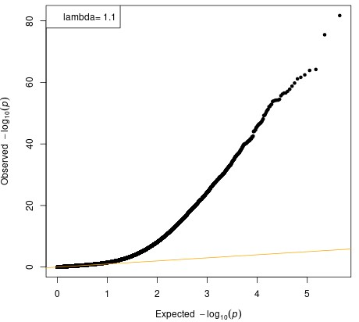
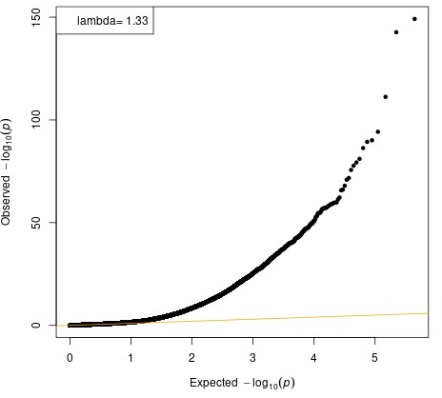
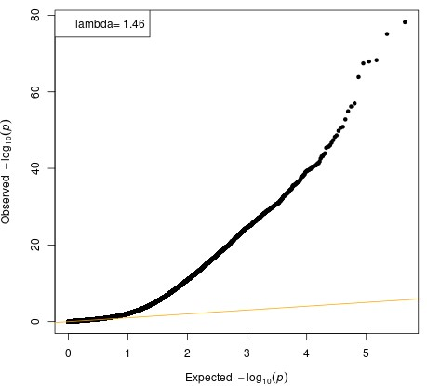

d.
ASXL1 CHIP
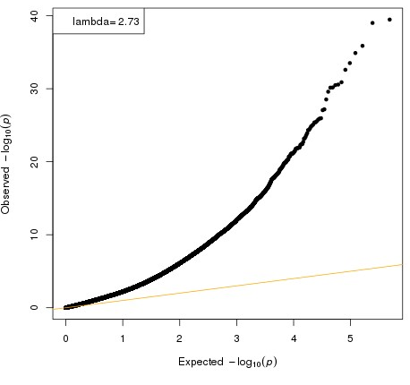

Supplementary Figure 1: Quantile-quantile plots in multiracial meta-EWAS of CHIP and CHIP subtypes. Genomic inflation factors were computed for the meta-EWAS of any CHIP and CHIP subtypes. (a) λ = 1.46 for any CHIP, (b) λ = 1.33 for DNMT3A CHIP, (c) λ = 1.1 for TET2 CHIP, and (d) λ = 2.73 for ASXL1 CHIP.

a.
c.
b.
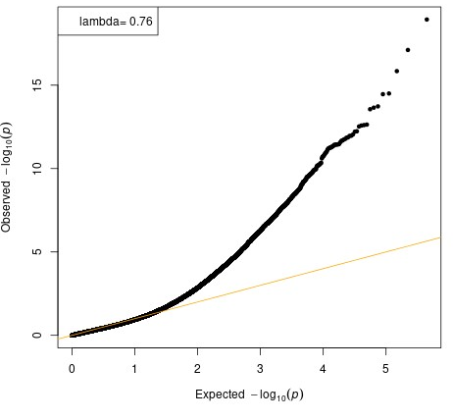
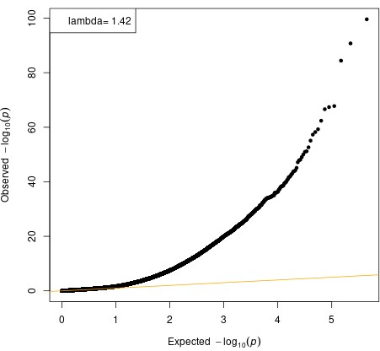
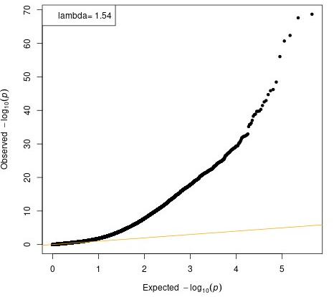
TET2 CHIP

DNMT3A CHIP

Any CHIP

Supplementary Figure 2. Quantile-quantile plots in CHIP meta EWAS of Black participants. Genomic inflation factors were computed for the meta-EWAS of any CHIP and CHIP subtypes in Black participants. (a) λ = 1.54 for any CHIP, (b) λ = 1.42 for DNMT3A CHIP, (c) λ = 0.76 for TET2 CHIP.
c.
b.
a.
Any CHIP

TET2 CHIP

DNMT3A CHIP

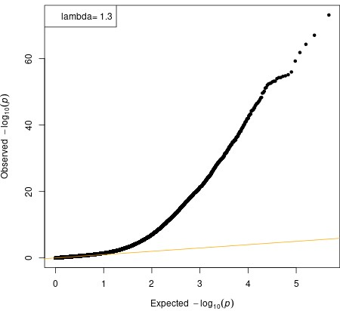
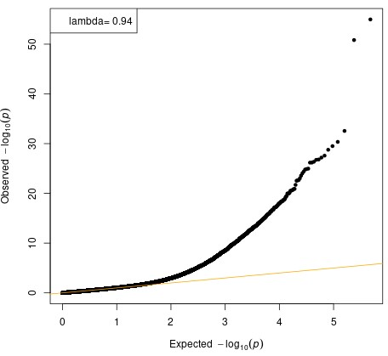
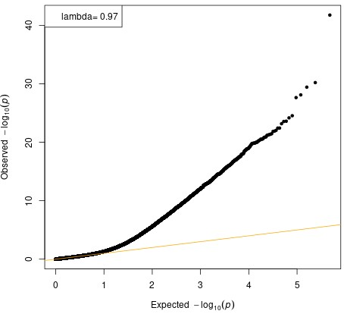

Supplementary Figure 3. Quantile-quantile plots in CHIP meta EWAS of White participants. Genomic inflation factors were computed for the meta-EWAS of any CHIP and CHIP subtypes in White participants. (a) λ = 0.97 for any CHIP, (b) λ = 0.94 for DNMT3A CHIP, (c) λ = 1.3 for TET2 CHIP.

b.
a.
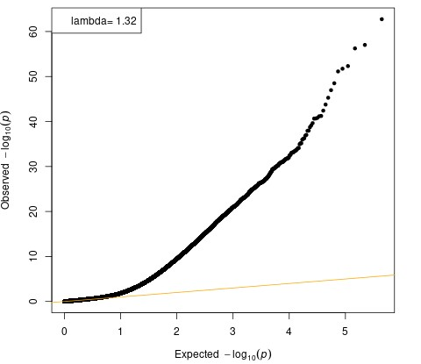
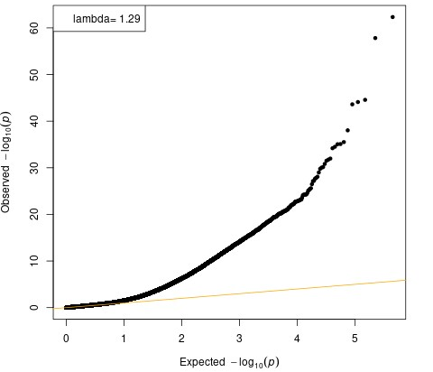

c.

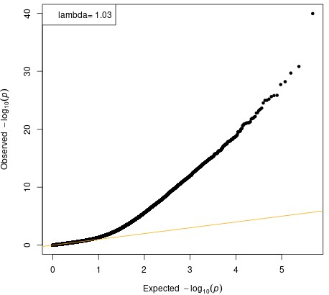

Supplementary Figure 4. Quantile-quantile plots for meta-EWAS of any CHIP with VAF > 10%. Genomic inflation factors were computed for the meta-EWAS of any CHIP with VAF > 10% in (a) all races: λ = 1.32, (b) in Black participants: λ = 1.29, (c) in White participants: λ = 1.03.

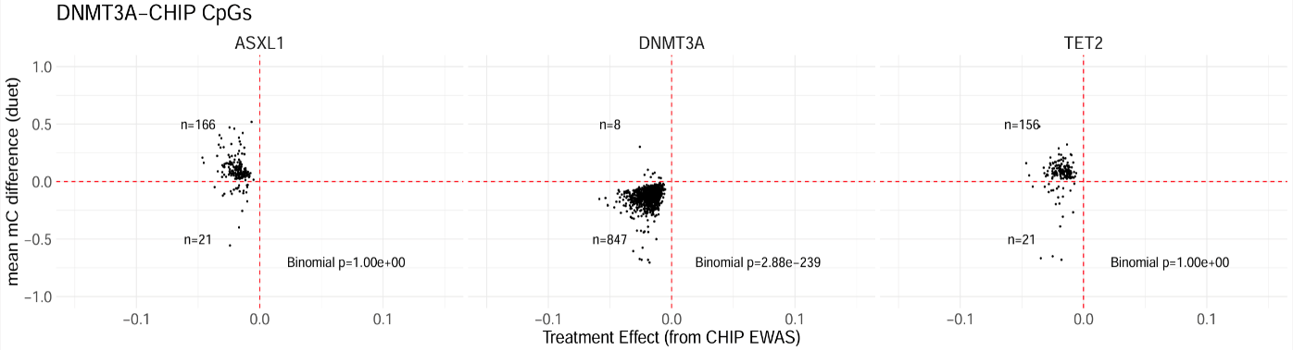
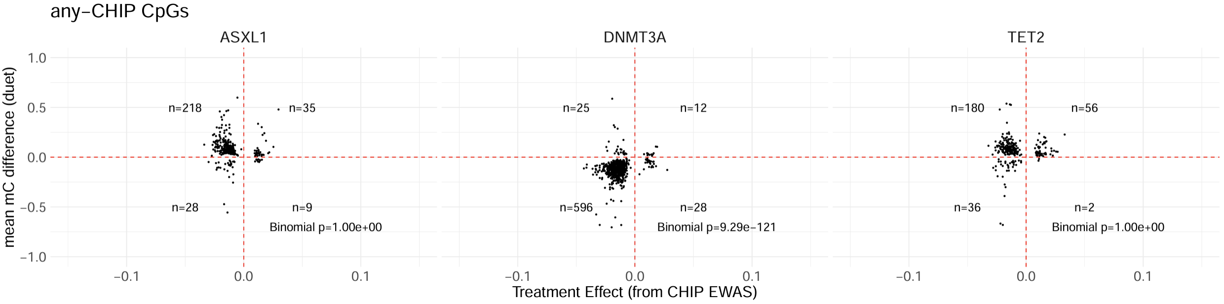
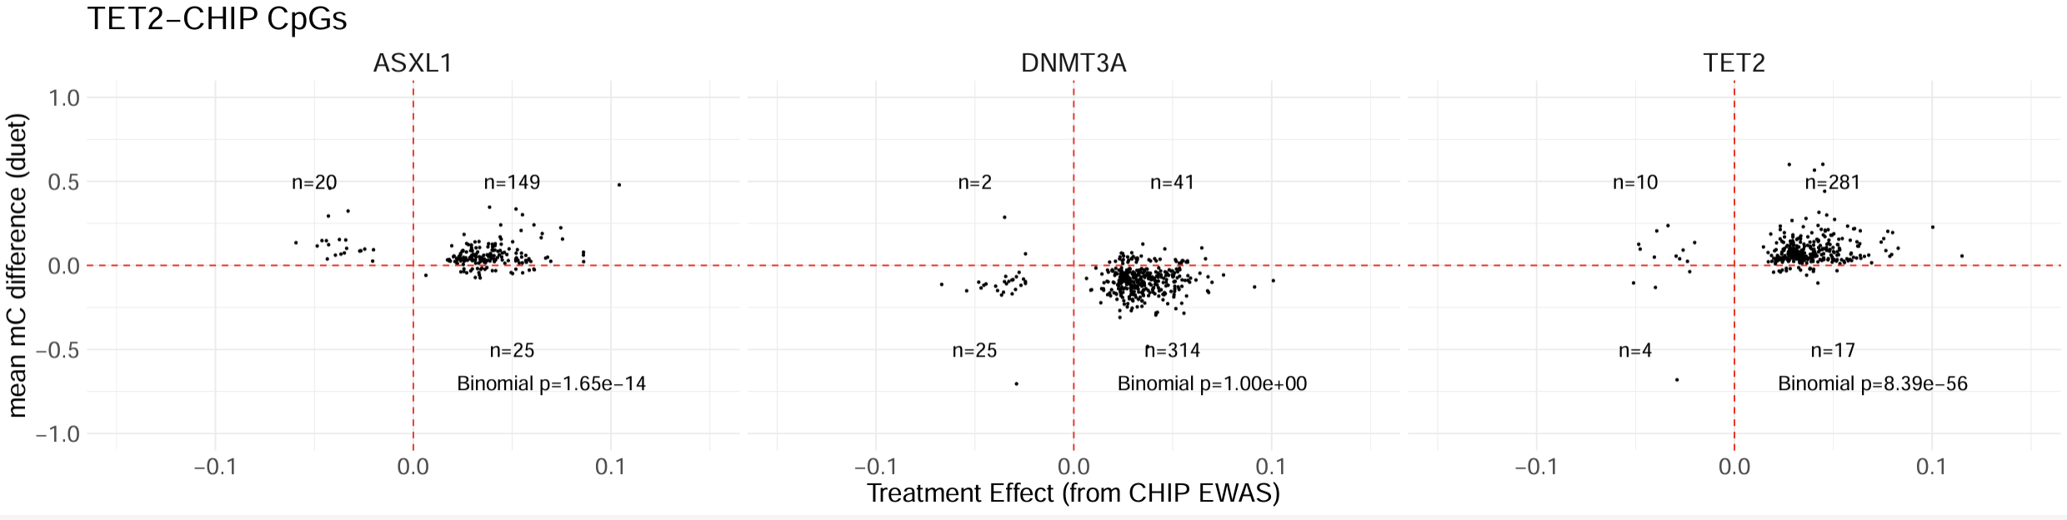
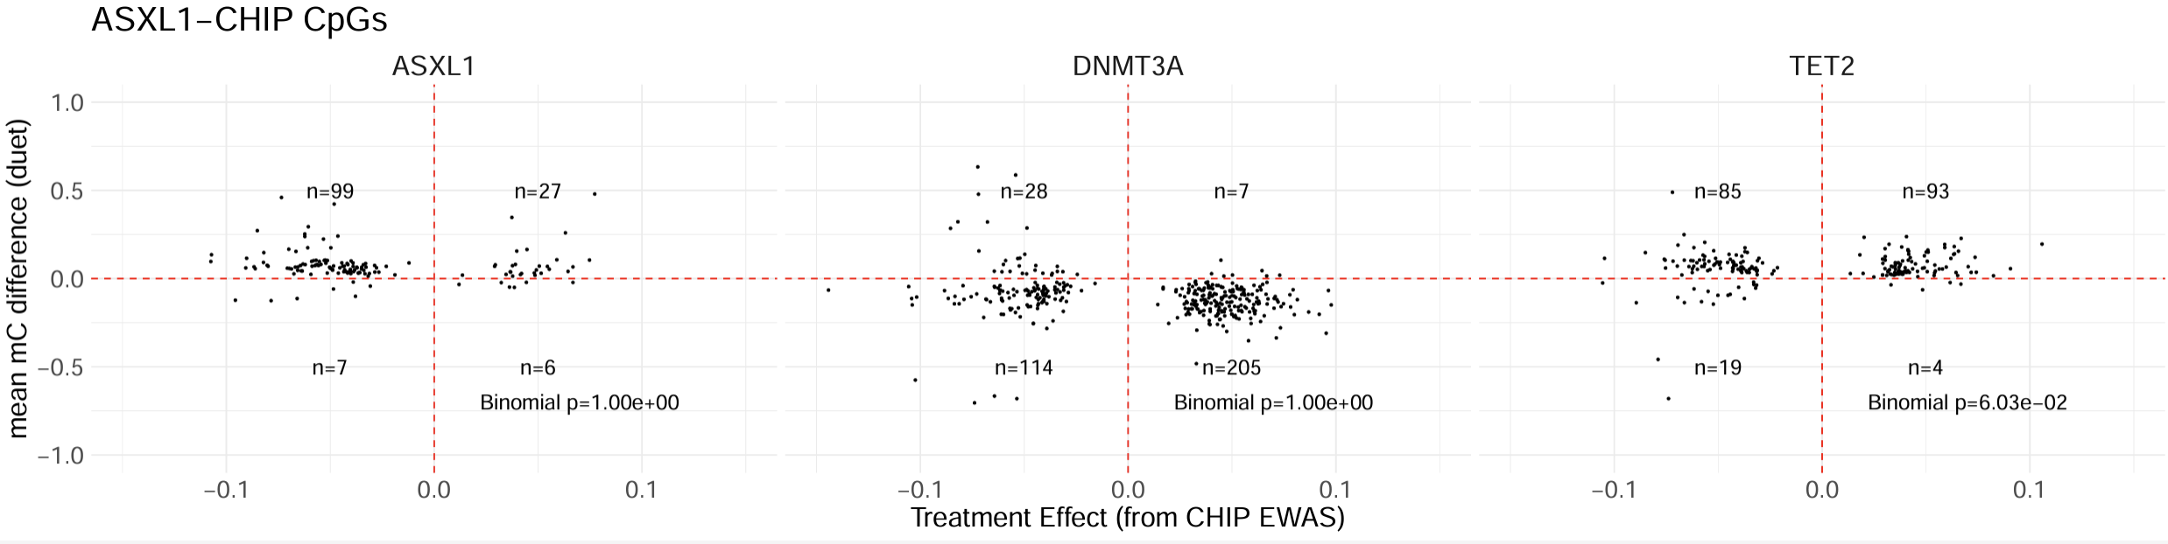
Supplementary Figure 5. Correlation of CpG Sites in Engineered Human Stem Cells
Dot plots of methylation status from -1.0 (no methylation) to 1.0 (complete methylation) seen in engineered primary cell cultures compared to correlation of EWAS results ranging from -0.1 to 0.1. Significance was determined with a binomial test. A) Comparison of any CHIP CpG sites compared to each engineered cell line. B) Comparison of DNMT3A-CHIP CpG sites compared to each engineered cell culture. C) Comparison of TET2-CHIP CpG sites compared to each engineered cell culture. D) Comparison of ASXL-1 CHIP CpG site compared to each engineered cell culture.

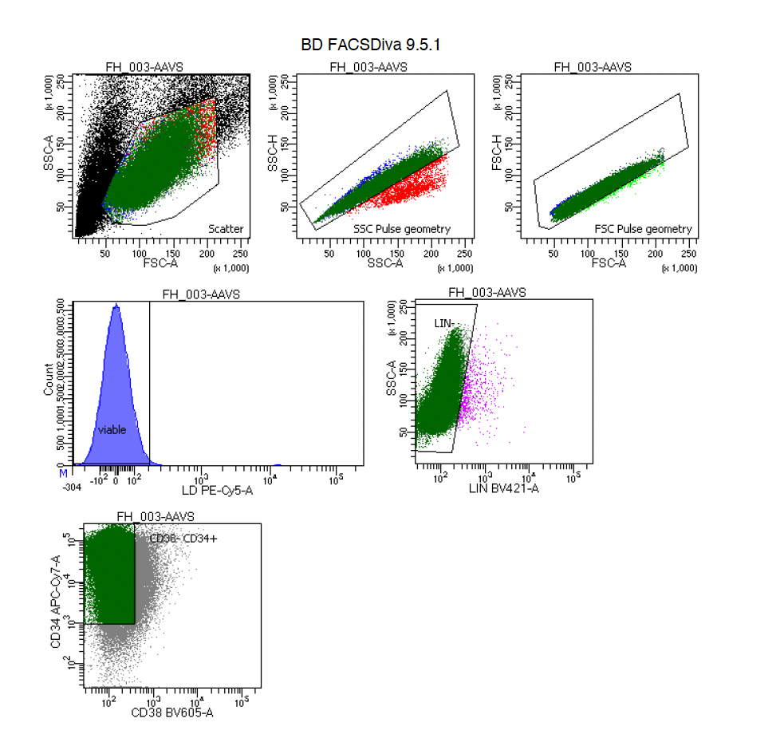
Supplementary Figure 6. Representative Fluorescent Activated Cell Sorting
Flow gating strategy for sorting human hematopoietic stem cells using 7-AAD (live/dead stain), CD34+ (APC-Cy7), CD38- (BV605), and Lineage- (Pacific Blue).

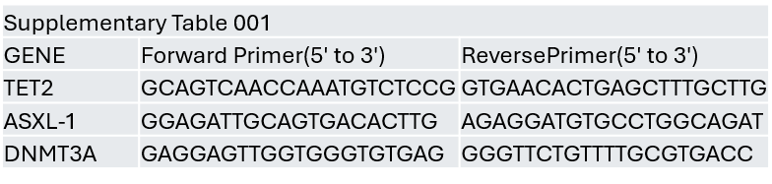
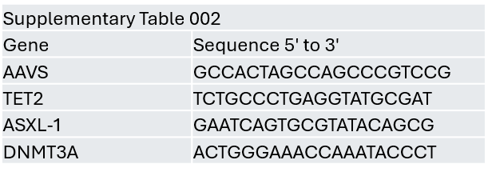
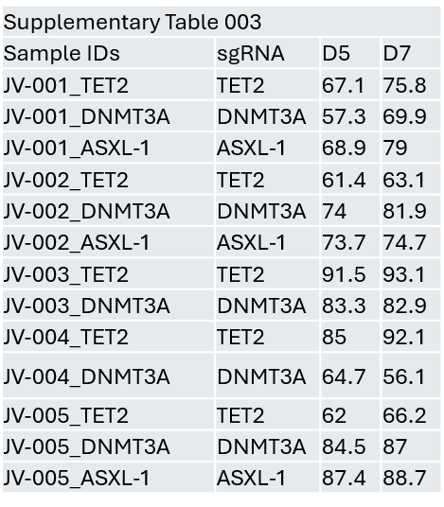
Supplementary Figure 7. Primer sequences for assessing indel formation present in each sgRNA.
Supplementary Figure 8. Single guide RNA sequences
SgRNA sequences for each guide RNA targeting AAVS, TET2, ASXL1, and DNMT3A.
Supplementary Figure 9. Indel Formation
TIDE results assessing indel formation from the various sgRNAs (seen in supplementary table 002) at Day 5(D5) and Day 7(D7) post knockout with CRISPR-Cas9. Each PCR product was amplified with primer sequences seen in supplementary table 001 compared to either scramble or AAVS control samples towards each of the following sgRNAs.
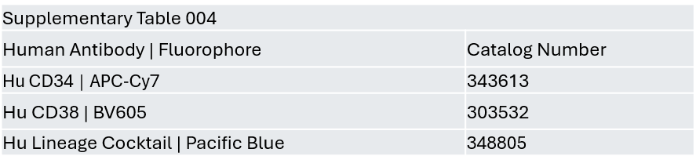
Supplementary Figure 10. Human Antibodies
Human Antibodies used towards CD34, CD38 and Lineage cocktail all from Biolegend.
.
Supplementary Table 004: Human Antibodies
Human Antibodies used towards CD34, CD38 and Lineage cocktail all from Biolegend.

