Supplementary Material

Title: COVID-19 vaccination atlas: an integrative systems vaccinology approach
Authors: Wasim Aluísio Prates-Syed^{1,2,16}, Dennyson Leandro Mathias da Fonseca³, Shahab Zaki Pour⁴, Lena F Schimke², Aline Lira^{1,2,16}, Nelson Cortes^{1,2,16}, Jaqueline Dinis Queiroz Silva^{1,6,16}, Evelyn Carvalho^{1,6,16}, Igor Salerno Filgueiras², Tania Geraldine Churascari Vinces⁵, Lorena C. S. Chaves⁷, Gerhard Wunderlich⁵, Ricardo Durães-Carvalho^{4,8}, Niels O. S. Câmara¹, Haroldo Dutra Dias¹², Hans D. Ochs¹¹, José E. Krieger¹⁰, Helder I Nakaya^{6,13}, Otávio Cabral-Marques^{1,3,6,15,16,+}, Gustavo Cabral-Miranda^{1,2,6,16, +,*}.
Emails: wasim.syed@usp.br, dennyson@usp.br, shahab.178@gmail.com, igor.filgueiras@usp.br, lenaschimke@hotmail.com, cv.tania@usp.br, aline.llira@usp.br, nelson.cortes@usp.br, jaquelinedinis@gmail.com, evelyn.carvalho@unesp.br, lorenacschaves@gmail.com, gwunder@usp.br, rdcarval@gmail.com, niels@icb.usp.br, haroldodd@gmail.com, hans.ochs@seattlechildrens.org, sabinoec@usp.br, j.krieger@hc.fm.usp.br, hnakaya@usp.br, otavio.cmarques@usp.br, gcabral.miranda@usp.br
Affiliations:
- Department of Immunology, Institute of Biomedical Sciences (ICB), University of São Paulo (USP), São Paulo, Brazil.
- The Interunits Graduate Program in Biotechnology of the University of São Paulo, the Butantan Institute, and the Technological Research Institute of the State of São Paulo, Brazil.
- Interunit Postgraduate Program on Bioinformatics, Institute of Mathematics and Statistics (IME), University of Sao Paulo (USP), Sao Paulo, Brazil.
- Laboratory of Molecular Evolution and Bioinformatics, Department of Microbiology, Biomedical Sciences Institute, University of São Paulo, São Paulo, Brazil;
- Department of Parasitology, Institute of Biomedical Sciences (ICB), University of São Paulo (USP), São Paulo, Brazil.
- Department of Clinical and Toxicological Analyses, School of Pharmaceutical Sciences, University of São Paulo, São Paulo, Brazil.
- Department of Microbiology and Immunology, School of Medicine, Emory University, Atlanta, Georgia, United States.
- São Paulo School of Medicine, Department of Microbiology, Immunology and Parasitology, and Department of Morphology and Genetics, Federal University of São Paulo (UNIFESP), São Paulo, SP, Brazil.
- Department of Infectious and Parasitic Diseases, Faculty of Medicine, University of São Paulo, São Paulo, Brazil
- Heart Institute, Clinical Hospital, Faculty of Medicine, University of São Paulo, Brazil; Laboratory of Genetics and Molecular Cardiology, Clinical Hospital, Faculty of Medicine, University of São Paulo, Brazil.
- Department of Pediatrics, University of Washington School of Medicine, and Seattle Children's Research Institute, Seattle, WA, USA.
- Department of Neuroscience, Institute of Biomedical Sciences, Federal University of Minas Gerais (UFMG), Belo Horizonte, Brazil
- Hospital Israelita Albert Einstein, São Paulo, SP, Brazil
- DO'R Institute for research, São Paulo, Brazil
- Department of Medicine, Division of Molecular Medicine, University of São Paulo School of Medicine, São Paulo, Brazil.
- Institute of Tropical Medicine, Faculty of Medicine of the University of São Paulo, Brazil
*Correspondence to: gcabral.miranda@usp.br or gcabral.miranda@gmail.com, Gustavo Cabral-Miranda, Institute of Tropical Medicine, Faculty of Medicine of the University of São Paulo, Brazil
+ Equal contribution as supervisor and senior author.

Supplementary Figures
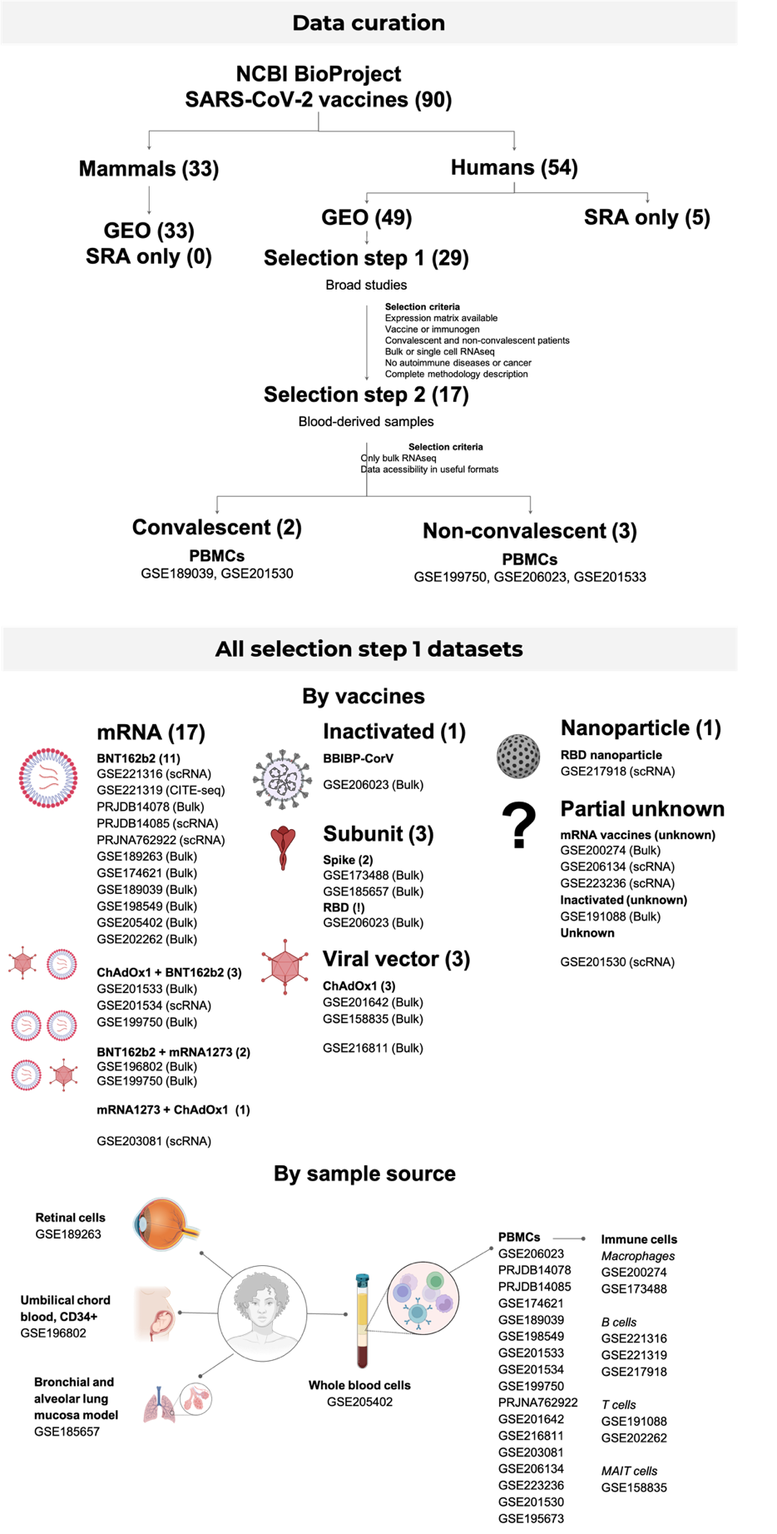
Fig. S1. Data curation. Datasets were obtained from NCBI BioProject and curated. All datasets, including the selected and non-selected, were classified by vaccine technology and vaccination regimen, and by sample source.
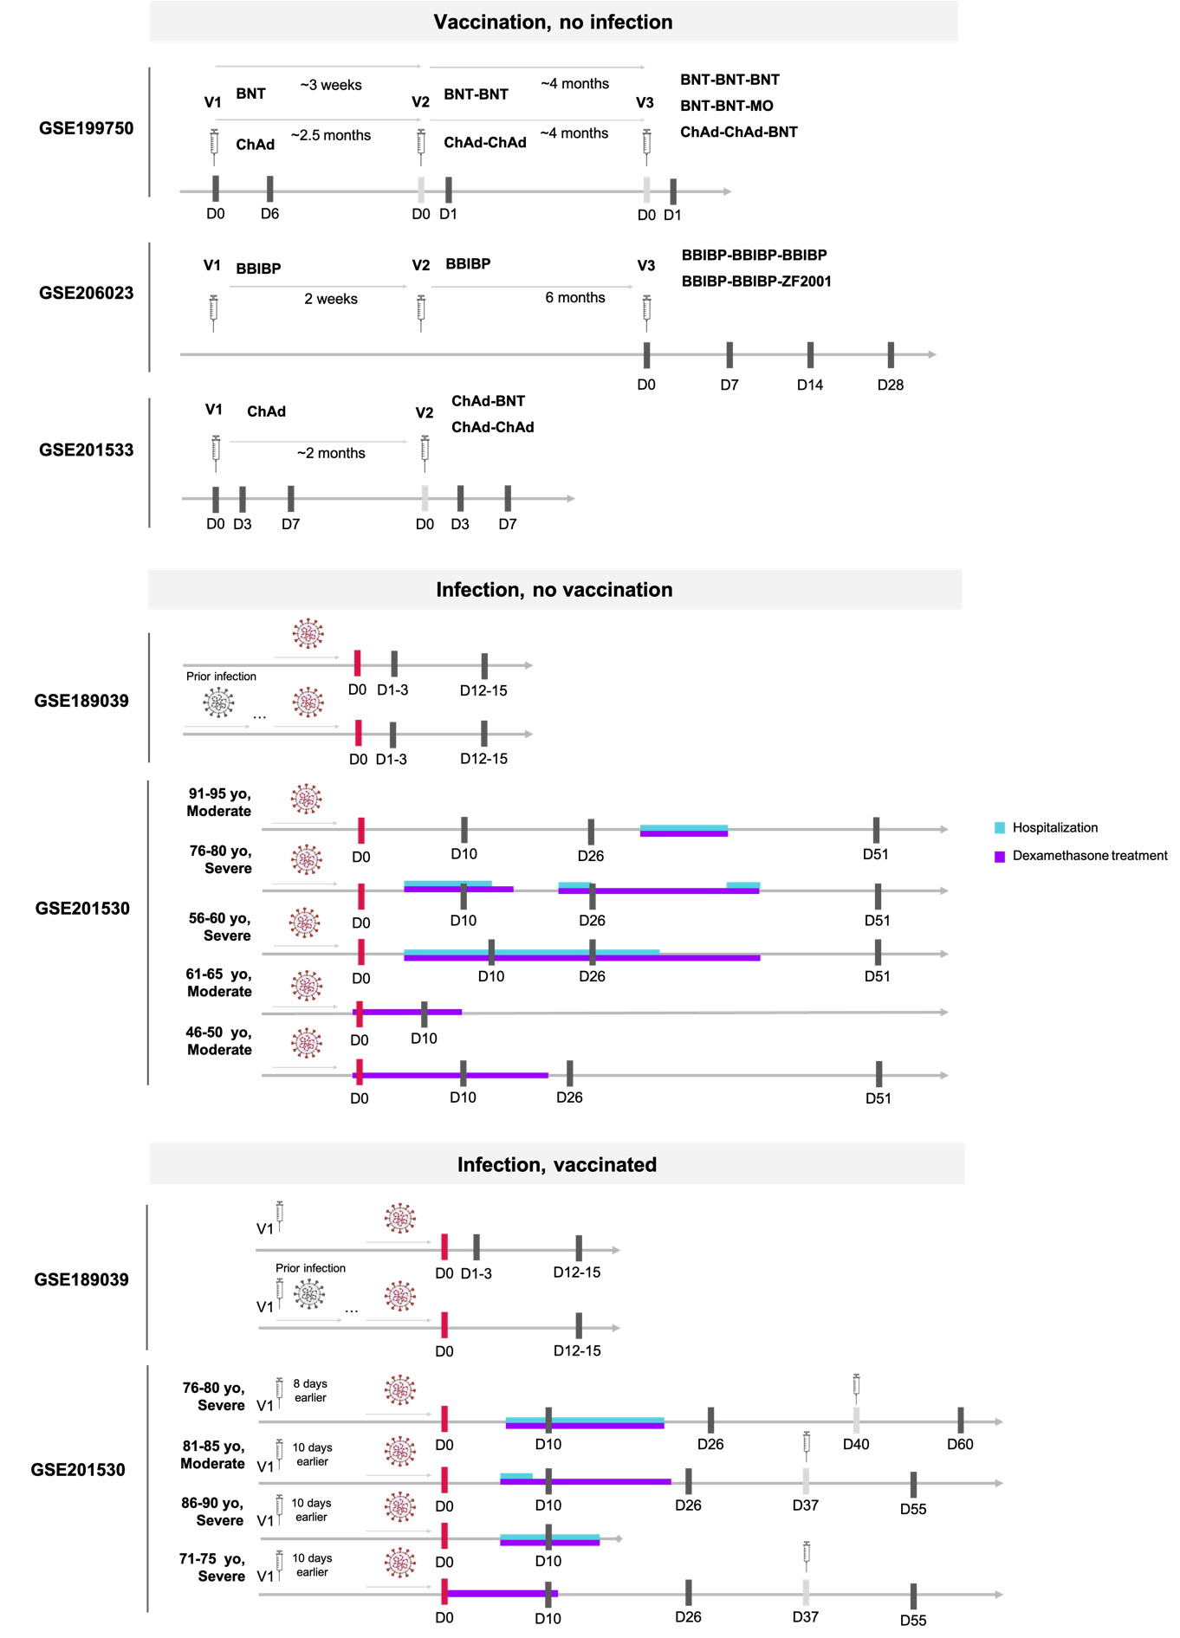
Fig. S2. Description of the selected datasets. The datasets include healthy vaccinees without prior infection, infected patients without vaccination, and patients with prior full or incomplete vaccination. Sample collection timelines are shown as black lines, with red lines indicating the first sample collection during hospitalization and gray lines representing events without sample collection. Days post-infection or vaccination are depicted, with blue lines representing hospitalization periods and purple lines indicating dexamethasone treatment.
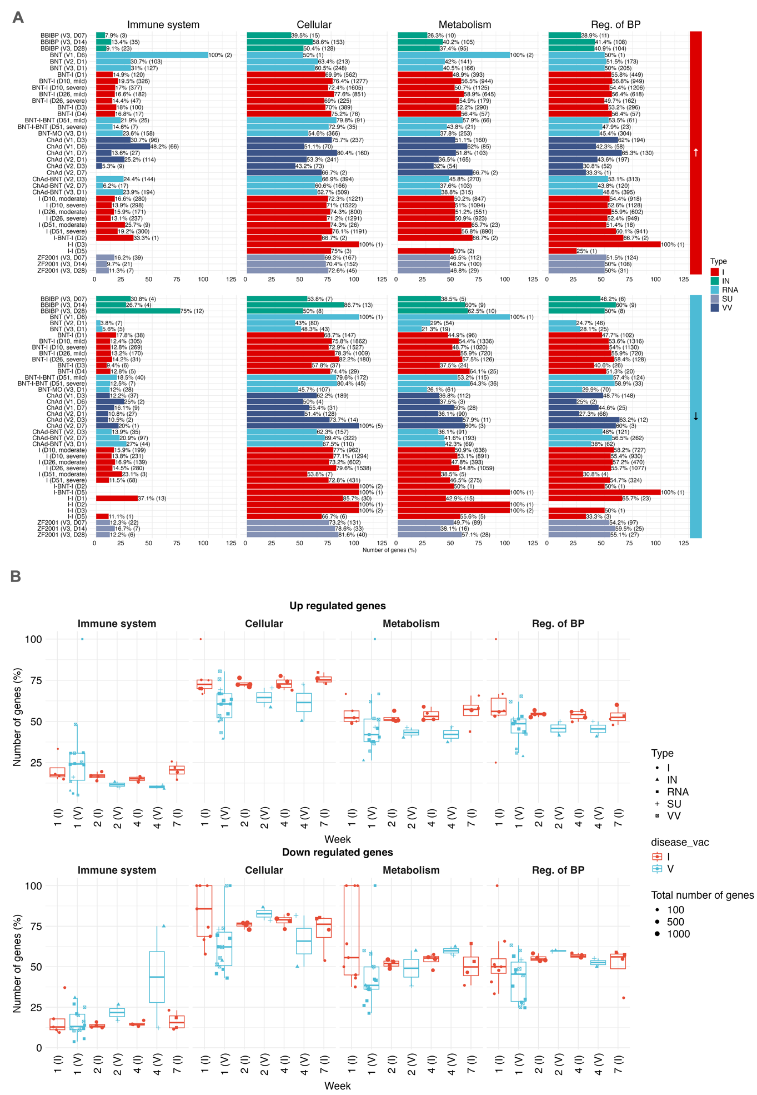
Fig. S3. DEGs were categorized as up- (A) and down-regulated (B) with the absolute and relative number of genes, and grouped based on infection (red) and vaccination (blue) conditions. The conditions were then plotted with the relative number of genes corresponding to their roles in essential biological processes, namely immune system, cellular processes, metabolism, and regulation of biological processes, respectively. Shapes correspond to type, colors to disease or infection, and size to total number of DEGs. I: Infection; IN: Inactivated; RNA: mRNA vaccines; SU: Subunit; VV: Viral vector.
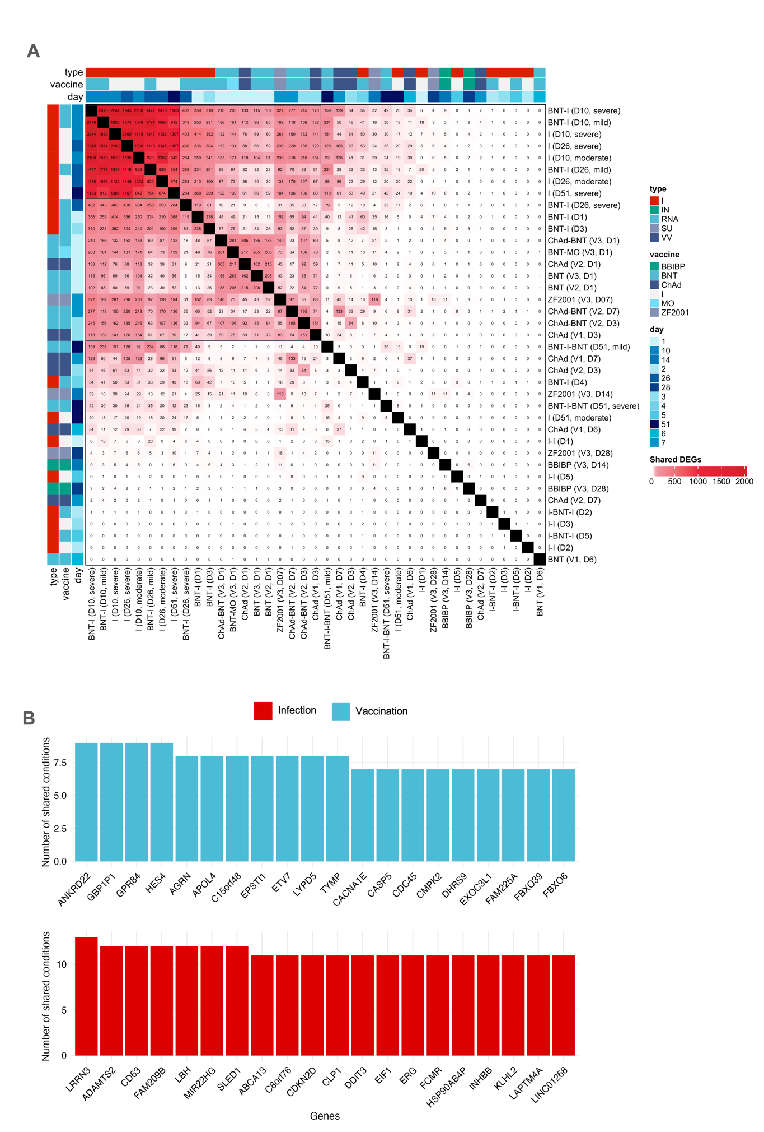
Fig. S4. A. Shared non-immune-related DEGs between infection and vaccination. B. Twenty most shared immune-related genes. BBIBP: BBIBP-CORV; BNT: BNT162b2, ChAd: ChAdOx-1; MO: mRNA-1273; I: Infected; V: Vaccinated; IN: Inactivated; RNA: mRNA vaccines; SU: Subunit; VV: Viral vector.
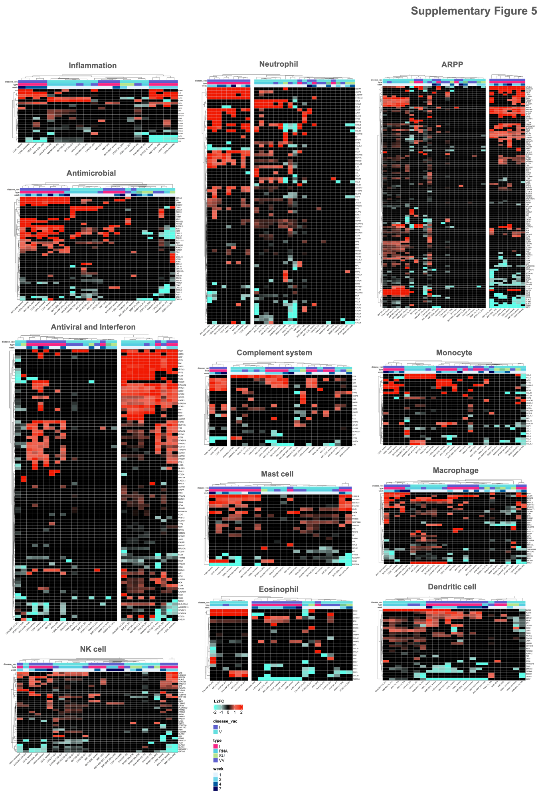
Fig. S5. Genes related to complement system, antimicrobial response, and innate immune system processes and cells. I: Infection; IN: Inactivated; RNA: mRNA vaccines; SU: Subunit; VV: Viral vector.
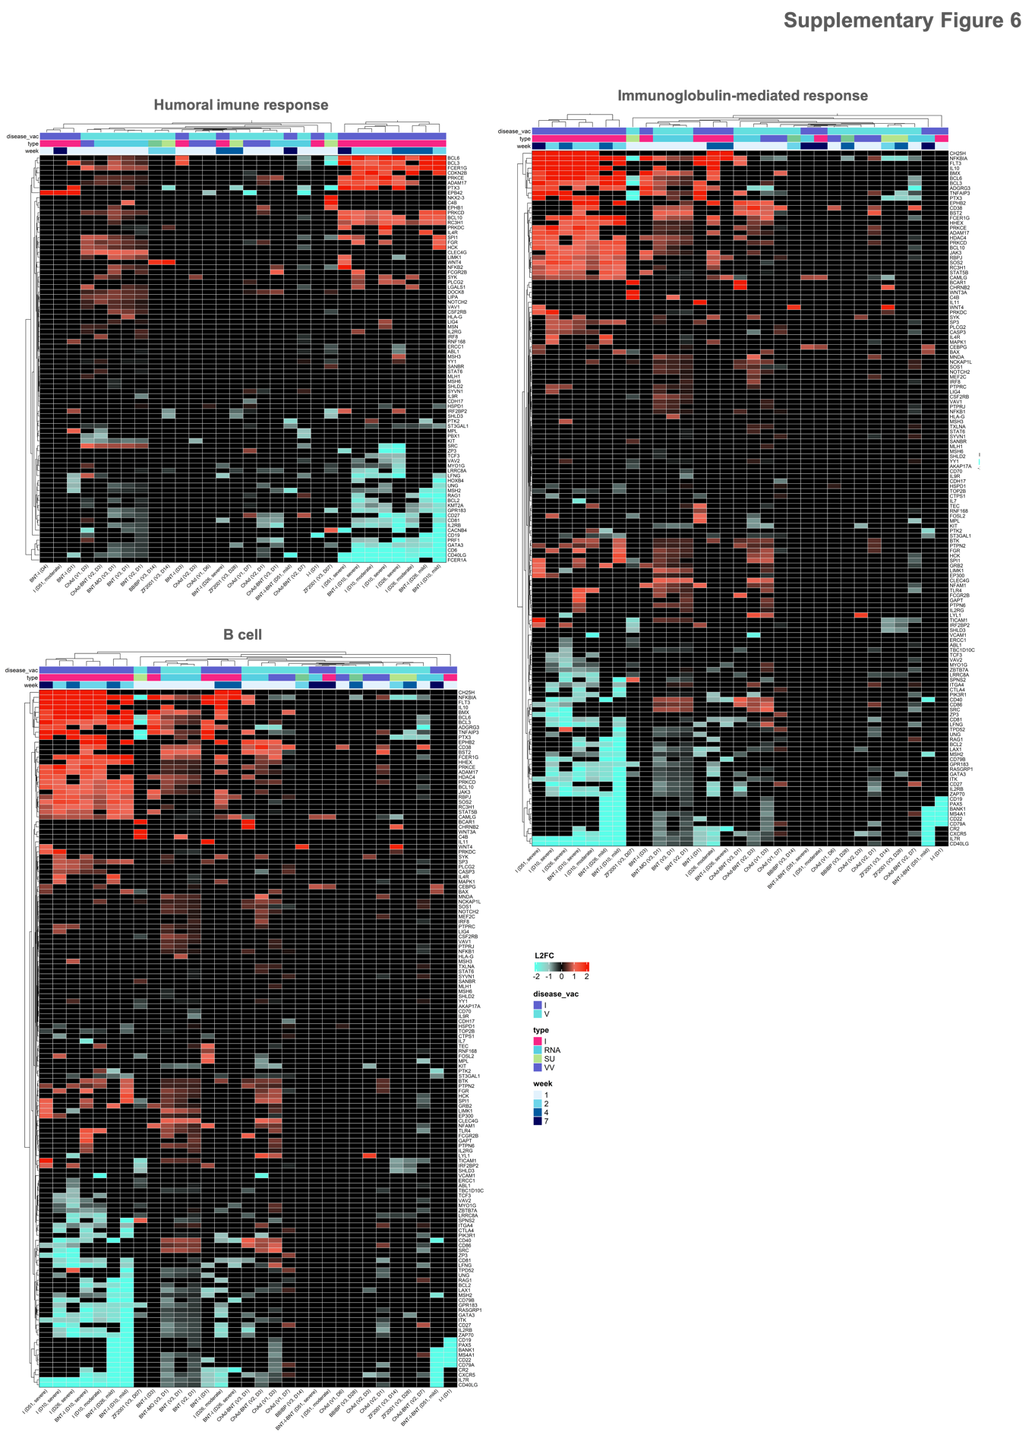
Fig. S6. Genes related to humoral adaptive immune system, including B cell processes and immunoglobulin-mediated response. I: Infection; IN: Inactivated; RNA: mRNA vaccines; SU: Subunit; VV: Viral vector.
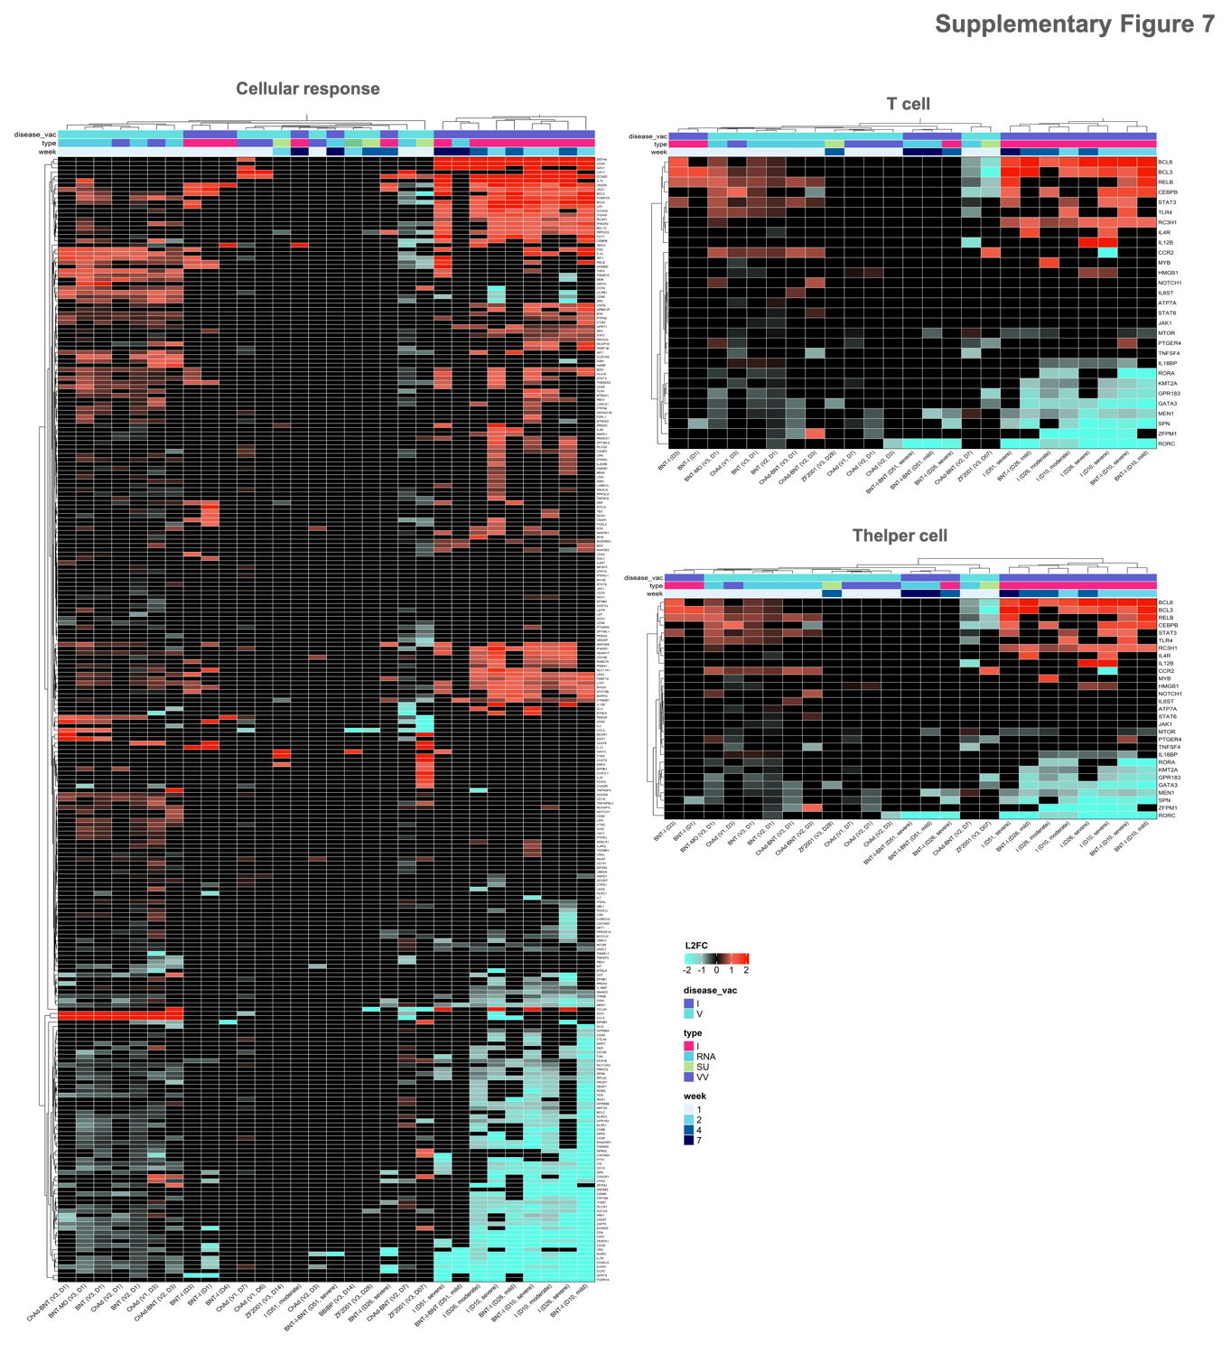
Fig. S7. Genes related to the cellular adaptive immune system, including cellular response and T- and T helper cell processes. I: Infection; IN: Inactivated; RNA: mRNA vaccines; SU: Subunit; VV: Viral vector.
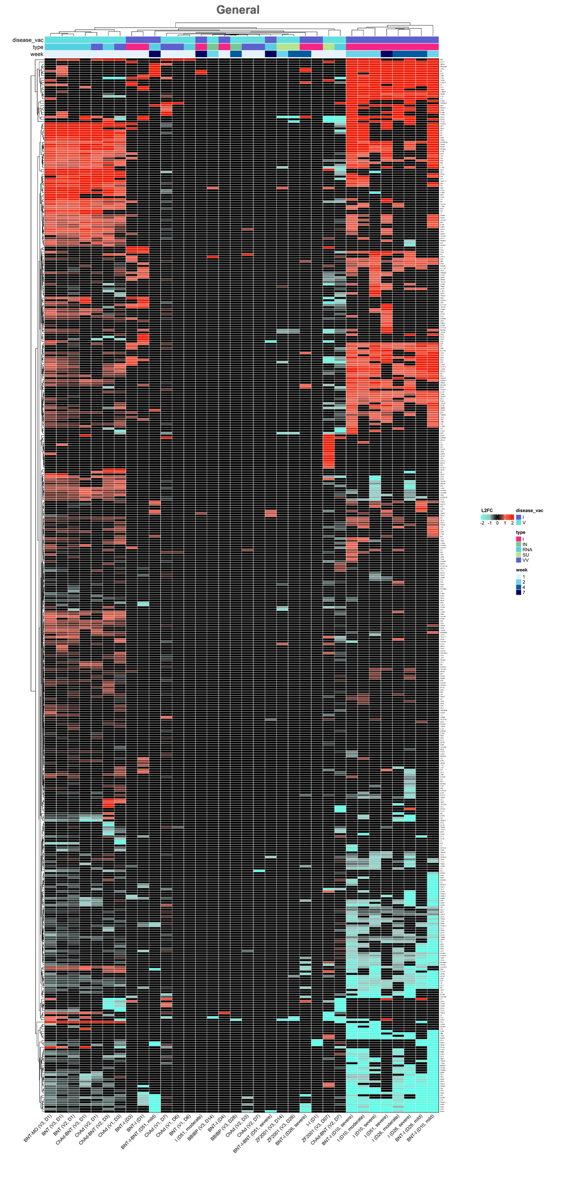
Fig. S8. General leukocyte processes. I: Infection; IN: Inactivated; RNA: mRNA vaccines; SU: Subunit; VV: Viral vector.
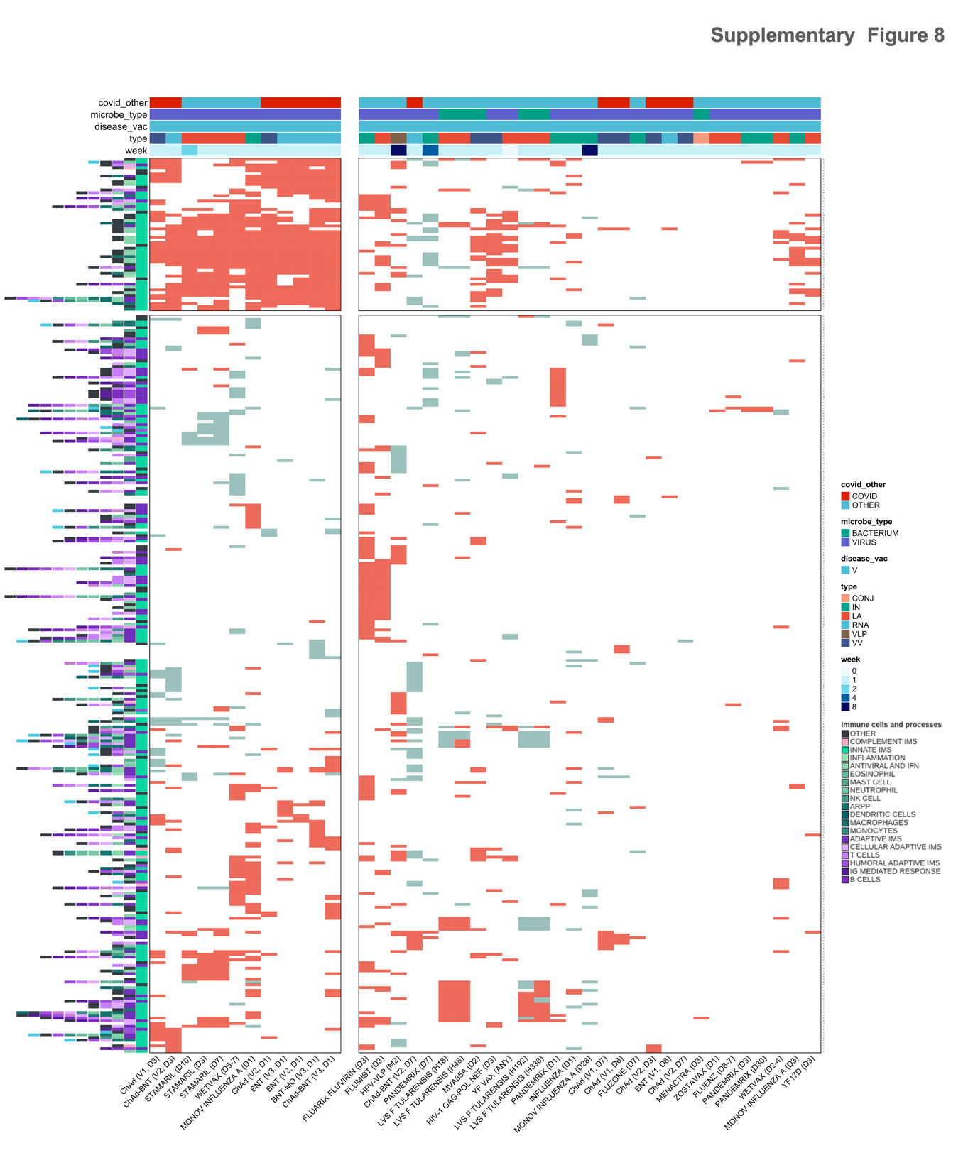
Fig. S9. Gene expression in vaccination against COVID-19 and other pathogens. I: Infection; IN: Inactivated; RNA: mRNA vaccines; SU: Subunit; VV: Viral vector; CONJ: Conjugated; LA: Live-attenuated; VLP: Virus-like particle.

