Supplemental Information
Targeted delivery of TGF-β mRNA to lung parenchyma using one-component ionizable amphiphilic Janus Dendrimers.
Jaclynn A. Meshanni¹, Emily R. Stevenson², Dapeng Zhang³, Rachel Sun², Nathan A. Ona¹, Erin K. Reagan¹, Elena Abramova², Chang-Jiang Guo², Melissa Wilkinson², Ishana Baboo¹, Yuzi Yang³, Liuyan Pan³, Devendra S. Maurya⁴, Virgil Percec⁴, Yongsheng Li³, Andrew Gow², Drew Weissman¹, Elena N. Atochina-Vasserman^{1*}
¹Penn Institute for RNA Innovation, University of Pennsylvania Perelman School of Medicine, Philadelphia, PA, USA,
²Environmental and Occupational Health Sciences Institute, Rutgers University, Piscataway, NJ, USA,
³Lab of Low-Dimensional Materials Chemistry, Key Laboratory for Ultraﬁne Materials of Ministry of Education, School of Materials Science and Engineering, East China University of Science and Technology, Shanghai 200237, China.
⁴Roy & Diana Vagelos Laboratories, Department of Chemistry, University of Pennsylvania, Philadelphia, PA, USA.

*Corresponding author: atochina@pennmedicine.upenn.edu

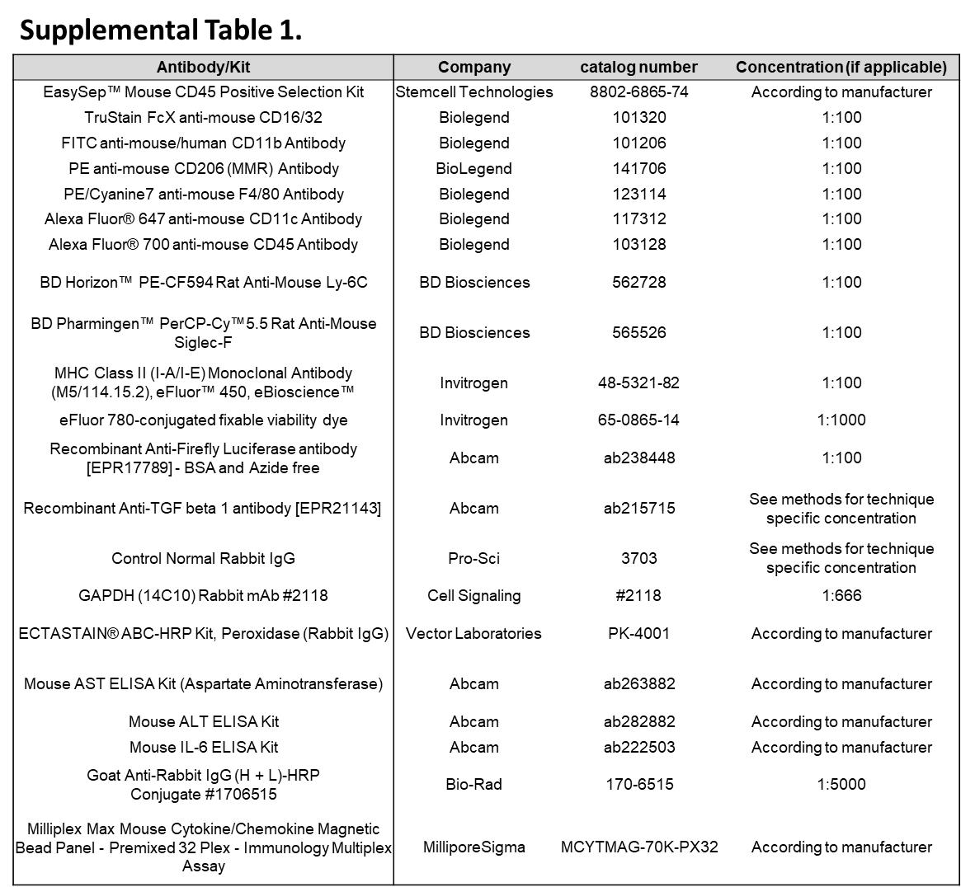
Supplemental Table 1. Antibodies used for assays. Antibodies and kits used for the completion of these assays are listed along with company, catalog number, and dilution if applicable.

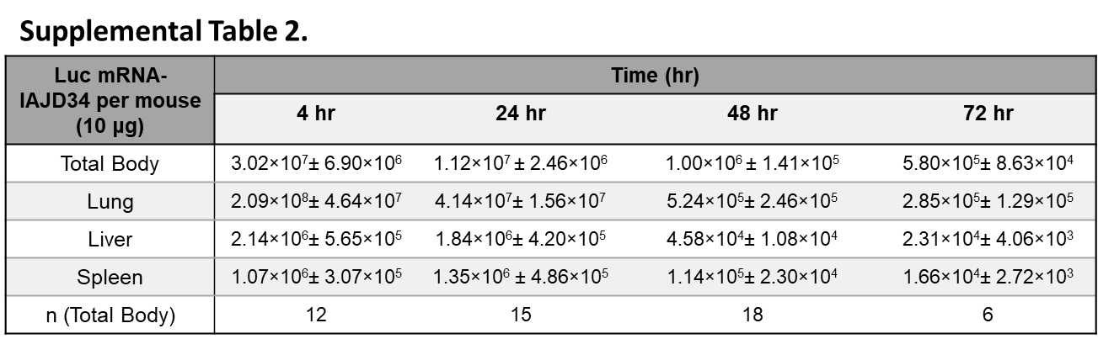
Supplemental Table 2. Specificity of IAJD34 for targeted mRNA delivery to the lung over time. IAJD34 formulated with luciferase mRNA (Luc mRNA-IAJD34) was i.v. injected into BALB/c mice and analyzed for efficient pulmonary mRNA using IVIS. IVIS images were analyzed, and the photon radiance (Lq) (s⁻¹sr⁻¹m⁻²) of each image was quantified. The quantitative bioluminescence imaging (BLI) data are shown as total flux (p/s); Whole-body radiant flux (p/s) at various time points following the injection of 10 μg Luc mRNA-IAJD34.

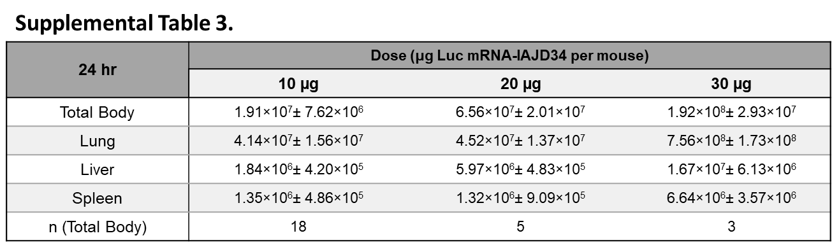
Supplemental Table 3. Specificity of IAJD34 for targeted mRNA delivery to the lung at multiple doses. IAJD34 formulated with luciferase mRNA (Luc mRNA-IAJD34) was i.v. injected into BALB/c mice and analyzed for efficient pulmonary mRNA using IVIS. IVIS images were analyzed, and the photon radiance (Lq) (s⁻¹sr⁻¹m⁻²) of each image was quantified. The quantitative bioluminescence imaging (BLI) data are shown as total flux (p/s); Dose-dependent pulmonary delivery of Luc mRNA-IAJD34. Whole-body and organs of mice injected with Luc mRNA-IAJD34 at doses of 10, 20, or 30 μg, imaged at 24 hrs post-injection. Data presented as mean+SEM.
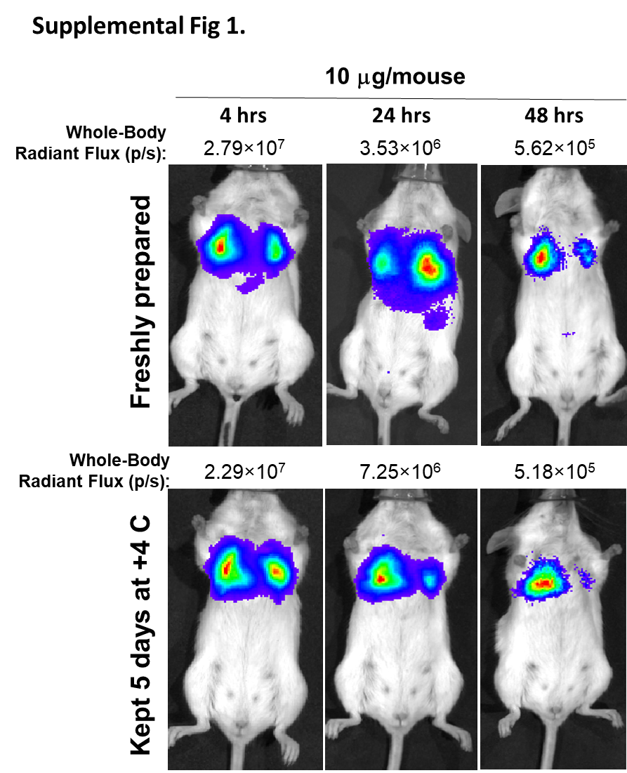
Supplemental Figure 1. Evaluation of stability of Luc mRNA-IAJD34 formulation. Luc mRNA-IAJD34 at dose 10 µg per mouse was injected into BALB/c mice immediately after formulating, or 5 days after storing formulations at 4C. IVIS images of whole-body of mice at 4, 24, and 48 hrs post-injection of 10 μg Luc mRNA-IAJD34 were analyzed, and radiances (p/sec/cm2/sr) of each image were quantified. The quantitative BLI data of representative IVIS images are shown as total flux (p/s).

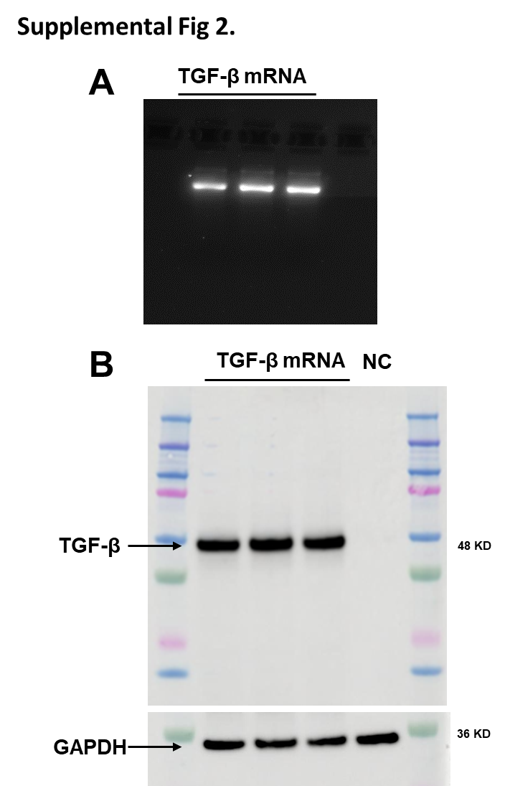
Supplemental Figure 2. Confirmation of TGF-β mRNA expression and protein production. (A) TGF-β mRNA was produced from plasmids, purified using cellulose, and imaged using gel electrophoresis to confirm mRNA presence and quality; (B) Human embryonic kidney (HEK) 293 cells were seeded into a 24 well plate at 150,000 cells/well and transfected with 500 ng mRNA/well or no mRNA for negative control (NC) according to Methods and Materials. Cells were collected in RIPA (Sigma Aldrich) buffer and equal protein (10 µg/well) was loaded for western blot analysis with primary antibody to TGF-β (1:5,000) or GAPDH (1:1,000) and secondary antibody anti-Rabbit IgG. Gels were imaged using an Amersham cytiva imager. Representative images are shown.

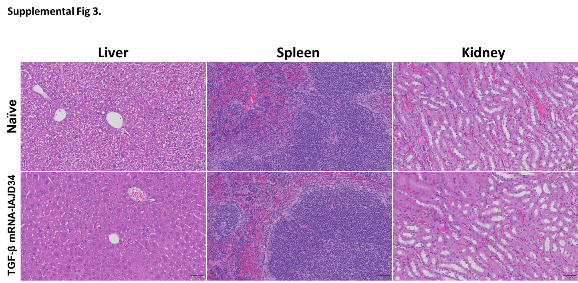
Supplemental Figure 3. Evaluation of dose-dependent toxicity of TGF-β mRNA delivery with IAJD34. BALB/c mice were injected with various doses of TGF-β mRNA-IAJD34 (10, 20, and 30 μg per mouse). At 24 hrs post-injection, lungs, liver, spleen, and kidney tissue were collected, stained with H&E and scored by a board-certified pathologist. Representative images of naïve mice and mice received 30 μg are shown. n = 5 mice per group.
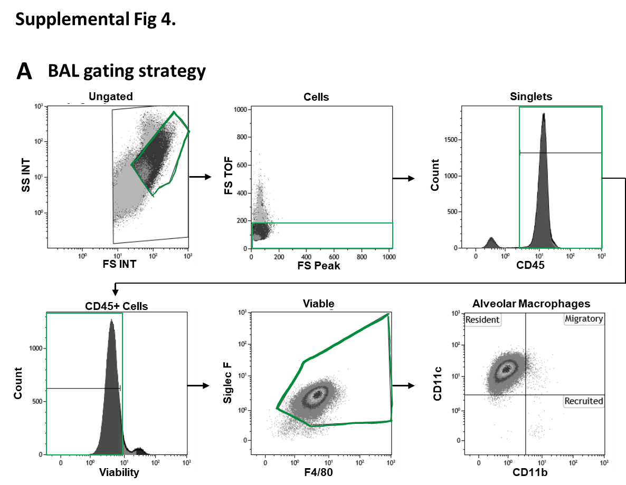
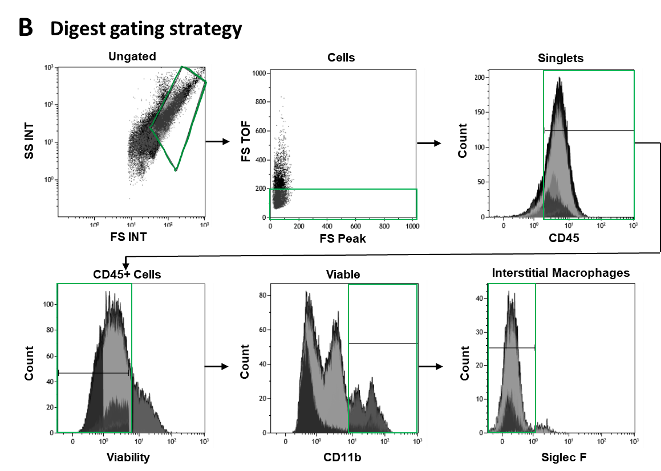
Supplemental Figure 4. Gating strategy for alveolar and Interstitial macrophage characterization. Cells were analyzed using a Gallios 10-color flow cytometer (Beckman Coulter, Brea, CA). Using Kaluza software (Beckman Coulter, Brea, CA) cells were gated upon size and complexity. Cells were confirmed to be CD45+ and viable. (A) Cells that were positively stained for both Siglec F and F4/80 were determined to be alveolar macrophages (AMs). Resident macrophages (CD11c+/CD11b-), can be differentiated from recruited (CD11c-/CD11b+) or migratory macrophages (CD11c+/CD11b+). (B) Cells from digested lung tissue were immunomagnetically separated based upon CD45 expression. CD45+ cells were isolated, immunostained, and analyzed. Cells that expressed F4/80 and CD11b in the absence of Siglec F were categorized as interstitial macrophages (IMs).

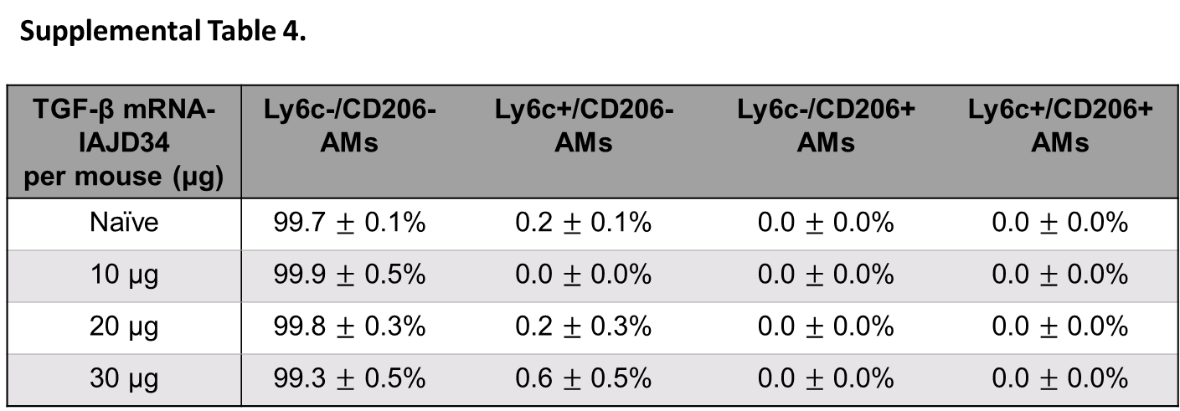
Supplemental Table 4. Evaluation of alveolar macrophages containing Ly6c and CD206. BALB/c mice were injected with various doses of TGF-β mRNA-IAJD34 (10, 20, and 30 μg per mouse). At 24 hrs post-injection BAL cells were isolated, immunostained, and analyzed by flowcytometry. Cells that were positively stained for both Siglec F and F4/80 were determined to be AMs and were evaluated for Ly6c and CD206 populations. Data are presented as mean ± SE for n=4-10 per group.

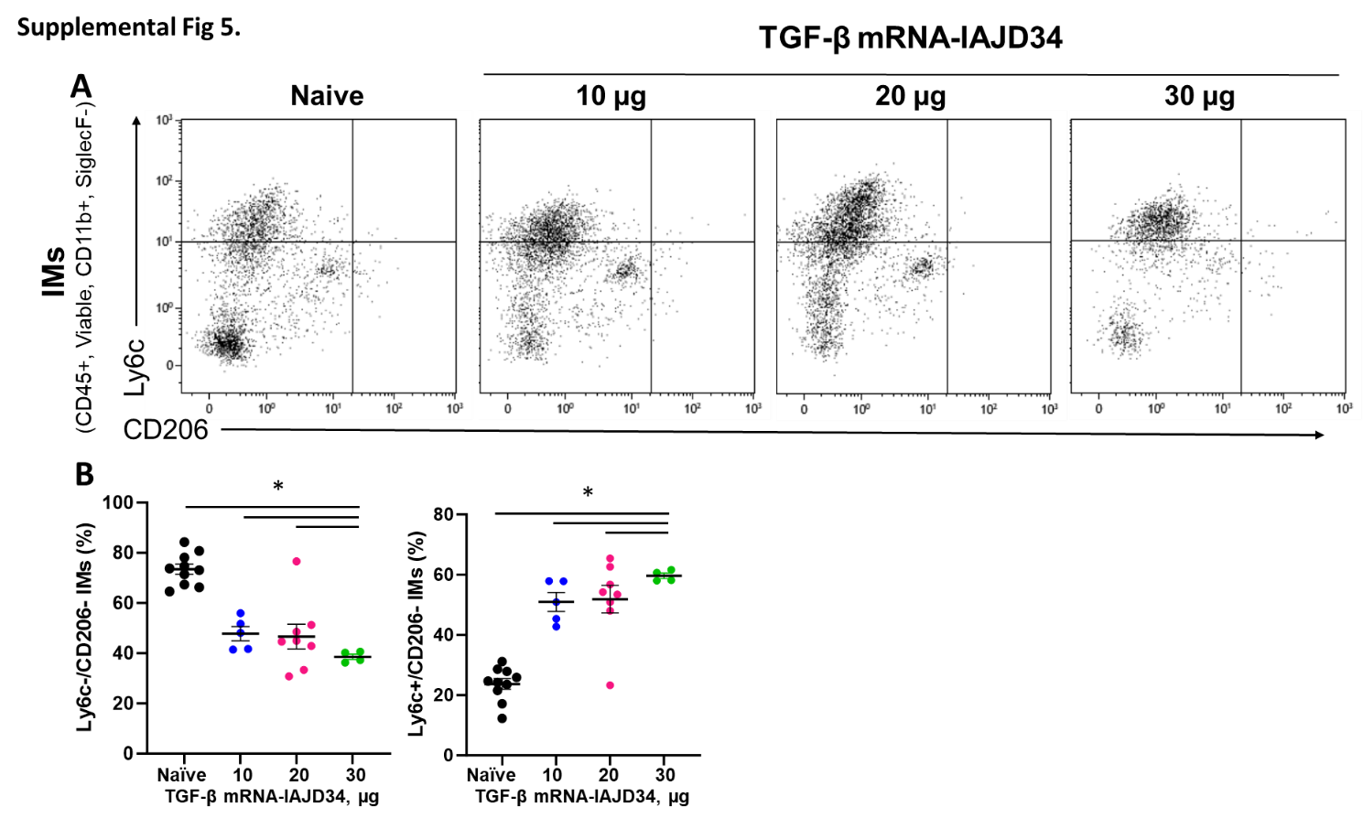
Supplemental Figure 5. Evaluation of interstitial macrophages containing Ly6c and CD206. BALB/c mice were injected with various doses of TGF-β mRNA-IAJD34 (10, 20, and 30 μg per mouse). At 24 hrs post-injection (A) cells from digested lung tissue were immunomagnetically separated based upon CD45 expression. CD45+ cells were isolated, immunostained, and analyzed. Cells that expressed F4/80 and CD11b in the absence of Siglec F were categorized as IMs and were analyzed for Ly6c and CD206 expression; (B) Percent Ly6c-/CD206- and Ly6c+/CD206- IMs were plotted. Data are presented as mean ± SE for n=4-10 per group. Data were evaluated for normality using a Shapiro Wilk’s test and compared using a one-way ANOVA followed by Tukey's multiple comparisons test. * indicates a significant difference from the naïve control, p<0.05.

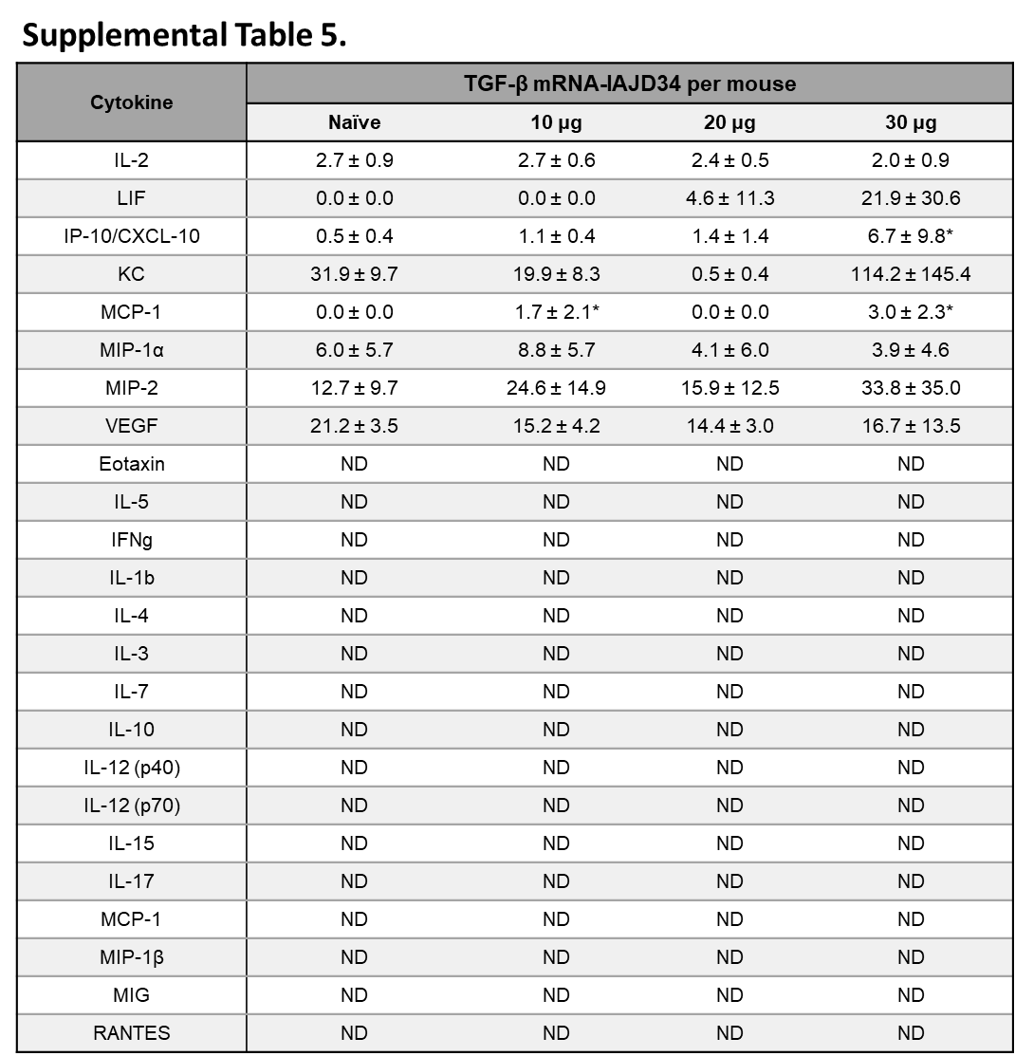
Supplemental Table 5. TGF-β mRNA-IAJD34-induced alterations in BAL cytokine production. BALB/c mice were injected with various doses of TGF-β mRNA-IAJD34 (10, 20, and 30 μg per mouse). At 24 hrs post-injection, cellfree BAL fluid was evaluated for cytokines using a Milliplex Max Mouse Cytokine/Chemokine Magnetic Bead Panel - Premixed 32 Plex - Immunology Multiplex Assay and are presented as pg/mL. Date shown as mean ± SE, n = 4-10 per group. Data were evaluated for normality using a Shapiro Wilk’s test and compared using a one-way ANOVA followed by Tukey's multiple comparisons test. * indicates a significant difference from the naïve control, p<0.05.

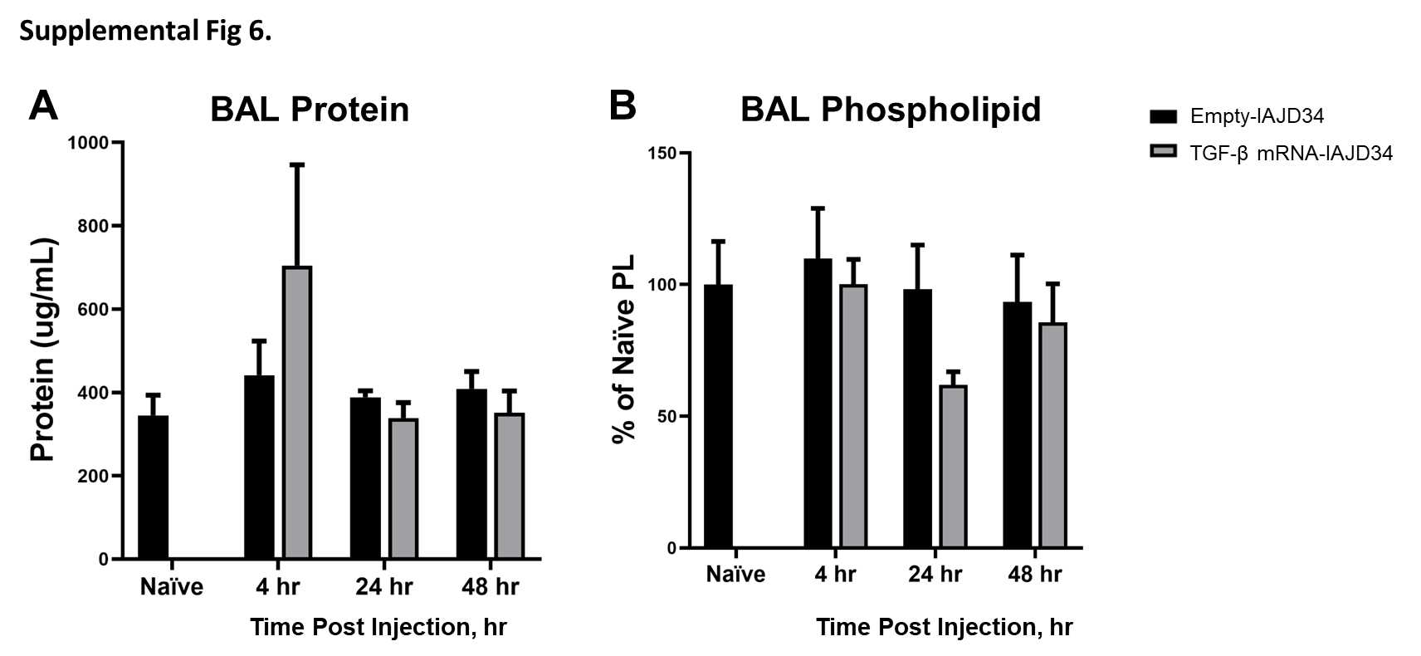
Supplemental Figure 6. Effects of TGF-β mRNA-IAJD34 delivery on BAL content over time. BALB/c mice were injected with 10 μg of TGF-β mRNA-IAJD34 or empty IAJD34, BAL fluid and large aggregate surfactant fractions were collected at 4, 24, and 48 hrs post-injection. (A) Cell-free BAL fluid was evaluated for total protein content using a BCA assay; (B) Total phospholipids were determined from the large aggregate surfactant fraction and normalized to naïve phospholipid content. Data are presented as mean ± SE, n = 3-5 per group. Data were evaluated for normality using a Shaprio-Wilks normality test and compared using a 2-way ANOVA.

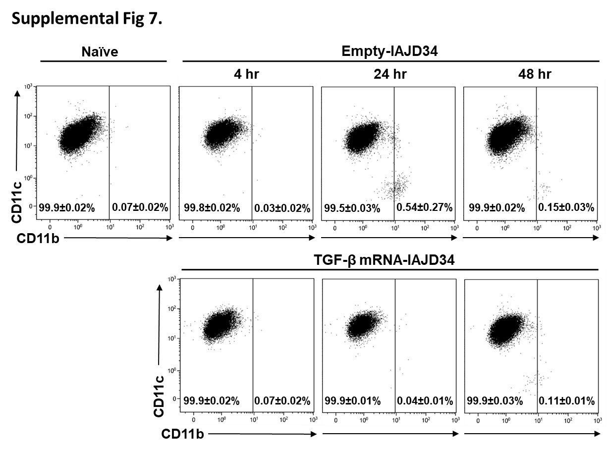
Supplemental Figure 7. Absence of time-dependent Inflammatory activation in response to TGF-β mRNA-IAJD34 in alveolar macrophages. BALB/c mice were injected with 10 μg of TGF-β mRNA-IAJD34 or empty IAJD34. At 4, 24, and 48 hrs post-injection BAL cells were isolated, immunostained, and analyzed by flow cytometry. Cells that were positively stained for both Siglec F and F4/80 were determined to be AMs. Mature macrophages (CD11c+/CD11b-), can be differentiated from recruited or migratory macrophages (CD11b+). No differences were observed in the percentage of CD11b+ alveolar macrophage population between groups, n=3-6 per group. Representative images are shown.

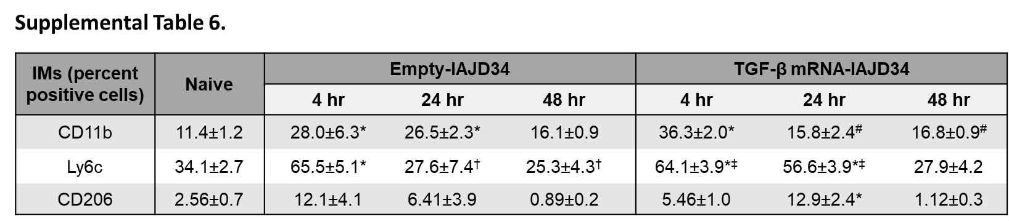
Supplemental Table 6. Absence of time-dependent Inflammatory activation in response to TGF-β mRNA-IAJD34 in interstitial macrophages. BALB/c mice were injected with 10 μg of TGF-β mRNA-IAJD34 or empty IAJD34. At 4, 24, and 48 hrs post-injection, cells from digested lung tissue were immunomagnetically separated based upon CD45 expression. CD45+ cells were isolated, immunostained, and analyzed by flow cytometry. Cells that expressed F4/80 and CD11b in the absence of Siglec F were categorized as interstitial macrophages and were analyzed for Ly6c and CD206 expression. Data are presented as mean ± SE, n=3-6 per group. Data were evaluated for normality using a Shaprio-Wilks normality test and then compared using a One-way ANOVA with Tukey’s multiple comparison. p < 0.05 when compared to the naïve control (*), empty IAJD34 4 hrs (†), TGF-β IAJD34 4 hrs (#), TGF-β IAJD34 48 hrs (‡).

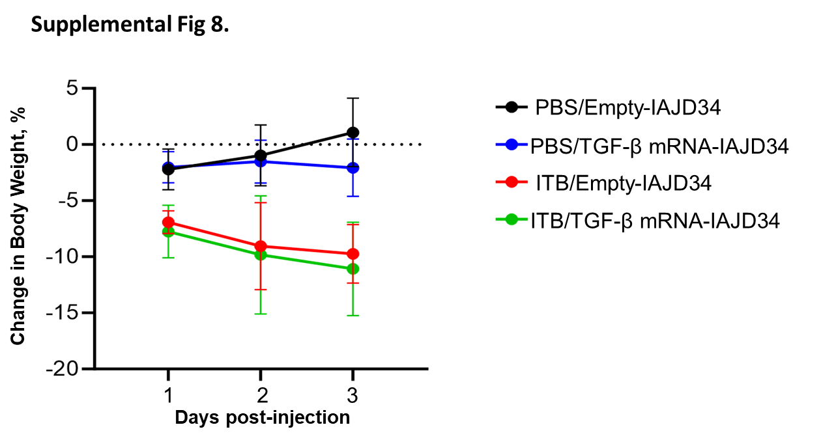
Supplemental Figure 8. Effects of TGF-β mRNA-IAJD34 on bleomycin-induced changes in body weight. BALB/c mice were exposed to PBS or bleomycin (ITB) and subsequently received either an empty IAJD34 or 10 µg TGF-β mRNA-IAJD34. Baseline body weights were measured, and then daily body weights were recorded. Percent change in body weight was determined based on baseline weights. Data are presented as mean ± SE, n = 6-10 per group.

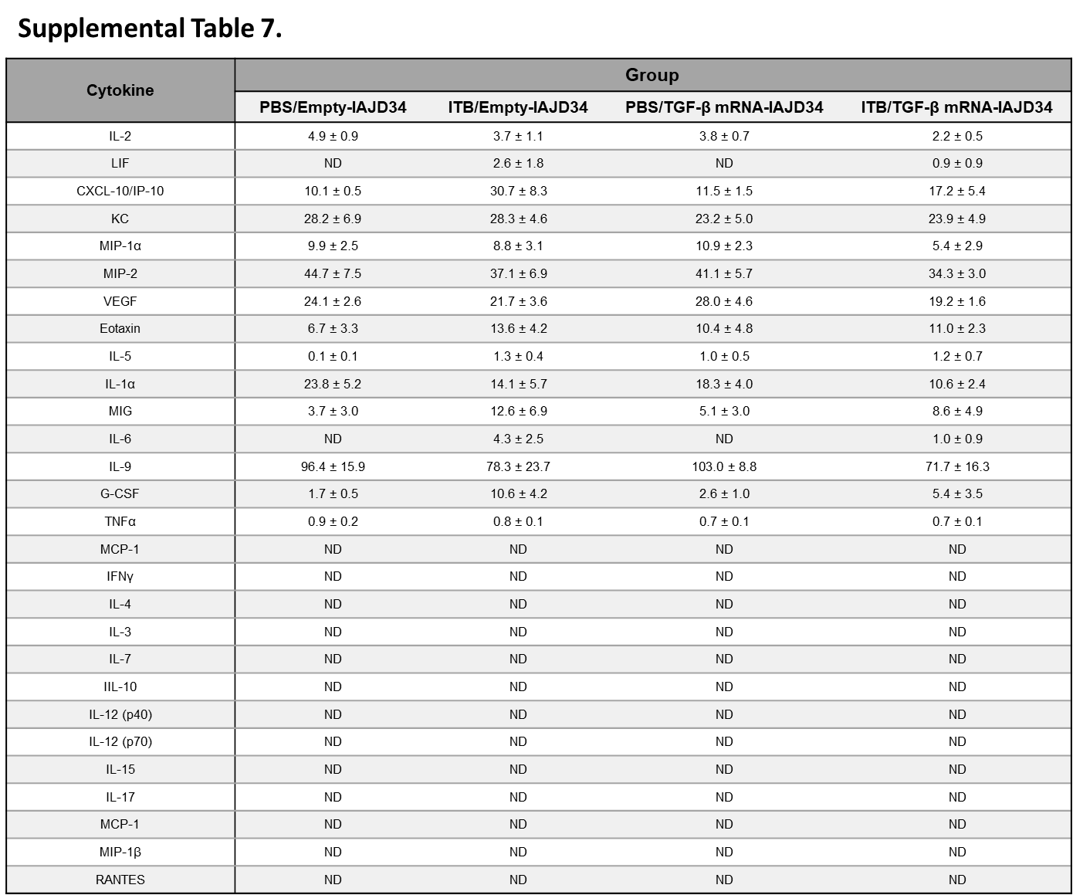
Supplemental Table 7. Effect of TGF-β mRNA-IAJD34 on Bleomycin induced alterations in BAL cytokine production. BALB/c mice were exposed to PBS or bleomycin (ITB) and subsequently received either an empty IAJD34 or 10 µg TGF-β mRNA-IAJD34. 3 days post exposure and injection, BAL fluid was collected. Cell-free BAL fluid was evaluated for cytokines using a Milliplex Max Mouse Cytokine/Chemokine Magnetic Bead Panel - Premixed 32 Plex - Immunology Multiplex Assay and are presented as pg/mL. Data shown as mean ± SE, n = 4-10 per group. Data were evaluated for normality using a Shapiro Wilk’s test and compared using a 2-way ANOVA followed by Tukey's multiple comparisons test if normally distributed, and a Kruskal Wallis test if not normally distributed. * indicates a significant difference from the control, p<0.05.

