Mapping the impact of age and APOE risk factors for late onset Alzheimer’s disease on long range brain connections through multiscale bundle analysis

Jacques Stout ¹ , Robert J Anderson ² , Ali Mahzarnia ² , Zay Han ², Kate Beck ³, Jeffrey Browndyke ⁴ , Kim Johnson ^{3,4} , Richard J O’Brien ³, Alexandra Badea ^{1,2,3} *
¹Duke Brain Imaging and Analysis Center, Duke University School of Medicine, Durham, NC, 27710, USA
²Department of Radiology, Duke University School of Medicine. Durham, NC, 27710, USA
³Department of Neurology, Duke University School of Medicine. Durham, NC, 27710, USA
⁴ Department of Psychiatry and Behavioral Sciences, Duke University School of Medicine. Durham, NC, 27710, USA

*Alexandra Badea, PhD
Box 3302 Duke University Medical Center
Durham, NC, 27710
Office Phone: +1-919-917-3095
Email: alexandra.badea@duke.edu

Keywords: APOE, tractography, MRI, diffusion, Alzheimer’s disease

Author contact details
Jacques Stout: jacques.stout@duke.edu, jacquesstout@live.fr
Robert J Anderson: robert.j.anderson@duke.edu
Ali Mahzarnia: ali.mahzarnia@duke.edu
Zay Han: zayyar.han@duke.edu
Kate Beck: kate.beck@duke.edu
Jeffrey Browndyke: j.browndyke@duke.edu
Kim Johnson: kim.g.johnson@duke.edu
Richard J O’Brien: richard.obrien@duke.edu
Alexandra Badea: alexandra.badea@duke.edu
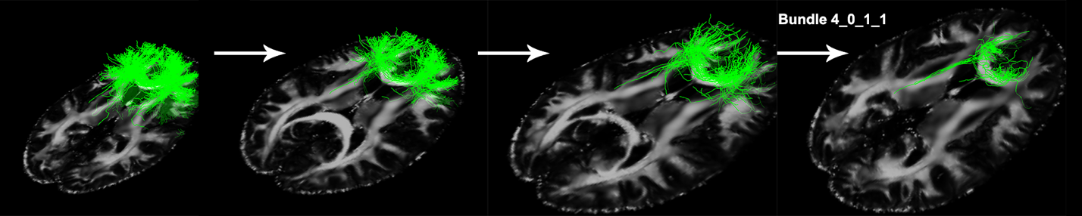Supplementary Figure 1: Splitting of bundle 4, to bundle 4_0, 4_0_1, and 4_0_1_1

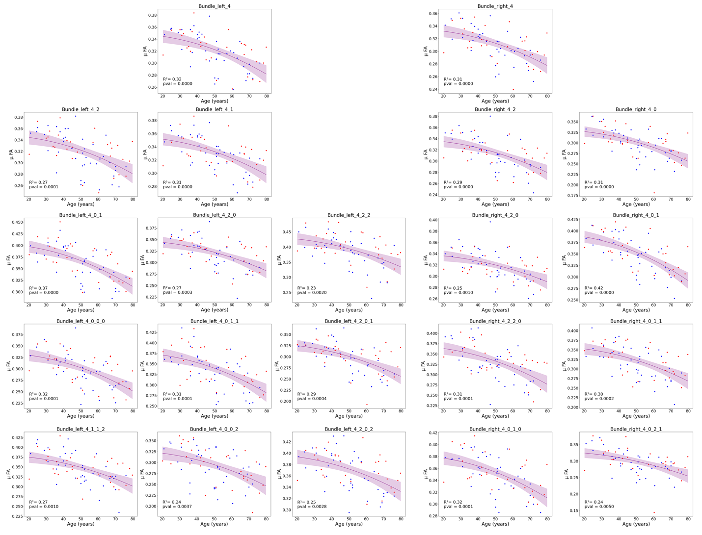Supplementary Figure 2: Additional measurements for frontal lobe data of significant mean FA changes with age

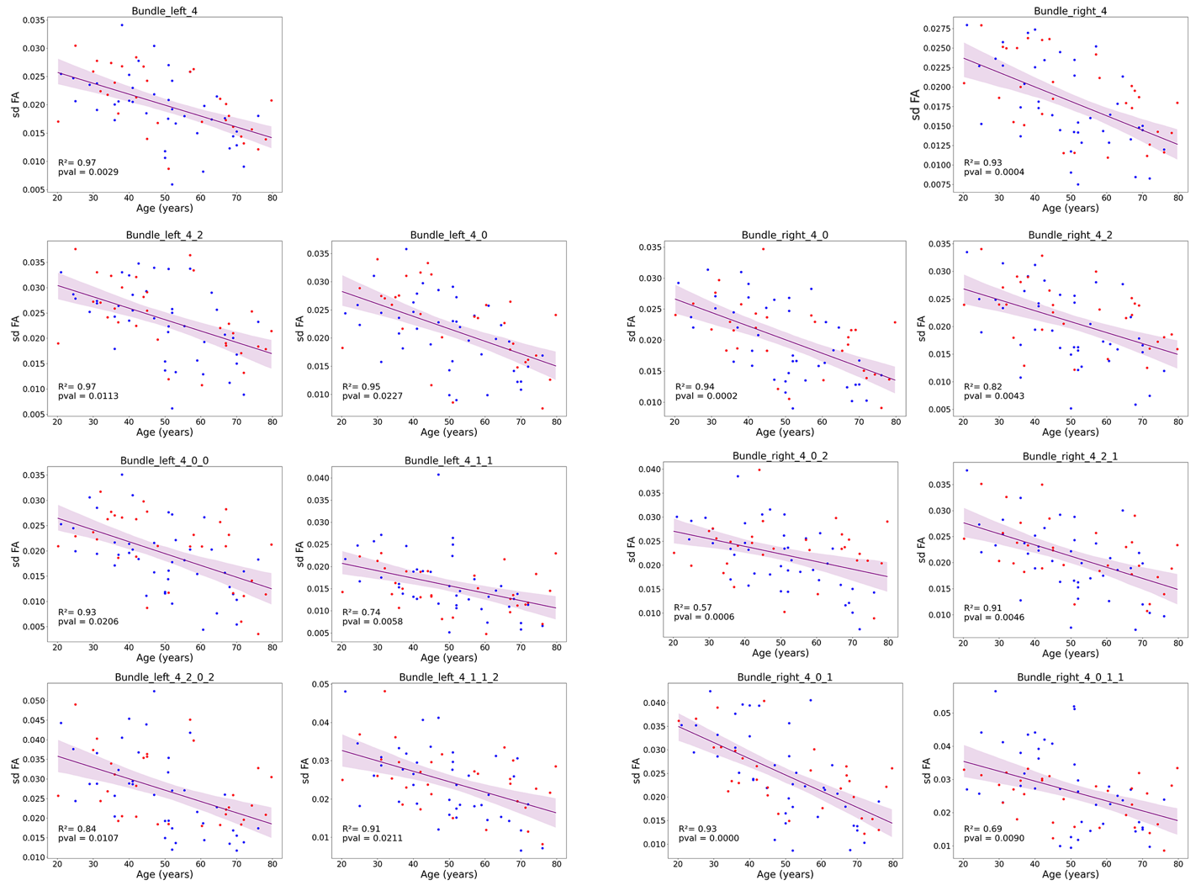Supplementary Figure 3: Additional measurements for frontal lobe data of significant variance FA changes with age

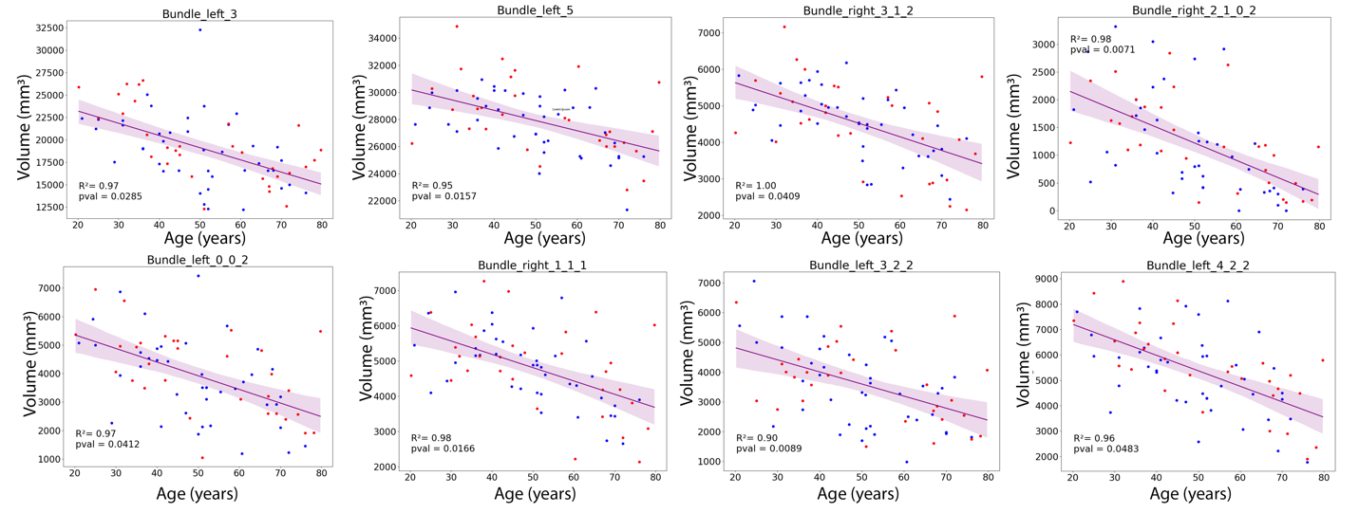Supplementary Figure 4: Additional measurements for significant volume changes of bundles with age

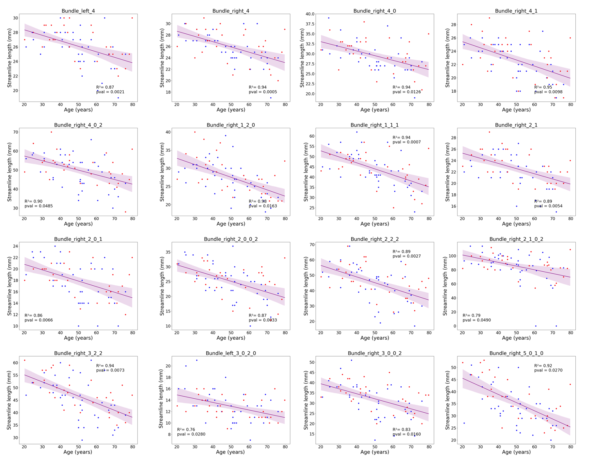Supplementary Figure 5: Additional measurements for significant average streamline length changes with age

