Appendix
As can be seen in Fig.1 to Fig.3, the appendix provides the scale effects and composition effects for all the economies (or regions) in World Input-output Database, and RoW represents the rest of world. From an overall perspective, most economies benefit from international trade in terms of reducing territorial CO₂ emissions.﻿
Most economies or regions’ no-trade emissions are higher than actual ones in most years, indicating that international trade helps to reduce emissions in these economies (AUS, BEL, BGR, BRA, CHE, CYP, CZE, DEU, ESP, EST, FRA, GBR, GRC, HRV, HUN, IDN, IND, IRL, ITA, JPN, KOR, LTU, LVA, MEX, MLT, POL, PRT, ROU, SVN, TWN, USA, RoW). Composition effect is the major reason for this result, as industry composition becomes cleaner due to international trade.
Still, there are some economies showing an opposite result (AUT, CAN, CHN, DNK, FIN, NLD, NOR, RUS, SVK, SWE, TUR). For economies including CHN, FIN, NLD and SWE, scale effect dominates and emissions would reduce under no-trade scenario, as the hypothetical no-trade production scale is much smaller. For the other economies, composition effect dominates and the no-trade industry composition would raise emissions.
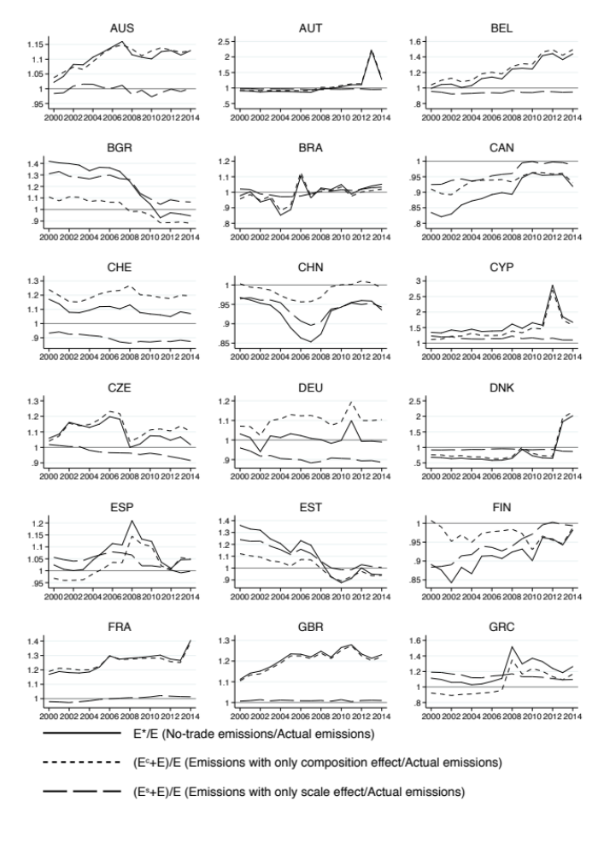
Fig 1. All the economies’ (or regions’) scale effects and composition effects (1)

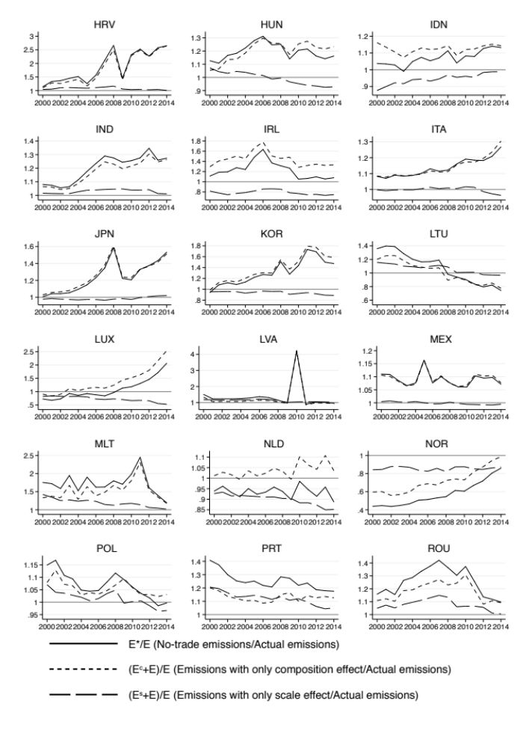
Fig 2. All the economies’ (or regions’) scale effects and composition effects (2)

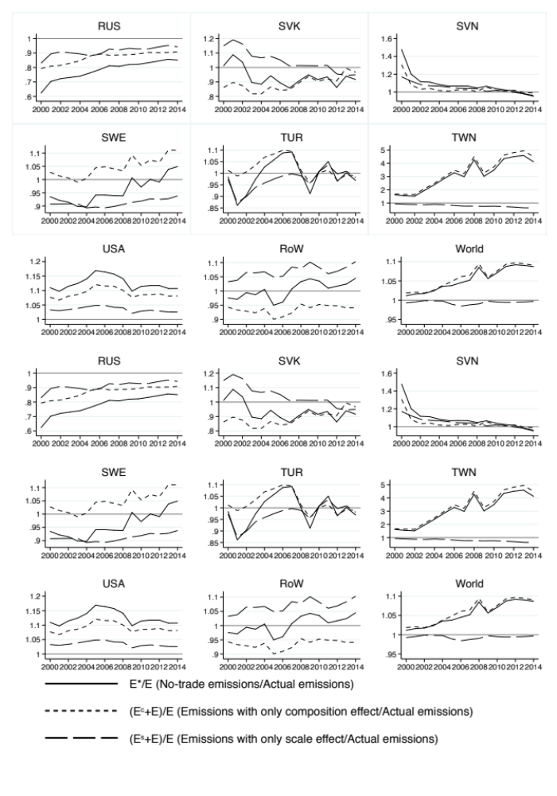
Fig 3. All the economies’ (or regions’) scale effects and composition effects (3)

