Scheme 1. Synthesis of (Z)-arylbenzoyl(phenethyl)carbamothioic-N-phenylbenzohydrazonic thioanhydride derivatives 3a-i

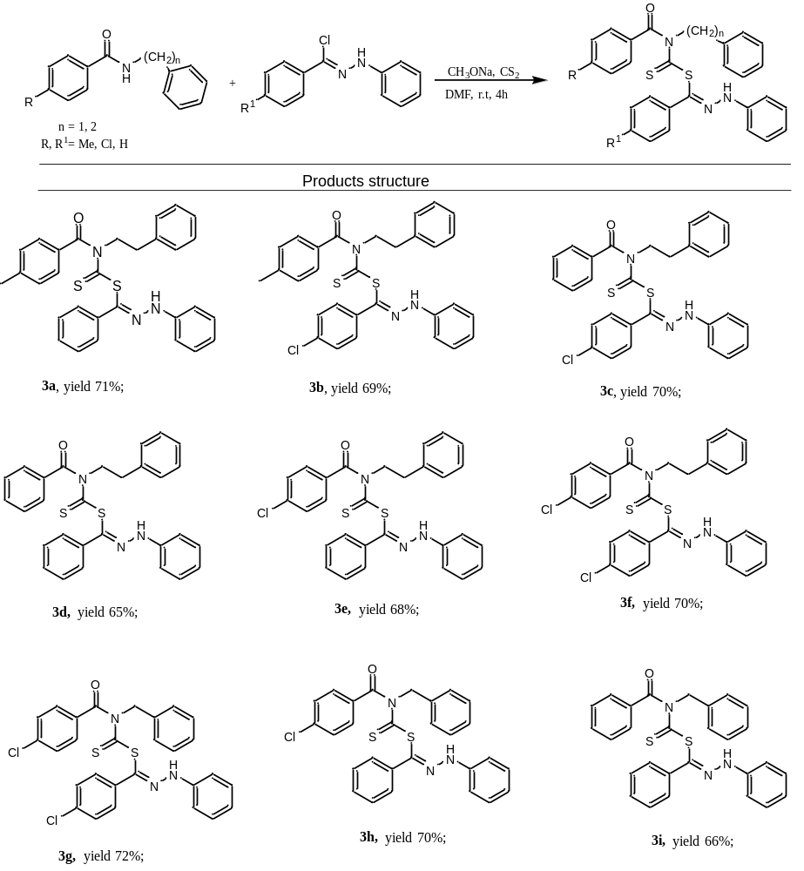

Scheme 2. Proposed mechanism pathway for 3a-i

