SUPPLEMENTARY INFORMATION: Additional file 1

Impact of Dietary Macromolecular Quantity and Quality on Host Assimilation of Microbially Derived Essential Amino Acids

Conner M. Mertz¹, Christy J. Mancuso¹, David M. Robinson¹, Leigh D. James¹, Marilyn L. Fogel², Cristina Takacs-Vesbach¹, Seth D. Newsome¹

Corresponding author: Conner M. Mertz¹, cmmertz123@gmail.com

The file includes:
Supplemental Figures 1- 6

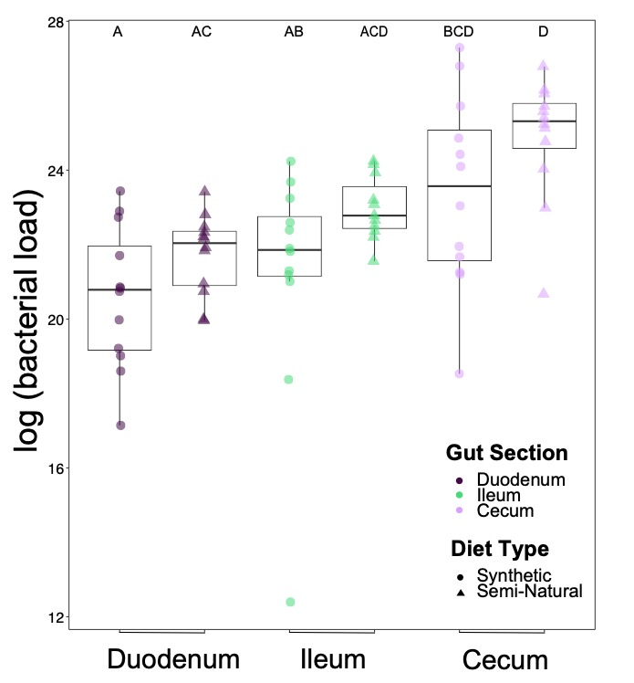

Supplemental Figure 1. Bacterial Biomass (expressed as 16S rRNA gene copies per gram of intestinal material adjusted for taxa with multiple 16S rRNA gene copies) by treatment (shape) and gut section (color). Letters (A, B, C, D) indicate statistically significant differences based on a Holm-adjusted Dunn test and a significance level of 0.05. Groups not sharing any letters are significantly different.

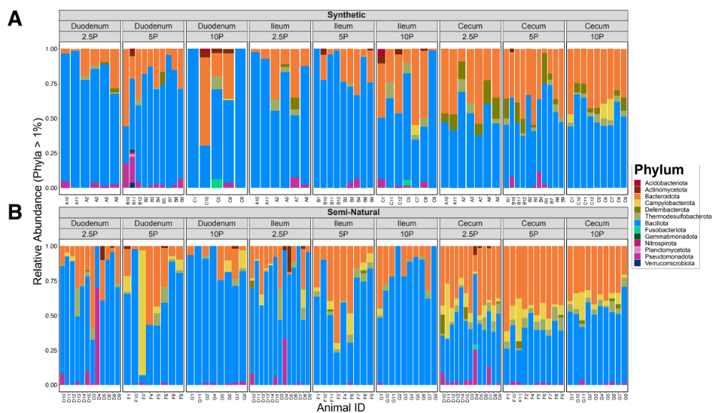

Supplemental Figure 2. Summary of the relative abundance ( > 1%) by phylum in each individual mouse in the Synthetic (A) and Semi-Natural diet treatment (A) grouped by gut section (duodenum, ileum, cecum) and then by protein content (Low (2.5P), Medium (5P), or High protein (10P)).

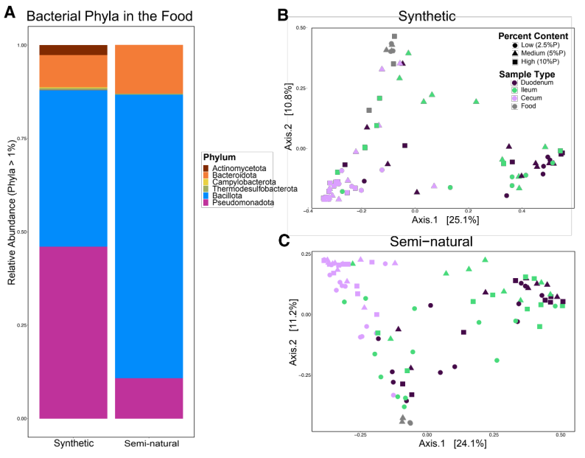

Supplemental Figure 3. Microbial Community Composition present in mouse food compared to in vivo mice gut sections. Relative abundance ( > 1%) by phylum present in the mouse food for the (B) Synthetic or (C) Semi-natural diet types. Microbial communities present in mouse food are significantly different compared to gut microbial communities in the synthetic (Bray-Curtis Dissimilarity: F=8.03, R² = 0.23, p = 0.00) and semi-natural diet treatments (Bray-Curtis Dissimilarity: F=10.41, R² = 0.23, p = 0.00).

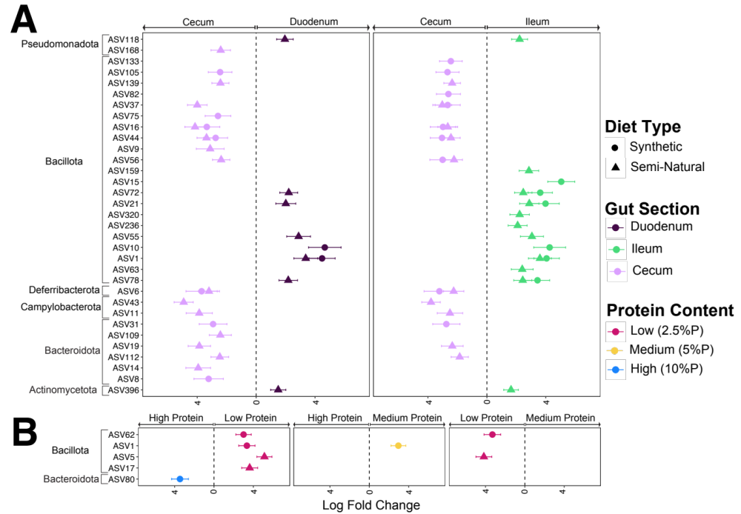

Supplemental Figure 4. Differentially abundant ASVs associated with the synthetic (circle) or semi-natural (triangle) diet type identified by ANCOM-BC2. Each dot represents a differentially abundant ASV plotted by its taxonomic assignment on the y- axis grouped by Phylum and log-fold change on the x axis. Error bars calculated using the standard error. Log fold change converted to absolute values, see SI table 6 & 7 for raw ANCOM-BC2 output. (A) Differentially abundant ASVs associated with each gut section (Duodenum (purple), Ileum, (green), and Cecum (pink)). Positive log fold change indicates taxa enriched in each respective gut section. (B) Differentially abundant ASVs associated with protein content (low 2.5% protein (red), medium 5% protein (yellow), and high 10% protein (blue)). Positive log fold change indicates taxa enriched in each respective diet.

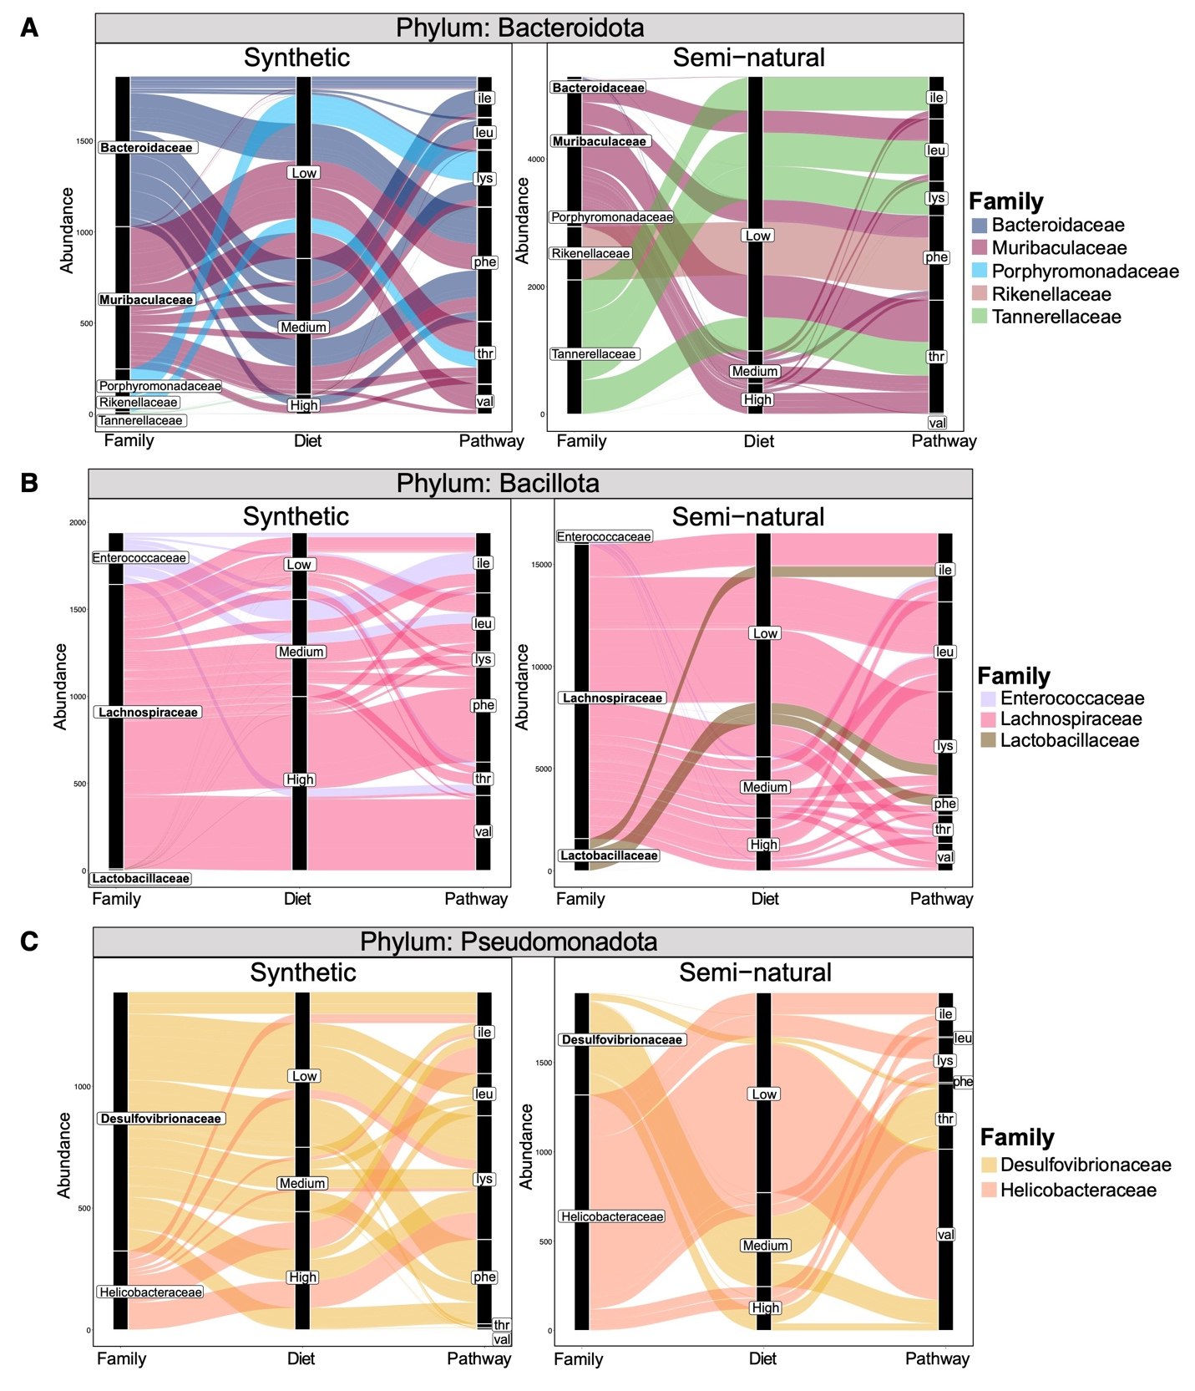

Supplemental Figure 5. Potential microbial contributions to essential amino acid biosynthesis among metagenomic-assembled microbial genomes from the cecal contents of mice fed the synthetic (left) or semi-natural (right) diet types. Microbial genomes represented at the family-level resolution within each respective phylum (A) Bacteroidota, (B) Bacillota, and (C) Pseudomonadota. The three columns from left to right represent taxonomic groups scaled by the abundance of each microbial group carrying genes involved in a specific essential amino acid biosynthesis pathway within each diet treatment. Colors are assigned based on bacterial family. Families also found to be differentially abundant in the 16S rRNA ANCOM-BC2 analysis are in bold font.

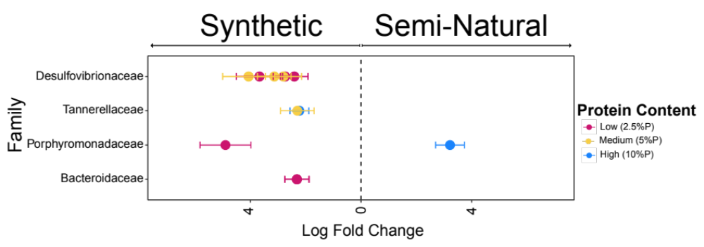

Supplemental Figure 6. Differentially abundant families identified by ANCOM-BC2 among Metagenomic-assembled microbial genomes from the cecal contents of mice fed the synthetic (left) or semi-natural (right) diet type. Each dot represents a differentially abundant family (determined via pair-wise comparisons) plotted by its taxonomic assignment on the y- axis and log-fold change on the x axis. Positive log fold change indicates taxa enriched in each diet treatment. Error bars calculated using the standard error. Standard error < 0.9 and p-value < 0.003 for all differentially abundant taxa identified. Log fold change converted to absolute values. See SI table 14 for all ANCOM-BC2 pairwise comparisons and raw ANCOM-BC2 output.

