Supplementary files for

A single-plasmid-based, easily curable CRISPR/Cas9 system for rapid, iterative genome editing in Pseudomonas putida KT2440

Qifeng Wen ^{1, 2}, JinJin Chen ³, Jin Li ³, Ida Putu Wiweka Dharmasiddhi ³, Maohua Yang ^{1,} *, Jianmin Xing ^{1, 2,} *, and Yilan Liu ^{3,} *

¹ State Key Laboratory of Petroleum Molecular & Process Engineering, Institute of Process Engineering, Chinese Academy of Sciences, Beijing, China
² College of Chemical Engineering, University of Chinese Academy of Sciences, Beijing, China
³ Department of Chemical Engineering, University of Waterloo, Waterloo, Canada

* Corresponding authors:
Maohua Yang, Email: mhyang@ipe.ac.cn
Jianmin Xing, Email: jmxing@ipe.ac.cn
Yilan Liu, Email: yilan.liu@uwaterloo.ca

The file includes:
Supplementary Figures S1-S3

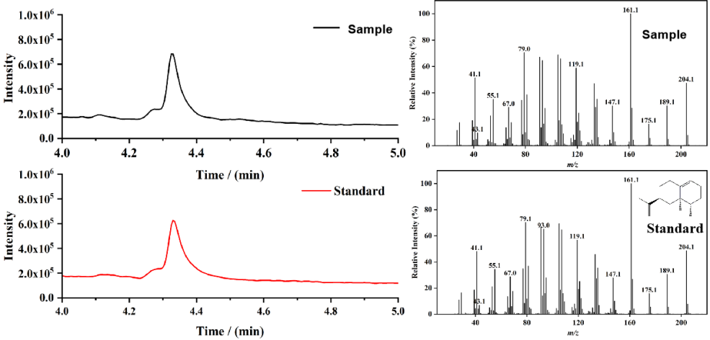
Fig. S1 GC-MS analysis of retention time and mass fragmentation for both a sample and a standard of valencene.

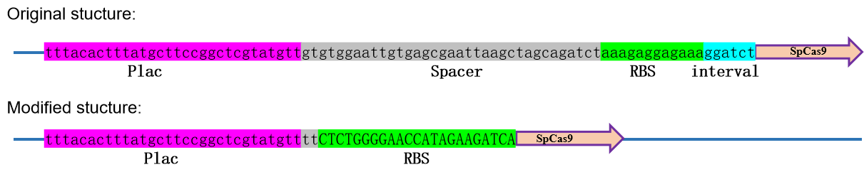
Fig. S2 Modified sequence before spCas9 to reduce its expression level. The spacer and interval were removed and the RBS was changed.

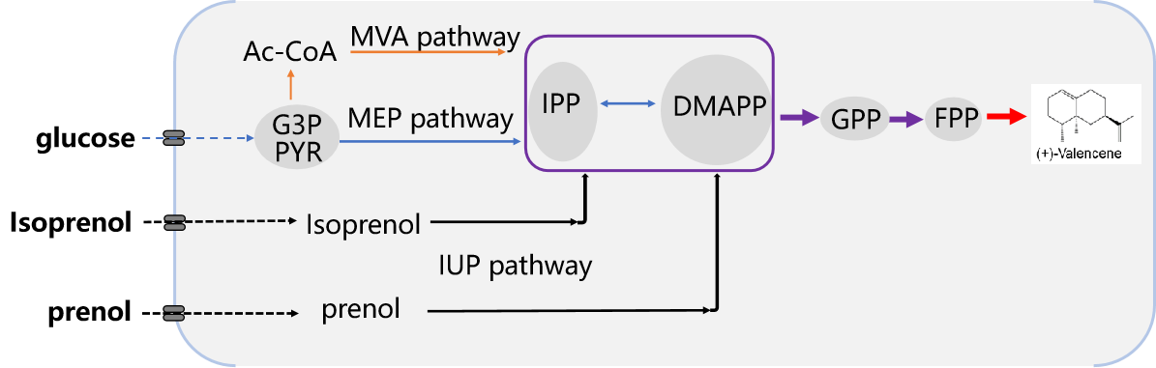
Fig. S3 Pathways for valencene synthesis. The valencene synthase (vs) was heterologously expressed to catalyze the formation of (+)-valencene from Farnesyl diphosphate (FPP) and geranyl diphosphate (GPP). These precursors typically originate from the condensation of dimethylallyl diphosphate (DMAPP) and isopentenyl diphosphate (IPP), which are synthesized via the methylerythritol 4-phosphate (MEP) pathway, the mevalonate (MVA) pathway, and the isopentenol (IUP) pathway.

