a)
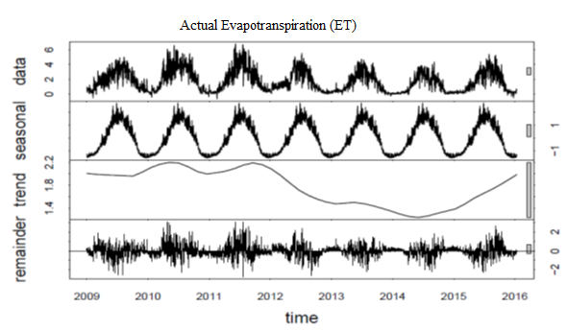
b)
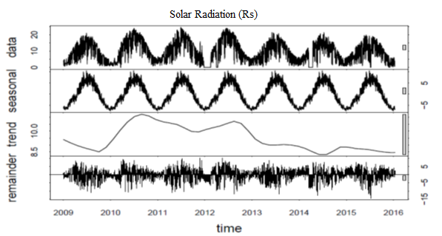

c)
d)
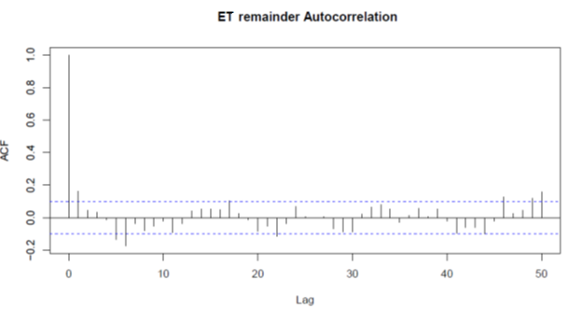

e)
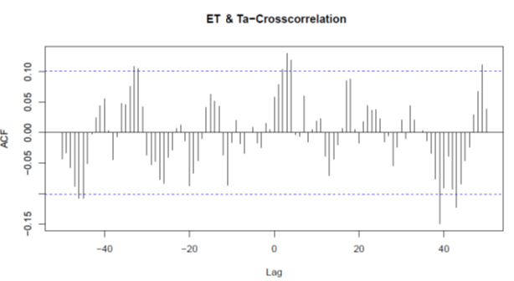
f)
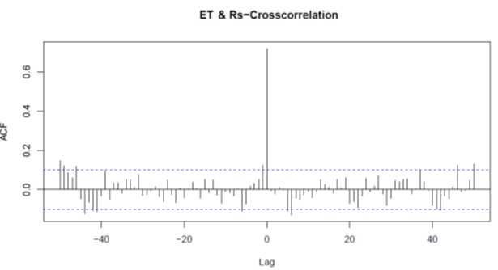

Figure S1. The seasonal trend decomposition method and the LOESS (STL) for ET (a), solar radiation, R_{s} (b), and air temperature, T_{a} (c) of M. × giganteus UIEF. From top to bottom, the original time series, seasonal component, trend component, and remainders are displayed. Further, the auto-correlation function of the ET-remainder (d), cross-correlation of R_{s} -remainder, and ET-remainder (e) and cross-correlation of T_{a}-remainder and ET-remainder (f) time series are shown. The dashed line indicates the confidence limit. The bar scale on the right side of each subplot (a,b and c) explains which component (seasonality or trend) is dominant for a series. The significance of the component is higher with a smaller bar scale (Cleveland, 1990).

