Supporting Information
Appendix S1. Genomic library preparation, sequencing and analysis of H. ethilla narcaea
DNA extraction was performed from butterfly thorax tissue using the Qiagen DNeasy Blood & Tissue Kit. Samples were quantified using a Qubit fluorimeter. ddRAD libraries were prepared as described by (Peterson et al. 2012) with some modifications. Each library was prepared from 100ng of starting genomic DNA. Not all collected individuals yielded this much DNA (likely because butterflies were not stored under ideal conditions following collection), therefore libraries were prepared from 88 of the 99 collected individuals. ddRAD uses the sequence specificity of restriction endonucleases to fragment genomic DNA at specific locations and therefore create reduced representation sequencing libraries. We used the restriction enzymes SbfI-HF and EcoRI-HF. P1 adaptors with a unique 8bp molecular identifier barcode for each sample (Table S3) were ligated to Sbf1 cut site, and generic P2 adaptors were ligated to the EcoR1 cut site. Fragments of 300bp were selected by running each sample on an agarose gel, and were then amplified with 24 cycles of PCR. The products were purified with AMPure XP beads and quantified with qPCR, before being pooled in equimolar amounts. The pooled libraries were sequenced on a single lane of Illumina HiSeq v4 at the Edinburgh Genomics sequencing facility to generate 460M 125 base paired-end sequence reads. These data are deposited in the European Nucleotide Archive under project PRJEB45832.
Individuals were de-multiplexed and the adaptor barcodes were removed using the process_radtags program within the STACKS package (Catchen et al. 2011), which also removes reads lacking a barcode or restriction site and with low quality or missing data (with default values and allowing correction of errors in the barcode and restriction site). Sequencing quality was checked with FastQC, which revealed some remaining adaptor sequence. We therefore trimmed the remaining adaptor sequence with the program cutadapt (v1.2.1) (Martin 2011). H. ethilla narcaea sequences were aligned to the H. melpomene (v2) reference genome (The Heliconius Genome Consortium 2012) (Davey et al. 2016) downloaded from Lepbase (Challis et al. 2016) using the program Stampy (v1.0.22) (Lunter and Goodson 2011), with substitution rate set to 0.05. This aligner was used because it has been shown to work well when aligning data to non-conspecific genomes (The Heliconius Genome Consortium 2012). Samtools was used to sort, index and convert SAM files to BAM files. We then called SNPs using UnifiedGenotyper in GATK (v2.5.2) with the heterozygosity prior set to 0.01, based on previous genomic studies in Heliconius (The Heliconius Genome Consortium 2012). VCF tools (v0.1.12b) (Danecek et al. 2011) were then used to process and filter the SNPs. We firstly removed 4 individuals for which very few sites had been called. We then removed SNPs with depth of coverage greater than 200 across all individuals, as these likely represent repetitive regions. Finally, we performed stricter filtering, removing individuals and positions with more than 50% missing data, and positions with a minor allele count below 2 and any indels, to leave a high-quality set of 6213 SNPs in 65 individuals. Fig. S1 shows the representative read depth across all sites and individuals in the final filtered data set (Knaus and Grünwald 2017).
Reference:
Peterson, Brant K., Jesse N. Weber, Emily H. Kay, Heidi S. Fisher, and Hopi E. Hoekstra. 2012. “Double Digest RADseq: An Inexpensive Method for de Novo SNP Discovery and Genotyping in Model and Non-Model Species.” PLoS ONE 7 (5). https://doi.org/10.1371/journal.pone.0037135.
Catchen, Julian M., Angel Amores, Paul Hohenlohe, William Cresko, and John H. Postlethwait. 2011. “Stacks : Building and Genotyping Loci De Novo From Short-Read Sequences.” G3: GENES, GENOMES, GENETICS 1 (3): 171–82. https://doi.org/10.1534/g3.111.000240.
Martin, Marcel. 2011. “Cutadapt Removes Adapter Sequences from High-Throughput Sequencing Reads.” EMBnet.Journal 17 (1): 10.
The Heliconius Genome Consortium. 2012. “Butterfly Genome Reveals Promiscuous Exchange of Mimicry Adaptations among Species.” Nature 487 (7405): 94–98. https://doi.org/10.1038/nature11041.
Davey, John W., Mathieu Chouteau, Sarah L. Barker, Luana Maroja, Simon W. Baxter, Fraser Simpson, Richard M. Merrill, et al. 2016. “Major Improvements to the Heliconius Melpomene Genome Assembly Used to Confirm 10 Chromosome Fusion Events in 6 Million Years of Butterfly Evolution.” G3: Genes, Genomes, Genetics 6: 695–708. https://doi.org/10.5061/dryad.3s795.
Challis, Richard J., Sujai Kumar, Kanchon K. Dasmahapatra, Chris D. Jiggins, and Mark Blaxter. 2016. “Lepbase: The Lepidopteran Genome Database.” BioRxiv, 056994. https://doi.org/10.1101/056994.
Lunter, Gerton, and Martin Goodson. 2011. “Stampy: A Statistical Algorithm for Sensitive and Fast Mapping of Illumina Sequence Reads.” Genome Research 21 (6): 936–39. https://doi.org/10.1101/gr.111120.110.
Danecek, Petr, Adam Auton, Goncalo Abecasis, Cornelis A. Albers, Eric Banks, Mark A. DePristo, Robert Handsaker, et al. 2011. “The Variant Call Format and VCFtools.” Bioinformatics. 2011. https://vcftools.github.io/license.html.
Knaus, Brian J., and Niklaus J. Grünwald. 2017. “Vcfr: A Package to Manipulate and Visualize Variant Call Format Data in R.” Molecular Ecology Resources 17 (1): 44–53. https://doi.org/10.1111/1755-0998.12549.
Appendix S2. Nymphalidae phylogenetic analysis
The phylogenetic tree used for community analysis was generated using the genus-level phylogeny (Wahlberg et al. 2009). Original branch lengths were preserved, but the tip information was refined to species levels, and, new species and two genera were added according to the literature to resolve the polytomies. Refining the tips does not compromise the phylogeny structure, so preserves the phylogenetic relationship from the original phylogeny. When a new species belonging to the same genus was added we defined the species divergence time as being half the original genus branch length. Similarly, when more than one new species was included in one original branch we resolved the polytomies according to the literature, as occurred when Blepolenis (Penz and Mohammadi 2013) and Capronnieria (Marín et al. 2017) genus, and Adelpha (Willmott 2003), Danaus (Brower et al. 2010), Hamadryas (Garzón-Orduña et al. 2013) and Heliconius (Kozak et al. 2015) species were added dividing the branch length in equal distances according to the number of species added. Finally, we removed all species from the phylogeny that were not present in our data set. All steps were conducted in the picante package (Kembel et al. 2010) and the final phylogeny is shown in Fig. S2.
Reference:
Wahlberg, Niklas, Julien Leneveu, Ullasa Kodandaramaiah, Carlos Peña, Sören Nylin, André V.L. Freitas, and Andrew V.Z. Brower. 2009. “Nymphalid Butterflies Diversify Following near Demise at the Cretaceous/Tertiary Boundary.” Proceedings of the Royal Society B: Biological Sciences 276 (1677): 4295–4302. https://doi.org/10.1098/rspb.2009.1303.
Penz, Carla Maria, and Neda Mohammadi. 2013. “Wing Pattern Diversity in Brassolini Butterflies (Nymphalidae, Satyrinae).” Biota Neotropica 13 (3): 154–80. https://doi.org/10.1590/s1676-06032013000300020.
Marín, Mario A., Carlos Peña, Sandra I. Uribe, and André V.L. Freitas. 2017. “Morphology Agrees with Molecular Data: Phylogenetic Affinities of Euptychiina Butterflies (Nymphalidae: Satyrinae).” Systematic Entomology 42 (4): 768–85. https://doi.org/10.1111/syen.12245.
Willmott, Keith R. 2003. “Cladistic Analysis of the Neotropical Butterfly Genus Adelpha (Lepidoptera: Nymphalidae), with Comments on the Subtribal Classification of Limenitidini.” Systematic Entomology 28 (3): 279–322. https://doi.org/10.1046/j.1365-3113.2003.00209.x.
Brower, Andrew V.Z., Niklas Wahlberg, Joshua R. Ogawa, Michael Boppré, and R. I. Vane-Wright. 2010. “Phylogenetic Relationships among Genera of Danaine Butterflies (Lepidoptera: Nymphalidae) as Implied by Morphology and DNA Sequences.” Systematics and Biodiversity 8 (1): 75–89. https://doi.org/10.1080/14772001003626814.
Garzón-Orduña, Ivonne J., Onildo Marini-Filho, Steve G. Johnson, and Carla M. Penz. 2013. “Phylogenetic Relationships of Hamadryas (Nymphalidae: Biblidinae) Based on the Combined Analysis of Morphological and Molecular Data.” Cladistics 29 (6): 629–42. https://doi.org/10.1111/cla.12021.
Kozak, Krzysztof M., Niklas Wahlberg, Andrew F.E. Neild, Kanchon K. Dasmahapatra, James Mallet, and Chris D. Jiggins. 2015. “Multilocus Species Trees Show the Recent Adaptive Radiation of the Mimetic Heliconius Butterflies.” Systematic Biology 64 (3): 505–24. https://doi.org/10.1093/sysbio/syv007.
Kembel, S.W., P.D. Cowan, M.R. Helmus, W.K. Cornwell, H. Morlon, D.D. Ackerly, S.P. Blomberg, and C.O. Webb. 2010. “Picante: R Tools for Integrating Phylogenies and Ecology.” Bioinformatics, 1463–64.

Table S1. Numbers of individuals of each species by site and treatment, ordered by subfamily of Nymphalidae. The final columns give the total numbers of each species by treatment, conventional (C), native (N) and agroforestry (A). The final rows give the total numbers of species and individuals at each site and by treatment. Site codes correspond to those in Fig. 2. (*) Shows species belonging to the Tiger mimicry ring.

Species |  | Sites and treatment |  |  |  |  |  |  |  |  |  |  |  |  |  |  |  |  |  |  |  |  |  |  |  |  |  |  | Total treatment
 |  | Ze |  |  | Va |  |  | Lu |  |  | To |  |  | Ad |  |  | Ja |  |  | Di |  |  | Ar |  |  | Ti
Heliconiinae |  | C | N | A | C | N | A | C | N | A | C | N | A | C | N | A | C | N | A | C | N | A | C | N | A | C | N | A | C | N | A
 | Actinote sp. | 0 | 3 | 3 | 2 | 0 | 0 | 2 | 4 | 13 | 0 | 0 | 0 | 2 | 3 | 0 | 1 | 3 | 2 | 0 | 0 | 4 | 2 | 0 | 3 | 2 | 1 | 1 | 11 | 14 | 26
 | Agraulis vanillae | 0 | 0 | 0 | 0 | 0 | 0 | 0 | 0 | 0 | 0 | 0 | 0 | 0 | 0 | 0 | 0 | 1 | 0 | 0 | 0 | 0 | 1 | 0 | 0 | 1 | 0 | 0 | 2 | 1 | 0
 | Heliconius besckei | 0 | 0 | 0 | 0 | 0 | 1 | 0 | 0 | 0 | 0 | 0 | 0 | 0 | 0 | 0 | 0 | 0 | 0 | 0 | 0 | 0 | 0 | 0 | 0 | 0 | 0 | 0 | 0 | 0 | 1
 | Heliconius erato | 0 | 5 | 3 | 2 | 0 | 1 | 2 | 5 | 0 | 3 | 1 | 9 | 2 | 15 | 10 | 2 | 11 | 5 | 1 | 9 | 5 | 1 | 3 | 4 | 1 | 4 | 7 | 14 | 53 | 44
 | Heliconius ethilla * | 10 | 6 | 5 | 0 | 1 | 1 | 2 | 5 | 5 | 1 | 0 | 3 | 4 | 9 | 0 | 2 | 3 | 2 | 4 | 4 | 8 | 4 | 3 | 9 | 1 | 4 | 2 | 28 | 35 | 35
 | Dione juno | 0 | 0 | 0 | 0 | 0 | 1 | 0 | 0 | 1 | 0 | 0 | 0 | 1 | 2 | 0 | 0 | 0 | 0 | 1 | 0 | 0 | 0 | 0 | 0 | 0 | 0 | 0 | 2 | 2 | 2
 | Dione moneta | 0 | 0 | 0 | 0 | 0 | 0 | 0 | 0 | 0 | 0 | 0 | 0 | 0 | 0 | 0 | 0 | 0 | 0 | 1 | 0 | 0 | 0 | 0 | 0 | 0 | 0 | 0 | 1 | 0 | 0
 | Eueides aliphera | 0 | 3 | 0 | 1 | 0 | 0 | 0 | 0 | 0 | 0 | 0 | 0 | 0 | 0 | 0 | 1 | 2 | 1 | 2 | 0 | 0 | 0 | 0 | 8 | 0 | 0 | 0 | 4 | 5 | 9
 | Eueides isabella * | 0 | 0 | 0 | 0 | 0 | 2 | 0 | 0 | 10 | 1 | 0 | 0 | 0 | 0 | 0 | 1 | 0 | 0 | 0 | 0 | 0 | 1 | 0 | 0 | 0 | 0 | 0 | 3 | 0 | 12
 | Philaethria wernickei | 0 | 0 | 0 | 0 | 0 | 0 | 0 | 0 | 0 | 0 | 0 | 0 | 0 | 0 | 0 | 0 | 0 | 0 | 0 | 0 | 0 | 0 | 0 | 0 | 1 | 1 | 0 | 1 | 1 | 0
Limenitidinae
 | Adelpha cocala | 0 | 0 | 0 | 0 | 1 | 0 | 0 | 0 | 0 | 0 | 0 | 0 | 0 | 0 | 0 | 0 | 0 | 0 | 0 | 0 | 0 | 0 | 0 | 0 | 0 | 0 | 0 | 0 | 1 | 0
 | Adelpha lycorias | 0 | 2 | 0 | 0 | 0 | 0 | 0 | 0 | 0 | 0 | 0 | 0 | 0 | 0 | 0 | 0 | 0 | 0 | 0 | 0 | 0 | 0 | 0 | 0 | 0 | 0 | 0 | 0 | 2 | 0
 | Adelpha mythra | 0 | 0 | 0 | 0 | 0 | 0 | 0 | 0 | 2 | 0 | 0 | 3 | 0 | 0 | 0 | 0 | 0 | 0 | 0 | 0 | 0 | 0 | 0 | 0 | 0 | 0 | 0 | 0 | 0 | 5
 | Adelpha plesaure | 0 | 0 | 1 | 0 | 0 | 0 | 0 | 0 | 0 | 0 | 0 | 0 | 0 | 0 | 0 | 0 | 0 | 0 | 0 | 0 | 0 | 0 | 0 | 0 | 0 | 0 | 0 | 0 | 0 | 1
 | Adelpha serpa | 0 | 0 | 0 | 0 | 0 | 0 | 0 | 1 | 0 | 1 | 0 | 0 | 0 | 0 | 0 | 0 | 0 | 0 | 0 | 0 | 0 | 0 | 0 | 0 | 0 | 1 | 0 | 1 | 2 | 0
 | Adelpha syma | 0 | 0 | 0 | 1 | 0 | 0 | 0 | 0 | 0 | 0 | 0 | 0 | 0 | 0 | 0 | 0 | 0 | 0 | 0 | 0 | 0 | 0 | 0 | 0 | 0 | 0 | 0 | 1 | 0 | 0
 | Adelpha thessalia | 0 | 0 | 0 | 0 | 0 | 0 | 0 | 0 | 0 | 0 | 0 | 0 | 1 | 0 | 0 | 0 | 0 | 0 | 0 | 0 | 0 | 0 | 0 | 0 | 0 | 0 | 0 | 1 | 0 | 0
 | Adelpha zea | 0 | 1 | 0 | 0 | 0 | 0 | 0 | 0 | 0 | 0 | 0 | 0 | 0 | 0 | 0 | 0 | 0 | 0 | 0 | 0 | 0 | 0 | 0 | 0 | 0 | 0 | 0 | 0 | 1 | 0
 | Smyrna blomfildia | 0 | 0 | 0 | 0 | 0 | 0 | 0 | 0 | 0 | 0 | 0 | 0 | 0 | 0 | 0 | 2 | 0 | 0 | 0 | 0 | 0 | 0 | 0 | 0 | 0 | 0 | 0 | 2 | 0 | 0
 | Libytheana carinenta | 0 | 0 | 0 | 0 | 0 | 0 | 0 | 0 | 0 | 0 | 0 | 0 | 0 | 0 | 0 | 1 | 0 | 0 | 0 | 0 | 0 | 0 | 0 | 0 | 0 | 0 | 0 | 1 | 0 | 0
Danainae
 | Aeria olena | 0 | 0 | 0 | 0 | 0 | 0 | 0 | 0 | 0 | 0 | 0 | 0 | 0 | 4 | 0 | 0 | 19 | 1 | 0 | 8 | 0 | 0 | 0 | 0 | 0 | 0 | 0 | 0 | 31 | 1
 | Danaus eresimus | 0 | 0 | 0 | 0 | 0 | 0 | 0 | 0 | 0 | 1 | 0 | 0 | 0 | 0 | 0 | 0 | 0 | 0 | 1 | 0 | 1 | 0 | 0 | 0 | 1 | 0 | 0 | 3 | 0 | 1
 | Danaus erippus | 0 | 0 | 0 | 0 | 0 | 0 | 0 | 0 | 0 | 0 | 0 | 0 | 0 | 0 | 2 | 0 | 0 | 0 | 0 | 0 | 1 | 0 | 0 | 1 | 1 | 0 | 1 | 1 | 0 | 5
 | Danaus gillipus | 0 | 0 | 0 | 0 | 0 | 0 | 0 | 0 | 0 | 0 | 0 | 0 | 0 | 0 | 0 | 0 | 0 | 0 | 0 | 0 | 0 | 0 | 0 | 1 | 0 | 0 | 1 | 0 | 0 | 2
 | Danaus plexippus | 0 | 0 | 0 | 0 | 0 | 0 | 0 | 0 | 1 | 0 | 0 | 0 | 0 | 0 | 0 | 0 | 0 | 1 | 0 | 0 | 0 | 0 | 0 | 0 | 0 | 0 | 0 | 0 | 0 | 2
 | Lycorea halia * | 0 | 0 | 0 | 1 | 0 | 0 | 1 | 0 | 1 | 0 | 0 | 1 | 0 | 0 | 1 | 0 | 0 | 0 | 1 | 0 | 0 | 0 | 0 | 0 | 0 | 0 | 0 | 3 | 0 | 3
 | Episcada hymenaea | 0 | 0 | 1 | 1 | 0 | 2 | 0 | 0 | 2 | 0 | 0 | 2 | 0 | 0 | 0 | 0 | 2 | 1 | 0 | 0 | 1 | 0 | 0 | 1 | 0 | 0 | 0 | 1 | 2 | 10
 | Epityches eupompe | 1 | 0 | 0 | 0 | 3 | 0 | 0 | 0 | 0 | 0 | 0 | 0 | 0 | 0 | 1 | 0 | 0 | 0 | 1 | 0 | 0 | 0 | 6 | 1 | 2 | 1 | 1 | 4 | 10 | 3
 | Ithomia agnosia | 0 | 0 | 0 | 0 | 4 | 0 | 0 | 0 | 1 | 0 | 0 | 0 | 0 | 0 | 0 | 0 | 0 | 0 | 0 | 0 | 0 | 0 | 0 | 0 | 0 | 1 | 0 | 0 | 5 | 1
 | Ithomia drymo | 0 | 1 | 0 | 0 | 1 | 0 | 0 | 1 | 0 | 0 | 0 | 0 | 0 | 0 | 0 | 0 | 1 | 1 | 0 | 1 | 0 | 0 | 0 | 0 | 0 | 0 | 0 | 0 | 5 | 1
 | Mechanitis lysimnia * | 2 | 2 | 8 | 7 | 3 | 3 | 1 | 5 | 15 | 2 | 6 | 1 | 0 | 6 | 4 | 1 | 7 | 1 | 2 | 0 | 2 | 1 | 8 | 1 | 6 | 4 | 1 | 22 | 41 | 36
 | Methona themisto | 0 | 3 | 0 | 0 | 0 | 0 | 0 | 0 | 0 | 0 | 0 | 0 | 0 | 0 | 0 | 0 | 0 | 0 | 0 | 0 | 0 | 0 | 2 | 0 | 0 | 0 | 0 | 0 | 5 | 0
 | Placidina euryanassa * | 1 | 0 | 11 | 1 | 0 | 0 | 0 | 9 | 5 | 0 | 0 | 0 | 0 | 0 | 0 | 1 | 0 | 1 | 0 | 0 | 0 | 0 | 0 | 0 | 3 | 2 | 0 | 6 | 11 | 17
 | Pseudoscada erruca | 0 | 3 | 0 | 0 | 3 | 0 | 0 | 0 | 1 | 0 | 1 | 0 | 0 | 0 | 1 | 0 | 0 | 0 | 0 | 0 | 0 | 1 | 1 | 0 | 1 | 1 | 0 | 2 | 9 | 2
 | Pteronymia sp | 0 | 1 | 0 | 0 | 1 | 0 | 0 | 0 | 4 | 0 | 0 | 0 | 0 | 1 | 1 | 0 | 0 | 0 | 0 | 1 | 0 | 1 | 2 | 0 | 0 | 1 | 1 | 1 | 7 | 6
 | Dircenna dero | 0 | 0 | 0 | 0 | 0 | 0 | 0 | 1 | 1 | 0 | 0 | 0 | 0 | 0 | 0 | 0 | 0 | 0 | 0 | 0 | 0 | 0 | 1 | 0 | 0 | 0 | 0 | 0 | 2 | 1
Nymphalinae
 | Colobura dirce | 1 | 0 | 0 | 1 | 0 | 0 | 0 | 0 | 0 | 0 | 0 | 0 | 0 | 0 | 0 | 2 | 1 | 0 | 0 | 0 | 0 | 0 | 0 | 0 | 3 | 0 | 0 | 7 | 1 | 0
 | Chlosyne lacinia | 0 | 0 | 0 | 0 | 0 | 0 | 0 | 0 | 3 | 0 | 0 | 0 | 0 | 0 | 0 | 1 | 0 | 0 | 0 | 0 | 2 | 0 | 0 | 0 | 0 | 0 | 0 | 1 | 0 | 5
 | Ortilia ithra | 0 | 0 | 0 | 2 | 0 | 0 | 0 | 0 | 0 | 0 | 0 | 0 | 0 | 0 | 0 | 0 | 0 | 0 | 0 | 0 | 0 | 0 | 0 | 0 | 0 | 0 | 0 | 2 | 0 | 0
 | Tegosa sp | 8 | 0 | 2 | 28 | 0 | 3 | 6 | 0 | 3 | 9 | 0 | 14 | 1 | 2 | 10 | 3 | 0 | 1 | 4 | 0 | 53 | 23 | 1 | 47 | 22 | 0 | 18 | 104 | 3 | 151
 | Hypanartia bella | 1 | 0 | 0 | 2 | 0 | 3 | 0 | 0 | 0 | 1 | 0 | 0 | 3 | 0 | 4 | 0 | 0 | 0 | 0 | 0 | 0 | 0 | 1 | 0 | 3 | 0 | 1 | 10 | 1 | 8
 | Hypanartia lethe | 1 | 0 | 0 | 0 | 0 | 2 | 0 | 0 | 0 | 2 | 0 | 0 | 1 | 0 | 4 | 1 | 0 | 0 | 3 | 0 | 0 | 2 | 0 | 3 | 4 | 0 | 0 | 14 | 0 | 9
 | Anartia amathea | 4 | 0 | 0 | 18 | 1 | 4 | 0 | 0 | 7 | 3 | 0 | 0 | 0 | 0 | 1 | 0 | 0 | 2 | 1 | 0 | 1 | 0 | 0 | 42 | 1 | 0 | 1 | 27 | 1 | 58
 | Anartia jatrophae | 0 | 0 | 0 | 0 | 0 | 0 | 0 | 0 | 0 | 0 | 0 | 0 | 0 | 0 | 0 | 0 | 0 | 0 | 0 | 0 | 1 | 0 | 0 | 0 | 0 | 0 | 0 | 0 | 0 | 1
 | Siproeta epaphus | 1 | 0 | 0 | 1 | 1 | 1 | 0 | 0 | 0 | 0 | 0 | 1 | 0 | 0 | 0 | 0 | 0 | 0 | 0 | 0 | 1 | 0 | 0 | 0 | 0 | 0 | 1 | 2 | 1 | 4
 | Siproeta stelenes | 0 | 0 | 0 | 0 | 0 | 1 | 0 | 0 | 0 | 0 | 0 | 0 | 0 | 0 | 0 | 0 | 0 | 0 | 0 | 0 | 0 | 0 | 0 | 0 | 0 | 0 | 0 | 0 | 0 | 1
 | Eresia lansdorfi | 0 | 0 | 0 | 4 | 0 | 1 | 1 | 0 | 2 | 0 | 1 | 1 | 0 | 0 | 0 | 0 | 0 | 0 | 0 | 0 | 0 | 0 | 0 | 0 | 0 | 0 | 0 | 5 | 1 | 4
 | Junonia sp. | 0 | 0 | 0 | 2 | 0 | 0 | 0 | 0 | 0 | 0 | 0 | 0 | 8 | 0 | 0 | 0 | 0 | 0 | 0 | 0 | 1 | 1 | 0 | 1 | 1 | 0 | 0 | 12 | 0 | 2
 | Vanessa braziliensis | 0 | 0 | 0 | 0 | 0 | 0 | 0 | 0 | 0 | 0 | 0 | 0 | 1 | 0 | 0 | 0 | 0 | 0 | 0 | 0 | 0 | 0 | 0 | 0 | 0 | 0 | 0 | 1 | 0 | 0
 | Vanessa myrinna | 0 | 0 | 0 | 0 | 0 | 0 | 0 | 0 | 0 | 0 | 0 | 0 | 0 | 0 | 0 | 0 | 0 | 0 | 0 | 0 | 1 | 0 | 0 | 0 | 0 | 0 | 0 | 0 | 0 | 1
Satyrinae
 | Blepolenis sp. | 0 | 0 | 0 | 0 | 0 | 0 | 0 | 0 | 0 | 0 | 0 | 0 | 0 | 0 | 0 | 0 | 0 | 0 | 0 | 0 | 0 | 0 | 0 | 0 | 1 | 0 | 0 | 1 | 0 | 0
 | Caligo eurilochus | 0 | 0 | 0 | 0 | 0 | 0 | 0 | 0 | 0 | 0 | 0 | 0 | 0 | 1 | 0 | 0 | 0 | 0 | 0 | 0 | 0 | 0 | 0 | 0 | 0 | 0 | 0 | 0 | 1 | 0
 | Caligo martia | 0 | 0 | 0 | 0 | 0 | 0 | 0 | 0 | 0 | 0 | 0 | 0 | 0 | 0 | 0 | 0 | 0 | 1 | 0 | 0 | 0 | 0 | 0 | 0 | 0 | 0 | 0 | 0 | 0 | 1
 | Catoblepia amphirhoe | 0 | 0 | 0 | 0 | 0 | 0 | 0 | 0 | 0 | 0 | 0 | 0 | 0 | 0 | 0 | 1 | 0 | 1 | 0 | 0 | 0 | 0 | 0 | 0 | 0 | 0 | 0 | 1 | 0 | 1
 | Dasyopthalma creusa | 0 | 0 | 0 | 0 | 0 | 0 | 0 | 2 | 0 | 0 | 0 | 0 | 0 | 0 | 0 | 0 | 0 | 0 | 0 | 0 | 0 | 0 | 1 | 0 | 0 | 0 | 0 | 0 | 3 | 0
 | Opsiphanes invirae | 0 | 0 | 0 | 0 | 0 | 0 | 0 | 0 | 0 | 1 | 0 | 1 | 0 | 0 | 1 | 0 | 0 | 0 | 0 | 0 | 0 | 0 | 0 | 0 | 1 | 0 | 0 | 4 | 0 | 4
 | Opsiphanes quiteria | 0 | 0 | 0 | 0 | 0 | 1 | 0 | 0 | 0 | 0 | 0 | 0 | 1 | 0 | 1 | 0 | 0 | 0 | 0 | 0 | 0 | 1 | 0 | 0 | 0 | 0 | 0
 | Morpho anaxibia | 0 | 0 | 0 | 0 | 0 | 0 | 0 | 1 | 0 | 0 | 0 | 0 | 0 | 0 | 0 | 0 | 0 | 0 | 0 | 0 | 0 | 0 | 0 | 0 | 0 | 0 | 0 | 0 | 1 | 0
 | Morpho epistrophus | 0 | 2 | 5 | 6 | 4 | 3 | 0 | 0 | 0 | 1 | 0 | 1 | 1 | 0 | 0 | 0 | 1 | 0 | 5 | 0 | 4 | 3 | 3 | 6 | 1 | 0 | 3 | 17 | 10 | 22
 | Capronnieria galesus | 0 | 0 | 0 | 0 | 0 | 0 | 0 | 0 | 0 | 0 | 0 | 0 | 0 | 0 | 0 | 0 | 0 | 0 | 0 | 0 | 1 | 0 | 0 | 2 | 0 | 0 | 1 | 0 | 0 | 4
 | Godartiana muscosa | 0 | 0 | 0 | 2 | 0 | 1 | 1 | 0 | 0 | 0 | 0 | 3 | 0 | 1 | 4 | 0 | 0 | 2 | 0 | 0 | 0 | 0 | 0 | 1 | 1 | 1 | 2 | 4 | 2 | 13
 | Moneuptychia paeon | 0 | 0 | 0 | 0 | 0 | 1 | 0 | 0 | 1 | 1 | 0 | 0 | 0 | 1 | 0 | 0 | 0 | 0 | 0 | 0 | 0 | 0 | 0 | 4 | 0 | 0 | 0 | 1 | 1 | 6
 | Moneuptychia soter | 1 | 0 | 0 | 1 | 0 | 2 | 4 | 0 | 0 | 0 | 0 | 1 | 0 | 0 | 2 | 0 | 0 | 1 | 0 | 0 | 3 | 0 | 0 | 4 | 0 | 1 | 11 | 6 | 1 | 24
 | Paryphthimoides phronius | 2 | 0 | 0 | 0 | 0 | 0 | 0 | 0 | 0 | 4 | 0 | 4 | 1 | 0 | 4 | 1 | 0 | 1 | 1 | 0 | 1 | 3 | 0 | 8 | 2 | 3 | 5 | 14 | 3 | 23
 | Paryphthimoides poltys | 0 | 0 | 0 | 0 | 0 | 1 | 0 | 0 | 0 | 0 | 0 | 0 | 0 | 0 | 0 | 0 | 0 | 0 | 0 | 0 | 1 | 0 | 0 | 0 | 0 | 0 | 2 | 0 | 0 | 4
 | Pedaliodes phanias | 0 | 1 | 0 | 0 | 0 | 0 | 0 | 0 | 0 | 0 | 0 | 0 | 0 | 0 | 0 | 0 | 0 | 0 | 0 | 0 | 0 | 0 | 0 | 0 | 0 | 0 | 0 | 0 | 1 | 0
 | Taygetis ypthima | 0 | 0 | 0 | 0 | 0 | 0 | 0 | 0 | 0 | 0 | 0 | 0 | 0 | 0 | 0 | 0 | 0 | 0 | 0 | 0 | 0 | 0 | 0 | 0 | 0 | 2 | 0 | 0 | 2 | 0
 | Yphthimoides sp. | 0 | 0 | 0 | 0 | 0 | 0 | 0 | 0 | 0 | 0 | 0 | 0 | 0 | 0 | 0 | 0 | 0 | 0 | 0 | 0 | 1 | 0 | 0 | 0 | 0 | 0 | 0 | 0 | 0 | 1
 | Hermeuptychia sp. | 19 | 0 | 3 | 7 | 0 | 14 | 8 | 1 | 21 | 13 | 2 | 8 | 9 | 4 | 39 | 1 | 0 | 11 | 12 | 0 | 9 | 4 | 2 | 7 | 3 | 1 | 10 | 76 | 10 | 122
Apaturinae
 | Doxocopa laurentia | 0 | 0 | 0 | 0 | 0 | 0 | 0 | 0 | 0 | 0 | 0 | 0 | 0 | 0 | 0 | 0 | 0 | 2 | 0 | 0 | 0 | 0 | 0 | 0 | 0 | 0 | 0 | 0 | 0 | 2
 | Doxocopa zunilda | 0 | 0 | 0 | 1 | 0 | 0 | 0 | 0 | 0 | 0 | 0 | 0 | 0 | 0 | 0 | 0 | 0 | 0 | 0 | 0 | 0 | 0 | 0 | 0 | 1 | 0 | 0 | 2 | 0 | 0
 | Dryas iulia | 2 | 0 | 0 | 1 | 0 | 1 | 0 | 0 | 0 | 0 | 0 | 0 | 1 | 2 | 2 | 0 | 1 | 0 | 0 | 0 | 0 | 4 | 0 | 0 | 1 | 1 | 4 | 9 | 4 | 7
Biblidinae
 | Hamadryas amphinome | 0 | 0 | 1 | 0 | 0 | 0 | 0 | 0 | 0 | 1 | 0 | 0 | 1 | 0 | 0 | 0 | 0 | 0 | 0 | 0 | 0 | 0 | 0 | 0 | 0 | 0 | 0 | 2 | 0 | 1
 | Hamadryas epinome | 0 | 1 | 1 | 0 | 0 | 0 | 0 | 0 | 0 | 0 | 0 | 0 | 0 | 1 | 0 | 1 | 0 | 4 | 0 | 0 | 0 | 0 | 0 | 0 | 0 | 0 | 2 | 1 | 2 | 7
 | Hamadryas februa | 0 | 0 | 1 | 0 | 0 | 0 | 0 | 0 | 0 | 0 | 0 | 0 | 1 | 0 | 0 | 0 | 0 | 1 | 0 | 0 | 0 | 0 | 0 | 0 | 0 | 0 | 0 | 1 | 0 | 2
 | Hamadryas fornax | 0 | 0 | 0 | 0 | 0 | 0 | 0 | 0 | 0 | 0 | 0 | 0 | 0 | 0 | 0 | 0 | 0 | 1 | 0 | 0 | 0 | 1 | 0 | 0 | 0 | 0 | 0 | 1 | 0 | 1
 | Callicore phygas | 1 | 1 | 1 | 0 | 0 | 0 | 0 | 0 | 0 | 0 | 0 | 0 | 0 | 0 | 0 | 0 | 0 | 0 | 0 | 0 | 0 | 0 | 0 | 0 | 0 | 0 | 0 | 1 | 1 | 1
 | Catonephele sp. | 0 | 0 | 0 | 0 | 0 | 0 | 0 | 0 | 0 | 0 | 0 | 0 | 0 | 0 | 0 | 0 | 0 | 0 | 0 | 0 | 0 | 0 | 0 | 0 | 1 | 0 | 0 | 1 | 0 | 0
 | Dynamine myrrhina | 0 | 1 | 0 | 0 | 0 | 0 | 0 | 0 | 0 | 0 | 0 | 0 | 0 | 0 | 0 | 0 | 0 | 0 | 0 | 0 | 0 | 0 | 1 | 1 | 1 | 1 | 0 | 1 | 3 | 1
 | Dynamine postverta | 0 | 0 | 3 | 0 | 0 | 0 | 0 | 0 | 0 | 0 | 0 | 0 | 0 | 0 | 0 | 0 | 1 | 5 | 0 | 0 | 0 | 0 | 0 | 1 | 1 | 0 | 0 | 1 | 1 | 9
 | Diaethria clymena | 0 | 0 | 1 | 2 | 0 | 0 | 2 | 0 | 0 | 1 | 0 | 1 | 1 | 0 | 1 | 1 | 0 | 0 | 0 | 0 | 0 | 0 | 0 | 0 | 1 | 0 | 0 | 8 | 0 | 3
 | Biblis hyperia | 0 | 0 | 4 | 0 | 0 | 0 | 0 | 0 | 0 | 0 | 0 | 1 | 1 | 1 | 0 | 0 | 0 | 0 | 0 | 0 | 0 | 0 | 0 | 1 | 0 | 0 | 0 | 1 | 1 | 6
 | Ectima thecla | 0 | 0 | 0 | 0 | 0 | 0 | 0 | 0 | 0 | 0 | 0 | 0 | 0 | 0 | 0 | 0 | 0 | 0 | 0 | 0 | 0 | 0 | 0 | 0 | 1 | 0 | 0 | 1 | 0 | 0
 | Haematera pyrame | 1 | 0 | 0 | 0 | 0 | 0 | 0 | 1 | 1 | 0 | 0 | 0 | 0 | 0 | 0 | 0 | 0 | 0 | 0 | 0 | 0 | 1 | 5 | 0 | 0 | 0 | 1 | 2 | 6 | 2
 | Temenis laothoe | 1 | 0 | 1 | 0 | 0 | 0 | 0 | 0 | 0 | 0 | 0 | 1 | 0 | 0 | 0 | 1 | 0 | 0 | 0 | 0 | 0 | 0 | 0 | 1 | 0 | 0 | 0 | 2 | 0 | 3
Charaxinae
 | Consul fabius * | 0 | 1 | 0 | 0 | 0 | 0 | 0 | 0 | 0 | 0 | 0 | 1 | 0 | 0 | 0 | 0 | 0 | 1 | 0 | 0 | 0 | 0 | 0 | 0 | 0 | 0 | 0 | 0 | 1 | 2
 | Memphis moruus | 0 | 0 | 0 | 0 | 0 | 0 | 0 | 0 | 0 | 0 | 0 | 0 | 0 | 0 | 0 | 0 | 2 | 0 | 0 | 1 | 0 | 0 | 0 | 0 | 0 | 0 | 0 | 0 | 3 | 0
 | Archaeoprepona amphimachus | 0 | 0 | 0 | 0 | 0 | 0 | 0 | 0 | 0 | 1 | 0 | 0 | 0 | 0 | 0 | 0 | 0 | 0 | 0 | 0 | 0 | 0 | 0 | 0 | 0 | 0 | 0 | 1 | 0 | 0
 | Archaeoprepona demophoon | 0 | 1 | 0 | 0 | 0 | 0 | 0 | 0 | 0 | 0 | 0 | 0 | 0 | 0 | 0 | 0 | 0 | 0 | 0 | 0 | 0 | 0 | 0 | 1 | 0 | 0 | 0 | 0 | 1 | 1
Cyrestinae
 | Marpesia sp. | 0 | 0 | 0 | 0 | 0 | 0 | 0 | 0 | 0 | 0 | 0 | 2 | 1 | 0 | 0 | 0 | 0 | 0 | 0 | 0 | 0 | 0 | 0 | 0 | 1 | 1 | 0 | 2 | 1 | 2
 | Total species | 17 | 18 | 18 | 23 | 11 | 22 | 11 | 12 | 21 | 18 | 5 | 20 | 20 | 15 | 19 | 19 | 14 | 24 | 15 | 6 | 21 | 18 | 15 | 25 | 31 | 19 | 22 | 60 | 50 | 63
 | Total individuals | 57 | 38 | 55 | 94 | 23 | 50 | 30 | 36 | 100 | 47 | 11 | 59 | 42 | 53 | 93 | 25 | 55 | 50 | 40 | 24 | 102 | 55 | 40 | 159 | 71 | 32 | 77 | 461 | 312 | 745

Table S2. Number of Heliconius ethilla narcaea individuals included in the final genetic analysis from each site and treatment. The two-letter site codes correspond to those in Fig. 2. Each block contains three treatment plots, native forestry (N), conventional (C) and agroforestry plantation (A). 65 individuals were included in the final analysis following quality filtering of the sequence data (Filt_65). Fig. S1 shows the data quality for the final filtered set.
Sites | Filt_65
 | C | A | N | Total
Ze | 7 | 4 | 4 | 15
Ti | 0 | 0 | 0 | 0
Ar | 3 | 6 | 1 | 10
Di | 4 | 6 | 1 | 11
Ja | 1 | 2 | 3 | 6
Ad | 1 | 0 | 6 | 7
To | 1 | 2 | 0 | 3
Lu | 2 | 4 | 5 | 11
Va | 0 | 1 | 1 | 2
TOTAL | 19 | 25 | 21 | 65

Table S3. Sequence barcode used for the 88 individuals of H. ethilla narcaea sent for sequencing. The individual's name has the information about the block, treatment and order of sampling. The first number corresponds to the respective block, followed by the treatment type (N, Native; O, Agroforestry; and C, conventional) and sampling order (I, initial; M, middle; and F, end).
Block | Individuals | Barcode
Va | 1NILuci01 | CGTTGGTT
 | 1NILuci01_2 | CCGACGAA
 | 1OIGa10 | TTCTGGTT
Lu | 3CILuan04 | GCATGGTT
 | 3CMDi07 | GTTCGGTT
 | 3NIDi03 | TGGCGGTT
 | 3NIDi06 | AACCGGTT
 | 3NILuci05 | TCTAGGTT
 | 3NMLuci02 | GATGCGTT
 | 3NMMa04 | CGCTCCTT
 | 3OFDi14 | AGGAGATT
 | 3OMDi03 | ATCTCATT
 | 3OMDi26 | CCTATGGT
 | 3OMWi22 | TTGATGGT
To | 4CIMa08 | TTCCTCGT
 | 4OFJu13 | TCTCGCGT
 | 4OFJu24 | AGCCTAGT
 | 4OMDi29 | TGGTCAGT
Ad | 5CIDi03 | TTAGAAGT
 | 5CIDI03_2 | GGTCTCAA
 | 5CIDi09 | CCGGTTCT
 | 5CIDi17 | GTCGTTCT
 | 5CINi04 | CATAACCT
 | 5NFDi07 | GCATAACT
 | 5NFDi09 | CGTAATAT
 | 5NFDi14 | GACTGCAT
 | 5NFDi15 | GATGGTTG
 | 5NFLuca03 | AGAGGTTG
 | 5NMDi09 | TATTATTG
 | 5NMGa04 | GTCCGCTG
 | 5NMJu10 | CTGGTTGG
Ja | 6CMLuca02 | ACTCTTGG
 | 6NIDi11 | CCAGCTGG
 | 6NINi05 | CTATATGG
 | 6NMGa05 | AGGATCGG
 | 6OFLuca04 | TCGCTAGG
 | 6OMAnd02 | CGTCGAGG
Di | 7CFDi15 | AGTTCAGG
 | 7CFDi17 | GTACCAGG
 | 7CMDi01 | CAGCTTCG
 | 7CMMa06 | CCGACTCG
 | 7NILuci03 | ATGATGCG
 | 7NIMa02 | TAGCGGCG
 | 7OFDi02 | GTCGAGCG
 | 7OFDi05 | AGCGAACG
 | 7OFDi06 | TGCCTACG
 | 7OFLuci13 | ATAACGAG
 | 7OIDi39 | GAACTCAG
 | 7OMAne03 | TTATCCAG
 | 7OMDi27 | GACTCAAG
Ar | 8CIDi08 | AACGGTTC
 | 8CIMa06 | CAGCGTTC
 | 8CMLuci10 | ATACGTTC
 | 8CMLuci11 | CTTAGTTC
 | 8NFLuci05 | CGAGCTTC
 | 8NFMa01 | TACTCCTC
 | 8NMDi01 | TAAGAATC
 | 8OFAne07 | GCTAACGC
 | 8OFAne26 | TACGTAGC
 | 8OFAne34 | TGACCAGC
 | 8OFDi22 | CCAATTCC
 | 8OFLuci17 | ATTAATCC
 | 8OIGa03 | GCAACGCC
 | 8OILuci05 | AGAGAGCC
 | 8OMDi25 | CGCCGACC
Ti | 9CIDi02 | GACTAACC
 | 9NIDi08 | GCTGAACC
 | 9NIGa14 | CCGGCTAC
 | 9NILuci10 | GAGAATAC
 | 9OILuci09 | AAGGCGAC
Ze | 10CFDi03 | GCCAAGAC
 | 10CFDi07 | AACTTAAC
 | 10CFDi09 | GTTGCAAC
 | 10CFLuan05 | TATTGAAC
 | 10CFWi01 | CGACGTTA
 | 10CIDi13 | AGTAGGTA
 | 10CIDi14 | CAAGTTGA
 | 10CIGa09 | CAGTAGGA
 | 10CIJu05 | ATGACCGA
 | 10CMTai09 | TCGAACGA
 | 10NFDi03 | CGAATAGA
 | 10NFDi03_2 | TGGATCAA
 | 10NFDi07 | ATATAAGA
 | 10NFGa01 | TTCTTGCA
 | 10NFJu03 | ACCTTCCA
 | 10NMDi01 | AATTACCA
 | 10OIDi10 | TCATACCA
 | 10OIWi03 | CAGGACCA
 | 10OMDi09 | GTCAACCA
 | 10OMDi10 | ACGCTTAA
 | 10OMGa12 | TCATCGAA

Table S4. Membership to each of the DAPC population genomic clusters at each site. The membership of each site was calculated based on the membership values of each individual from that site (Fig. S4). The corresponding treatments (Treat.) are presented according to each block sampled: conventional (C), native (N) and agroforestry (A). NA indicates no individuals sampled at that site.
Block | Treat. | Genomic Clusters
Block | Treat. | 1 | 2 | 3 | 4 | 5 | 6
Ze | C | 0.3 | 0 | 0 | 0 | 0 | 0.7
Ze | N | 0.5 | 0 | 0 | 0 | 0.5 | 0
Ze | A | 0.5 | 0 | 0 | 0 | 0.3 | 0.3
Va | C | NA | NA | NA | NA | NA | NA
Va | N | 0 | 0 | 0 | 0 | 0 | 1
Va | A | 1 | 0 | 0 | 0 | 0 | 0
Lu | C | 0 | 0 | 0 | 0.5 | 0 | 0.5
Lu | N | 0.2 | 0.4 | 0 | 0.2 | 0 | 0.2
Lu | A | 0.5 | 0 | 0.3 | 0.3 | 0 | 0
To | C | 0.1 | 0 | 0 | 0 | 0 | 1
To | N | NA | NA | NA | NA | NA | NA
To | A | 1 | 0 | 0 | 0 | 0 | 0
Ad | C | 1 | 0 | 0 | 0 | 0 | 0
Ad | N | 0.2 | 0 | 0.3 | 0.3 | 0 | 0.2
Ad | A | NA | NA | NA | NA | NA | NA
Ja | C | 0 | 0 | 0 | 0 | 0 | 1
Ja | N | 1 | 0 | 0 | 0 | 0 | 0
Ja | A | 0.5 | 0.5 | 0 | 0 | 0 | 0
Di | C | 0.5 | 0 | 0 | 0.3 | 0 | 0.3
Di | N | 1 | 0 | 0 | 0 | 0 | 0
Di | A | 0.5 | 0 | 0 | 0.2 | 0 | 0.3
Ar | C | 0 | 0 | 0 | 0.3 | 0 | 0.7
Ar | N | 0.9 | 0 | 0 | 0.1 | 0 | 0
Ar | A | 0.2 | 0 | 0 | 0.1 | 0 | 0.7
Ti | C | NA | NA | NA | NA | NA | NA
Ti | N | NA | NA | NA | NA | NA | NA
Ti | A | NA | NA | NA | NA | NA | NA

Table S5. Rao's quadratic entropy diversity considering H. ethilla narcaea individuals, phylogenetic, and species composition in each site and then by each treatment (total): conventional (C), native (N) and agroforestry (A). NA indicates no individuals sampled at that site.
Local |  | H. ethilla | Nymphalidae
 |  | H. ethilla | Phylogenetic | Species ID
Block | Trat.
Ze | C | 0.1364 | 64.8219 | 0.8267
 | N | 0.1146 | 66.4266 | 0.9183
 | A | 0.1192 | 70.2565 | 0.9012
Va | C | NA | 60.4031 | 0.8533
 | N | 0 | 56.3567 | 0.8771
 | A | 0 | 67.0516 | 0.8896
Lu | C | 0.0777 | 64.2047 | 0.8489
 | N | 0.1223 | 63.246 | 0.8596
 | A | 0.1197 | 70.149 | 0.8912
To | C | 0 | 65.9247 | 0.8628
 | N | NA | 51.7387 | 0.6446
 | A | 0.0799 | 68 | 0.8842
Ad | C | 0 | 66.4166 | 0.8912
 | N | 0.132 | 58.854 | 0.8572
 | A | NA | 60.312 | 0.7895
Ja | C | 0 | 69.504 | 0.9376
 | N | 0.1073 | 58.3665 | 0.8126
 | A | 0.0711 | 70.1891 | 0.9112
Di | C | 0.1175 | 67.2944 | 0.8588
 | N | 0 | 50.7658 | 0.7153
 | A | 0.1316 | 54.1754 | 0.7078
Ar | C | 0.1046 | 61.2694 | 0.7974
 | N | 0 | 66.3105 | 0.8938
 | A | 0.1283 | 59.6305 | 0.828
Ti | C | NA | 66.8765 | 0.88
 | N | NA | 68.4762 | 0.9238
 | A | NA | 65.9504 | 0.8868
Total | C | 0.1501 | 68.6022 | 0.9046
 | N | 0.151 | 66.6025 | 0.9212
 | A | 0.152 | 69.8183 | 0.9113

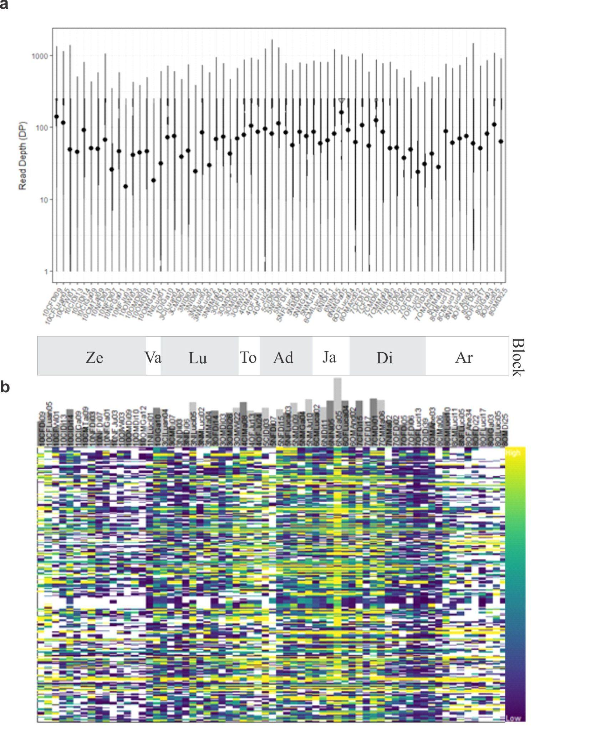
Fig. S1 Quality of the data set following filtering with VCF tools. This set only includes individuals with less than 50% missing data per individual (65), and positions with less than 50% missing data across all individuals, a minor allele count of at least 2 and no indels (10245 SNPs). (a) The read depth from each of the 65 individuals and the respective block they belong to. (b) The read depth in each individual at each position across the genome. The high and low depth are represented by yellow and blue colours, respectively and missing data in white.

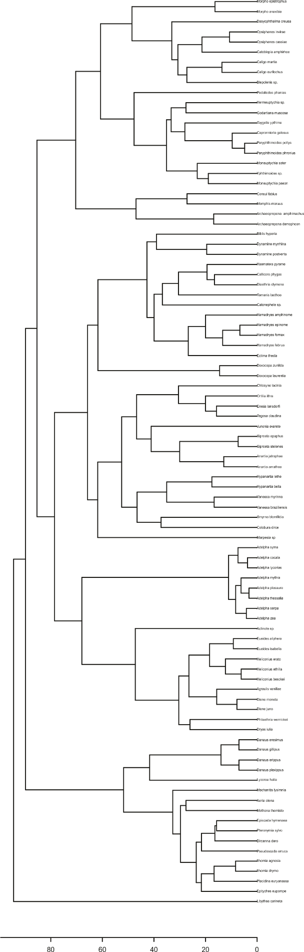
Fig. S2 Final phylogeny of the Nymphalidae community present in the whole sample.
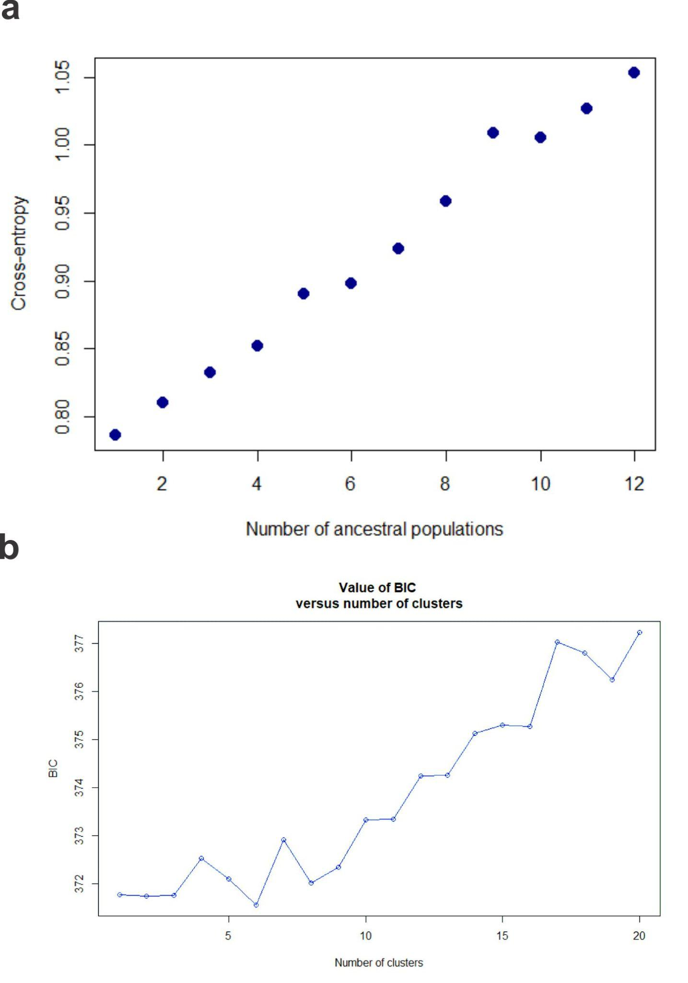
Fig. S3 Population number predicted by the LEA package and the number of genomic clusters predicted by discriminant analysis (DAPC). (a) Cross-entropy suggested only one ancestral population. (b) DAPC results with the lowest BIC value suggest six genomic clusters in the data set.

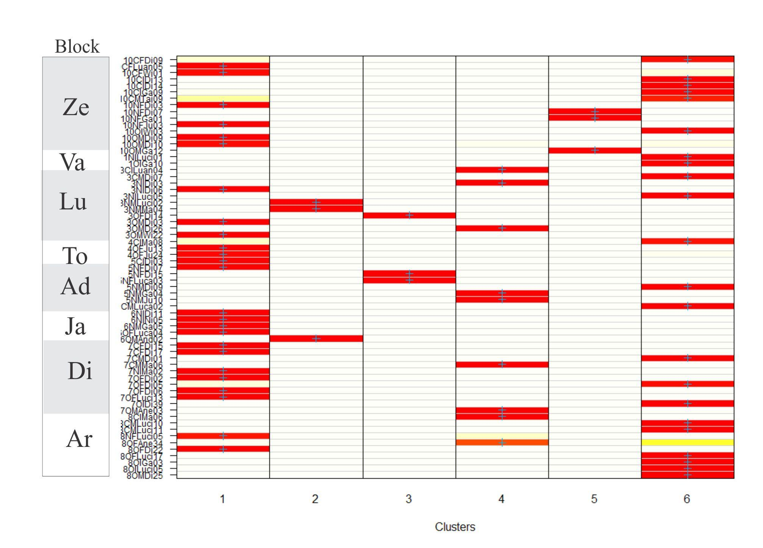
Fig. S4 The membership of each individual to each genomic cluster. The membership probability to distinct clusters is strong (red) or weak (yellow). For each sample there is the correspondent block in the right.

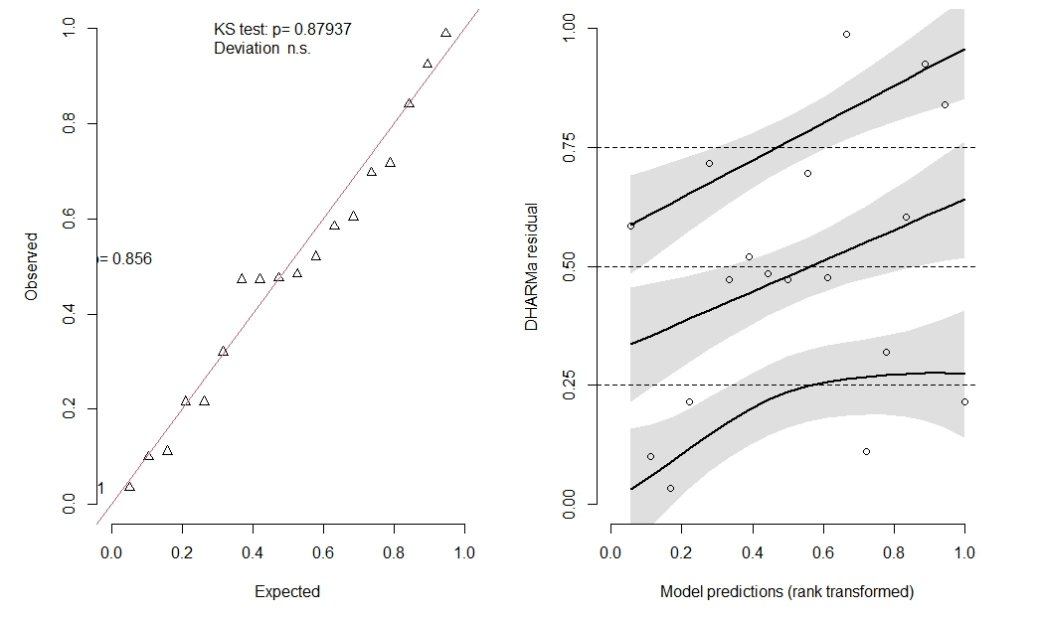
Fig. S5 DHARMa residual fit from a generalised linear model (GLM). On the left side is a QQplot residual and on the right is a residual versus predicted model. No significant problems were detected.
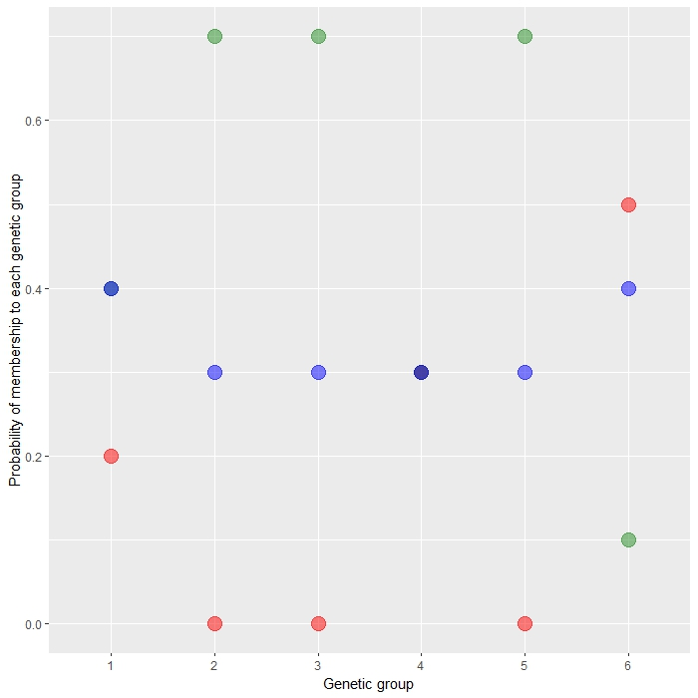
Fig. S6 Percentage of membership of distinct genetic groups by treatment: Conventional plantation (red), native forest (green), agroforestry (blue). Six distinct genetic groups were defined according to DAPC analysis (Fig. 3). Similar probability was found in genetic group 1 between agroforestry and native area plus in genetic group 4 between all three treatments. As they are superimposed it is presented in dark blue here.
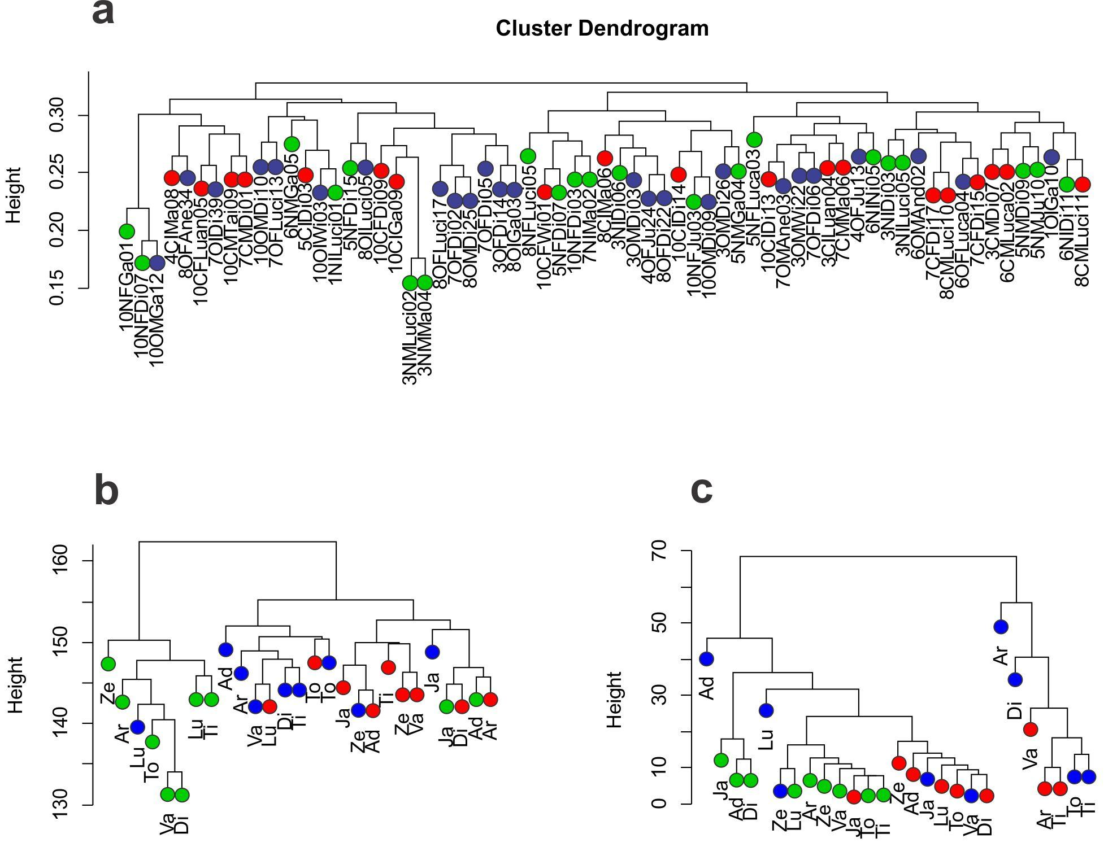
Fig. S7 Cluster dendrograms based on (a) the genetic distances between 65 individuals of H. ethilla narcaea at 21 sites, (b) phylogenetic relationships between species of Nymphalidae at each site, and (c) species composition of Nymphalidae at each site. Each individual and site are identified according to their treatment and block. Treatments are represented by colour: native (green), agroforestry (blue) and conventional (red), while blocks are named on the tips.

