Bimetallic Chalcogenides Enable Highly Efficient Polysulfide Capture and Conversion in Lean-Electrolyte Li-S Batteries
Junhua Wang^{1,5, #}, Hao Sun^{2,5 #}, Weiran Zhao^{3,5 #}, Chongxiang Pan⁴, Rongrong Li⁴, Yuan Yao^{4,} *, Caiyun Chang^{5,} *

¹ Weifang University, Weifang 261061, China.
²Department of Computer Science and Technology, Institute for Artificial Intelligence，Tsinghua University, Beijing 100091, China.
³State Key Laboratory of Fine Chemicals, School of Chemical Engineering, Dalian University of Technology, Dalian 116024, China.
⁴CAS Center for Excellence in Nanoscience, Beijing Key Laboratory of Micro-Nano Energy and Sensor, Beijing Institute of Nanoenergy and Nanosystems, Chinese Academy of Sciences, Beijing 101400, China
⁵Faculty of Materials Science and Energy Engineering/Institute of Technology for Carbon Neutrality, Shenzhen Institute of Advanced Technology, Chinese Academy of Sciences, Shenzhen 518055, China.

# These authors contributed equally.
*Corresponding author E-mail: yaoyuancy1017@163.com; cy.chang@siat.ac.cn.

Figure S1. SEM images of (Co, Ni)₉S₈@CNF.
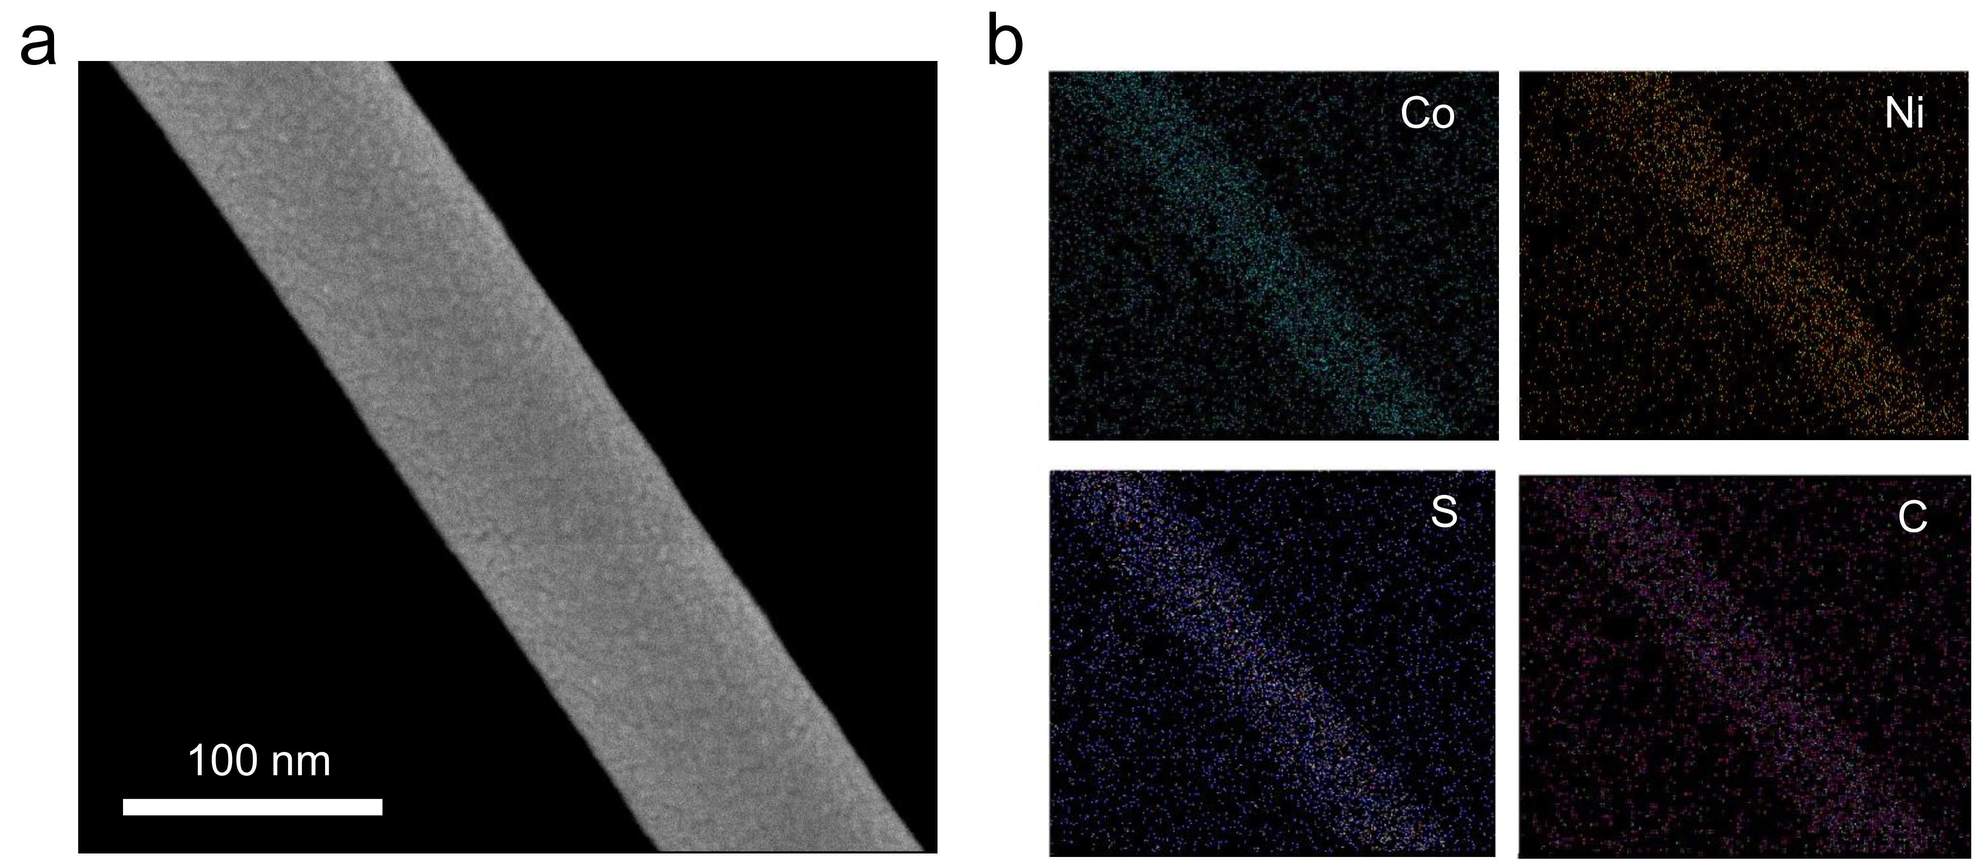
Figure S2. (a) SEM image and (b) EDS elemental mappings of (Co, Ni)₉S₈@CNF nanofiber.

Figure S3. (a) The contents of Co, Ni and S in the (Co, Ni)₉S₈. (b) XRD patterns of CNFs/S, Co₉S₈@CNFs/S, and (Co, Ni)₉S₈@CNFs/S. (c) The resistivity and electrical conductivity of the three hosts.

Figure S4. XPS survey spectra of CNFs, Co₉S₈@CNFs, and (Co, Ni)₉S₈@CNFs (a) before and (b) after adsorbing test.

Figure S5. (a) S 2p core level of precipitate recovered from (Co, Ni)₉S₈@CNFs soaking Li₂S_{x} solution. (b) Co 2p core level of the pristine Co₉S₈@CNFs and precipitate recovered from Co₉S₈@CNFs/Li₂S_{x} suspension.

Figure S6. The band gap of (a) pure Co₉S₈ and (b) pure (Co, Ni)₉S₈. The total density of states (TDOS) for (c) pure Co₉S₈ and (d) pure (Co, Ni)₉S₈, and polysulfides on the (311) surfaces.

Figure S7. Optimized configurations for the binding of Li₂S₄ and Li₂S₆ on top view and side view of Co₉S₈, and (Co, Ni)₉S₈ (311).

Figure S8. CVs of (a) CNFs/S, (b) Co₉S₈@CNFs/S (c) (Co, Ni)₉S₈@CNFs/S at various scan rates from 0.1 to 0.8 mV s⁻¹.

Figure S9. CV curves of the Li-S batteries with (a) CNFs/S, (b) Co₉S₈@CNFs/S, and (c) (Co, Ni)₉S₈@CNFs/S as cathode at various temperatures. (d) Polarization voltage gaps of anodic peaks c and cathodic peaks b.

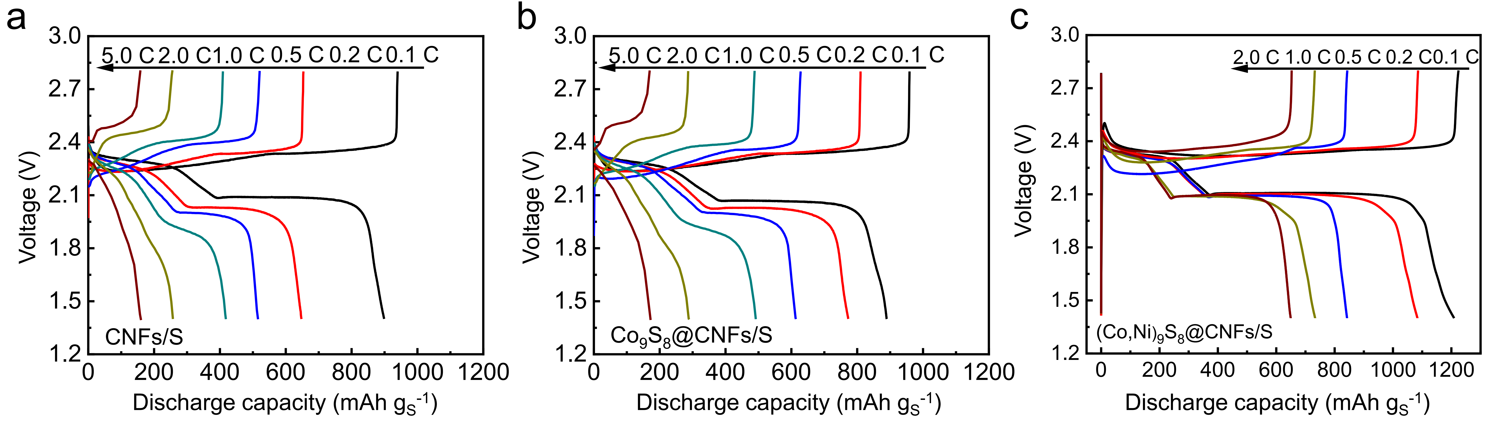
Figure S10. The discharge-charge curves of (a) CNFs/S and (b) Co₉S₈@CNFs/S at current densities ranging from 0.1 C to 5.0 C, and (c) (Co, Ni)₉S₈@CNFs/80.0S at current densities ranging from 0.1 C to 2.0 C.

Figure S11. TG curves of (Co, Ni)₉S₈@CNFs with high sulfur loading.

Table S1. The resistances of lithium-sulfur batteries with CNFs/S, Co₉S₈@CNFs/S, and (Co, Ni)₉S₈@CNFs/S cathodes after first and after 400th discharge at 0.1 C.
Fitted Data | CNFs/S |  |  | Co₉S₈@CNFs /S |  |  | (Co,Ni)₉S₈@CNFs /S
Fitted Data | R_{s} | R_{ct} | R_{l} | R_{s} | R_{ct} | R_{l} | R_{s} | R_{ct} | R_{l}
After first | 4.2 | 16.1 | 42.5 | 4.3 | 47.9 | 92.8 | 3.7 | 68.2 | 34.5
After 400th cycling | 5.9 | 26.2 | 16.8 | 4.5 | 12.9 | 12.0 | 4.1 | 23.1 | 7.4
Here, R_{s} represents the resistance of the electrolyte, R_{ct} is assigned to the resistance of the charge-transfer resistance, R_{l} is the resistance of the deposition of the insoluble Li₂S₂/Li₂S on the surface.

Table S2 Li-S battery performance based on catalyst-anchored carbon cathodes.
Cathodes | Sulfur content  (wt %) | E/S ratio  (μl mg⁻¹) | Initial capacity (mAh g⁻¹) | Cycle number |  | Decay rate per cycle | Ref.
Ni-MoS₂/rGO | 68.4 | 5 | ~900 | 140 | 0.198% (0.5 C) |  | [1]
Ti₃C₂/C | 53.4 | 28 | 1180 | 200 | 0.165% (0.5 C) |  | [2]
Co₉S₈@CNTs | 68.67 | 15 | 1019 | 30 | 0.543% (0.5 C) |  | [3]
Ni₃(HITP)₂-CNT | 65.5 | 20 | 968 | 300 | 0.116% (1.0 C) |  | [53]
NiCo-LDH@rGO | ~75 | 15 | 1336 | 100 | 0.251% (0.1 C) |  | [4]
CC@NiCo₂O₄ | ~70 | - | ~1000 | 200 | 0.170% (0.2 C) |  | [5]
Co₉S₈@NCNHP | - | 20 | 1186 | 200 | 0.135% (0.2 C) |  | [39]
(Co, Ni)₉S₈@CNF | 83.3 | 5 | 890 | 180 | 0.110% (0.1 C) |  | This work

References
[1] R. Zhang, Y. Dong, M. A. Al-Tahan, Y. Zhang, R. Wei, Y. Ma, C. Yang, J. Zhang. J. Energy Chem. 2021, 60, 85-94.
[2] H. Y. Zhou, Z. Y. Sui, K. Amin, L. W. Lin, H. Y. Wang, B. H. Han. ACS Appl. Mater. Interfaces 2020, 12 (12), 13904-13913.
[3] J. Zhou, X. Liu, J. Zhou, H. Zhao, N. Lin, L. Zhu, Y. Zhu, G. Wang, Y. Qian. Nanoscale Horiz. 2019, 4 (1), 182-189.
[4] D. Cai, M. Lu, Li, J. Cao, D. Chen, H. Tu, J. Li, W. Han. Small 2019, 15 (44), 1902605-1902615.
[5] W. Qiu, G. Li, D. Luo, Y. Zhang, Y. Zhao, G. Zhou, L. Shui, X. Wang, Z. Chen. Adv. Sci. (Weinh) 2021, 8 (7), 2003400-2003410.

