Supplementary Figure 1. Blast results for the sequences of the LSU gene that were amplified by PCR. It was used as template in the PCR the genomic the DNA obtained from the fungus analyzed in this study. The amplicons were sequenced using a Sanger methodology.

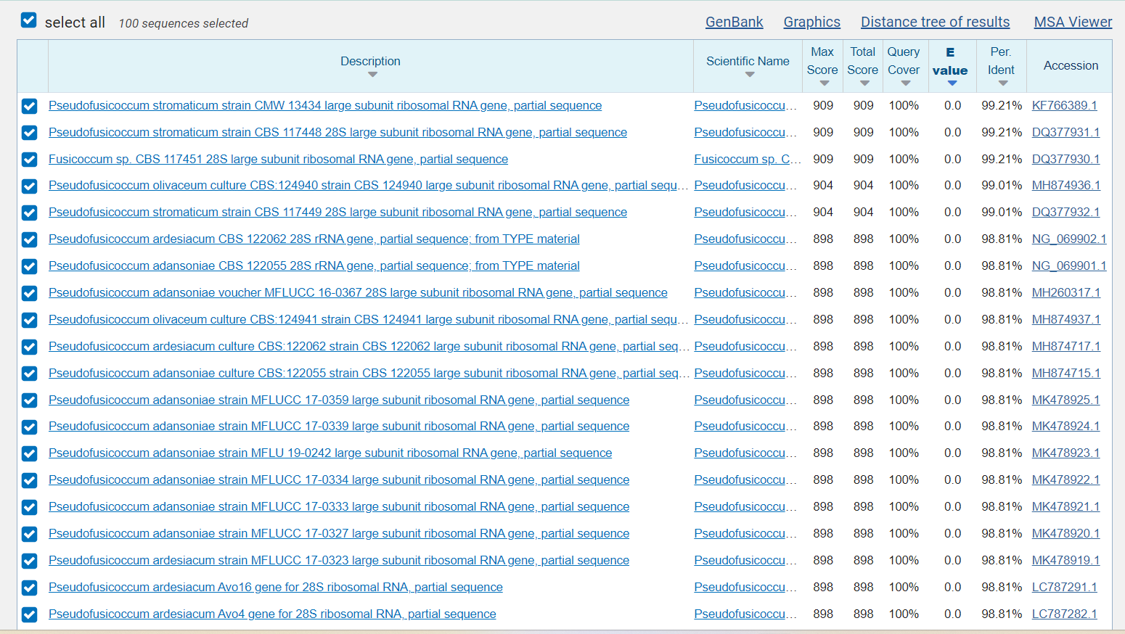

Supplementary Figure 2. Blast results for the sequences of the ITS gene that were amplified by PCR. It was used as template in the PCR the genomic the DNA obtained from the fungus analyzed in this study. The amplicons were sequenced using a Sanger methodology.

