Supplementary material
Supplementary Table S1. Overview of samples analysed using RNA sequencing.
SampleID | Sample | Subjectnr | Timepoint | Group | Responder  (molecular)
105669-001-004 | S6_Untreated | 6 | Untreated | Untreated
105669-001-009 | S1_Untreated | 1 | Untreated | Untreated
105669-001-014 | S2_Untreated | 2 | Untreated | Untreated
105669-001-019 | S3_Untreated | 3 | Untreated | Untreated
105669-001-024 | S4_Untreated | 4 | Untreated | Untreated
105669-001-029 | S5_Untreated | 5 | Untreated | Untreated
105669-001-034 | S7_Untreated | 7 | Untreated | Untreated
105669-001-049 | S10_Untreated | 10 | Untreated | Untreated
105669-001-001 | S6_IMQ48h* | 6 | IMQ48h | Short exposure (48h + 72h) | no
105669-001-006 | S1_IMQ48h* | 1 | IMQ48h | Short exposure (48h + 72h) | no
105669-001-011 | S2_IMQ48h | 2 | IMQ48h | Short exposure (48h + 72h) | yes
105669-001-016 | S3_IMQ48h | 3 | IMQ48h | Short exposure (48h + 72h) | yes
105669-001-021 | S4_IMQ48h | 4 | IMQ48h | Short exposure (48h + 72h) | yes
105669-001-026 | S5_IMQ48h | 5 | IMQ48h | Short exposure (48h + 72h) | yes
105669-001-031 | S7_IMQ48h | 7 | IMQ48h | Short exposure (48h + 72h) | yes
105669-001-036 | S8_IMQ48h | 8 | IMQ48h | Short exposure (48h + 72h) | yes
105669-001-041 | S9_IMQ48h | 9 | IMQ48h | Short exposure (48h + 72h) | yes
105669-001-046 | S10_IMQ48h* | 10 | IMQ48h | Short exposure (48h + 72h) | no
105669-001-002 | S6_IMQ72h* | 6 | IMQ72h | Short exposure (48h + 72h) | no
105669-001-007 | S1_IMQ72h* | 1 | IMQ72h | Short exposure (48h + 72h) | no
105669-001-017 | S3_IMQ72h* | 3 | IMQ72h | Short exposure (48h + 72h) | no
105669-001-020 | S2_IMQ72h* | 2 | IMQ72h | Short exposure (48h + 72h) | no
105669-001-022 | S4_IMQ72h* | 4 | IMQ72h | Short exposure (48h + 72h) | no
105669-001-027 | S5_IMQ72h | 5 | IMQ72h | Short exposure (48h + 72h) | yes
105669-001-032 | S7_IMQ72h | 7 | IMQ72h | Short exposure (48h + 72h) | yes
105669-001-037 | S8_IMQ72h | 8 | IMQ72h | Short exposure (48h + 72h) | yes
105669-001-047 | S10_IMQ72h | 10 | IMQ72h | Short exposure (48h + 72h) | yes
105669-001-003 | S6_IMQ120h* | 6 | IMQ120h | Long exposure (120h + 168h) | no
105669-001-008 | S1_IMQ120h | 1 | IMQ120h | Long exposure (120h + 168h) | yes
105669-001-013 | S2_IMQ120h* | 2 | IMQ120h | Long exposure (120h + 168h) | no
105669-001-018 | S3_IMQ120h* | 3 | IMQ120h | Long exposure (120h + 168h) | no
105669-001-023 | S4_IMQ120h | 4 | IMQ120h | Long exposure (120h + 168h) | yes
105669-001-028 | S5_IMQ120h | 5 | IMQ120h | Long exposure (120h + 168h) | yes
105669-001-033 | S7_IMQ120h* | 7 | IMQ120h | Long exposure (120h + 168h) | no
105669-001-043 | S9_IMQ120h | 9 | IMQ120h | Long exposure (120h + 168h) | yes
105669-001-048 | S10_IMQ120h | 10 | IMQ120h | Long exposure (120h + 168h) | yes
105669-001-005 | S6_IMQ168h* | 6 | IMQ168h | Long exposure (120h + 168h) | no
105669-001-010 | S1_IMQ168h | 1 | IMQ168h | Long exposure (120h + 168h) | yes
105669-001-012 | S3_IMQ168h* | 3 | IMQ168h | Long exposure (120h + 168h) | no
105669-001-015 | S2_IMQ168h | 2 | IMQ168h | Long exposure (120h + 168h) | yes
105669-001-025 | S4_IMQ168h | 4 | IMQ168h | Long exposure (120h + 168h) | yes
105669-001-030 | S5_IMQ168h | 5 | IMQ168h | Long exposure (120h + 168h) | yes
105669-001-035 | S7_IMQ168h* | 7 | IMQ168h | Long exposure (120h + 168h) | no
105669-001-040 | S8_IMQ168h | 8 | IMQ168h | Long exposure (120h + 168h) | yes
105669-001-045 | S9_IMQ168h | 9 | IMQ168h | Long exposure (120h + 168h) | yes

Supplementary Table S2. Overview of subject demographics
All subjects
Age (years)
N | 10
Mean (SD) | 25.6 (6.7)
Median | 24
Min, Max | 18, 37
Height (cm)
N | 10
Mean (SD) | 176.57 (7.48)
Median | 176.0
Min, Max | 164.9, 192.0
Weight (kg)
N | 10
Mean (SD) | 77.290 (13.677)
Median | 77.68
Min, Max | 57.40, 95.50
BMI (kg/m2)
N | 10
Mean (SD) | 24.68 (3.33)
Median | 24.7
Min, Max | 20.1, 30.0
Sex
Female | 7 (70.0%)
Male | 3 (30.0%)

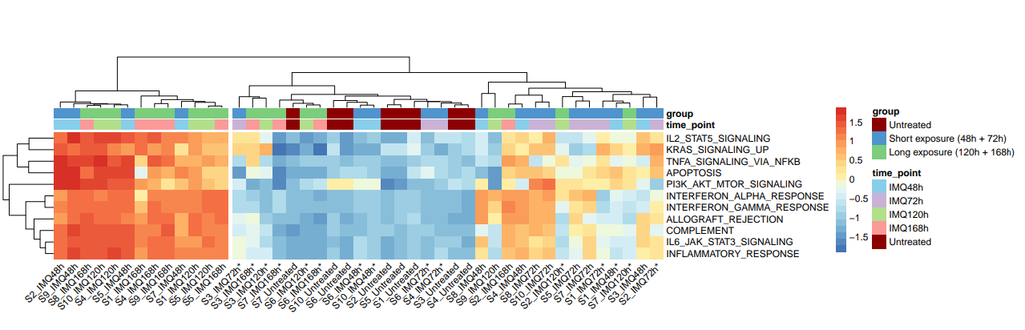
Supplementary Figure S3.Heatmap of GSVA single-sample pathway enrichment scores on 11 representative MsigDB Hallmark gene sets, scaled by row and shown across the full data set (n=45 samples).

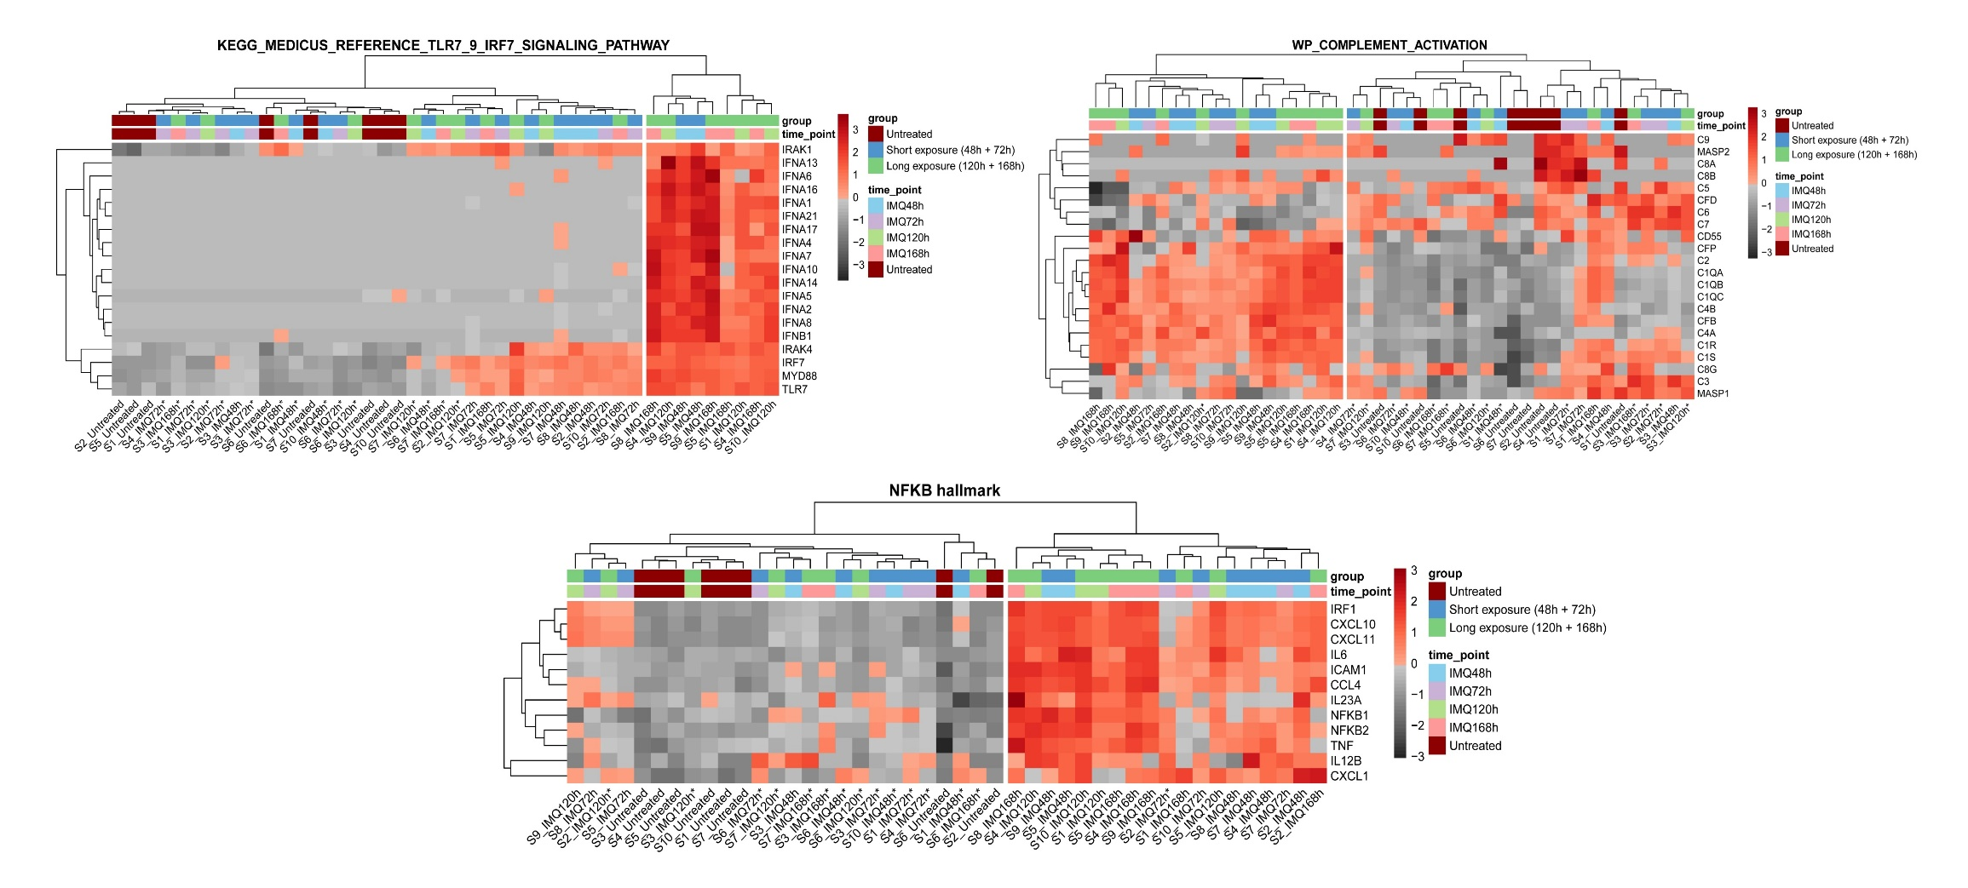
A
B
C

Supplementary Figure S4. Key pathways involved in the IMQ response. Gene expression for members of the a) TLR7/9 signalling pathway (KEGG Medicus), b) complement activation pathway (WP; WikiPathways), c) a subset of the TNF signalling via NF-kB pathway (Hallmark gene sets); scaled by row across the full dataset (n=45 samples).

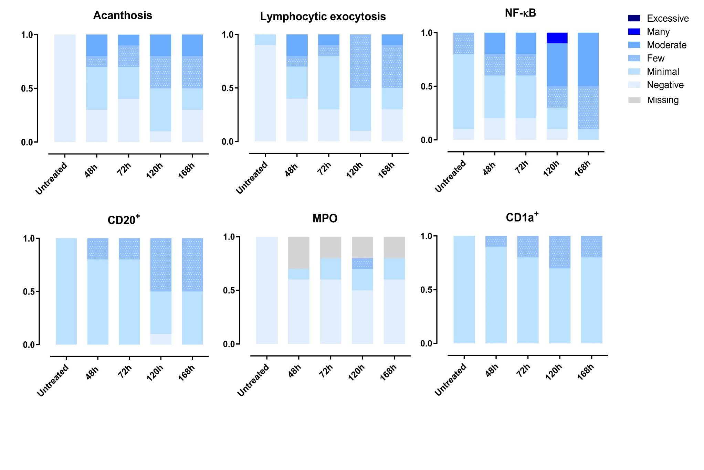
Supplementary Figure S5. Staining of biopsies for a) acanthosis b) lymphocytic exocytosis c) NF-κB d) B cells e) neutrophils f) Langerhans cells.
A
B
C
D
E
F
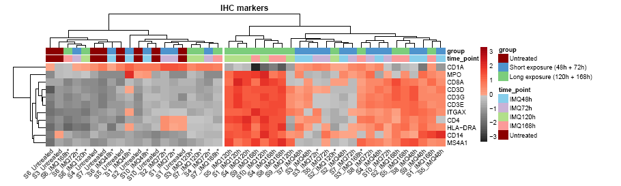
Supplementary Figure S6. Expression of transcripts corresponding to the markers used for IHC across the full data set (n=45 samples).

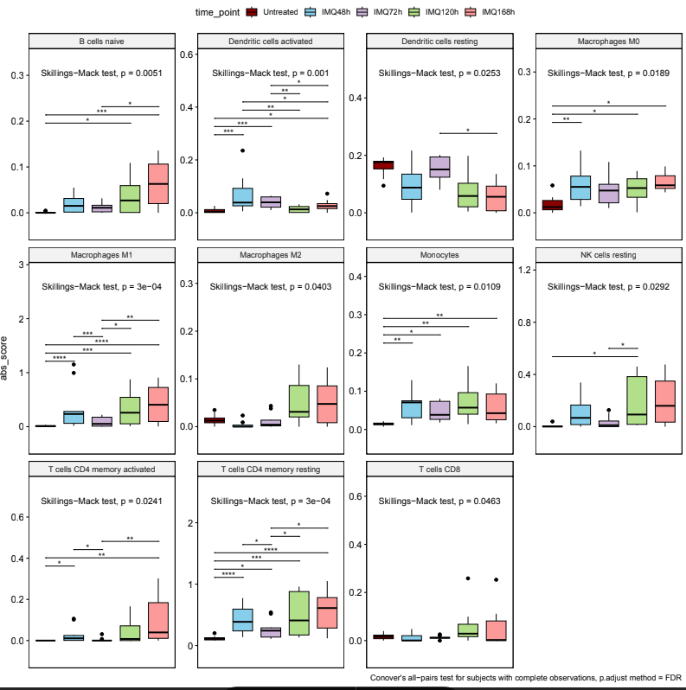
Supplementary Figure S7. Overview of cell types profiled using CIBERSORTx per time point. Boxplots depicting absolute scores for 11 cell types with statistically significant changes across time points (Skillings-Mack test). The Conover’s all-pairs test with FDR correction was applied as the post hoc test using data from subjects with complete observations. Three subjects were excluded from the analysis due to incomplete observations.

