Appendix

Content of Appendix
A. Additional information on methods 2
Details on eligibility screening 2
Details on informed consent procedures 2
Inclusion and exclusion criteria 2
Saliva handling and preparation for analysis 2
B. Deviation from pre-registered analysis plan 3
C. Description of Bayesian methods and results including sensitivity analyses of priors 4
Description of Bayesian methods 4
Results of Bayesian analyses 5
D. Exploration of non-linearities by random forest 6
E. Detailed description of full and reduced models and results from frequentist analyses 12
F. Exploratory analyses 18
Methods exploratory tests in supplement 18
Results 19
G. Patient information on comorbidity, somatic disorders, and medication 23

Additional information on methods

Details on eligibility screening
All children and adolescents were screened for eligibility with the Kiddie-Schedule for Affective Disorders and Schizophrenia – Present and Lifetime Version (K-SADS-PL)¹, full-scale Wechsler Intelligence Scales (either WISC-V for children aged 16.9 years or below or WAIS-IV for adolescents above age 16.9)^{2,3}. Children and adolescents with OCD also completed The Children’s Yale-Brown Obsessive-Compulsive Scale (CY-BOCS)⁴. Diagnoses were based on the criteria for International Classification of Diseases‑10 (ICD-10)⁵ and diagnostic status was confirmed by a psychiatrist or psychologist specialized in child and adolescent psychiatry.

Details on informed consent procedures
Children and adolescents, and parents received verbal information and children above 15 years and parents/legal guardians also received written information about the child’s participation in the trial. Parents or legal guardians signed informed consent concerning participation of their child. Parents were given verbal and written information on their own participation and gave informed consent to their own participation.

Inclusion and exclusion criteria
Inclusion criteria for children and adolescents with OCD were OCD according to ICD-10⁵ as primary diagnosis, CY-BOCS total score ≥16, age 8 to 17 years both inclusive, and signed informed consent from parents/legal caretakers. Exclusion criteria for children with OCD were comorbid illness with pervasive developmental disorder not including Asperger’s syndrome, schizophrenia/psychosis, mania or bipolar disorder, depressive psychotic disorders, substance dependence syndrome, IQ<70, treatment with cognitive behavioral therapy, psychoeducation with relaxation training, antidepressant, or antipsychotic medications within the last six months prior to trial entry.
Inclusion criteria for children and adolescents without OCD were age 8 to 17 years both inclusive, sex and age matched with an included child with OCD (+/- 3 months of birthday) and signed informed consent from parents/legal caretakers. Exclusion criteria for children without OCD were any current or previous psychiatric disorder according to ICD-10 criteria, non-Danish-speaking, and IQ<70.
We included parents with a child participating in the study and with informed consent to participation.

Saliva handling and preparation for analysis
After sampling, the saliva was stored in a -20 °C freezer. In the preparation for analysis, the samples were 1) thawed, 2) centrifuged at 3,000 rpm for five minutes at 4 °C, 3) frozen to -80 °C for at least one day, 4) thawed at 5 °C, 5) centrifuged at 4 °C at 1,500 × g for 20 minutes, 6) stored at -80 °C, 7) lyophilized (freeze dried) for 17 hours, and 8) stored at -20 °C. On the assay day, the samples were 1) thawed, 2) reconstituted in assay buffer, 3) mixed twice for five minutes at 2700 rpm with a 5-minute interval, and 4) centrifuged for five minutes at 10,000 rpm. We did not use extraction of the saliva samples.

Deviation from pre-registered analysis plan

We chose the following deviation from the pre-registered statistical analysis plan:

- We tested variance in OCD status groups prior to model 1. Because the difference in variance was not significant, we performed the analysis as a student’s t-test and not as a Welsch t-test as described in the pre-registration.
- The family variable in model 4 was included as a random intercept effect which was not specified in the analysis plan.
- The Bayesian statistics was only specified regarding the use of a Cauchy Prior in analysis plan. Full description of method and priors used are described in the method section.
- In the supplemental analysis of menstrual cycle, we chose to analyze girls and mothers separately as we would have many missing variables in the family variable should be included.
- Analyses without logarithmic transformation and with outliers included would break the assumptions of normality and we therefore did not include these sensitivity analyses.
- Analyses was performed in R studio only and not JASP as mentioned in the pre-registration.

Description of Bayesian methods and results including sensitivity analyses of priors

Description of Bayesian methods
Bayesian statistics was performed using R-studio with R (version 4.2.0) and the packages brm (version 2.20.4) and stan (version 2.32.3).

Bayesian statistics is provided as a supplement to the frequentist model reduction and hypothesis testing. We will mainly use Bayes Factor to compare models, as suggested by Quintana et al. who consider hypothesis testing in psychiatry⁶.
However, Bayes Factor has been criticized for being highly sensitive to the choice of prior and the problem structure. Gelman et al. therefore generally advise against the use of this measure to compare models⁷. They particularly advise against the use of Bayes Factor for hypotheses which are not truly discrete⁷.
In the light of these recommendations, we will supplement the selected frequentist analyses by a measure of Bayes factor, when we test a discrete parameter. We supplement all selected frequentist analyses by a measure of the predictive performance based on the expected log-pointwise predictive density estimated by leave-one-out cross validation (ELPD-LOO).

We use Cauchy priors with scale r on the fixed effects and Jeffrey’s prior on the variance (JZS priors) to compare models by Bayes Factor as suggested by these references^{6,8}. Bayes factor is very sensitive to the choice of scale of the prior and provides increased evidence for the null-hypothesis with increasing values of r⁸. We therefore provide results for both r=0.5 and r=1.0. The ELPD-LOO estimates are based on the default priors provided in the brms package.

Interpretation was made with the classification for the Bayes factor described by Lee and Wagenmaker⁹. The Bayes factor, BF₁₀, describes the evidence of the alternative hypothesis (H₁) compared to the null hypothesis (H₀). Values above 1 describes evidence for H₁ with increasing values describing increased degree of evidence (1-3 “anecdotal”, 3-10 “moderate”, 10-30 “strong”, 30-100 “very strong”, >100 “extreme). Values below 1 describes evidence of H₀ with decreasing values describing increased level of evidence (1- 1/3 “anecdotal”, 1/3-1/10 “moderate”, 1-10-1/30 “strong”, 1/30-1/100 “very strong”, <1/100 “extreme)⁹.

We estimate all Bayesian models using MCMC with 4 chains which each have 8000 iterations. We use the first 1000 iterations for warmup.

Results of Bayesian analyses
Table C..1. Results from the Bayesian analyses including sensitivity-analyses with different prior and reporting of predictive performance in terms of expected log pointwise predictive density (ELPD-LOO)
Models | Hypotheses |  | BF₁₀ (r=0.5) | BF₁₀  (r=1.0) | ELPD-LOO (SE)  (H₁- H₀)
Model 1
1. Bayes factor | H₁ | OCD-status | 0.37 | 0.21 | -0.3 (1.2)
1. Bayes factor | H₀ | Intercept
Model 2
1. Bayes factor | H₁ | Red. model (age) | - | - | 3.5 (2.7)
1. Bayes factor | H₀ | Intercept
2. Bayes factor | H₁ | Red. model (age) and OCD-status | 0.31 | 0.17 | -0.6 (0.9)
2. Bayes factor | H₀ | Red. model (age)
Model 3
1. Bayes factor | H₁ | Red. model (pubertal stage) | - | - | 6.6 (4.1)
1. Bayes factor | H₀ | Intercept
2. Bayes factor | H₁ | Red. model (pubertal stage) and OCD-status | 0.52 | 0.31 | 0.0 (1.5)
2. Bayes factor | H₀ | Red. model (pubertal stage)
Post Hoc test B
1. Bayes factor | H₁ | Red. Model 3 (pubertal stage) with OCD-status | - | - | 2.9 (3.0)
1. Bayes factor | H₀ | Red. Post Hoc Model A (age and age²) and OCD-status
Post Hoc Model C
1. Bayes factor | H₁ | Red. Post Hoc Model C (pubertal stage) | - | - | 5.9 (5.1)
1. Bayes factor | H₀ | Red. Model 4 (age)
Note: ELPD-LOO, expected log-pointwise predictive density estimated by leave-one-out cross validation; SE, standard error. Red, reduced; OCD, Obsessive Compulsive Disorder, (H₁) the alternative hypothesis; H₀, the null hypothesis

Exploration of non-linearities by random forest

Random forests are ensemble models based on a collection of decision trees. We used random forests to explore non-linear associations between the response (oxytocin) and the relevant covariates/predictors.
We explored random forest models on the data set only including children and adolescents (RF child and adolescent) and the data set including children and parents (RF all). We used R (version 4.3.0) to perform the analysis.

RF child and adolescent:
This random forest regression used the log-transformed oxytocin as the dependent variable and took the five predictors - OCD-status, sex, age, pubertal stage, and hormonal stage (hormonal stage here denotes menarche status) (levels: pre-menarche, menarche, male, missing) - as input. Note, that here sex was a subset of hormonal stage.

The models were fitted and optimized using the R-package randomForest (version 4.7-1.1).

We split each data set in a training set (~70%) and a test set (~30%) to evaluate the performance of the random forests and compare them to the linear models. The dataset has imbalanced groups. We therefore used stratified sampling to split the data in a training set and a test set and when building the random forest models. We used the R -package splitTools (version 1.0.1) to generate the strata. We normalized both the training set and the test set before fitting the random forests. Random forests include several hyperparameters which we optimized by a crude grid-search. The hyper-parameters and the range over which they were optimized are found in Table D.1. We used out-of-bag (OOB) error estimates to evaluate the performance of the hyperparameter settings. We grew 5000 trees.
We handled missing values in the categorical predictors in random forest by adding an extra category named “missing”.

Table D.1. Description of hyper-parameters and range of the RF child and adolescent analyses
Hyperparameter | Name in RandomForest package | Range
Number of variables randomly sampled as candidates in each split | mtry | 1, 2, 3, 4
Sample size | sampsize | 50%, 60%,70%,80%, 90%
Minimum size of the terminal nodes | nodesize | 5, 10, 15, …, 95, 100

Optimization of the hyperparameters based on OOB error estimates found the combination
(mtry, sampsize, nodesize) = (4, 90%, 100)
of hyperparameters.

Variable importance is plotted in Figure D.1.

Figure D.1. Variable importance for the Random forest children model
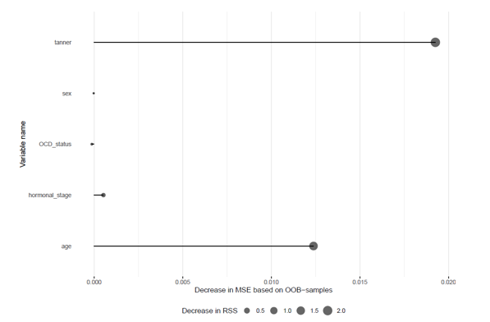

We found that tanner and age are the most important variables. This is similar to the findings using traditional linear regression. Looking at the predictions from the random forest model on the test set (Figure D.2. and D.3.) it is evident that the random forest captures the same tendencies in the data as the linear models.

Figure D.2. The relationship between oxytocin and age predicted by the reduced Model 2 (pink line), the reduced Post Hoc Model A (purple line) and Random Forest approach (green line). Predictors are based on the test set. The black dots are data in the test set.
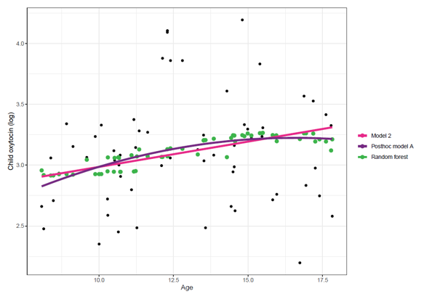
Figure D.3. The relationship between oxytocin and pubertal stage predicted by the reduced model 3 (purple dots) and random forest (green dots). Predictors are based on the test set. The black dots are data in the test set. 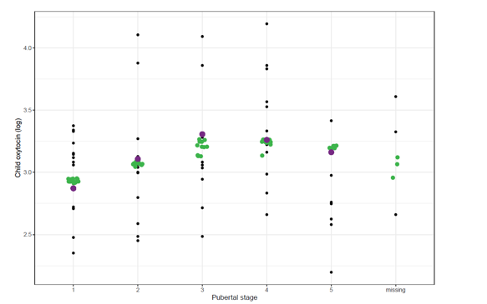
The MSE of random forest on the test set is similar to the MSE of the linear models (see Table D.2.) All in all, this indicates that the random forest has not captured signals in the data, which were not captured by the linear models.

Table D.2. Mean Squared Error of the RF child and adolescent, Model 1, Post Hoc Model A and Model 3
 | RF child and adolescent | Model 1 | Post Hoc model A | Model 3
MSE (test set) | 0.190 | 0.190 | 0.181 | 0.187
Note: MSE, Mean Squared Error; RF, Random Forest

RF all:
This random forest regression used the log-transformed oxytocin as response and takes as input the five predictors, sex, age, tanner, hormonal stage (levels: pre-menarche, menarche, menopause, male, missing) and hormonal protection (levels: Yes (oral), Yes (not oral), Yes (no specification), No, Not mother, missing). Note that sex is a subset of hormonal stage.

Observations from the same family are correlated, which makes this data, which contain information on both children, adolescents, and parents, correlated. We did not take this into account when modelling the data. Tools such as Mixed Effect Random Forests (MERF) can account for correlation in data, but tools for these models are sparse in R. We will therefore neglect the correlation when modelling the data.

This data set also has imbalanced groups. We split the data into a training set (~70%) and test set (~30%) based on family and strata hereof. This means that observations from the same family will not be split between training and test set. This ensures no leak of information between the two data sets. We used the R -package splitTools (version 1.0.1) to generate the strata. We normalized both the training set and the test set before fitting the random forests.
We used a random forest to model. We optimized the hyper-parameters listed in Table D.1. We used out-of-bag (OOB) error estimates to evaluate the performance of the hyperparameter settings. Note that OOB error estimates might be biased because of the correlated data and imbalanced groups. We grew 5000 trees. We handled missing values in the categorical predictors in random forest by adding an extra category named “missing”.

Optimization of the hyperparameter based on OOB error estimates finds
(mtry, sampsize, nodesize) = (3, 100, 50%).

Variable importance is plotted in Figure D.4. We found that pubertal stage and age were the most important variables. This is similar to the findings using traditional linear regression. Looking at the predictions from the random forest model on the test set (Figure D.5. and D.6.) it is evident that the random forest captures the quadratic-like effect of age for the children and adolescents and the linear effect of age for the parents.

Figure D.4. Variable importance for the Random Forest all model
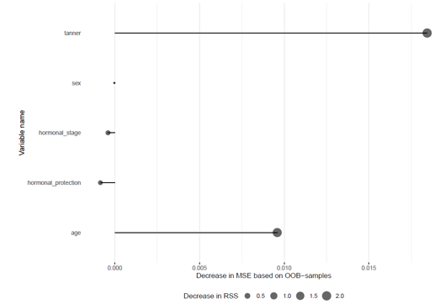

Figure D.5. The relationship between oxytocin and age predicted by the reduced model 4 (blue line) and random forest (green dots). Predictors are based on the test set. The black dots are data in the test set.

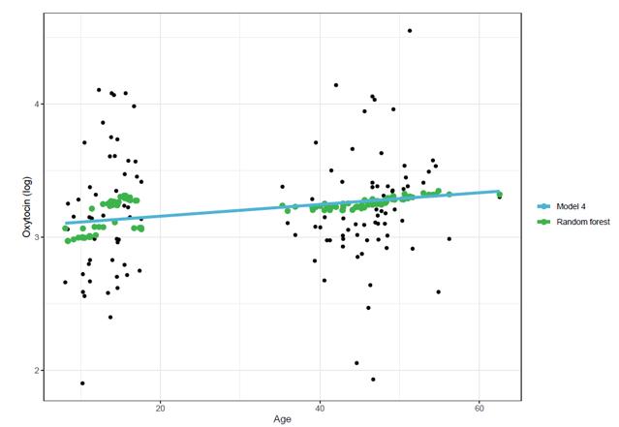

Figure D.6. The relationship between oxytocin and tanner predicted by the reduced post hoc model C (purple dots) and random forest (green dots). Predictions are based on the test set. The black dots are data in the test set.
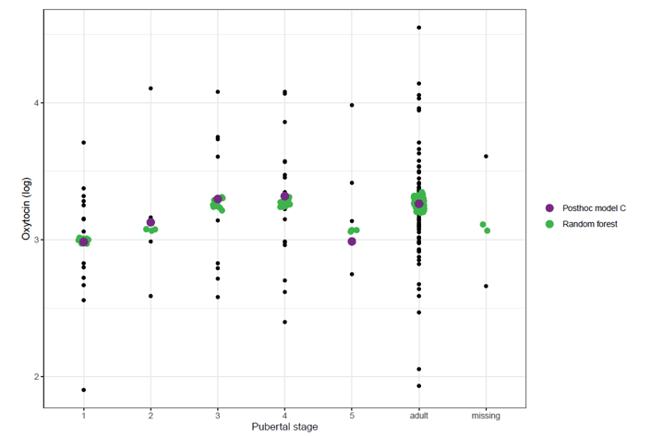

The MSE of random forest on the test set is similar to the MSE of the mixed effect model (see Table D.3). All in all, this indicates that the random forest has not captured signals in the data, which were not captured by the linear models.

Table D.3. Mean Squared Error of the RF all, Model 4, and Post Hoc Model C
 | RF all | Model 4 | Post Hoc Model C
MSE (test set) | 0.192 | 0.200 | 0.198
Note: MSE, Mean Squared Error; RF, Random Forest

Detailed description of full and reduced models and results from frequentist analyses
Model 1
Eq. E.1. Model 1:
$\log\left(oxytocin_i\right)=+β\left({OCD status}_{i}\right)+ϵ_{i}$ $ϵ_{i}\sim N(0,σ^{2})$
Log denotes the natural logarithm and $i=1,…, 201$describes the individual participants (in this model children and adolescents). The intercept is denoted by μ, β represents the regression coefficient, and $ϵ_{i}$ represents the residuals. The residuals are assumed to be independent and identically normal distributed with mean zero and standard deviation σ.

Table E.1. Descriptive statistics of child and adolescent salivary oxytocin concentrations
Child salivary oxytocin concentrations | Children and adolescents with OCD | Children and adolescents without OCD
Mean (SD) | 26.61 (14.28) | 25.61 (13.95)
Missing (n) | 0 | 0
Note. n, number of observations; SD, standard deviation; OCD, obsessive-compulsive disorder

Table E.2. Results on parameters from reduced model 1
Parameter | Estimate | Standard Error
μ | 3.107 | 0.052
β (OCD status) | 0.079 | 0.069
σ | 0.488
Note: n, number; SD, standard deviation; OCD, obsessive-compulsive disorder

Model 2
Eq. E.2. Full Model 2:
$\log\left(oxytocin_{i}\right)={μ+β}_{1}\left({OCD status}_{i}\right)+{β_{2}∙{age}_{i}+β_{3}\left({sex}_{i}\right)+β_{4}\left({sex}_{i}\right)∙{age}_{i}+ϵ}_{i},$ $ϵ_{i}\sim N(0,σ^{2})$
Log denotes the natural logarithm and $i=1,…, 201$describes the individual participants (in this model children and adolescents). The intercept is denoted by μ, β represent the regression coefficient, and $ϵ_{i}$ represent the residuals. The residuals are assumed to be independent and identically normal distributed with mean zero and standard deviation σ.

Eq. E.3. Reduced Model 2
$\log\left(oxytocin_{i}\right)=+{β_{2}∙{age}_{i}+ϵ}_{i},$ $ϵ_{i}\sim N(0,σ^{2})$

Table E.3. Stepwise reduction of model 2
Drop | Variable | F-statistics | p-value
1 | Interaction between age and sex | 0.112 | 0.7387
2 | Sex | 0.068 | 0.7953
3 | OCD-status | 0.840 | 0.3605
 | Age | 8.913 | 0.0031
Note: OCD, Obsessive Compulsive Disorder

TableE.4. Parameter estimates and standard errors from reduced Model 2
Parameter | Estimate | Standard Error
μ | 2.677 | 0.163
β₂ (age) | 0.036 | 0.012
σ | 0.479

Model 3
Eq. E.4. Full Model 3
$\log\left(oxytocin_i\right)=μ+β_{1}\left({OCD status}_{i}\right)+{β_{2}\left({pubertal stage}_{i}\right)+β_{3}\left({sex}_{i}\right)+β_{4}\left({sex}_{i}×{pubertal stage}_{i}\right) +ϵ}_{i}$ $ϵ_{i}\sim N(0,σ^{2})$
Log denotes the natural logarithm and $i=1,…, 191$describes the individual participant (in this model children and adolescents). The intercept is denoted by μ , β_{x} represents the regression coefficients, and $ϵ_{i}$ represents the residuals. The residuals are assumed to be independent and identically normal distributed with mean zero and standard deviation σ.

Eq. E.5.Reduced Model 3
$\log\left(oxytocin_{i}\right)=μ+{β_{2}(pubertal stage_{i})+ϵ}_{i},$ $ϵ_{i}\sim N(0,σ^{2})$

Table E.5. Stepwise reduction of model 3.
Drop | Variable | F-statistics | p-value
1 | Interaction between pubertal stage and sex | 0.571 | 0.6838
2 | Sex | 0.010 | 0.9192
3 | OCD-status | 2.113 | 0.1477
 | Pubertal stage | 5.384 | 0.0004
Note: OCD, Obsessive Compulsive Disorder

Table E.6. Parameter estimates and standard errors from reduced model 3
Parameter | Estimate | Standard Error
μ | 2.951 | 0.064
β₂ (pubertal stage 2) | 0.181 | 0.104
β₂ (pubertal stage 3) | 0.359 | 0.103
β₂ (pubertal stage 4) | 0.381 | 0.093
β₂ (pubertal stage 5) | 0.118 | 0.121
σ | 0.471

Model 4
Eq. E.6.. Full Model 4
$\log\left(oxytocin_i\right)={{a\left({family}_{i}\right)+ β}_{1}∙{age}_{i}+β_{2}\left({sex}_{i}\right)+β_{3}\left({sex}_{i}\right)∙{age}_{i}+ϵ}_{i}$ $ϵ_{i}\sim N(0,σ^{2})$ $a_{i}\sim N(0,σ_{a}^{2})$
Log denotes the natural logarithm and $i=1,…, 442$describes the individual participant (in this model children, adolescents, and parents). The intercept is denoted by μ, β_{x} represents the coefficients of the fixed effects, $a$ denotes the random effects and ε represents the residuals.

Eq. E.7. Reduced Model 4
$\log\left(oxytocin_{i}\right)={{μ+a\left({family}_{i}\right)+ β}_{1}∙{age}_{i}+ϵ}_{i},$ $ϵ_{i}\sim N(0,σ^{2})$, $a(family_{i})\sim N\left(0,σ_{a}^{2}\right)$

Table E.7. Stepwise reduction of the from the mixed effect model 4 (model reduction table). Family-variable included as random effect in all steps
Drop | Variable | F-statistics | p-value
1 | Interaction between age and sex | 1.499 | 0.2228
2 | Sex | 0.074 | 0.7857
 | Age | 13.281 | 0.0003

Table E.8. Parameter estimates and standard errors from reduced model 4
Parameter | Estimate | Standard Error
μ | 3.092 | 0.042
β₁ (age) | 0.004 | 0.001
σ_{a} | 0.082
σ | 0.130

Post Hoc model A
Eq. E.8. Full Post Hoc model Aodel
$\log\left(oxytocin_i\right)=β_{1}\left({OCD status}_{i}\right)+{β_{2}∙{age}_{i}+β_{3}∙{age}_{i}^{2}+β_{4}\left({sex}_{i}\right)+β_{5}\left({sex}_{i}\right)∙{age}_{i}+β_{6}({sex}_{i})∙{age}_{i}^{2}+ϵ}_{i}$ $ϵ_{i}\sim N(0,σ^{2})$
Log describes “logarithmic”, $i=1,…, 201,($describes the individual participant - in this model children and adolescents), μ represent the intercept-mean, β_{x} the coefficients, ε the residual, σ the standard deviation and Ν a normal distribution
Eq. E.9. Reduced Post Hoc model A
$\log\left(oxytocin_{i}\right)=μ+{β_{2}∙{age}_{i}+β_{3}∙{age}_{i}^{2}+ϵ}_{i}$, $ϵ_{i}\sim N(0,σ^{2})$

Table E.9. Stepwise reduction of Post Hoc Model A (model reduction table).
Drop | Variable | F-statistics | p-value
1 | Interaction between age² and sex | 3.028 | 0.0834
2 | Interaction between age and sex | 0.005 | 0.942
3 | Sex | 0.286 | 0.593
4 | OCD-status | 0.946 | 0.332
 | Age² (with age) | 3.904 | 0.0496
Note: OCD, Obsessive Compulsive Disorder

Table E.10. Parameter estimates and standard errors from reduced Post hoc model A
Parameter | Estimate | Standard Error
μ | 1.137 | 0.796
β₂ (age) | 0.282 | 0.125
β₃ (age²) | -0.009 | 0.005
σ | 0.476

Post Hoc Model C
Eq. E.10. Full Post Hoc model C
$\log\left(oxytocin_i\right)={{a\left({family}_{i}\right)+ β}_{1}({modified pubetal stage}_{i})+β_{2}\left({sex}_{i}\right)+β_{3}\left({sex}_{i}×modified {pubertal stage}_{i}\right)+ϵ}_{i}$ $ϵ_{i}\sim N(0,σ^{2})$ $a_{i}\sim N(0,σ_{a}^{2})$
Log denotes the natural logarithm and $i=1,…, 188$describes the individual participant (in this model children, adolescents, and parents). The intercept is denoted by μ, β_{x} represents coefficients of the fixed effects, a denotes random effects and ε represents residuals.
Eq. E.11. Reduced Post Hoc model C
$\log\left(oxytocin_i\right)={μ+{a\left({family}_{i}\right)+ β}_{1}\left({modified pubetal stage}_{i}\right)+ ϵ}_{i}$ $ϵ_{i}\sim N(0,σ^{2})$ $a_{i}\sim N(0,σ_{a}^{2})$

Table E.11. Stepwise reduction of Post Hoc Model C (model reduction table). Family-variable included as random effect in all steps
Drop | Variable | F-statistics | p-value
1 | Interaction between pubertal stage and sex | 0.576 | 0.7187
2 | Sex | 0.022 | 0.8836
 | Modified pubertal stage | 4.562 | 0.0005

Table E.12. Parameter estimates and standard errors from reduced Post hoc model C
Parameter | Estimate | Standard Error
μ | 3.002 | 0.060
β₁ (pubertal stage 2) | 0.133 | 0.097
β₁ (pubertal stage 3) | 0.265 | 0.092
β₁ (pubertal stage 4) | 0.284 | 0.085
β₁ (pubertal stage 5) | 0.045 | 0.109
β₁ (pubertal stage adult) | 0.247 | 0.061
σ_{α} | 0.081
σ | 0.128

Post Hoc model D
Eq. E.12. Full Post Hoc model D
$\log\left(oxytocin_i\right)={{μ+a\left({family}_{i}\right)+ β}_{1}∙{age}_{i}+β_{2}\left({sex}_{i}\right)+β_{3}\left({sex}_{i}\right)∙{age}_{i}+ϵ}_{i}$ $ϵ_{i}\sim N(0,σ^{2})$ $a_{i}\sim N(0,σ_{a}^{2})$
Log denotes the natural logarithm and $i=1,…, 254$describes the individual participant (in this model youths and parents). The intercept is denoted by μ, β_{x} represent the coefficients of the fixed effects, $a$ denotes the random effects and ε represents the residuals
Eq. E.13. Reduced Post Hoc model D
$\log\left(oxytocin_{i}\right)={μ+{a\left({family}_{i}\right)+ β}_{1}∙{age}_{i}+ϵ}_{i}$, $ϵ_{i}\sim N(0,σ^{2})$, $a(family_{i})\sim N(0,σ_{a}^{2})$

Table E.14. Stepwise reduction of Post Hoc Model D (adults alone) (model reduction table). Family-variable included as random effect in all steps
Drop | Variable | F-statistics | p-value
1 | Interaction between age and sex | 0.035 | 0.8516
2 | Sex | 0.146 | 0.7033
3 | Age | 2.696 | 0.1019

Figure E.1. The relationship between oxytocin and modified pubertal stage predicted by the reduced post hoc model C. The dashed lines represent the 95-confidence interval of the mean.
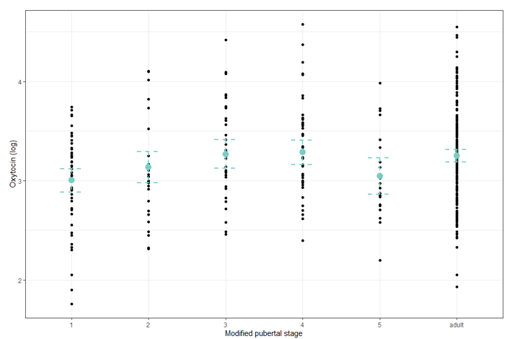

Exploratory analyses
We chose to analyze additional variables that could cause variation in oxytocin, but since these analyses were not the primary focus of the present study, we provide them as supplementary analyses.

Methods exploratory tests in supplement
For all models we used logarithmic transformation and exclusion of outliers as for the primary analyses. We provide unadjusted results and results adjusted for age when relevant.

Time of sample
Time of the saliva sample was registered by investigators at the time of sampling. We analyzed time of sample in all participants (both children, adolescents, and parents). There were no missing values on time of sample. Time of sample was included as a categorical variable with four categories (8am-09:59am, 10am-11:59am, 12am-01:59pm, 2pm-03:59pm). Age was included as covariate. We included the family-variable as a random effect variable for the same reason as described for Model 4 (described in main text). We used a mixed effect model.
Eq. F.1.
$\log\left(oxytocin_{i}\right)={{μ+ a\left({family}_{i}\right)+β_{1}\left({time of sample}_{i}\right)+ β}_{2}∙{age}_{i}+ϵ}_{i}$ $ϵ_{i}\sim N(0,σ^{2})$ $a\left({family}_{i}\right)\sim N(0,σ_{a}^{2})$

CGAS
Children and adolescents functional level was measured with the Children's Global Assessment Scale (CGAS)¹⁰. The scoring was scored by trained investigators after the initial clinical assessment of the children and adolescents. CGAS has a range from 0 to 100 with higher values indicating better function. It was included as a continuous variable. We used a partial correlation analysis with age as covariate.
Eq. F.2.
$\log\left(oxytocin_i\right)=μ+{β_{1}∙{CGAS}_{i}+β_{2}∙{age}_{i}+ϵ}_{i}$ $ϵ_{i}\sim N(0,σ^{2})$

HIK
We planned to investigate IQ with age as a covariate. When investigating assumptions, we found age and IQ correlated in our sample. We therefore chose not to analyze oxytocin and IQ.

CYBOCS
We used the CYBOCS total score as a measure of children and adolescents OCD severity⁴. Trained investigators performed and scored the CYBOCS semi-structured interview. The CYBOCS total score has a range from 0-40 with higher levels indicating more severe OCD. We included CYBOCS total score as a continuous variable and used a partial correlation analysis age as covariate.
Eq. F.3.
$\log\left(oxytocin_{i}\right)={{μ+β}_{1}∙{CYBOCS}_{i}+β_{2}∙{age}_{i}+ϵ}_{i}$ $ϵ_{i}\sim N(0,σ^{2})$

Social responsiveness scale
Social responsiveness was assessed in patients by parent answering the Social Responsiveness Scale questionnaire (SRS-2)¹¹. The consist of 65 questions with answers on a 4-point scale. We used a total score that can be calculated from the questionnaire with higher values indicating problem with social responsiveness. The total score was included as a continuous variable. We analyzed the total scores for mothers and fathers separately. We used a partial correlation with age as a covariate.
Eq. F.4.

$\operatorname{Log}\left(oxytocin_i\right)={μ+β_{1}∙{SRS}_{i}+β_{2}∙{age}_{i}+ϵ}_{i}$ $ϵ_{i}\sim N(0,σ^{2})$

Menarche status
The menarche status was reported in a questionnaire by the youths. We included menarche status as a binary variable and tested for a difference in child and adolescent oxytocin concentrations in the binary variable “Menarche” with a Welsch t-test. Age was not included as a covariate as it is closely associated with menarche.
Eq. F.5.
$\log\left(oxytocin_i\right)={ μ+β}_{1}{\left({menarche status}_{i}\right)+ϵ}_{i}$ $ϵ_{i}\sim N(0,σ^{2})$

We estimated the menstrual phase of the female participants from the first day of last menstruation which was reported by the participants in a questionnaire. The participants were estimated as in menstrual phase if the day of saliva sampling was two days before or two days after first day of last menstruation. The participants were estimated in ovulatory phase if day of saliva sampling was 10 till 14 days after first day of last menstruation. We chose to analyze girls and mothers separately as we only had information on two pairs of mothers and daughters and could therefore not include the family variable.
For the mothers, we used a Welsch t-test to investigate oxytocin differences between the two menstrual phases.
Eq. F.6.
$\operatorname{Log}\left(oxytocin_i\right)=μ+{ β}_{1}{\left({menstrual phase}_{i}\right)+ϵ}_{i}$ $ϵ_{i}\sim N(0,σ^{2})$
For the children and adolescents, we used an ANCOVA with age as a covariate.
Eq. F.7.
$\operatorname{Log}\left(oxytocin_i\right)={{{μ+β}_{1}\left({menstrual phase}_{i}\right)+ β}_{2}∙{age}_{i}+ϵ}_{i}$ $ϵ_{i}\sim N(0,σ^{2})$

Results
The flowchart of participants in each exploratory analysis can be seen in Figure F.1. Descriptive statistics and results of all analyses can be seen in Table F.1-12.
We only found a significant difference between oxytocin concentrations of adult females in menstrual phase compared to adult females in menstrual phase. This should be interpreted with caution since it is part of exploratory analyses with no adjustment of multiple testing. The results of the analyses should be replicated in studies designed to investigate the specific variables with adequate sample sizes.
In addition, the measure of menstrual cycle is uncertain as it is self-reported as last day of menstruation which is a very insecure measure of menstrual cycle phase. The results can however be interesting in planning future studies.

Figure F.1. Flow chart of participants in supplementary analyses

Note: OCD, Obsessive Compulsive Disorder; n, number; SRS, Social Responsiveness Scale, CGAS, Children’s Global Assessment Scale

All participants
Time of day
Table F.1. Descriptive on time of day.
Time of sample (n (%))
 | 8am – 09:59am | 165 (37.33%)
 | 10am-11:59am | 166 (37.56%)
 | 12am-13:59am | 71 (16.06%)
 | 14am-15:59am | 40 (9.05%)

Table F.2. Time of sample results from mixed effect model **Family-variable included as random effect in all steps.
 | Sum Sq | F- statistics | p-value
Time of sample (corrected for age) | 0.86 | 2.22 | 0.09
Time of sample (not correction) | 0.95 | 2.37 | 0.07

All child and adolescent participants
CGAS
Table F.3. Descriptive on CGAS
CGAS
 | Mean (SD) | 69.85 (18.44)
 | Median (min, max) | 65 (35,100)

Table F.4. CGAS results from partial correlation
 | Estimate | t-statistics | p-value
CGAS (corrected for age) | -0.0002 | -0.11 | 0.90
CGAS (no correction) | -0.0006 | -.033 | 0.74

Children and adolescents with OCD only
CYBOCS
Table F.5. Descriptive on CYBOCS
CYBOCS Total score
 | Mean (SD) | 25.32 (4.91)
 | Median (min, max) | 25 (16,36)

Table F.6. CYBOCS results from partial correlation
 | Estimate | t-statistics | p-value
CYBOCS (corrected for age) | 0.003 | 0.34 | 0.73
CYBOCS (no correction) | 0.004 | 0.44 | 0.66

SRS
Table F.7. Descriptive on SRS
SRS
SRS mor
 | Mean (SD) | 52.58 (8.05)
 | Median (min, max) | 50 (39,76)
SRS far
 | Mean (SD) | 52.89 (8.83)
 | Median (min, max) | 52 (41,83)

Table F.8. SRS results from partial correlation
 | Estimate | t-statistics | p-value
SRS total mor (corrected for age) | 0.003 | 0.48 | 0.63
SRS total mor (no correction) | 0.002 | 0.40 | 0.69
SRS total far (corrected for age) | -0.005 | -0.80 | 0.43
SRS total far (no correction) | -0.006 | -0.79 | 0.43

Female children and adolescents only
Menarche
Table F.9. Descriptive on menarche
Menarche (n (%))
 | Yes | 62 (64%)
 | No | 35 (36%)

Table F.10. Menarche results from t-test
 | Estimate | t-statistics | p-value
Menarche (no correction) | 0.17 | 1.53 | 0.13

Female participants only
Menstrual cycle
Table F.11. Descriptive on menstrual cycle
Menstrual cycle (n (%)) |  | Female children and adolescents | Female adults
 | Menstrual phase | 7 (58%) | 9 (41%)
 | Ovulatory phase | 5 (42%) | 13 (59%)

Table F.12. Menstrual cycle results from t-test
 | Estimate | t- statistics | p-value
Menstrual phase children (corrected for age) | 0.33 | 0.79 | 0.45
Menstrual phase children (no correction) | 0.20 | 0.57 | 0.58
Menstrual phase mothers (no correction) | 0.53 | 2.94 | 0.008

Patient information on comorbidity, somatic disorders, and medication
Table G.1. Information on comorbid psychiatric disorders, medicine and somatic disorders on children and adolescents with OCD included in model 1 (patients with saliva samples available and outliers excluded)
 |  | Children and adolescents with OCD
Comorbid psychiatric disorders (n (%))
 | Depressive disorders, ICD-10 F32 | 1 (0.88%)
 | Anxiety disorders, ICD-10 F40-41, F93 | 12 (10.62%)
 | Stress and adjustment disorders, ICD-10 F43 | 12 (10.62)
 | Eating disorders, ICD-10 F50 | 4 (3.54%)
 | Sleeping disorders, ICD-10 F51 | 1 (0.88%)
 | Personality disorders, ICD-10 F60-69 | 1 (0.88%)
 | Asperger’s Syndrome, ICD-10 F84∙5 | 14 (12.39%)
 | Other developmental disorders, ICD-10 F88 | 4 (3.54%)
 | Hyperkinetic disorders ICD-10 F90.0 | 13 (11.50%)
 | Hyperkinetic conduct disorders ICD-10 F90.1 | 2 (1.77%)
 | Conduct disorders ICD-10 F91.3 | 1 (0.88%)
 | Attachment disorders, ICD-10 F94 | 1 (0.88%)
 | Tic disorders, ICD-10 F95 | 13 (11.50%)
 | Enuresis, ICD-10 F98.0 | 3 (2.65%)
 | Attention deficit disorder, ICD-10 F98.8 | 2 (1.77%)
Medication (n (%))
 | Methylphenidate | 2 (1.77%)
 | Melatonin | 9 (7.96%)
 | Phenergan | 1 (0.88%)
 | Antiepileptic medication (Valproat) | 1 (0.88%)
 | Medication for asthma or allergy | 13 (11.50%)
 | Antihormonal contraception | 2 (1.77%)
 | Thyroid hormone (Levothyroxine) | 1 (0.88%)
Somatic disorders (n (%))
 | Epilepsy | 1 (0.88%)
 | Migraine | 3 (2.65%)
 | Hypothyroidism | 1 (0.88%)
 | Allergy | 14 (12.39%)
 | Asthma | 6 (5.31%)
 | Skin conditions (eczema, psoriasis, vitiligo) | 14 (12.39%)
 | Kidney disease (hydronephrosis, Henoch-Schonlein purpura) | 2 (1.77%)
 | Sticklers’ syndrome | 1(0.88%)
Note: ICD-10, International Classification of Diseases-10; n, number; OCD, Obsessive Compulsive Disorder

References - Appendix
1. Kaufman, J. et al. Schedule for Affective Disorders and Schizophrenia for School-Age Children-Present and Lifetime Version (K-SADS-PL): Initial Reliability and Validity Data. Journal of the American Academy of Child & Adolescent Psychiatry 36, 980–988 (1997).
2. Wechsler D. WISC‑V: Technical and interpretive manual: NCS Pearson, Incorporated; 2014.
3. Wechsler D, Coalson DL, Raiford SE. WAIS‑IV: Wechsler adult intelligence scale. San Antonio: Pearson; 2008.
4. Scahill, L. et al. Children’s Yale-Brown Obsessive Compulsive Scale: reliability and validity. J Am Acad Child Adolesc Psychiatry 36, 844–852 (1997).
5. World Health Organization. The ICD‑10 Classification of Mental and Behavioural Disorders: Clinical Descriptions and Diagnostic Guidelines. 1992: Geneva: World Health Organization. (1992).
6. Quintana, D. S. & Williams, D. R. Bayesian alternatives for common null-hypothesis significance tests in psychiatry: a non-technical guide using JASP. BMC Psychiatry 18, 178 (2018).
7. Gelman Andrew. Bayesian Data Analysis. (CRC Press, Boca Raton, FL, 2014).
8. Rouder, J. N., Speckman, P. L., Sun, D., Morey, R. D. & Iverson, G. Bayesian t tests for accepting and rejecting the null hypothesis. Psychonomic Bulletin & Review 16, 225–237 (2009).
9. Lee, M. D. & Wagenmakers, E.-J. Bayesian Cognitive Modeling: A Practical Course. (Cambridge University Press, Cambridge, 2014). doi:10.1017/CBO9781139087759.
10. Shaffer, D. et al. A children’s global assessment scale (CGAS). Arch Gen Psychiatry 40, 1228–1231 (1983).
11. Constantino JN, Gruber CP. Social responsiveness scale (SRS). (2007).

