Supplementary Information

Ultrastable Fe-N₄-C₆O₂ Single Atom Sites for Highly Efficient PMS Activation and Enhanced Fe^{IV}=O Reactivity

Tiantian Chen¹, Ganbing Zhang²*, Hongwei Sun¹, Yetong Hua¹, Shu Yang¹, Dandan Zhou¹, Haoxin Di¹, Yiling Xiong¹, Shenghuai Hou¹, Hui Xu*¹, and Lizhi Zhang³*

¹National Key Laboratory of Green Pesticide, College of Chemistry, Central China Normal University, Wuhan 430079, P.R. China

²College of Chemistry and Chemical Engineering, Hubei University, Wuhan, 430062, P. R. China

³School of Environmental Science and Engineering, Shanghai Jiao Tong University, Shanghai, 200240, P. R. China

E-mail: huixu@ccnu.edu.cn; gbzhang@hubu.edu.cn; zhanglz@mail.ccnu.edu.cn.

Supplementary Texts

Supplementary Text 1. Materials and instruments
Materials
Ferrous chloride tetrahydrate (FeCl₂·4H₂O, ≥ 99.7%), 1,10-phenanthroline monohydrate (AR), sodium hydroxide (NaOH, AR), hydrochloric acid (HCl, AR), tetramethyl orthosilicate (TMOS), anhydrous sodium acetate (NaAc, AR), acetic acid (HAc, AR), absolute ethanol (C₂H₄OH, ≥ 99.7%), ammonia (28% NH₃·H₂O, AR), sodium thiosulfate (Na₂S₂O₃, 99%), formaldehyde aqueous solution (37 wt%), bisphenol A (BPA, AR) and 4-Chlorophenol (4-CP, 99.0%) were all supplied by Sinopharm Chemical Reagent Co., Ltd (Shanghai, China). Sodium tetraborate (Na₂B₄O₇, ≥ 99%), 2,4-dichlorophenol (2,4-DCP, ＞98.0%), phenol (PE), p-nitrophenol (PNP, 98%), methyl phenyl sulfone (PMSO₂, ＞97.0%), ferroferric oxide (Fe₃O₄, 99.5% metals basis, 20 nm spheroidal), benzoic acid (BA, AR), resorcinol (AR), and oxone (2KHSO₅·KHSO₄·K₂SO₄, active oxygen ≥ 4.50%) were obtained from Shanghai Aladdin Biochemical Technology Co., Ltd (Shanghai, China). Methyl phenyl sulfoxide (PMSO, 98%), 5,5-dimethyl-1-pyrrolineN-oxide (DMPO), (S,S)-(+)-N,N'-Bis(3,5-di-tert-butylsalicylidene)-1,2-cyclohexanediamin (98%), and perchloric acid (HClO₄, AR) were acquired from Shanghai Maclin Biochemical Technology Co., Ltd (Shanghai, China). Methanol (MeOH, HPLC) and acetonitrile (HPLC) were bought from Thermo Fisher Technology Co., Ltd. (USA). 2,2,6,6-tetramethyl-4-piperidinol (TEMP), P-nitrobenzaldehyde (PNBD, AR), fipronil (FP, AR), and p-nitrobenzyl alcohol (PNBA, 98%) and m-dihydroxybenzene were purchased from Shanghai Annaeji Chemical Co., Ltd (Shanghai, China). P-chlorobenzoic acid (pCBA, 98%) was purchased from Shanghai Beade Pharmaceutical Technology Co., Ltd. The arium® pro-Ultrapure Water Systems (Sartorius Stedim Biotech, Gottingen, Germany) was used to obtain ultrapure water in the experiments.
Instruments
Field emission scanning electron microscope (FESEM) images were investigated on a JSM7900F (JEOL, Japan) microscope. Transmission electron microscopy (TEM) and High-resolution TEM images (HRTEM) were recorded on a FEI Talos F200x (Thermo Fisheries, USA) instrument. Powder X-ray diffraction (PXRD) analysis was carried out on a D8 ADVANCE apparatus (Bruker, Germany) with a scanning angle (2θ) of 10°- 80°, operated at 40 kV and 40 mA. The chemical state of the catalysts was characterized by X-ray photoelectron spectroscopy (XPS, Escalab 250 Xi, Thermo Fisheries, USA). The Raman spectra were collected using a DXR laser Raman spectrophotometer (Thermo Fisheries, USA). Avio 200 inductively coupled plasma optical emission spectrometry (ICP-OES, PerkinElmer, USA) was used to determine the Fe ions in the Fe-SACs and dissolved iron ions. The aberration-corrected high angle annular dark field scanning transmission electron microscopy (AC-HAADF STEM) image was obtained by FEI TitanTM Themis 60-300 instrument at an accelerating voltage of 200 kV (FEI, USA). The X-ray absorption spectra (XAS) including X-ray absorption near-edge structure (XANES) and extended X-ray adsorption fine structure (EXAFS) for the Fe K-edge in Fe-SACs were carried out on the sample at 21A X-ray nano diffraction beamline of Taiwan Photon Source (TPS), National Synchrotron Radiation Research Center (NSRRC). This beamline adopted 4-bounce channel-cut Si (111) monochromator for mono-beam X-ray nano diffraction and X-ray absorption spectroscopy. The end station is equipped with three ionization chambers and Lytle/SDD detector after the focusing position of the KB mirror for fluorescence/transmission mode X-ray absorption spectroscopy. The photon flux on the sample is range from 1x10¹¹~3x10⁹ photon/sec for X-ray energy from 6-27 keV. XAS data is processed and analyzed by ATHENA and ARTEMIS applications included in IFEFFIT¹. Hama Fortran was used to calculate the wavelet transform of the EXAFS spectrum and to reconstruct the spectra from the wavelet transform². SO₄•–, •OH, electron transfer, and hypervalent iron oxides were detected by electron paramagnetic resonance (EPR, EMX-PLUS, Bruker, Germany) spectroscopy. The total organic carbon (TOC) was determined with the TOC-L series analyzer (Shimadzu, Japan).
⁵⁷Fe Mössbauer spectroscopy:
In order to characterize the various iron species in Fe-N₄-C₆O₂ and Fe-N₄ -C, ⁵⁷Fe Mössbauer spectroscopy was performed using ⁵⁷Co (Rh) γ–ray radioactive source maintained at room temperature (298 K). The measurements were made in the transmission mode using a 50 mCi ⁵⁷Co/Rh-source, and the velocity scale and isomer shift (δ_{Iso}) were calibrated with respect to α-Fe-Standard (25 μm thick, 99.99% purity). All Mössbauer spectra were plotted as relative absorption against the Doppler velocity (ν). The relative absorption was calculated from the original transmission data using equation S1 (Eq. S1):
$${\text{Abs}}_{\text{ν}\text{Doppler}}\text{ =}\frac{{\text{Trans}}_{\text{max}}\text{-}{\text{Trans}}_{\text{ν}\text{Doppler}}}{{\text{Trans}}_{\text{max}}}$$ | (S1)
Where, Trans_{max} and Trans$\text{ν}$_{Doppler} represent the maximum background transmission that occurs at ν where no absorption is observed and the transmission at a specific ν, respectively. Abs$\text{ν}$_{Doppler} is the relative absorption for each ν, and expressed as a percentage.
The δ_{Iso} describes the shift of the electron cloud density at the iron nucleus of the sample (E_{A,CFSE}) with respect to the α-Fe-Standard source (E_{S,CFSE}), which is used to characterize the electrostatic interaction. Specifically, the δ_{Iso} refers to the difference in ν between the center of gravity of the Mössbauer singlet, doublet, or multiplet state and the zero velocity of the spectral line, and its value is related to the electric monopole interaction. Chemical information such as chemical bond properties, oxidation state, and coordination information etc. can be obtained from the δ_{Iso} value. The reference formula for determining δ_{Iso} is shown in Eq. S2:
$${\text{δ}}_{\text{ISO}}\text{=}{\text{E}}_{\text{A, CFSE}}\text{-}{\text{E}}_{\text{S, CFSE}}\text{=}\frac{\text{2}}{\text{3}}\text{πZ}{\text{e}}^{\text{2}}\left({\text{ρ}}_{{\text{e}}^{\text{-}}\text{,A}} \text{-}{\text{ ρ}}_{{\text{e}}^{\text{-}}\text{,S}}\right)\text{×}\left({\text{R}}_{\text{Excited}}^{\text{2}} \text{-}{ \text{R}}_{\text{Ground}}^{\text{2}}\right)\text{=}\frac{\text{ν}}{\text{c}}\text{∙}{\text{E}}_{γ}$$ | (S2)
Where, Z is the atomic number of Fe-57 and e is the electronic charge of a single electron. The coefficients ρ_{e−,A} and ρ_{e−,S} represent the s-electron density at the nuclei of the iron species in the sample (Fe-N₄-C₆O₂ or Fe-N₄-C₁₀) and the α-Fe source, respectively. R_{Excited} and R_{Ground} denote the nuclear radius in the excited state and ground state of Fe-57, respectively. The second coefficient in the Eq. S2 is always negative since R_{Excited} is always less than R_{Ground}.
Quadrupole splitting (∆E_{Q}) is used to describe the change in energy caused by the electric quadrupole interaction between the external electric field and the nucleus. When the electric field gradient is not zero, the excited state splits into substates with different energies.

Supplementary Text 2. Synthesis details.
Synthesis of carrier.
Synthesis of silica. First, 10 mL of ultrapure water, 70 mL of absolute ethanol, and 3 mL of ammonia water were stirred together for 10 min at room temperature. Subsequently, 3.5 mL of TMOS was quickly added to the above solution and stirred for 24 h at 25 ℃. Finally, the white SiO₂ precipitates were collected by centrifugation after washing with ethanol and water for many times.
Synthesis of silica@resorcinol formaldehyde oligomers nanospheres. Silica@resorcinol formaldehyde oligomers (SiO₂@RF) nanospheres with core-shell structures were prepared by a one-pot method using in situ generated silica primary particles as templates and used as precursors for the synthesis of single atoms (Figure S1)³. First, 10 mL of ultrapure water, 70 mL of absolute ethanol, and 3 mL of ammonia water were stirred together for 10 min at room temperature. Subsequently, 3.5 mL of TMOS was quickly added to the above solution and stirred for 15 min. Next, 0.56 mL formaldehyde (37 wt%) and 0.4 g resorcinol were added and stirred for 24 h at 25 °C. Finally, the orange-yellow precipitates collected by centrifugation were washed several times with ethanol and water to obtain SiO₂@RF nanospheres.
Synthesis of SiO₂@N-C. SiO₂@phen was obtained by depositing 2 mmol of 1,10-phenanthroline monohydrate dissolved in anhydrous ethanol onto 3 g SiO₂ nanospheres by rotary evaporation. Finally, SiO₂@N-C was obtained by carbonization of SiO₂@phen at 700° for 2h.
Synthesis of different catalysts.
Synthesis of Fe-N₄-C₆O₂ SAC. FeCl₂·4H₂O and 10-phenanthroline monohydrate were ultrasonically dispersed in 60 mL absolute ethanol to obtain Fe-N coordination complex (I). Then, SiO₂@RF was added to the solution and stirred under reflux at 60 °C for 4h. Next, the pre-prepared complex (I) was deposited on SiO₂@RF by reduced pressure evaporation at 50 °C. The dried solid was then heated to 700 °C (calcined for 2 h) at a rate of 2 °C min⁻¹ in an N₂ atmosphere. Subsequently, the resulting black solid was dispersed into 100 mL 5 wt % HF and stirred at room temperature for 4 h to remove SiO₂. This procedure was repeated three times. Afterward, the solid was washed repeatedly with a large amount of ultrapure water until the filtrate reached neutral pH. Finally, the dried black powder was recorded as Fe-N₄-C₆O₂ SAC.
Synthesis of Fe-N₂O₂-C₁₀ SAC. The other steps remained unchanged except that 10-phenanthroline monohydrate and SiO₂@RF were replaced with (S,S)-(+)-N,N'-Bis(3,5-di-tert-butylsalicylidene)-1,2-cyclohexanediamin and SiO₂@N-C, respectively.
Synthesis of Fe-N₄-C₁₀. The other steps remained unchanged except for the deposition of complex (I) on SiO₂.
Synthesis of Fe-NPs/NC. The other steps remained unchanged except without adding SiO₂@RF.
Synthesis of metal-free N\O co-doped carbon materials (N/O-C). The other steps remained unchanged except that no FeCl₂·4H₂O was added.
Synthesis of N-doped carbon materials (N-C). Compared with N/O-C, N-C can be obtained by replacing the SiO₂@RF template with the SiO₂ template. Besides, the preparation method for each catalyst is summarized in Table S1.

Supplementary Text 3. Catalytic performances of Fe-SACs/PMS system-based advanced oxidation processes (AOPs).
The catalytic activity and stability of Fe-SACs were investigated by activating PMS to degrade BPA at room temperature under neutral pH conditions. In addition, the effects of PMS dosages (100-500 μM), catalyst dosages (0.01, 0.02, 0.05, 0.1 mg mL⁻¹), pH (pH=2-10) and coexisting ions (Cl⁻, HCO₃⁻) were also investigated. To investigate pH effects, 10 mM acetate and borate buffers were used for maintaining acidic (pH＜7.0) and alkaline (pH≥7.0) pH, respectively. HAc and NaOH were used to regulate pH in acidic condition, ClO₄ and NaOH were used to regulate pH in alkaline condition. If it was not otherwise specified, the experiments were carried out at room temperature at pH=7.0, the amount of catalyst is 0.05 mg mL⁻¹ and the amount of PMS is 400 μM. In a typical experiment, the catalyst stock suspension was introduced into the target pollutants solution and stirred at T ± 1 °C for 10 min to achieve the adsorption-desorption equilibrium. After that, the PMS stock solution (10 mM) was placed in the above solution to initiate the oxidation reaction. The mixture was magnetically stirred at T ± 1 °C with a water bath. At predetermined time intervals, sample aliquots (1 mL) were withdrawn and immediately quenched with 20 μL of Na₂S₂O₃ (0.5 M). Then, it was filtered through a 0.22 μm glass fiber membrane (negligible adsorption for reactants), and injected into a 2 mL glass vial for tests. The batch experiments were conducted in duplicates at least, and the average values with standard deviations were given.
Radical quenching and EPR experiments were performed to investigate the activation mechanism. Among them, the quenching experiment is different from the above experiment in that the quenching agent was added together with the catalyst. To evaluate the contribution of singlet oxygenation (¹O₂) to organic oxidation, the degradation of pollutants based on Fe-SACs/PMS system-based AOPs and ¹O₂ was also compared, in which ¹O₂ was produced by photoexcitation of RB under visible light (400-800nm)⁴.

Supplementary Text 4. Analytical Methods.
The concentration of target pollutants was analyzed by high-performance liquid chromatograph (HPLC, Shimadzu) equipped with an SPD-M20A diode array detector. Chromatographic separations were performed using an Agilent Eclipse XDB-C18 column (4.6 ×150 mm, i.d., 5 µm, Agilent) at a flow rate of 1 mL min⁻¹. The column was maintained at 35 °C. The detailed chromatographic parameters (the flow rate, wavelength, and mobile phase) for the separation and detection of each organic compound are listed in Table S10.
To comprehensively detect the intermediates produced in the process of BPA degradation, the intermediates were purified and enriched by solid phase extraction (SPE). In addition, lower concentrations of catalyst and shorter catalytic time were selected in this study to prevent BPA from being completely degraded. Finally, these intermediates were identified by liquid chromatography-mass spectrometry (LC-MS) and gas chromatography-mass spectrometry (GC-MS) analysis.
Alliance e2695 separations module (Waters, Manchester, UK) and an Agilent Eclipse XDB-C18 column (4.6 ×150 mm, i.d., 5 µm) were used as the LC system to separate the intermediates. The mobile phase started with 80/20 (v/v) methanol/water at a flow rate of 0.2 mL min⁻¹ and the analysis time was 70 min. The column temperature was 30 °C. Acquity TQD instrument with electrospray ionization (ESI) was used as the MS system (Waters, Manchester, UK). The mass-charge ratio is set to 30-500 to qualitatively analyze the intermediates. The full scan negative ion mode in the MS system is selected to analyze the intermediates. Some other MS parameters were set as follows, capillary voltage: 3 kV, cone hole voltage 30 V. Besides, ion source temperature: 150 °C, solvent temperature: 400 °C.
The GC-MS analysis was performed on a GC-MS-QP2010 plus (Shimadzu, Japan) equipped with an electron impact ion source (EI). Chromatographic separation was carried out with a DB-5MS capillary column (30 m × 0.25 mm, i.d., 0.25 µm, Agilent, J&W, USA). The analytes were introduced into the column using a splitless mode. Ultra-pure helium was used as the carrier gas at a flow rate of 1.2 mL min⁻¹. The injection temperature was set as 240 °C and the column temperature program was as follows: the initial temperature of the GC column was set at 80 °C (held for 1 min), the temperature was increased to 280 °C at a rate of 5 °C min⁻¹ (held for 9 min). The total running time was 50 min. The full scan mode of m/z 35~500 was used to record the mass spectrum in EI mode at 70 eV potential with an ion source temperature of 200 °C. The detected peaks were identified according to the NIST data library.

Supplementary Text 5. Calculation formula
(1) Pseudo-first-order reaction rate constant
In the kinetic investigation, the degradation of organic pollutants is fitted with the pseudo-first-order kinetic model, and the apparent rate constants (k) was calculated according to the following Eq. S3:
$\text{ln}{{{\text{C}}_{\text{t}}}/{{\text{C}}_{\text{0}}}\text{=- k}}$t | (S3)
Where C_{t} and C₀ denote the real-time concentration and initial concentration of contaminants (mol L⁻¹), respectively. k stands for the apparent rate constants or pseudo-first-order reaction rate constant (min⁻¹). t represents the reaction time (min)
(2) Turnover frequency
The turnover frequency (TOF) of SACs was calculated by Eq. S4 - Eq. S6:
$$\text{TOF=}\frac{{\text{C}}_{\text{0}}\text{×(Contaminants Removal)}}{\text{t×}{\text{C}}_{\text{Fe}}}$$ | (S4)
$\text{Contaminants Removal=}\frac{{\text{C}}_{\text{0}}\text{-}{\text{C}}_{\text{t}}}{{\text{C}}_{\text{0}}}\text{×100}$% | (S5)
$${\text{C}}_{\text{Fe}}\text{=}\frac{{\text{C}}_{\text{cat.}}\text{×(Fe content/wt\%)}}{{\text{M}}_{\text{Fe}}}$$ | (S6)
Where C₀ denotes the initial concentration of BPA (mol L⁻¹). C_{t} indicates the concentration of BPA after 5 s of degradation. C_{Fe} (mol L⁻¹) and C_{cat} (g L⁻¹) are the concentration of Fe element and catalyst, respectively. t stands for the reaction time (0.083 min). M_{Fe}=56 g mol⁻¹.
(3) Catalyst dose-pollutant concentration normalized kinetic rate constant
The catalyst dose-pollutant concentration normalized kinetic rate constant (k-value) was calculated by Eq. S10.
$$\text{k-value}\text{=}\text{k[}{\text{C}}_{\text{1}}\text{] / [}{\text{C}}_{\text{2}}\text{]}$$ | (S7)
Where k, $\text{[}{\text{C}}_{\text{1}}\text{]}$ and $\text{[}{\text{C}}_{\text{2}}\text{]}$ represent the pseudo-first-order kinetic reaction rate (s⁻¹), contaminant concentration (μmol L⁻¹), and catalyst dosage (g L⁻¹), respectively.
(4) Total Organic Carbon (TOC) removal
The TOC removal of the BPA solution was determined by Eq. S8.
$$\text{TOC Reduction}\text{=}\frac{{\text{TOC}}_{\text{0}}\text{-}{\text{TOC}}_{\text{t}}}{{\text{TOC}}_{\text{0}}}\text{×100\%}$$ | (S8)
where TOC₀ and TOC_{t} (2 min) are the initial and final TOC values of BPA, respectively. The TOC reduction shows the mineralization degree of BPA to CO₂ and water.

Supplementary Text 6. Construction of Fe-SAC/MCE continuous flow reactor.
The Fe-SAC suspension was deposited on a Mixed Cellulose Esters (MCE) membrane (pore size=0.45 μm, D.25 mm) through filtration and then placed in a filter (i.D. 25 mm). The effective membrane area of the Fe-SAC /MCE composite microfiltration membrane is 1.33 cm² and the loading capacity of the catalyst is 15.03 mg/cm². Next, the Fe-SAC /MCE filter and peristaltic pump are used to form a continuous flow reactor to evaluate the long-term stability of Fe-SAC.

Supplementary Text 7. Electrode preparation
Nafion® solution (5.0wt %, 0.1 mL) and Fe-SAC powder (10 mg) were ultrasonically dispersed with ethanol (1 mL) for 30 min to form a suspension. Then, 60 μL suspension was dropped on the carbon paper electrode (1 cm*1 cm) in three portions (20 μL each) and dried under vacuum at 60 °C for 3 h.

Supplementary Text 8. Quantifying the steady-state concentration and contribution of reactive oxygen species (ROS)
(1) The steady-state concentrations of •OH and SO₄^{•-}
BA does not react with ¹O₂, O₂^{•-}, and high-valent iron oxo (Fe^{IV}=O) species, but exhibits high reactivity towards •OH and SO₄^{•-}. Additionally, pCBA is inert towards Fe^{IV}=O, but can react with •OH, SO₄^{•-}, ¹O₂, and O₂^{•-}. Quenching experiments and EPR tests indicate the presence of a small number of radicals (•OH and SO₄^{•-}) and a significant amount of Fe^{IV}=O in the Fe-N₄-C₆O₂/PMS and Fe-N₄-C₁₀/PMS system, while ¹O₂ and O₂^{•-} are almost absent. The consumption rate of pCBA is simplified to be related to •OH and SO₄^{•-} only. Therefore, the steady state concentrations of •OH and SO₄^{•-} ([•OH]_{ss} and [SO₄^{•-}]_{ss}, M) in the Fe-N₄-C₆O₂/PMS and Fe-N₄-C₁₀/PMS system can be obtained by using BA and pCBA as probe compounds. The second-order reaction rate constants (k_{BA,•OH}, ${\text{k}}_{{BA,\text{SO}}_{\text{4}}^{\text{•-}}}$, k_{pCBA,•OH}, ${\text{k}}_{{\text{pCBA,}\text{SO}}_{\text{4}}^{\text{•-}}}$, M⁻¹∙s⁻¹) between probe compounds and ROS were provided in Table S6.
$$-\frac{\text{d[BA]}}{\text{d}\text{t}}\text{=}{\text{k}}_{\text{BA, •OH}}\text{[•OH][BA]+}{\text{k}}_{\text{BA, SO}\text{4}\text{•-}}\text{[SO}\text{4}\text{•-}\text{][BA]}$$ | (S9)
$$-\frac{\text{d[pCBA]}}{\text{d}\text{t}}\text{=}{\text{k}}_{\text{pCBA, •OH}}\text{[•OH][}\text{pCBA}\text{] +}{\text{k}}_{\text{pCBA}\text{, SO}\text{4}\text{•-}}\text{[SO}\text{4}\text{•-}\text{][}\text{pCBA}\text{]}$$ | (S10)
Where, [BA] and [pCBA] are the concentrations of BA and pCBA at time (min), respectively. [BA]₀ and [pCBA]₀ are the initial concentrations of BA and pCBA, respectively.
Rearranging Eqs. S10-11 yields:
$$-\frac{\text{d[BA]}}{\text{[BA]}}\text{=}{\text{(}\text{k}}_{\text{BA, •OH}}\text{[•OH]+}{\text{k}}_{\text{BA, SO}\text{4}\text{•-}}\text{[SO}\text{4}\text{•-}\text{])d}\text{t}$$ | (S11)
$$-\frac{\text{d[pCBA]}}{\text{[pCBA]}}\text{=(}{\text{k}}_{\text{pCBA, •OH}}\text{[•OH] +}{\text{k}}_{\text{pCBA, SO}\text{4}\text{•-}}\text{[SO}\text{4}\text{•-}\text{])d}\text{t}$$ | (S12)
Integrating Eqs. S12-13 gives
$$\ln{\frac{{\text{[BA]}}_{\text{0}}}{[\text{BA}]}}\text{=(}{\text{k}}_{\text{BA, •OH}}{\text{[•OH]}}_{ss}\text{+}{\text{k}}_{\text{BA, SO}\text{4}\text{•-}}{\text{[SO}\text{4}\text{•-}\text{]}}_{ss})\text{t}={\text{k}}_{\text{obs, BA}}\text{t}$$ | (S13)
$$\text{ln}{\frac{{\text{[pCBA]}}_{\text{0}}}{\text{[pCBA]}}}\text{=(}{\text{k}}_{\text{pCBA, •OH}}{\text{[•OH]}}_{ss}\text{+}{\text{k}}_{\text{pCBA, SO}\text{4}\text{•-}}{\text{[SO}\text{4}\text{•-}\text{]}}_{ss}\text{)}\text{t}\text{=}{\text{k}}_{\text{obs, pCBA}}\text{t}$$ | (S14)
The pseudo-first-order reaction rate constants (k_{obs,BA} and k_{obs, pCBA}, min⁻¹) can be obtained from the plots of $\ln{\frac{{\text{[BA]}}_{\text{0}}}{[\text{BA}]}}$ and $\ln{\frac{{[\text{pCBA}]}_{0}}{[\text{pCBA}]}}$ versus time (min), respectively. Then, [•OH]_{ss} and [SO₄^{•-}]_{ss} can be obtained by solving Eqs. S13-14.
(2) The steady-state concentrations of Fe^{IV}=O
The second-order reaction rate constants between PMSO and ROS were provided in Table S6. As indicated in Eqs. 16-18, the PMSO can react with •OH (${\text{k}}_{\text{ PMSO, •OH}}$ = 3.61 × 10⁹ M^{–1} s^{–1}), SO₄^{•-} (${\text{k}}_{{\text{PMSO, }\text{SO}}_{\text{4}}^{\text{•-}}}$= 3.17 × 10⁸ M^{–1}s^{–1}), and Fe^{IV}=O (${\text{k}}_{\text{PMSO, }{\text{Fe}}^{\text{IV}}\text{=O}}$=2.58 × 10³ M^{–1}s^{–1}), but it will only be oxidized to PMSO₂ by Fe^{IV}=O^{5,6}. Therefore, the steady-state concentration of Fe^{IV}=O ([Fe^{IV}=O]_{ss}) in the Fe-N₄-C₆O₂/PMS and Fe-N₄-C₁₀/PMS systems can be determined by the kinetics of PMSO₂ formation.
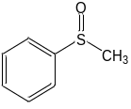$\text{(PMSO)+ }{\text{Fe}}^{\text{(n+2)+}}\text{=O}\underset{→}{\text{ OAT }}$ 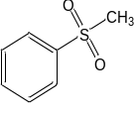$\text{(}{\text{PMSO}}_{\text{2}}\text{)+ }{\text{Fe}}^{\text{n+}}$ | (S15)
$\text{+ SO}\text{4}\text{•-}\underset{→}{ }$ 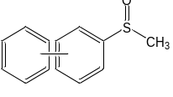 or 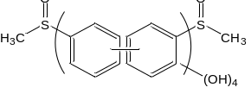 | (S16)
+ •OH 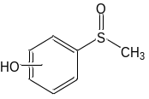 | (S17)
The kinetics of PMSO₂ formation can be represented as:
$$\frac{\text{d[}{\text{PMSO}}_{\text{2}}\text{]}}{\text{d}\text{t}}\text{=}{\text{k}}_{\text{PMSO, }{\text{Fe}}^{\text{IV}}\text{=O}}\text{[}{\text{Fe}}^{\text{IV}}\text{=O][PMSO]}$$ | (S18)
$$\frac{\text{d[}{\text{PMSO}}_{\text{2}}\text{]}}{\text{[PMSO]}}\text{=}{\text{k}}_{\text{PMSO, }{\text{Fe}}^{\text{IV}}\text{=O}}\text{[}{\text{Fe}}^{\text{IV}}\text{=O]d}\text{t}$$ | (S19)
[PMSO₂] and [Fe^{IV}=O] are the concentrations of PMSO₂ and Fe^{IV}=O at time t (s), respectively. [PMSO]₀ is the initial concentrations of PMSO.
$$\text{ŋ=}\frac{\text{∆[}{\text{PMSO}}_{\text{2}}\text{]}}{\text{∆[PMSO]}}\text{=}\frac{\text{[}{\text{PMSO}}_{\text{2}}\text{]}}{{\text{[PMSO]}}_{\text{0}}-\text{[PMSO]}}$$ | (S20)
$$\text{[PMSO]=} {\text{[PMSO]}}_{\text{0}}-\frac{1}{ŋ}\text{[}{\text{PMSO}}_{\text{2}}\text{]}$$ | (S21)
ŋ is the conversion rate of PMSO to PMSO₂, which represents mole of PMSO₂ produced per mole of PMSO oxidized.
Substituting Eq. S21 into Eq. S19 gives
$$\frac{\text{d[}{\text{PMSO}}_{\text{2}}\text{]}}{{\text{[PMSO]}}_{\text{0}}-\frac{1}{ŋ}\text{[}{\text{PMSO}}_{\text{2}}\text{]}}\text{=}{\text{k}}_{\text{PMSO, }{\text{Fe}}^{\text{IV}}\text{=O}}\text{[}{\text{Fe}}^{\text{IV}}\text{=O]d}\text{t}$$ | (S22)
Integrating Eq. S23 gives
$$\int_{\text{0}}^{\text{[}{\text{PMSO}}_{\text{2}}\text{]}}{\frac{\text{1}}{{\text{[PMSO]}}_{\text{0}}\text{-}\frac{\text{1}}{\text{ŋ}}\text{[}{\text{PMSO}}_{\text{2}}\text{]}}}\text{ d[}{\text{PMSO}}_{\text{2}}\text{]=}\int_{\text{0}}^{\text{t}}{{\text{k}}_{\text{PMSO, }{\text{Fe}}^{\text{IV}}\text{=O}}\text{[}{\text{Fe}}^{\text{IV}}\text{=O}\text{]d}\text{t}}$$ | (S23)
$$-\text{ŋ}\int_{\text{0}}^{\text{[}{\text{PMSO}}_{\text{2}}\text{]}}{[\ln{({\text{[PMSO]}}_{\text{0}}-\frac{\text{1}}{\text{ŋ}}\text{[}{\text{PMSO}}_{\text{2}}\text{]})}]^{'}}\text{ d[}{\text{PMSO}}_{\text{2}}\text{]=}\int_{\text{0}}^{\text{t}}{({\text{k}}_{\text{PMSO, }{\text{Fe}}^{\text{IV}}\text{=O}}\text{[}{\text{Fe}}^{\text{IV}}\text{=O}\text{]}\text{t}{\text{)}}^{'}\text{d}\text{t}}$$ | (S24)
$$-\text{ŋ}\ln{|{\text{[PMSO]}}_{\text{0}}-\frac{\text{1}}{\text{ŋ}}\text{[}{\text{PMSO}}_{\text{2}}\text{]}||_{0}^{\text{[}{\text{PMSO}}_{\text{2}}\text{]}}}\text{=}{\text{k}}_{\text{PMSO, }{\text{Fe}}^{\text{IV}}\text{=O}}{\text{[}{\text{Fe}}^{\text{IV}}\text{=O]}}_{\text{ss}}\text{t}$$ | (S25)
$$\text{ŋ}\text{ln}{\frac{{\text{[PMSO]}}_{\text{0}}}{{\text{[PMSO]}}_{\text{0}}\text{-}\frac{\text{1}}{\text{ŋ}}\text{[}{\text{PMSO}}_{\text{2}}\text{]}}\text{=}{\text{k}}_{\text{PMSO, }{\text{Fe}}^{\text{IV}}\text{=O}}{\text{[}{\text{Fe}}^{\text{IV}}\text{=O]}}_{\text{ss}}}\text{t}\text{=}{\text{k}}_{\text{obs, PMSO}}\text{t}$$ | (S26)
Where, the ${\text{k}}_{\text{obs, PMSO}}$ can be obtained from plots of $\text{ŋ}\text{ln}{\frac{{\text{[PMSO]}}_{\text{0}}}{{\text{[PMSO]}}_{\text{0}}- \frac{\text{1}}{\text{ŋ}}\text{[}{\text{PMSO}}_{\text{2}}\text{]}}}$ versus time (Figure S32). The values of ${\text{k}}_{\text{PMSO, }{\text{Fe}}^{\text{IV}}\text{=O}}$ are listed in Table S6.
$${\text{[}{\text{Fe}}^{\text{IV}}\text{=O]}}_{\text{ss}}\text{=}\frac{{\text{k}}_{\text{obs, PMSO}}}{{\text{k}}_{\text{PMSO, }{\text{Fe}}^{\text{IV}}\text{=O}}}$$ | (S27)
(3) The oxidation contributions
The quenching experiments and ESR tests have demonstrated that the degradation of BPA in the Fe-N₄-C₆O₂/PMS and Fe-N₄-C₁₀/PMS system is associated with electron transfer process (ETP), radicals (•OH and SO₄^{•-}) and Fe^{IV}=O oxidation processes. Therefore, the degradation kinetics of BPA can be simply represented by Eq. S29. In this equation, k_{BPA, ETP} (s⁻¹) stands for the observed first-order reaction rate constants for the ETP of BPA. It can be obtained from a plot of $\ln{\frac{{\text{[BPA]}}_{\text{0}}}{[\text{BPA}]}}$ vs. time (s) in the methanol and PMSO co-quenching experiments. ${\text{k}}_{\text{BPA, •OH}}$, ${\text{k}}_{\text{BPA, SO}\text{4}\text{•-}}$, and${\text{k}}_{BPA\text{, }{\text{Fe}}^{\text{IV}}\text{=O}}$ (M⁻¹∙s⁻¹) represent the second-order reaction rate constants between the reactive species (•OH, SO₄^{•-}, and Fe^{IV}=O) and BPA.
$$-\frac{\text{d[B}\text{PA]}}{\text{d}\text{t}}\text{=}{\text{k}}_{\text{BPA, ETP }}\text{[BPA] +}{\text{k}}_{\text{BPA, •OH}}\text{[•OH][BPA]+}{\text{k}}_{\text{BPA, SO}\text{4}\text{•-}}\text{[SO}\text{4}\text{•-}\text{][BPA]}$$  $$\text{+}{\text{k}}_{\text{BPA, }{\text{Fe}}^{\text{IV}}\text{=O}}\text{[}{\text{Fe}}^{\text{IV}}\text{=O][BPA]}$$ | (S28)
$$-\frac{\text{d[B}\text{PA]}}{\text{[BPA]}}\text{=(}{\text{k}}_{\text{BPA, ETP }}\text{ +}{\text{k}}_{\text{BPA, •OH}}\text{[•OH] +}{\text{k}}_{\text{BPA, SO}\text{4}\text{•-}}\text{[SO}\text{4}\text{•-}\text{] }$$  $$\text{+}{\text{k}}_{\text{BPA, }{\text{Fe}}^{\text{IV}}\text{=O}}\text{[}{\text{Fe}}^{\text{IV}}\text{=O])d}\text{t}$$ | (S29)
Integrating Eq. S30 gives
$$\text{ln}{\frac{{\text{[B}\text{PA]}}_{\text{0}}}{\text{[BPA]}}}\text{=(}{\text{k}}_{\text{BPA, ETP }}\text{ +}{\text{k}}_{\text{BPA, •OH}}{\text{[•OH]}}_{\text{ss}}\text{ +}{\text{k}}_{\text{BPA, SO}\text{4}\text{•-}}{\text{[SO}\text{4}\text{•-}\text{]}}_{\text{ss}}$$  $$\text{+}{\text{k}}_{\text{BPA, }{\text{Fe}}^{\text{IV}}\text{=O}}{\text{[}{\text{Fe}}^{\text{IV}}\text{=O]}}_{\text{ss}}\text{)}\text{t}\text{=}{\text{k}}_{\text{obs, BPA}}\text{t}$$ | (S30)
The pseudo-first-order reaction rate constants (${\text{k}}_{\text{obs, BPA}}$, s⁻¹) can be obtained from the plots of $\ln{\frac{{\text{[BPA]}}_{\text{0}}}{[\text{BPA}]}}$ versus time (s). The observed pseudo-first-order reaction rate constants for the active species can then be obtained from Eqs. S31-33.
$${\text{k}}_{\text{obs, •OH}}={\text{k}}_{\text{BPA, •OH}}{\text{[•OH]}}_{\text{ss}}$$ | (S31)
$${{\text{k}}_{\text{obs, SO}\text{4}\text{•-}}=\text{k}}_{\text{BPA, SO}\text{4}\text{•-}}{\text{[SO}\text{4}\text{•-}\text{]}}_{\text{ss}}$$ | (S32)
$${{\text{k}}_{\text{obs, }{\text{Fe}}^{\text{IV}}\text{=O}}={\text{k}}_{\text{obs, BPA}}-{\text{k}}_{\text{BPA, ETP }}-{\text{k}}_{\text{BPA, •OH}}{\text{[•OH]}}_{\text{ss}}-\text{k}}_{\text{BPA, SO}\text{4}\text{•-}}{\text{[SO}\text{4}\text{•-}\text{]}}_{\text{ss}}$$ | (S33)
The oxidation contributions of each reactive species to BPA degradation can be expressed as Eq. S34.
$$\text{Contributions (\%)=}\frac{{\text{k}}_{\text{obs, ROS}}}{{\text{k}}_{\text{obs, BPA}}}\text{×100\%}$$ | (S34)
(4) The second-order reaction rate between BPA and Fe^{IV}=O
$${\text{k}}_{\text{BPA, }{\text{Fe}}^{\text{IV}}\text{=O}}=\frac{{\text{k}}_{\text{obs, }{\text{Fe}}^{\text{IV}}\text{=O}}}{{\text{[}{\text{Fe}}^{\text{IV}}\text{=O]}}_{\text{ss}}}$$ | (S35)

Supplementary Text 9. Theoretical Calculation
The density functional theory (DFT) calculations were carried out by Gaussian 16 program using a cluster model⁷. First, the cluster C₃₂H₁₈FeN₄O₂ with the Fe-N₄-C₆O₂ structure, C₃₆H₁₆FeN₄ with the Fe-N₄ structure, and C₃₄H₁₆FeN₄O₂ with the Fe-N₂O₂-C₁₀ structure were constructed for modeling the coordination environment of atomically dispersed Fe active sites in three Fe-SACs. Next, the spin-unrestricted DFT calculation with Perdew-Burke-Ernzerh (PBE) of functional and the basis set of Stuttgart-Dresden-Bonn (SDB) relativistic effective core potential for Fe, and 6-31+G (d, p) for the other nonmetal were used for the full geometric optimization of the model clusters, PMS adsorbed clusters, and various evolution species to minimize the total energies. The frequency calculation was used to verify whether the optimized geometry corresponds to the energy minimum or not, and obtained thermodynamic corrections, where the Grimme’s D3 dispersion correction term, UPBE-D3(BJ) were employed to describe van der Waals interactions. Based on the optimal geometries, energies for all species were calculated by UPBE-D3(BJ) method combined with SMD solvation model taking water as solvent, and the basis set of SDB for Fe and 6-311++G(d,p) for the other nonmetal. Natural population analysis (NPA) was carried out for the calculation of natural charges. In order to be convenient for orbital analysis for unrestricted open-shell wavefunction, biorthogonalization between alpha and beta orbitals have been performed for triplets of Leq-Fe=O species. The Multiwfn 3.8 program ⁸ was used to calculate partial density of states, PDOS of Fe, N, O and C, d-band center of Fe, and the biorthogonalization process. In addition, highest occupied molecular orbital (HOMO), lowest unoccupied molecular orbital (LUMO), and molecular orbitals were plotted using the Multiwfn 3.8 program.The adsorption energy (E_{ads}) of PMS at Fe-SACs was calculated according to the following formula.
E_{ads}=E_{total}-E_{catal}-E_{PMS} | (S36)
Where E_{total} stands for the total energy of the adsorbed species, E_{catal} and E_{PMS} represent the energy of the catalyst surface and the free PMS molecule, respectively.
The dynamic simulations elucidating the material's dynamic behaviors were conducted through the application of Born−Oppenheimer molecular dynamics (BOMD) simulations, as implemented within the openly accessible CP2K/Quickstep package. The systems were subjected to periodic repetition, and focus was solely directed towards processes occurring on the upper surface of the graphene substrate. In each ab initio molecular dynamics (AIMD) simulation, the initial structural configuration underwent optimization, succeeded by an equilibration phase preceding the production period. Canonical (NVT) ensemble sampling was employed for the simulations, utilizing Nose−Hoover thermostats with a time step of 1.0 fs, while maintaining a finite temperature of 300 K. The core electrons of the atoms were characterized by Goedecker-Teter-Hutter pseudopotentials, and their valence states were represented using the Gaussian-type MOLOPT DZVP-MOLOPT-SR-GTH basis set of double-zeta polarized quality sourced from the CP2K package.

Supplementary Figures
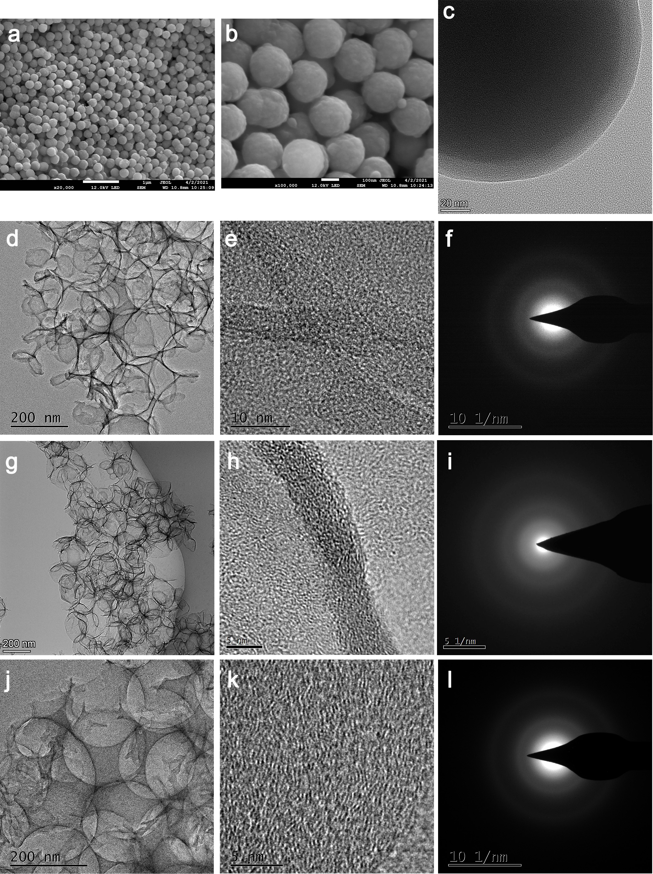

Supplementary Figure 1. (a-b) FESEM and (c) HR-TEM images of the SiO₂@RF nanospheres. (d) TEM, (e) HR-TEM, and (f) SAED images of Fe-N₂O₂-C₁₀. (g) TEM, (h) HR-TEM, and (i) SAED images of Fe-N₄-C₆O₂. (j) TEM, (k) HR-TEM, and (l) SAED images of Fe-N₄-C₁₀.
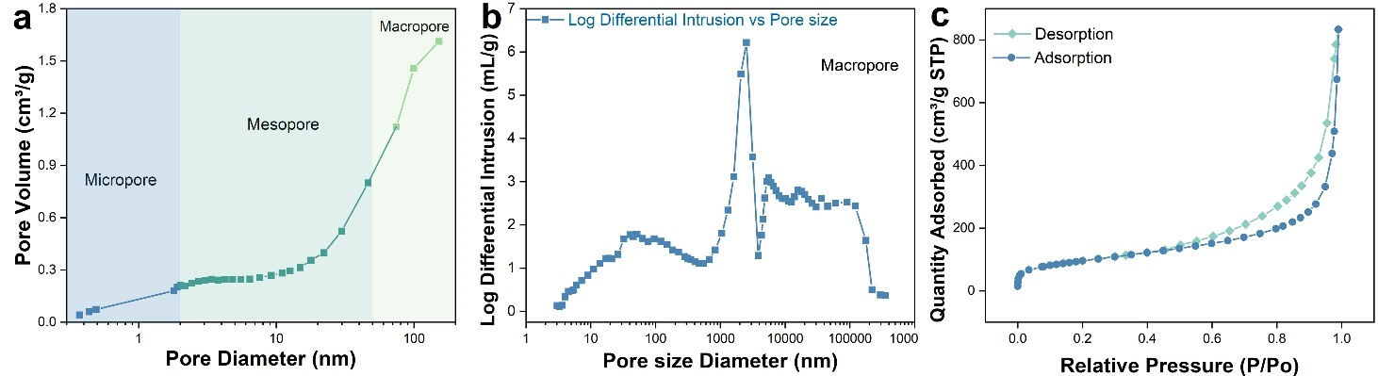

Supplementary Figure 2. (a) Pore size diameter distributions of the Fe-N₄-C₆O₂ analyzed by Horvath-Kawazoe (HK, Micropores) and Barrett-Joyner-Halenda (BJH, Mesopores). (b) Pore size diameter distributions of the Fe-N₄-C₆O₂ analyzed by mercury intrusion porosimetry (MIP, Macropores). (c) Nitrogen adsorption isotherms of the Fe-N₄-C₆O₂.

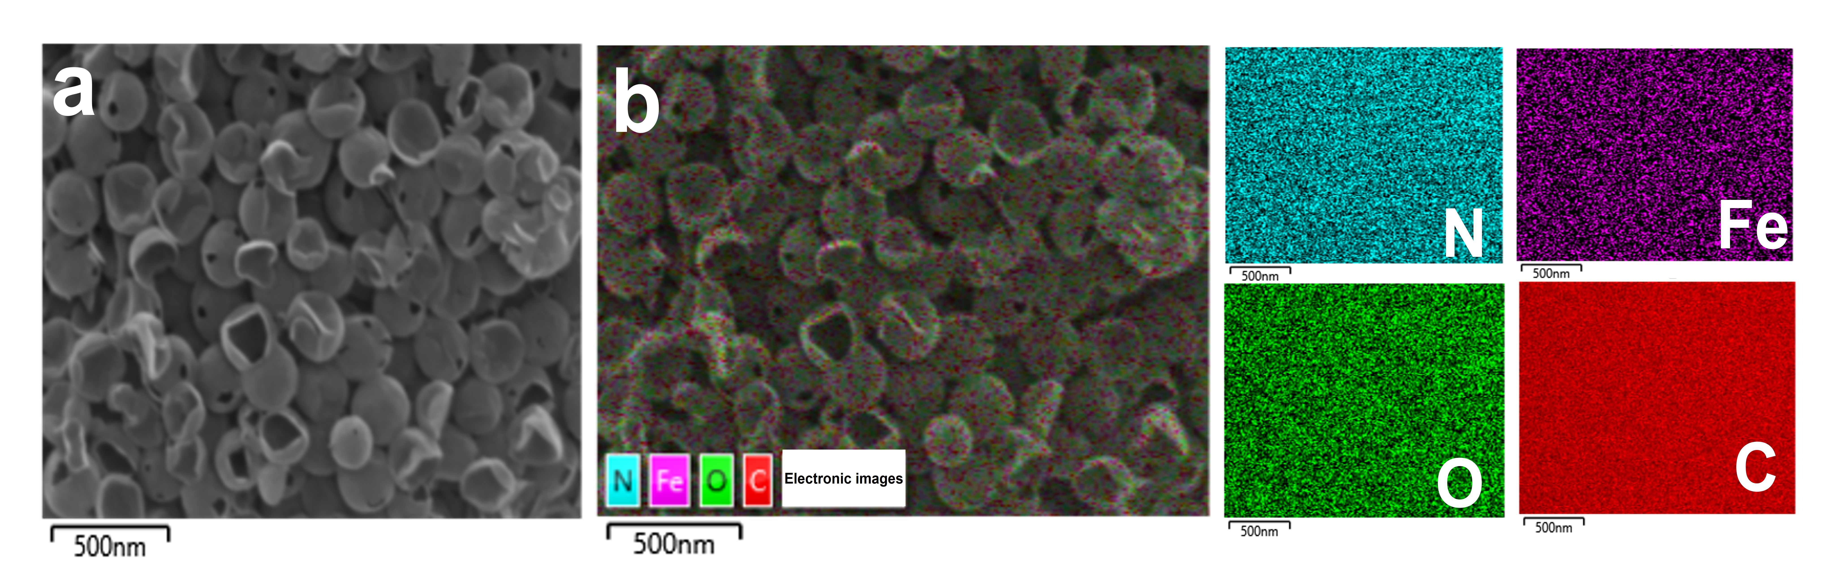

Supplementary Figure 3. (a) FESEM and (b) EDS mapping images of Fe-N₄-C₆O₂.

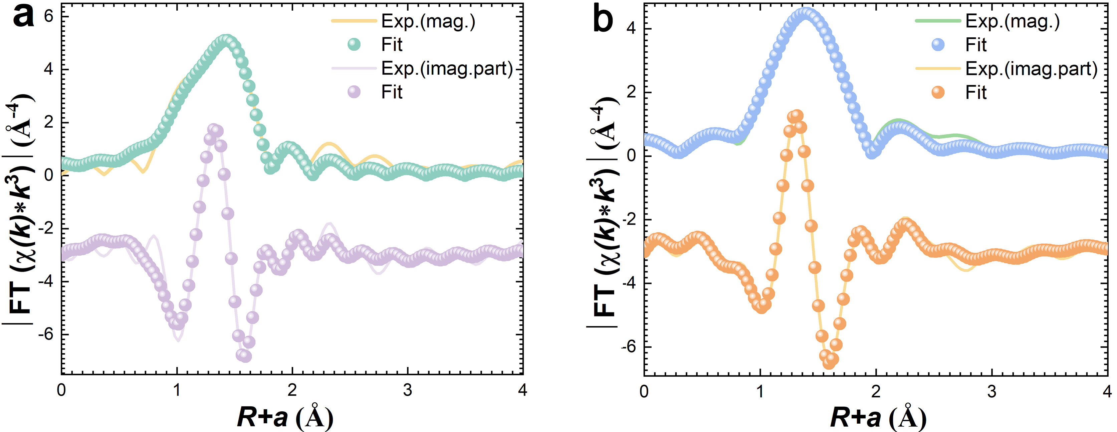

Supplementary Figure 4. Fe K-edge EXAFS (line) and the curve fit (circle) analysis for (a) Fe-N₂O₂-C₁₀ and (b) Fe-N₄-C₁₀ in R-space.

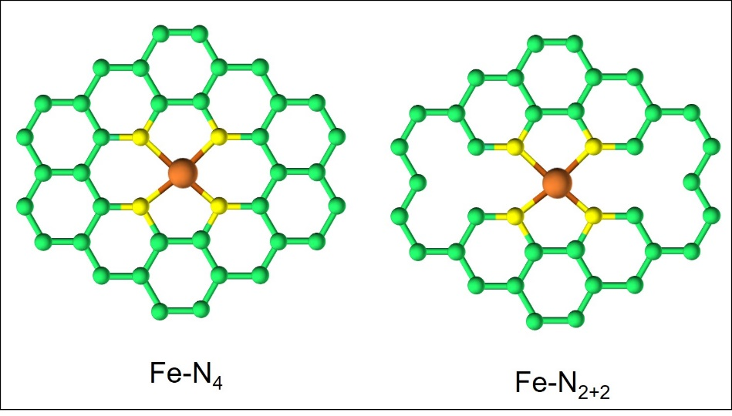

Supplementary Figure 5. Atomic structure of Fe-N₄ and Fe-N₂₊₂ active sites of Fe-SACs.

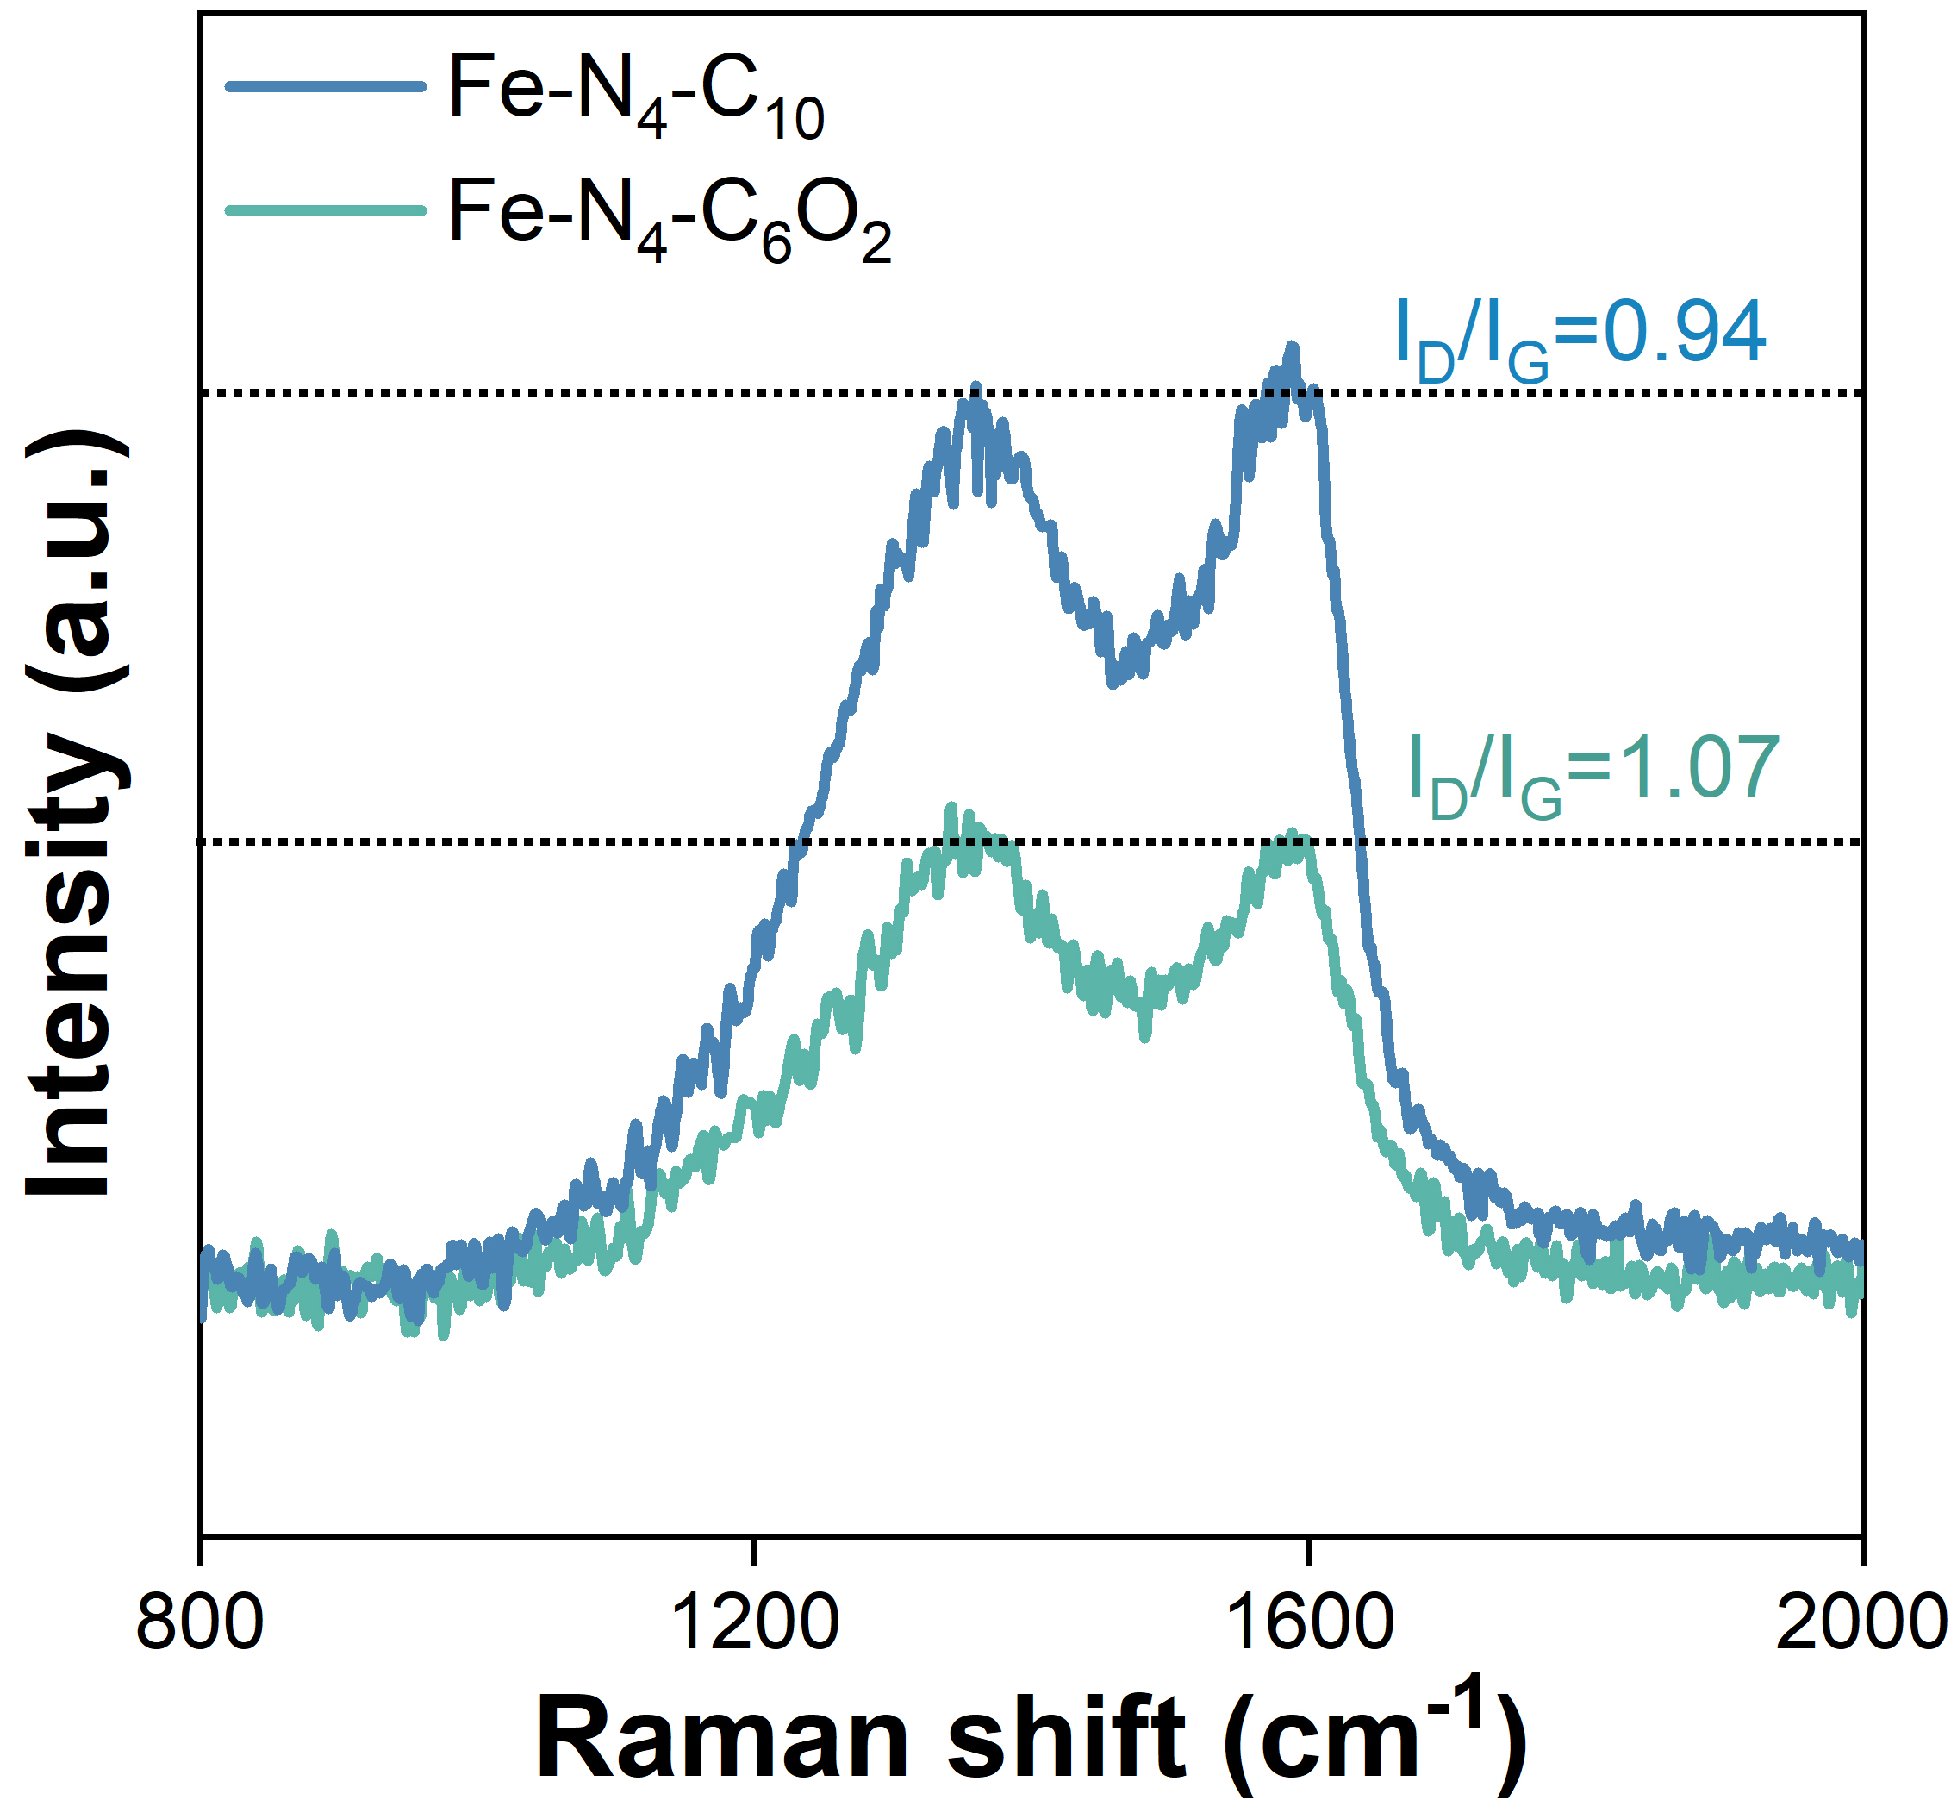

Supplementary Figure 6. Raman spectroscopy of Fe-SACs.

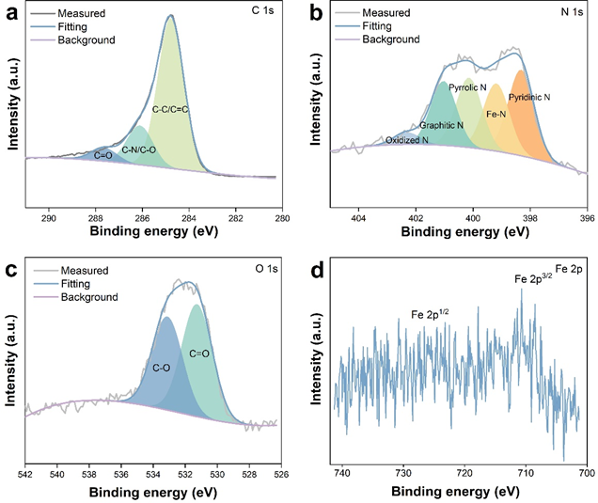

Supplementary Figure 7. HR-XPS spectra of (a) C 1s, (b) N 1s, (c) O 1s, and (d) Fe 2p of Fe-N₄-C₆O₂.

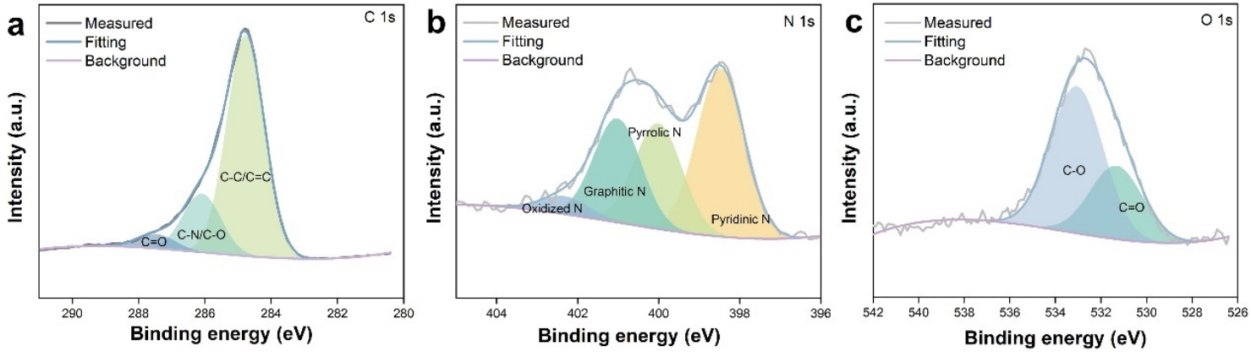

Supplementary Figure 8. HR-XPS spectra of (a) C 1s, (b) N 1s, and (c) O 1s of N/O-C.
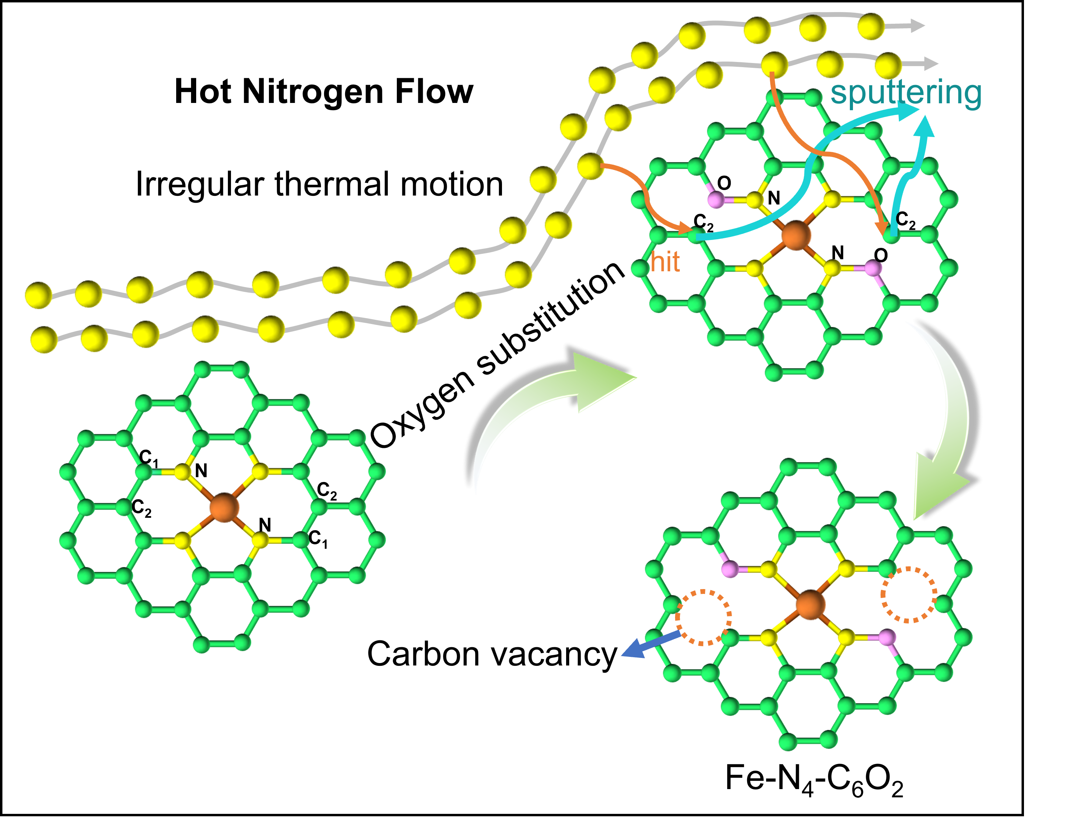

Supplementary Figure 9. The possible mechanism for the formation of the Fe-N₄-C₆O₂ structure.

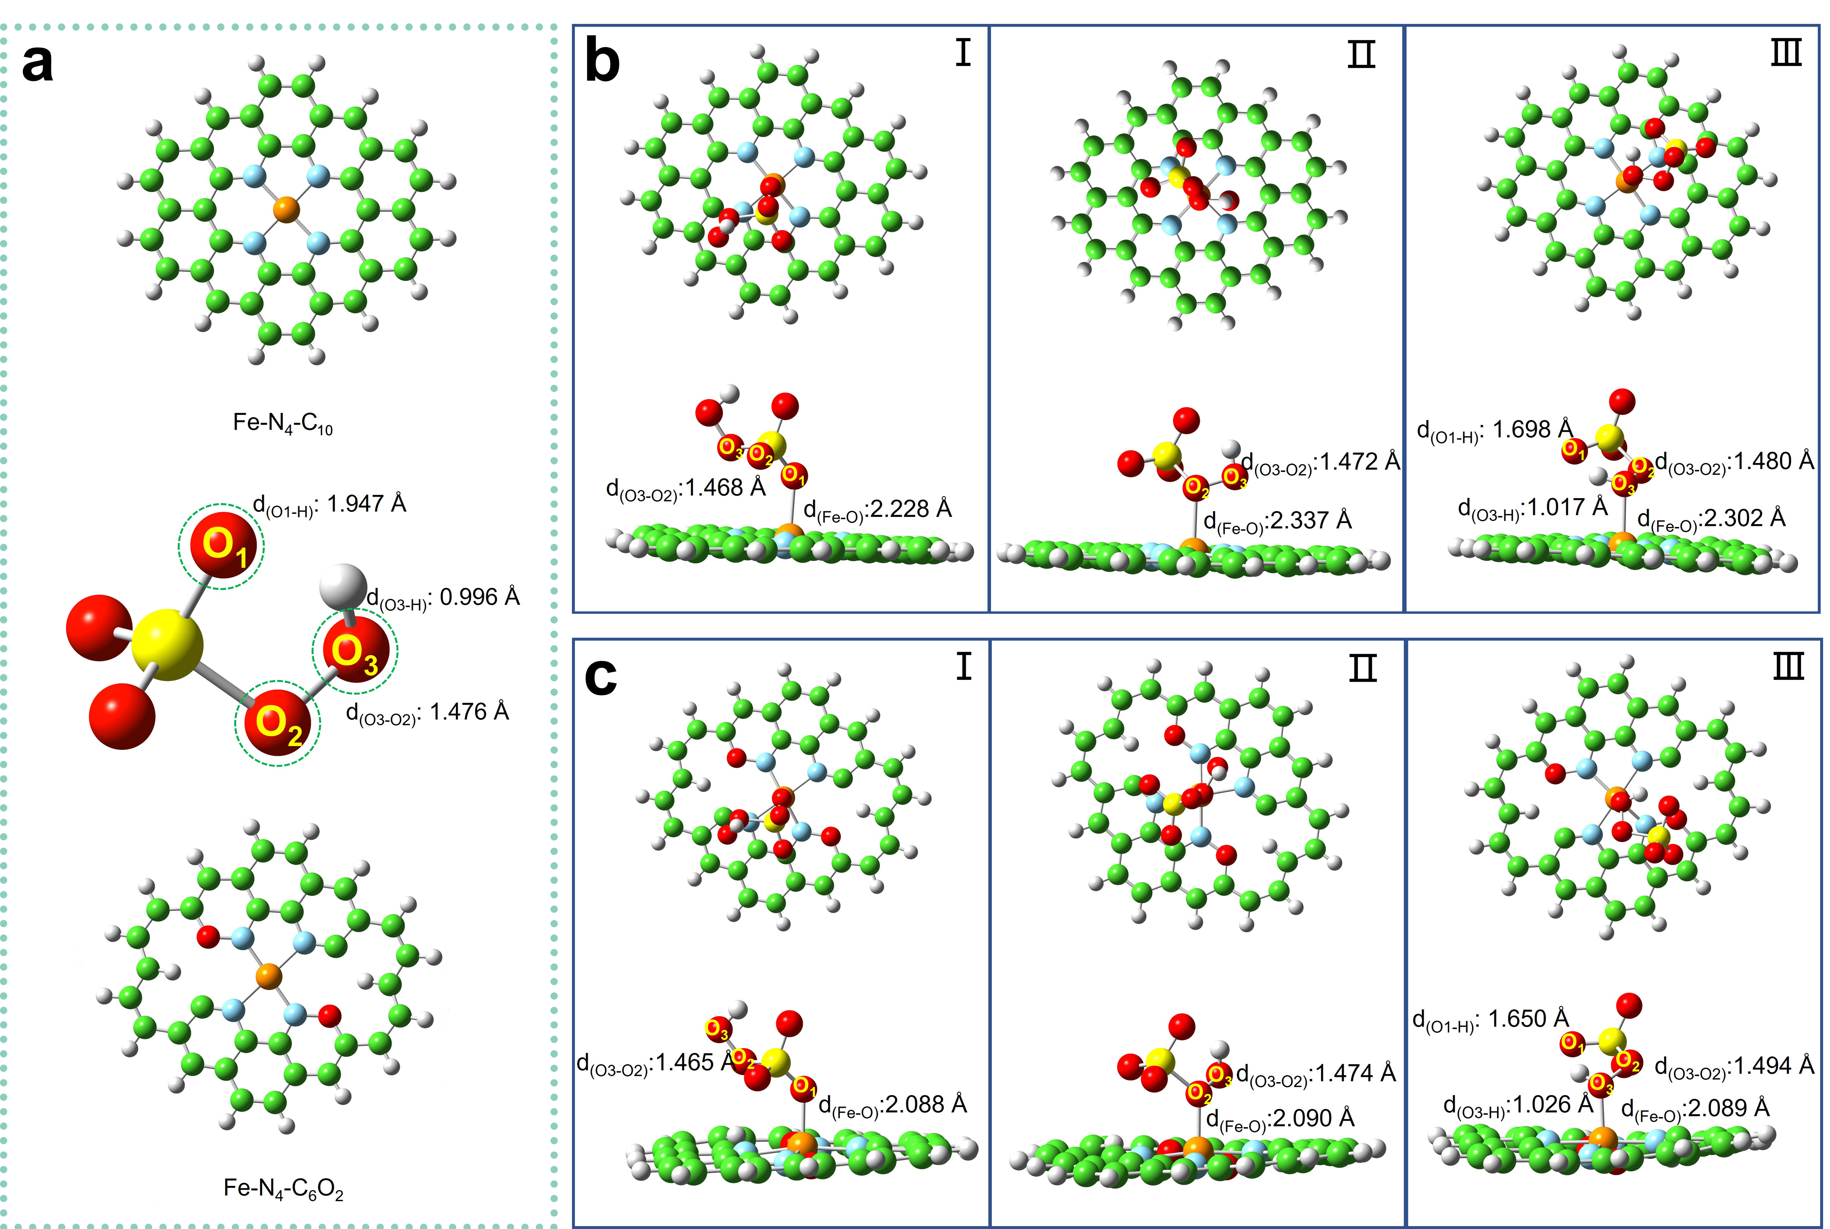

Supplementary Figure 10. (a) Schematic diagram of the structure of Fe-N₄-C₁₀, PMS and Fe-N₄-C₆O₂. The adsorption of different PMS sites (O₁, O₂, and O₃) on (b) Fe-N₄-C₁₀ and (c) Fe-N₄-C₆O₂ calculated by DFT.
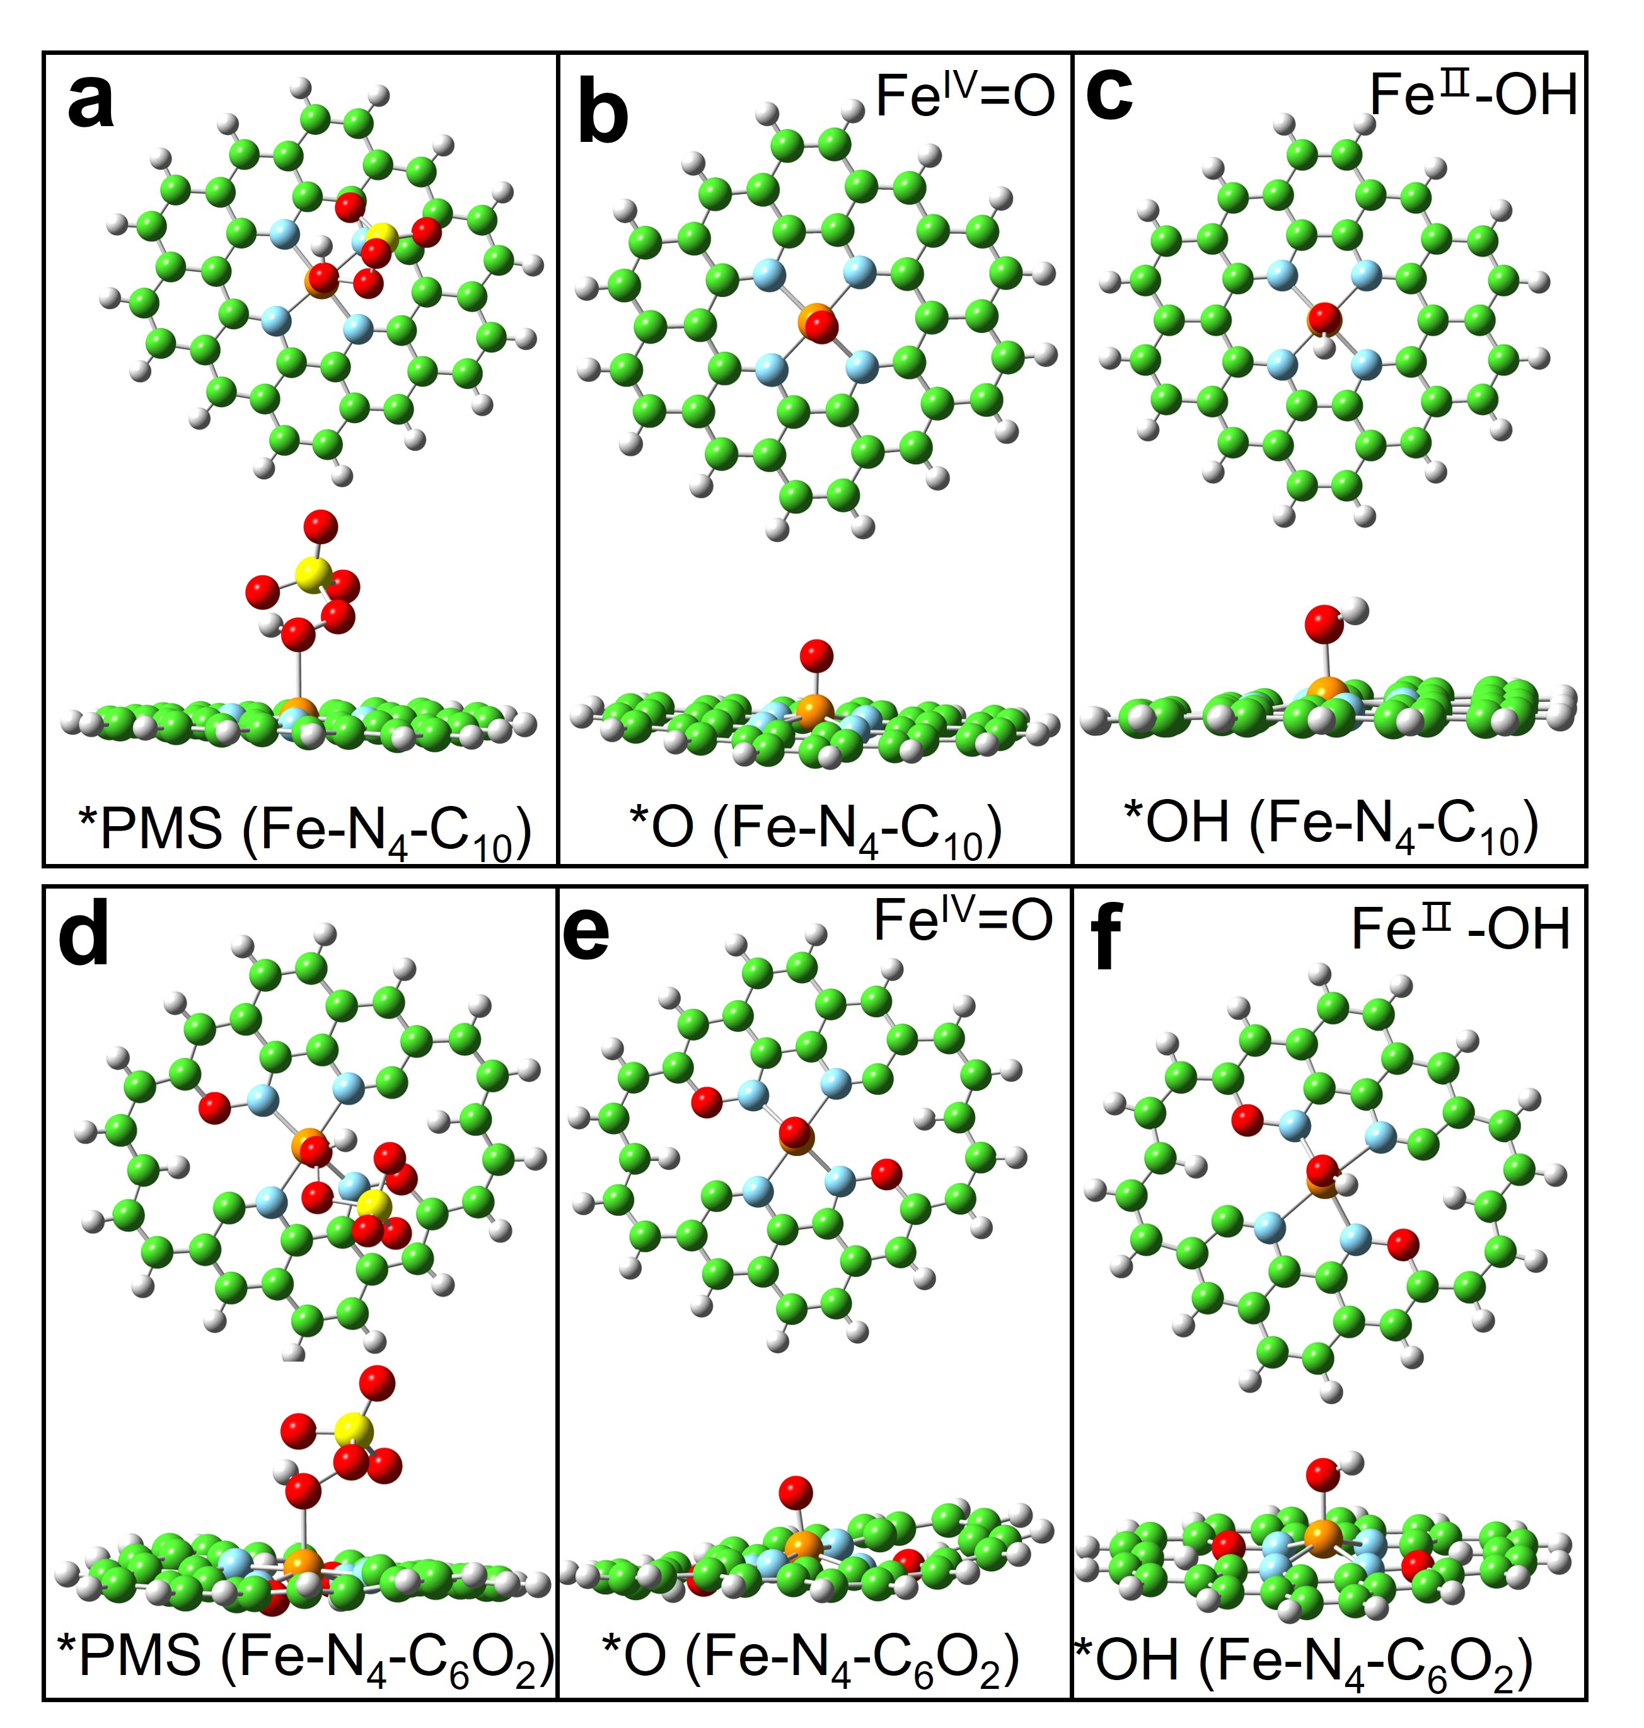

Supplementary Figure 11.The structures of reaction intermediates in Fe-SACs/PMS system.
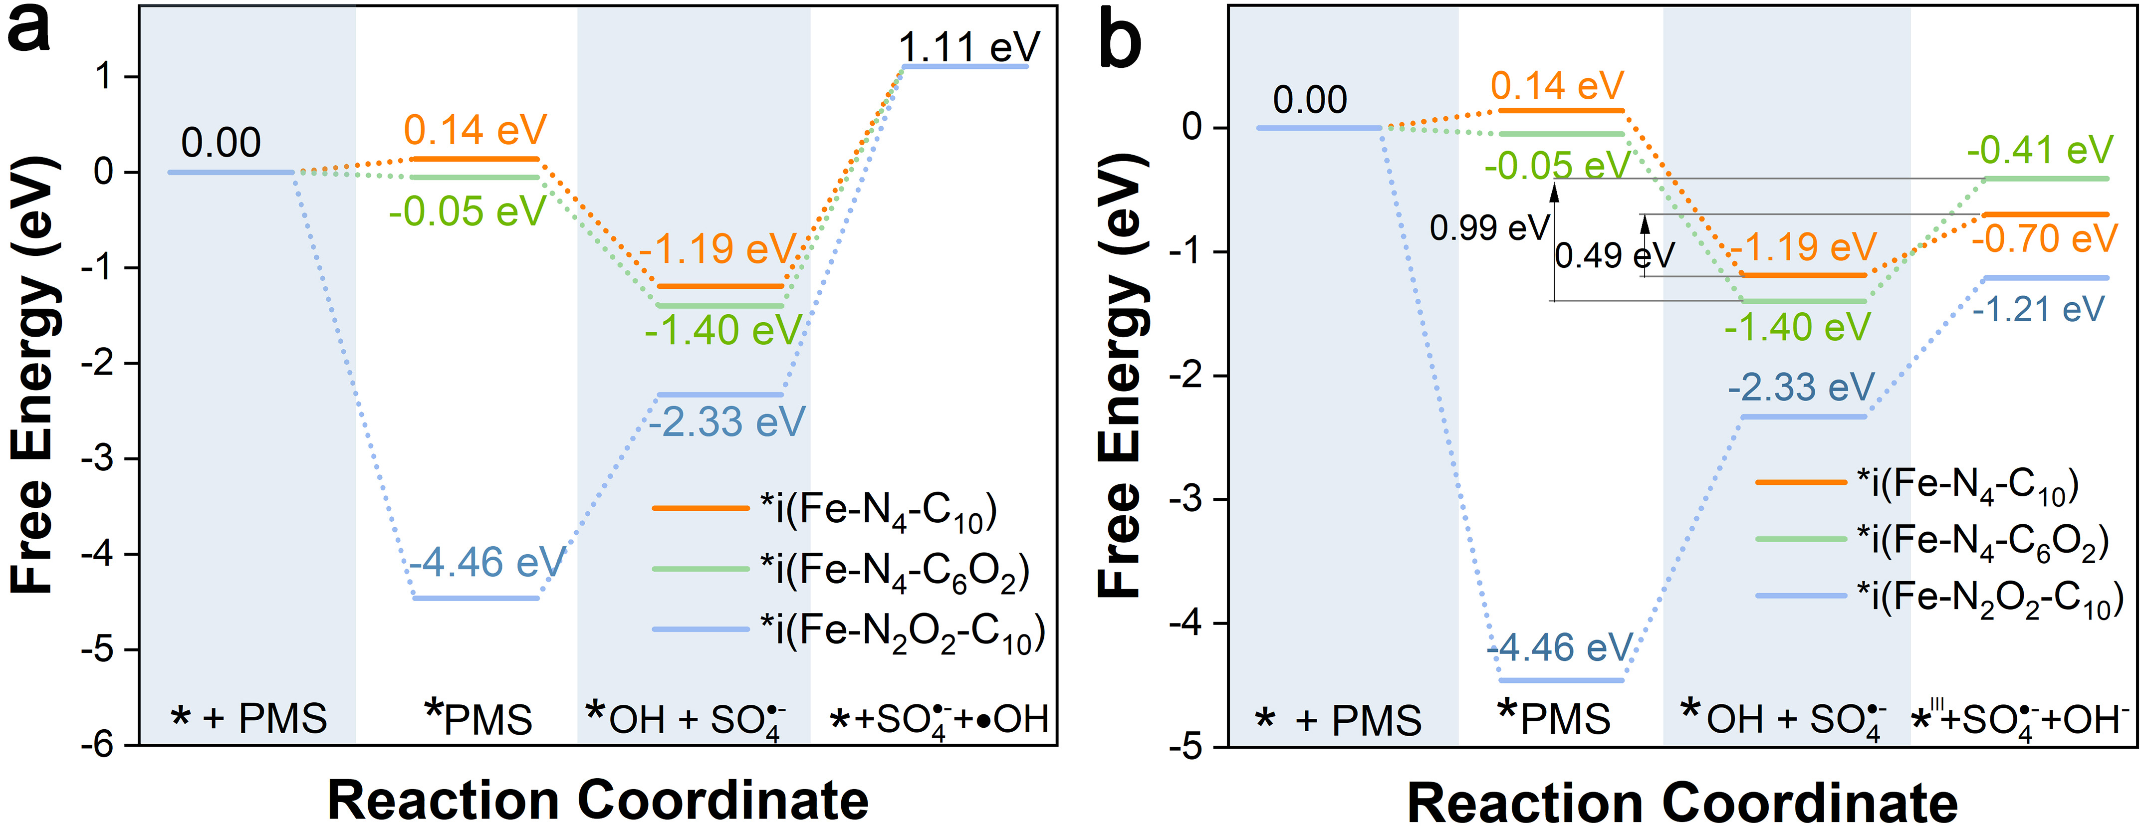

Supplementary Figure 12. (a) The free energy diagram of PMS activation through homolytic cleavage on Fe-SACs. (b) The free energy diagram of PMS activation through single electron transfer on Fe-SACs.
For radical pathway, the generation of SO₄^{•−} and •OH via the direct homolytic cleavage of the O-O bond was proved to be thermodynamically unfavorable (1.11 eV) for three Fe-SACs (Figure S12a). Although the formation of radical through the single electron transfer pathway was thermodynamically possible in the three Fe-SACs systems, Fe^{IV}=O was more inclined to be formed than radicals due to lower ΔG (Figures 3e, 3g, and S12b).

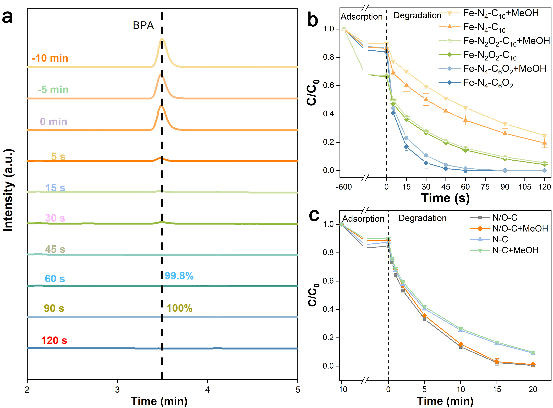

Supplementary Figure 13. (a) The HPLC spectra of BPA in the Fe-N₄-C₆O₂/PMS at different times. (b) Degradation of BPA in the Fe-SACs/PMS system. (c) Degradation of BPA in the N/O-C/PMS and N-C/PMS system. Reaction conditions: [catalysts]=0.05 g L⁻¹, [PMS]₀=400 μM, pH=7.0, [BPA]₀=50 μM, [MeOH]/[PMS]=1000 if need.

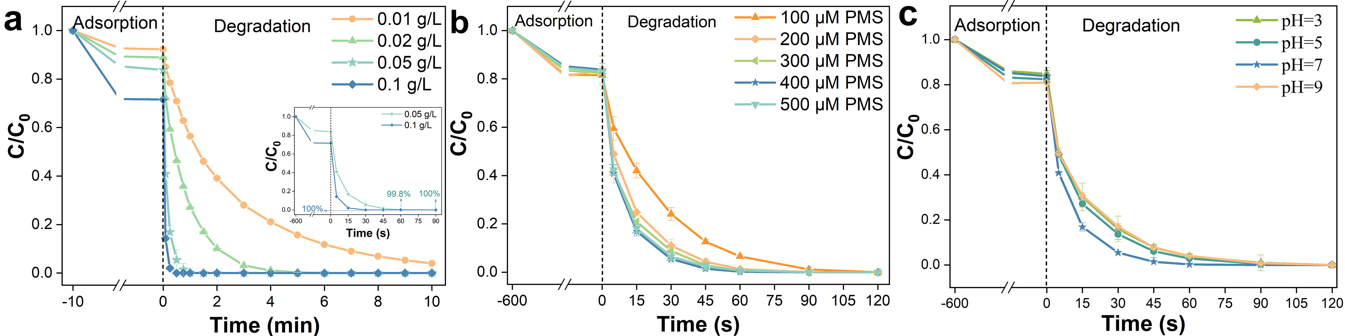

Supplementary Figure 14. Influence of (a) Fe-N₄-C₆O₂ dosage, (b) PMS dosage, and (c) pH on the degradation of BPA in Fe-N₄-C₆O₂/PMS system. Reaction conditions: (a) [PMS]₀=400 μM, pH=7.0 (b) [Fe-N₄-C₆O₂]=0.05 g L⁻¹, pH=7.0. (c) [Fe-N₄-C₆O₂]=0.05 g L⁻¹, [PMS]₀=400 μM. In all experiments, [BPA]₀=50 μM.
To further achieve optimal reaction conditions and explore the most reactive Fe-N₄-C₆O₂/PMS system, the catalyst dosage, PMS dosage, and pH were systematically investigated (Figure S14). As can be seen from Figure S14a, the degradation of BPA was significantly influenced by the amount of Fe-N₄-C₆O₂ catalyst. Fe-N₄-C₆O₂ with a dose of 0.1 g L⁻¹ can achieve 100% ultra-fast removal of BPA in 30 s. This fact is attributed to the increase in catalyst dosage, more active centers can participate in the advanced oxidation process to accelerate the degradation of BPA. Besides, the contaminant adsorbed on the catalyst increased with the increase of Fe-N₄-C₆O₂ dosage, improving the degradation efficiency. The degradation performance of BPA by the Fe-N₄-C₆O₂/PMS system at varying PMS concentrations was further studied (Figure S14b). In the beginning, the degradation efficiency of BPA increased with the increase of the dosage of PMS, which may be due to the production of more reactive oxygen species (ROS) at higher concentrations of PMS. Subsequently, when the concentration of PMS increased further, the degradation efficiency remained almost unchanged, which shows that the degradation of BPA may be not carried out through the free radical mechanism. As shown in Figure S14c, 100% degradation of BPA was achieved in just 2 min at all pH conditions, indicating that the activity of the Fe-N₄-C₆O₂ catalyst is hardly affected by pH. Considering the organic pollutants removal efficiency and reagent cost, 0.05 g L⁻¹ Fe-N₄-C₆O₂ was chosen to activate 400 μM PMS to degrade 50 μM BPA (pH=7) in Fe-N₄-C₆O₂/PMS system.
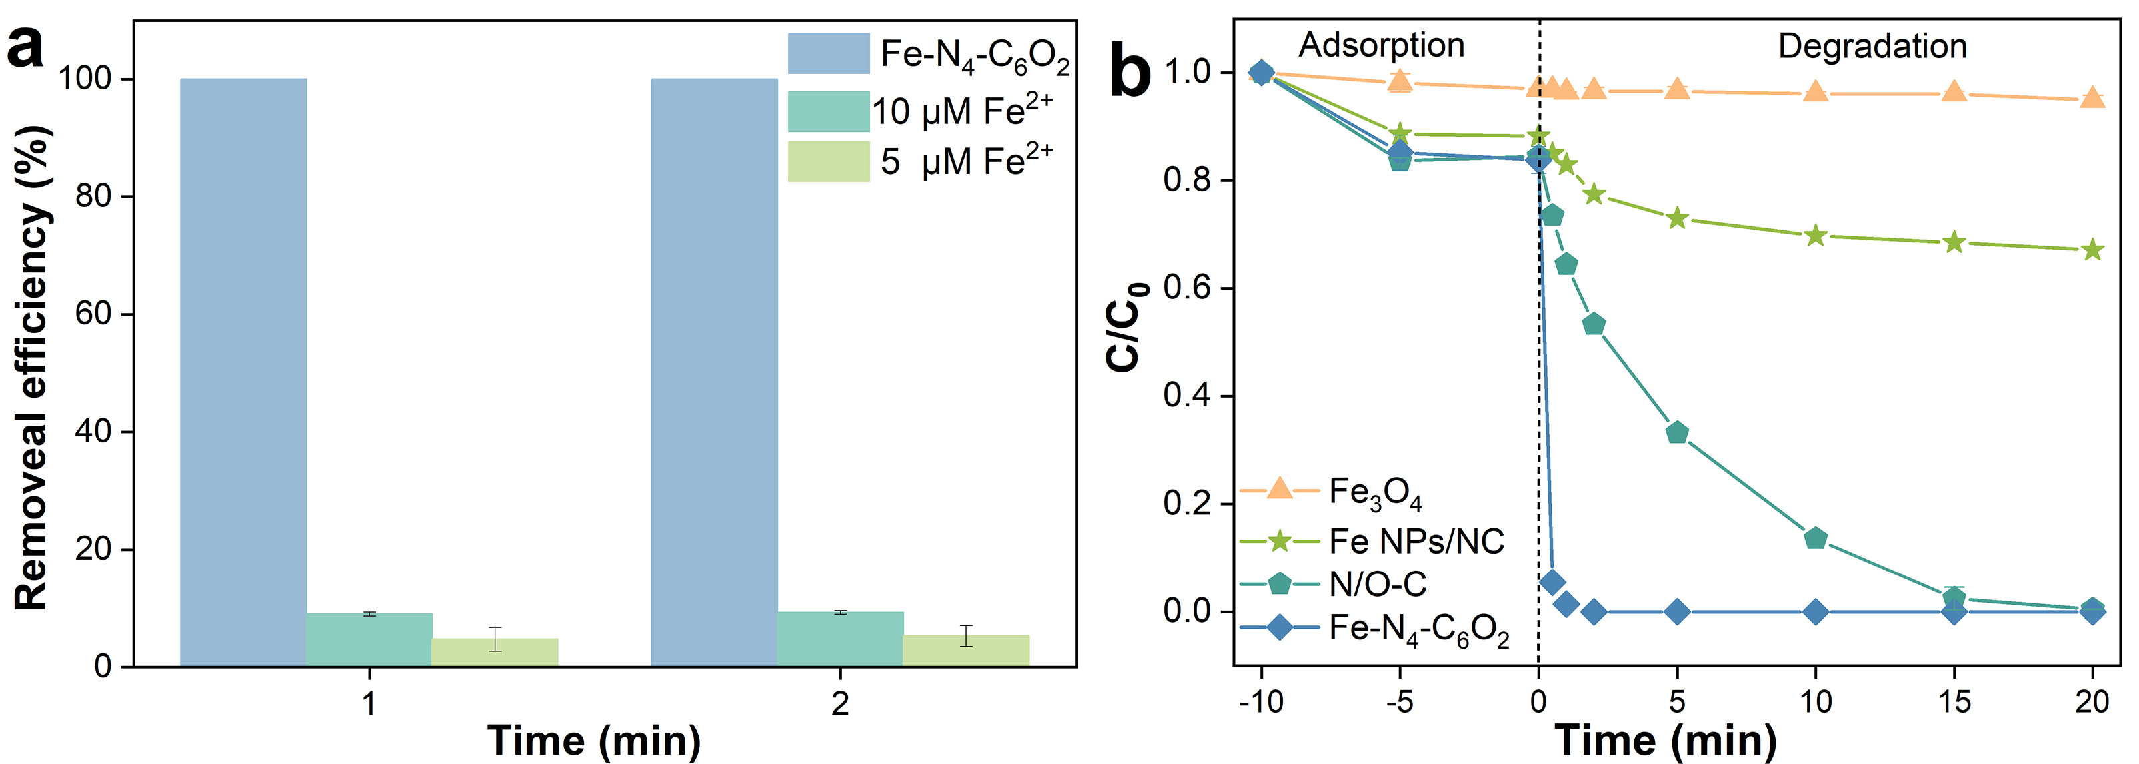

Supplementary Figure 15. (a) Removal of BPA during homogeneous catalyst/PMS system and Fe-N₄-C₆O₂ /PMS system. (b) Removal of BPA during other catalysts/PMS systems. Experimental conditions: [BPA]=50 μM, [catalyst]=0.05 g L⁻¹ if need, T=25 °C, pH=7.0, [PMS]₀=400 μM.
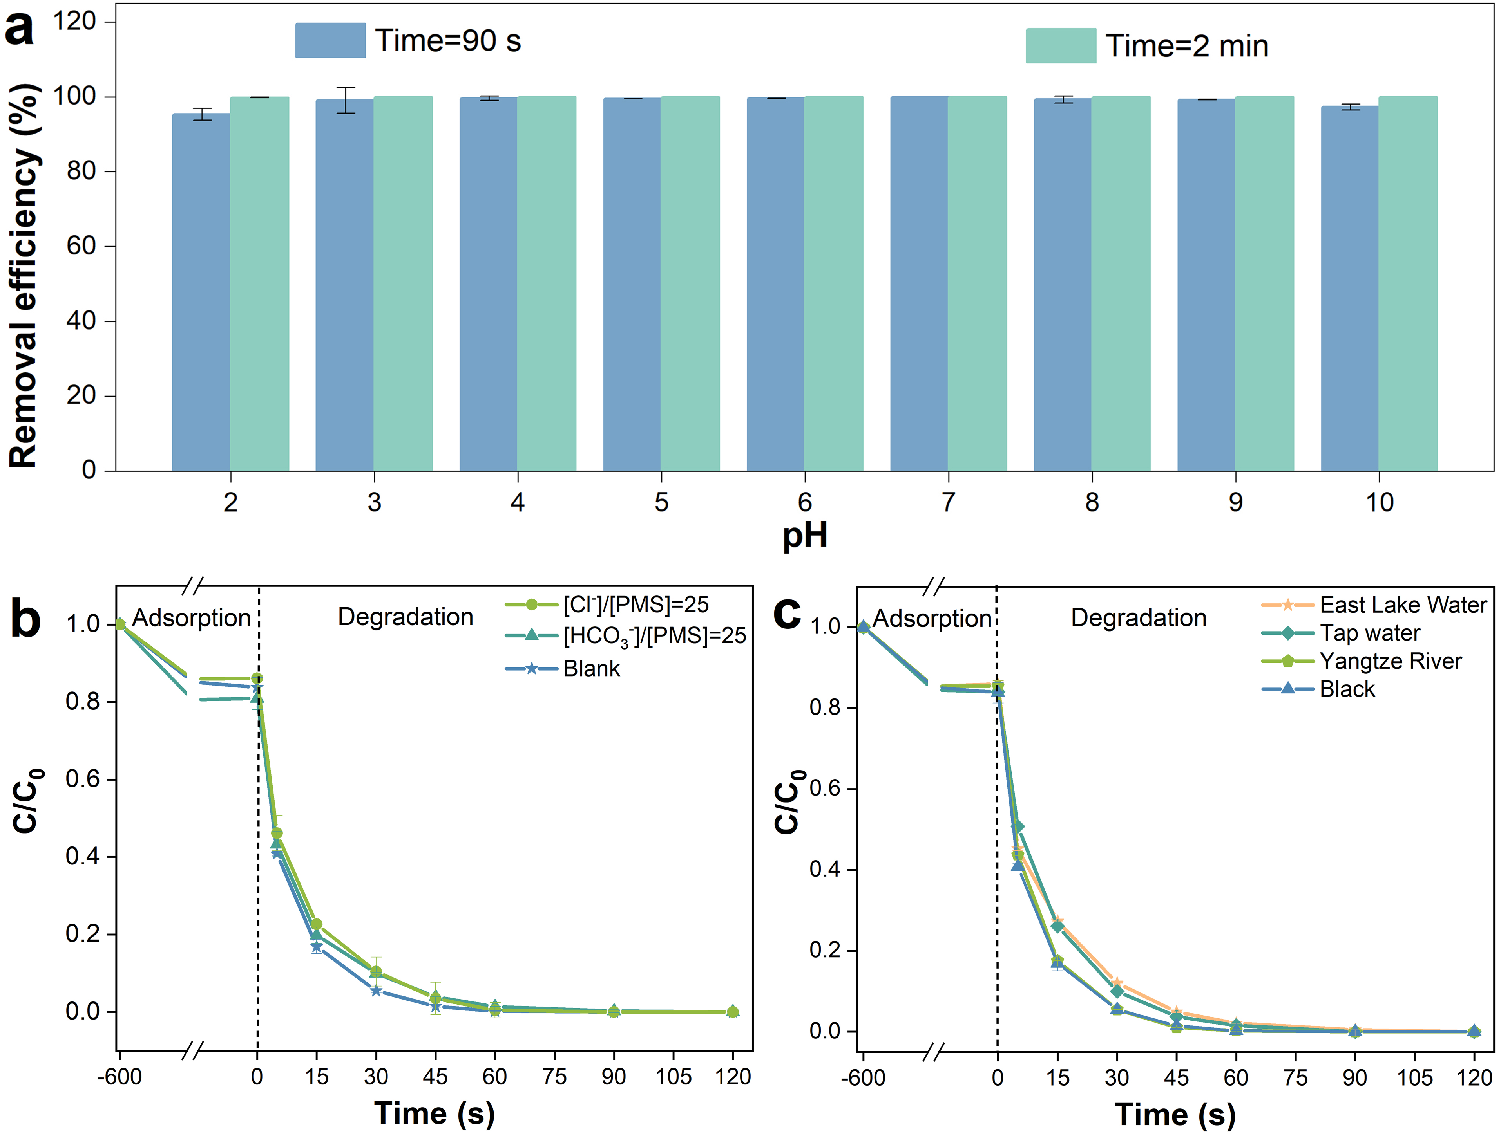

Supplementary Figure 16. (a) Influence of pH on BPA degradation in the Fe-N₄-C₆O₂/PMS system. (b) Influence of Cl⁻ and HCO₃⁻ on BPA degradation in Fe-N₄-C₆O₂/PMS system. (c) Removal of BPA by Fe-N₄-C₆O₂/PMS under complex water conditions. Experimental conditions: [Fe-N₄-C₆O₂]=0.05 g L⁻¹, [BPA]=50 μM, T=25 °C, [Cl⁻]/[PMS]=25 if need, [HCO₃⁻]/[PMS]=25 if need, pH=7 without special requirements. Other experimental conditions, pH=7.0.

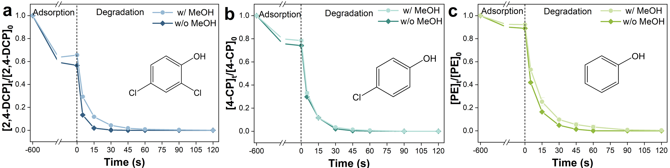

Supplementary Figure 17. Removal of (a) 2,4-DCP, (b) 4-CP, and (c) PE during Fe-N₄-C₆O₂/PMS system. Experimental conditions: [Pollutants]₀=20 μM, T=25 °C, pH=7.0, [catalysts]=0.05 g L⁻¹, [PMS]₀=400 μM, [MeOH]/[PMS]=1000 if need.
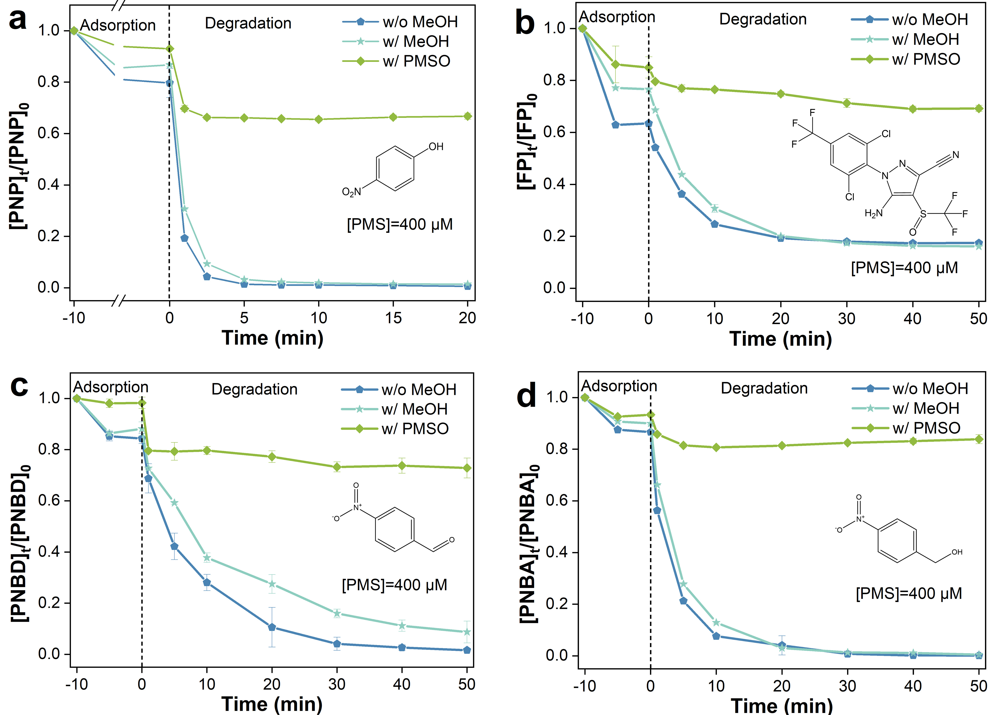

Supplementary Figure 18. The degradation of (a) PNP, (b) FP, (c) PNBD, and (d) PNBA by Fe-N₄-C₆O₂/PMS system at different conditions. Experimental conditions: [contaminants]₀=20 μM, [Fe-N₄-C₆O₂]=0.05 g L⁻¹, [PMS]₀=400 μM, [MeOH]/[PMS]=1000 if need, [PMSO]/[PMS]=100 if need, T=25 °C, pH=7.0.

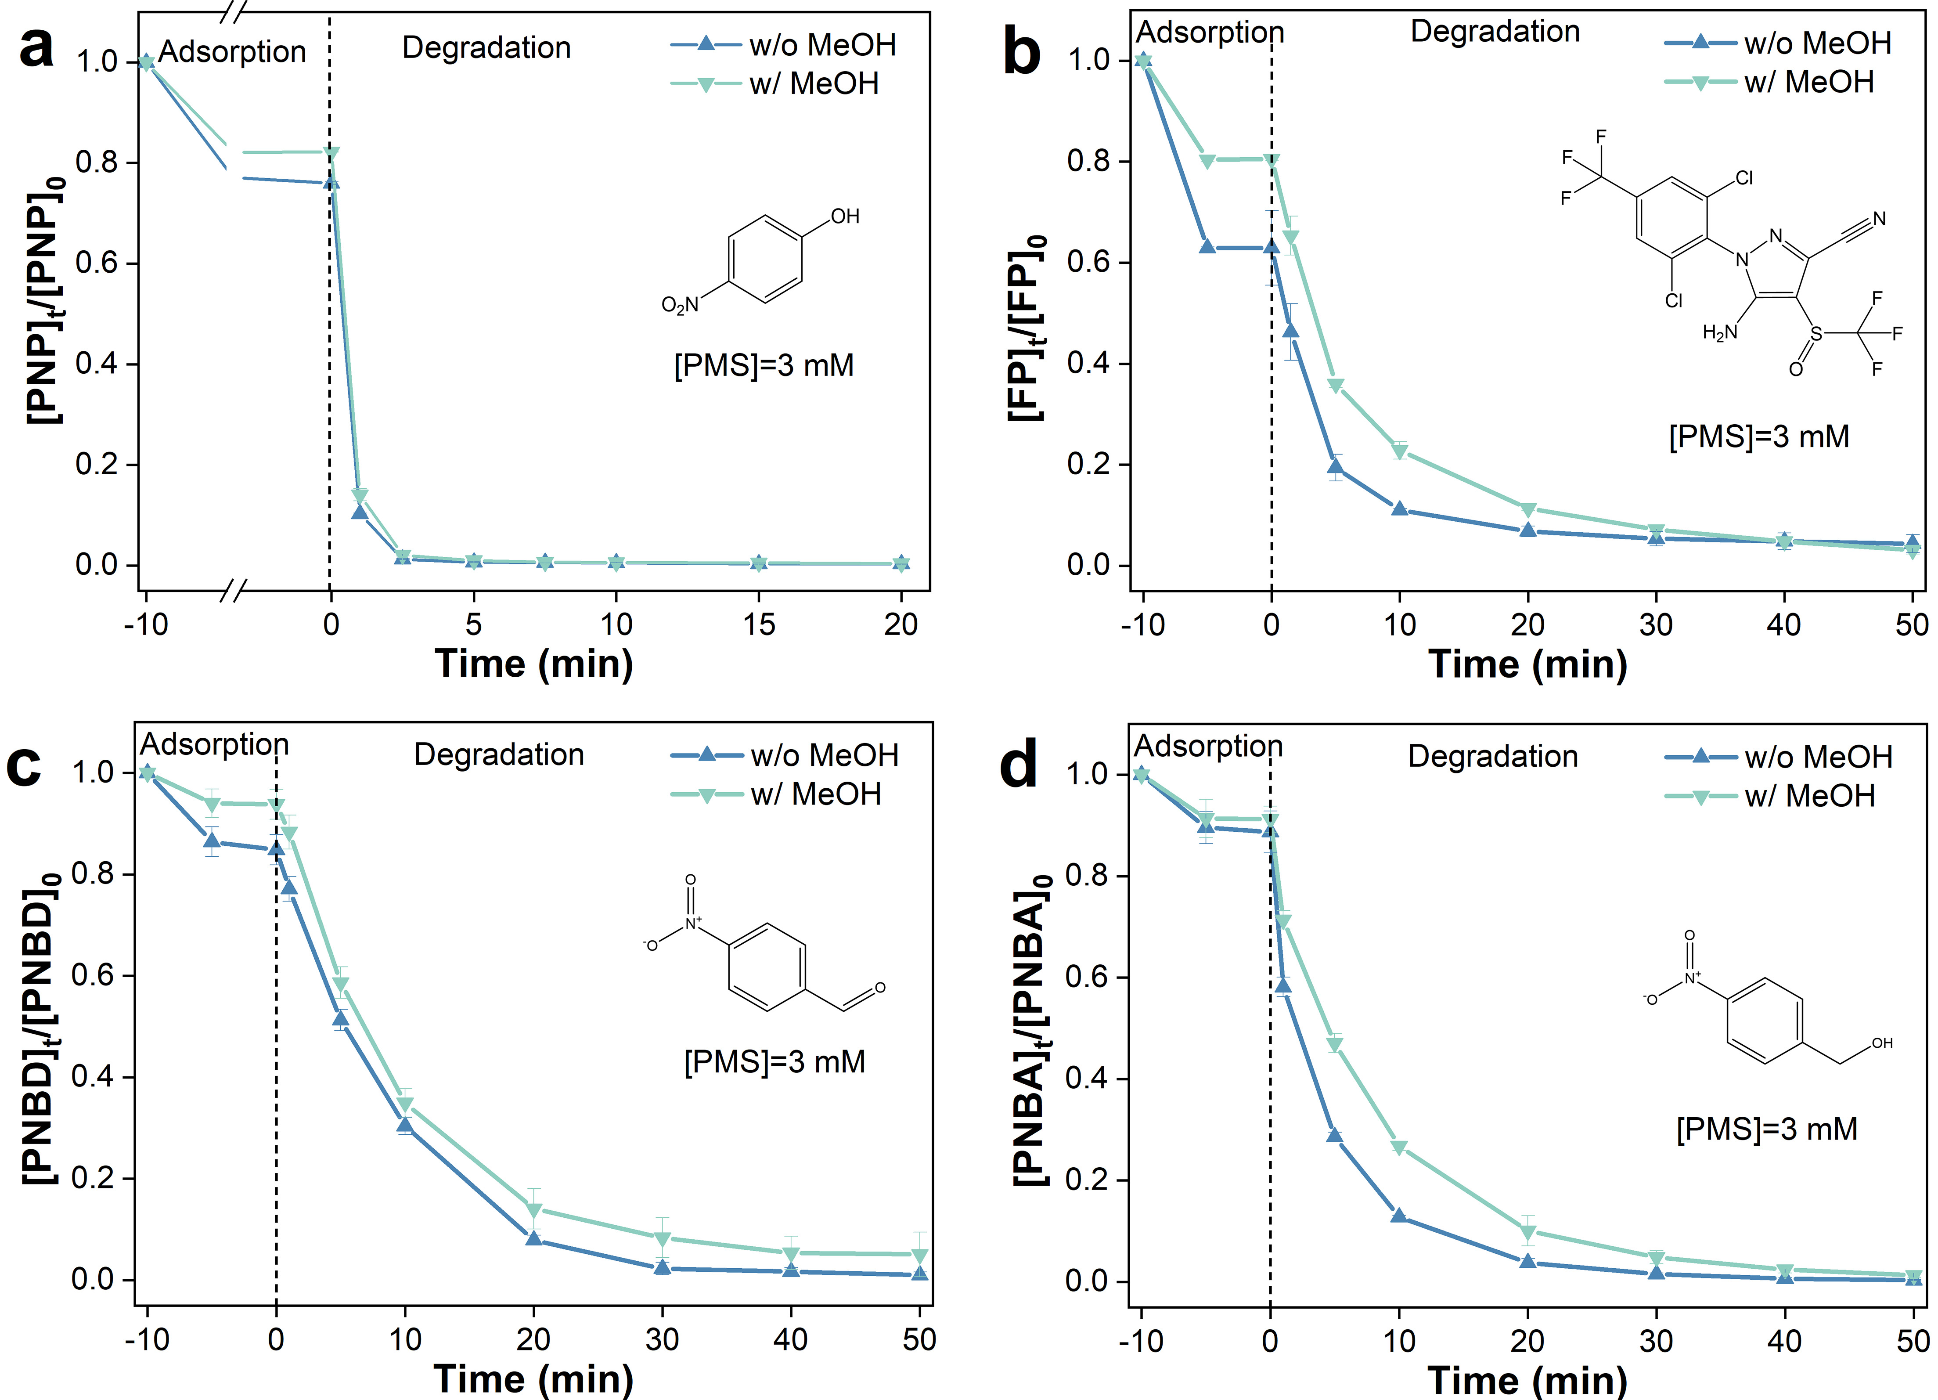

Supplementary Figure 19. The degradation of (a) PNP, (b) FP, (c) PNBD, and (d) PNBA by Fe-N₄-C₆O₂/PMS system at different conditions. Experimental conditions: [contaminants]₀=20 μM, [Fe-N₄-C₆O₂]=0.05 g L⁻¹, [PMS]₀=3 mM, [MeOH]/[PMS]=1000 if need, T=25 °C, pH=7.0.
As illustrated in S17-S19, and Table S4, the Fe^{IV}=O generated by the Fe-N₄-C₆O₂/PMS system can also efficiently remove various pollutants with electron-donating groups (EDG), such as 2,4-dichlorophenol (2,4-DCP), p-chlorophenol (4-CP), and phenol (PE), and pollutants with electron-withdrawing groups (EWG), such as p-nitrophenol (PNP), fipronil (FP), p-nitrobenzyl alcohol (PNBA), and p-nitrobenzaldehyde (PNBD). Notably, the removal rates of pollutants containing EWG were significantly lower than those of the substances containing EDG. This is attributed to the high electron density environment of pollutants containing EDG, which provides effective targets for electrophilic attack by Fe^{IV}=O^{9,10}.

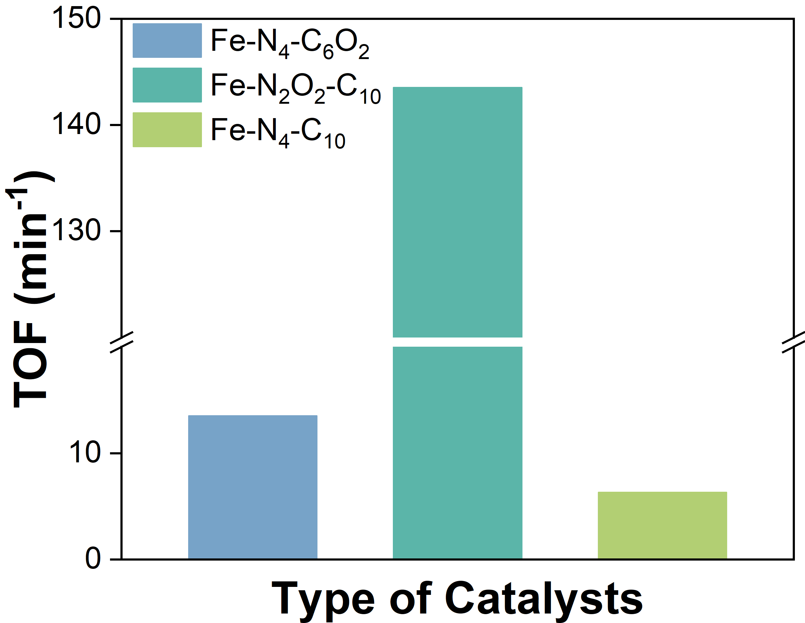

Supplementary Figure 20. TOF of per metal atom for BPA removal.
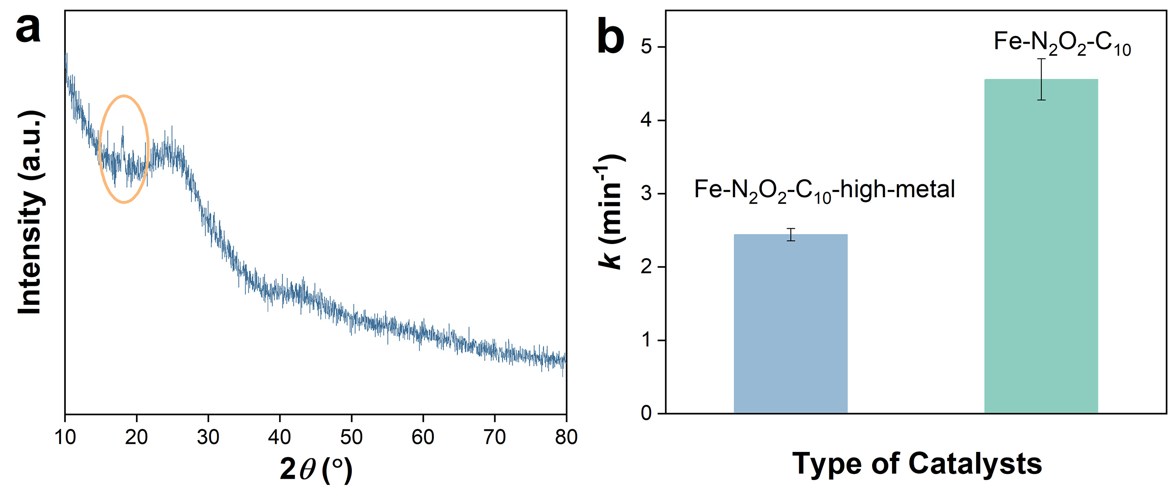

Supplementary Figure 21. (a) PXRD pattern of Fe-N₂O₂-C₁₀-high-metal. (b) Pseudo-first-order rate constant for BPA degradation by Fe-SACs-activated PMS.
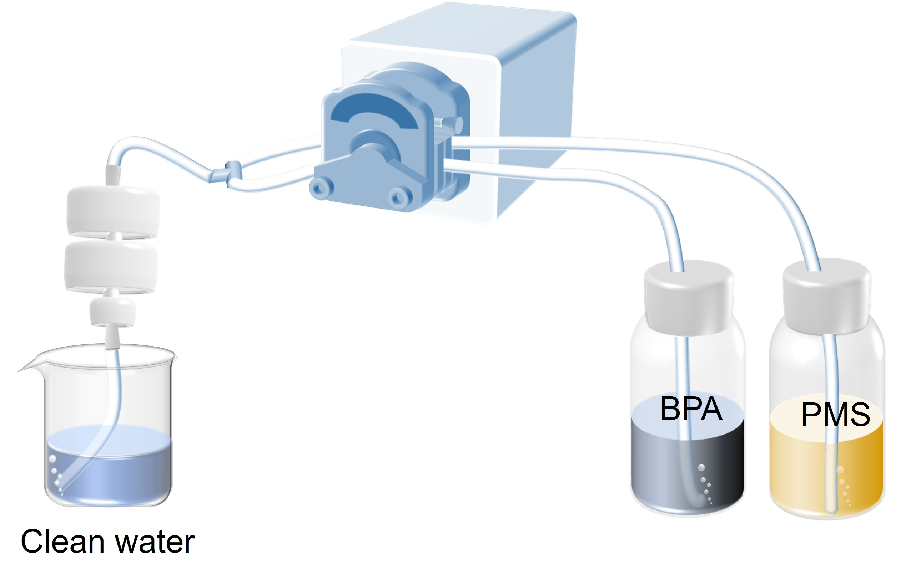

Supplementary Figure 22. Schematic diagram of a continuous flow catalytic device. Experimental conditions: [BPA]=40 μM and [PMS]=800 μM, pH=7.0, and T=25 °C, average flow rate 45 L/m²/h.

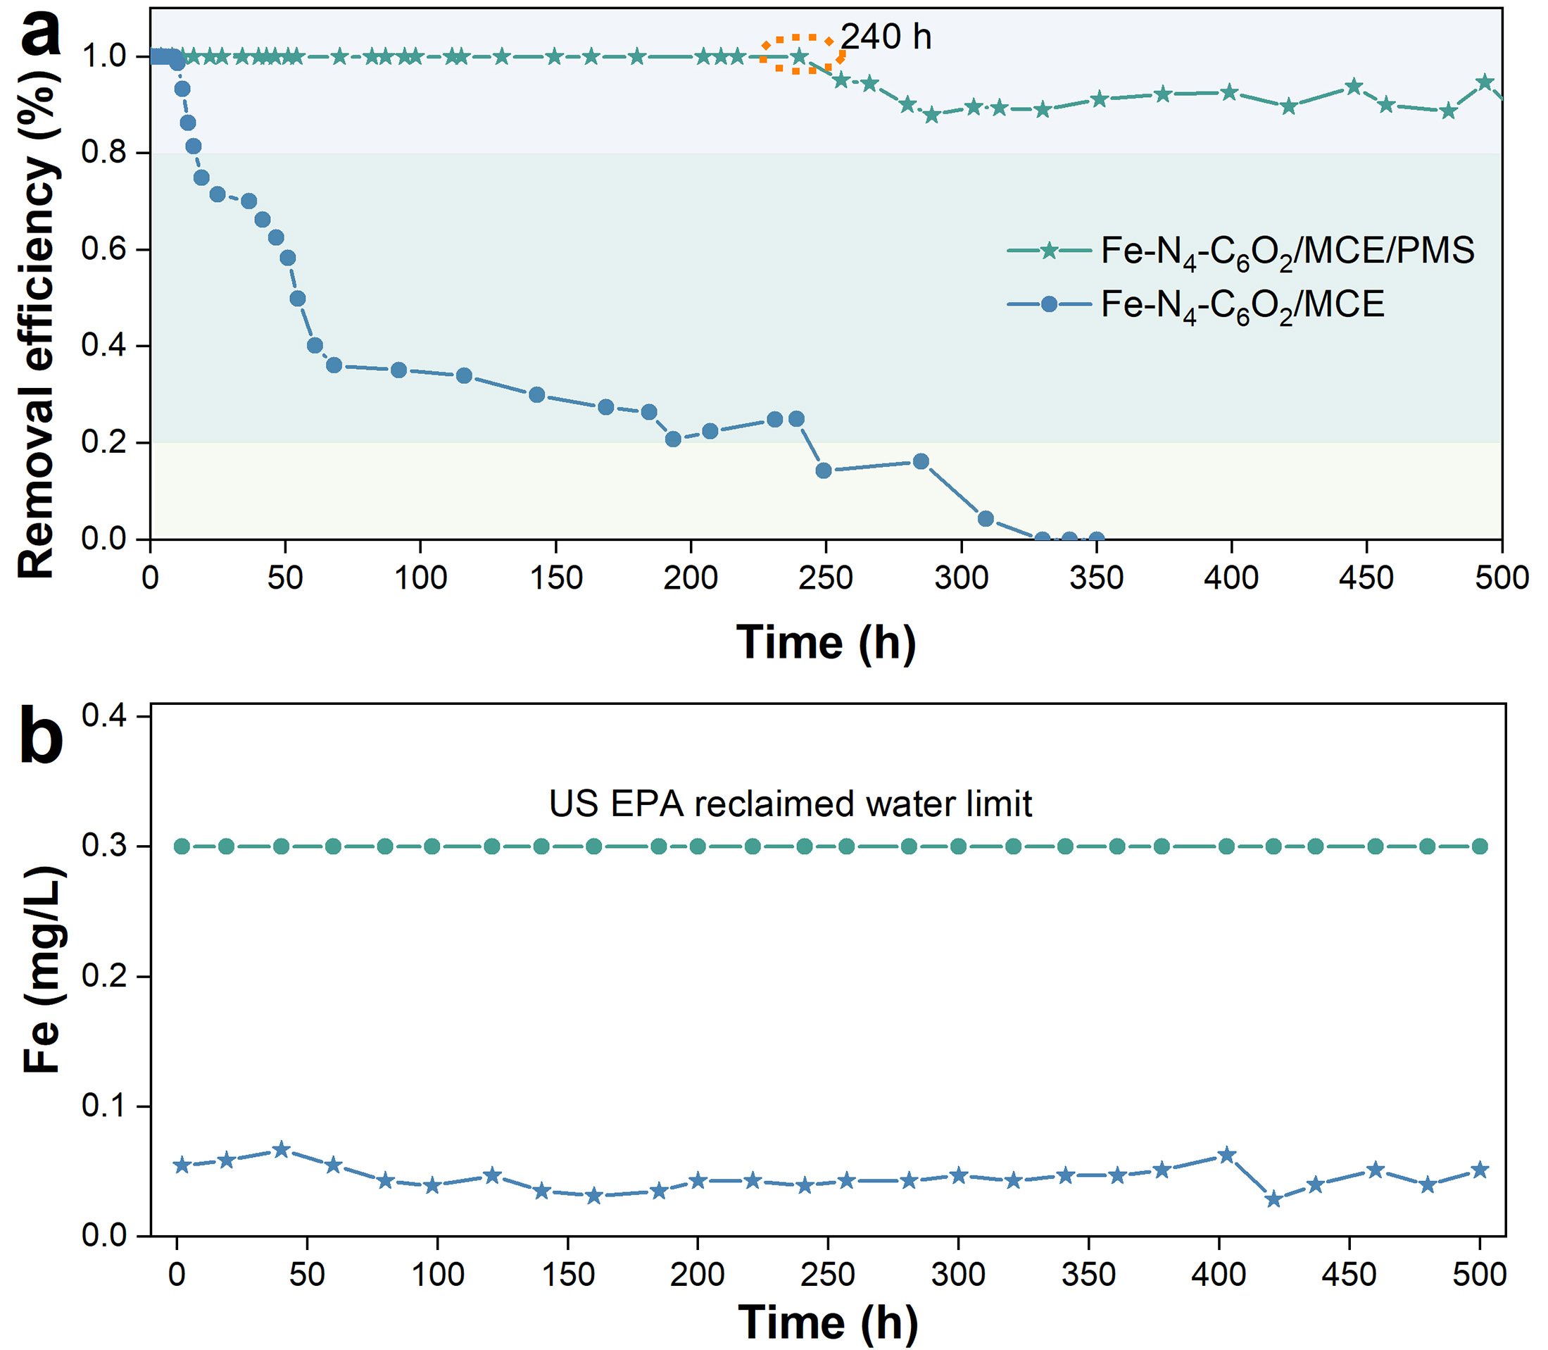

Supplementary Figure 23. (a) BPA removal performance of Fe-N₄-C₆O₂/MCE/PMS and Fe-N₄-C₆O₂/MCE system. (b) Dissolution of Fe in Fe-N₄-C₆O₂/MCE/PMS system at different times. Experimental conditions: [BPA]=40 μM and [PMS]=800 μM, pH=7.0, and T=25 °C, average flow rate 45 L/m²/h in Fe-N₄-C₆O₂/MCE/PMS system.
As depicted in Figure S22, a continuous flow-through water purification apparatus was designed to test the longevity of Fe-N₄-C₆O₂/MCE composite membrane for BPA removal. The Fe-N₄-C₆O₂/MCE composite membrane alone exhibited limited effectiveness in BPA removal, whereas the Fe-N₄-C₆O₂/MCE/PMS system could completely remove the BPA over the duration of 240 h (Figure S23a). Notably, the leaching of Fe during the continuous flow experiments remained significantly below the recommended limit of 0.3 mg/L in water set by US EPA (Figure S23b)¹¹. The above experiments fully demonstrated that Fe-N₄-C₆O₂ exhibited excellent stability in sustaining PMS activation for pollutant degradation and had immense potential in practical applications.
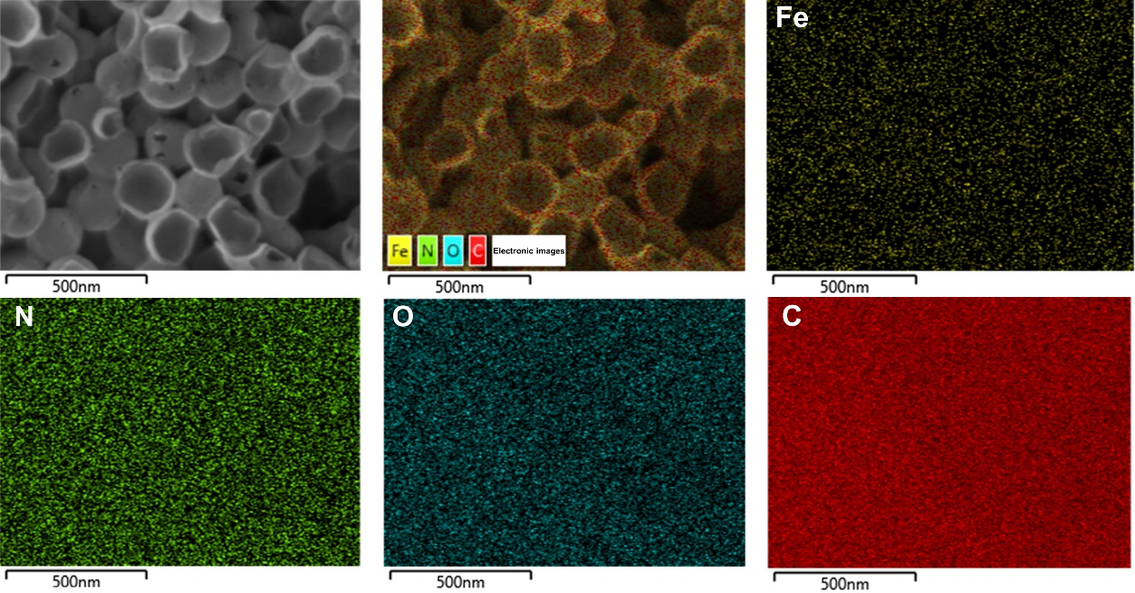

Supplementary Figure 24. FESEM and energy dispersive X-ray spectroscopy images of Fe-N₄-C₆O₂ after being used for 500 h.
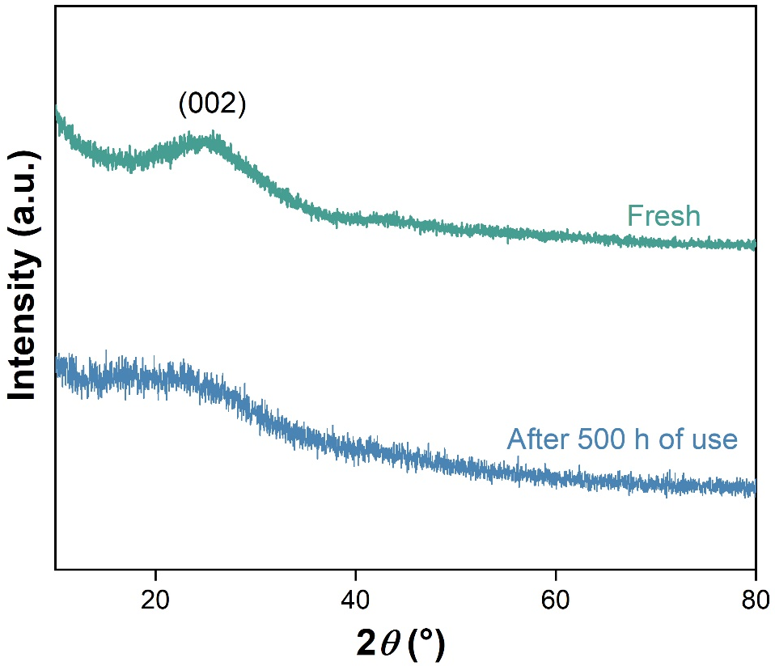

Supplementary Figure 25. PXRD patterns of Fe-N₄-C₆O₂ before and after 500 h of catalysis.

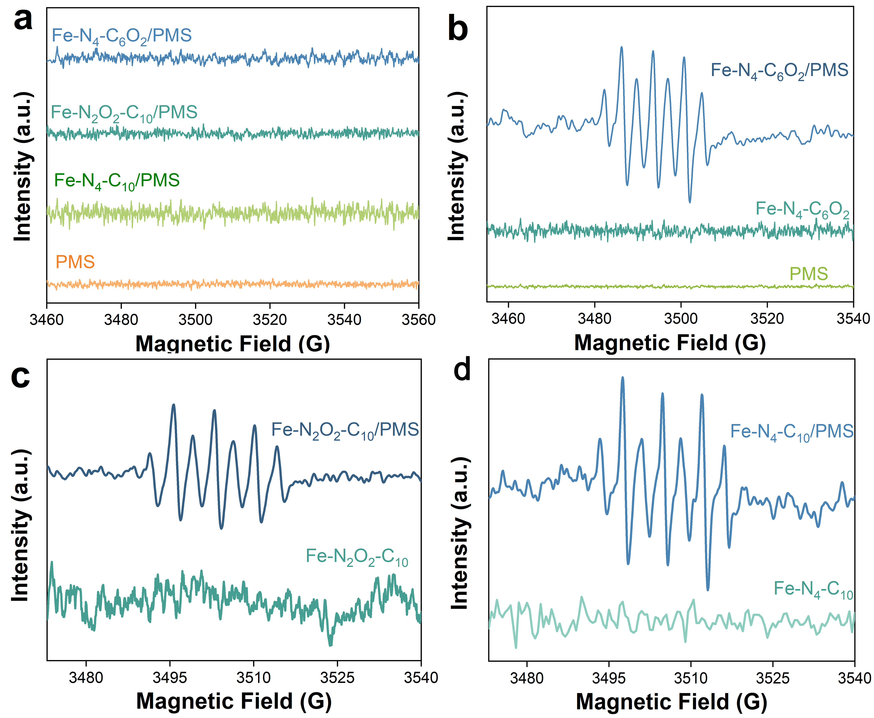

Supplementary Figure 26. (a) ESR spectra for O₂^{•-} in the Fe-SACs/PMS/DMPO (MeOH) system. ESR spectra for •OH/SO₄^{•−} in the (b) Fe-N₄-C₆O₂/PMS/DMPO (water), (c) Fe-N₂O₂-C₁₀/PMS/DMPO (water), and (d) Fe-N₄-C₁₀/PMS/DMPO (water) system.

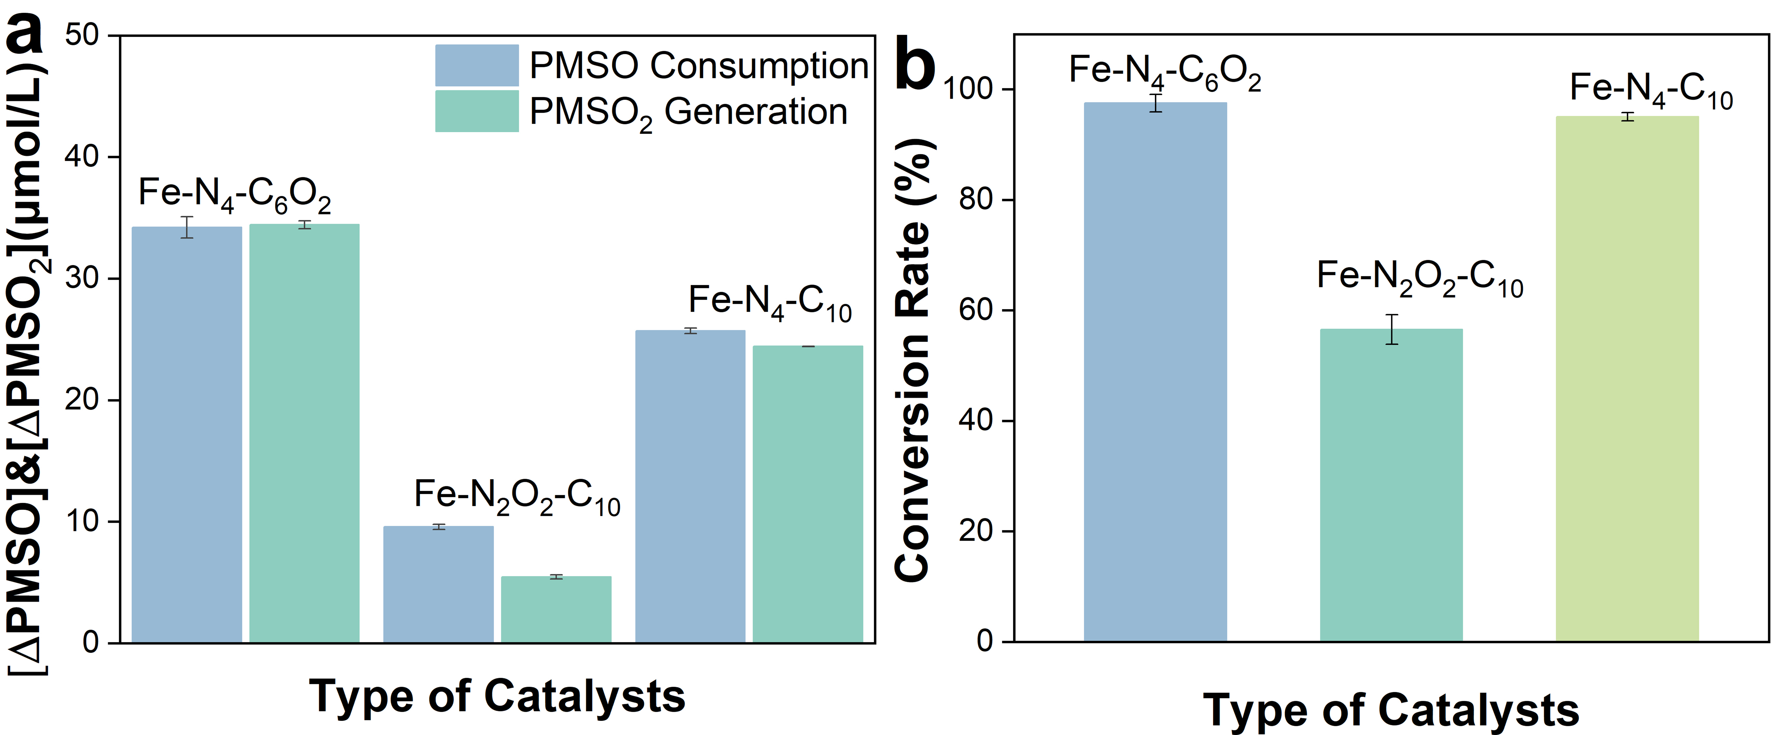

Supplementary Figure 27. (a) The amount of PMSO consumption and PMSO₂ generation during the Fe-SACs/PMS system. (b)The conversion rate of PMSO₂ during the Fe-SACs/PMS system. Experimental conditions: [Fe-SACs]=0.05 g L⁻¹, [PMS]=400 μM, T=25 °C, pH=7.0, [PMSO] =50 μM, t=2 min.

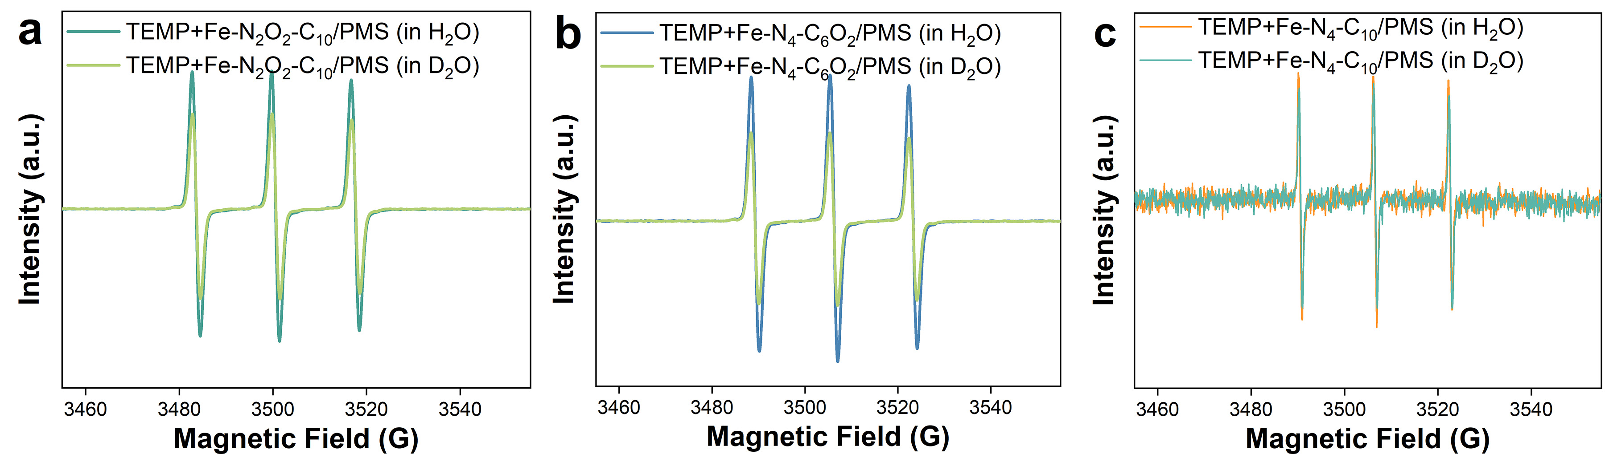

Supplementary Figure 28. ESR spectra recorded in H₂O- and D₂O-based (a) Fe-N₂O₂-C₁₀/PMS/TEMP system, (b) Fe-N₄-C₆O₂/PMS/TEMP system, and (b) Fe-N₄-C₁₀/PMS/TEMP system.
Previous studies have demonstrated that ¹O₂ quenching such as azide, L-histidine or furfuryl alcohol consume PMS, resulting in false positive^{4,12}. Therefore, the presence of ¹O₂ is not directly verified by quenching experiments in this paper.

Supplementary Figure 29. Pseudo-first-order rate constants for phenolic compounds degradation by (a) RB (under visible light irradiation), (b) Fe-N₂O₂-C₁₀/PMS system, (c) Fe-N₄-C₆O₂/PMS system, and (d) Fe-N₄-C₁₀/PMS system under various pH conditions. Experimental conditions: [BPA]=50 μM if need, [2,4-DCP]=20 μM if need, [Catalysts]=0.05 g L⁻¹, [PMS]=400 μM, T=25 °C, pH=7.0, [MeOH/PMS]=1000 and [PMSO/PMS]=100 in Fe-SACs/PMS system.
In ¹O₂ oxidation (visible-lightirradiated RB solution), the degradation rates of the two pollutants increased significantly with increasing pH. This may be attributed to the fact that with the increase of pH, phenolic compounds are more readily dissociated into phenolate anions which are more easily oxidized by ¹O₂¹³. However, under the quenching of excess methanol and PMSO, the pH dependence of BPA and 2,4-DCP during the non-radical degradation of Fe-SACs/PMS was completely opposite to that of ¹O₂ oxidation process. This result also refuted the possibility that the oxidation process is accompanied by the formation of ¹O₂ and proved that the ETP exists.

Supplementary Figure 30. Open circuit potential in different systems. Calomel electrode and platinum wire electrode were used as reference electrodes and opposite electrodes, respectively. Experimental conditions: V(Na₂B₂O₄, 0.02 M) : V(PMS, 10 mM) : V(BPA, 150 μM)=6 mL : 1 mL : 1 mL, sample interval:0. 1 s, run time: 1800 s.

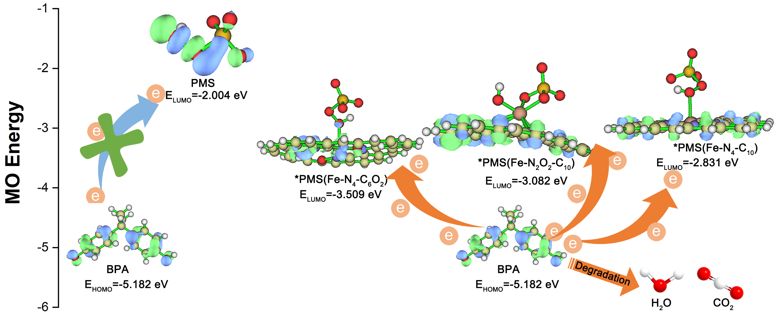

Supplementary Figure 31. Electron transfer mechanism.

Supplementary Figure 32. The pseudo-first-order kinetic fitting on BA and pCBA in (a) Fe-N₄-C₁₀/PMS and (b) Fe-N₄-C₆O₂/PMS system. Experimental conditions: [catalysts]=0.05 g L⁻¹, [PMS]=400 μM, [BPA]=50 μM, [BA or pCBA]=1 μM, T=25 ℃, pH=7.0. (c) The plots of $\text{ŋ}\text{ln}{\frac{{\text{[PMSO]}}_{\text{0}}}{{\text{[PMSO]}}_{\text{0}}- \frac{\text{1}}{\text{ŋ}}\text{[}{\text{PMSO}}_{\text{2}}\text{]}}}$ versus time in the Fe-N₄-C₁₀/PMS and Fe-N₄-C₆O₂/PMS system. Experimental conditions: [Catalysts]=0.05 g L⁻¹, [PMS]=400 μM, [PMSO]=5 μM, [BPA]=50 μM, T=25 ℃, pH=7.0.

Supplementary Figure 33. (a) Schematic representation of bonding information for the Fe=O portion of Fe^{IV}=O. (b) Different iron species in Fe-N₄-C₆O₂ and Fe-N₄-C₁₀.

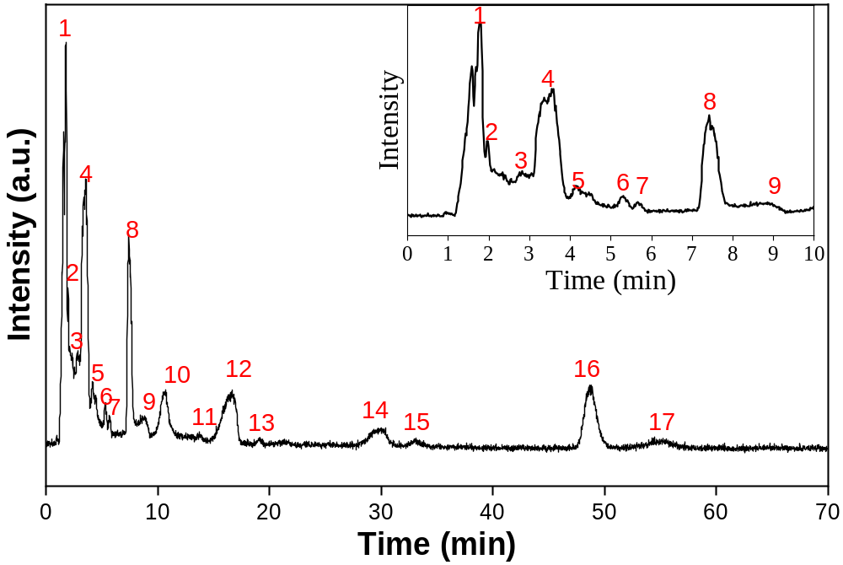

Supplementary Figure 34. LC-MS total ion chromatography (TIC) for BPA during the degradation process. Reaction conditions: [Fe-N₄-C₆O₂]=0.02 g L⁻¹, [PMS]₀=400 μM, [BPA]₀=50 μM, pH=7.0, reaction time=1 min.

Supplementary Figure 35. (a-q) ESI mass spectra of various BPA degradation intermediates. Reaction conditions: [Fe-N₄-C₆O₂]=0.02 g L⁻¹, [PMS]₀=400 μM, [BPA]₀=50 μM, pH=7.0, reaction time=1 min.

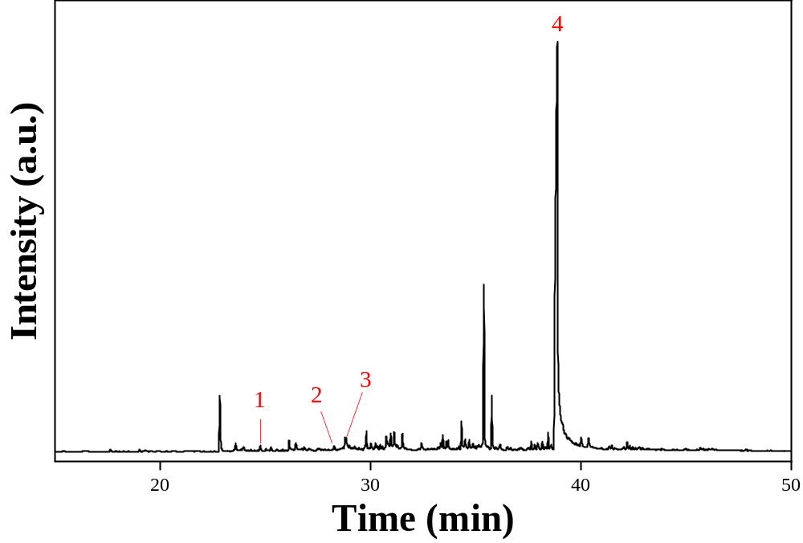

Supplementary Figure 36. GC-MS chromatogram of various BPA degradation intermediates. Reaction conditions: [Fe-N₄-C₆O₂]=0.02 g L⁻¹, [PMS]₀=400 μM, [BPA]₀=50 μM, pH=7.0, reaction time=1 min.

Supplementary Figure 37. (a-d) EI mass spectra of BPA during the degradation process. Reaction conditions: [Fe-N₄-C₆O₂]=0.02 g L⁻¹, [PMS]₀=400 μM, [BPA]₀=50 μM, pH=7.0, reaction time=1 min.

Supplementary Figure 38. Proposed pathways for the BPA degradation in the Fe-N₄-C₆O₂/PMS system.
According to the intermediates of BPA degradation identified by LC-MS and GC-MS techniques (Figures S34-S37 and Tables S9-S10), two possible degradation pathways for the BPA degradation in Fe-N₄-C₆O₂/PMS system were proposed (Figure S38). Among them, the molecules marked red (HI₁-HI₇) and black (I₁-I₁₅) are hypothetical intermediates and experimentally detected intermediates, respectively. Substances marked green were presumed transition state species. In these two pathways, BPA was oxidized by Fe^{IV}=O through oxygen atom transfer (OAT) reaction, electrophilic addition and H-abstraction/O-rebound mechanism. Among them, the OAT reaction was that the electrons of the pollutants are filled into the low-lying σ* orbitals of Fe/O to form the substrate-O-Fe collinear transition state¹⁴. Next, another electron transfer occurred between the substrate and the Fe center in this transition state, which led to the breaking of the Fe-O bond and the transfer of oxygen atoms, resulting in the oxidation of pollutants and the reduction of Fe^{IV}=O species. Electrophilic addition refers to the hydroxylation of aromatic ring was promoted by Fe^{IV}=O species, which usually consists of two steps¹⁵. In the initial step, the carbon with high π electron density on the aromatic ring was electrophilic attacked by Fe^{IV}=O to form a radical σ-complex. The intermediate then underwent a ring rearrangement and again triggered the transfer of electrons from the carbon to the metal, thus hydroxylating the aromatic ring. In the H-abstraction/O-rebound mechanism, the cleavage of C-H bond and the formation of C-O-H bond were divided into two successive steps. First, a hydrogen atom from hydrocarbons was extracted by Fe^{IV}=O species to form high valent iron hydroxyl (Fe^{III}-OH) and aliphatic radical intermediates¹⁶⁻¹⁸. Following hydrogen extraction, the generated radical intermediates rapidly recombined with Fe^{III}-OH species, transferring oxygen atoms to organic substrates through the so-called “oxygen rebound” mechanism to form hydroxylated substances. This step not only completed the oxidation of organic substrates. The iron species were also regenerated into their original state, allowing the catalytic cycle to continue. Overall, at the core of all three oxidation mechanisms was the filling of pollutant electrons into the low σ* orbital of Fe/O in Fe^{IV}=O, forming a substrate-O-Fe intermediate.
In pathway P1, the quaternary carbon atom located in the center of the BPA molecule was attacked by Fe^{IV}=O due to its high frontier electron density, resulting in the formation of 4-isopropenyl radical (R₁) and phenyl (R₂) radical through the β-scission^{19,20}. Subsequently, R₁ could be oxidized to intermediate I₁ by Fe^{IV}=O species. The high reactivity between the C=C bond in intermediate I₁ and Fe^{IV}=O made them easy to form the hypothetical intermediates HI₁ and ≡Fe^{II} via the OAT pathway. HI₁ then undergoes demethylation to form intermediate I₂. Following this, intermediate I₂ reacted with the Fe^{IV}=O species to generate intermediate HI₂ and ≡Fe^{II} through a H-abstraction/O-rebound mechanism. The generated HI₂ reacted with Fe^{IV}=O via an electrophilic addition mechanism to form I₃ and ≡Fe^{II}. Intermediate I₃ was subsequently oxidized to form ring-opened products, ultimately degrading into CO₂ and H₂O. In addition, the carbonyl carbon atom in intermediate HI₁ was attacked by Fe^{IV}=O, thus forming radical R₃ and methyl radicals (•CH₃) through an α-scission reaction. The radical R₃ could react with Fe^{IV}=O to form intermediate HI₂, while •CH₃ and R₁ were further transformed into 4-(tert-butyl) phenol (HI₃) via a C-C coupling reaction. On the one hand, the aromatic ring in intermediate HI₃ lost an electron via the electron transfer to form a phenolic radical (R₄). On the other hand, the C-C bond between the isobutyl and phenyl ring in HI₃ was attacked by Fe^{IV}=O, leading to the formation of the isobutyl radical (R₅) and phenyl radical (R₂) through a β-scission reaction. These radicals could be further converted to 2,4-di-tert-butylphenol (I₄₋₂), 2-(tert-butyl)phenol (HI₄), and 3-(tert-butyl)phenol (HI₅) by reorganization. Similarly, intermediates HI₄ and HI₅ could form four types of di-tert-butylphenol (I₄₋₁-I₄₋₂) via the electron transfer and radical reorganization reactions. Subsequently, I₄₋₁ and I₄₋₄ could react with Fe^{IV}=O via an electrophilic addition mechanism to generate hydroxylated intermediate I₅, which was further oxidized and converted into I₆. With further oxidation, these compounds were gradually converted into organic acids and eventually fully mineralized.
In pathway P2, on the one hand, the radical R₂ could react with Fe^{IV}=O to form hydroquinone (HI₆) and ≡Fe^{II} via electrophilic addition reaction. The resulting HI₆ can be readily oxidized by Fe^{IV}=O to benzoquinone (HI₇), which was further ring-opened to form intermediate I₁₀. The generated intermediate I₁₀ could be further oxidised into CO₂ and H₂O by Fe^{IV}=O. On the other hand, radicals R₂ form (1,1'-biphenyl)-4,4'-diphenol (I₇) through self-reorganization. Next, I₇ was gradually oxidized to ring-opening product I₈, which was further oxidized toI₉ and ultimately mineralized into CO₂ and H₂O.

Supplementary Figure 39. The TOC removal efficiency of BPA in Fe-N₄-C₆O₂/PMS system. Experimental conditions: [BPA]₀=50 μM, T=25 °C, pH=7.0, [Fe-N₄-C₆O₂]=0.1 g L⁻¹ or 0.05 g L⁻¹, [PMS]₀=400 μM, reaction time=2 min.

Supplementary Tables

Supplementary Table 1. Synthetic conditions of different samples.
Catalysts | synthetic conditions
Catalysts | FeCl₂·4H₂O  (mmol) | 1,10-phenanthroline  (mmol) | (S,S)-(+)-N,N'-Bis(3,5-di-tert-butylsalicylidene)-1,2-cyclohexanediamine | SiO₂ ª/SiO₂@RF ^{b}/ SiO₂@N-C^{c} (g) | Calcination | Etching
Fe-N₂O₂-C₁₀ | 0.5 | / | 1.5 | 3^{c} | 2 °C min⁻¹, 700 °C, 2h | 5 wt % HF, 12h
Fe-N₂O₂-C₁₀-high metal | 0.5 | / | 0.6 | 3^{c} | 2 °C min⁻¹, 700 °C, 2h | 5 wt % HF, 12h
Fe-N₄-C₆O₂ | 0.5 | 2 | / | 3^{b} | 2 °C min⁻¹, 700 °C, 2h | 5 wt % HF, 12h
Fe-N₄-C₁₀ | 0.5 | 2 | / | 3ª | 2 °C min⁻¹, 700 °C, 2h | 5 wt % HF, 12h
Fe NPs/NC | 0.5 | 2 | / | / | 2 °C min⁻¹, 700 °C, 2h | 5 wt % HF, 12h
N/O-C | / | 2 | / | 3^{b} | 2 °C min⁻¹, 700 °C, 2h | 5 wt % HF, 12h
N-C | / | 2 | / | 3ª | 2 °C min⁻¹, 700 °C, 2h | 5 wt % HF, 12h

Supplementary Table 2. Curve fit Parameters for Fe K-edge EXAFS for FePC and Fe-SACs.
Sample | Scattering path | CN | R/Å | σ²/Å² | ∆E₀/eV | R-factor
FePC | Fe-N | 4.0 | 1.98 ± 0.03 | 0.007 ± 0.002 | 0.5 ± 2.0 | 0.011
Fe-N₂O₂-C₁₀ | Fe-N | 2.0 | 2.00 ± 0.05 | 0.003 ± 0.002 | -6.4 ± 3.3 | 0.018
Fe-N₂O₂-C₁₀ | Fe-O | 2.4 | 2.23 ± 0.08 | 0.008 ± 0.005 | -6.4 ± 3.3 | 0.018
Fe-N₄-C₆O₂ | Fe-N1 | 2.2 | 1.91 ± 0.01 | 0.002 ± 0.001 | -2.0 ± 1.3 | 0.014
Fe-N₄-C₆O₂ | Fe-N2 | 2.1 | 2.09 ± 0.09 | 0.003 ± 0.004 | -2.0 ± 1.3 | 0.014
Fe-N₄-C₁₀ | Fe-N | 4.4 | 1.97 ± 0.01 | 0.009 ± 0.003 | -2.8 ± 1.8 | 0.016
Where，σ² stands for the Debye-Waller factor. ΔE stands for threshold energy correction; R-factor (%) indicates the goodness of the fit.

Supplementary Table 3. Mössbauer parameters and assignment of feature components in the deconvoluted Mössbauer spectra.
Catalysts | Component | δ_{iso} (mm/s) | ∆E_{Q} (mm/s) | Γ(mm/s) | Area (%) ª | Assignment ^{b}
Fe-N₄-C₁₀ | D1 | 0.22 | 2.30 | 0.98 | 60.6 | Fe^{II}N₂₊₂, MS
Fe-N₄-C₁₀ | D2 | 0.11 | 0.77 | 0.46 | 33.2 | Fe^{III}N₂₊₂, MS
Fe-N₄-C₁₀ | D3 | 1.10 | 2.13 | 0.32 | 6.2 | N-Fe^{II}N₂₊₂, HS
Fe-N₄-C₆O₂ | D4 | 0.50 | 2.00 | 0.88 | 2.6 | Fe^{III}N₄/C, LS
Fe-N₄-C₆O₂ | D5 | 0.26 | 1.14 | 0.88 | 71.5 | Fe^{Ⅱ}N₄/C, LS
Fe-N₄-C₆O₂ | D6 | 0.24 | 2.90 | 0.88 | 22.6 | Fe^{Ⅱ}N₄/C, MS
Fe-N₄-C₆O₂ | D7 | 0.90 | 3.30 | 0.42 | 3.3 | Fe^{Ⅱ}N₄/C, HS
ª The relative absorption area of each iron species in Fe-SACs samples. ^{b} LS, MS, and HS denote low-spin, medium-spin, and high-spin, respectively.

Supplementary Table 4. The molecular structures of the organic substance used in this study and the HPLC conditions used to analyze them.
No. | Contaminant | Molecular Structure | Formula | Molar Mass  (g mol⁻¹) | Eluent | flow rate (mL min⁻¹) | λ (nm) | Retention time (min)
1 | BPA | 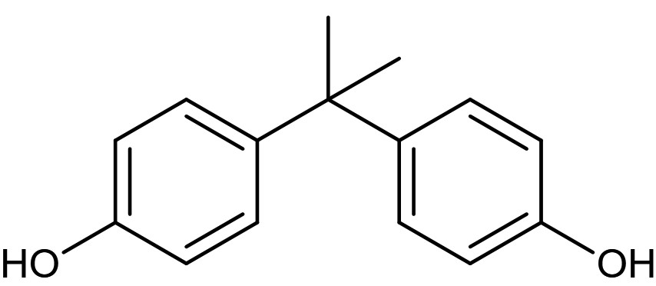 | C₁₅H₁₆O₂ | 228.29 | 30% ultrapure water + 70% methanol | 1 | 276 | 3.489
2 | 2,4-DCP | 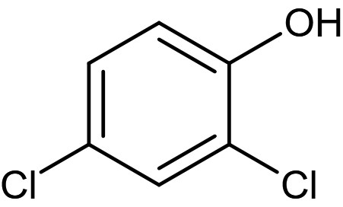 | C₆H₄Cl₂O | 163.00 | 20% ultrapure water + 80% methanol | 1 | 286 | 2.954
3 | 4-CP | 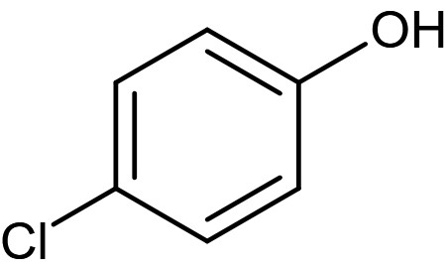 | C₆H₅ClO | 128.56 | 30% ultrapure water + 70% methanol | 1 | 281 | 3.004
4 | PE |  | C₆H₆O | 94.11 | 40% ultrapure water + 60% methanol | 1 | 270 | 2.705
5 | PMSO |  | C₇H₈OS | 140.03 | 70% ultrapure water + 30% acetonitrile | 1 | 232 | 2.485
6 | PMSO₂ |  | C₇H₈O₂S | 156.20 | 70% ultrapure water + 30% acetonitrile | 1 | 264 | 3.969
7 | PNP |  | C₆H₅NO₃ | 139.11 | 40% ultrapure water+ 60% methanol | 1 | 316 | 3.004
8 | FP |  | C₁₂H₄Cl₂F₆N₄OS | 437.15 | 20% ultrapure water + 80% methanol | 1 | 270 | 3.357
9 | PNBD |  | C₇H₅NO₃ | 151.12 | 40% ultrapure water + 60% methanol | 1 | 266 | 3.145
10 | PNBA |  | C₇H₇NO₃ | 153.14 | 40% ultrapure water + 60% methanol | 1 | 274 | 2.653
11 | BA |  | C₇H₆O₂ | 122.04 | 95% 0.02 M ammonium acetate solution + 5% acetonitrile | 1 | 230 | 3.561
12 | pCBA |  | C₇H₅ClO₂ | 156.00 | 90% ultrapure water + 10% acetonitrile | 1 | 233 | 3.787

Supplementary Table 5. Comparison between Fe-N₄-C₆O₂ and the previously reported metal-based catalysts in the catalytic performance.
Catalysts  （Dosage, g/L） | Metal (wt%) | Contaminant (μM) | PMSª/PDS^{b}/PS^{c}  (mM) | pH | Removal  Efficiency | k (min⁻¹) | k-value  (μmol s⁻¹ g⁻¹) | Ref.
nZVI/kaolinite (0.5) | ~80 | BPA (109.5) | 1.00 ª | 7.0 | 15 min (~90%) | 0.212 | 0.77 | ²¹
Mn_{1.8}Fe_{1.2}O₄ (0.1) | / | BPA (43.8) | 0.65 ª | 7.5 | 30 min (95%) | 0.100 | 0.73 | ²²
Fe_{0.8}Co_{2.2}O₄ (0.1) | / | BPA (87.6) | 0.65 ª | 6.0 | 60 min (95%) | 0.049 | 0.72 | ²³
CuFe₂O₄-Fe₂O₃ (0.2) | / | BPA (21.9) | 1.17 ª | 7.0 | 10 min (100%) | 0.620 | 1.13 | ²⁴
Fe₁Mn₅Co₄-N@C (0.1) | / | BPA (87.6) | 0.65 ª | 6.0 | 10 min (100%) | 0.480 | 7.01 | ²⁵
Co₃O₄-Bi₂O₃ (0.3) | / | BPA (87.6) | 0.65 ª | 7.0 | 30 min (98.5%) | 0.122 | 0.59 | ²⁶
CoMnAl-MMO (0.02) | / | BPA (43.8) | 0.65 ª | 3.6 | 90 min (100%) | 0.058 | 2.12 | ²⁷
Fe₃Co₇@C-650 (0.1) | / | BPA (87.6) | 0.65 ª | 6.0 | 30 min (98%) | 0.132 | 1.93 | ²⁸
DPA-hematite (0.5) | / | BPA (65.7) | 6.50 ª | 7.0 | 120 min (100%) | 0.039 | 0.09 | ²⁹
Co-doped MIL-53-NH₂ (0.25) | / | BPA (219.0) | 0.5 (g L⁻¹) ^{c} | 4.0 | 73 min (90%) | ＜0.030 | ＜0.44 | ³⁰
Co-TPML (0.2) | 0.04 | BPA (50.0) | 2.00 ª | 3.5 | 5 min (100%) | ＜2.500 | ＜10.42 | ³¹
SA-Fe-NC (0.05) | 1.12 | BPA (100.7) | 1.96 ª | 6.7 | 3 min (100%) | 1.990 | 66.33 | ³²
FeCo@NC-1 (0.1) | 0.98 (Fe)/ 0.79 (Co) | BPA (87.6) | 0.65 ª | 6.0 | 1 min (100%) | 6.062 | 88.50 | ³³
Fe@NC (0.1) | / | BPA (87.6) | 0.65 ª | 6.0 | 3 min (100%) | 2.370 | 34.60 | ³³
Co@NC (0.1) | / | BPA (87.6) | 0.65 ª | 6.0 | 2 min (100%) | 4.367 | 63.76 | ³³
CoSA/NHCS (0.1) | 1.78 | BPA (87.6) | 0.33 ª | 7.0 | 1 min (98%)  2 min (100%) | / | / | ³⁴
Co_{SA}-N₄-C (0.05) | 1.17 | BPA (50.0) | 2.0 ^{b} | 6.4 | 5 min (96%) | 0.630 | 10.5 | ³⁵
Co_{SA}-N₃-C (0.05) | 1.20 | BPA (50.0) | 2.0 ^{b} | 6.4 | 4 min (100%) | 1.280 | 21.33 | ³⁵
Fe_{SA}-NC-20 (0.15) | 0.88 | BPA (87.6) | 1.30 ª | 6.5 | 30 min (100%) | 0.318 | 3.10 | ³⁶
Fe-N₂O₂-C₁₀ (0.1) | 0.196 | BPA (50.0) | 0.40 ª | 7.0 | 5 s (83.7%)  60 s (100%) | 4.558 | 37.983 | This  work
Fe-N₄-C₆O₂ (0.1) | 2.14 | BPA (50.0) | 0.40 ª | 7.0 | 5 s (85.7%)  30 s (100%) | 13.299 | 110.83 | This  work
Fe-N₄-C₁₀ (0.1) | 2.63 | BPA (50.0) | 0.40 ª | 7.0 | 5 s (49.5%)  120 s (96.1%) | 1.423 | 11.858 | This  work
Note: PS and PDS stand for persulfate and peroxodisulfate, respectively.

Supplementary Table 6. The second-order reaction rate constants between quenchers with various ROS (M⁻¹ s⁻¹).
Quencher | k_{•OH} | $${\text{k}}_{{\text{SO}}_{\text{4}}^{\text{•-}}}$$ | Ref.
MeOH | 9.7×10⁸ | 3.2 × 10⁶ | ³⁷⁻⁴⁰

Supplementary Table 7. The second-order reaction rate constants between probe compounds and BPA with various ROS (M⁻¹ s⁻¹).
Compounds | k_{•OH} | $${\text{k}}_{{\text{SO}}_{\text{4}}^{\text{•-}}}$$ | $${\text{k}}_{{\text{1}}_{{\text{O}}_{\text{2}}}}$$ | $${\text{k}}_{{\text{O}}_{\text{2}}^{\text{•-}}}$$ | k_{Fe}^{IV}_{=O} | Ref.
BA | 5.9 × 10⁹ | 1.2 × 10⁹ | / | / | / | ⁴¹⁻⁴⁴
pCBA | 1.5 × 10¹⁰ | 1.3 × 10¹⁰ | 1.4 × 10⁷ | 8.6 × 10⁷ | / | ^{37,45,46}
PMSO | 3.61 × 10⁹ | 3.17 × 10⁸ | / | / | 2.58 × 10³ | ^{37,41}
BPA | 1.7 × 10¹⁰ | 1.37 × 10⁹ | 3.0 × 10⁵ | / | 1.08× 10^{3 a} | ^{39,47,48}
 |  |  |  |  | 4.6 × 10^{4 b} | ^{39,47,48}
“a” and “b” represent data provided by this study.
ª The second-order reaction rate constants between BPA and Fe^{IV}=O generated from Fe-N₄-C₁₀.
^{b} The second-order reaction rate constants between BPA and Fe^{IV}=O produced from Fe-N₄-C₆O₂.

Supplementary Table 8. The steady-state concentrations, observed pseudo-first-order reaction rate constants, and oxidation contributions to BPA of different ROS in Fe-SAC/PMS system.
Oxidation Pathway | Steady-state concentration ([ROS]_{ss}, mol L-¹) |  | Observed pseudo-first-order reaction rate constant (k_{obs,ROS}, min⁻¹) |  | Oxidation contribution (%)
Oxidation Pathway | Fe-N₄-C₁₀/PMS | Fe-N₄-C₆O₂/PMS | Fe-N₄-C₁₀/PMS | Fe-N₄-C₆O₂/PMS | Fe-N₄-C₁₀/PMS | Fe-N₄-C₆O₂/PMS
ETP | / | / | 0.5069 | 0.7616 | 60.00 | 13.45
•OH | 2.60 × 10⁻¹³ | 2.08 × 10⁻¹³ | 0.2652 | 0.2124 | 31.40 | 3.75
SO₄^{•-} | 2.51 × 10⁻¹⁴ | 3.92 × 10⁻¹⁴ | 2.06 × 10⁻³ | 3.22 × 10⁻³ | 0.24 | 0.06
Fe^{IV}=O | 1.09 × 10⁻⁶ | 1.71 × 10⁻⁶ | 0.0706 | 4.6838 | 8.36 | 82.74

Supplementary Table 9. Possible intermediates during BPA degradation. The mass spectrometric data were obtained from LC-MS.
NO. | Compound name | Structure | Marked | Detected | RT (min) | Pseudo-molecular ion | m/z ${\text{[M-H]}}_{\text{obs}}^{\text{-}}$ | Ref.
1 | pent-2-enoic acid | 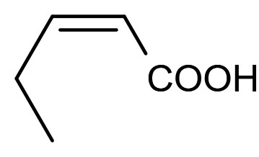 | I₁₁₋₁ |  | 1.79 | [C₅H₈O₂-H]⁻ | 99.05 | ⁴⁹
2 | 4-hydroxybenzaldehyde |  | I₂ |  | 1.97 | [C₇H₆O₂-H]⁻ | 121.03 | ⁵⁰
3 | fumaric acid |  | I₁₁₋₂ |  | 2.78 | [C₄H₄O₄-H]⁻ | 115.00 | ⁵¹
4 | 3-(3,4-dihydroxyphenyl)pentanedioic acid |  | I₉ |  | 3.35 | [C₁₁H₁₂O₆-H]⁻ | 239.06 | /
5 | 2-methylmaleic acid |  | I₁₁₋₃ |  | 4.12 | [C₅H₆O₄-H]⁻ | 129.02 | /
6 | 4-(prop-1-en-2-yl) phenol |  | I₁ |  | 4.12 | [C₉H₁₀O-H]⁻ | 133.07 | ^{20,23,51-55}
7 | 3,4-dihydroxybenzoic acid |  | I₃ |  | 5.29 | [C₇H₆O₄-H]⁻ | 153.02 | ^{50,56}
8 | 4,4'-(propane-2,2-diyl) diphenol (BPA) |  | / |  | 7.49 | [C₁₅H₁₆O₂-H]⁻ | 227.11 | /
9 | 2,3-dimethylmaleic acid |  | I₁₁₋₄ |  | 8.82 | [C₆H₈O₄-H]⁻ | 143.03 | /
10 | 2,4-di-tert-butylphenol |  | I₄₋₂ |  | 10.68 | [C₁₄H₂₂O-H]⁻ | 205.19 | ^{20,53}
11 | 2,5-di-tert-butylphenol |  | I₄₋₃ |  | 10.68 | [C₁₄H₂₂O-H]⁻ | 205.19 | /
12 | 2,6-di-tert-butylphenol |  | I₄₋₁ |  | 10.68 | [C₁₄H₂₂O-H]⁻ | 205.19 | /
13 | 3,5-di-tert-butylphenol |  | I₄₋₄ |  | 10.68 | [C₁₄H₂₂O-H]⁻ | 205.19 | ²³
14 | (E)-3-methylhex-3-enedioic acid |  | I₁₁₋₅ |  | 16.65 | [C₇H₁₀O₄-H]⁻ | 157.05 | /
15 | 2,5-dioxohex-3-enedioic acid |  | I₁₀ |  | 29.94 | [C₆H₄O₆-H]⁻ | 170.99 | /
16 | 3-(3,4-dioxocyclohexa-1,5-dien-1-yl)pent-2-enedioic acid |  | I₈ |  | 48.72 | [C₁₁H₈O₆-H]⁻ | 235.02 | /
17 | (1,1'-biphenyl)-4,4'-diol |  | I₇ |  | 54.47 | [C₁₂H₁₀O₂-H]⁻ | 185.06 | ⁵⁷
18 | 1-(4-hydroxyphenyl)ethan-1-one |  | HI₁ | / | / | [C₈H₈O₂-H]⁻ | 135.14 | ^{19,21}
19 | 4-hydroxybenzoic acid |  | HI₂ | / | / | [C₇H₆O₃-H]⁻ | 137.02 | ²⁰
20 | 4-(tert-butyl)phenol |  | HI₃ | / | / | [C₁₀H₁₄O-H]⁻ | 149.10
21 | 2-(tert-butyl)phenol |  | HI₄ | / | / | [C₁₀H₁₄O-H]⁻ | 149.10 | /
22 | 3-(tert-butyl)phenol |  | HI₅ | / | / | [C₁₀H₁₄O-H]⁻ | 149.10 | /
23 | hydroquinone |  | HI₆ | / | / | [C₆H₆O₂-H]⁻ | 109.03 | ^{19,20,49,52,54}
24 | benzoquinone | 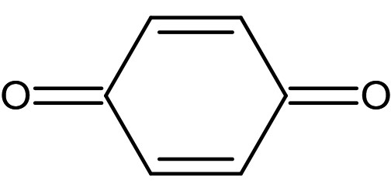 | HI₇ | / | / | [C₆H₄O₂-H]⁻ | 107.01 | ^{19-21,52,58}

Supplementary Table 10. Possible intermediates during BPA degradation. The mass spectrometric data were obtained from GC-MS.
NO. | Compound name | Structure | Marked | Detected | RT (min) | Molecular ion | m/z [${\text{M}}^{\text{.+}}]$ | Ref.
1 | 2,4-di-tert-butylphenol |  | I₄₋₂ |  | 24.76 | $${\text{C}\text{14}\text{H}\text{22}\text{O}}^{\text{┐}\text{.+}}$$ | 206.10 | ^{20,53}
2 | 2,5-di-tert-butylphenol |  | I₄₋₃ |  | 24.76 | $${\text{C}\text{14}\text{H}\text{22}\text{O}}^{\text{┐}\text{.+}}$$ | 206.10 | /
3 | 2,6-di-tert-butylphenol |  | I₅₋₁ |  | 24.76 | $${\text{C}\text{14}\text{H}\text{22}\text{O}}^{\text{┐}\text{.+}}$$ | 206.10 | /
4 | 3,5-di-tert-butylphenol |  | I₄₋₄ |  | 24.76 | $${\text{C}\text{14}\text{H}\text{22}\text{O}}^{\text{┐}\text{.+}}$$ | 206.10 | ²³
5 | 2,6-di-tert-butylcyclohexa-2,5-diene-1,4-dione |  | I₆ |  | 28.27 | $${{\text{C}}_{\text{14}}{\text{H}}_{\text{20}}{\text{O}}_{\text{2}}}^{\text{┐}\text{.+}}$$ | 220.00 | ²³
6 | 2,6-di-tert-butylbenzene-1,4-diol |  | I₅ |  | 28.87 | $${{\text{C}}_{\text{14}}{\text{H}}_{\text{22}}{\text{O}}_{\text{2}}}^{\text{┐}\text{.+}}$$ | 222.00 | /
7 | BPA |  | / |  | 38.86 | $${{\text{C}}_{\text{15}}{\text{H}}_{\text{16}}{\text{O}}_{\text{2}}}^{\text{┐}\text{.+}}$$ | 228.00 | /

Supplementary References
1 Ravel, B. & Newville, M. ATHENA, ARTEMIS, HEPHAESTUS: data analysis for X-ray absorption spectroscopy using IFEFFIT. J. Synchrotron Radiat. 12, 537-541 (2005).
2 Funke, H., Scheinost, A. C. & Chukalina, M. Wavelet analysis of extended x-ray absorption fine structure data. Phys. Rev. B 71, 094110 (2005).
3 Zhang, H. et al. Surfactant-free assembly of mesoporous carbon hollow spheres with large tunable pore sizes. ACS Nano 10, 4579-4586 (2016).
4 Yun, E. T., Lee, J. H., Kim, J., Park, H. D. & Lee, J. Identifying the nonradical mechanism in the peroxymonosulfate activation process: singlet oxygenation versus mediated electron transfer. Environ. Sci. Technol. 52, 7032-7042 (2018).
5 Wang, Z. et al. Is Sulfate Radical Really Generated from Peroxydisulfate Activated by Iron(II) for Environmental Decontamination? Environ. Sci. Technol. 52, 11276-11284 (2018).
6 Zong, Y. et al. Unraveling the Overlooked Involvement of High-Valent Cobalt-Oxo Species Generated from the Cobalt(II)-Activated Peroxymonosulfate Process. Environ. Sci. Technol. 54, 16231-16239 (2020).
7 M. J. Frisch et al. Gaussian, Inc., Wallingford CT (2016).
8 Lu, T. & Chen, F. Multiwfn: a multifunctional wavefunction analyzer. J. Comput. Chem. 33, 580-592 (2012).
9 Yang, M. et al. Unveiling the origins of selective oxidation in single-atom catalysis via Co-N(4)-C intensified radical and nonradical pathways. Environ. Sci. Technol. 56, 11635-11645 (2022).
10 Chen, Y. et al. Facile fabrication of rGO/PPy/nZVI catalytic microreactor for ultrafast removal of p-nitrophenol from water. Appl. Catal. B Environ. 324 (2023).
11 Vol. EPA 600-R-12-618 (U.S. Environmental Protection Agency, 2012-09).
12 Yang, Y., Banerjee, G., Brudvig, G. W., Kim, J. H. & Pignatello, J. J. Oxidation of organic compounds in water by unactivated peroxymonosulfate. Environ. Sci. Technol. 52, 5911-5919 (2018).
13 Scully Jr, F. E. & Hoigné, J. Rate constants for reactions of singlet oxygen with phenols and other compounds in water. Chemosphere 16, 681-694 (1987).
14 Larson, V. A., Battistella, B., Ray, K., Lehnert, N. & Nam, W. Iron and manganese oxo complexes, oxo wall and beyond. Nature Reviews Chemistry 4, 404-419 (2020).
15 Wang, Z. et al. Aqueous iron(iv)-oxo complex: an emerging powerful reactive oxidant formed by iron(ii)-based advanced oxidation processes for oxidative water treatment. Environ. Sci. Technol. 56, 1492-1509 (2022).
16 Michel, C. & Baerends, E. J. What singles out the FeO²⁺ moiety? A density-functional theory study of the methane-to-methanol reaction catalyzed by the first row transition-metal oxide dications MO(H₂O)_{p}²⁺,M ) V-Cu. Inorganic Chemistry 48, 3628-3638 (2009).
17 Groves, J. T. & Van der Puy, M. Stereospecific aliphatic hydroxylation by iron-hydrogen peroxide. Evidence for a stepwise process. Journal of the American Chemical Society 98, 5290-5297 (1976).
18 Groves, J. T. & McClusky, G. A. Aliphatic hydroxylation via oxygen rebound. Oxygen transfer catalyzed by iron. Journal of the American Chemical Society 98, 859-861 (1976).
19 Al-Kahtani, A. A., Alshehri, S. M., Naushad, M., Ruksana & Ahamad, T. Fabrication of highly porous N/S doped carbon embedded with ZnS as highly efficient photocatalyst for degradation of bisphenol. Int. J. Biol. Macromol. 121, 415-423 (2019).
20 Du, J. et al. Efficient activation of peroxymonosulfate by magnetic Mn-MGO for degradation of bisphenol A. J. Hazard. Mater. 320, 150-159 (2016).
21 Li, C. et al. Efficient catalytic degradation of bisphenol A coordinated with peroxymonosulfate via anchoring monodispersed zero-valent iron on natural kaolinite. Chem. Eng. J. 448, 137746 (2022).
22 Huang, G. X., Wang, C. Y., Yang, C. W., Guo, P. C. & Yu, H. Q. Degradation of Bisphenol A by peroxymonosulfate catalytically activated with Mn_{1.8}Fe_{1.2}O₄ nanospheres: synergism between Mn and Fe. Environ. Sci. Technol. 51, 12611-12618 (2017).
23 Li, X. et al. Fe_{x}Co_{3−x}O₄ nanocages derived from nanoscale metal–organic frameworks for removal of bisphenol A by activation of peroxymonosulfate. Appl. Catal. B Environ. 181, 788-799 (2016).
24 Oh, W.-D., Donga, Z., Hu, Z.-T. & Lim, T.-T. A novel quasi-cubic CuFe₂O₄–Fe₂O₃ prepared at low temperature for enhanced oxidation of bisphenol A via peroxymonosulfate activation. J. Mater. Chem. A 3, 22208-22217 (2015).
25 Li, X. et al. Topotactic transformation of metal-organic frameworks to graphene-encapsulated transition-metal nitrides as efficient Fenton-like catalysts. ACS Nano 10, 11532-11540 (2016).
26 Hu, L. et al. Facile synthesis of novel Co₃O₄-Bi₂O₃ catalysts and their catalytic activity on bisphenol A by peroxymonosulfate activation. Chem. Eng. J. 326, 1095-1104 (2017).
27 Li, W. et al. Catalytic degradation of bisphenol A by CoMnAl mixed metal oxides catalyzed peroxymonosulfate: Performance and mechanism. Chem. Eng. J. 279, 93-102 (2015).
28 Li, X., Rykov, A. I., Zhang, B., Zhang, Y. & Wang, J. Graphene encapsulated Fe_{x}Co_{y} nanocages derived from metal–organic frameworks as efficient activators for peroxymonosulfate. Catal. Sci. Technol. 6, 7486-7494 (2016).
29 Oh, W.-D., Lua, S.-K., Dong, Z. & Lim, T.-T. High surface area DPA-hematite for efficient detoxification of bisphenol A via peroxymonosulfate activation. J. Mater. Chem. A 2, 15836-15845 (2014).
30 Lv, S.-W. et al. A novel cobalt doped MOF-based photocatalyst with great applicability as an efficient mediator of peroxydisulfate activation for enhanced degradation of organic pollutants. New J. Chem. 44, 1245-1252 (2020).
31 Chu, C. et al. Cobalt single atoms on tetrapyridomacrocyclic support for efficient peroxymonosulfate activation. Environ. Sci. Technol. 55, 1242-1250 (2021).
32 Gao, Y. et al. Unraveling the high-activity origin of single-atom iron catalysts for organic pollutant oxidation via peroxymonosulfate activation. Environ. Sci. Technol. 55, 8318-8328 (2021).
33 Yang, J. et al. A highly efficient Fenton-like catalyst based on isolated diatomic Fe-Co anchored on N-doped porous carbon. Chem. Eng. J. 404, 126376 (2021).
34 Xu, Z. et al. Co single-atom confined in N-doped hollow carbon sphere with superb stability for rapid degradation of organic pollutants. Chem. Eng. J. 452, 139229 (2023).
35 Liang, X. et al. Engineering the low-coordinated single cobalt atom to boost persulfate activation for enhanced organic pollutant oxidation. Appl. Catal. B Environ. 303, 120877 (2022).
36 Yang, T., Fan, S., Li, Y. & Zhou, Q. Fe-N/C single-atom catalysts with high density of Fe-N_{x} sites toward peroxymonosulfate activation for high-efficient oxidation of bisphenol A: Electron-transfer mechanism. Chem. Eng. J. 419, 129590 (2021).
37 Wu, Q. Y., Yang, Z. W., Wang, Z. W. & Wang, W. L. Oxygen doping of cobalt-single-atom coordination enhances peroxymonosulfate activation and high-valent cobalt-oxo species formation. Proc. Nat. Acad. Sci. U.S.A. 120, e2219923120 (2023).
38 Li, X. et al. CoN₁O₂ single-atom catalyst for efficient peroxymonosulfate activation and selective Cobalt(IV)=O generation. Angew. Chem. Int. Ed. 62, e202303267 (2023).
39 Ren, W. et al. Origins of electron-transfer regime in persulfate-based nonradical oxidation processes. Environ. Sci. Technol. 56, 78-97 (2021).
40 Guan, Y. H., Ma, J., Li, X. C., Fang, J. Y. & Chen, L. W. Influence of pH on the formation of sulfate and hydroxyl radicals in the UV/peroxymonosulfate system. Environ. Sci. Technol. 45, 9308-9314 (2011).
41 Wang, Z. et al. High-valent iron-oxo species mediated cyclic oxidation through single-atom Fe-N₆ sites with high peroxymonosulfate utilization rate. Appl. Catal. B Environ. 305, 121049 (2022).
42 Liu, B. et al. Peroxymonosulfate activation by cobalt(II) for degradation of organic contaminants via high-valent cobalt-oxo and radical species. J. Hazard. Mater. 416, 125679 (2021).
43 Cong, J., Wen, G., Huang, T., Deng, L. & Ma, J. Study on enhanced ozonation degradation of para-chlorobenzoic acid by peroxymonosulfate in aqueous solution. Chem. Eng. J. 264, 399-403 (2015).
44 Tian, L. et al. Selective oxidation of diclofenac sodium with different electronegative moieties via coexisting SO^{·−}and ·OH. Sci. Total Environ. 782, 146857 (2021).
45 Guo, Y., Long, J., Huang, J., Yu, G. & Wang, Y. Can the commonly used quenching method really evaluate the role of reactive oxygen species in pollutant abatement during catalytic ozonation? Water Res. 215, 118275 (2022).
46 Gao, L., Guo, Y., Zhan, J., Yu, G. & Wang, Y. Assessment of the validity of the quenching method for evaluating the role of reactive species in pollutant abatement during the persulfate-based process. Water Res. 221, 118730 (2022).
47 Sanchez, P. M., Abdel daiem, M. M., Ocampo, P., R., Rivera, U., J. & Mota, A. J. Comparative study of the photodegradation of bisphenol A by HO(*), SO₄(*⁻) and CO₃(*⁻)/HCO₃ radicals in aqueous phase. Sci. Total Environ. 463, 423-431 (2013).
48 Ding, J. et al. Electrochemical activation of persulfate on BDD and DSA anodes: Electrolyte influence, kinetics and mechanisms in the degradation of bisphenol A. J. Hazard. Mater. 388, 121789 (2020).
49 Qian, K. et al. Single-atom Fe catalyst outperforms its homogeneous counterpart for activating peroxymonosulfate to achieve effective degradation of organic contaminants. Environ. Sci. Technol. 55, 7034-7043 (2021).
50 Oh, W.-D., Lok, L.-W., Veksha, A., Giannis, A. & Lim, T.-T. Enhanced photocatalytic degradation of bisphenol A with Ag-decorated S-doped g-C₃N₄ under solar irradiation: Performance and mechanistic studies. Chem. Eng. J. 333, 739-749 (2018).
51 Jia, Y. et al. Oxygen vacancy rich Bi₂O₄-Bi₄O₇-BiO_{2-x} composites for UV-vis-NIR activated high efficient photocatalytic degradation of bisphenol A. J. Hazard. Mater. 382, 121121 (2020).
52 Tan, X. et al. Three-dimensional MnO₂ porous hollow microspheres for enhanced activity as ozonation catalysts in degradation of bisphenol A. J. Hazard. Mater. 321, 162-172 (2017).
53 Li, Y. et al. Uniform N-coordinated single-atomic iron sites dispersed in porous carbon framework to activate PMS for efficient BPA degradation via high-valent iron-oxo species. Chem. Eng. J. 389, 124382 (2020).
54 Chang, C., Zhu, L., Fu, Y. & Chu, X. Highly active Bi/BiOI composite synthesized by one-step reaction and its capacity to degrade bisphenol A under simulated solar light irradiation. Chem. Eng. J. 233, 305-314 (2013).
55 Xie, Y. et al. Thermally treated fungal manganese oxides for bisphenol A degradation using sulfate radicals. Chem. Eng. J. 335, 728-736 (2018).
56 Darsinou, B., Frontistis, Z., Antonopoulou, M., Konstantinou, I. & Mantzavinos, D. Sono-activated persulfate oxidation of bisphenol A: Kinetics, pathways and the controversial role of temperature. Chem. Eng. J. 280, 623-633 (2015).
57 Liu, Y. et al. Sandwich-like Co₃O₄/MXene composite with enhanced catalytic performance for Bisphenol A degradation. Chem. Eng. J. 347, 731-740 (2018).
58 Khan, M. A. N. et al. Metal-organic framework-derived hollow Co₃O₄/carbon as efficient catalyst for peroxymonosulfate activation. Chem. Eng. J. 363, 234-246 (2019).

