Supplementary Materials for

Chemical-induced dimerization of GSDMD C-terminal domain blocks GSDMD N-terminal domain-mediated pyroptosis
Jixuan Xu¹, Pengyuan Zheng², Xiufeng Chu^{3,2}*
¹Department of Gastrointestinal & Thyroid Surgery, The Fifth Affiliated Hospital of Zhengzhou University, Zhengzhou, China.
²Marshall medical center, The Fifth Affiliated Hospital of Zhengzhou University, Zhengzhou, China.
³Department of Oncology, The Fifth Affiliated Hospital of Zhengzhou University, Zhengzhou, China.

*Corresponding author Email: xchu@zzu.edu.cn

This file includes:
Extended Fig. 1 to 6

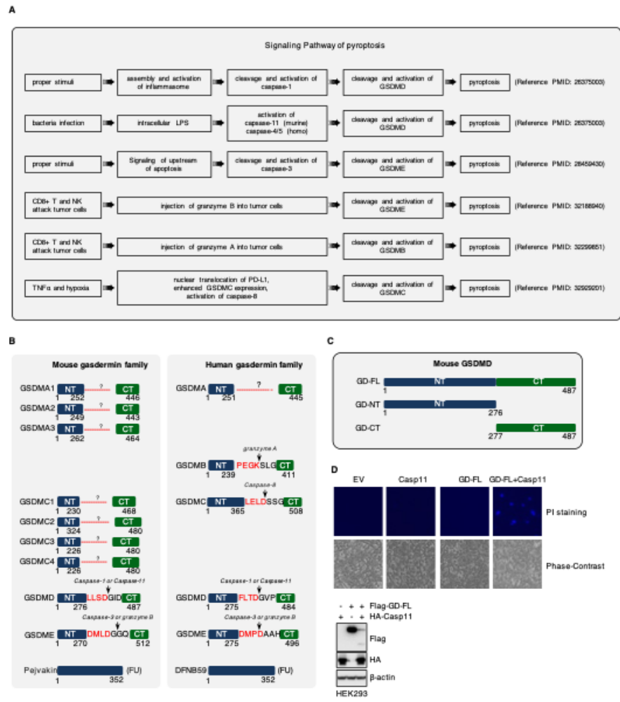
Extended Data Fig. 1 | Protease-mediated cleavage of gasdermin causes pyroptosis.
A. Schematic illustration of pyroptotic signaling pathways indicates that the specific cleavage and activation of gasdermin family is the key event of pyroptosis.
B. Schematic illustration of the cleavage site in human or mouse gasdermin family and the proteases responsible for the specific cleavage.
C. Schematic illustration of mouse GSDMD full-length (GD-FL), N-terminal domain (GD-NT) and C-terminal domain (GD-CT).
D. Caspase-11 cleaves GSDMD to produce the cytolytic fragment GD-NT. HEK293 cells were transfected with Flag-GD-FL and/or HA-caspase-11. 24 hour later, cells were subjected to DAPI staining for fluorescent microscope imaging or cell lysis for immunoblot with the indicated antibodies.

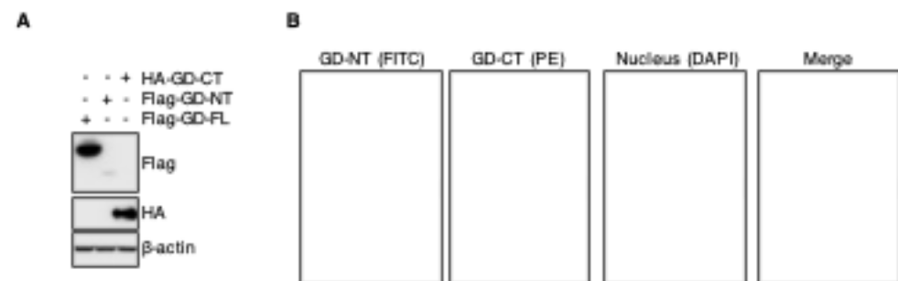

Extended Data Fig. 2 | GD-CT binds GD-NT and blocks its translocation to plasma membrane
A. Validation of GSDMD constructs. HEK293 cells were transfected with Flag-GD-FL, Flag-GD-NT or HA-GD-CT. 24 hours later, cells were harvested and WCL was subjected to IB analysis with indicated antibodies.
B. Co-distribution of NT and CT by fluorescent-macroscopy. HeLa cells were co-transfected with Flag-GD-NT and HA-GD-CT, 18 hours later, cells were fixed with methanol, stained with mouse FITC-Flag or rabbit PE-HA antibody, counter stained with Hoechst. The distribution of NT and CT were visualized by fluorescent-macroscopy.

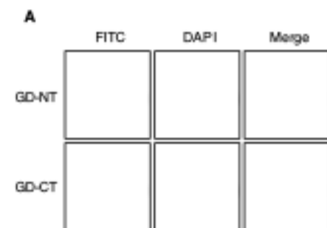

Extended Data Fig. 3 | The free GD-CT does not localize on plasma membrane
A. Co-distribution of NT and CT by fluorescent-macroscopy. HeLa cells were transfected with Flag-GD-NT or Flag-GD-CT, respectively. 18 hours later, cells were fixed with methanol, stained with mouse FITC-Flag or rabbit PE-HA antibody, counter stained with Hoechst. The distribution of NT and CT were visualized by fluorescent-macroscopy.

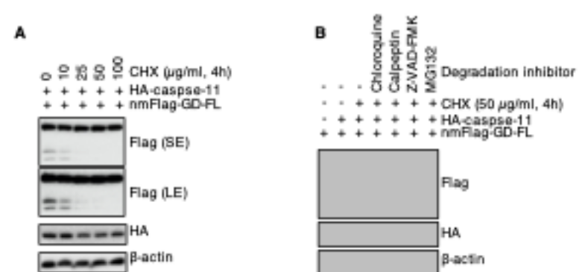

Extended Data Fig. 4 | The short half-life of GD-CT contributes to the liberation of GD-NT.
A. HEK293T cells were transfected with nmFlag-GD-FL and/or HA-caspase-11. 20 hours later, different concentration of CHX were used to block protein synthesis and the cells were harvested at 4 hours post-CHX for IB analysis with indicated antibodies.
B. HEK293T cells were transfected with nmFlag-GD-FL and/or HA-caspase-11. 20 hours later, the cells were treated with with CHX (50 µg/ml) and different degradation hibhitors. 4 hours post-CHX, the cells were harvested for IB analysis with indicated antibodies.

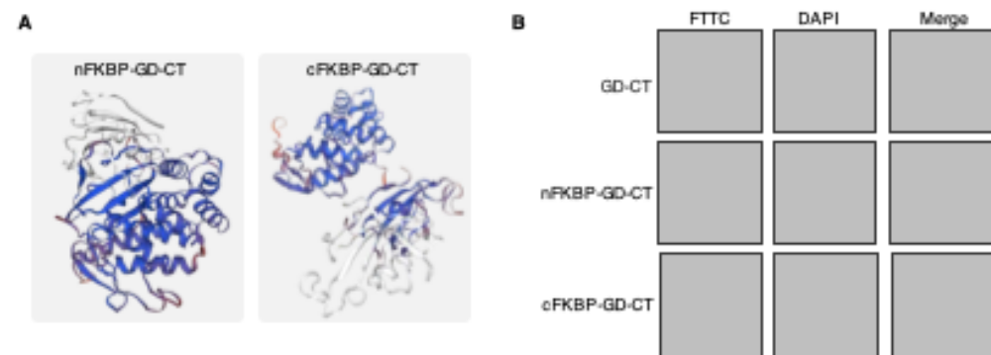

Extended Fig. 5 | The design of chimera protein FKBP-GD-CTs.
A. Schematic illustration depicts the structure of mouse GSDMD. Structure of FKBP-GD-CTs was analyzed and predicted via RCSB PDB (PDB code: 6N9N) and PyMOL was used to generate structure model.
B. Distribution of NT and CT by fluorescent-macroscopy. HeLa cells were co-transfected Flag-FKBP-GD-CTs or Flag-GD-CT, 18 hours later, cells were fixed with methanol, stained with mouse FITC-Flag antibody, counter stained with Hoechst. The distributions of these proteins were visualized by fluorescent-macroscopy.

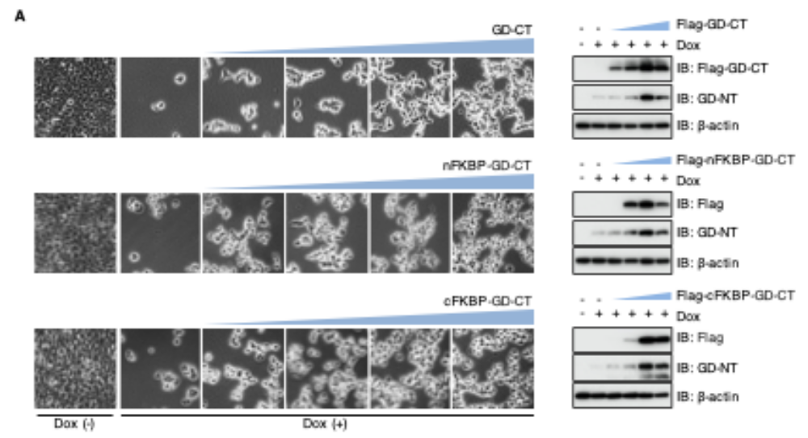
Extended Fig. 6 | FKBP-GD-CTs blocks GD-NT-mediated pyroptosis in a more efficient way.
A, 293-tetO-GD cells were transfected with the indicated constructs. 24 hours later, cells were treated with Dox (2 µg /ml). 16 hours after Dox, the cells were imaged under phase-contrast microscope (left) or subjected to IB analysis with indicated antibodies (right).

