Supporting information

Formic acid dehydrogenation using Ruthenium-POP pincer complexes in ionic liquids
Alexander Tobias Nikol¹, Brenda Rabell¹, René Wugt Larsen¹ & Martin Nielsen¹
1) Department for Chemistry, Technical University of Denmark (DTU), 2800 Kongens Lyngby, Denmark, Email: marnie@kemi.dtu.dk

General Information
All syntheses, unless otherwise stated, were performed under inert gas conditions using standard Schlenk or glovebox techniques. Ligand precursors were commercially achieved and used without further purification or synthesized according to established protocols[1-3]. Solvents were deoxygenated by argon bubbling and dried from water impurities by the use of an Inert Puresolv solvent purification system or by distillation over sodium/benzophenone followed by three cycles of freeze-pump-thaw. Ionic liquids were commercially acquired and used without further purification.

Instrumentation
Nuclear Magnetic Resonance spectroscopy (NMR)
NMR spectra were obtained using a Bruker Ascend 400, 600 or 800 MHz spectrometer equipped with BBFO and TCI CryoProbe probes. Chemical shifts are expressed in ppm relative to tetramethylsilane (TMS) for ¹H and ¹³C spectra using residual solvent signal peaks or TMS as internal reference. For ³¹P spectra, values are expressed in ppm relative to H₃PO₄. Residual solvent chemical shifts are explained according to literature[4]. Coupling constants, if available, are given in Hz as absolute values. Multiplicities are given as singlets (s), dublets (d), triplets (t), quartets (q) and multiplets (m). Literature-known compounds were analyzed only using ¹H-NMR spectroscopy to confirm purity. NMR spectra were analysed using MestReNova software.
Single-Crystal X-ray diffraction (SC-XRD)
All crystals were submerged in polybutene oil (Sigma, > 90%) as protection against oxidation and hydrolysis by air. Suitable crystals were identified using light microscopy and harvested with a MiTeGen cryo loop. They were mounted on a 5-axis goniometer attached to a Rigaku SuperNova dual source CCD-diffractometer. The measurements were conducted at 120 K using either Mo Kα or Cu Kα radiation. Structures were solved using Olex2[5] equipped with SHELXT[6] software using intrinsic phasing and refined to completion using SHELXL employing least square minimizations against F². Thermal ellipsoids are printed at 70% probability. All depictions follow the following colour code: Hydrogen white, carbon grey, oxygen red, phosphorous purple, chlorine dark green, ruthenium dark blue.
Elemental Analysis (EA)
Elemental Analysis (EA, CHN analysis) was performed by Mikroanalytisches Laboratorium Kolbe in Oberhausen, Germany.
Infrared Spectroscopy (ATR-IR)
Solid-state attenuated total reflectance Fourier transform infrared (ATR-FTIR) spectroscopy was performed employing a VERTEX 80 vacuum Fourier transform spectrometer from Bruker Optics GmbH equipped with a Germanium-coated KBr beam splitter, a LN₂-cooled HgCdTe detector and globar radiation source. The solid samples were brought in contact with a Germanium ATR crystal of a single-reflection ATR accessory from PIKE Technologies, Inc., which in contrast to a conventional diamond ATR crystal is highly transparent in the important spectral region of the Ru-H stretching fundamental transitions around 2000 cm⁻¹. Blocks of 300 co-added scans with a spectral resolution of 2 cm⁻¹ were collected both with the sample and of the cleaned ATR crystal before and after sample measurements. Minor traces of residual water vapor absorption were subtracted and gentle corrections for baseline drifts were introduced before the final application of extended ATR corrections compensating for the wavelength-dependent penetration depth of the infrared probe beam into the sample.
Gas chromatography (GC)
GC-TCD measurements were taken on an Agilent Technologies 6890M Network GC system.

Catalyst synthesis
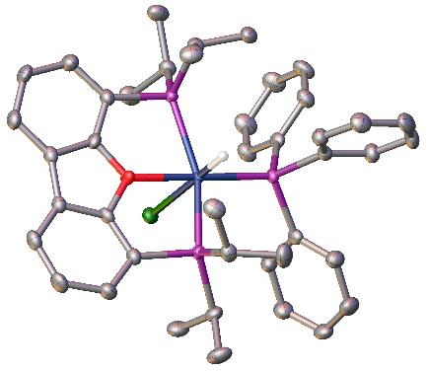
The metal precursor [RuHCl(PPh₃)₃]•toluene, the iPr-DBFphos ligand, and Ru-1 were synthesized according to previously established protocols[7-9]. The protocol established for Ru-1 was applied for the synthesis of Ru-2.
[RuHCl(iPr-DBFphos)(PPh₃)] Ru-2
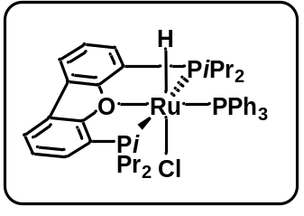
In a 50 mL Schlenk flask, iPr-DBFphos (46.2 mg, 0.115 mmol, 1.1 eq.) and [RuHCl(PPh₃)₃]•toluene (106.4 mg, 0.105 mmol, 1.0 eq.) were dissolved in dry THF (15 mL) and refluxed for four hours. A colour change from dark purple to orange was observed. The mixture was allowed to cool to room temperature and the solvent was removed in vacuo. The crude product was freeze-dried from benzene and obtained as an orange powder. It was washed with hexane (3 times 12 mL), dried in vacuo overnight and obtained as a yellow solid in quantitative yield. Crystals of sufficient quality for XRD can be grown by crystallization from THF/diethyl ether, toluene/diethyl ether or toluene/hexane using the gas diffusion method at -30 °C or from benzene/hexane using the gas diffusion method at room temperature.
¹H NMR (400 MHz, C₆D₆, 298 K, ppm) δ 8.49 (t, J = 9.7 Hz, 6H), 7.47 (d, J = 7.6 Hz, 2H), 7.40 (d, J = 7.5 Hz, 2H), 7.20 (d, J = 7.6 Hz, 6H), 7.07 (t, J = 7.4 Hz, 3H), 7.01 (t, J = 7.6 Hz, 2H), 2.04 – 1.93 (m, 2H), 1.64 – 1.54 (m, 6H), 1.16 – 1.09 (m, 8H), 0.95 – 0.81 (m, 12H), -16.80 (dt, J = 28.6, 22.0 Hz, 1H, RuH).
¹³C NMR (101 MHz, C₆D₆, 298 K, ppm) δ 161.20, 141.71 (d, J = 39.9 Hz), 135.80 (d, J = 9.5 Hz), 129.11, 128.89, 127.20 (d, J = 8.9 Hz), 124.59, 123.32, 123.08 (t, J = 3.0 Hz), 120.78 (t, J = 7.5 Hz), 28.41 (t, J = 12.1 Hz), 26.06 (t, J = 6.4 Hz), 22.01, 19.79 (t, J = 2.5 Hz), 19.30, 19.03 (t, J = 4.4 Hz).
³¹P{¹H} NMR (162 MHz, C₆D₆, 298 K, ppm): δ 73.22 (t, ²J_{PP} = 27.8 Hz, 1P, PPh₃), 58.97 (d, ²J_{PP} = 27.4 Hz, 2P, iPr-DBFphos).
IR (ATR, Germanium, cm⁻¹): 3051, 2980, 2956, 2924, 2868, 2054, 1481, 1477, 1468, 1436, 1431, 1417, 1401, 1382, 1238, 1223, 1086, 1029, 884, 836, 769, 753, 750, 739, 701, 682, 648, 629, 618, 549, 546, 541, 532, 515, 506, 485, 459.
EA Calcd. (%) for C₄₂H₅₀ClOP₃Ru (800.30) C 63.03, H 6.30, found C 62.91, H 6.35.
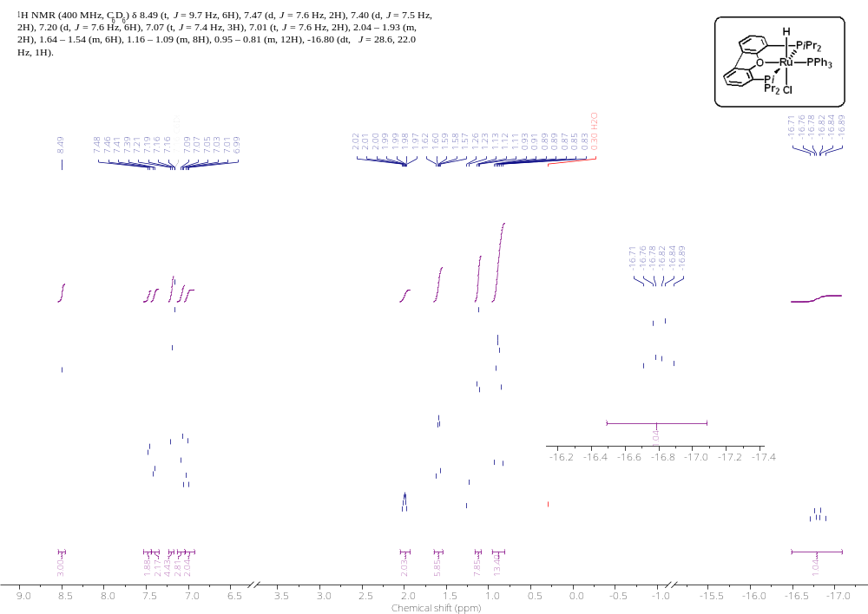
Supplementary Figure 1: 400 MHz ¹H NMR spectrum of Ru-2 in C₆D₆ at 25 °C.

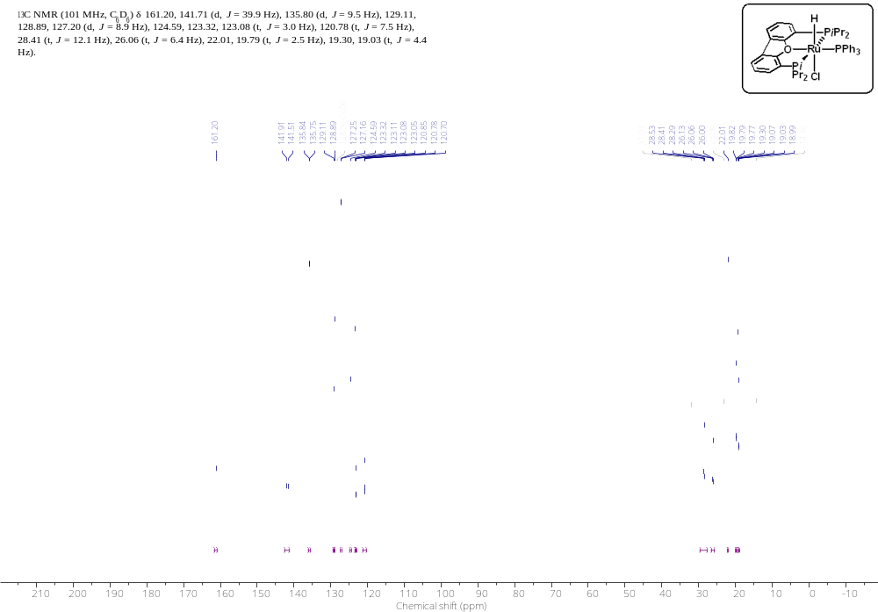
Supplementary Figure 2: 101 MHz ¹³C NMR spectrum of Ru-2 in C₆D₆ at 25 °C.

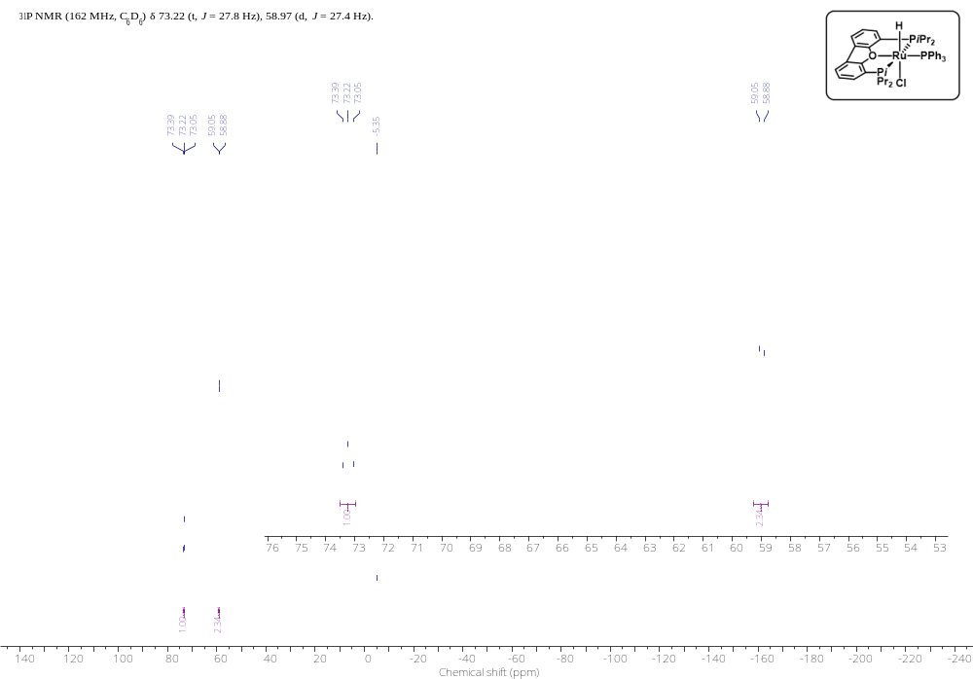
Supplementary Figure 3: 162 MHz ³¹P{¹H} NMR spectrum of Ru-2 in C₆D₆ at 25 °C.

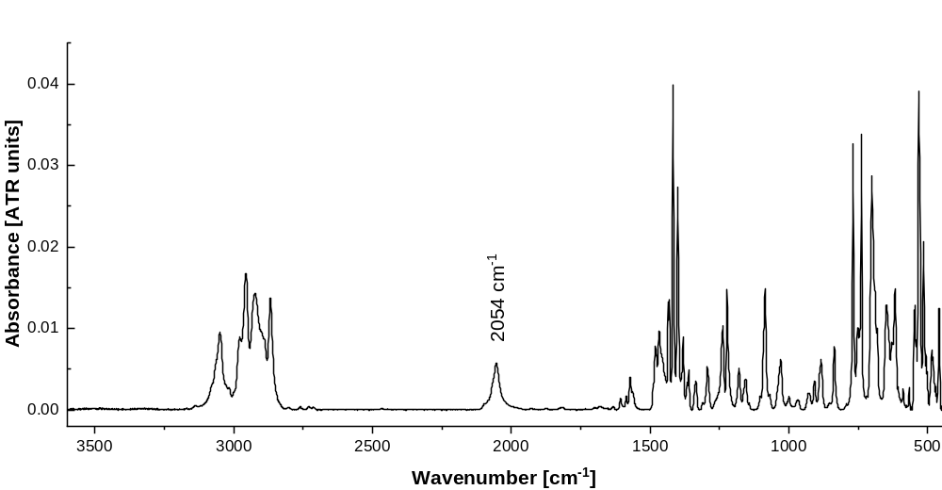
Supplementary Figure 4: ATR-IR spectrum of Ru-2.

Supplementary Table 1: Crystallographic data for Ru-2.
[RuHCl(iPr-dbfphos)(PPh₃)]
Ru-2
Empirical formula | C₄₈H₅₆ClOP₃Ru
Formula weight | 878.418
Temperature/K | 120.00(16)
Crystal system | triclinic
Space group | P-1
a/Å | 10.9901(2)
b/Å | 11.9981(2)
c/Å | 16.9442(2)
α/° | 100.981(1)
β/° | 91.241(1)
γ/° | 97.890(1)
Volume/Å³ | 2179.97(6)
Z | 2
ρ_{calc}g/cm³ | 1.344
μ/mm⁻¹ | 4.797
F(000) | 921.0
Crystal size/mm³ | 0.225 × 0.062 × 0.062
Radiation | Cu Kα (λ = 1.54184)
2Θ range for data collection/° | 5.32 to 153.06
Index ranges | -13 ≤ h ≤ 13, -15 ≤ k ≤ 14, -21 ≤ l ≤ 20
Reflections collected | 46550
Independent reflections | 9080 [R_{int} = 0.0397, R_{sigma} = 0.0286]
Data/restraints/parameters | 9080/0/499
Goodness-of-fit on F² | 1.037
Final R indexes [I>=2σ (I)] | R₁ = 0.0253, wR₂ = 0.0608
Final R indexes [all data] | R₁ = 0.0273, wR₂ = 0.0624
Largest diff. peak/hole / e Å⁻³ | 0.65/-0.76

Catalytic protocols
In an inert gas glovebox, a 50 mL two-neck flask equipped with a stir bar and a nitrogen adapter was charged with the ruthenium complex (13.0 µmol, 0.1 mol%), sealed with a stopper and brought outside. It was connected to an air-cooled reflux condenser and BMIM OAc (1.0 mL, 5.35 mmol, 0.4 eq.) was injected via a syringe through a septum. The mixture was stirred and heated to the desired temperature. Formic acid (FA, 0.50 mL, 13.25 mmol, 1.0 eq.) was injected via syringe through a septum. Immediate gas formation of CO₂ and H₂ as well as a colour change was observed and the mixture was kept stirring at a constant temperature for 3 h, during which multiple samples for NMR analysis were taken via syringe through the septum.
To calculate conversions, the ¹H NMR signal of the methyl group on the BMIM cation (peak e) was integrated to three times the molar amount of BMIM. Then, the formate signal was integrated, and divided by the injected amount of FA. An example of this can be found below with 5.35 mmol BMIM OAc and 13.25 mmol of FA. All NMRs were taken at room temperature on a 400 MHz Bruker Ascend spectrometer using acetonitrile-d₃ as solvent.
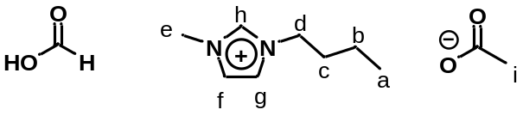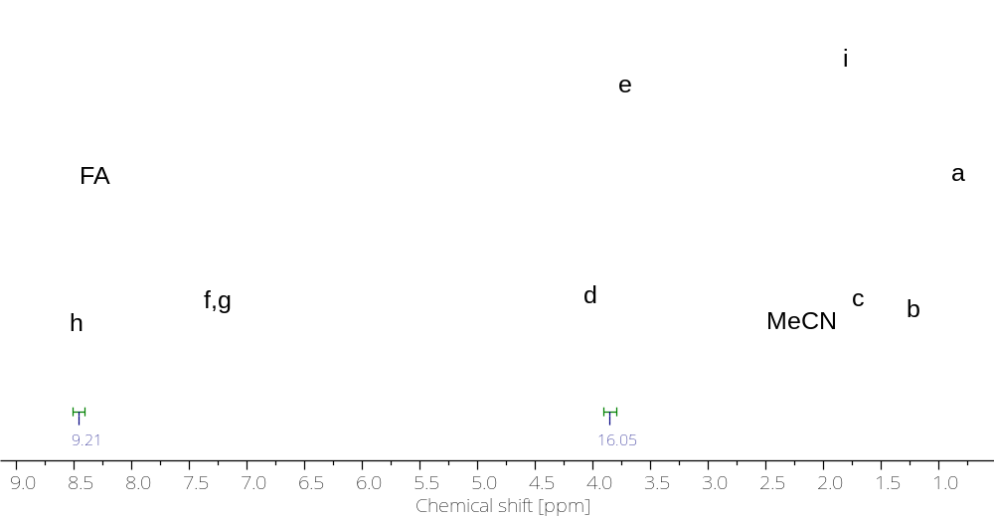
Supplementary Figure 5: Example 400 MHz ¹H NMR of FA dehydrogenation using BMIM OAc in d₃-MeCN, showing 30% conversion (9.21 mmol of 13.25 mmol FA remaining).

The turnover frequencies were calculated using the following formula:
$$TOF=\frac{{n (FA)}_{Start}}{n (catalyst)}×conversion×\frac{1}{t [h]}$$
For the time of TOF_{max}, the timeframe was chosen in which the conversion per unit time was highest (i.e where the conversion/timeline was the steepest).
Supplementary Table 2: Temperature screening of [RuHCl(PPh₃)₃]•toluene.
 | 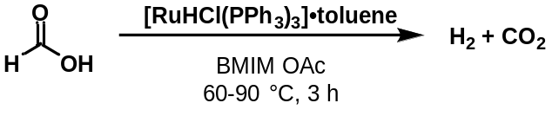
T [°C] | Conversion [%] |  |  |  |  | TOF_{overall}  [h⁻¹] | TOF_{max} [h⁻¹]  (time interval [min])
T [°C] | 10 min | 30 min | 60 min | 120 min | 180 min | TOF_{overall}  [h⁻¹] | TOF_{max} [h⁻¹]  (time interval [min])
90 | 56 | 78 | 87 | 94 | 97 | 330 | 3424  (0-10)
80 | 24 | 51 | 72 | 84 | 91 | 309 | 1467  (0-10)
70 | 18 | 43 | 65 | 81 | 88 | 299 | 1101  (0-10)
60 | 6 | 29 | 40 | 59 | 65 | 221 | 703  (10-30)
Conditions: 0.5 mL (13.25 mmol) FA, 1.0 mL (5.35 mmol) BMIM OAc, 13.2 mg (13 µmol, 0.1 mol%) [RuHCl(PPh₃)₃]•toluene.

Supplementary Table 3: Arrhenius plot data of FA dehydrogenation using [RuHCl(PPh₃)₃]•toluene.
T [°C] | 1/T [K⁻¹] | TOF_{max} [h⁻¹] | ln (TOF_{max})
90 | 0.00275 | 3424 | 8.14
80 | 0.00283 | 1467 | 7.29
70 | 0.00291 | 1101 | 7.00
60 | 0.003 | 703 | 6.56

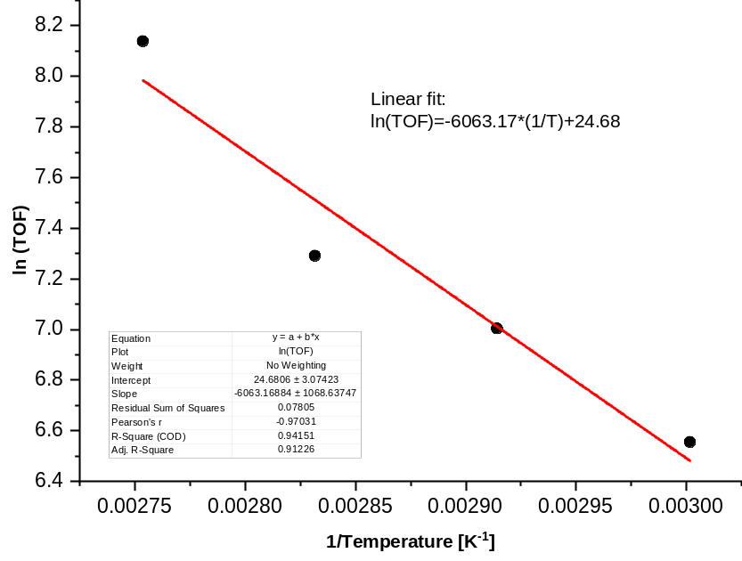
Supplementary Figure 6: Arrhenius plot of FA dehydrogenation using [RuHCl(PPh₃)₃]•toluene

$$Slope= -6063.17 \\ E_{A }=50.4 {kJ mol}^{-1}$$

Supplementary Table 4: Temperature screening of Ru-1.
 |  | 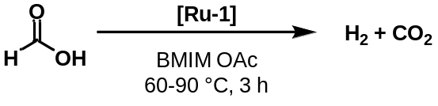
T [°C] | Conversion [%] |  |  |  |  |  | TOF_{overall}  [h⁻¹] | TOF_{max} [h⁻¹]  (time interval [min])
T [°C] | 10 min |  | 30 min | 60 min | 120 min | 180 min | TOF_{overall}  [h⁻¹] | TOF_{max} [h⁻¹]  (time interval [min])
90 | 74 |  | 90 | 93 | 96 | 98 | 333 | 4525  (0-10)
80 | 14 |  | 79 | 87 | 92 | 96 | 326 | 1988  (10-30)
70 | 23 |  | 73 | 85 | 90 | --- | 458 | 1529  (10-30)
60 | 0 |  | 0 | 12 | 79 | 83 | 281 | 682  (60-120)
Conditions: 0.5 mL (13.25 mmol) FA, 1.0 mL (5.35 mmol) BMIM OAc, 12.7 mg (13 µmol, 0.1 mol%) Ru-1.

Supplementary Table 5: Arrhenius plot data of FA dehydrogenation using Ru-1.
T [°C] | 1/T [K⁻¹] | TOF_{max} [h⁻¹] | ln (TOF_{max})
90 | 0.00275 | 4525 | 8.42
80 | 0.00283 | 1988 | 7.59
70 | 0.00291 | 1529 | 7.33
60 | 0.003 | 682 | 6.53

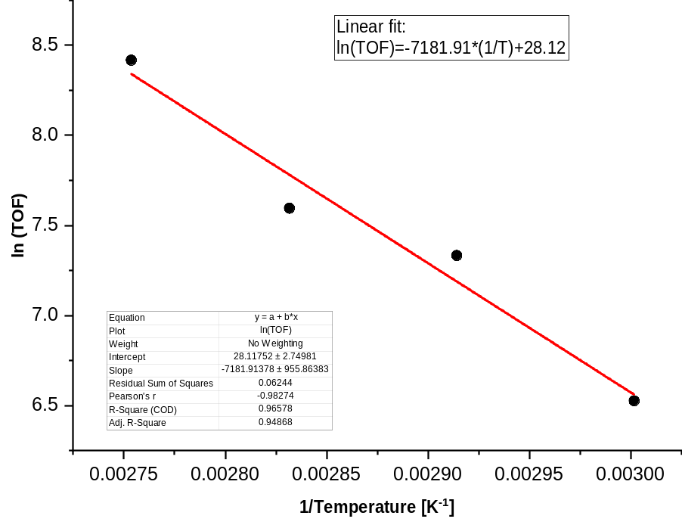
Supplementary Figure 7: Arrhenius plot of FA dehydrogenation using Ru-1.
$$Slope= -7181.91$$$E_{A }= 59.7 {kJ mol}^{-1}$
Supplementary Table 6: Temperature screening of Ru-2.
 |  | 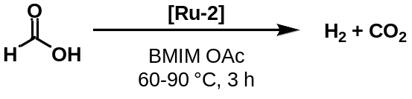
T [°C] | Conversion [%] |  |  |  |  |  | TOF_{overall}  [h⁻¹] | TOF_{max} [h⁻¹]  (time interval [min])
T [°C] | 10 min |  | 30 min | 60 min | 120 min | 180 min | TOF_{overall}  [h⁻¹] | TOF_{max} [h⁻¹]  (time interval [min])
90 | 60 |  | 89 | 99 | --- | --- | 1009 | 3669  (0-10)
80 | 24 |  | 76 | 83 | 92 | 96 | 326 | 1590  (10-30)
70 | 0 |  | 42 | 80 | 86 | 86 | 292 | 1284  (10-30)
60 | 0 |  | 9 | 31 | 78 | 79 | 268 | 479  (60-120)
Conditions: 0.5 mL (13.25 mmol) FA, 1.0 mL (5.35 mmol) BMIM OAc, 10.4 mg (13 µmol, 0.1 mol%) Ru-2.

Supplementary Table 7: Arrhenius plot of FA dehydrogenation using Ru-2.
T [°C] | 1/T [K⁻¹] | TOF_{max} [h⁻¹] | ln (TOF_{max})
90 | 0.00275 | 3669 | 8.21
80 | 0.00283 | 1590 | 7.37
70 | 0.00291 | 1284 | 7.16
60 | 0.003 | 479 | 6.17

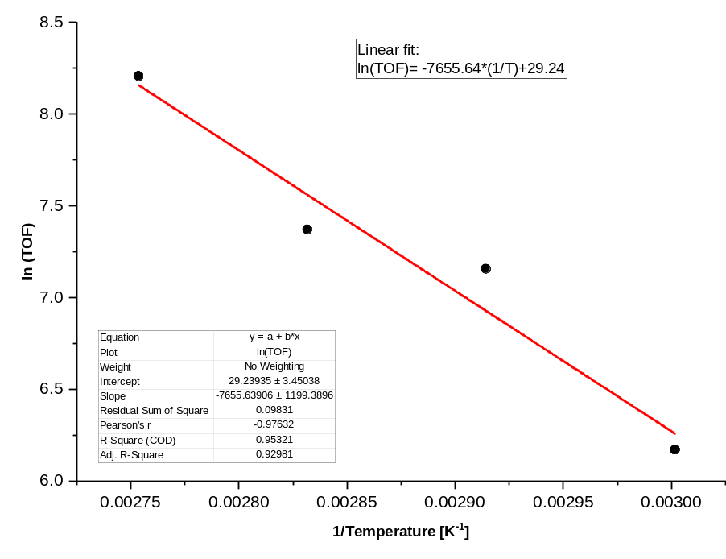
Supplementary Figure 8: Arrhenius plot of FA dehydrogenation using Ru-2.

$$Slope= -7655.64 \\ E_{A}=63.7 {kJ mol}^{-1}$$

GC-TCD report of inorganic gases
Example: Table 1, Entry 5
Reaction conditions: 13 µmol catalyst, 0.5 mL (13.25 mmol) FA, 1.0 mL (5.35 mmol) BMIM OAc. Reaction temperature and -time varies.
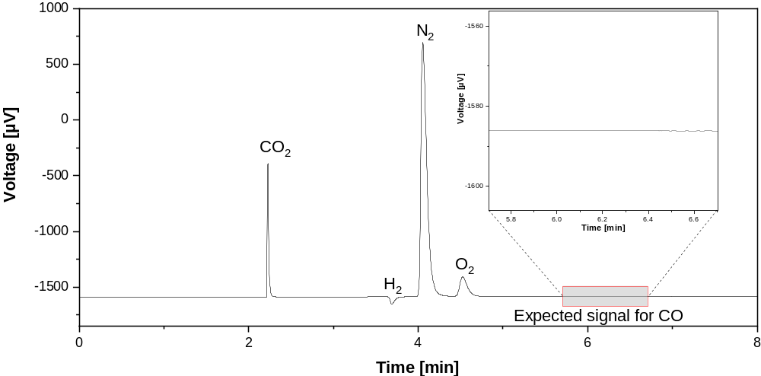
Supplementary Figure 9: GC-TCD chromatogram of FA dehydrogenation.
Bibliography

(1) Asensio, G. et al. Osmium(III) Complexes with POP Pincer Ligands: Preparation from Commercially Available OsCl₃•3H₂O and their X-ray Structures. Inorg. Chem. 49, 8665–8667 (2010).
(2) Veits, Y. A., Mutsenek, E. V., Neganova, E. G. & Beletskaya, I. P. Niew bidentate diphosphine ligands on the basis of diphenyl ether. Russ. J. Org. Chem. 37, 1583–1586 (2001).
(3) Abdur-Rashid, K. et al. The generation of hydrogen from ammonia borane through catalytic hydrolysis. (2008).
(4) Fulmer, G. R. et al. NMR chemical shifts of trace impurities: Common laboratory solvents, organics, and gases in deuterated solvents relevant to the organometallic chemist. Organometallics 29, 2176–2179 (2010).
(5) Dolomanov, O. V., Bourhis, L. J., Gildea, R. J., Howard, J. A. K. & Puschmann, H. OLEX2: A complete structure solution, refinement and analysis program. J. Appl. Crystallogr. 42, 339–341 (2009).
(6) Sheldrick, G. M. SHELXT - Integrated space-group and crystal-structure determination. Acta Crystallogr. Sect. A Found. Crystallogr. 71, 3–8 (2015).
(7) Schunn, R. A., Wonchoba, E. R. & Wilkinson, G. Chlorohydridotris(triphenylphosphine)ruthenium(II). Inorganic Syntheses 131–134 (1972)
(8) Ledger, A. E. W. et al. Pincer Phosphine Complexes of Ruthenium: Formation of Ru(P-O-P)(PPh₃) HCl(P-O-P=xantphos, DPEphos, (Ph₂PCH₂CH₂)₂O) and Ru(dppf)(PPh₃)HCl and Characterization of Cationic Dioxygen, Dihydrogen, Dinitrogen, and Arene Coordinated Phosphine Products. Inorg. Chem. 49, 7244–7256 (2010).
(9) Ledger, A. E. W. Chelating Phosphine Complexes of Ruthenium for the Coordination and Activation of Small Molecules. (University of Bath, 2011).

NMR data of catalytic dehydrogenation of formic acid

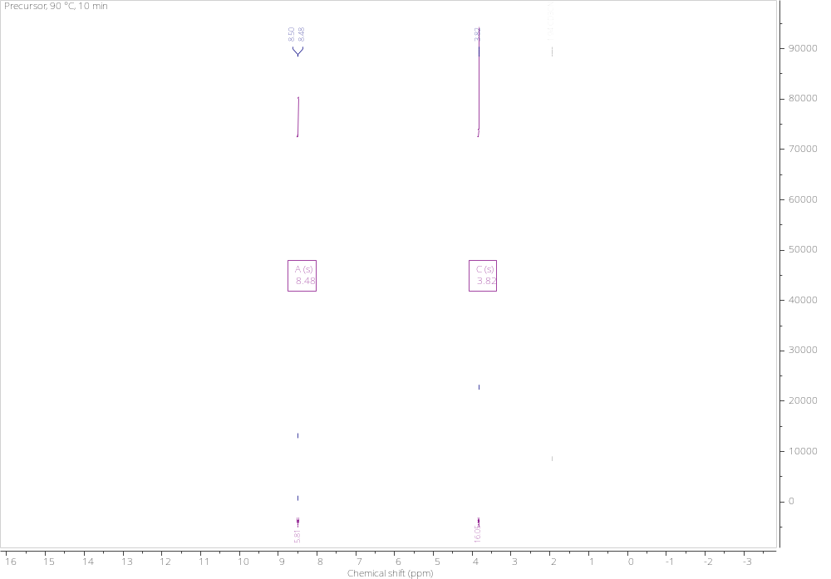

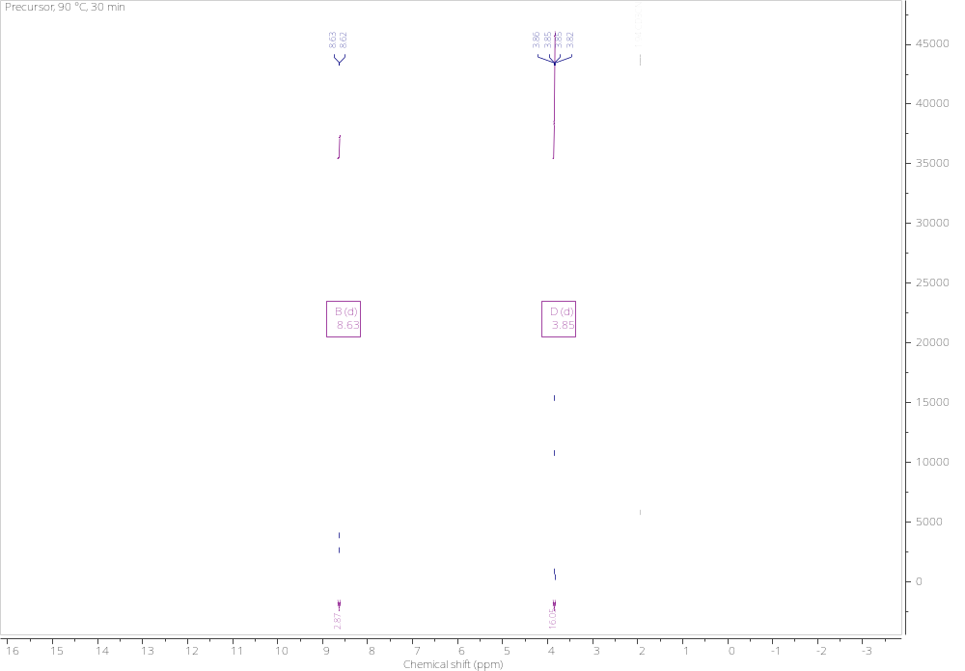
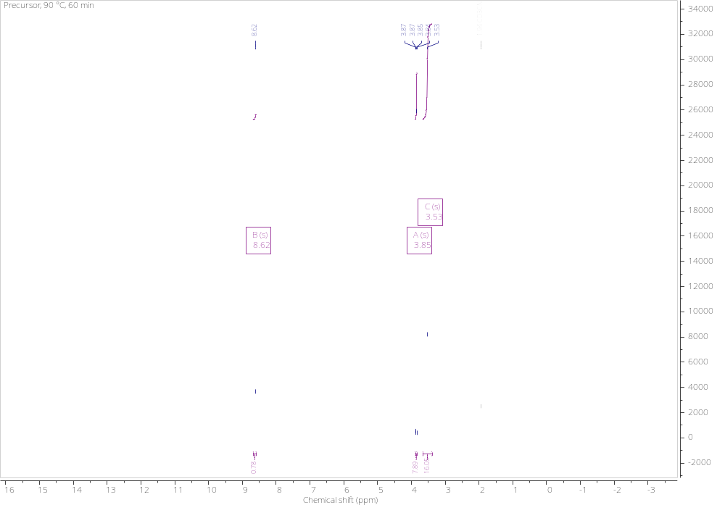

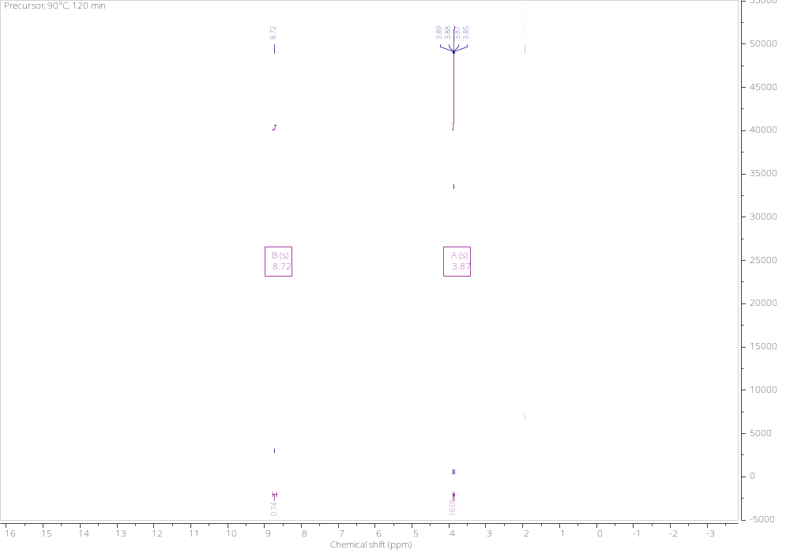
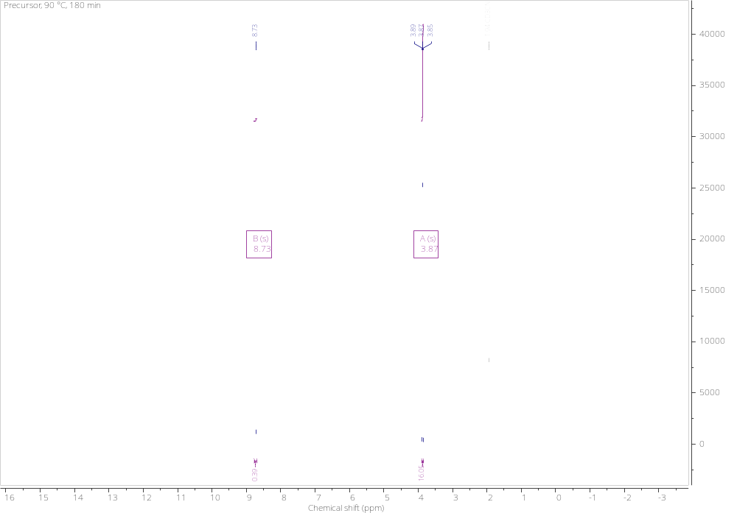

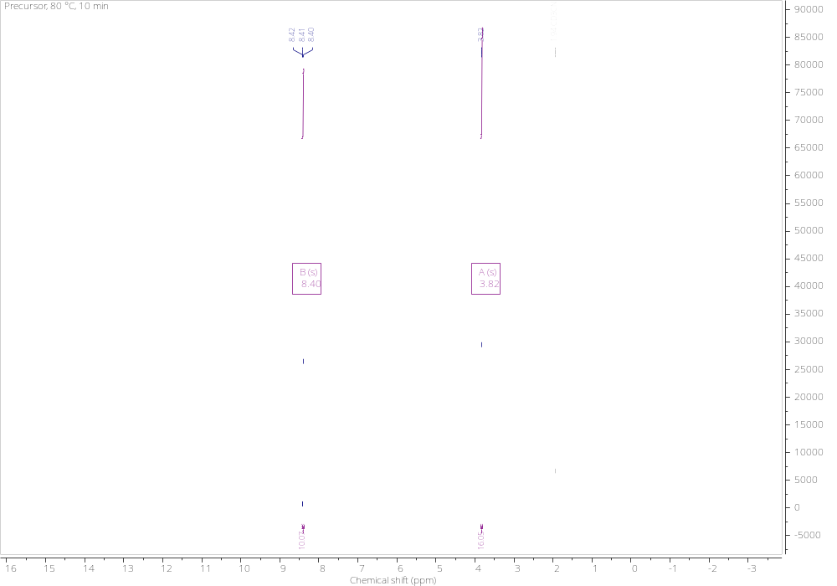

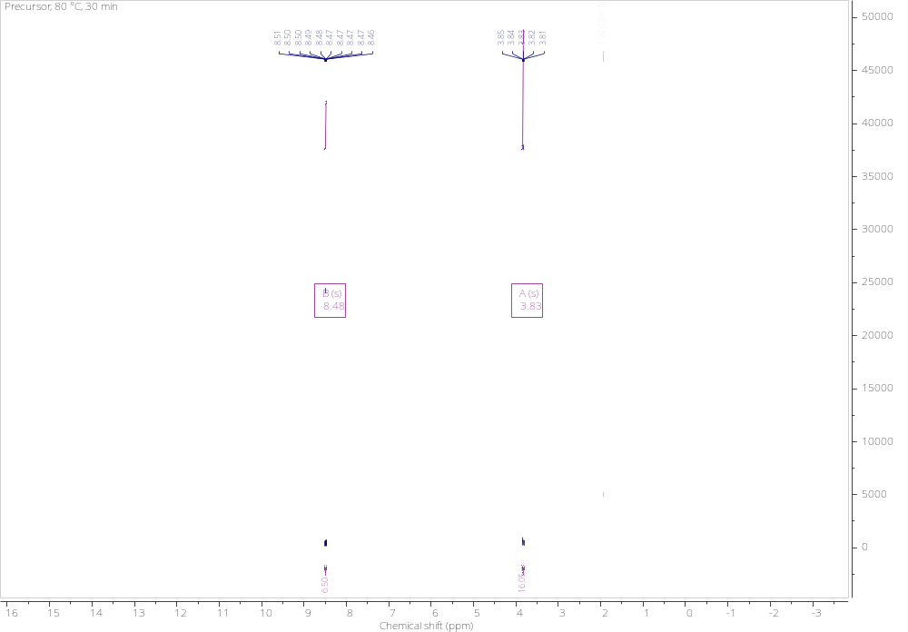
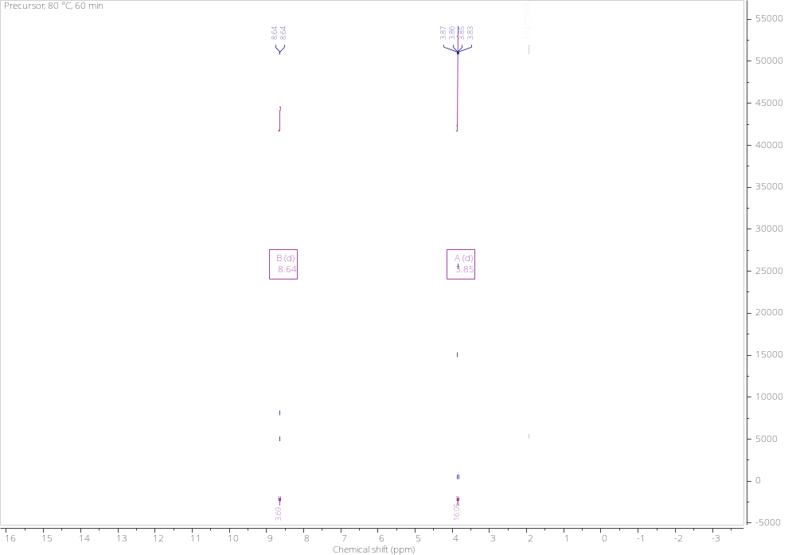
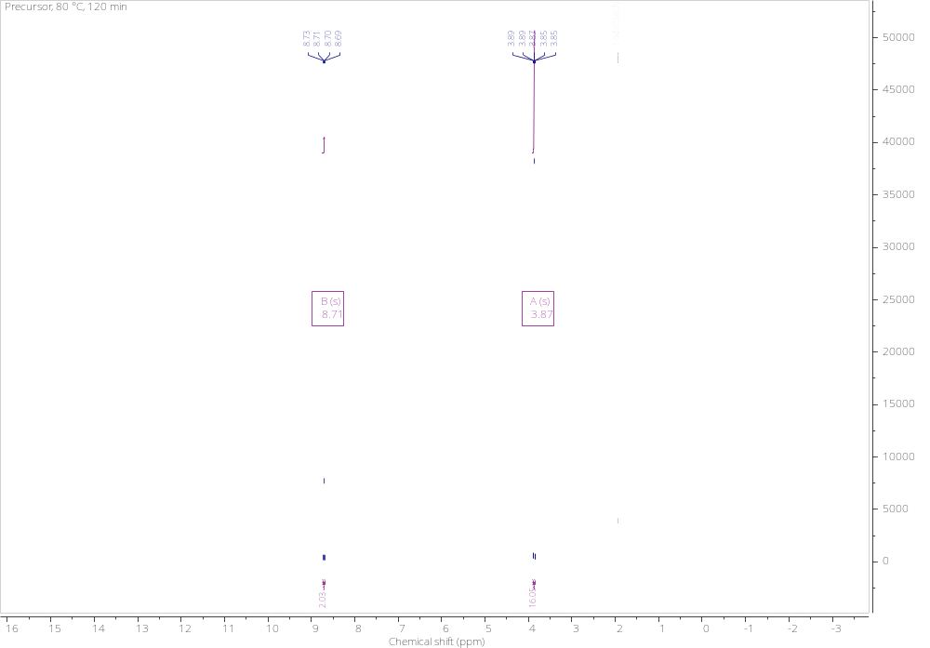

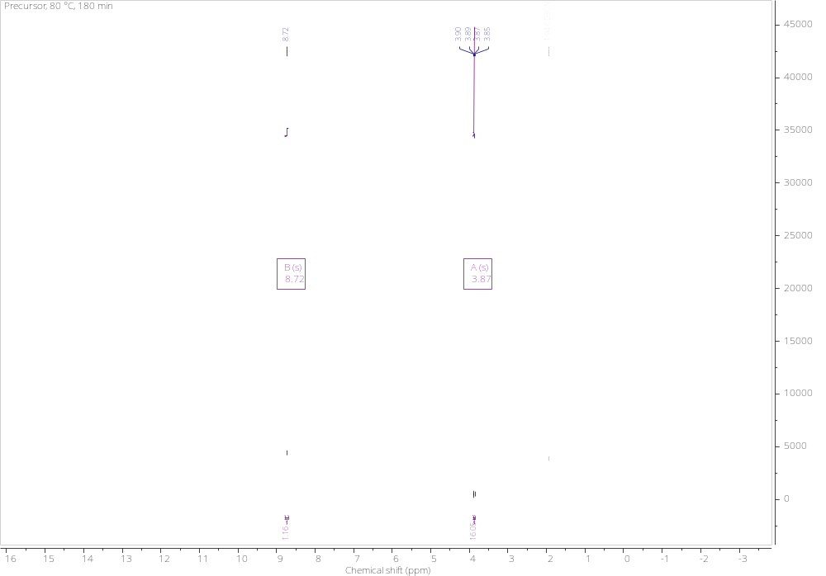
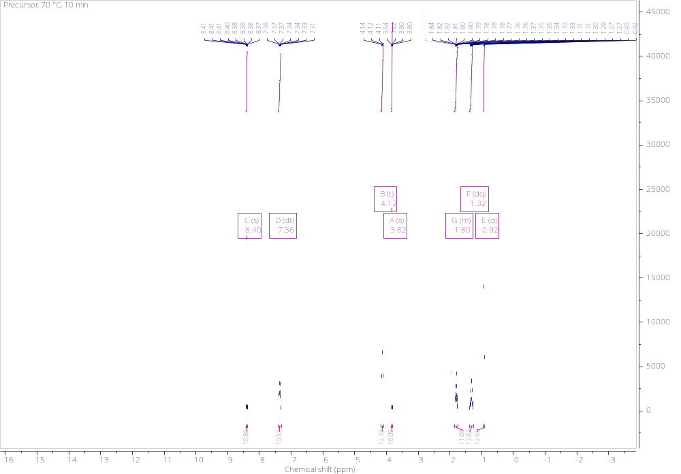

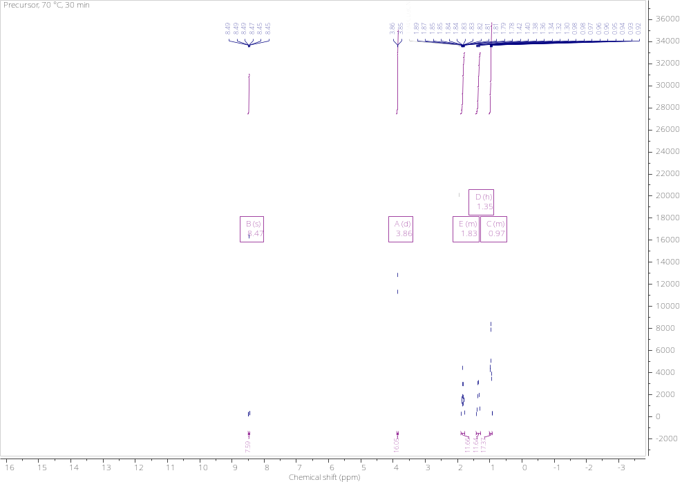
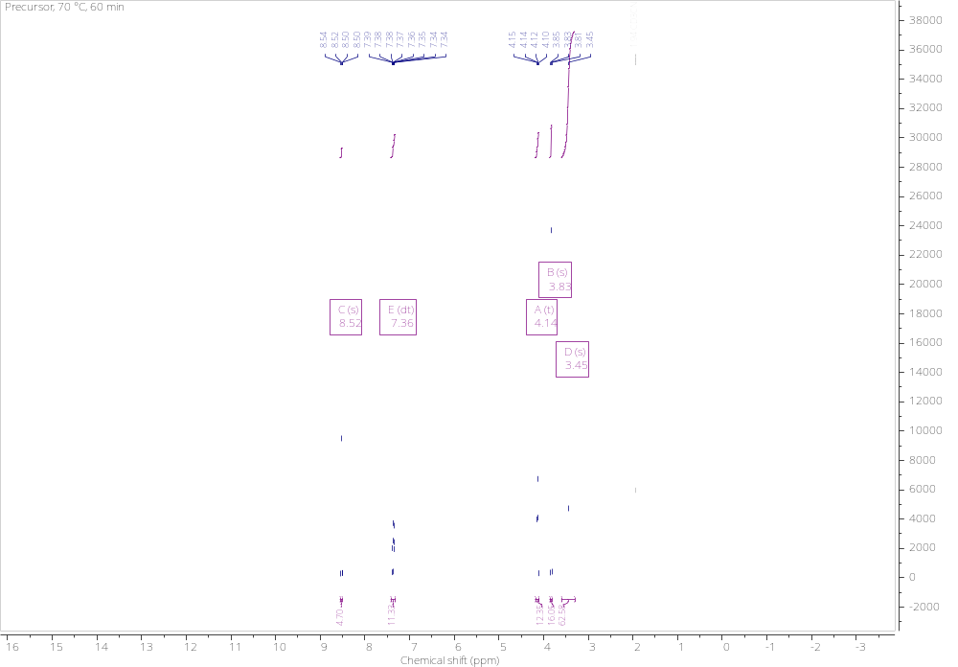

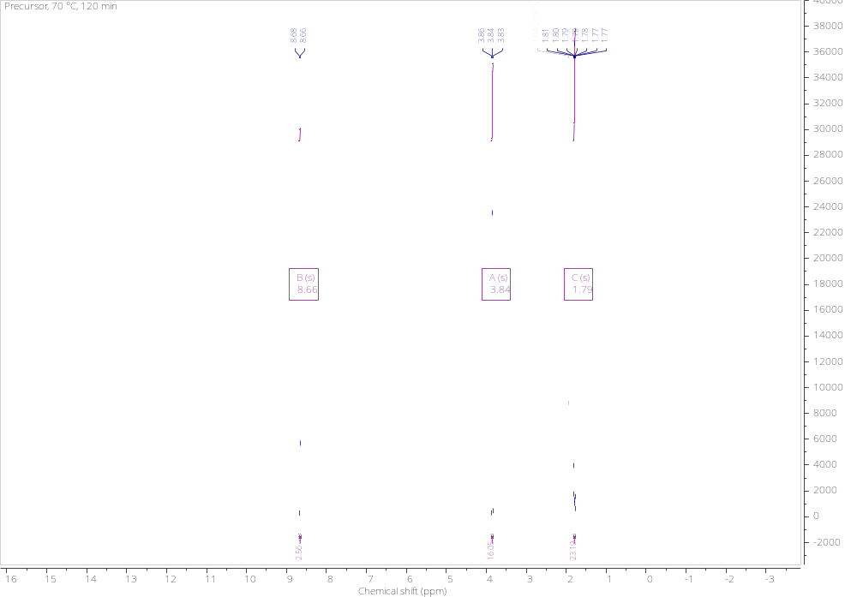
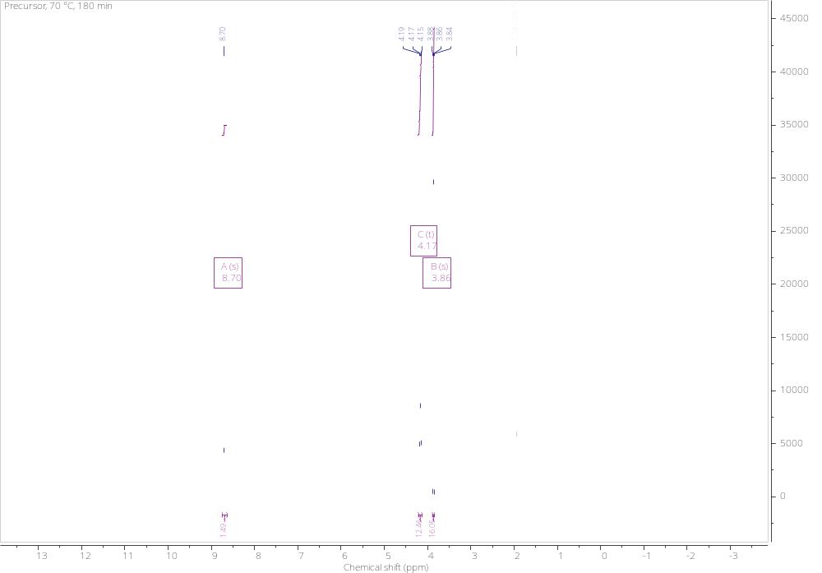

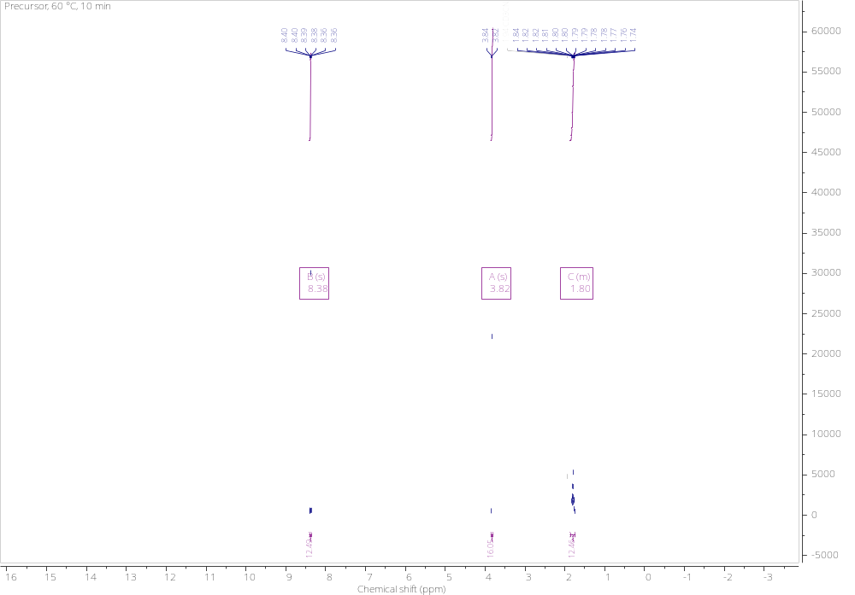

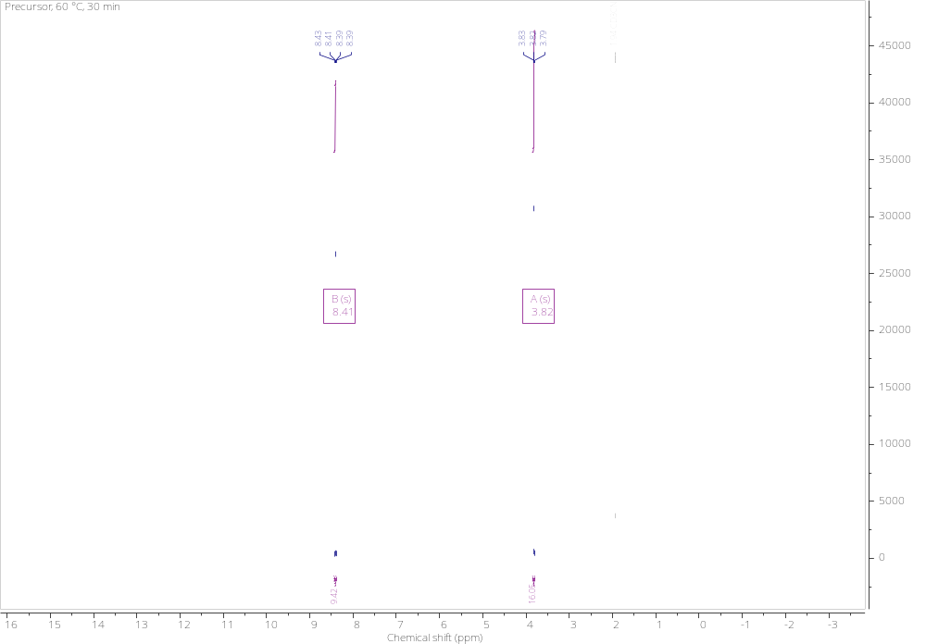
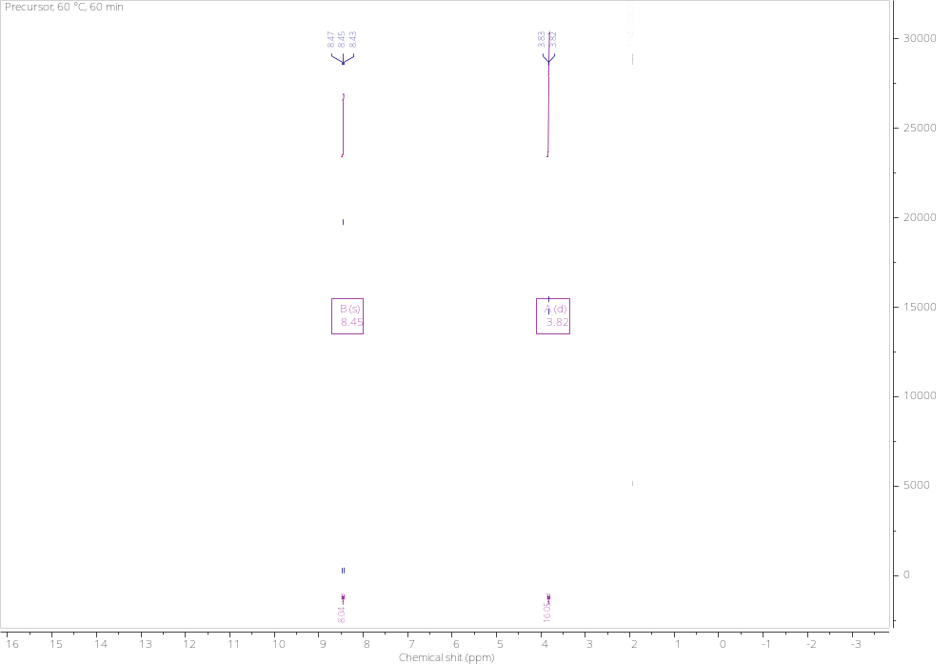

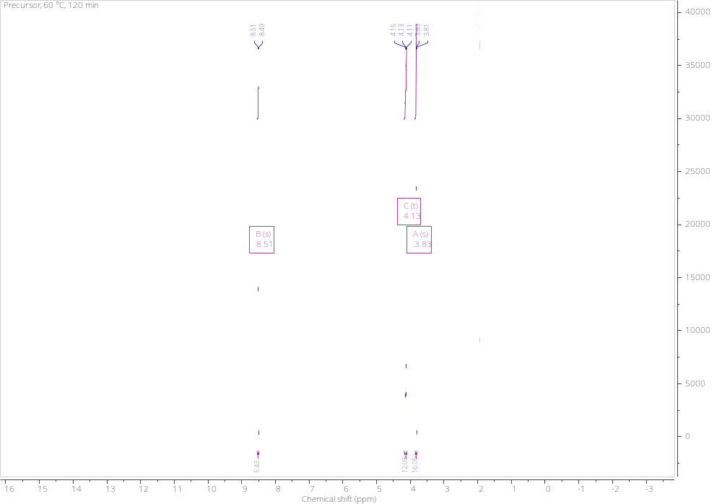
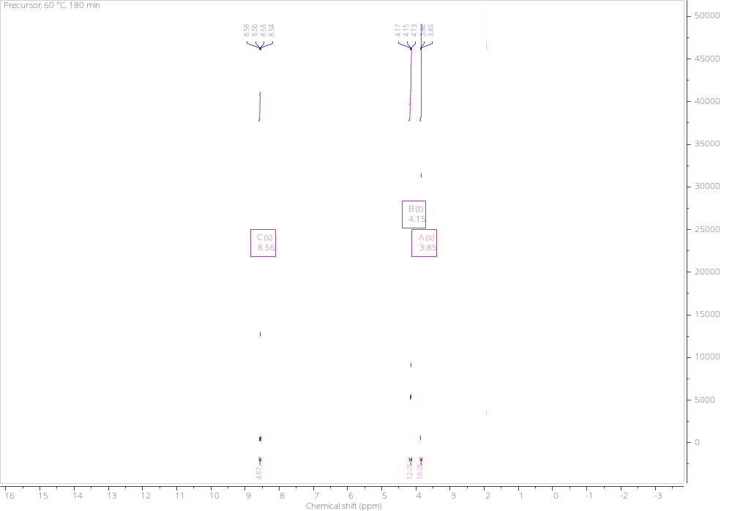

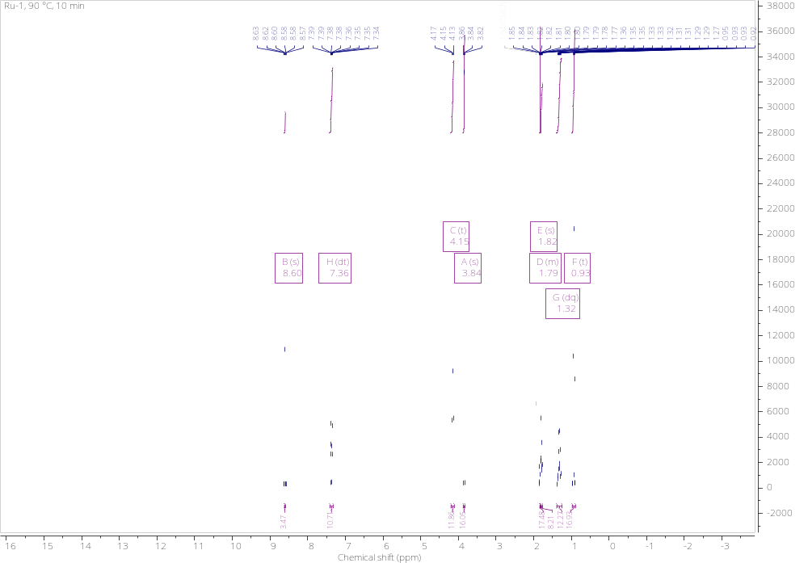

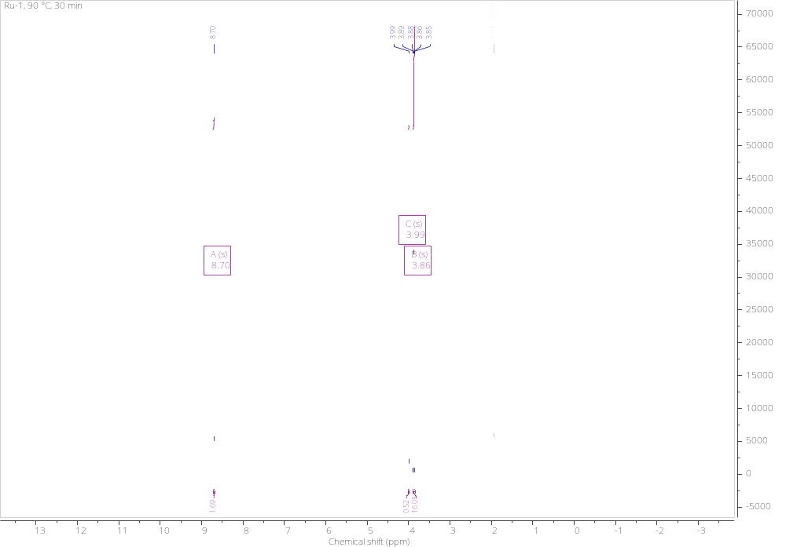
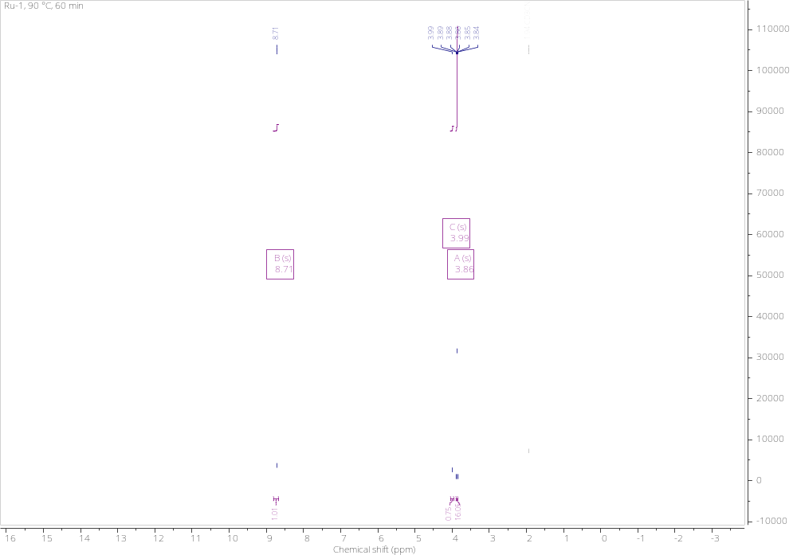

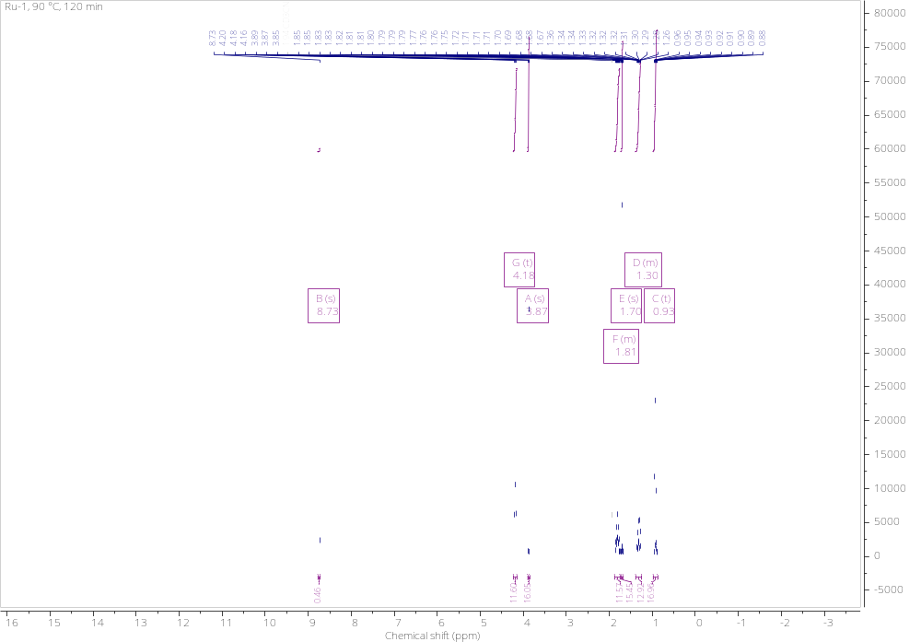
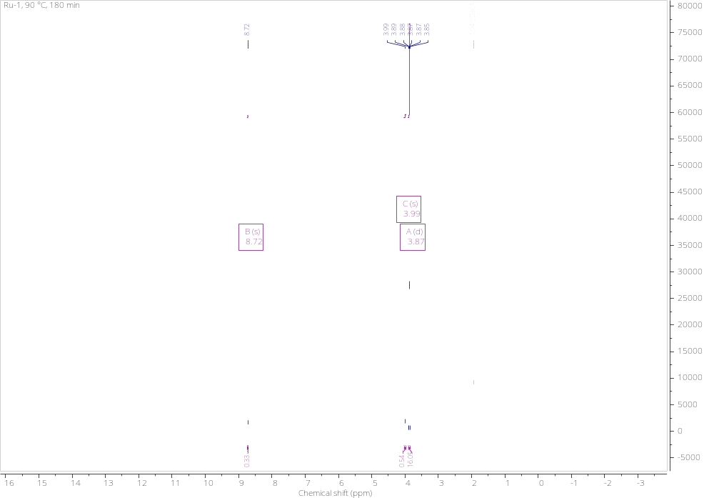

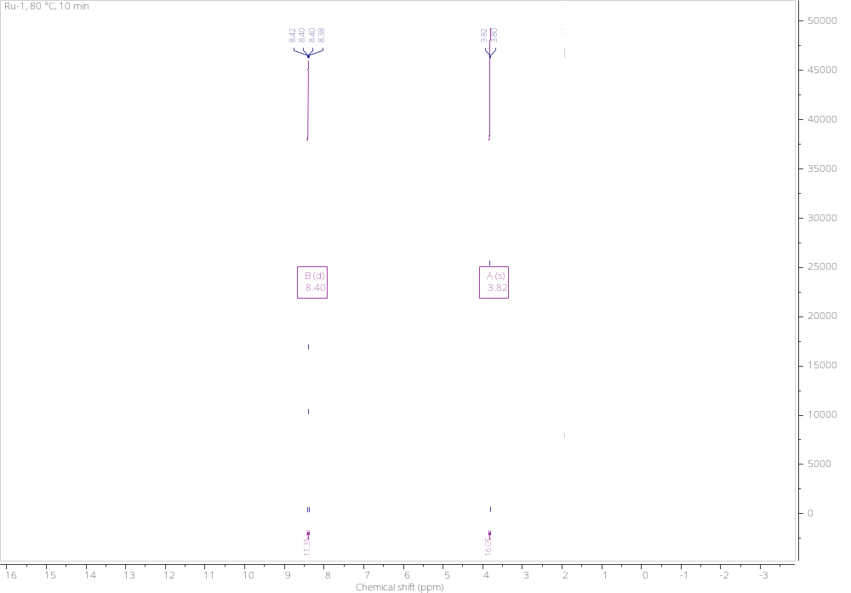

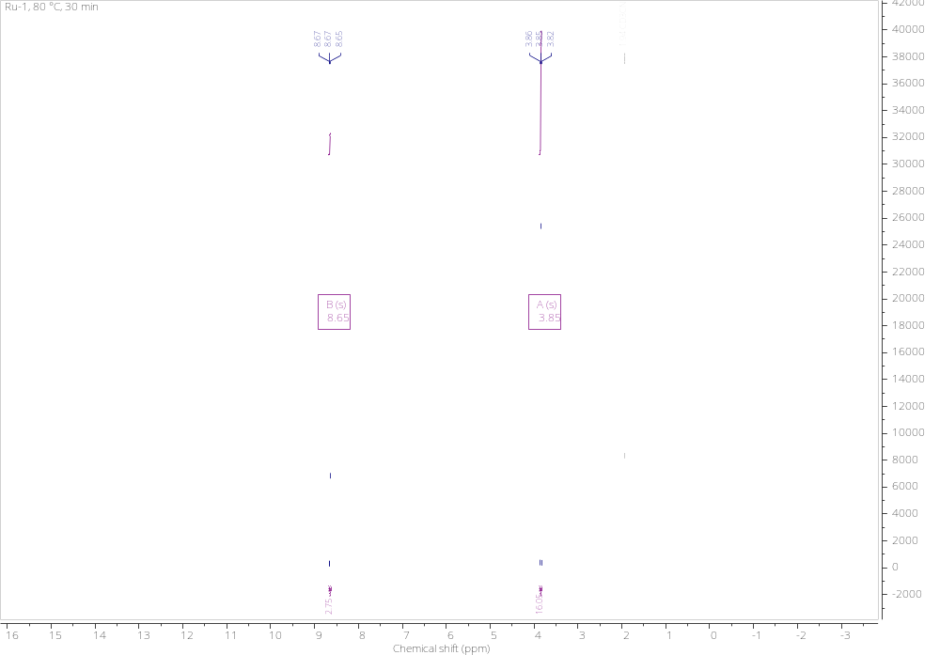
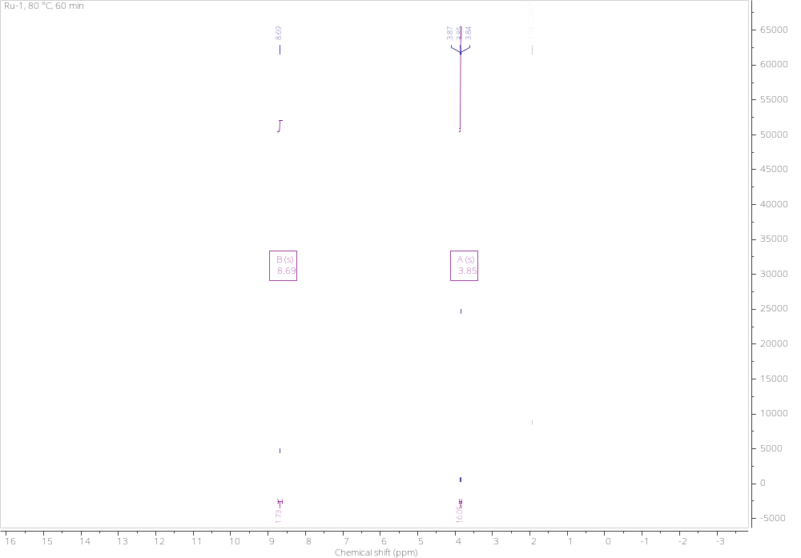

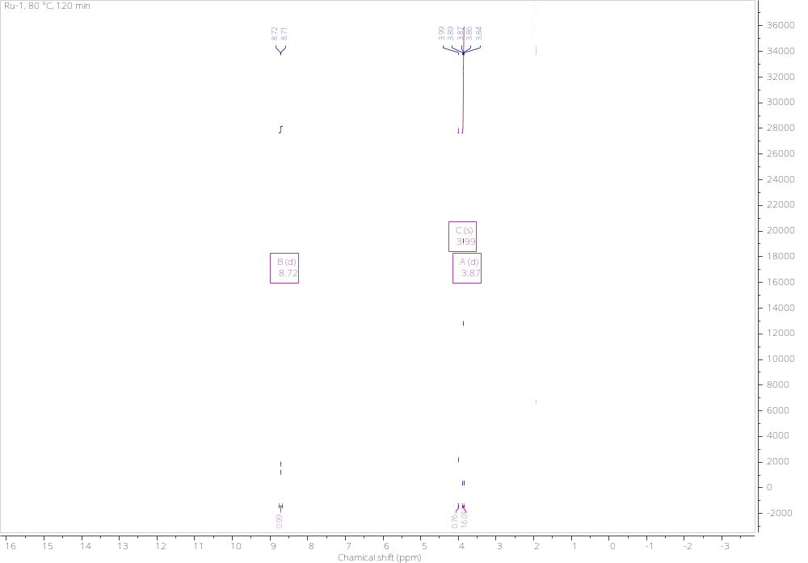
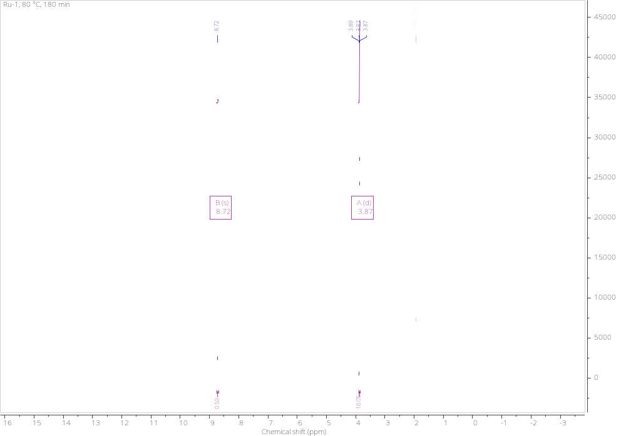

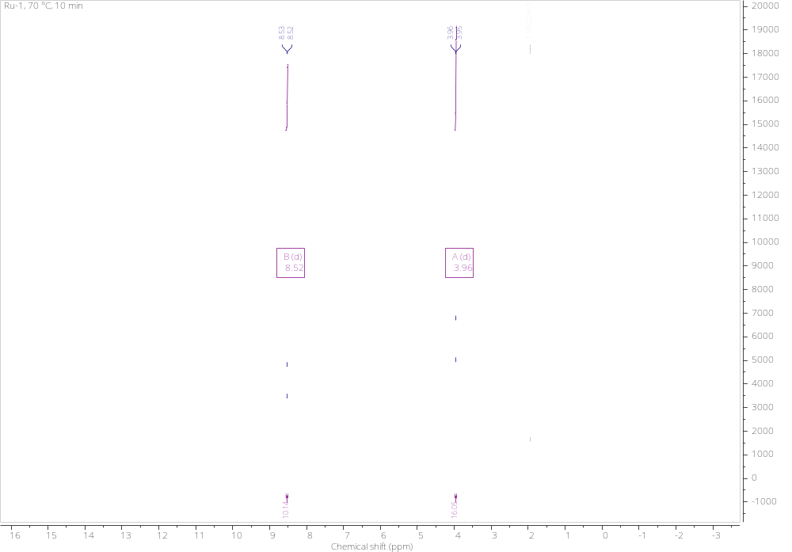

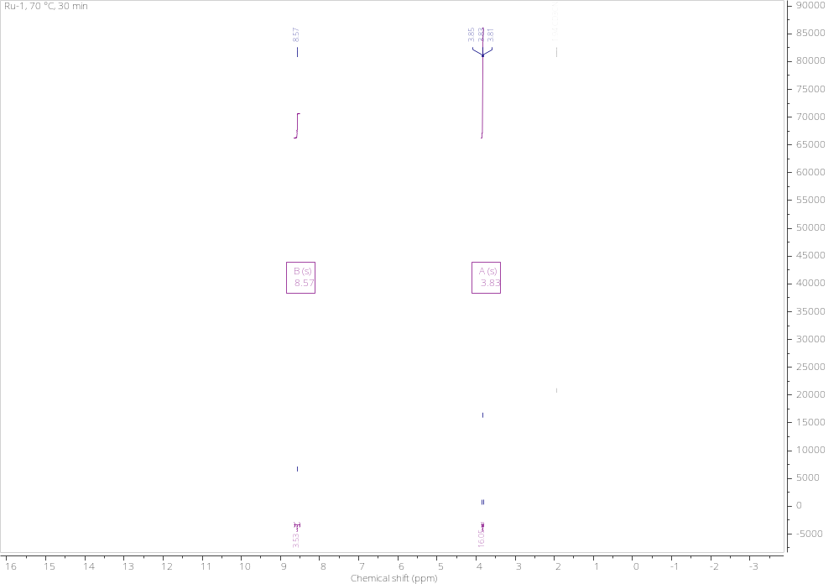
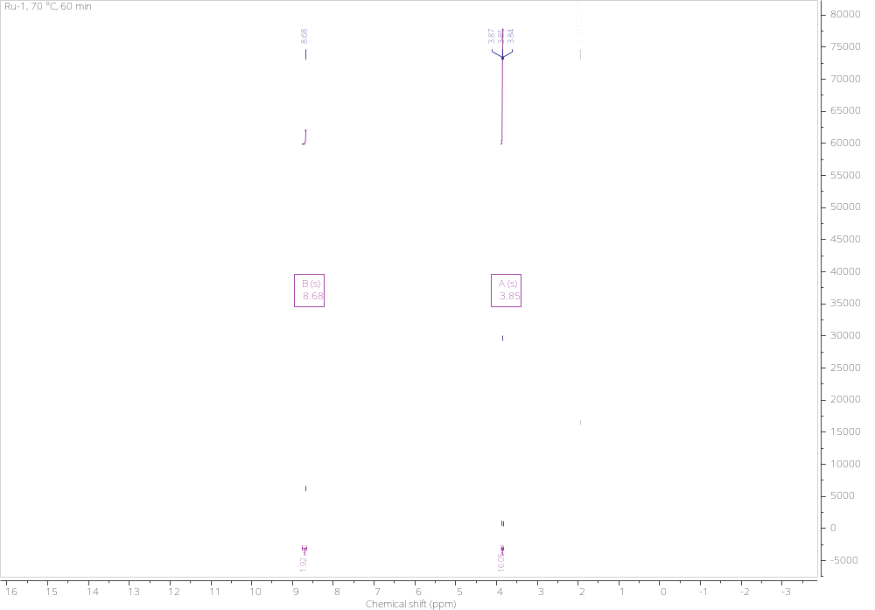

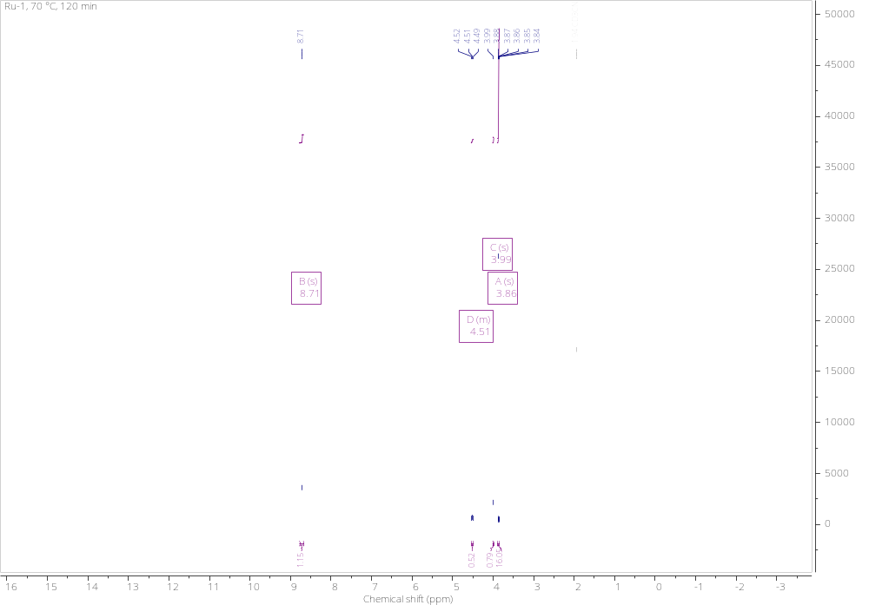
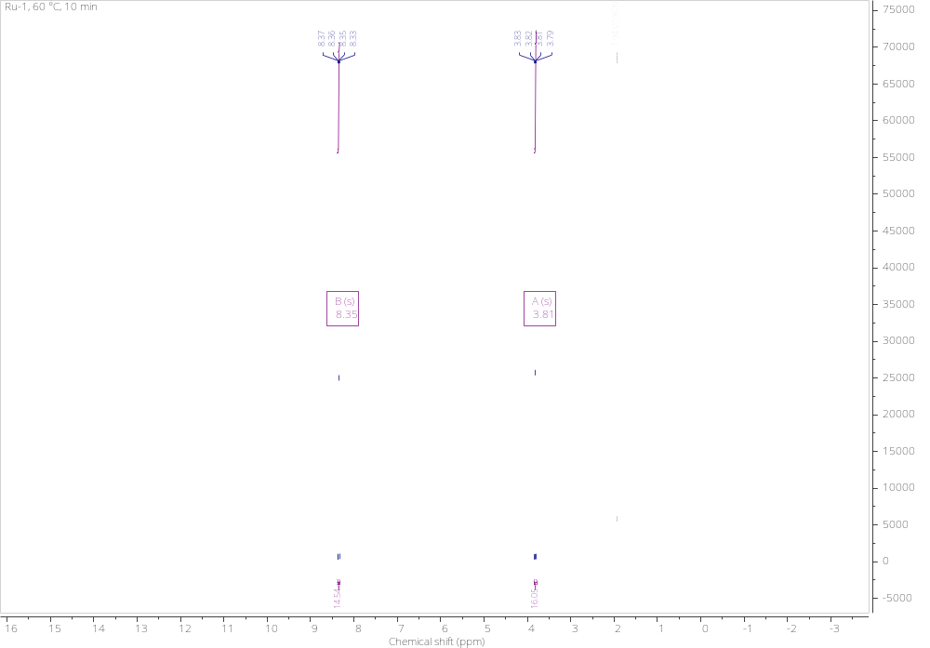

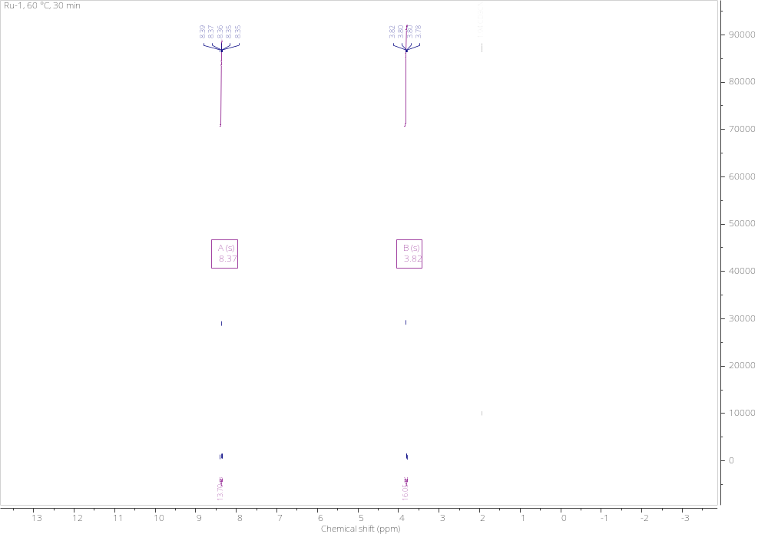
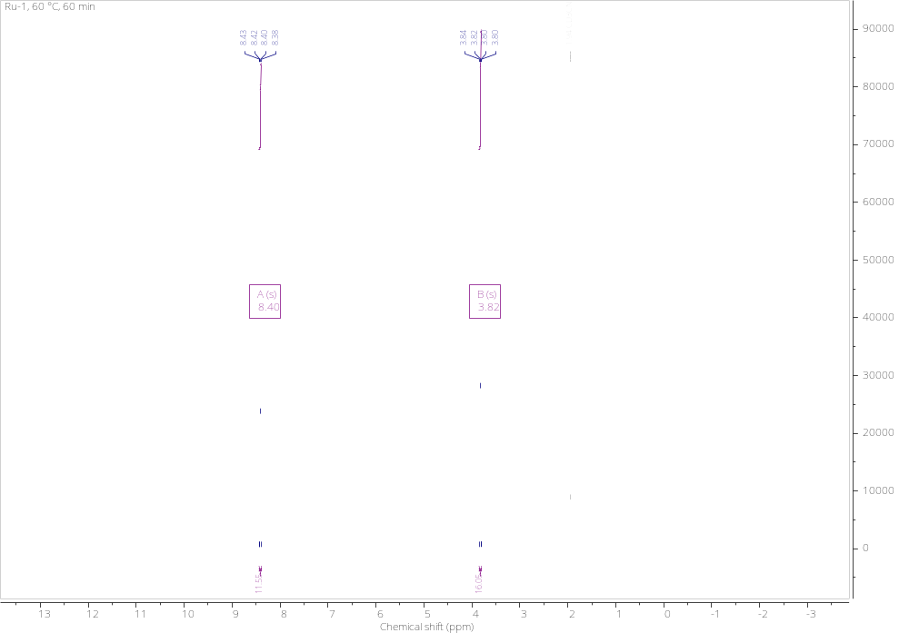

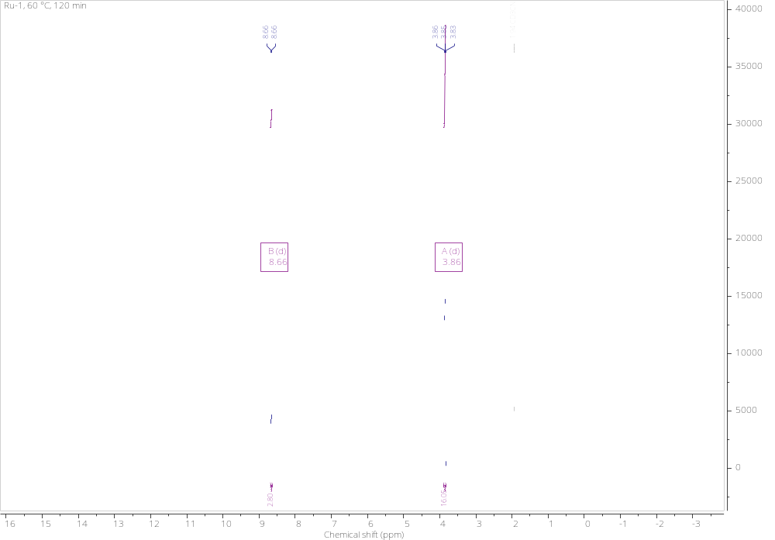
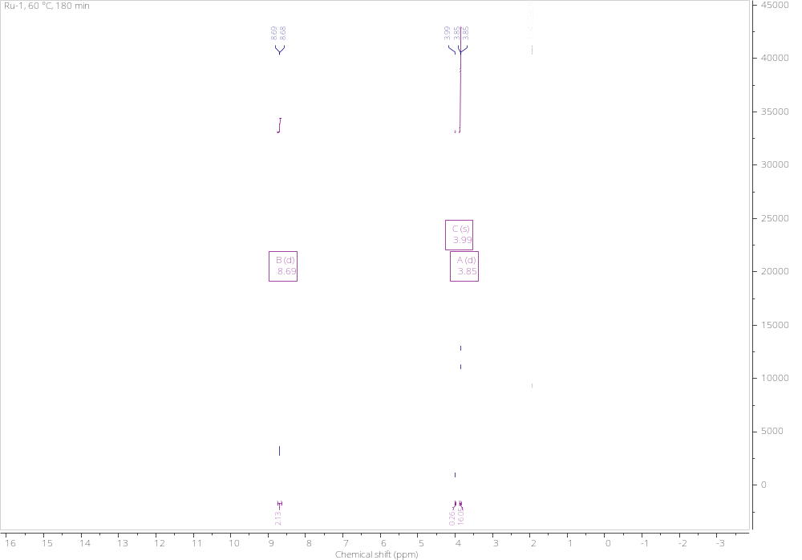

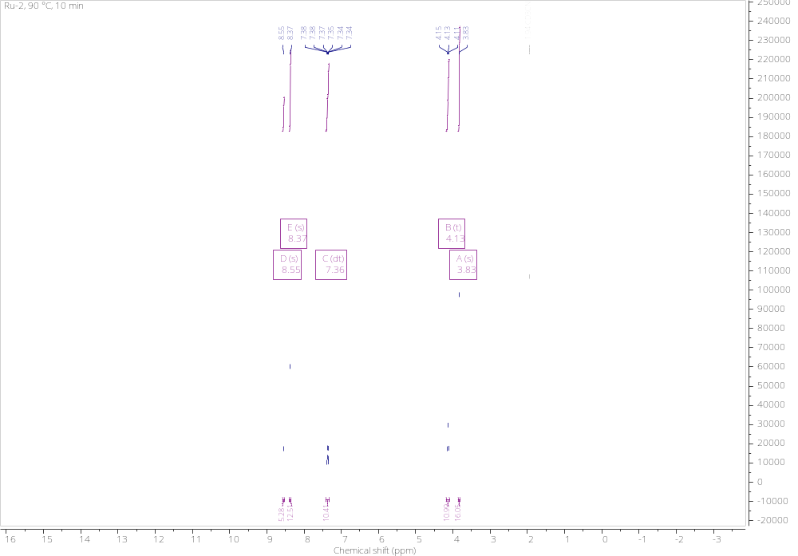

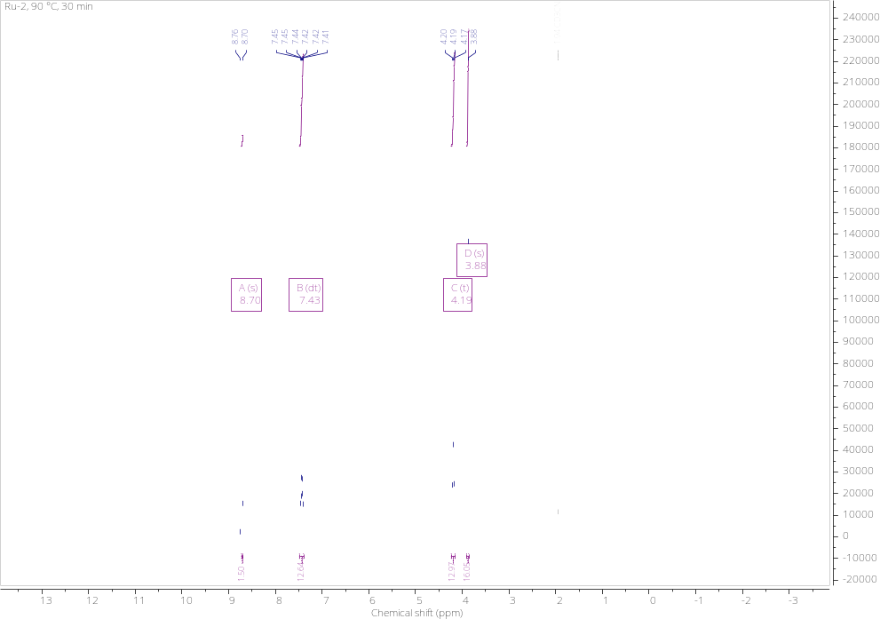
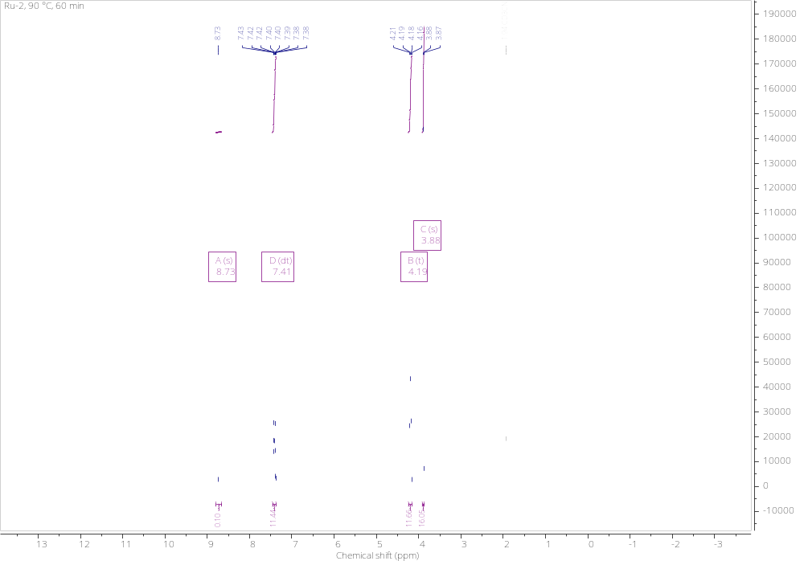

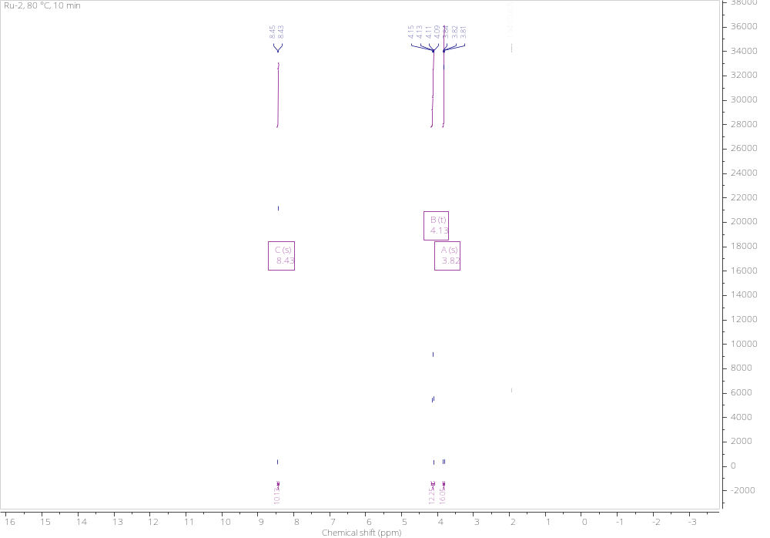

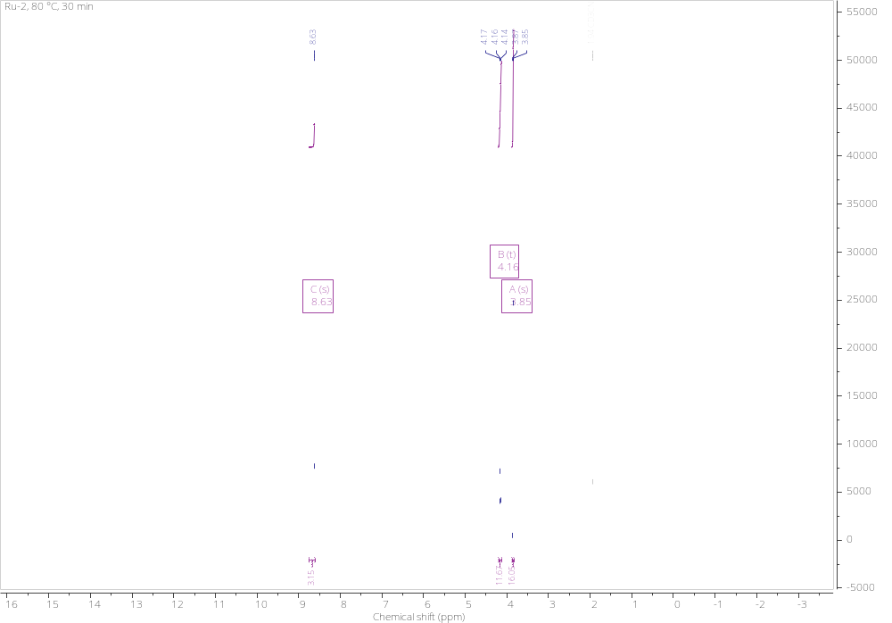
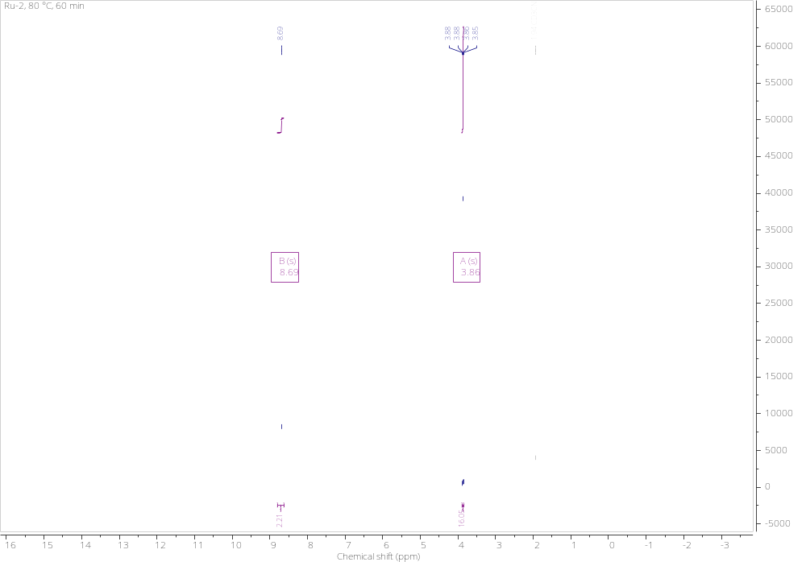

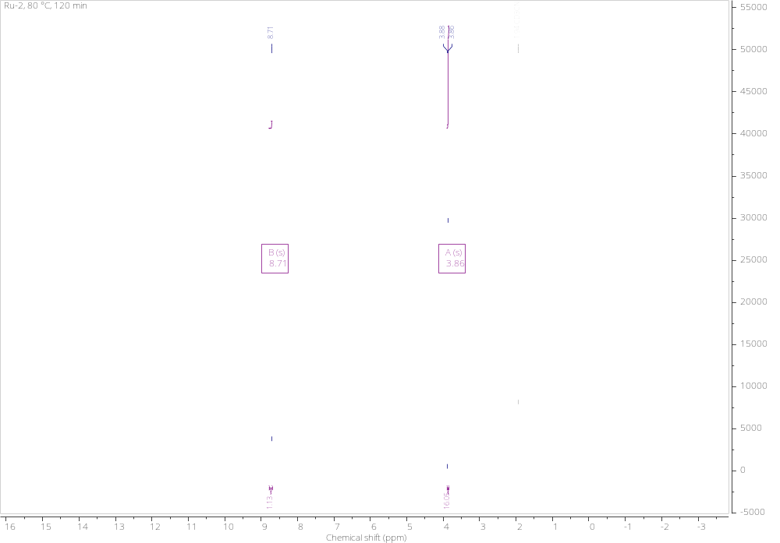
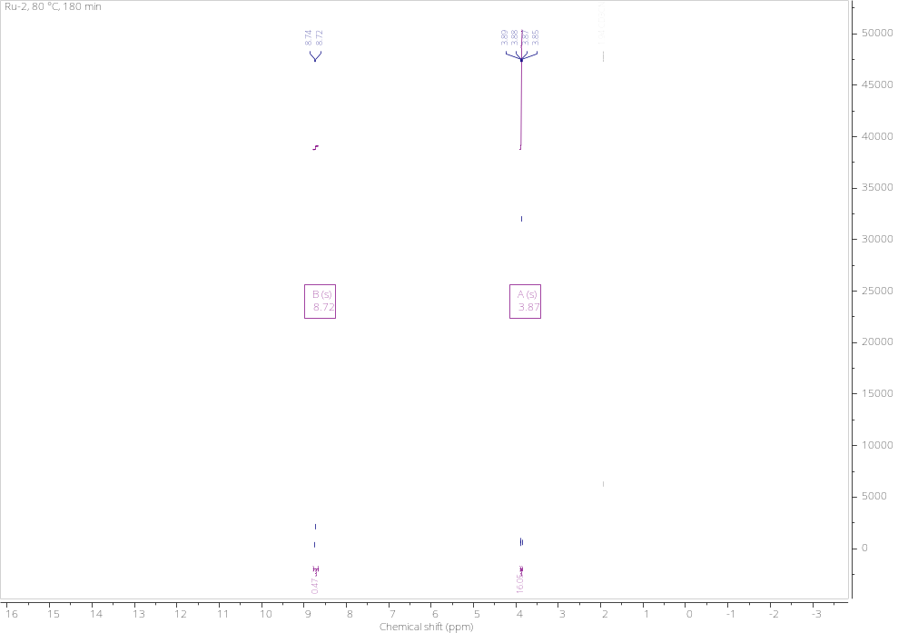

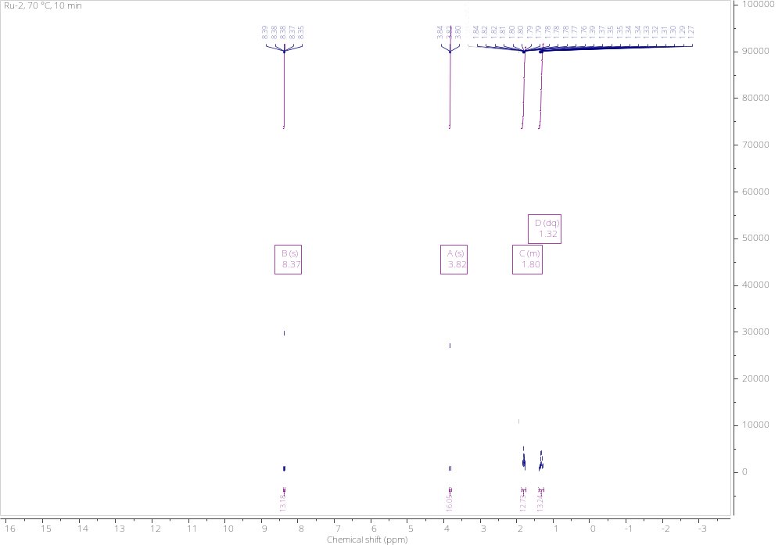

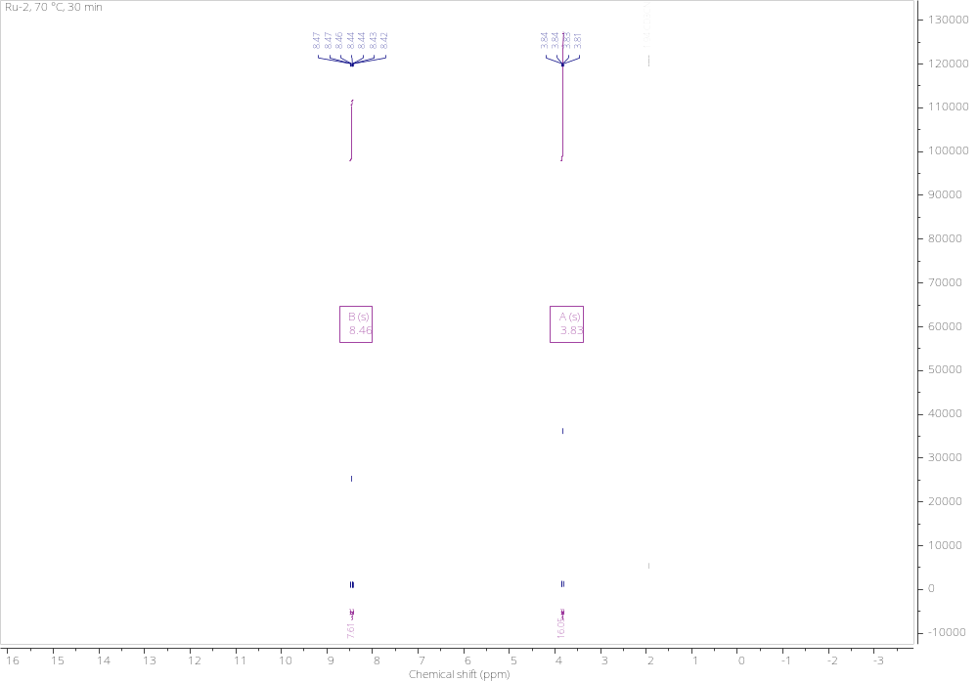
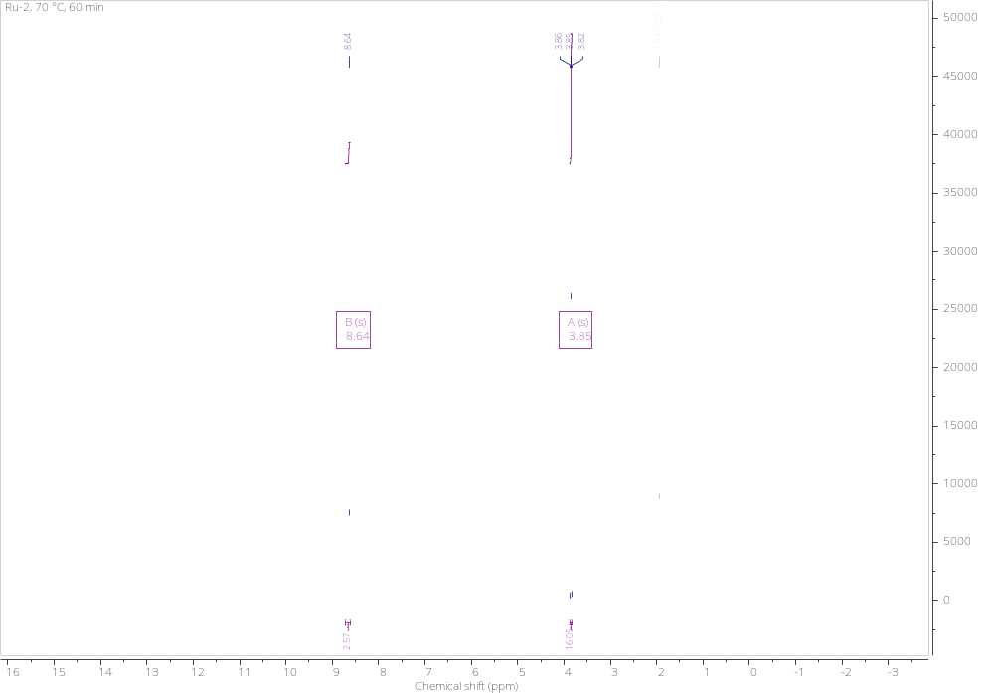

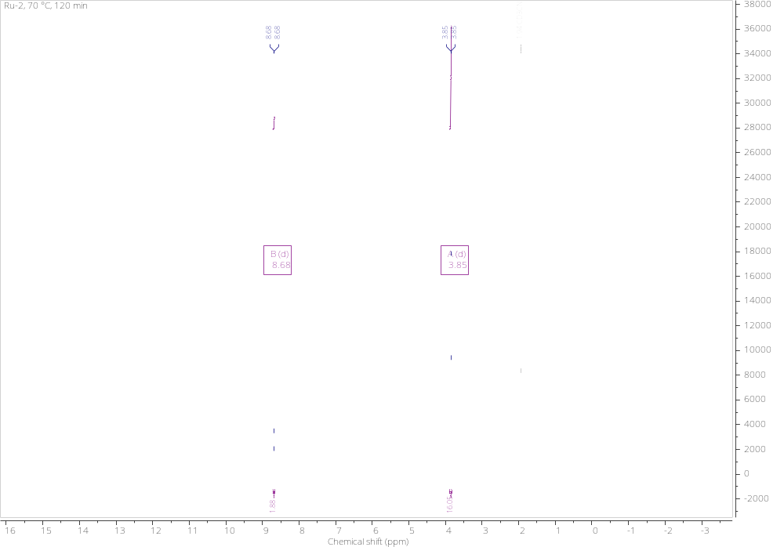
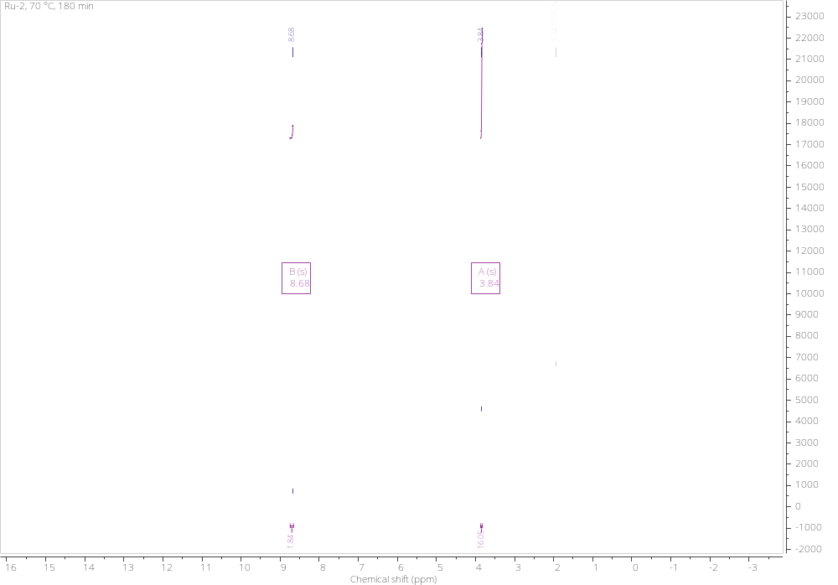

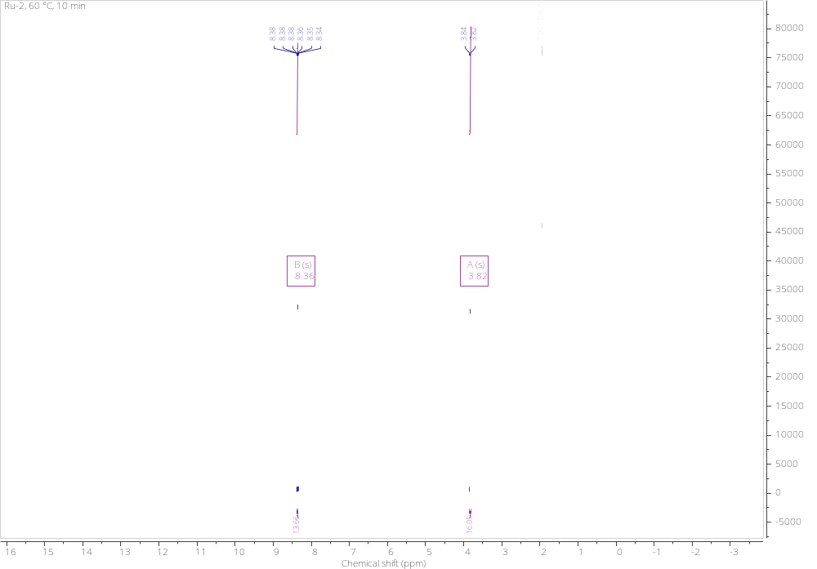

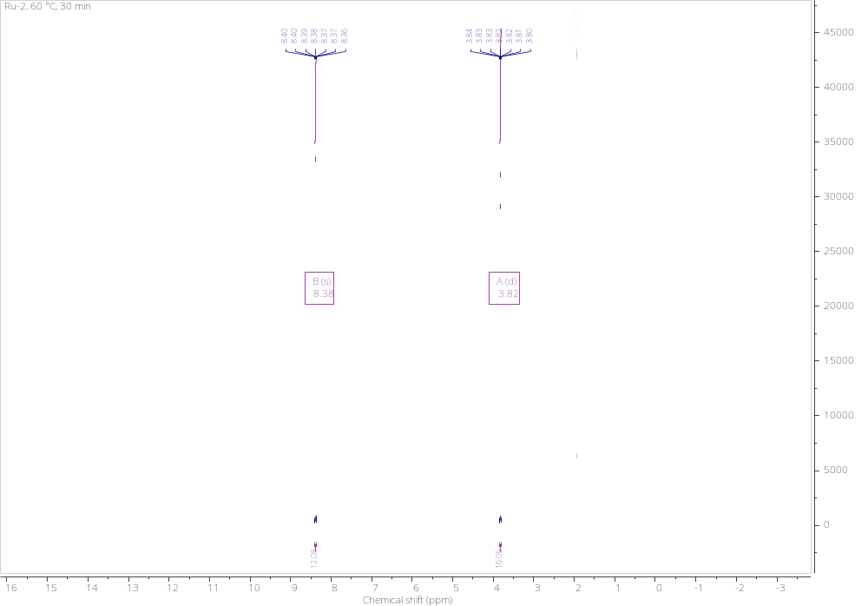
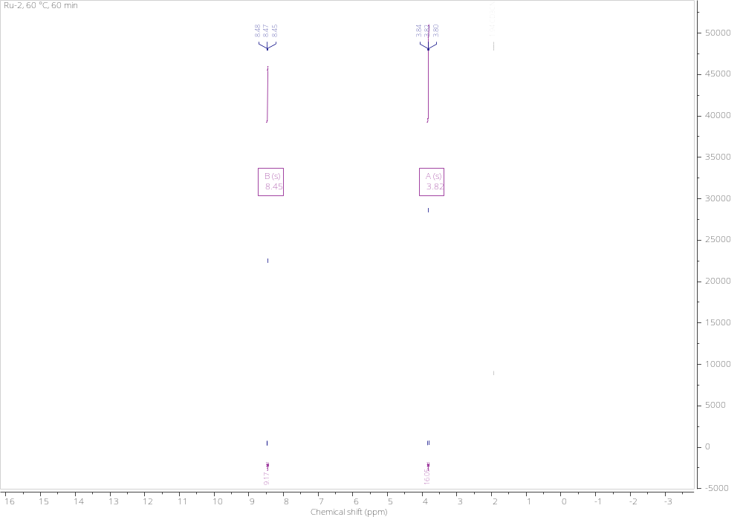

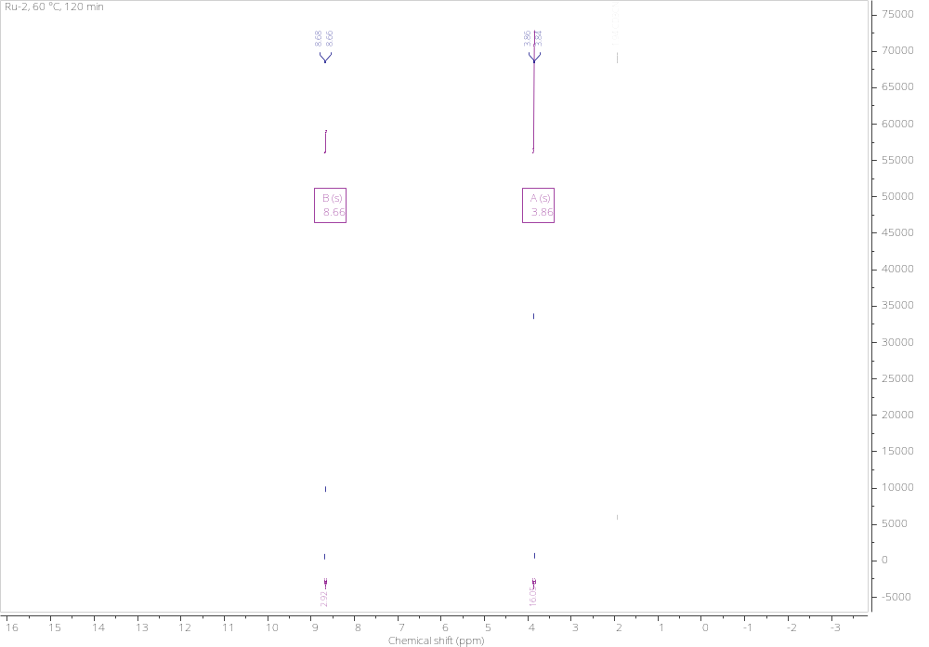
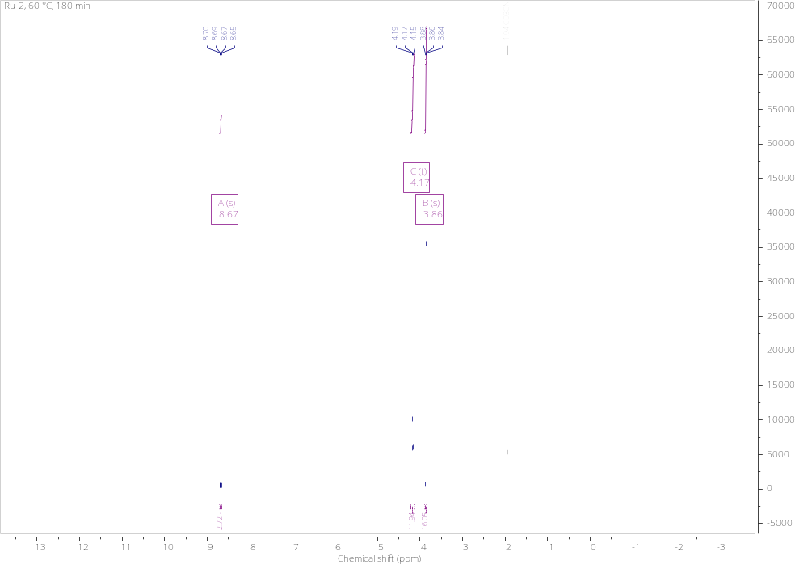

Structural crystallographic data for Ru-2
Fractional atomic coordinates (x10⁴) and equivalent isotropic displaccement parameters (Å²x10³)
Atom x y z U(eq)
Ru01 3156.68(10) 6170.32(9) 7079.04(6) 9.27(4)
Cl02 981.0(3) 6745.0(3) 7265.5(2) 15.44(8)
P03 3724.8(4) 7574.2(3) 6265.1(2) 11.17(8)
P04 4068.6(3) 7042.9(3) 8268.0(2) 10.18(8)
P05 2589.3(4) 4266.1(3) 7292.5(2) 10.49(8)
O006 2315.3(11) 5345.2(10) 5959.2(6) 13.8(2)
C007 2229.2(15) 5828.0(14) 5294.8(9) 13.0(3)
C008 1215.0(15) 3999.1(14) 4985.2(9) 13.5(3)
C009 4058.4(16) 8613.3(14) 8500.4(9) 13.8(3)
C00A 1718.3(15) 4247.8(13) 5775.0(9) 12.9(3)
C00B 5124.2(16) 9411.2(15) 8577.6(11) 19.3(3)
C00C 1728.0(15) 3550.6(14) 6330.6(9) 13.5(3)
C00D 1555.6(15) 5048.3(14) 4668.4(9) 13.2(3)
C00E 3794.2(15) 3324.0(14) 7313.1(9) 14.2(3)
C00F 2815.0(15) 6918.7(14) 5309.6(9) 13.3(3)
C00G 3878.5(16) 6002.4(15) 9656.8(10) 17.7(3)
C00H 6252.0(16) 7548.2(15) 9263.0(10) 18.2(3)
C00I 5698.1(15) 6982.7(13) 8511.2(9) 13.2(3)
C00J 3303.1(15) 6565.2(13) 9136.4(9) 13.2(3)
C00K 5294.4(15) 7674.2(15) 5876.7(10) 16.1(3)
C00L 6438.4(16) 6425.6(14) 7950.1(10) 16.5(3)
C00M 7686.8(17) 6444.6(16) 8124.7(11) 21.4(3)
C00N 1569.2(15) 3882.6(14) 8093.4(9) 14.7(3)
C00O 2689.2(16) 7269.4(15) 4572.3(10) 16.8(3)
C00P 4602.3(16) 3719.7(15) 8090.3(10) 18.5(3)
C00Q 5633.4(17) 6495.7(16) 5519.7(10) 20.8(3)
C00R 3460.0(16) 9108.2(14) 6488.2(10) 16.2(3)
C00S 2000.0(16) 6537.2(16) 3918.3(10) 18.6(3)
C00T 612.8(16) 2883.7(15) 4719.7(10) 17.3(3)
C00U 1129.5(17) 2435.5(15) 6038.5(10) 18.7(3)
C00V 3225.9(18) 5536.6(16) 10242.0(10) 21.7(4)
C00W 1426.5(15) 5440.4(15) 3948.8(9) 16.6(3)
C00X 281.3(16) 4177.3(16) 7949.4(11) 21.2(3)
C00Y 1407.5(17) 6204.5(17) 9819.4(11) 21.9(4)
C00Z 1476.7(17) 2650.4(16) 8234.6(11) 21.0(3)
C010 1994.0(18) 5635.2(16) 10327.8(10) 21.7(4)
C011 4587.3(17) 3267.6(15) 6579.1(11) 21.5(3)
C012 2921.3(16) 9020.7(15) 8524.5(10) 17.8(3)
C013 7491.7(17) 7555.4(16) 9439.3(11) 22.3(4)
C014 2856.2(17) 10188.5(15) 8657.5(11) 20.4(3)
C015 2051.8(16) 6646.3(15) 9223.9(10) 18.7(3)
C016 3927.8(18) 10972.6(15) 8753.1(10) 20.6(3)
C017 4072(2) 9892.8(16) 5949.5(12) 25.5(4)
C018 8214.6(16) 7010.7(17) 8867.9(12) 23.6(4)
C019 2086.2(17) 9194.2(15) 6512.5(11) 21.9(3)
C01A 585.8(17) 2126.1(15) 5254.1(11) 20.8(3)
C01B 6258.5(17) 8326.1(18) 6525.8(11) 24.8(4)
C01C 5058.5(18) 10583.8(16) 8704.6(12) 24.1(4)
C01D 9375(3) 9507(2) 7876(2) 62.5(10)
C01E 9128(3) 9947(2) 7198(3) 61.1(9)
C01F 8435(3) 11014(3) 8677(3) 79.6(14)
C01G 9045(3) 10030(3) 8611(3) 74.3(11)
C01H 8542(3) 10904(3) 7252(3) 71.3(11)
C01I 8202(3) 11419(3) 7983(3) 75.3(12)

Bond lengths (Å)
Atom Atom Length/Å Atom Atom Length/Å
Ru01 Cl02 2.5874(4) C00G C00V 1.393(2)
Ru01 P03 2.4005(4) C00H C00I 1.406(2)
Ru01 P04 2.2316(4) C00H C013 1.387(3)
Ru01 P05 2.3818(4) C00I C00L 1.398(2)
Ru01 O006 2.0958(11) C00J C015 1.401(2)
P03 C00F 1.8624(16) C00K C00Q 1.527(2)
P03 C00K 1.8563(17) C00K C01B 1.529(2)
P03 C00R 1.8713(16) C00L C00M 1.393(2)
P04 C009 1.8516(16) C00M C018 1.385(3)
P04 C00I 1.8431(16) C00N C00X 1.531(2)
P04 C00J 1.8558(16) C00N C00Z 1.532(2)
P05 C00C 1.8617(16) C00O C00S 1.408(2)
P05 C00E 1.8591(16) C00R C017 1.534(2)
P05 C00N 1.8634(16) C00R C019 1.528(2)
O006 C007 1.3678(18) C00S C00W 1.390(3)
O006 C00A 1.3635(19) C00T C01A 1.398(3)
C007 C00D 1.395(2) C00U C01A 1.406(2)
C007 C00F 1.372(2) C00V C010 1.384(3)
C008 C00A 1.399(2) C00Y C010 1.395(3)
C008 C00D 1.466(2) C00Y C015 1.390(2)
C008 C00T 1.395(2) C012 C014 1.388(2)
C009 C00B 1.394(2) C013 C018 1.389(3)
C009 C012 1.402(2) C014 C016 1.388(3)
C00A C00C 1.374(2) C016 C01C 1.385(3)
C00B C01C 1.394(3) C01D C01E 1.389(5)
C00C C00U 1.400(2) C01D C01G 1.364(5)
C00D C00W 1.399(2) C01E C01H 1.381(4)
C00E C00P 1.531(2) C01F C01G 1.424(5)
C00E C011 1.530(2) C01F C01I 1.387(6)
C00F C00O 1.402(2) C01H C01I 1.359(6)
C00G C00J 1.398(2)

Bond angles (°)
Atom Atom Atom Angle/˚ Atom Atom Atom Angle/˚
P03 Ru01 Cl02 92.486(13) C00W C00D C008 138.77(15)
P04 Ru01 Cl02 100.169(13) C00P C00E P05 110.12(11)
P04 Ru01 P03 101.622(14) C011 C00E P05 112.79(11)
P05 Ru01 Cl02 95.101(13) C011 C00E C00P 110.38(14)
P05 Ru01 P03 153.937(13) C007 C00F P03 113.87(11)
P05 Ru01 P04 101.509(14) C00O C00F P03 133.08(13)
O006 Ru01 Cl02 80.36(3) C00O C00F C007 112.77(14)
O006 Ru01 P03 78.33(3) C00V C00G C00J 120.95(16)
O006 Ru01 P04 179.48(3) C013 C00H C00I 121.05(16)
O006 Ru01 P05 78.43(3) C00H C00I P04 120.49(12)
C00F P03 Ru01 101.45(5) C00L C00I P04 121.73(12)
C00K P03 Ru01 117.84(5) C00L C00I C00H 117.72(15)
C00K P03 C00F 99.42(7) C00G C00J P04 122.81(13)
C00R P03 Ru01 126.23(5) C015 C00J P04 118.93(12)
C00R P03 C00F 105.40(7) C015 C00J C00G 117.82(15)
C00R P03 C00K 102.59(8) C00Q C00K P03 112.05(12)
C009 P04 Ru01 114.10(5) C01B C00K P03 111.53(12)
C00I P04 Ru01 121.69(5) C01B C00K C00Q 110.54(15)
C00I P04 C009 100.38(7) C00M C00L C00I 121.17(16)
C00J P04 Ru01 113.51(5) C018 C00M C00L 120.15(16)
C00J P04 C009 102.64(7) C00X C00N P05 110.12(11)
C00J P04 C00I 101.99(7) C00Z C00N P05 117.02(12)
C00C P05 Ru01 102.07(5) C00Z C00N C00X 109.88(14)
C00E P05 Ru01 119.36(5) C00S C00O C00F 120.51(16)
C00E P05 C00C 100.47(7) C017 C00R P03 116.95(12)
C00N P05 Ru01 124.27(5) C019 C00R P03 110.92(11)
C00N P05 C00C 104.70(7) C019 C00R C017 109.71(15)
C00N P05 C00E 102.50(7) C00W C00S C00O 123.49(15)
C007 O006 Ru01 125.92(10) C01A C00T C008 117.70(15)
C00A O006 Ru01 125.96(10) C01A C00U C00C 120.70(16)
C00A O006 C007 108.08(12) C010 C00V C00G 120.60(16)
C00D C007 O006 110.42(14) C00S C00W C00D 117.72(15)
C00F C007 O006 119.64(14) C015 C00Y C010 120.12(16)
C00F C007 C00D 129.87(15) C00Y C010 C00V 119.25(16)
C00D C008 C00A 105.31(14) C014 C012 C009 121.03(16)
C00T C008 C00A 115.74(15) C018 C013 C00H 120.26(16)
C00T C008 C00D 138.88(15) C016 C014 C012 120.01(17)
C00B C009 P04 123.16(13) C00Y C015 C00J 121.23(16)
C012 C009 P04 118.40(13) C01C C016 C014 119.72(16)
C012 C009 C00B 118.15(15) C013 C018 C00M 119.65(16)
C008 C00A O006 110.58(14) C00U C01A C00T 123.30(16)
C00C C00A O006 119.65(14) C016 C01C C00B 120.26(17)
C00C C00A C008 129.69(15) C01G C01D C01E 119.8(3)
C01C C00B C009 120.76(16) C01H C01E C01D 121.2(4)
C00A C00C P05 113.50(12) C01I C01F C01G 118.3(4)
C00U C00C P05 133.59(13) C01F C01G C01D 119.8(4)
C00U C00C C00A 112.85(14) C01I C01H C01E 119.1(4)
C008 C00D C007 105.60(14) C01H C01I C01F 121.8(3)
C00W C00D C007 115.60(15)

Torsion angles (°)
A B C D Angle/˚ A B C D Angle/˚
Ru01 O006 C007 C00D -176.98(13) C007 C00D C00W C00S 1.78(17)
Ru01 O006 C007 C00F 5.67(13) C007 C00F C00O C00S 1.08(17)
Ru01 O006 C00A C008 176.96(13) C008 C00A C00C C00U -0.4(2)
Ru01 O006 C00A C00C -5.83(13) C008 C00D C00W C00S -175.8(2)
P03 C00F C007 O006 2.31(13) C008 C00T C01A C00U 0.2(2)
P03 C00F C007 C00D -174.45(11) C009 C00B C01C C016 -0.2(2)
P03 C00F C00O C00S 174.53(16) C009 C012 C014 C016 1.3(2)
P04 C009 C00B C01C 176.06(14) C00A C00C C00U C01A -0.57(18)
P04 C009 C012 C014 -176.90(13) C00B C01C C016 C014 -1.4(2)
P04 C00I C00H C013 -176.90(14) C00C C00U C01A C00T 0.7(2)
P04 C00I C00L C00M 176.12(14) C00D C00W C00S C00O -0.57(19)
P04 C00J C00G C00V -172.24(14) C00F C00O C00S C00W -1.0(2)
P04 C00J C015 C00Y 174.02(14) C00G C00J C015 C00Y 1.38(19)
P05 C00C C00A O006 0.49(13) C00G C00V C010 C00Y 0.2(2)
P05 C00C C00A C008 177.10(10) C00H C00I C00L C00M -0.97(19)
P05 C00C C00U C01A -177.37(17) C00H C013 C018 C00M -1.0(2)
O006 C007 C00D C008 -0.45(14) C00I C00L C00M C018 0.7(2)
O006 C007 C00D C00W -178.79(13) C00J C015 C00Y C010 -2.1(2)
O006 C007 C00F C00O 177.08(15) C00L C00M C018 C013 0.3(2)
O006 C00A C008 C00D 0.50(14) C00V C010 C00Y C015 1.3(2)
O006 C00A C008 C00T 178.04(13) C012 C014 C016 C01C 0.8(2)
O006 C00A C00C C00U -176.99(15) C01D C01E C01H C01I -0.1(3)
C007 C00D C008 C00A -0.03(14) C01D C01G C01F C01I -0.5(4)
C007 C00D C008 C00T -176.65(13) C01E C01H C01I C01F 0.4(3)

Hydrogen Atom Coordinates (Å×10⁴) and Isotropic Displacement Parameters (Å²×10³)
Atom x y z U(eq)
H00B 5904.3(16) 9153.1(15) 8543.2(11) 23.2(4)
H00E 3371.4(15) 2530.6(14) 7312.4(9) 17.1(4)
H00G 4726.8(16) 5936.4(15) 9610.9(10) 21.2(4)
H00H 5769.5(16) 7931.4(15) 9656.4(10) 21.9(4)
H00K 5302.1(15) 8119.7(15) 5434.1(10) 19.4(4)
H00L 6084.2(16) 6027.0(14) 7440.7(10) 19.8(4)
H00M 8176.9(17) 6068.3(16) 7733.0(11) 25.7(4)
H00N 1913.2(15) 4393.7(14) 8608.9(9) 17.6(4)
H00O 3071.7(16) 8006.7(15) 4513.4(10) 20.1(4)
H00a 5051(11) 4487(6) 8097(4) 27.7(5)
H00c 4084(2) 3745(13) 8554.7(11) 27.7(5)
H00d 5190(9) 3181(7) 8116(5) 27.7(5)
H00f 5680(14) 6053(5) 5946(2) 31.2(5)
H00i 5005(8) 6089(6) 5107(7) 31.2(5)
H00j 6432(7) 6589.6(16) 5276(8) 31.2(5)
H00R 3815.2(16) 9433.3(14) 7046.2(10) 19.4(4)
H00S 1923.2(16) 6807.4(16) 3430.3(10) 22.4(4)
H00T 234.2(16) 2647.1(15) 4194.0(10) 20.7(4)
H00U 1090.2(17) 1881.8(15) 6373.6(10) 22.5(4)
H00V 3630.5(18) 5147.8(16) 10585.1(10) 26.1(4)
H00W 962.5(15) 4972.9(15) 3496.6(9) 19.9(4)
H00p 342(2) 4985(4) 7904(9) 31.8(5)
H00q -99(6) 3691(9) 7450(5) 31.8(5)
H00x -224(5) 4045(13) 8401(5) 31.8(5)
H00Y 566.2(17) 6290.4(17) 9880.2(11) 26.2(4)
H00z 1140(13) 2114.3(17) 7744(3) 31.5(5)
H 2297(3) 2490(5) 8374(9) 31.5(5)
Ha 934(11) 2559(4) 8676(6) 31.5(5)
H010 1552.5(18) 5318.8(16) 10728.5(10) 26.0(4)
H01a 4067(3) 2954(13) 6088.9(13) 32.2(5)
H01b 4989(12) 4041(2) 6554(6) 32.2(5)
H01c 5214(10) 2772(11) 6624(5) 32.2(5)
H012 2183.7(16) 8489.4(15) 8448.7(10) 21.4(4)
H013 7847.9(17) 7934.1(16) 9952.8(11) 26.8(4)
H014 2078.3(17) 10451.3(15) 8683.1(11) 24.4(4)
H015 1635.8(16) 7010.0(15) 8869.6(10) 22.5(4)
H016 3885.5(18) 11772.4(15) 8851.3(10) 24.8(4)
H01d 4962(3) 9880(11) 5968(8) 38.3(6)
H01e 3739(11) 9621(9) 5394(2) 38.3(6)
H01f 3906(13) 10678(3) 6142(6) 38.3(6)
H018 9066.4(16) 7026.5(17) 8986.4(12) 28.3(4)
H01g 1714(3) 8990(13) 5964.1(14) 32.8(5)
H01h 1692(3) 8667(10) 6838(8) 32.8(5)
H01i 1971.8(17) 9981(4) 6751(9) 32.8(5)
H01j 179.7(17) 1363.9(15) 5078.6(11) 24.9(4)
H01k 6044(8) 9090(5) 6734(7) 37.2(6)
H01l 6282(11) 7904(7) 6966(5) 37.2(6)
H01m 7068(3) 8402(13) 6294(3) 37.2(6)
H01n 5792.4(18) 11118.1(16) 8758.0(12) 29.0(4)
H01o 9773(3) 8844(2) 7828(2) 75.0(11)
H01p 9366(3) 9583(2) 6689(3) 73.4(11)
H01q 8193(3) 11384(3) 9184(3) 95.5(16)
H01r 9222(3) 9738(3) 9078(3) 89.2(14)
H01s 8378(3) 11198(3) 6784(3) 85.6(13)
H01t 7795(3) 12075(3) 8019(3) 90.4(15)
Hb 4450(30) 5820(20) 6884(16) 35(7)

