Extended Data Figure 1. Study design.
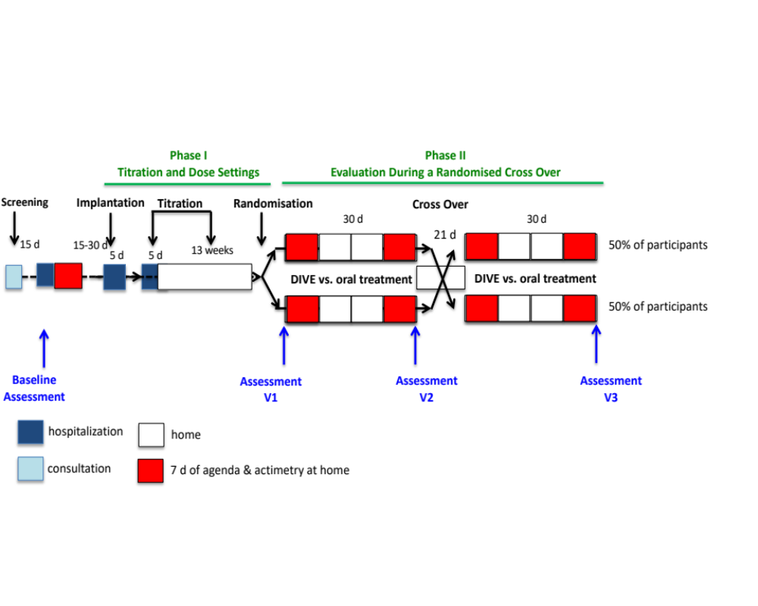
D: day; vs: versus
Extended Data Table 1. Baseline characteristics of the patients included in the phase II efficacy comparison, overall and according to treatment sequences
 | Overall (n=9) | Oral L-dopa /  A-dopamine (n=5) | A- dopamine /  oral L-dopa (n=4)
Age (years) | 59.2 (52.7; 69.1) [59.5] | 57.2 (52.7; 69.1) [59.9] | 59.9 (53.7; 62.8) [59.0]
Sex, n (%)
Male | 7 (77.8) | 4 (80.0) | 3 (75.0)
Female | 2 (22.2) | 1 (20.0) | 1 (25.0)
Body mass index (kg/m²) | 23.9 (19.0; 32.7) [25.4] | 23.9 (20.6; 32.7) [25.2] | 29.0 (19.0; 30.9) [26.3]
Disease duration (years)
From the first symptoms | 10.7 (6.4; 19.4) [12.0] | 10.0 (6.4; 19.4) [10.9] | 13.7 (10.7; 15.7) [13.5]
From diagnosis | 8.2 (6.4; 12.2) [8.9] | 7.5 (6.4; 10.3) [8.2] | 10.0 (7.3; 12.2) [9.8]
Under oral L-dopa treatment | 7.2 (4.1; 12.2) [7.8] | 7.2 (4.1; 9.4) [7.3] | 8.0 (5.6; 12.2) [8.5]
With motor fluctuations | 4.3 (1.6; 6.4) [4.2] | 4.2 (2.6; 6.4) [4.2] | 4.5 (1.7; 6.2) [4.2]
With dyskinesia | 2.3 (0.4; 4.4) [2.3] | 2.5 (0.4; 4.4) [2.6] | 2.0 (0.7; 3.2) [2.0]
L-dopa sensitivity (%) | 79.5 (55.0; 92.3) [77.9] | 80.0 (62.8; 92.3) | 78.9 (55.0; 87.2) [75.0]
Hoehn & Yahr of symptoms progression, n (%)
2 | 8 (88.9) | 5 (100.0) | 3 (75.0)
3 | 1 (11.1) | 0 (0.0) | 1 (25.0)
Schwab & England activities of daily living | 80 (50; 90) [80] | 90 (70; 90) [84] | 80 (50; 90) [75]
MDS-UPDRS total score of handicap | 52 (28; 71) [52] | 50 (46; 71) [54] | 53 (28; 64) [48] ª
MDS-UPDRS motor handicap, part III (On drug) | 17 (5; 27) [16.3] | 19 (10; 23) [18.4] | 12 (5; 27) [13.8]
MoCA | 26 (16; 27) [24.2] | 26 (16; 27) [24.0] | 25 (20; 27) [24.5]
LEDD before phase I | 1750 (650-2387) [1622] | 1770 (1200-2387) [1751] | 1675 (650-1845) [1461]
LEDD at end of phase I | 600 (250-1250) [711] | 600 (250-1250) [695] | 650 (450-1174) [731]
LEDD reduction (%) | 58.3 (30.8-79.2) [55.2] | 58.3 (47.6-79.2) [61.7] | 47.5 (30.8-62.5) [47.1]
ª One missing value.
Values provided are median (range: minimum; maximum) [mean] unless stated otherwise.
LEDD: Levodopa Equivalent Daily Dose; MDS-UPDRS: Movement Disorders Society-Unified Parkinson Disease Rating Scale. MoCA: Montreal Cognitive Assessment (/30, the highest being the best). Hoehn and Yahr scale (/5, the highest being the worst); Schwab and England activities of daily living (/100%, the highest being the best); MDS-UPDRS (the highest being the worst); MDS-UPDRS part III (On) was assessed at 10 am after the L-dopa dose at 9 am under conditions of both exclusive oral treatment or in association with A-dopamine; percentage of L-dopa sensitivity is the ratio of the MDS-UPDRS Part III motor handicap score in Off (after one night's withdrawal of oral medication) to the score in On drug.

Extended Data Table 2. Individual data for primary outcome measure (percent time over target) according to treatment
Patient (inclusion number) | 1 | 5 | 6 | 9 | 12 | 13 | 14 | 15 | 16 | Mean | Median (range)
A-dopamine treatment (%) | 47.6 | 32.7 | 30.2 | 29.8 | 46.4 | 15.7 | 82.4 | 68.7 | 36.3 | 43.3 | 36.3 (15.7; 82.4)
Oral L-Dopa treatment (%) | 58.0 | 71.6 | 44.5 | 59.3 | 36.7 | 20.9 | 90.9 | 90.8 | 37.3 | 56.7 | 58.0 (20.9; 90.0)
Intra-patient difference (%) | -10.4 | -38.9 | -14.3 | -29.5 | 9.7 | -5.2 | -8.5 | -22.1 | -1.0 | -13.4 | -10.4 (9.7; -38.9)
A-dopamine treatment (h) | 4.3 | 2.9 | 2.7 | 2.7 | 4.2 | 1.4 | 7.4 | 6.2 | 3.3 | 3.9 | 3.3 (2.7; 4.2)
Oral L-Dopa treatment (h) | 5.2 | 6.4 | 4.0 | 5.3 | 3.3 | 1.9 | 8.2 | 8.2 | 3.4 | 5.1 | 5.2 (3.4; 6.4)
Intra-patient difference (h) | -0.9 | -3.5 | -1.3 | -2.6 | 0.9 | -0.5 | -0.7 | -2 | -0.1 | -1.2 | -0.9 (-2; - 0.5)
One-week actimetry at home: actimeter (Parkinson Kinetograph™ from GKC) in a wristwatch worn on the most affected side: the percentage over total target is the percentage of time the subject was not well controlled (i.e. the lowest the best). The percentage over total target is the sum of the percentage over target for bradykinesia and for dyskinesia. The percentage over target bradykinesia is the percentage of time the subject was bradykinetic. This is the proportion of time in bradykinesia score severity level 3 or above (% of 2-min periods with bradykinesia score >26) after removing artifacts. Higher values represent more epochs that the subject was severely bradykinetic. The percentage over target dyskinesia is the percentage of time the subject was dyskinetic during the recording period between 9 am and 6 pm (% of 2-min periods with dyskinesia score >10) after removing walking and tremor artifacts. The lower section shows the results in terms of the number of corresponding hours on the 9-h recording between 9 am and 6 pm.
Extended Data Figure 2. Spaghetti plots of intra-patient differences in primary and secondary efficacy outcomes from oral L-dopa treatment to A-dopamine treatment.
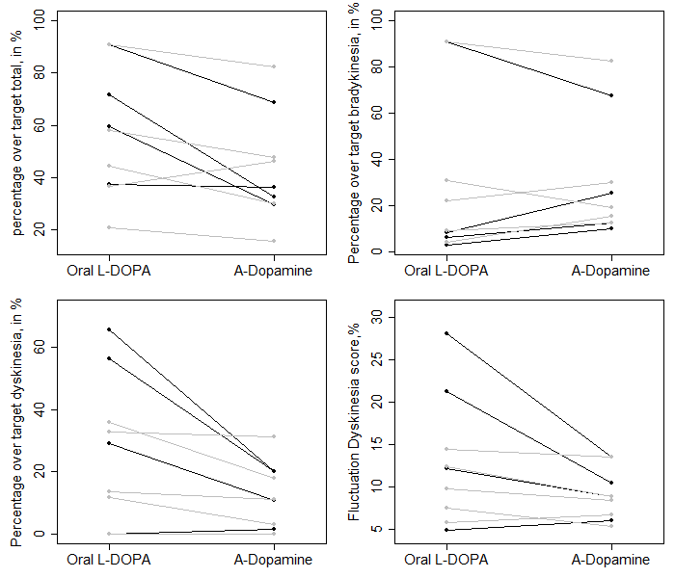

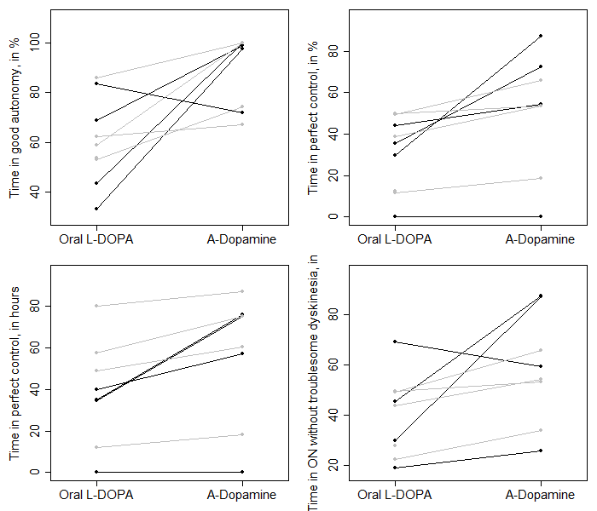

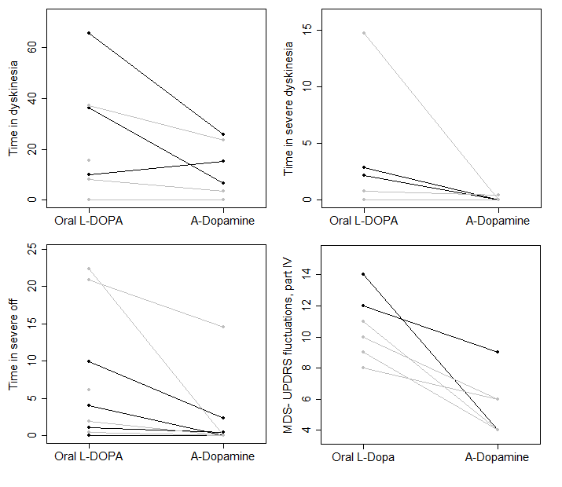
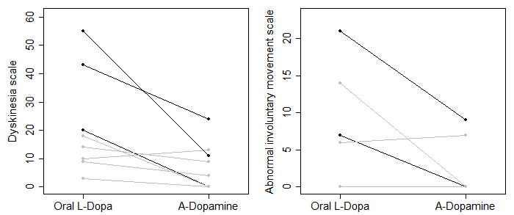

Lines in grey indicate patients allocated to oral L-dopa/A-dopamine treatment sequences and lines in black indicate patients allocated to A-dopamine/oral L-dopa treatment sequences.

Extended Data Table 3. Target dose and dose received of oral L-dopa per week of actimetry/agenda outcome assessments according to treatment
Patient (inclusion number) | 1 | 5 | 6 | 9 | 12 | 13 | 14 | 15 | 16
A-dopamine treatment
Target LEDD ª | 600 | 700 | 250 | 450 | 1250 | 875 | 500 | 600 | 1174
First week: oral treatment LEDD | 600 | 700 | 250 | 450 | 1250 | 875 | 350³ | 600 | 700 ^{c}
Last week: oral treatment LEDD | 500³ | 700 | 100³ | 450 | 1250 | 700³ | 500 | 200 e | 1174
Oral L-dopa treatment
Target LEDD ^{b} | 2200 | 1845 | 1200 | 650 | 2387 | 1770 | 1200 | 1280 | 1750
First week: oral treatment LEDD | 1500 ^{d} | 1500 ^{d} | 500 ^{d} | 350 ^{d} | 2387 | 1770 | 700 ^{d} | 1280 | 1750
Last week: oral treatment LEDD | 2200 | 1845 | 1200 | 650 | 2387 | 1770 | 1200 | 1280 | 2199 ^{f}
ª As defined in end of titration phase I study.
^{b} As defined at the start of titration phase I study. Unreliable weekly measures identified during blinded data review prior to any analysis are underlined in grey (excluded from the per-protocol primary efficacy analysis). All patients received a great deal of therapeutic education in order to learn how to manage their treatment on a daily basis during phase I, as the effective doses of A-dopamine were not known, and over- or under-dosing had to be avoided. This explains why, despite strict recommendations to maintain treatment during phase II, many patients spontaneously tried to adapt their treatment.
^{c} On A-dopamine, patients felt better and spontaneously tried to lower their medication further.
^{d} A-dopamine was stopped just at the end of period 1 for those randomised to the group starting with the oral phase. The after-effect was unknown and led to a disruption of oral treatment. Patients who felt better did not resume full oral treatment.
^{e} Confusion leading to poor compliance and missed doses.
^{f} The patient experienced back pain, which he attributed to Parkinsonian pain, and spontaneously increased the dose. It was, however, an unrelated lumbago.

Extended Data Table 4. Individual patient data for percentage of time over total target values by the two planned weeks of assessment (first and last week of each treatment period)
Patient (inclusion number) | 1 | 5 | 6 | 9 | 12 | 13 | 14 | 15 | 16
A-dopamine treatment
First week | 47.6 | 26.7 | 30.2 | 29.1 | 43.6 | 15.7 | 94.2 | 68.7 | 38.2
Last week | 60.7 | 38.7 | 72.9 | 30.5 | 49.2 | 24.2 | 82.4 | 90.0 | 36.3
Two weeks average | 54.2 | 32.7 | 51.6 | 29.8 | 46.4 | 20.0 | 88.3 | 79.4 | 37.3
Oral L-dopa
First week | 52.1 | 41.7 | 31.9 | 35.6 | 36.9 | 29.1 | 79.6 | 84.0 | 37.3
Last week | 58.0 | 71.6 | 44.5 | 59.3 | 36.6 | 12.7 | 90.9 | 97.6 | 30.9
Two weeks average | 55.1 | 56.7 | 38.2 | 47.5 | 36.7 | 20.9 | 90.8 | 90.8 | 34.1
Highlighted values indicated non-reliable weekly measures (excluded from per-protocol primary efficacy analysis) due to non-compliance with oral L-dopa therapy (see the reasons in Extended Data Table 3).

Extended Data Table 5. Secondary and exploratory actimetry and home diary outcomes calculated as the average values of the two planned weeks of assessment (first and last week of treatment period regardless deviations from target L-dopa treatment)
Efficacy Outcomes | Oral L-dopa  treatment | A-dopamine  treatment | Intra-patient differences | Effect size  [95%CI] ª
Actimetry at home
Over target bradykinesia (%) | 9.8 (4.1; 90.8) [29.6] | 26.9 (9.8; 88.3) [37.2] | 8.3 (-12.4; 21.4) [7.6] | 0.58 [0.19; 1.31]
Over target dyskinesia (%) | 24.3 (0.0; 48.4) [22.1] | 10.4 (0.0; 31.2) [11.6] | -9.2 (-28.1; 1.0) [-10.5] | -0.54 [-1.21; -0.18]
Fluctuation dyskinesia score (%) | 11.1 (5.0; 22.1) [11.5] | 8.5 (5.3; 13.6) [9.0] | -2.3 (-8.5; 1.3) [-2.6] | -0.49 [-1.09; -0.13]
Bradykinesia score (50 percentile) (%) | 19.8 (13.2; 37.0) [22.0] | 23.3 (17.4; 36.3) [25.1] | 3.0 (-0.7; 6.3) [3.1] | 0.39 [0.17; 0.86]
Dyskinesia score (50 percentile) (%) | 5.0 (0.3; 28.7) [6.9] | 1.8 (0.2; 6.6) [2.1] | -1.9 (-26.5; 1.2) [-4.8] | -0.71 [-1.57; -0.16]
Time of immobility (%) | 6.1 (1.9; 16.9) [6.8] | 5.9 (2.5; 19.8) [8.4] | 1.9 (-1.7; 5.8) [1.6] | 0.09 [-0.27; 0.51]
Time with a tremor (%) | 0.8 (0.4; 6.4) [1.6] | 0.8 (0.5; 6.6) [1.8] | 0.1 (-1.6; 1.6) [0.1] | 0.06 [-0.42; 0.56]
Diary at home
Time in On without dyskinesia (perfect control) (%) | 36.9 (0.0; 54.1) [30.5] | 62.2 (0.0; 75.0) [50.0] | 15.0 (-3.5; 52.8) [19.5] | 1.00 [0.32; 2.08]
Time in On without troublesome dyskinesia (%) | 43.7 (19.3; 67.4) [40.3] | 62.2 (25.8; 89.2) [57.0] | 10.7 (-7.9; 44.5) [16.6] | 0.81 [0.17; 1.77]
Time in good autonomy (%) | 62.2 (33.3; 85.8) [60.9] | 95.3 (58.2; 100.0) [87.3] | 31.0 (-8.9; 62.0) [26.4] | 1.55 [0.69; 2.88]
Time in “On” time without dyskinesia and/or with slight dyskinesia and/or with slight bradykinesia (%) | 55.2 (45.0; 104.7) [62.1] | 95.3 (58.2; 100.0) [87.3] | 31.4 (-4.7; 50.3) [25.2] | 1.24 [0.42; 2.44]
Time in dyskinesia (%) | 8.8 (0.0; 65.7) [19.9] | 3.5 (0.0; 25.9) [8.2] | -8.8 (-39.8; 6.4) [-11.7] | -0.63 [-1.47; -0.07]
Time in severe dyskinesia (%) | 0.8 (0.0; 11.3) [2.0] | 0.0 (0.0; 1.0) [0.2] | -0.3 (-10.2; 0.0) [-1.9] | -0.84 [-1.85; -0.12]
Time in severe Off (%) | 6.2 (0.0; 20.9) [6.6] | 0.0 (0.0; 14.6) [2.4] | -2.2 (-12.2; 0.0) [-4.2] | -0.91 [-1.88; -0.31]
Values are expressed as median (range: minimum; maximum) [mean] unless otherwise indicated.
ª Hedge’s g values for A-dopamine vs. oral L-dopa treatment, calculated using rank-transformed data with non-central 95%CIs. The percentage over target bradykinesia is the percentage of time the subject was bradykinetic. This is the proportion of time in bradykinesia score severity level 3 or above (% of 2-min periods with bradykinesia score >26) after removing artifacts. Higher values represent more epochs that the subject was severely bradykinetic. The percentage over target dyskinesia is the percentage of time the subject was dyskinetic during the recording period between 9 am and 6 pm (% of 2-min periods with dyskinesia score >10) after removing walking and tremor artifacts. Higher values represent more periods that the subject was severely dyskinetic.
The bradykinesia score should be as close as possible to the 50th percentile (normal value = 18.6); the dyskinesia score should be as close as possible to the 50th percentile (normal value = 4.3); the dyskinesia and fluctuation score is an estimate of variability in relation to optimal control (i.e. insufficient control (bradykinesia) or overdose (dyskinesia)) with an expected benefit in the sense of % reduction. The immobility time is the percentage of time the subject is abnormally immobile (the highest being the worse). Time with a tremor is the percentage of time the subject has tremor (the highest being the worse). Time in good autonomy is expressed in % and represents the time in On state or with slight dyskinesia or slight Off (the highest being the best). Time in perfect control is expressed in % and represents the time in On state without dyskinesia (the highest being the best). Time in On without troublesome dyskinesia is expressed in % and represents the time in On state without moderate or severe dyskinesia (i.e. time in On and time in In with slight dyskinesia). Time in dyskinesia is expressed in % and represents the time with slight, moderate or severe dyskinesia (the highest being the worse).

Extended Data Figure 3. Effect sizes in primary and secondary actimetry and home diary efficacy outcomes for A-dopamine vs. oral L-dopa treatment, in primary and secondary efficacy analyses.
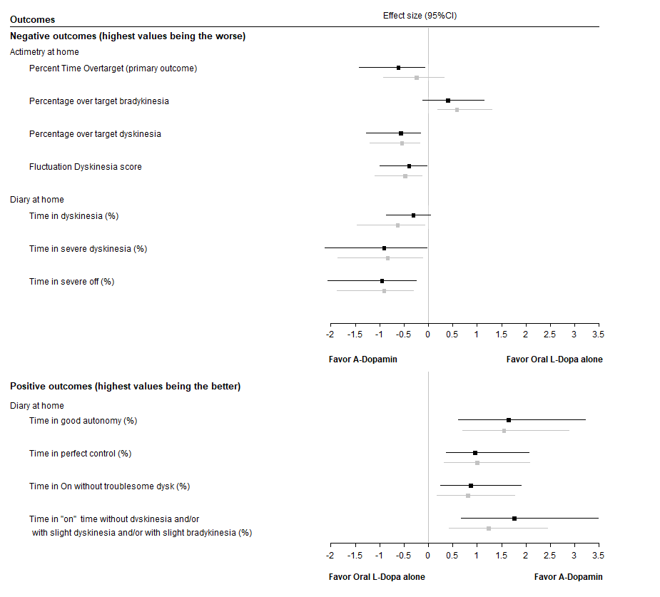Effect sizes were Hedge’s g values (calculated using rank-transformed data), with non-central 95% CIs. Effect sizes calculated in per-protocol primary efficacy analysis (which referred to outcome measures calculated after excluding weeks with deviations from target L-dopa oral dose) are reported in black. Effect sizes calculated in secondary efficacy analysis (which referred to outcome measures calculated from all planned recording weeks) are reported in grey.

Extended Data Table 6. Secondary and exploratory efficacy diary outcomes expressed in hours according to treatment period (in main analysis excluding recording weeks with deviations of L-dopa oral treatment).
 | Oral L-dopa treatment | A-dopamine treatment | Intra-patient difference
Diary at home ª
Time in On without dyskinesia (perfect control) (%) | 8.5 (0.0; 11.9) [7.2] | 12.9 (0.0; 20.9) [12.2] | 3.0 (0.0; 13.8) [4.4]
Time in On without troublesome dyskinesia (h) | 10.5 (4.6; 16.6) [9.5] | 13.7 (6.2; 21.0) [14.0] | 2.7 (-2.3; 13.8) [4.2]
Time in good autonomy (h) | 14.2 (8.0; 20.6) [14.5] | 23.6 (16.1; 24.0) [21.3] | 6.2 (-2.8; 15.4) [6.6]
Time in “On” time without dyskinesia and/or with slight dyskinesia and/or with slight bradykinesia (h) | 14.8 (10.7; 21.1) [15.2] | 23.6 (16.1; 24.0) [21.3] | 6.3 (-0.6; 12.7) [6.1]
Time in dyskinesia (h) | 2.4 (0.0; 15.8) [4.6] | 1.2 (0.0; 6.2) [2.3] | -0.6 (-9.6; 1.2) [-2.5]
Time in severe dyskinesia (h) | 0.0 (0.0; 3.5) [0.5] | 0.0 (0.0; 0.1) [0.0] | -0.0 (-3.5; 0.0) [-0.6]
Time in severe Off (h) | 1.0 (0.0; 5.4) [1.8] | 0.0 (0.0; 3.5) [0.5] | -0.7 (-5.4; 0.0) [-1.3]

Values are expressed as median (range: minimum; maximum) [mean] unless indicated otherwise.
ª Assessed by average value of actimetry from first and last recording weeks of each treatment period without deviations in oral therapy, estimated from percentage of time under the condition and by considering a period of 24 h.
Extended Data Table 7. Exploratory efficacy outcomes
Efficacy outcomes | Oral L-dopa  treatment | A-dopamine  treatment | Intra-patient  differences | Effect size  [95%CI] ^{b}
Actimetry at home ª
Bradykinesia score (50th percentile) | 19.5 (9.5; 39.5) [21.4] | 22.4 (17.4; 33.2) [23.5] | 2.4 (-6.3; 10.0) [2.1] | 0.32 [-0.08; 0.90]
Dyskinesia score (50th percentile) | 5.4 (0.2; 53.4) [11.0] | 1.6 (0.2; 6.6) [2.3] | -1.9 (-51.2; 1.4) [-8.7] | -0.65 [-1.55; 0.01]
Percentage of time of immobility | 5.3 (1.9; 19.1) [6.7] | 5.0 (3.1; 17.6) [7.5] | -0.6 (-3.2; 7.4) [0.8] | 0.00 [-0.65; 0.65]
Percentage of time with a tremor | 0.9 (0.4; 8.3) [1.8] | 1.1 (0.5; 5.1) [1.7] | 0.2 (-3.2; 1.6) [-0.2] | 0.23 [-0.30; 0.95]
Non-motor assessment
Quality of life PDQ-39 | 34.8 (18.3; 60.7) [37.5] | 34.1 (12.9; 55.2) [37.4] | 0.2 (-15.6; 14.7) [-0.1] | 0.02 [-0.44; 0.49]
Schwab & England scale score | 8 (6; 9) [7.7] | 8.0 (6; 10) [7.9] | 0 (-1; 2) [0.2] | 0.12 [-0.52; 0.81]
Values are expressed as median (range: minimum; maximum) [mean] unless indicated otherwise.
ª Calculated from weeks of assessment without in-target oral L-dopa dose as pre-specified in per-protocol primary efficacy analysis.
^{b} Hedge’s g values for A-dopamine vs. oral L-dopa treatment, calculated using rank-transformed data with non-central 95%CIs.
One-week actimetry at home: actimeter (Parkinson Kinetograph™ from GKC) in a wristwatch worn on the most affected side. The bradykinesia score should be as close as possible to the 50th percentile (normal value = 18.6); the dyskinesia score should be as close as possible to the 50th percentile (normal value = 4.3). The immobility time is the percentage of time the subject is abnormally immobile (the highest being the worse). Time with a tremor is the percentage of time the subject has tremor (the highest being the worse). The PDQ-39 is a 39-question self-questionnaire assessing the quality of life of Parkinson's disease patients over the past month (the highest being the worst). The Schwab and England scale score measures the daily function (the highest being the best).

Extended Data Table 8. Secondary and exploratory safety outcomes
Safety outcomes | Oral L-dopa  treatment | A-dopamine  treatment | Intra-patient  differences | Effect size  [95%CI] ^{b}
Non-motor assessment
MDS-UPDRS part I | 18 (7; 21) [16.4] | 16 (6; 22) [15.9] | 1 (-8; 6) [-0.6] | 0.04 [-0.68; 0.77]
Sleepiness (Epworth) | 10 (5; 18) [10.8] | 13 (6; 20) [11.9] | 3 (-12; 12) [1.1] | 0.34 [-0.59; 1.37]
PD sleep scale | 108 (62; 141) [103.1] | 101 (46; 129) [95.8] | -5 (-50; 39) [-7.3] | -0.29 [-1.03; 0.34]
MoCA | 27 (17; 29) [26.1] | 28 (17; 30) [24.8] | 0 (-8; 1) [-1.3] | 0.00 [-0.43; 0.48]
NPI-C | 19 (5; 38) [17.9] | 15 (4; 44) [19.9] | -2 (-4; 17) [2.0] | 0.00 [-0.38; 0.38]
Parkinson anxiety scale | 9 (3; 16) [9.3] | 13 (2; 22) [11.7] | 2 (-5; 7) [2.3] | 0.24 [-0.20; 0.82]
Apathy (LARS) | -29 (-33; -23) [-28.8] ^{c} | -29.5 (-32; -21) [-28.1] ^{c} | 0.5 (-4; 5) [0.6] ^{c} | 0.29 [-0.32; 1.05]
ECMP | 9 (4; 16) [9.2] | 10.0 (4; 23) [11.5] ^{c} | 1.5 (-3; 15) [2.4] ^{c} | 0.32 [-0.27; 1.08]
Biological parameters
Dopamine in blood (μg/l) ª | 1.0 (0.2; 9.1) [2.5] | 11.3 (3.7; 41.6) [13.7] | 9.4 (-5.4; 39.6) [11.2] | 2.10 [1.08; 3.73]
Dopamine in urine (μg/24 h) ª | 16520 (5600; 41814) [22121] | 9650 (7065; 12450) [9969] ^{d} | -7801 (-29364; -1600) [-13811] ^{d} | -1.57 [-4.01; -0.75]
HVA in urine (mg/24 h) ª | 59.8 (14.1; 84.8) [51.8] | 50.1 (14.1; 122.4) [55.3] ^{d} | 13.2 (-41.9; 60.4) [9.1] ^{d} | 0.00 [-1.13; 1.13]
Values are expressed as median (range: minimum; maximum) [mean] unless indicated otherwise.
ª Pre-specified as exploratory outcomes.
^{b} Hedge’s g values for A-dopamine vs. oral L-Dopa treatment, calculated using rank-transformed data with non-central 95%CIs.
^{c} One missing value.
^{d} Four missing values.
Movement Disorders Society-Unified Parkinson Disease Rating Scale (MDS-UPDRS) part I (cognition and behaviour) (the highest being the worst). Epworth Sleepiness Scale (/24, the highest being the worst). PD sleep scale (/150, the highest being the best). MoCA: Montreal Cognitive Assessment (/30, the highest being the best). NPI-C: Neuropsychiatric Inventory-Clinician (/798, the highest being the worst); Parkinson Anxiety Scale (/48, the highest being the worst); LARS: Lille Apathy Rating scale (-36 to +36, the highest being the worst); ECMP French scale of assessment of hyper- and hypodopaminergic behaviours in Parkinson's disease (/72, the highest being the worst); HVA: homovanillic acid.
Extended Data Table 9. Extended data safety

Patient number | Phase | MedDRA Low Level Term | Severity | Serious Adverse Event | Outcome | Imputability with A-dopamine | Imputability with medical device | Imputability with neurosurgery | Other etiology
01 | After neurosurgery ;  before phase 1 | Device failure | Mild | Yes | Resolved | No | Yes (dysfunction) |  | Other
01 | After neurosurgery ;  before phase 1 | Post procedural oedema | Mild |  | Resolved | No |  | Yes
01 | Acute challenge | Drowsiness | Mild |  | Resolved | Yes
01 | Acute challenge | On and off phenomenon | Mild |  | Resolved | Yes
01 | Phase 1 | Scar revision | Moderate | Yes | Resolved | No | No | Yes
01 | Long term | Bronchitis | Moderate |  | Resolved | No
01 | Long term | Fall | Moderate |  | Resolved | No |  |  | Parkinson
01 | Long term | Faecaloma | Moderate | Yes | Resolved | No |  |  | Parkinson
01 | Long term | Basal cell carcinoma | Mild |  | Resolved | No
01 | Long term | Disorientation | Mild |  | Resolved | No |  |  | Parkinson
01 | Long term | Oedema of extremities | Mild |  | Resolved | No
01 | Long term | Asthenia | Moderate |  | On going | No |  |  | Parkinson
01 | Long term | Fall | Moderate |  | Resolved | No
01 | Long term | Medical device site haematoma | Mild |  | On going | No | Yes (refill)
02 | Before neurosurgery | Chronic urticaria | Mild |  | Resolved | No
02 | Acute challenge | Drowsiness | Mild |  | Resolved | Yes
02 | Acute challenge | Nausea | Mild |  | Resolved | Yes
02 | Acute challenge | Orthostatic hypotension | Mild |  | Resolved | Yes
02 | Acute challenge | On and off phenomenon | Mild |  | Resolved | Yes
02 | Phase 1 | Fall | Severe | Yes | Resolved | No |  |  | Parkinson
02 | Phase 1 | Fall | Mild | Yes | Resolved | No |  |  | Parkinson
02 | Phase 1 | Accidental overdose | Moderate | Yes | Resolved | No |  |  | Parkinson
02 | Phase 1 | Fall | Mild |  | Resolved | No |  |  | Parkinson
02 | Phase 1 | SARS-CoV-2 infection | Moderate |  | Resolved | No
02 | Phase 2 (group 1 : first period DIVE-I) | Vomiting | Moderate |  | Resolved | Yes
02 | Phase 2 (group 1 : first period DIVE-I) | On and off phenomenon | Moderate |  | Resolved | No | Yes (refill) | No
02 | Phase 2 (group 1 : first period DIVE-I) | Device use issue | Mild |  | Resolved | No | Yes (refill) | No
02 | Long term | Alcohol poisoning | Moderate | Yes | Resolved | No |  |  | Death of father
02 | Long term | Confusion | Moderate | Yes | Resolved | No |  |  | Parkinson
02 | Long term | Confusion | Mild |  | Resolved | No
02 | Long term | Disorder sleep | Moderate |  | Resolved | No |  |  | Parkinson
02 | Long term | Appetite lost | Moderate |  | Resolved | No
02 | Long term | Hypothymia | Moderate |  | Resolved | No
02 | Long term | On and off phenomenon | Moderate |  | Resolved | No |  |  | Parkinson
02 | Long term | Micturition urgency | Moderate |  | Resolved | No |  |  | Parkinson
02 | Long term | On and off phenomenon | Moderate |  | Resolved | No |  |  | Parkinson
02 | Long term | Balance disorder | Moderate |  | Resolved | No |  |  | Parkinson
02 | Long term | Constipation | Moderate |  | Resolved | No |  |  | Parkinson
02 | Long term | Lung infection | Mild |  | On going | No
03 | Before neurosurgery | Death | Death | Yes | Fatal | No |  |  | Ischemic heart disease
05 | After neurosurgery;  before phase 1 | Medical device site pain | Mild |  | Resolved | No |  | Yes
05 | Phase 1 | Rehabilitation therapy | Mild | Yes | Resolved | No (PI) / Yes (Sponsor) |  |  | Parkinson
05 | Phase 1 | Medical device site extravasation | Moderate |  | Resolved | No | Yes (refill) | No
05 | Phase 1 | Fall | Mild |  | Resolved | No |  |  | Parkinson
05 | Phase 1 | Parkinson's disease aggravated | Moderate |  | Resolved | No |  |  | Parkinson
05 | Long term | Orthostatic hypotension | Moderate |  | Resolved | No
05 | Long term | Excess sweating | Mild |  | Resolved | No |  |  | Parkinson
05 | Long term | Syringe broken | Mild |  | Resolved | No | Yes
05 | Long term | Medical device site oedema |  |  | Rn going | No | Yes
05 | Long term | Therapy regimen changed | Mild | Yes | On going | No |  |  | Parkinson
06 | Phase 1 | Vomiting | Mild |  | Resolved | Yes
06 | Phase 1 | Inappropriate dose of drug administered | Mild |  | Resolved | Yes
06 | Phase 2 (group 2 : first period oral treatment) | Vomiting | Mild |  | Resolved | Yes
06 | Long term | Device infusion failure | Mild | Yes | Resolved | No | Yes (dysfunction)
06 | Long term | Parkinson's disease aggravated | Moderate |  | Resolved | No | Yes (dysfunction) |  | Parkinson
06 | Long term | Asthenia | Moderate |  | Resolved | Yes
06 | Long term | Confusion | Mild |  | Resolved | Yes
06 | Long term | Confusion | Mild |  | Resolved | Yes
06 | Long term | Vomiting | Mild |  | Resolved | Yes
06 | Long term | Cramps of lower extremities | Mild |  | Resolved | No
06 | Long term | Brittle diabetes | Mild | Yes | Resolved | No |  |  | Diabetes
07 | Before neurosurgery | Brain tumor | Moderate | Yes | On going | No
08 | Phase 1 | Nausea | Moderate |  | resolved | Yes
08 | Phase 1 | Confusion | Mild |  | resolved | No |  |  | DULOXETINE
08 | Phase 1 | Confusion | Moderate |  | resolved | No |  |  | Parkinson
08 | Phase 1 | Constipation | Moderate |  | Resolved | No |  |  | Parkinson
08 | Phase 1 | Vomiting | Moderate |  | Resolved | No |  |  | Parkinson
08 | Phase 1 | Vomiting | Moderate |  | Resolved | Yes
08 | Phase 1 | Anxiety | Moderate |  | On going | No |  |  | Parkinson
08 | Phase 1 | Gastritis | Mild |  | On going | No
08 | Phase 1 | Pneumonia pneumococcal | Death | Yes | Fatal | No |  |  | Community-acquired pneumonia
09 | Phase 1 | Nausea | Moderate |  | Resolved | Yes
09 | Phase 1 | Fatigue | Mild |  | Resolved | Yes
09 | Long term | Drenching sweats | Moderate |  | Resolved | No
10 | Phase 1 | Vomiting | Moderate |  | Resolved | Yes
10 | Phase 1 | Drowsiness | Mild |  | Resolved | Yes
10 | Phase 1 | Breast cancer | Severe |  | Resolved | No |  |  | Considered to be in remission
10 | Phase 1 | Vomiting | Moderate |  | Resolved | Yes
10 | Phase 1 | Headache | Moderate |  | Resolved | Yes
10 | Phase 1 | On and off phenomenon | Mild |  | Resolved | No |  |  | Parkinson
10 | Phase 1 | Orthostatic hypotension | Mild |  | Resolved | Yes
10 | Phase 2 (group 2 : first period oral treatment) | Cancer surgery | Moderate |  | Resolved | No
10 | Phase 2 (group 2 : first period oral treatment) | Nausea | Mild |  | Resolved | No
10 | Phase 2 (group 2 : first period oral treatment) | Lymphocele | Mild |  | Resolved | No
10 | Phase 2 (group 2 : first period oral treatment) | Hypothyroidism | Moderate |  | Resolved | No
10 | Phase 2 (group 2 : first period oral treatment) | Bladder prolapse | Moderate |  | Resolved | No
10 | Phase 2 (group 2 : first period oral treatment) | Polymyalgia | Mild |  | Resolved | No
10 | Phase 2 (group 2 : first period oral treatment) | Haematuria | Mild |  | Resolved | No
10 | Phase 2 (group 2 : first period oral treatment) | Abdominal pain | Mild |  | Resolved | No
10 | Phase 2 (group 2 : first period oral treatment) | Coxalgia | Moderate |  | On going | No
12 | After neurosurgery ;  before phase 1 | Hematoma postoperative | Moderate |  | Resolved | No |  | Yes
12 | Phase 1 | Nausea | Mild |  | Resolved | Yes
12 | Phase 1 | Headache | Mild |  | Resolved | Yes
12 | Phase 1 | Drowsiness | Mild |  | Resolved | Yes
12 | Phase 2 (group 2 : first period oral treatment) | Weight increased | Moderate |  | On going | Yes
12 | Long term | Injection site pain | Mild |  | Resolved | No | Yes
12 | Long term | Urine discolouration | Mild |  | Resolved | No
12 | Long term | Headache | Mild |  | Resolved | No
12 | Long term | Phlebitis lower limb | Moderate |  | Resolved | No
12 | Long term | Urine discolouration | Mild |  | Resolved | No
12 | Long term | Epistaxis | Mild |  | Resolved | No
12 | Long term | Diplopia | Mild |  | Resolved | No |  |  | Parkinson
12 | Long term | COVID-19 | Mild |  | Resolved | No
12 | Long term | Tendinopathy | Mild |  | On going | No
13 | Phase 1 | Nausea | Mild |  | Resolved | Yes
13 | Long term | Vomiting | Moderate |  | Resolved | Yes
13 | Long term | Pain stomach | Mild |  | Resolved | No
13 | Long term | Oesophagitis | Moderate | Yes | Resolved | No
14 | Phase 1 | Pollakiuria | Mild | Yes | Resolved | No |  |  | Prostate adenoma and Parkinson's disease
14 | Phase 1 | Confusion | Mild |  | Resolved | Yes |  |  | MODOPAR® overdose
14 | Phase 1 | Prostate adenoma | Mild |  | On going | No
14 | Phase 2 (group 2 : first period oral treatment) | Movements involuntary | Mild | Yes | Resolved | No |  |  | Parkinson
14 | Long term | Contusion of thigh | Mild | Yes | Resolved | No | No | No | Parkinson
14 | Long term | Disinhibition | Moderate |  | Resolved | No |  |  | Parkinson's disease and treatment errors
15 | Phase 1 | Vomiting | Moderate |  | Resolved | Yes
15 | Phase 1 | Nausea | Moderate |  | Resolved | Yes
15 | Phase 1 | Flushing | Mild |  | Resolved | Yes
15 | Phase 1 | Partial epilepsy | Moderate | Yes | Resolved | No |  |  | Arteriovenous malformation
15 | Phase 2 (group 1 : first period DIVE-I) | Confusion | Moderate |  | Resolved | No |  |  | DULOXETINE
15 | Long term | Reversible cerebral vasoconstriction syndrome | Severe | Yes | Resolved | No |  |  | ZONEGRAN®
15 | Long term | Partial epilepsy | Moderate | Yes | Resolved | No |  |  | Surgical arteriovenous malformation
15 | Long term | Fall | Mild |  | On going | No
15 | Long term | Syndrome of inappropriate antidiuretic hormone secretion | Moderate |  | Resolved | No
16 | After neurosurgery ;  before phase 1 | Headache | Mild | Yes | Resolved | No |  | Yes | Migraines
16 | Phase 1 | Inappropriate dose of drug administered | Moderate |  | Resolved | Yes
16 | Phase 1 | Vomiting | Moderate |  | Resolved | Yes
16 | Phase 1 | Headache | Mild |  | Resolved | Yes
16 | Phase 2 (group 1 : second period oral treatment) | Rectal abscess | Moderate |  | Resolved | No
16 | Phase 2 (group 1 : second period oral treatment) | Bacterial prostatitis | Moderate | Yes | Resolved | No |  |  | Urinary tract infection, prostatitis
16 | Long term | Lumbalgia | Moderate |  | On going | No
16 | Long term | Pain | Moderate | Yes | On going | Yes | Yes (possible)
16 | Long term | Skull trauma | Moderate | Yes | On going | No | No

