Suppl Table1. Audit form of the Institutional Review Board of each hospital

Suppl Table1.1 The medical research ethics review board audit form of Shandong Provincial Hospital Affiliated to Shandong First Medical University

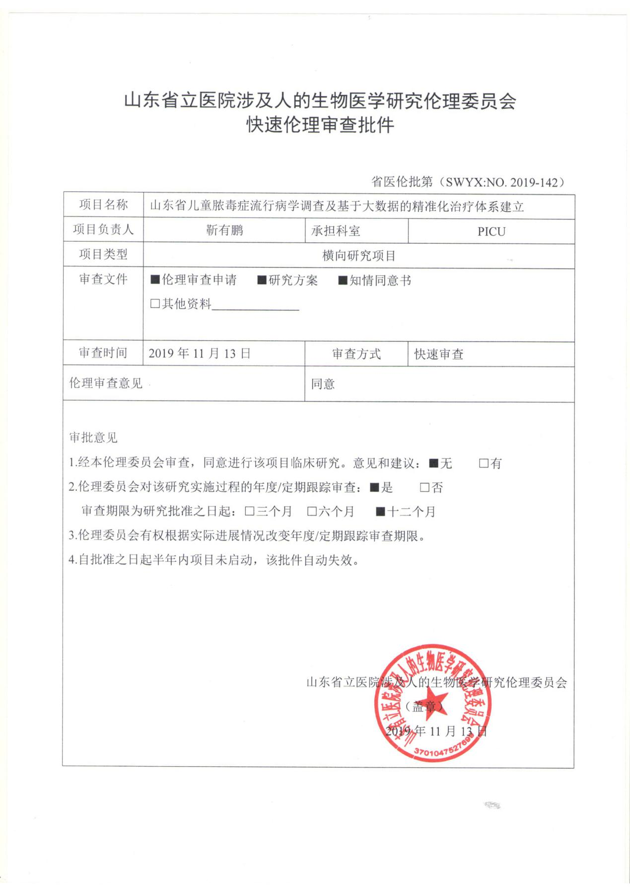

Suppl Table1.2 The medical research ethics review board audit form of Affiliated Hospital of Jining Medical University

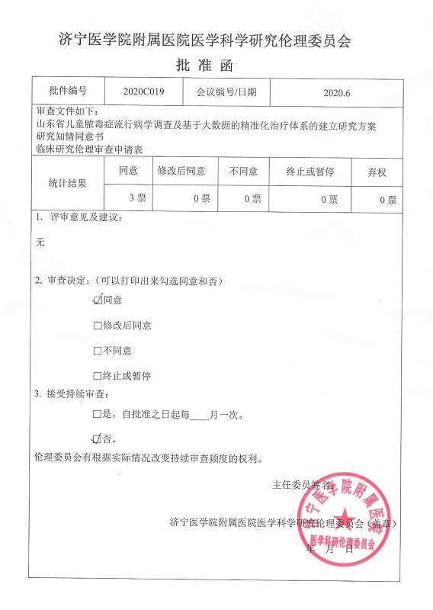

Suppl Table1.3 The medical research ethics review board audit form of Qingdao Women and Children Hospital

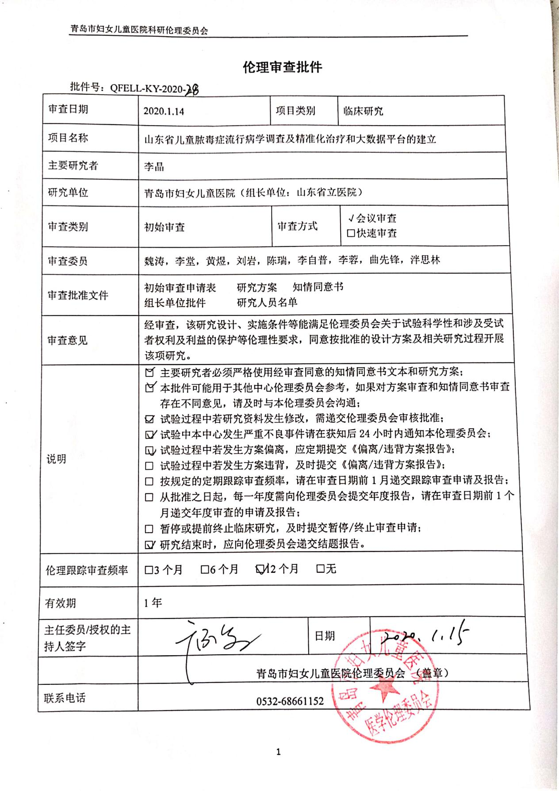
Suppl Table 2. Pediatric Sequential Organ Failure Assessment Score

Variables | Scoreª
Variables | 0 | 1 | 2 | 3 | 4
Respiratory
PaO₂:FiO₂ ^{b}  or  SpO₂:FiO₂ ^{c} | ≥400 | 300-399 | 200-299 | 100-199 With respiratory support | ＜100 With respiratory support
PaO₂:FiO₂ ^{b}  or  SpO₂:FiO₂ ^{c} | ≥292 | 264-291 | 221-264 | 148-220 With respiratory support | ＜148 With respiratory support
Coagulation
Platelet count, ×10³ /μL | ≥150 | 100-149 | 50-99 | 20-49 | ＜20
Hepatic
Bilirubin, mg/dL | ＜1.2 | 1.2-1.9 | 2.0-5.9 | 6.0-11.9 | ＞12
Cardiovascular
MAP by age group or vasoactive infusion, mm Hg or μg/kg/min^{d}
＜1 mo | ≥46 | <46 | Dopamine hydrochloride ≤5 or dobutamine hydrochloride (any) | Dopamine hydrochloride >5 or epinephrine ≤0.1 or norepinephrine bitartrate ≤0.1 | Dopamine hydrochloride >15 or epinephrine >0.1 or norepinephrine bitartrate >0.1
1-11 mo | ≥55 | <55 | Dopamine hydrochloride ≤5 or dobutamine hydrochloride (any)
12-23 mo | ≥60 | <60 | Dopamine hydrochloride ≤5 or dobutamine hydrochloride (any)
24-59 mo | ≥62 | <62 | Dopamine hydrochloride ≤5 or dobutamine hydrochloride (any)
60-143 mo | ≥65 | <65 | Dopamine hydrochloride ≤5 or dobutamine hydrochloride (any)
144-216 mo | ≥67 | <67 | Dopamine hydrochloride ≤5 or dobutamine hydrochloride (any)
>216mo^{e} | ≥70 | <70 | Dopamine hydrochloride ≤5 or dobutamine hydrochloride (any)
Neurologic
Glasgow Coma Score^{f} | 15 | 13-14 | 10-12 | 6-9 | <6
Renal
Creatinine by age group, mg/dL
＜1 mo | <0.8 | 0.8-0.9 | 1.0-1.1 | 1.2-1.5 | ≥1.6
1-11 mo | <0.3 | 0.3-0.4 | 0.5-0.7 | 0.8-1.1 | ≥1.2
12-23 mo | <0.4 | 0.4-0.5 | 0.6-1.0 | 1.1-1.4 | ≥1.5
24-59 mo | <0.6 | 0.6-0.8 | 0.9-1.5 | 1.6-2.2 | ≥2.3
60-143 mo | <0.7 | 0.7-1.0 | 1.1-1.7 | 1.8-2.5 | ≥2.6
144-216 mo | <1.0 | 1.0-1.6 | 1.7-2.8 | 2.9-4.1 | ≥4.2
>216mo^{e} | <1.2 | 1.2-1.9 | 2.0-3.4 | 3.5-4.9 | ≥5

Abbreviations: FiO₂, fraction of inspired oxygen; MAP, mean arterial pressure; pSOFA, pediatric Sequential Organ Failure Assessment; SpO₂, peripheral oxygen saturation. SI conversion factors: To convert bilirubin to micromoles per liter, multiply by 17.104; creatinine to micromoles per liter, multiply by 88.4; and platelet count to ×109 /L, multiply by 1.
ª The pSOFA score was calculated for every 24-hour period. The worst value for every variable in each 24-hour period was used to calculate the subscore for each of the 6 organ systems. If a variable was not recorded in a given 24-hour period, it was assumed to be normal and a score of 0 was used. Daily pSOFA score was the sum of the 6 subscores (range, 0-24 points; higher scores indicate a worse outcome).
^{b} PaO₂ was measured in millimeters of mercury.
^{c} Only SpO₂ measurements of 97% or lower were used in the calculation.
^{d} MAP (measured in millimeters of mercury) was used for scores 0 and 1; vasoactive infusion (measured in micrograms per kiligram per minute), for scores 2 to 4. Maximum continuous vasoactive infusion was administered for at least 1 hour.
^{e} Cutoffs for patients older than 18 years (216 months) were identical to the original SOFA score.
^{f} Glasgow Coma Scale was calculated using the pediatric scale.

- Matics TJ, Sanchez-Pinto LN. Adaptation and Validation of a Pediatric Sequential Organ Failure Assessment Score and Evaluation of the Sepsis-3 Definitions in Critically Ill Children. JAMA Pediatr. 2017;171(10):e172352.

Suppl Table 3. Definitions of systemic inflammatory response syndrome (SIRS)
SIRS

The presence of at least two of the following four criteria, one of which must be abnormal temperature or leukocyte count:
- Coreª temperature of > 38.5°C or <36°C.
- Tachycardia, defined as a mean heart rate 2 SD above normal for age in the absence of external stimulus, chronic drugs, or painful stimuli; or otherwise unexplained persistent elevation over a 0.5- to 4-hr time period OR for children <1 yr old: bradycardia, defined as a mean heart rate < 10th percentile for age in the absence of external vagal stimulus, β-blocker drugs, or congenital heart disease; or otherwise unexplained persistent depression over a 0.5-hr time period.
- Mean respiratory rate 2 SD above normal for age or mechanical ventilation for an acute process not related to underlying neuromuscular disease or the receipt of general anesthesia.
- Leukocyte count elevated or depressed for age (not secondary to chemotherapy-induced leukopenia) or 10% immature neutrophils.
ª core temperature must be measured by rectal, bladder, oral, or central catheter probe.

- Goldstein B, Giroir B, Randolph A. International Consensus Conference on Pediatric Sepsis. International pediatric sepsis consensus conference: definitions for sepsis and organ dysfunction in pediatrics. Pediatr Crit Care Med. 2005;6(1):2-8.

