Supplementary Information
Plant derivative extracts' (Brahmastra) characterization and their impact on Lipaphis erysimi and natural enemies in oilseed-mustard under organic farming conditions
Subash Singh^{1*} and Mehra S. Sidhu²
¹ School of Organic Farming, Punjab Agricultural University, Ludhiana, Punjab, India 141 004
² Electron Microscopy and Nanoscience Lab, Dept. of Soil Science, Punjab Agricultural University, Ludhiana, Punjab, India 141 004
*Corresponding author email: subashsingh@pau.edu
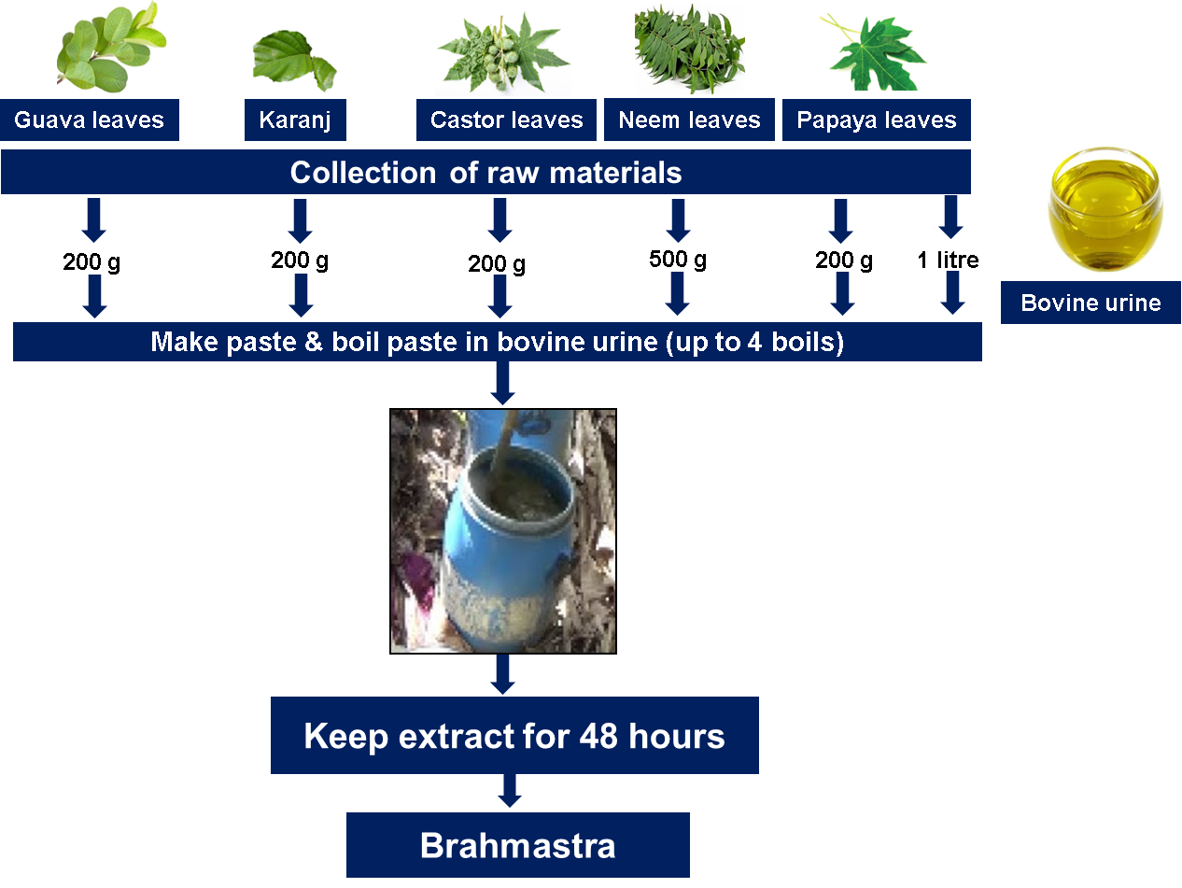
Fig S1. Schematic diagram of brahmastra preparation
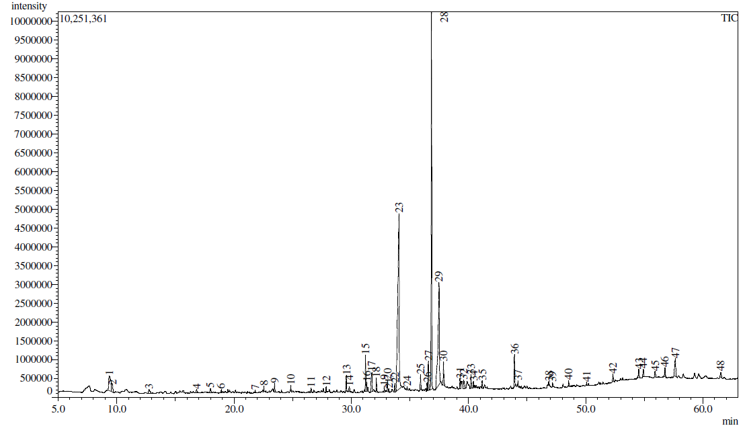
Fig S2. Gas chromatogram and mass spectra of methanolic extract of Karanj leaves, Pongamia pinnate
Table S1. The mass spectrum of the unidentified components in methanolic extract of Karanj Leaves were compared to the mass spectra of known components stored in the NIST library. The major components are marked in yellow.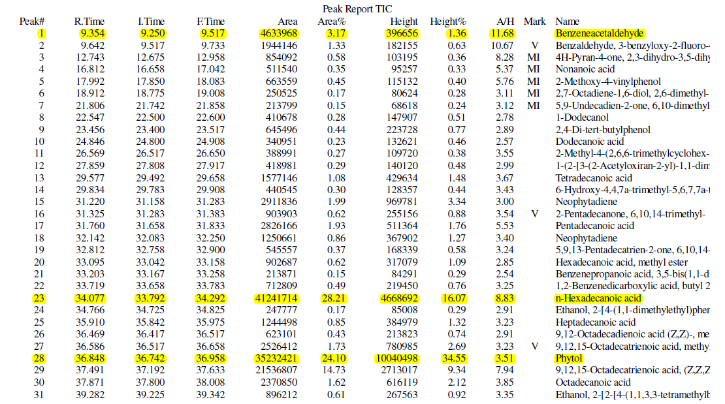
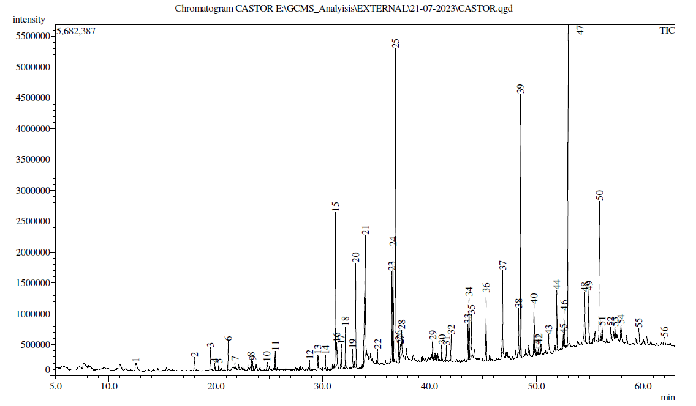
Fig S3. Gas chromatogram and mass spectra of methanolic extract of Castor leaves

Table S2. The mass spectrum of the unidentified components in methanolic extract of Castor Leaves were compared to the mass spectra of known components stored in the NIST library. The major components are marked in yellow.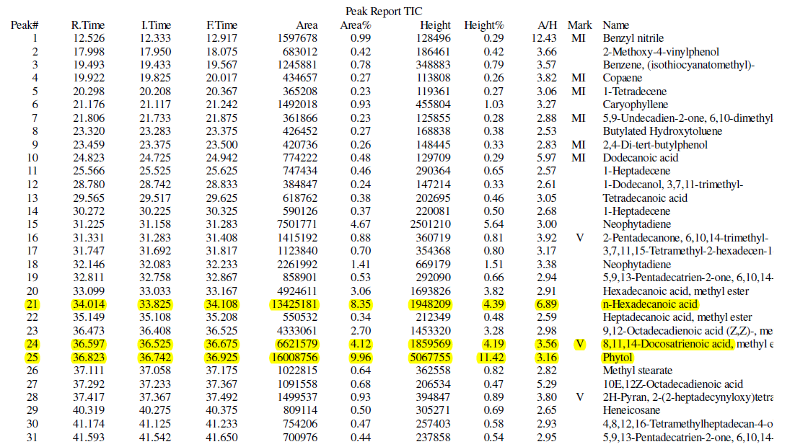 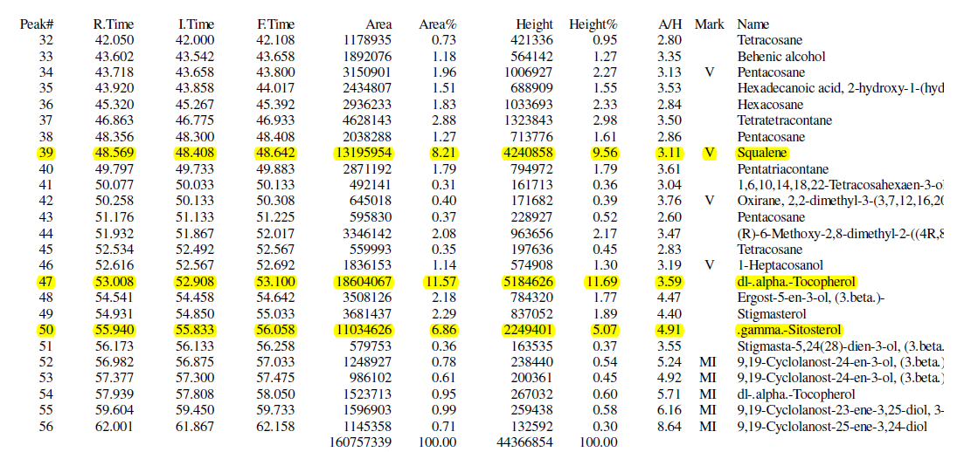
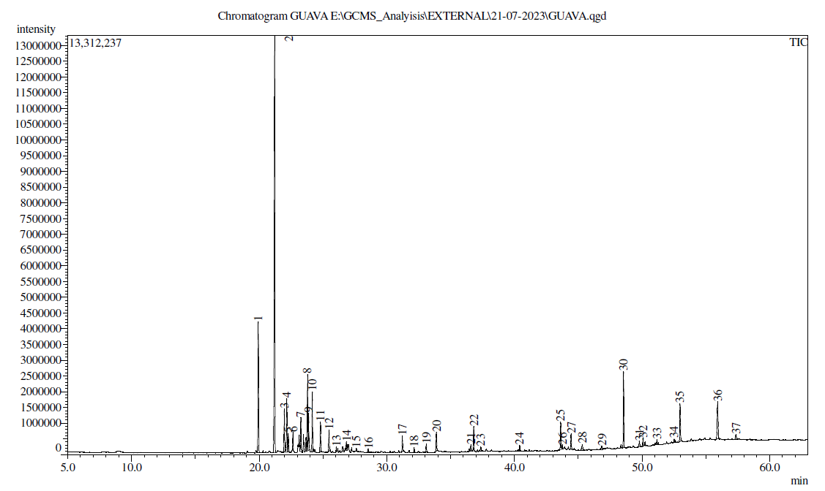
Fig S4. Gas chromatogram and mass spectra of methanolic extract of Guava leaves
Table S3. The mass spectrum of the unidentified components in methanolic extract of Guava Leaves were compared to the mass spectra of known components stored in the NIST library. The major components are marked in Yellow.
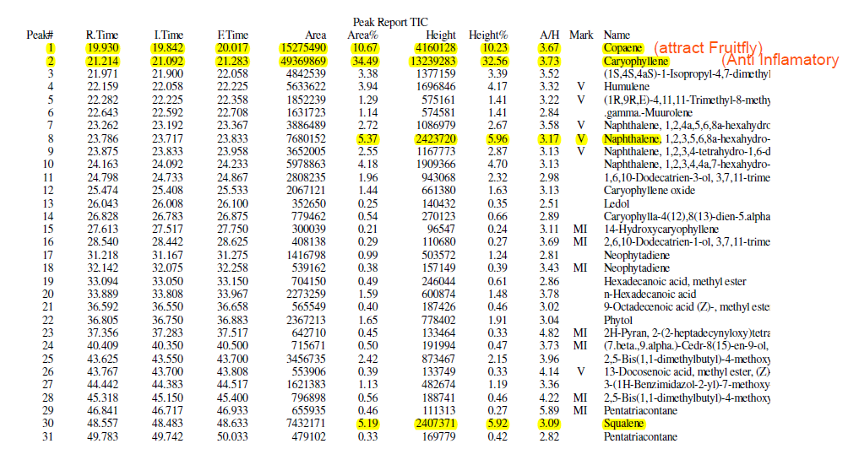

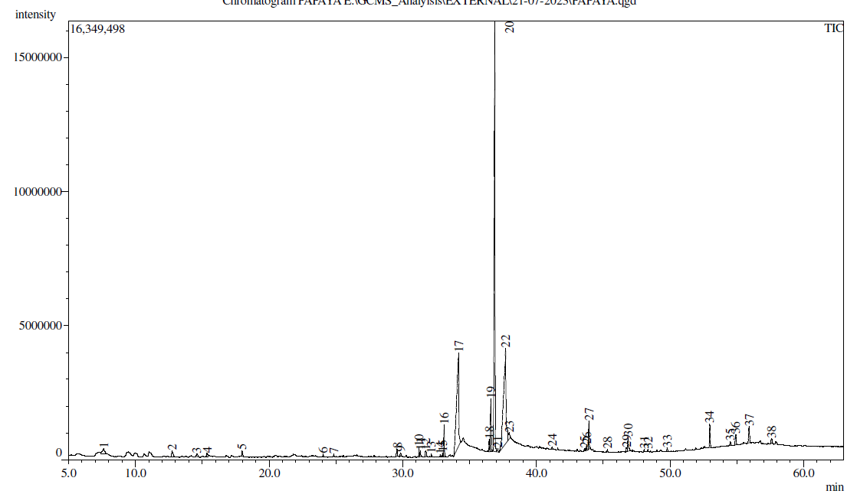
Fig S5. Gas chromatogram and mass spectra of methanolic extract of Papaya leaves
Table S4. The mass spectrum of the unidentified components in methanolic extract of Papaya Leaves were compared to the mass spectra of known components stored in the NIST library. The major components are marked in Yellow.
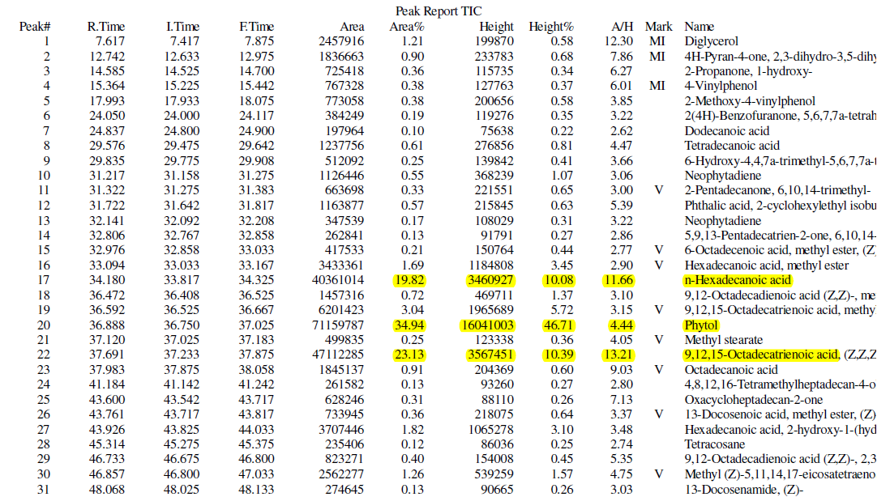
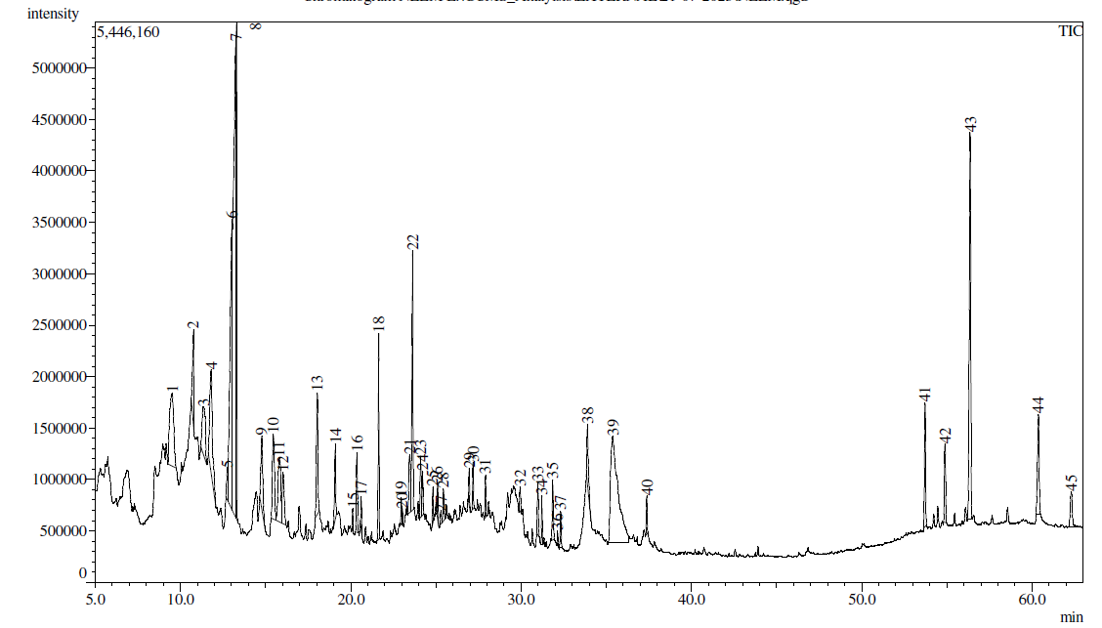
Fig S6. Gas chromatogram and mass spectra of methanolic extract of Neem leaves

Table S5. The mass spectrum of the unidentified components in methanolic extract of Neem Leaves (Azadirachta indica) were compared to the mass spectra of known components stored in the NIST library. The major components are marked in yellow.
