“Matthew Effect” in Global Major Cities Over Decades: In the context of the spatiotemporal 3D urban expansion

Supplementary Information

Data

Sentinel-1
Sentinel-1 Ground Range Detected (GRD) scenes, acquired from a dual-polarization C-band Synthetic Aperture Radar (SAR) instrument, were employed for estimating urban building heights. These Sentinel-1 images offer a spatial resolution of 10 meters and a rapid revisit frequency ranging from 6 to 12 days(Dai et al., 2016). In this study, the analysis leveraged two polarization bands, VV and VH, and the dual-polarization information known as VVH (Eq. 1) (X. Li, Zhou, et al., 2020), to enhance building height estimations. All Sentinel-1 SAR GRD data are accessible via the Google Earth Engine (GEE) platform (Gorelick et al., 2017). In order to ensure data quality, all GEE-hosted data underwent processing using the Sentinel-1 Toolbox (Veci et al., 2014) to produce calibrated, ortho-corrected products(Wu et al., 2023).
$$VVH=VV×γ^{VH} (1)$$
Where, γ was set to 5 based on previous research (X. Li, Zhou, et al., 2020).

Sentinel-2
After masking out poor-quality observations in Sentinel-2 images using the QA60 bitmask band, we selected RGB, NIR, SWIR, and red-edge bands as independent variables. Additionally, based on raw indices of Sentinel-2, six calculated indices are also used as input variables, including the Normalized Difference Vegetation Index (NDVI) (Tucker, 1979), the Normalized Difference Built-up Index (NDBI) (Zha et al., 2003), the Modified Normalized Difference Water Index (MNDWI) (Xu, 2006), the Enhanced Vegetation Index (EVI) (Huete et al., 2002), the Land Surface Water Index (LSWI) (Xiao et al., 2004), and the Combinational Shadow Index (CSI)(Sun et al., 2019):
$$NDVI=\frac{ρ_{NIR}-ρ_{red}}{ρ_{NIR}+ρ_{red}} (2)$$
$$EVI=\frac{2.5(ρ_{NIR}-ρ_{red})}{{(ρ}_{NIR}+6ρ_{red}-7.5ρ_{blue}+1)} (3)$$
$$LSWI=\frac{ρ_{NIR}-ρ_{swir1}}{ρ_{NIR}+ρ_{swir1}} (4)$$
$$mNDWI=\frac{ρ_{green}-ρ_{swir1}}{ρ_{green}+ρ_{swir1}} (5)$$
$$NDBI=\frac{ρ_{swir1}-ρ_{NIR}}{ρ_{swir1}+ρ_{NIR}} (6)$$
$$SEI=\frac{{(ρ}_{aerosols}+ρ_{water vapor})-(ρ_{green}+ρ_{NIR})}{{(ρ}_{aerosols}+ρ_{water vapor})+(ρ_{green}+ρ_{NIR})} (7)$$
$$CSI=\left\{\begin{aligned}SEI-ρ_{NIR}, if ρ_{NIR}≥NDWI \\ SEI-NDWI, else\end{aligned}\right. (8)$$

PALSAR
The Phased Array Type L-band Synthetic Aperture Radar (PALSAR) is a multi-polarization active microwave sensor. In this study, we obtained global 25-meter PALSAR/PALSAR-2 yearly mosaic data covering the period from 2019 to 2021 from the Google Earth Engine (GEE) data catalog under the collection "JAXA/ALOS/PALSAR/YEARLY/SAR." We collected HH and HV polarizations data to capture surface reflectance and scattering characteristics comprehensively.

VIIRS
Visible Infrared Imaging Radiometer Suite (VIIRS) is an earth observation sensor usually mounted on satellites to capture image data in the visible and infrared spectral spectrums. The Annual Global VIIRS Nighttime Lights dataset (Elvidge et al., 2021) is a collection of Earth observation data derived from the VIIRS sensor, providing valuable information about the distribution of artificial nighttime lights (NTL) across the globe.

Settlement coverage data
In this study, we adopted World Settlement Footprint 2019 (WSF 2019) (Marconcini et al., 2021), Microsoft Building footprint (Microsoft, 2018/2018), China Building Rooftop Area(Liu et al., 2023), EUBUCCO v0.1 (Milojevic-Dupont et al., 2023), and Global Artificial Impervious Area (GAIA)(Gong et al., 2020) to illustrate the settlement coverage globally. The first four were combined to extract the intersection and calculate a more accurate horizontal range of building areas. GAIA was used to attach year information to the final obtained building dataset.

Other dataset products
In this study, we adopted World population and Global Canopy Height 2020 (Lang et al., 2022) as two independent input variables. Global Building Height (He et al., 2023) and GEDI data were used as the labeled data for the training set, showcasing the heights of buildings constructed before 2010. To validate our estimated dataset, we collected publicly available reference height data from various sources for different cities. Specifically, for Europe, reference height data for the year 2012 was obtained from the Copernicus Global Land Service (https://land.copernicus.eu). For the US, publicly available datasets were retrieved from the local government's website for the year 2015 (see Table 2 for details), which includes vector data of building footprints with vertical features for urban areas. For China, building height references for the year 2010, expressed as floor numbers, were collected from AMAP (https://amap.com/). It was assumed that each floor corresponds to a height of 3 meters for all buildings (Lin et al., 2018).

Administrative, population and economic data
The global major city and country administrative areas were generated from the GAIA dataset (X. Li, Gong, et al., 2020) and the Database of Global Administrative Areas (GADM), respectively. The global major city refers to contiguous impervious surfaces with a built-up area exceeding 50km². Consequently, it may encompass cities spanning two or more administrative levels. The 100m resolution gridded population data were obtained from WorldPop via the Google Earth Engine (GEE) platform (Sorichetta et al., 2015), which was then adjusted to the city-level. The 1 km × 1 km gridded revised real gross domestic product were obtained from Chen et al. (2022). The World Bank classifies economies as low income (<$1025), lower middle income ($1026–$3995), upper middle income ($3996–$12,375), or high income (more than $12,375) based on the GNI per capita in 2018. In this study, we used the same classification criteria for per capita GNI as applied to per capita GDP. We calculated the ratio ($R_{ep}$, Eq. 3) of the ${UBE}_{r}$ to the ${PG}_{r}$ for the 2071 major cities. For each large city, the ${UBE}_{r}$ and ${PG}_{r}$ were defined as follows:
$$\begin{aligned}{UBE}_{r}=\frac{{UBV}_{2020}-{UBV}_{2000}}{{UBV}_{2000}}\#\left(9\right)\end{aligned}$$

$$\begin{aligned}{PG}_{r}=\frac{P_{2020}-P_{2000}}{P_{2000}}\#\left(10\right)\end{aligned}$$

$$\begin{aligned}R_{ep}=\frac{{UBE}_{r}}{{PG}_{r}}\#\left(11\right)\end{aligned}$$
Where ${UBE}_{r}$ represents the urban building expansion rate, ${UBV}_{2020}$ and ${UBV}_{2000}$ are the building volumes of a large city in 2020 and 2000, respectively. ${PG}_{r}$ represents the urban population growth rate, $P_{2020}$ and $P_{2000}$ are the urban populations of a large city in 2020 and 2000, respectively. $R_{ep}$ represents the ratio of urban building expansion rate to the population growth rate
Supplementary table 1. Data used in this study
Data | Variables | Resolution | Time | Data Source
WSF 2019 | Settlement coverage | 10m | 2019 | https://geoservice.dlr.de/web/maps/eoc:wsf2019
Microsoft Building Footprint | Settlement coverage | / | 2014-2021 | https://github.com/microsoft/GlobalMLBuildingFootprints
China Building Rooftop Area | Settlement coverage in China | 2.5m | 2016-2021 | https://zenodo.org/record/7500612
EUBUCCO v0.1 | Settlement coverage in Europe | / | / | https://eubucco.com/data/
GAIA | Settlement coverage | 30m | 1985-2022 | http://data.ess.tsinghua.edu.cn/
Sentinel-1 | VV; VH; VVH | 10m | 2019-2021 | “COPERNICUS/S1_GRD” (Collection Snippet in GEE)
Sentinel-2 | Red; Green; Blue; SWIR1-2; Red-edge 1-4; NDVI; NDBI; mNDWI; EVI; LSWI; CSI | 10/20/60m | 2019-2021 | “COPERNICUS/S2_SR” (Collection Snippet in GEE)
PALSAR | HH; HV | 25m | 2019-2021 | “JAXA/ALOS/PALSAR/YEARLY/ SAR”
VIIRS | Annual global VIIRS nighttime lights (NTL) dataset | 463.83m | 2012-2021 | “VIIRS Nighttime Day/Night Annual Band Composites” (Collection Snippet in GEE)
SRTM | DEM; slope | 90m | 2000 | https://srtm.csi.cgiar.org
Location | Latitude; Longitude | 10m | / | /
Global Building Height | Building height | 30m | 1990-2010 | https://github.com/XinYijie/GlobalBuildingHeight
Global Ecosystem Dynamics Investigation (GEDI) | Building height | 30m | 2019 | (Potapov et al., 2021)
Population | / | 100m | 2000, 2020 | https://www.worldpop.org
GDP | / | 1000m | 2000, 2019 | (Chen et al., 2022)

Supplementary table 2. Collection of 3D building dataset for the US used for model training and validation.
US City | Source
Southeast Michigan | https://maps.semcog.org/BuildingFootprints
Chicago | https://data.cityofchicago.org/Buildings/Building-Footprints-current-/hz9b-7nh8
LA | https://egis3.lacounty.gov/dataportal/2016/11/03/countywide-building-outlines-2014-update-public-domain-release/
Boulder | https://hub.arcgis.com/datasets/0d43652d038a4a0dbca68f0501151bb0_0
Fort Collins | http://hub.arcgis.com/datasets/7e577a14c83f4d83a6b58657c48027da_0/data?geometry=-105.502%2C40.489%2C-104.343%2C40.671
Norman | http://hub.arcgis.com/datasets/d68b0defa057465db7167d9260c90ad9_0
Austin | https://data.austintexas.gov/browse?q=footprint&sortBy=relevance
Albuquerque | http://datacabq.opendata.arcgis.com/datasets/e65e375b680345e0b21fa7585d83ce9c_0?uiTab=table
New York | https://data.cityofnewyork.us/Housing-Development/Building-Footprints/nqwf-w8eh
San Francisco | https://data.sfgov.org/Housing-and-Buildings/Building-Footprints-File-Geodatabase-Format-/asx6-3trm
Miami | https://mdc.maps.arcgis.com/home/item.html?id=ab4d3a61e60c441bbfc1098d701fc991
Sarasota | http://hub.arcgis.com/datasets/6c679d2949544274aee3bee8182c5611_0?geometry=-84.608%2C29.432%2C-78.802%2C30.265&page=9
Boston | http://boston.maps.arcgis.com/home/item.html?id=c423eda7a64b49c98a9ebdf5a6b7e135
Santa_Clara | http://hub.arcgis.com/datasets/ee83a3518a7249fda22866117463de3f_0?page=10
Reedsburg | http://hub.arcgis.com/datasets/dbe64a71897e4982934dbd7637d576d5_0?geometry=-91.204%2C43.336%2C-87.378%2C44.031
Macomb | http://hub.arcgis.com/datasets/b5bbaf4fef6e4b59b8214ccaa17b8331_0
Washtenaw | http://hub.arcgis.com/datasets/beefad4ecf334b43b883123a72bf86b7_0
Henderson | http://hub.arcgis.com/datasets/23e5f3506f034c3d99b84e54fce51584_11
Lincoln | http://hub.arcgis.com/datasets/1b6a5a2ef1b34c28950c4e720e8d7a3d_0
Monroe | http://hub.arcgis.com/datasets/61e3bf9f7da143b3b87e17dabe5b0c52_0
St._Clair | http://hub.arcgis.com/datasets/d00d7cffefd6466086dcfc7202f185f4_0/data?orderBy=MEDIAN_HGT&page=109
Sioux Falls | https://hub.arcgis.com/datasets/065e40f79b784848b403130234d95a1e_5?geometry=-97.326%2C43.445%2C-96.019%2C43.619&page=8145
Bernalillo | https://hub.arcgis.com/datasets/e65e375b680345e0b21fa7585d83ce9c_0
Arlington | https://hub.arcgis.com/datasets/bac045c94c144838a7e65fbcf7aa939c_0?page=1532
DC | http://opendata.dc.gov/datasets?q=3d&sort_by=relevance
Cambridge | https://www.cambridgema.gov/GIS/gisdatadictionary/Basemap/BASEMAP_Buildings.aspx

Method

Overall design
The workflow involved four main sections, as depicted in Supplementary figure 1. Firstly, we selected regions with uninterrupted spectral bands between 2010 and 2020. Subsequently, sample points were identified based on elevation, and 60-meter radius buffer zones were created around them. Secondly, for the selected sample regions, a preprocessing methodology employing multi-temporal, multi-spectral, and multi-statistical techniques was applied to construct input variables for our model. Additionally, we utilized both the global building height dataset (He et al., 2023) and GEDI datasets (Potapov et al., 2021) as labels for model training. Thirdly, the variables and corresponding building heights were utilized to build and optimize a Random Forest model. Accuracy validation was performed using actual height data from 2020. The building height results were integrated with the GAIA dataset, incorporating temporal information to create a spatiotemporal dataset that includes construction years. Finally, we conducted accuracy validation using actual height data from 2020. We integrated the building height results with the GAIA dataset, assigning temporal information to create a spatiotemporal dataset that includes construction years.
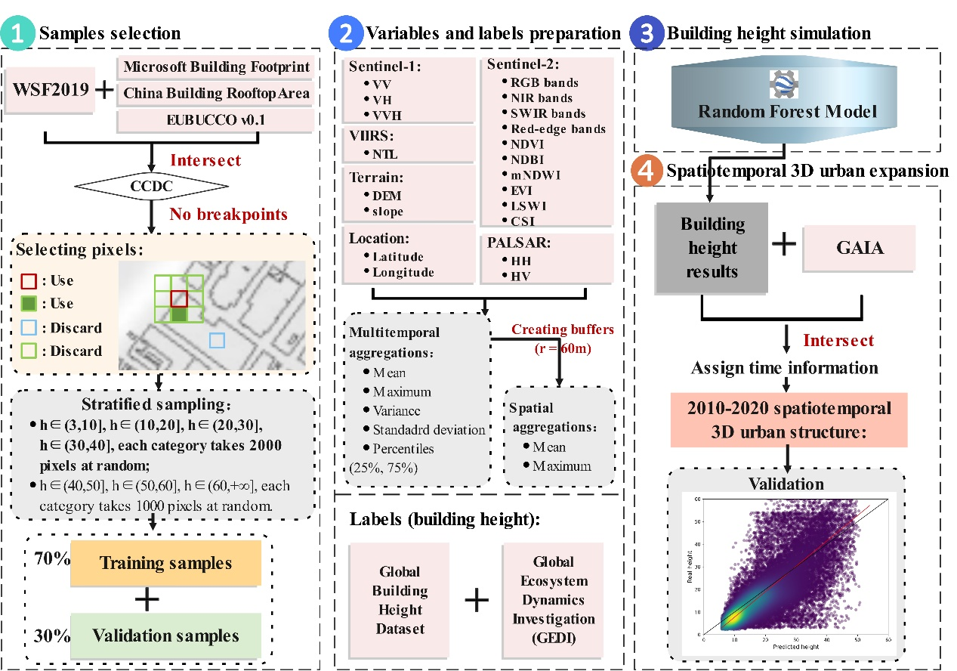
Supplementary figure 1. Technical framework.

Sample selection
The selection of samples before constructing a machine learning model significantly impacts training accuracy and generalization ability. Some existing research heavily relies on open cadastral data (M. Li et al., 2020, 2022), requiring the collection of building height data from government websites of various countries worldwide. This approach requires substantial labor and, on the other hand, is infeasible in areas without high-precision building height data. Other research utilizes building height data from certain remote sensing products, such as GEDI (Ma et al., 2023), derived through calculations. However, due to inherent limitations in processing these product data to obtain building heights, this method introduces significant errors, raising concerns about the precision of the training samples generated. In order to address these shortcomings in sample selection for model training, our study introduces an innovative, globally applicable, three-step sampling method. It involves “CCDC detection,” “pixel selection along building boundaries,” and “sampling based on height categories,” as illustrated in Fig. 3. First, we took the intersection of four datasets: WSF2019, Microsoft Building Footprint, EUBUCCO v0.1, and China Building Rooftop Area to obtain a more reliable horizontal range of built-up areas. Subsequently, we applied the Continuous Change Detection and Classification (CCDC) temporal algorithm (Arévalo et al., 2020; Deng & Zhu, 2020) in GEE to detect all building pixels and identified areas with uninterrupted spectral bands in the 2010-2020 decade as potential sampling regions. Moreover, we selected pixels located on building boundaries to mitigate the impact of the original data's limitations. During the sampling process, we selected 2000 samples from each category of pixels with heights ranging from 3-10, 10-20, 20-30, and 30-40 meters. For pixels with heights in the ranges of 40-50, 50-60, and >60 meters, we selected 1000 samples from each category. From the resulting sample collection, 70% was randomly chosen as the training set, while the remaining 30% was designated as the validation set.
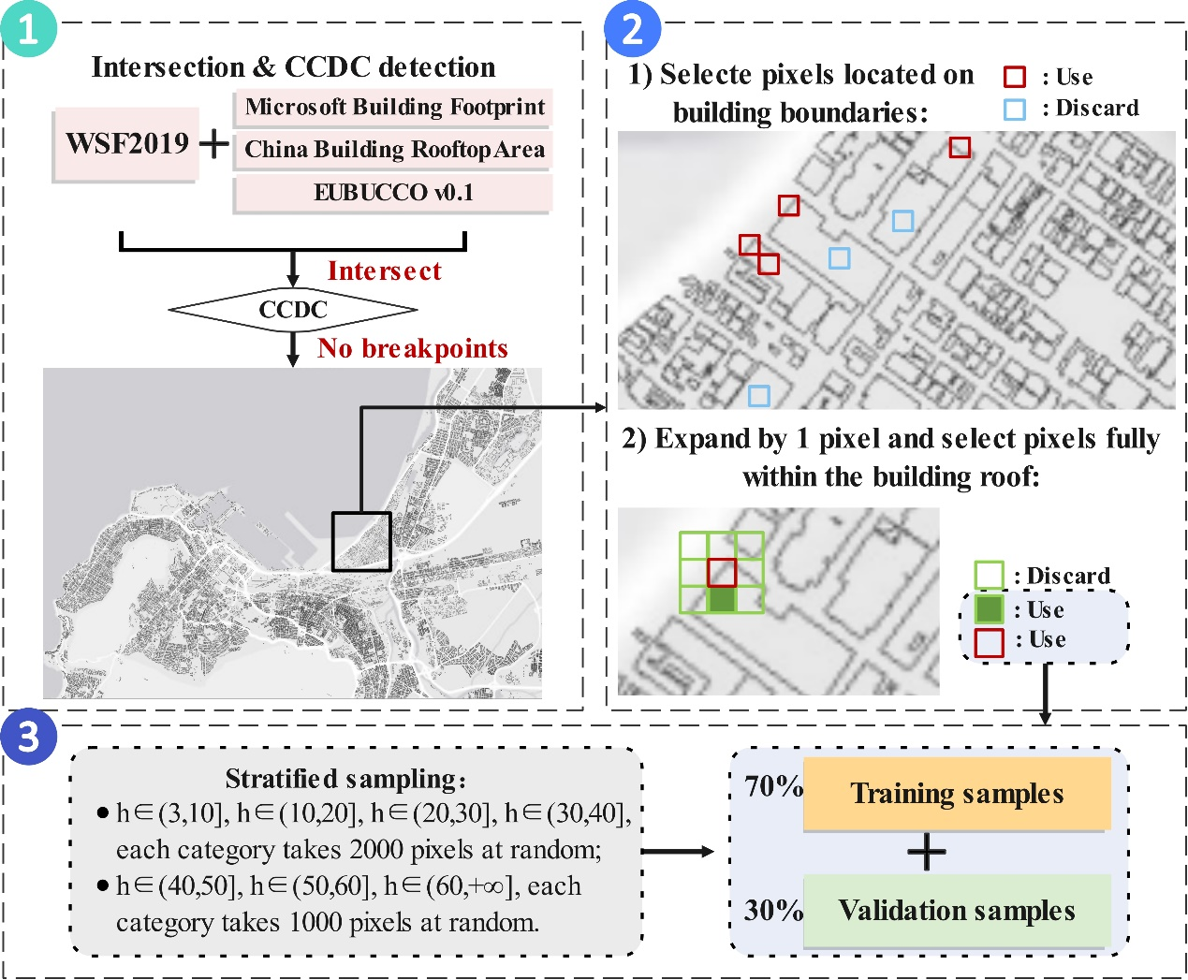
Supplementary figure 2. Illustration of sample selection methods.

Variable and label preparation
Once the sample areas are selected, it is essential to establish the relationships between the building heights at each sample point and the surrounding natural features, social factors, and remote sensing spectral attributes within a certain range. To enrich the information content of the input variables, we conducted temporal and spatial feature statistics on various variables (Frantz et al., 2021). Among these variables, Sentinel-1 and Sentinel-2 possessed temporal sequences. Therefore, we initially conducted temporal feature statistics on these variables, calculating mean, maximum, variance, standard deviation, and percentiles for all images at sample points in 2020. Subsequently, for variables without temporal sequences (including PALSAR, VIIRS, terrain, location, population, and canopy height), we synthesized the mean values for 2020 to create single images for each variable. Following this, spatial feature statistics were performed on the mean-synthesized variables and the temporal feature statistical variables from the Sentinel bands. Specifically, centered around each sample point, we created buffer zones with a 60-meter radius and computed each variable's mean and maximum values within these buffer zones. These calculated values were assigned to the pixel corresponding to the central sample point as spatial feature statistics. The resulting temporal feature statistical values and spatial feature statistical values for each sample point were collectively prepared as input variables for that sample point. In contrast, the building height for that sample point served as the output value for constructing the Random Forest model.
In setting the training set labels, i.e., building heights, the precision of machine learning models is significantly influenced. Thus, this study comprehensively selected two performance-complementary datasets. The first dataset is a global 30-meter spatiotemporal 3D urban expansion dataset proposed by He et al. (2023). This dataset, derived from ALOS DSM products using a moving window method to calculate building heights, exhibits lower accuracy in relatively smooth areas with less noticeable height variations but is suitable for capturing the heights of tall buildings with distinct height differences. Conversely, with height information available only along 14 ground tracks, GEDI data (Potapov et al., 2021) has limited samples, especially for tall buildings. Consequently, it is better suited for capturing the heights of extensive low-rise structures, such as slums, effectively compensating for the deficiencies in the other dataset regarding numerous low-rise buildings with less apparent height differences.

Building height data simulation
After preparing the sample area variables, we constructed a black-box model using spatiotemporal statistical data as independent variables and sample building heights as the dependent variable to capture their statistical relationships. We utilized the Random Forest (RF) regression model (Liaw & Wiener, 2002) for building height estimation. The Random Forest model depends on two critical parameters: N_{tree}, the number of trees, and M_{try}, the number of randomly selected features used for node splitting. Increasing N_{tree} can substantially enhance Random Forest's performance. Given that the RF classifier is computationally efficient and robust against overfitting, it is often recommended to set N_{tree} to the highest feasible value(Guan et al., 2013). Most of the studies used a value of 500 for N_{tree}, as it was observed that the errors of the classification tree tend to stabilize before reaching this number (Lawrence et al., 2006). When M_{try} is kept small, it reduces the model’s variance but increases bias, possibly overlooking critical features.
Conversely, with a large M_{try}, the model's variance increases, but the bias decreases as it considers more features. Previous studies suggested that M_{try} be set as the square root of the number of variables (Gislason et al., 2006). Here, we set N_{tree} to 500 and M_{try} to the square root of the variable count. In this study, World Settlement Footprint 2019 (WSF 2019) (Marconcini et al., 2021), Microsoft Building footprint (Microsoft, 2018/2018), EUBUCCO v0.1 (Milojevic-Dupont et al., 2023), and China Building Rooftop Area (Liu et al., 2023) were utilized to define the building footprint of the global case cities. The RF regression model was constructed using all the input variables mentioned earlier and was implemented on the Google Earth Engine (GEE) platform. After using the established model to predict the building heights for the year 2020, we further intersected them with the Global Artificial Impervious Area (GAIA) data (Gong et al., 2020) to assign the year attribute from GAIA. This process allowed us to identify the newly developed building footprints for each year from 2010 to 2020, effectively capturing the three-dimensional expansion process.

Per capita building volume, GDP and inequality for each city
In this study, our building map employs a 10m×10m grid size, considerably smaller than the footprint of typical buildings. We calculated individual grid building volumes by multiplying each pixel's building height by its area. The total building volume for each city was then derived by summing the volumes of all grids within that city. The population and per capita building volume in each city were calculated using the population records from the WorldPop. We use national GDP per capita data as a proxy for the economic development stage of each city, categorizing all 2071 cities into major cities within high-income, upper-middle-income, lower-middle-income, and low-income countries. We examined the relationship between per capita building volume and national GDP per capita. Since the GDP data we employed is a reproduced dataset synthesized from statistical data with a 1km resolution, the results obtained by resampling the GDP raster data are not entirely accurate, particularly when downscaling to higher spatial resolutions for subsequent urban-calibrated analyses. This is especially notable when calculating the per capita GDP of various cities in conjunction with population data, as it tends to overestimate the per capita GDP of smaller cities with fewer inhabitants. Hence, we utilized the national per capita GDP to represent the economic development stage of cities, although in reality, the economic development level of cities larger than >50km² may not align entirely with the overall economic development level of their respective countries. To quantitatively depict patterns in the distribution of building heights, we computed the inequality index of building height distribution in each city, as proposed by Brelsford et al. (Brelsford et al., 2017) and Pandey et al. (Pandey et al., 2022). Given the prevalence of lower values and occasional extreme values in building heights within cities, we mitigated the influence of a few extremely high values by considering the top 95% of building heights for each city. We calculated the mean value and standard deviation of this top 95%, normalized the mean value to a range between 0 and 1, and employed the normalized mean value and standard deviation to assess the unevenness of building height distribution in each city (Eq. 12).
$$\begin{aligned}I=\frac{σ}{\sqrt{μ×\left(1-μ\right)}};0<μ<1\#\left(12\right)\end{aligned}$$
Where $I$ represents the inequality index, ranging from 0 (lowest inequality) to 1 (highest inequality), and $μ$ and $σ$ denote the normalized mean value and standard deviation, respectively, of building height distributions constrained by an upper bound in each city.

Accuracy validation of building height
Supplementary figure 3 illustrates the relationship between the heights predicted by the RF model and the reference heights for the regions: USA, China, Europe, and the union of these three regions. Overall, the Bias for all four regions is below ±2 meters, with the Root Mean Square Error (RMSE) the four cities ranges from 3.308m to 11.770m. The results show that the proposed model in this study is suitable for extracting building heights in different continents and geographic contexts. The color of points represents the point density of the pixel area, where the color changes from purple to green to yellow, representing a gradual increase in dot density. A cross-comparison of the four cities reveals that the yellow dots, representing the maximum density in each region, cluster around 6 m (USA), 15 m (China), 12 m (Europe), and 9 m (all), indicating the predominant building heights within these regions. The area with the highest point density aligns closely with the 1:1 line, indicating that the predicted results for most pixels in each region are quite accurate.
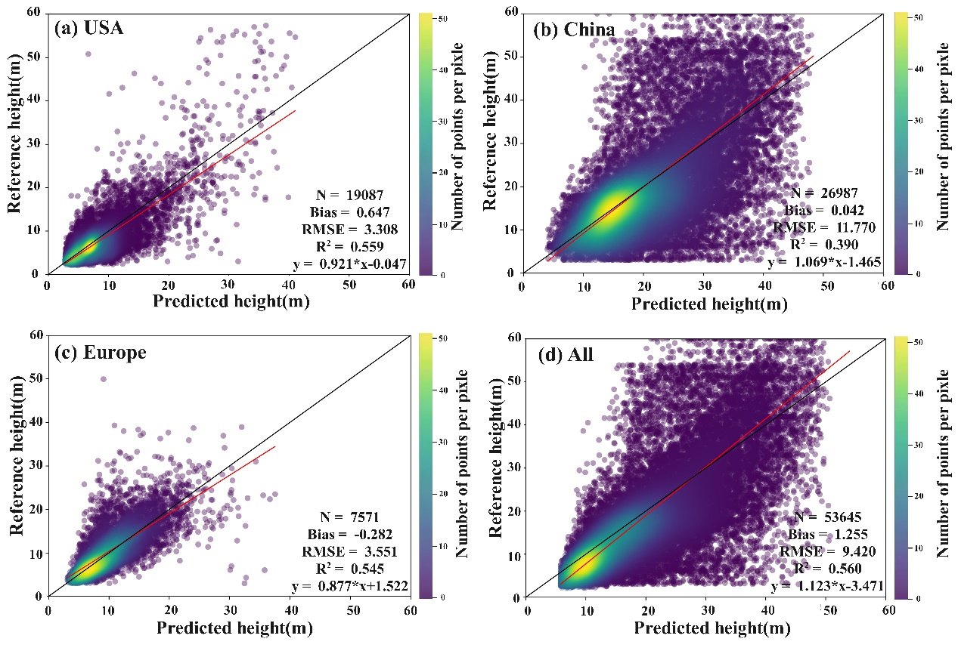
Supplementary figure 3. Illustration of sample selection methods.

References
Arévalo, P., Bullock, E. L., Woodcock, C. E., & Olofsson, P. (2020). A Suite of Tools for Continuous Land Change Monitoring in Google Earth Engine. Frontiers in Climate, 2. https://doi.org/10.3389/fclim.2020.576740
Brelsford, C., Lobo, J., Hand, J., & Bettencourt, L. M. A. (2017). Heterogeneity and scale of sustainable development in cities. Proceedings of the National Academy of Sciences, 114(34), 8963–8968. https://doi.org/10.1073/pnas.1606033114
Chen, J., Gao, M., Cheng, S., Hou, W., Song, M., Liu, X., & Liu, Y. (2022). Global 1 km × 1 km gridded revised real gross domestic product and electricity consumption during 1992–2019 based on calibrated nighttime light data. Scientific Data, 9(1), Article 1. https://doi.org/10.1038/s41597-022-01322-5
Dai, K., Li, Z., Tomás, R., Liu, G., Yu, B., Wang, X., Cheng, H., Chen, J., & Stockamp, J. (2016). Monitoring activity at the Daguangbao mega-landslide (China) using Sentinel-1 TOPS time series interferometry. Remote Sensing of Environment, 186, 501–513. https://doi.org/10.1016/j.rse.2016.09.009
Deng, C., & Zhu, Z. (2020). Continuous subpixel monitoring of urban impervious surface using Landsat time series. Remote Sensing of Environment, 238, 110929. https://doi.org/10.1016/j.rse.2018.10.011
Elvidge, C. D., Zhizhin, M., Ghosh, T., Hsu, F.-C., & Taneja, J. (2021). Annual Time Series of Global VIIRS Nighttime Lights Derived from Monthly Averages: 2012 to 2019. Remote Sensing, 13(5), Article 5. https://doi.org/10.3390/rs13050922
Frantz, D., Schug, F., Okujeni, A., Navacchi, C., Wagner, W., van der Linden, S., & Hostert, P. (2021). National-scale mapping of building height using Sentinel-1 and Sentinel-2 time series. Remote Sensing of Environment, 252, 112128. https://doi.org/10.1016/j.rse.2020.112128
Gislason, P. O., Benediktsson, J. A., & Sveinsson, J. R. (2006). Random Forests for land cover classification. Pattern Recognition Letters, 27(4), 294–300. https://doi.org/10.1016/j.patrec.2005.08.011
Gong, P., Li, X., Wang, J., Bai, Y., Chen, B., Hu, T., Liu, X., Xu, B., Yang, J., Zhang, W., & Zhou, Y. (2020). Annual maps of global artificial impervious area (GAIA) between 1985 and 2018. Remote Sensing of Environment, 236, 111510. https://doi.org/10.1016/j.rse.2019.111510
Gorelick, N., Hancher, M., Dixon, M., Ilyushchenko, S., Thau, D., & Moore, R. (2017). Google Earth Engine: Planetary-scale geospatial analysis for everyone. Remote Sensing of Environment, 202, 18–27.
Guan, H., Li, J., Chapman, M., Deng, F., Ji, Z., & Yang, X. (2013). Integration of orthoimagery and lidar data for object-based urban thematic mapping using random forests. International Journal of Remote Sensing, 34(14), 5166–5186. https://doi.org/10.1080/01431161.2013.788261
He, T., Wang, K., Xiao, W., Xu, S., Li, M., Yang, R., & Yue, W. (2023). Global 30 meters spatiotemporal 3D urban expansion dataset from 1990 to 2010. Scientific Data, 10(1), Article 1. https://doi.org/10.1038/s41597-023-02240-w
Huete, A., Didan, K., Miura, T., Rodriguez, E. P., Gao, X., & Ferreira, L. G. (2002). Overview of the radiometric and biophysical performance of the MODIS vegetation indices. Remote Sensing of Environment, 83(1–2), 195–213. https://doi.org/10.1016/S0034-4257(02)00096-2
Lang, N., Jetz, W., Schindler, K., & Wegner, J. D. (2022). A high-resolution canopy height model of the Earth (arXiv:2204.08322). arXiv. https://doi.org/10.48550/arXiv.2204.08322
Lawrence, R. L., Wood, S. D., & Sheley, R. L. (2006). Mapping invasive plants using hyperspectral imagery and Breiman Cutler classifications (randomForest). Remote Sensing of Environment, 100(3), 356–362. https://doi.org/10.1016/j.rse.2005.10.014
Li, M., Koks, E., Taubenböck, H., & van Vliet, J. (2020). Continental-scale mapping and analysis of 3D building structure. Remote Sensing of Environment, 245, 111859. https://doi.org/10.1016/j.rse.2020.111859
Li, M., Wang, Y., Rosier, J. F., Verburg, P. H., & van Vliet, J. (2022). Global maps of 3D built-up patterns for urban morphological analysis. International Journal of Applied Earth Observation and Geoinformation, 114, 103048. https://doi.org/10.1016/j.jag.2022.103048
Li, X., Gong, P., Zhou, Y., Wang, J., Bai, Y., Chen, B., Hu, T., Xiao, Y., Xu, B., Yang, J., Liu, X., Cai, W., Huang, H., Wu, T., Wang, X., Lin, P., Li, X., Chen, J., He, C., … Zhu, Z. (2020). Mapping global urban boundaries from the global artificial impervious area (GAIA) data. Environmental Research Letters, 15(9), 094044. https://doi.org/10.1088/1748-9326/ab9be3
Li, X., Zhou, Y., Gong, P., Seto, K. C., & Clinton, N. (2020). Developing a method to estimate building height from Sentinel-1 data. Remote Sensing of Environment, 240, 111705. https://doi.org/10.1016/j.rse.2020.111705
Liaw, A., & Wiener, M. (2002). Classiﬁcation and Regression by randomForest. 2.
Lin, L., Homma, R., & Iki, K. (2018). Preferences for a lake landscape: Effects of building height and lake width. Environmental Impact Assessment Review, 70, 22–33. https://doi.org/10.1016/j.eiar.2018.03.001
Liu, Z., Tang, H., Feng, L., & Lyu, S. (2023). China Building Rooftop Area: The first multi-annual (2016–2021) and high-resolution (2.5 m) building rooftop area dataset in China derived with super-resolution segmentation from Sentinel-2 imagery. Earth System Science Data, 15(8), 3547–3572. https://doi.org/10.5194/essd-15-3547-2023
Ma, X., Zheng, G., Chi, X., Yang, L., Geng, Q., Li, J., & Qiao, Y. (2023). Mapping fine-scale building heights in urban agglomeration with spaceborne lidar. Remote Sensing of Environment, 285, 113392. https://doi.org/10.1016/j.rse.2022.113392
Marconcini, M., Metz- Marconcini, A., Esch, T., & Gorelick, N. (2021). Understanding Current Trends in Global Urbanisation—The World Settlement Footprint Suite. GI_Forum, 1, 33–38. https://doi.org/10.1553/giscience2021_01_s33
Microsoft. (2018, July). Microsoft/USBuildingFootprints. https://github.com/microsoft/USBuildingFootprints (Original work published 2018)
Milojevic-Dupont, N., Wagner, F., Nachtigall, F., Hu, J., Brüser, G. B., Zumwald, M., Biljecki, F., Heeren, N., Kaack, L. H., Pichler, P.-P., & Creutzig, F. (2023). EUBUCCO v0.1: European building stock characteristics in a common and open database for 200+ million individual buildings. Scientific Data, 10(1). Scopus. https://doi.org/10.1038/s41597-023-02040-2
Pandey, B., Brelsford, C., & Seto, K. C. (2022). Infrastructure inequality is a characteristic of urbanization. Proceedings of the National Academy of Sciences, 119(15), e2119890119. 2023-11-16. https://doi.org/10.1073/pnas.2119890119
Potapov, P., Li, X., Hernandez-Serna, A., Tyukavina, A., Hansen, M. C., Kommareddy, A., Pickens, A., Turubanova, S., Tang, H., Silva, C. E., Armston, J., Dubayah, R., Blair, J. B., & Hofton, M. (2021). Mapping global forest canopy height through integration of GEDI and Landsat data. Remote Sensing of Environment, 253, 112165. https://doi.org/10.1016/j.rse.2020.112165
Sorichetta, A., Hornby, G. M., Stevens, F. R., Gaughan, A. E., Linard, C., & Tatem, A. J. (2015). High-resolution gridded population datasets for Latin America and the Caribbean in 2010, 2015, and 2020. Scientific Data, 2(1), Article 1. https://doi.org/10.1038/sdata.2015.45
Sun, G., Huang, H., Weng, Q., Zhang, A., Jia, X., Ren, J., Sun, L., & Chen, X. (2019). Combinational shadow index for building shadow extraction in urban areas from Sentinel-2A MSI imagery. International Journal of Applied Earth Observation and Geoinformation, 78, 53–65. https://doi.org/10.1016/j.jag.2019.01.012
Tucker, C. J. (1979). Red and photographic infrared linear combinations for monitoring vegetation. Remote Sensing of Environment, 8(2), 127–150. https://doi.org/10.1016/0034-4257(79)90013-0
Veci, L., Prats-Iraola, P., Scheiber, R., Collard, F., Fomferra, N., & Engdahl, M. (2014). The Sentinel-1 Toolbox. Proceedings of the IEEE International Geoscience and Remote Sensing Symposium (IGARSS), 1–3. http://www.igarss2014.org/
Wu, W.-B., Ma, J., Banzhaf, E., Meadows, M. E., Yu, Z.-W., Guo, F.-X., Sengupta, D., Cai, X.-X., & Zhao, B. (2023). A first Chinese building height estimate at 10 m resolution (CNBH-10 m) using multi-source earth observations and machine learning. Remote Sensing of Environment, 291, 113578. https://doi.org/10.1016/j.rse.2023.113578
Xiao, X., Hollinger, D., Aber, J., Goltz, M., Davidson, E. A., Zhang, Q., & Moore, B. (2004). Satellite-based modeling of gross primary production in an evergreen needleleaf forest. Remote Sensing of Environment, 89(4), 519–534. https://doi.org/10.1016/j.rse.2003.11.008
Xu, H. (2006). Modification of normalised difference water index (NDWI) to enhance open water features in remotely sensed imagery. International Journal of Remote Sensing, 27(14), 3025–3033. https://doi.org/10.1080/01431160600589179
Zha, Y., Gao, J., & Ni, S. (2003). Use of normalized difference built-up index in automatically mapping urban areas from TM imagery. International Journal of Remote Sensing, 24(3), 583–594. Scopus. https://doi.org/10.1080/01431160304987

