Mechanically deformable organic ferroelectric crystal with adaptive shape locking
Pei-Zhi Huang¹, Hao-Fei Ni¹, Jia-Qi Luo¹, Gele Teri¹, Qiang-Qiang Jia¹, Bo Zhuang², Chang-Feng Wang¹, Zhi-Xu Zhang*¹, Yi Zhang*¹ and Da-Wei Fu*^{1, 2}
¹ Institute for Science and Applications of Molecular Ferroelectrics, Key Laboratory of the Ministry of Education for Advanced Catalysis Materials, Zhejiang Normal University, Jinhua 321004, People’s Republic of China
² Ordered Matter Science Research Center, Jiangsu Key Laboratory for Science and pliations of Molecular Ferroelectrics, Southeast University, Nanjing 211189, People’s Republic of China
Correspondence and requests for materials should be addressed to Z.-X. Z. (email: zhangzhixu@zjnu.edu.cn); Y. Z. (email: yizhang1980@seu.edu.cn) or to D.-W. F. (email: dawei@zjnu.edu.cn)

Supplementary Note 1 | Details of synthesis and crystal growth.
All reagents used were commercially available and were used without subsequent purification. For PEA-TFMS (PEA = phenethylammonium, TFMS = trifluoromethanesulfonate), 5 mmol trifluoromethanesulfonic acid was first dissolved in methanol under stirring. Subsequently, 5 mmol phenylethylamine was slowly added into the mixed solution with continuously stirring. The obtained clear solution was placed at room temperature and slowly evaporated. The colorless needle crystals of PEA-TFMS can be easily grow well after a few days. The crystal growth procedure of other crystals mentioned in this paper are similar to that of PEA-TFMS, except using their corresponding amine and acid.
Compound | Reagent
PEA-MS  (phenethylammonium mesylate) | phenethylammine,  methanesulfonic acid
o-FPEA-MS  (o-fluorophenethylammonium mesylate) | o-fluorophenethylammine, methanesulfonic acid
m-FPEA-MS  (m-fluorophenethylammonium mesylate) | m-fluorophenethylammine, methanesulfonic acid
p-FPEA-MS  (p-fluorophenethylammonium mesylate) | p-fluorophenethylammine, methanesulfonic acid

Supplementary Figures
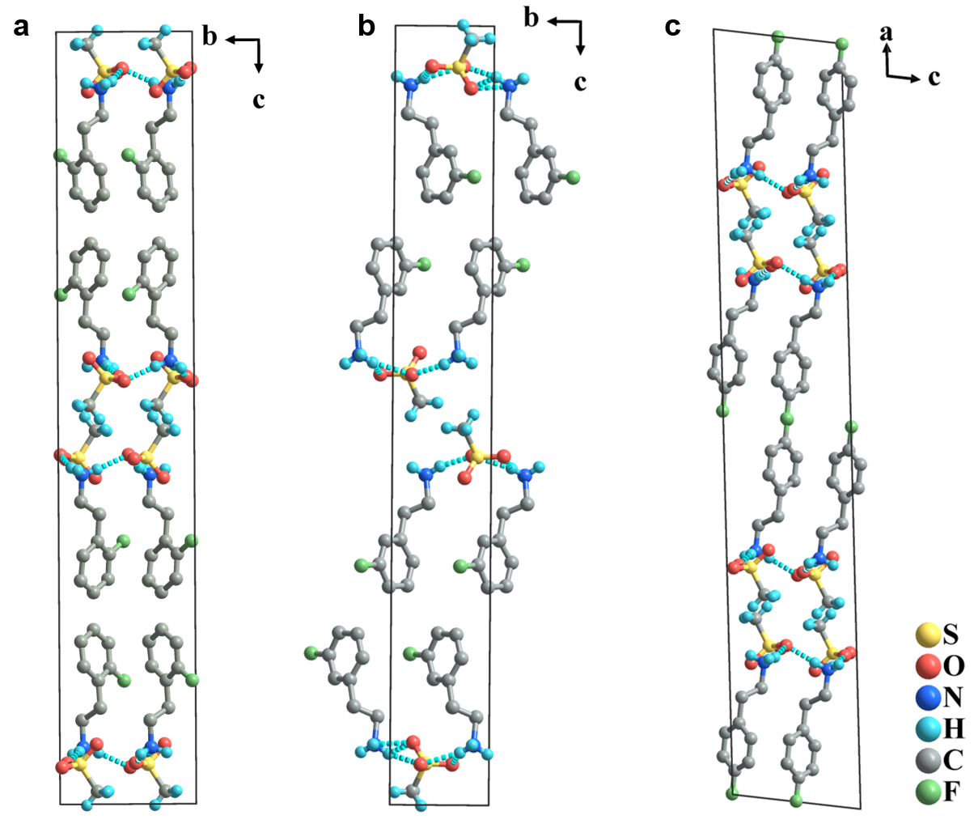
Supplementary Fig. 1. Packing structures of o-FPEA-MS (a), m-FPEA-MS (b) and p-FPEA-MS (c). Some hydrogen atoms were omitted for clarity.

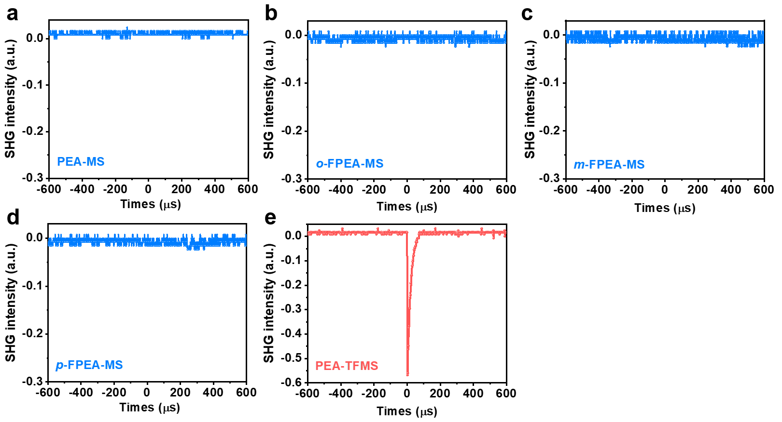
Supplementary Fig. 2. SHG signals of PEA-MS (a), o-FPEA-MS (b), m-FPEA-MS (c), p-FPEA-MS (d) and PEA-TFMS (e).

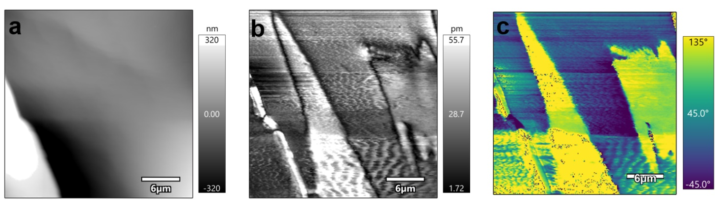
Supplementary Fig. 3. Topography (a), amplitude (b) and phase (c) images for PEA-TFMS.

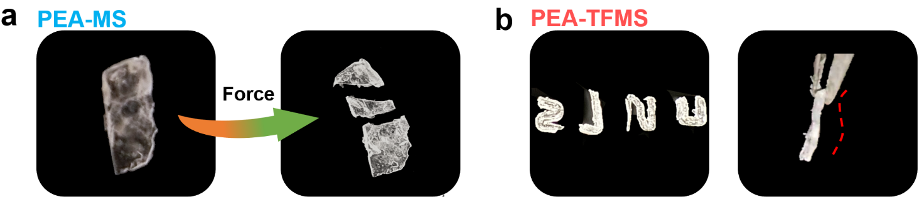
Supplementary Fig. 4. a The PEA-MS crystal cracks under external forces. b Bending of PEA-TFMS crystals with several shapes and even helical-like deformation.
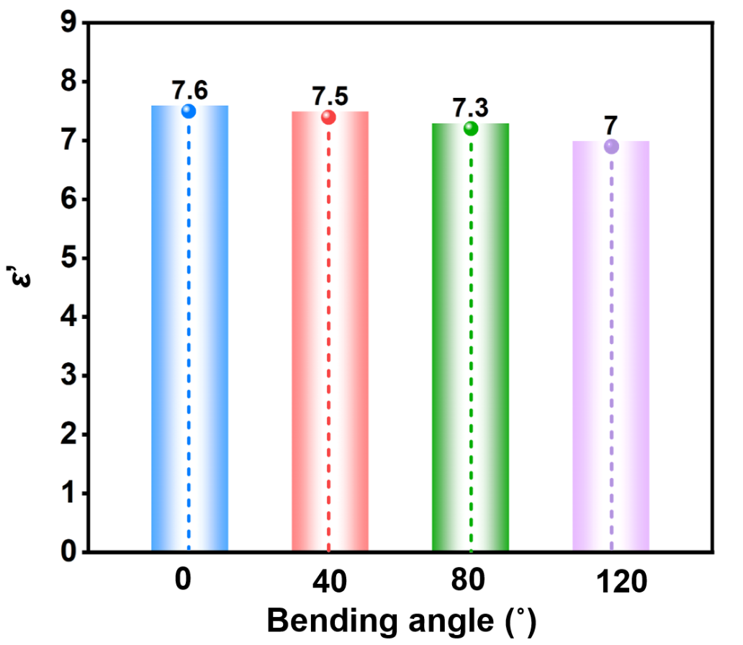
Supplementary Fig. 5. PEA-TFMS crystal’s dielectric constants after bending measured at room temperature of 1 MHz.

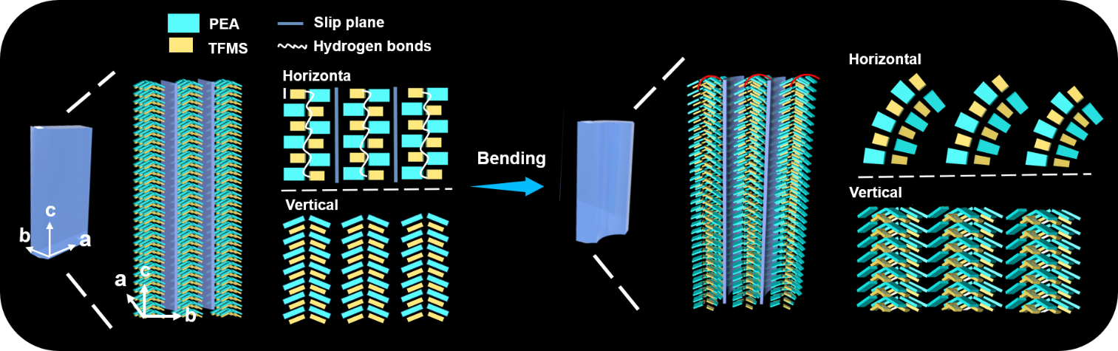
Supplementary Fig. 6. Schematic of the mechanism for the plastic bending process of PEA-TFMS.
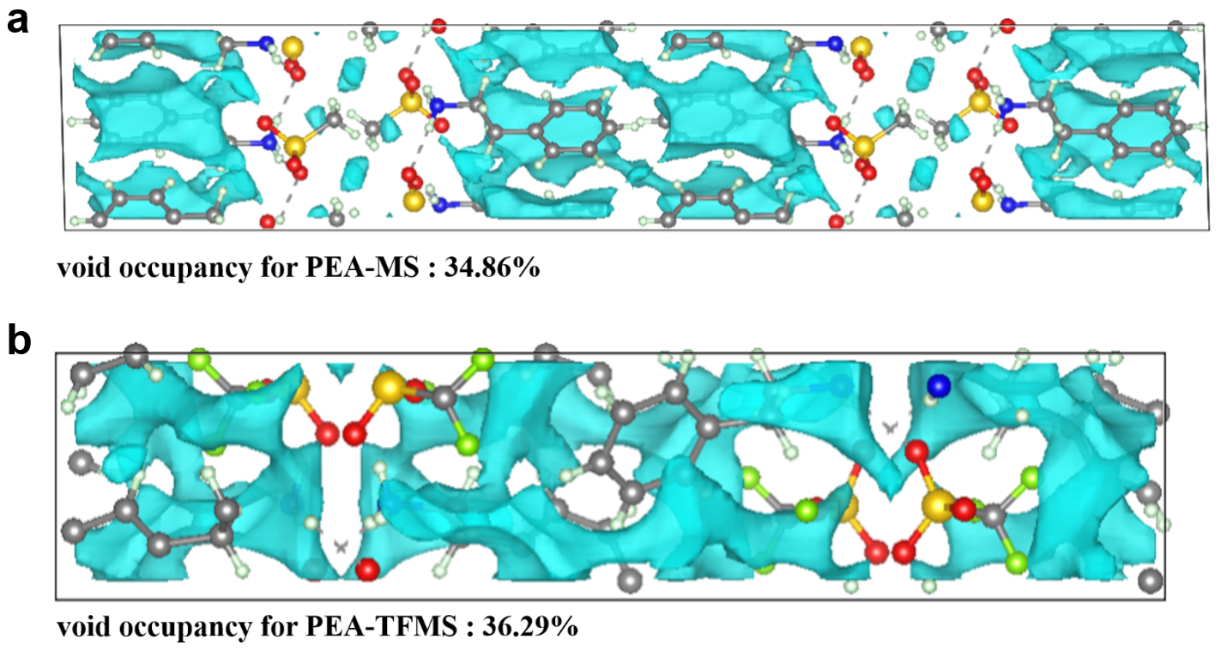
Supplementary Fig. 7. The cell void occupancy of PEA-MS (a) and PEA-TFMS (b) calculated by multiwfn software.

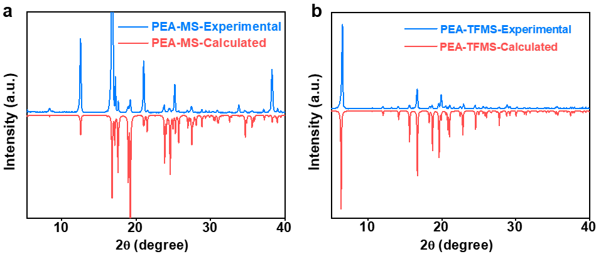
Supplementary Fig. 8. Powder X-ray diffraction (PXRD) patterns of PEA-MS (a) and PEA-TFMS (b) measured at room temperature match well with the ones obtained by fitting the crystal data.

Supplementary Table 1. Crystal data and structure refinement for PEA-MS, PEA-TFMS, PEA-TFMS at 223 K, 253 K, and 353 K, respectively.
Compound | PEA-MS | PEA-TFMS | PEA-TFMS
Temperature | 223 K | 253 K | 353 K
Empirical formula | C₈H₁₂N • CH₃O₃S | C₈H₁₂N • CF₃O₃S | C₈H₁₂N • CF₃O₃S
Formula weight | 217.28 | 271.26 | 271.26
Space group | I2/a | Pna2₁ | Pbam
Crystal system | Monoclinic | Orthorhombic | Orthorhombic
a/ Å | 7.399 (8) | 8.4905 (5) | 9.332 (4)
b/ Å | 7.240 (7) | 26.2519 (17) | 25.810 (11)
c/ Å | 42.310 (4) | 5.6633 (3) | 5.5140 (13)
α/° | 90.000 | 90.000 | 90.000
β/° | 91.539 (19) | 90.000 | 90.000
γ/° | 90.000 | 90.000 | 90.000
Volume/ Å³ | 2266 (4) | 1262.30 (13) | 1328.1 (9)
Z | 8 | 4 | 4
F(000) | 928 | 560 | 524
GOF | 1.09 | 1.5 | 1.08
R1[I>2σ(I)] | 0.068 | 0.095 | 0.093
wR2[I>2σ(I)] | 0.163 | 0.292 | 0.213

Supplementary Table 2. Crystal data and structure refinement for o-FPEA-MS, m-FPEA-MS, p-FPEA-MS at 243 K, 273 K and 273 K, respectively.
Compound | o-FPEA-MS | m-FPEA-MS | p-FPEA-MS
Temperature | 243 K | 273 K | 273 K
Empirical formula | C₈H₁₁FN • CH₃O₃S | C₈H₁₁FN • CH₃O₃S | C₈H₁₁FN • CH₃O₃S
Formula weight | 235.27 | 235.27 | 235.27
Space group | Pbca | P2₁/n | C2/c
Crystal system | Orthorhombic | Monoclinic | Monoclinic
a/ Å | 7.272 (5) | 5.193 (2) | 44.024 (5)
b/ Å | 7.470 (5) | 5.201 (2) | 7.2472 (7)
c/ Å | 42.23 (3) | 40.94 (2) | 7.4028 (9)
α/° | 90.000 | 90.000 | 90.000
β/° | 90.000 | 91.340 (3) | 97.918 (7)
γ/° | 90.000 | 90.000 | 90.000
Volume/ Å³ | 2294 (3) | 1105.4 (9) | 2339.3 (5)
Z | 8 | 4 | 8
F(000) | 992 | 496 | 992
GOF | 1.13 | 0.84 | 1.05
R1[I>2σ(I)] | 0.070 | 0.150 | 0.041
wR2[I>2σ(I)] | 0.217 | 0.342 | 0.117

Supplementary Table 3. Comparisons of mechanical properties of the PEA-TFMS with other related materials.
Compound | H (MPa) | E (GPa) | Mechanical flexibility  in bulk crystal | Shape locking | Ferroelectric | Ref.
BaTiO₃ | 13600 | 167.9 | NO | NO | YES | 1
PVDF poled film | 240.3 | 3.28 | YES | NO | YES | 2
triglycine sulfate | 1910 | 37.65 | Non | NO | YES | 2, 3
NDABCO-NH₄-Br₃ | 1020 | 20.69 | Non | NO | YES | 4
EA₄Pb₃Br₁₀^{[a]} | Non | Non | Non | NO | YES | 5, 6
[Q]ReO₄^{[b]} | Non | Non | No | NO | YES | 7
[3-O-Q]ClO₄[c] | Non | Non | Non | NO | YES | 8
D-chiro-inositol-SiMe₃ | 72.8 | 5.04 | Non | NO | YES | 2
HOCH₂(CF₂)₃CH₂OH | 437.4 | 6.14 | Non | NO | YES | 9
BPMNB^{[d]} | Non | 15 | YES | YES | No | 10
APHO^{[e]} | 205 | 2.66 | YES | NO | No | 11
PEA-MS | 482.4 | 10.21 | No | NO | No | this work
PEA-TFMS | 204.1 | 4.31 | YES | YES | YES | this work
[a] EA is ethylammonium. [b] [Q]ReO₄ is quinuclidinium perrhenate. [c] [3-O-Q]ClO₄ is 3-oxoquinuclidinium perchlorate. [d] BPMNB is 4-bromophenyl 3-methyi-4-nitrobenzoate. [e] APHO is an anthracene−pentiptycene hybrid organic π-system.

References
1. Ryu S. S., Kim H. T., Kim H. J., Kim S. Characterization of mechanical properties of BaTiO₃ ceramic with different types of sintering aid by nanoindentation. J. Ceram. Soc. Jpn. 117, 811-814 (2009).
2. Zhang Z. X., et al. The First Chiro-Inositol Organosilicon Ferroelectric Crystal. Angew. Chem. Int. Ed. 61, e202210809 (2022).
3. Matthias B. T., Miller C. E., Remeika J. P. Ferroelectricity of Glycine Sulfate. Phys. Rev. 104, 849-850 (1956).
4. Zhang H., et al. Large Piezoelectric Response in a Metal-Free Three-Dimensional Perovskite Ferroelectric. J. Am. Chem. Soc.145, 4892-4899 (2023).
5. Ding R., et al. Effective Piezo-Phototronic Enhancement of Flexible Photodetectors Based on 2D Hybrid Perovskite Ferroelectric Single-Crystalline Thin-Films. Adv. Mater. 33, 2101263 (2021).
6. Wang S., et al. An Unprecedented Biaxial Trilayered Hybrid Perovskite Ferroelectric with Directionally Tunable Photovoltaic Effects. J. Am. Chem. Soc. 141, 7693-7697 (2019).
7. Harada J., et al. Directionally tunable and mechanically deformable ferroelectric crystals from rotating polar globular ionic molecules. Nat. Chem. 8, 946-952 (2016).
8. Yang C.-K., et al. Directional Intermolecular Interactions for Precise Molecular Design of a High-Tc Multiaxial Molecular Ferroelectric. J. Am. Chem. Soc. 141, 1781-1787 (2019).
9. Zhang H.-Y., et al. Biodegradable ferroelectric molecular crystal with large piezoelectric response. Science 383, 1492-1498 (2024).
10. Saha S., Desiraju G. R. Crystal Engineering of Hand-Twisted Helical Crystals. J. Am. Chem. Soc. 139, 1975-1983 (2017).
11. Chen Y.-S., Wang C.-H., Hu Y.-H., Lu C.-Y. D., Yang J.-S. An Elastic Organic Crystal Enables Macroscopic Photoinduced Crystal Elongation. J. Am. Chem. Soc. 145, 6024-6028 (2023).

